Output torque:

$$T_{0}= 25 [N]$$

Rotational speed:

Power:

Motor and Gearbox Selection:

Key load parameters:

|  |  |  |
| --- | --- | --- |
| Output Torque [Nm] | Rotational Speed [rpm] | Power [W] |
| 25 | 30 | 78.54 |

We firstly select the gear box that can allow 25 [Nm] output torque from company Maxon. From the product catalogue [See Appendix], we select the gearbox Planetary Gearhead GP 52 C.

Free body diagram:

Force analysis:

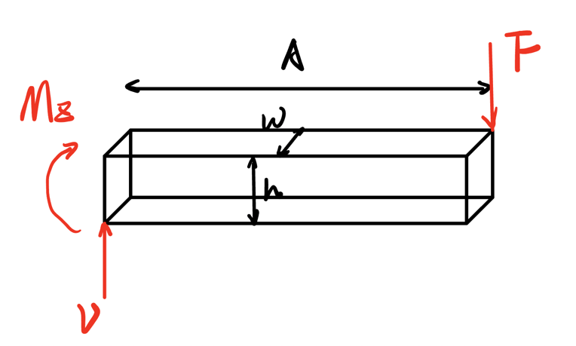

$$F=mgγ=2.5 \left[kg\right]× 9.81 \left[\frac{m}{s^{2}}\right]×3=73.575 \left[N\right]$$

where $γ$ is the magnification factor.

Force Diagram:

Point D is the critical point since the bending moment at this point is highest and there is a stress concentration of the guide rail.

The internal moment and the shear force at the critical point:

$$V = F$$

$$M_{z}=V*A=110.363 \left[Nm\right]$$

Let’s choose G10300 HR steel as the material from Shigley’s book Table A-20, the properties:



Dimension of the beam:

Thickness: h = 0.015 m

Width: b = 0.015 m

Let’s check for the yielding:

Choose the safety factor as

$$n = 1.3$$

Bending stress:

Normal: $τ_{x}=-\frac{M_{z}y}{I_{z}}= -196.200000 [MPa]$

Shear: $τ_{xz}=\frac{VQ}{Ib}=0.490500 [MPa]$

Since it’s a ductile material, choose Distortion-energy criterion:

$$σ^{'}=(τ_{x}^{2}+3{τ_{xz}^{2})}^{\frac{1}{2}} = 196.200613 [MPa]$$

$$σ^{'}≤\frac{S_{y}}{n_{d}}=\frac{260}{1.3}= 200 [MPa]$$

Thus, the beam will not yield.

**Appendix:**

