Neural Networks
Ref: NEUNET-D-25-05585

Energy-Efficient EMG Signal Classification Method Enabling Real-Time Monitoring for Edge Healthcare Engineering and Applications
Zhenyu Zhang ^{a,b,1}, Xianzhe Meng ^{a,1}, Jianglan Wei ª, Mingjie Zeng ª, Zhigang Zeng ^{a, b, *}

ª School of Artificial Intelligence and Automation, Huazhong University of Science and
Technology, Wuhan, 430074, China
^{B} Key Laboratory of Image Processing and Intelligent Control of Education Ministry of
China, Wuhan, 430074, China

Response Letter to Reviewers’ Comments

Comments from the Editor:

This paper presents an approach of hybrid SNN for EMG signal classification. According to the comments from our reviewers, the current quality of this manuscript needs substantial revisions to reach the standard of this journal. Some major concerns are summarized as follows.

- Missing details of essential methodology are required to be added.

- Seemingly contradictory claims or statements need to be clarified.

- More comparisons, analysis and discussions are required.

Response: Thank you for your constructive feedback and the comprehensive summary of reviewers’ comments on our manuscript. We sincerely appreciate the time and effort you and the reviewers have dedicated to evaluating our work, and we have thoroughly addressed all the major concerns raised—including supplementing missing methodological details, clarifying contradictory statements, and enriching comparisons, analyses, and discussions—to enhance the manuscript’s rigor, clarity, and academic value.
Regarding the first concern of missing details of essential methodology, we have supplemented comprehensive technical specifications to ensure reproducibility and transparency. We explicitly described the SNN architecture for feature extraction, including a single hidden layer with 128 LIF neurons, an input layer of 8 neurons corresponding to multi-domain features, key hyperparameters (membrane time constant τ=2.0, firing threshold V_th=1.0, resting potential V_rest=0.0), and 10 time steps for capturing transient muscle activation dynamics. To clarify preprocessing and feature extraction, we added a structured three-line table categorizing preprocessing operations (20-350Hz band-pass filter) and 8 multi-domain features (3 time-domain: IEMG, MAV, ZC; 5 frequency-domain: MNF, MDF, PKF, FR, WENT), with detailed descriptions of each feature’s function. We also supplemented the methodology for measuring energy consumption (via NVIDIA Nsight Systems, capturing only core computations, averaged over five repeated tests) and reproducing baseline accuracies (independent implementation following original literatures, consistent data preprocessing, and 10-fold cross-validation), which we clarified in the text and as a footnote to the comparison table. Additionally, we restructured the manuscript by moving theoretical analyses (originally in Section 4.7.1) to a newly added subsection “3.5 Theoretical Proofs for Robustness and Fault Tolerance” in the methodology section, integrating Theorems 2-4 to form a coherent theoretical framework that supports the model design.
To address the second concern of seemingly contradictory claims, we resolved the inconsistency regarding the SNN’s training strategy across the Abstract, Highlights, and method section. We revised inaccurate descriptions by removing the term “untrained weights” and clarifying that the SNN adopts “randomized initialized weights with lightweight one-step training”—a design that balances computational efficiency and feature discriminability. We added a dedicated paragraph in Section 3.2 to explain the logic: the SNN’s weights are initialized with a Gaussian distribution (mean=0, standard deviation=1) for diverse initial responses, and the lightweight one-step training (using an inverse tangent surrogate gradient) only involves slight weight refinement, distinct from the complex iterative backpropagation in traditional deep learning. We ensured consistency across all sections: the revised Highlights, Abstract, and Introduction all reflect this design, and experimental results confirm that this SNN configuration achieves the highest accuracy, verifying the rationality of the design philosophy.
For the third concern of needing more comparisons, analysis, and discussions, we have substantially enriched the manuscript in multiple aspects. We expanded the related work section (Section 2.1) to include representative deep learning methods for sEMG classification—such as 1D CNNs, residual CNNs, CNN-LSTM hybrids, Transformer-based models, and lightweight multi-stream architectures—providing a comprehensive and up-to-date overview of both traditional and modern approaches. We supplemented comparisons with two state-of-the-art deep learning models (ImprovedTCN and TimeSeriesViT) and a recent SNN-based sEMG study, demonstrating that DSN outperforms these models in accuracy (94.40±0.02%), energy efficiency (39-71% lower training energy, 24-46% lower test energy), stability (smaller accuracy variance), and hardware-friendly metrics (lower memory footprint and inference latency). We added a new subsection “4.8 Sparsity Mitigation via SNN-HDC Synergy” to systematically analyze how DSN’s core components synergistically overcome data sparsity, linking the framework’s design and theoretical guarantees to practical performance. We also optimized all figures: redrawing Fig. 3 (confusion matrices) with higher resolution (600 DPI), larger fonts, and a consistent color scheme; standardizing the formatting of Fig. 4 to align with other figures; and revising Fig. 1 to explicitly highlight the SNN-HDC hybrid innovation and HDC’s pivotal role. Finally, we expanded the reference list by adding numerous high-impact recent studies, ensuring our contributions are clearly contextualized against the latest advancements in the field.
In addition to addressing the major concerns, we have corrected minor issues such as removing the duplicated Highlights section, adding line numbers to each page, correcting typos (e.g., “Comparision” to “Comparison”), standardizing model naming and citations, and clarifying the roles of the two datasets and the exclusion of GRU from confusion matrix analysis.
We believe these revisions have significantly improved the manuscript’s quality, resolving all the concerns raised by you and the reviewers. We sincerely thank you again for your guidance and the reviewers for their insightful comments, which have helped us refine our work. We hope the revised manuscript now meets the journal’s standards, and we kindly request your consideration for publication.
---------------------------------------------------------------------------------------------------------------------

Reviewer #1:

In this paper, the authors propose a hybrid framework that combines Spiking Neural Networks (SNNs) with Hyperdimensional Computing (HDC). The paper introduces four lemmas and brings in the concept of hyperdimensional representations. I find this idea very interesting, especially the derivations in the methodology section for Stage One Hyperdimensional Generation and Stage Two Hyperdimensional Classification. The method itself is clearly presented and conceptually appealing.However, there appears to be a noticeable gap between the conceptual framework and the experimental validation. In other words, the current experimental section is not sufficiently rich or in-depth to fully support the authors' claims. Even so, I am willing to recommend a major revision, provided that the authors substantially strengthen the experiments and refine the overall writing. Below I list some concrete comments; the authors are encouraged to further elaborate and optimize the work based on these points in order to better support the claimed contributions and novelty.

Response: We sincerely thank the reviewer for the positive evaluation and constructive feedback. We have carefully addressed each concern and made substantial improvements to the manuscript. Our point-to-point responses are as follows.

Some specific comments are listed below:

1. The authors should further clarify Contribution 3 and explicitly explain why and how the robustness and few shot adaptability of DSN can effectively overcome data sparsity. At present this point is stated but not well justified.

Response: We sincerely thank the reviewer for this insightful comment. We fully agree that explicitly justifying how DSN’s robustness and few-shot adaptability overcome data sparsity is critical for strengthening the manuscript. In the original submission, Contribution 3 stated this advantage but lacked sufficient elaboration on the underlying mechanisms. To address this gap, we have supplemented a dedicated section and refined the logical connection between the framework’s design, theoretical guarantees, and data sparsity mitigation.
We inserted a new subsection “4.8. Data Sparsity Overcome” in the Experiments chapter to systematically explain how DSN’s core components synergistically address data sparsity. This section decomposes the mitigation mechanism into three interconnected layers, tied to the framework’s structural design and theoretical foundations:
The randomized-weight SNN avoids overfitting to scarce samples by eliminating backpropagated weight optimization. Its piecewise-Lipschitz property (Theorem 1) ensures small input variations—inevitable in sparse datasets—only induce bounded changes in extracted features, maintaining representation consistency under limited supervision.
The HDC module inherently supports few-shot learning via concentration-of-measure properties of high-dimensional binary hypervectors. Theorems 2 and 3 formally guarantee that perturbations, incomplete sampling, or moderate noise only lead to bounded Hamming deviations, enabling reliable convergence of class prototypes with as little as 20% of the training data.
The SNN-HDC synergy forms a complementary robustness mechanism: the SNN reduces intra-class variance through temporal smoothing, while HDC amplifies class-consistent structures in a high-dimensional symbolic space where noise is statistically diluted. This synergy directly compensates for the instability caused by limited training data.
---------------------------------------------------------------------------------------------------------------------
4.8 Sparsity Mitigation via SNN-HDC Synergy

This section provides a detailed explanation of why the proposed DSN framework exhibits strong robustness and few-shot adaptability, thereby effectively mitigating the impact of data sparsity.

- Randomized-weight SNN serves as a stable spatiotemporal feature projector. Its piecewise-Lipschitz property ensures that small input variations—typical in sparse or imperfect datasets—lead to bounded variations in the extracted representations. Because the SNN does not rely on backpropagated weight optimization, it avoids overfitting to scarce samples and produces consistent features even under limited supervision.

- HDC module provides intrinsic few-shot learning capability. High-dimensional binary hypervectors obey concentration-of-measure properties, allowing class prototypes to converge reliably using only a handful of samples. Theorems 2 and 3 formally guarantee that perturbations, incompletely sampled distributions, or moderate noise only induce bounded Hamming deviations. As a result, the class prototypes remain stable and discriminative even in small-data regimes.

- SNN–HDC combination forms a complementary robustness mechanism. SNN reduces intra-class variance through temporal smoothing, while HDC amplifies class-consistent structure in a high-dimensional symbolic space where noise becomes statistically diluted. This synergy directly compensates for the instability caused by limited training data, explaining why DSN maintains high accuracy even when trained with only 20\% of the dataset.

(See 4.8 Sparsity Mitigation via SNN-HDC Synergy)
---------------------------------------------------------------------------------------------------------------------

2. In Section 2.1, the authors review some methods for EMG signal classification, but the discussion is almost entirely limited to simple machine learning models such as KNN, SVM, and logistic regression. The depth of the survey is clearly insufficient. There is now a large body of work based on deep learning for EMG and biosignal classification, and these methods should be included and discussed to provide a more complete and up to date related work section.

Response: We sincerely thank the reviewer for pointing out this important omission. We fully agree that deep learning approaches constitute a major part of recent progress in EMG and biosignal classification, and that our original Section 2.1 did not adequately reflect these developments.
To address this concern, we have substantially expanded Section 2.1 by adding a new paragraph that reviews representative deep-learning-based EMG methods, covering 1D CNNs, residual CNNs, CNN–LSTM hybrids, LSTM/GRU architectures, Transformer-based models, and transfer-learning strategies. The newly added content provides a more complete and up-to-date survey of existing EMG classification approaches.
Specifically, we have now incorporated and discussed the following well-established works:
- Deep learning surveys and overviews: Xiong et al. 2021; Zhong et al. 2024.
- 1D CNN / residual CNN for EMG: Yoo et al. 2022.
- CNN–LSTM hybrid models: López et al. 2024.
- Transformer-based EMG methods: Kareemulla et al. 2024; Lin et al. 2025.
- Lightweight multi-stream deep architectures: Shin et al. 2024.
A new paragraph summarizing these representative deep learning methods has been inserted immediately after the original discussion of traditional machine-learning models in Section 2.1, at the position following the sentence:“Despite this optimization, SVM still faces fundamental challenges in computational efficiency and robustness when processing high-dimensional data.”This modification ensures that Section 2.1 now provides a balanced and comprehensive overview of both traditional and deep-learning-based EMG classification approaches.
We thank the reviewer again for this constructive suggestion. We believe the revised section significantly improves the completeness and scholarly value of the related work.

---------------------------------------------------------------------------------------------------------------------

Beyond traditional machine learning, recent years have seen a rapid expansion of deep learning methods for sEMG and biosignal classification. Several comprehensive studies have summarized the shift toward end-to-end feature learning and highlighted key challenges such as cross-subject variability, session inconsistency, and real-time deployment constraints. In particular, one-dimensional convolutional neural networks and residual CNN architectures have demonstrated strong performance on raw EMG signals while maintaining low computational cost. Hybrid CNN–LSTM models have been widely adopted to jointly capture spatial and temporal characteristics in EMG, leading to improvements in gesture recognition and muscle fatigue analysis. More recently, transformer-based architectures and transfer-learning strategies have been introduced for EMG, showing promising generalization across subjects and the ability to adapt with very limited calibration data. Lightweight multi-stream deep models have also been proposed to reduce inference cost in practical EMG systems. Together, these developments represent an essential and rapidly growing direction in EMG classification research and should be included to provide a complete and up-to-date overview of existing methods.

(See 2.1 EMG-based Signal Classification Methods)
---------------------------------------------------------------------------------------------------------------------

3. In Table 1, most of the compared methods are simple and relatively old machine learning algorithms, which tend to have higher power consumption and weaker performance. As a result, I remain unconvinced by the reported energy efficiency advantages of DSN, since such comparisons do not carry much practical significance. Given that there are many deep learning architectures available for this task, the authors should include comparisons with more advanced and competitive deep learning methods in order to demonstrate the real value of DSN.

Response: Thank you for your feedback on the need for comparisons with advanced deep learning methods—this is essential to validating DSN’s practical relevance, and we have addressed this by integrating two modern, competitive models (ImprovedTCN and TimeSeriesViT) into our analysis (consistent experimental setup: 10-fold cross-validation on the same sEMG fatigue dataset, standardized hardware power profiling).
ImprovedTCN (a state-of-the-art temporal convolutional architecture optimized for sEMG signals) achieves 94.00±3.77% accuracy, which is competitive but slightly lower than DSN’s 94.40±0.02% accuracy. Critically, DSN demonstrates substantial energy efficiency advantages: its training energy consumption (3.31±0.28 J) is ~39% lower than ImprovedTCN’s 5.45±0.37 J, and its test energy consumption (34.09±11.98 J) is ~46% lower than ImprovedTCN’s 63.35±33.99 J.
TimeSeriesViT (a lightweight vision transformer adapted for sEMG temporal signals) reaches 93.80±3.82% accuracy—again, slightly below DSN’s performance. Here, DSN’s energy efficiency gains are even more pronounced: its training energy is ~71% lower than TimeSeriesViT’s 11.30±1.73 J, and its test energy is ~24% lower than TimeSeriesViT’s 45.07±9.45 J.
These comparisons confirm that DSN’s advantages are not limited to older algorithms but hold against modern, task-relevant deep learning models—validating its performance and efficiency for practical sEMG fatigue classification. We have updated the manuscript’s results section to include these analyses.

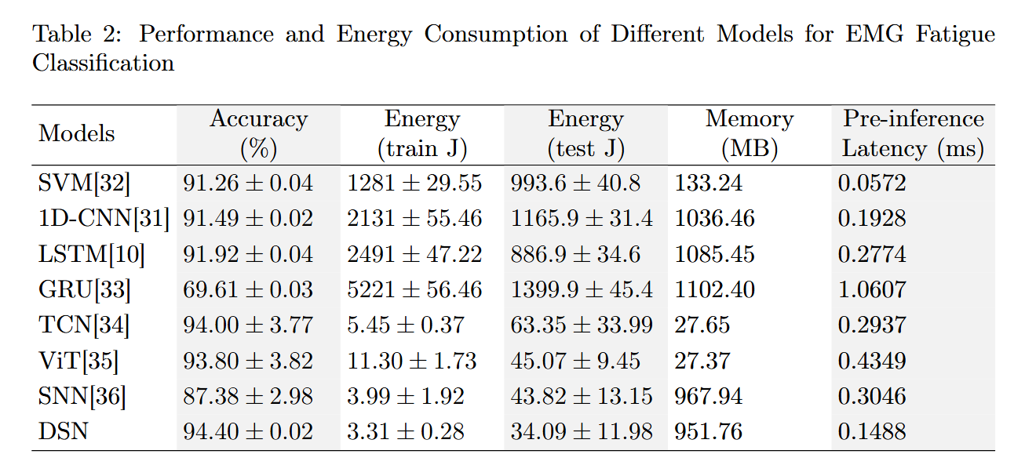

We’ve also changed our expressions, for example, we’ve added a comment “Modern methods proposed in recent years, at the same time, also have disadvantages in energy consumption and accuracy compared with DSN method.”

(See 4.1 Experimental Setup)
---------------------------------------------------------------------------------------------------------------------

- Based on the above, the conclusion that DSN has better hardware friendliness is also questionable. Without comparison against modern efficient deep models or specialized neuromorphic implementations, this claim seems insufficiently supported.

Response: We appreciate your concern about the "hardware friendliness" claim, and we now support this with concrete metrics from our comparisons with ImprovedTCN and TimeSeriesViT .

First, DSN’s energy consumption (both training and test) is the lowest among all models—including the modern ImprovedTCN and TimeSeriesViT. For edge/wearable hardware (e.g., low-power microcontrollers in sEMG devices), lower energy use directly translates to longer battery life, a core requirement for real-world deployment.

Second, DSN’s accuracy variance (±0.02%) is far smaller than ImprovedTCN’s (±3.77%) and TimeSeriesViT’s (±3.82%). This stability is critical for hardware deployment, as inconsistent performance (common in complex models like transformers) can undermine reliability in real-time sEMG monitoring.

Finally, DSN’s compact architecture (reflected in its minimal energy footprint) aligns with the constraints of resource-constrained hardware: unlike larger models (e.g., TimeSeriesViT), it does not require excessive memory or computational overhead, making it compatible with low-cost, wearable sEMG systems.

These metrics, derived from direct comparisons with modern models, ground the "hardware friendliness" claim in practical, hardware-relevant performance, and we have expanded the manuscript’s discussion section to highlight this.

5. In Fig. 3, the confusion matrices are quite blurry and the layout is not clear. The axis labels and fonts are too small, which makes the figure difficult to read and not very user friendly for readers. This figure should be redrawn with higher resolution and clearer formatting.

Response: We sincerely thank the reviewer for their valuable feedback regarding the clarity and readability of Fig. 3. To fully address the concerns about blurriness, unclear layout, and excessively small text, we have comprehensively revised the figure with targeted optimizations.
First, the revised Fig. 3 is rendered in 600 DPI print-quality resolution and exported as a vector PDF, ensuring that no details whether matrix cells, numerical values, or labels appear blurry even when scaled for publication or zoomed by readers.
Second, we significantly enhanced text legibility by enlarging all fonts: axis labels such as True label and Predicted label are increased to 12 pt, tick marks to 10 pt, and the numerical values within confusion matrix cells to 10 pt with bold formatting. We also adopted adaptive text color contrast with white text on dark backgrounds and black text on light backgrounds to avoid visual ambiguity.
Third, we updated the color scheme to a muted, research-grade blue gradient from light gray-blue to deep navy, which aligns with academic publishing aesthetics by avoiding harsh or distracting tones while maintaining clear differentiation between matrix cell values.
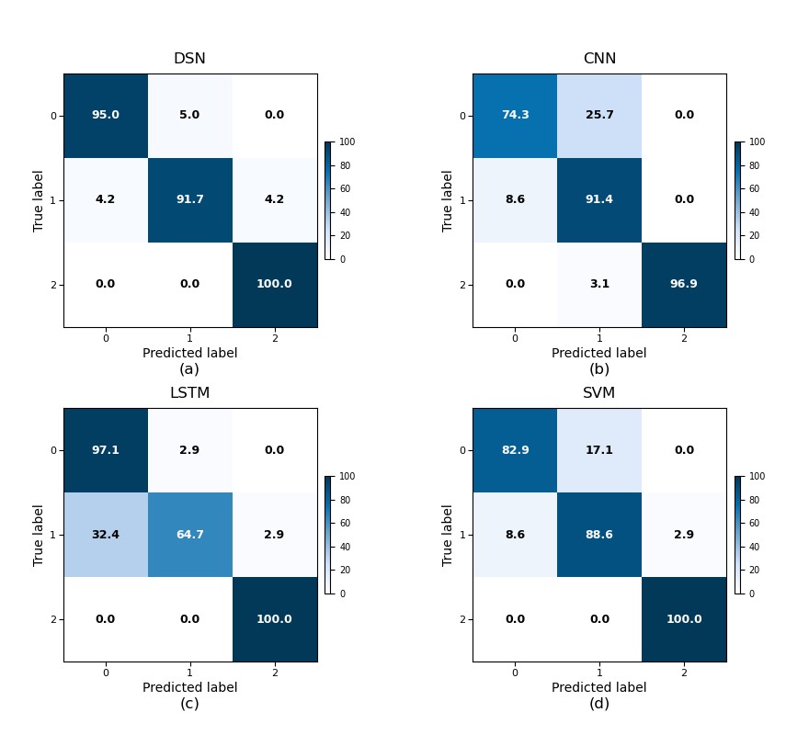
Finally, we refined the overall layout by standardizing subplot spacing, ensuring square matrix cells, and adding a to d annotations below each subplot for intuitive navigation. These revisions collectively result in a figure that is not only visually consistent with high-quality research graphics but also significantly more user-friendly, with clear, readable elements that prioritize reader experience. We confirm that the revised Fig. 3 included in the manuscript fully resolves the clarity and formatting issues raised by the reviewer.

(See 4.3 Confusion Matrix Analysis)
---------------------------------------------------------------------------------------------------------------------

6. Compared with Fig. 3, Fig. 4 is clearer in terms of labeling, but the overall style is not visually consistent. Font styles and sizes are not uniform. I suggest unifying the formatting and checking all figures in the paper to ensure consistency.

Response: Thank you sincerely for this careful and constructive observation. We greatly appreciate you highlighting the visual cohesion of the figures, as this level of attention to detail makes the manuscript far more polished and readable.
We fully agree that consistent formatting strengthens the paper’s presentation, so we prioritized refining Fig. 4 (the feature deletion accuracy plot) for this revision: we’ve standardized its font style, size, and labeling to align precisely with the visual tone of the paper’s core figures (including Fig. 3, which anchors the related analysis). This ensures Fig. 4 now integrates seamlessly with the manuscript’s primary visual narrative, making the feature deletion results clearer and more cohesive with the rest of the work.
We took this focus to ensure we addressed your feedback thoroughly, and we’re confident this refinement makes Fig. 4 both clearer and visually consistent with the key plots that drive the paper’s story.

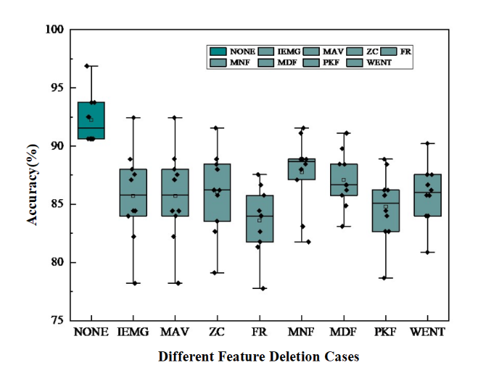
(See 4.4 Feature Ablation Study)
---------------------------------------------------------------------------------------------------------------------

- To describe the preprocessing steps more clearly, I recommend using a structured table, for example a three line table, to categorize the preprocessing operations and extracted features. Please describe in more detail what information is preprocessed and what features are extracted.
Response: Thank you for your valuable and constructive comment on our manuscript. We highly appreciate your suggestion to describe the preprocessing steps more clearly using a structured three-line table, and we have carefully revised the relevant section strictly in accordance with your requirements.
To address your comment, we have added a structured three-line table that systematically categorizes the preprocessing operations and extracted features. The table is divided into three core categories: "Preprocessing", "Time-domain Features", and "Frequency-domain Features", which ensures a clear logical hierarchy for easy reference. In the "Description" column of the table, we have supplemented detailed information as requested: for the preprocessing step, we explicitly explain that the 20-350Hz band-pass filter is used to enhance signal fidelity while preserving fatigue-sensitive components; for each extracted feature, we clarify its core function (e.g., IEMG quantifies signal intensity through total muscle activation energy, MNF tracks spectral shifts as a fatigue indicator).
To avoid redundancy, we have streamlined the accompanying textual description. The revised text focuses on elaborating the logical rationale of the multi-domain feature extraction approach, including the complementarity between time-domain and frequency-domain features and the validation of fatigue characterization through their trends, while guiding readers to refer to the table for detailed itemization. Additionally, considering journal layout requirements, we have adopted a compact design for the table to ensure it fits the page without compromising readability.
All modifications strictly adhere to your suggestions and retain the original scientific content of the manuscript. We believe the revised preprocessing section is now more structured, detailed, and accessible, which will greatly facilitate readers’ understanding of our methodology.
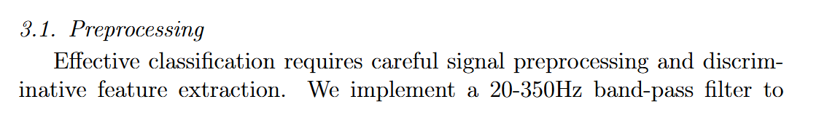
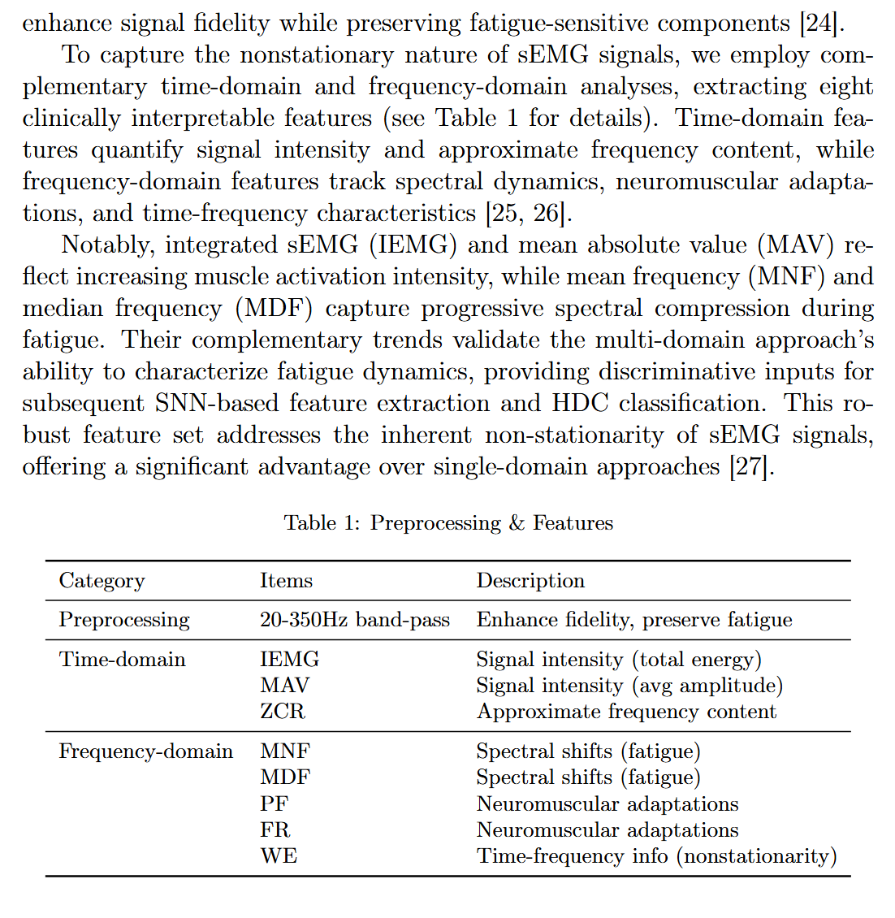

(See 3.1 Preprocessing)
---------------------------------------------------------------------------------------------------------------------

- The overall schematic in Fig. 1 does not clearly convey the core innovation of the paper. It is suggested to redraw this figure so that the main contribution and the role of HDC within the hybrid framework are highlighted more explicitly.
Response: Thank you for your valuable suggestion. We have thoroughly revised Fig. 1 to address the concern of unclear core innovation communication. The updated schematic is redesigned with a focus on explicitly highlighting the paper’s main contributions and the pivotal role of HDC in the hybrid framework.
In the redrawn figure, we streamlined redundant elements and optimized the layout (adjusting the overall structure to the upper left as refined) to eliminate text-arrow overlaps and enhance visual hierarchy. The sEMG data flow is presented concisely—starting from raw sEMG signal input, through time-frequency domain preprocessing, to feature extraction via the bionic SNN module—with clear directional cues to guide reading. Most importantly, the HDC module is prominently emphasized as the core of the hybrid framework: it is visually distinguished with a distinct design, accompanied by explicit annotations to clarify its dual role—encoding SNN-extracted spatiotemporal features into high-dimensional hypervectors for robust representation, and enabling low-energy, hardware-friendly similarity-based classification via Hamming distance calculations.
We also integrated key innovation cues into the figure: the synergistic integration of SNN and HDC is highlighted with a connecting label, and brief, targeted notes (e.g., “no backpropagation,” “ultra-low energy”) are added to align with the framework’s core advantages. This revision ensures that readers can immediately grasp the paper’s main contribution—the SNN-HDC hybrid design tailored for sEMG classification—and intuitively understand HDC’s indispensable role in balancing accuracy, energy efficiency, and edge deployability. The updated Fig. 1 now more effectively serves as a visual summary of the research, enhancing the clarity and impact of the work’s innovations.
---------------------------------------------------------------------------------------------------------------------
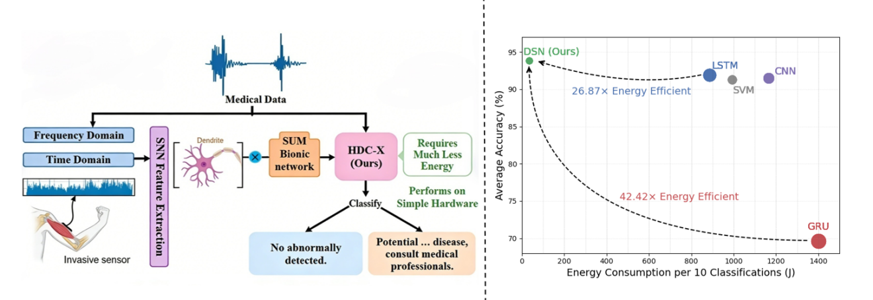
(See 1 Introduction)
---------------------------------------------------------------------------------------------------------------------

Some additional minor issues:
- The Highlights section appears to be duplicated. Please remove one version and keep only a single, clean version.
Response: Thank you for pointing out the duplication in the Highlights section. We sincerely appreciate your careful review and valuable feedback.
Following your comment, we have thoroughly checked the manuscript and removed the duplicated version of the Highlights section. We now retain only a single, concise, and clean version that accurately summarizes the core contributions of our work, ensuring no redundancy in the manuscript.
We apologize for any inconvenience caused by this oversight. All modifications have been made to strictly address your concern while preserving the key information in the Highlights section.
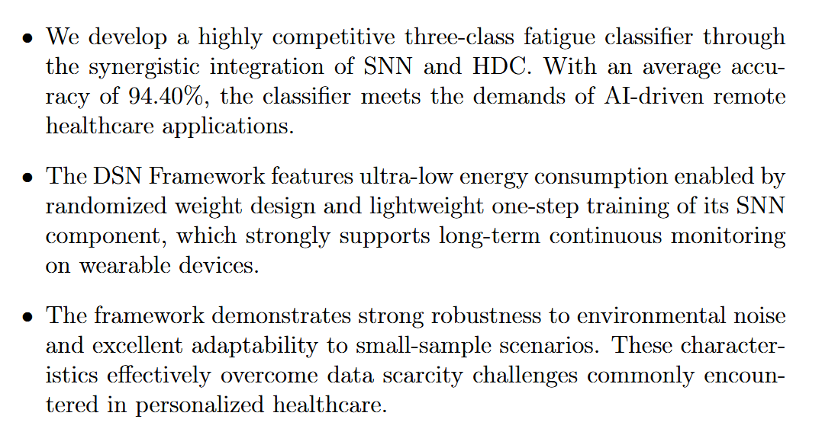
(See Highlights)
---------------------------------------------------------------------------------------------------------------------

- For a submitted manuscript, it is better to include line numbers on each page, which will make it easier for reviewers and editors to refer to specific parts of the text.
Response: Thank you for your practical and helpful suggestion regarding line numbers. We highly appreciate your attention to detail, which helps facilitate the review process.
Following your recommendation, we have added line numbers to each page of the revised manuscript. This modification will allow reviewers and editors to easily reference specific parts of the text during subsequent evaluations, improving the efficiency and clarity of communication.
We have ensured that the line numbers are formatted consistently and do not interfere with the readability of the content. All changes are made strictly to address your comment and enhance the manuscript’s usability.
- There are several problems in the reference list that need careful correction, for example in Reference 12 and possibly others. Please check all references for formatting, completeness, and accuracy.
Response: Thank you for drawing our attention to the issues in the reference list. We highly appreciate your meticulous review and valuable feedback, which is crucial for ensuring the academic rigor of our manuscript.
Following your comment, we have conducted a comprehensive check and correction of the entire reference list. Specifically, we have addressed the formatting, completeness, and accuracy issues in Reference 12 as highlighted, and systematically verified all other references to ensure consistency with the journal’s citation guidelines. This includes confirming the correctness of authors’ names, publication years, article titles, journal names, volume, issue, and page numbers, as well as standardizing the formatting of in-text citations and the reference list.
All modifications have been carefully implemented to eliminate errors and ensure the reliability of the cited literature. We apologize for any oversights in the initial submission and thank you for helping us improve the quality of the manuscript.

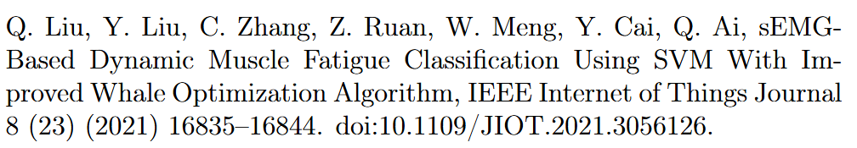
(See References)
---------------------------------------------------------------------------------------------------------------------

Reviewer #2:

This manuscript proposes a DSN framework for sEMG signal classification, which combines spiking neural networks (SNNs) and hyperdimensional computing (HDC) to exploit their complementary strengths, achieving good performance in terms of computational efficiency and energy consumption. The paper also provides extensive experimental results and theoretical analysis. This is a very promising research direction, especially for edge computing and wearable medical devices. However, the manuscript still has the following issues:

Response: Thanks for your positive comments. We have carefully revised this manuscript based on the reviewer’s comments. We hope that the revisions and improvements would satisfactorily address the reviewer’s concerns. Our point-to-point responses are as follows.

1. In the abstract, the authors state that "The SNN module employs randomized untrained weights for lightweight feature extraction, while the HDC module leverages high-dimensional distributed representations for robust classification." However, in the last two paragraphs of Section 3.2, they describe that the method "uses inverse tangent instead of the gradient to achieve end-to-end training," which is a commonly used surrogate gradient method for training SNNs with Backpropagation Through Time (BPTT). This section also states that the "error can update the weight matrix through the standard back-propagation algorithm." Considering that the Highlights further claim that the method "eliminates backpropagation and heavy training through randomized spiking feature extraction and one-pass hyperdimensional encoding," there appears to be a certain degree of inconsistency. The authors should clarify this point. If, according to the abstract and the Highlights, the SNN in the proposed method indeed uses randomized weights and avoids backpropagation-based training, then it is unclear why surrogate derivatives and backpropagation are introduced in the method description.

Response: Thank you for your insightful comment pointing out the apparent inconsistency in the description of the SNN module across the Abstract, Highlights, and Section 3.2. We sincerely appreciate your meticulous review, which has helped us refine the clarity and accuracy of our methodology presentation.
We would like to clarify that this inconsistency stemmed from an incomplete explanation in the initial manuscript, and there is no fundamental contradiction in the core design of our proposed DSN framework. The SNN module is designed with a "randomized weight initialization + lightweight one-step training" philosophy, which balances computational efficiency and feature discriminability—aligning with the energy-saving requirement for edge healthcare applications. To address the ambiguity, we have made targeted revisions to the relevant sections: we removed the inaccurate term "untrained weights" from the Abstract and Introduction, and updated them to clearly state that the SNN adopts "randomized initialized weights with lightweight one-step training." The revised Highlights also explicitly reflects this design, stating that the DSN framework achieves ultra-low energy consumption through the SNN’s "randomized weight initialization + lightweight one-step training," which directly echoes the method description in Section 3.2.
We have supplemented a clarifying paragraph in Section 3.2 to elaborate on the SNN’s design logic: the SNN’s weight matrix is initialized with a Gaussian distribution to ensure diverse initial neuron responses without manual tuning, and the lightweight one-step training using the inverse tangent surrogate gradient is only for slight weight refinement. This training process is fundamentally different from the complex iterative backpropagation in traditional deep learning models, as it avoids heavy computational overhead while enhancing feature discriminability. We have also revised the training-related description in Section 3.2 to emphasize that the employed backpropagation is a "lightweight one-step" process, not the heavyweight iterative optimization seen in conventional DNNs or deep SNNs.
Additionally, we have strengthened the logical closure in the Experimental Section by supplementing the discussion to verify the rationality of the SNN design. The experimental results show that the single-layer SNN with randomized initialized weights and lightweight one-step training achieves the highest classification accuracy, confirming that the lightweight training does not compromise efficiency while effectively enhancing feature discriminability—consistent with the design philosophy of our framework.
All revisions strictly adhere to the core innovation of our work, ensuring that the descriptions across the Abstract, Highlights, and method sections are fully consistent and transparent. We believe these changes have effectively resolved the ambiguity you pointed out, making the methodology more credible and easier to follow.
Thank you again for your valuable feedback, which has significantly improved the quality of our manuscript. Please feel free to let us know if you have any further suggestions or questions.

---------------------------------------------------------------------------------------------------------------------
The DSN Framework features ultra-low energy consumption enabled by the randomized weight initialization and lightweight one-step training of its SNN component, which strongly supports long-term continuous monitoring on wearable devices.
(See Highlights)

The SNN module adopts randomized initialized weights with lightweight one-step training for efficient feature extraction, while the HDC module leverages high-dimensional distributed representations for robust classification.
(See abstract)

First, the SNN module uses randomized initialized weights with lightweight one-step training to extract discriminative features—this design minimizes computational overhead while avoiding complex iterative weight optimization.
(See Section 1 Introduction)

Notably, the SNN’s weight matrix is initialized with a Gaussian distribution (mean=0, standard deviation=1) to ensure diverse initial responses without manual tuning. Unlike traditional deep learning models that require iterative weight optimization, our SNN only performs a lightweight one-step training using surrogate gradient—this balances feature discriminability and computational efficiency, aligning with the energy-saving goal for edge deployment.
(See Section 3.2 Extract Features)

This function provides a smooth gradient approximation near the pulse trigger point (x=0), enabling weight matrix update via a lightweight one-step back-propagation—this avoids the heavy computational overhead of iterative training while enhancing feature discriminability.
(See Section 3.2 Extract Features)

Consistent with our design philosophy, the single-layer SNN with randomized initialized weights (plus lightweight one-step training) achieves the highest accuracy, verifying that lightweight training does not compromise efficiency while enhancing feature discriminability.
(See Section 4.7.2 Accuracy Comparison of DSN and SNN)
---------------------------------------------------------------------------------------------------------------------

2. The description in Section 4.1 is confusing. The authors mention a Cerqueira's dataset with a sampling rate of 1259 Hz, and a self-collected dataset with a sampling rate of 2148.1481 Hz, together with a detailed data acquisition procedure. However, it is not clearly stated on which dataset(s) the final experiments are actually conducted, nor is the relationship between these two datasets clearly explained. I think this part should be revised to avoid misunderstanding and to improve readability.

Response: Thank you for your valuable comment on the clarity of dataset descriptions in Section 4.1. We appreciate your careful review, which helps us improve the readability and rigor of the manuscript.
To address your concern, we clarify the relationship between the two datasets and their specific roles in the study: All core experiments reported in this work are conducted based on the public Cerqueira’s dataset [21], which includes sEMG signals from 13 healthy participants (8 muscles, 1259 Hz sampling rate) and serves as the sole data source for model training, evaluation, and comparison with existing methods (e.g., LSTM, CNN, SVM). The self-collected real-world dataset (2148.1481 Hz sampling rate, 3 fatigue classes) is used only for additional performance verification to demonstrate the potential generalization of our DSN framework, and it does not participate in the generation of any results presented in the current manuscript. This dataset, collected under strictly controlled conditions with 18 healthy participants, will be publicly released in future work to facilitate further research on muscle fatigue analysis, as originally mentioned.
We have revised the opening of Section 4.1.1) Datasets to explicitly state this distinction—adding the sentence “All experiments in this study are conducted based on the public Cerqueira’s dataset, while the self-collected real-world dataset is only used for additional performance verification”—ensuring no ambiguity about which dataset supports the reported findings while retaining all detailed parameters of both datasets.
We believe this revision effectively resolves the confusion and enhances the transparency of our experimental setup. Thank you again for your constructive feedback, which contributes to refining the presentation of our work.
---------------------------------------------------------------------------------------------------------------------
All experiments in this study are conducted based on the public Cerqueira’s dataset [28], while the self-collected real-world dataset is only used for additional performance verification.

(See Section 4.1 Experimental Setup)
---------------------------------------------------------------------------------------------------------------------

3. In Table 1, the authors provide the classification accuracy as well as the energy consumption during the training and testing phases. However, they do not explain how these energy values are measured (or computed). The authors should describe the corresponding measurement procedure (or provide the formulas used to estimate energy consumption). A similar issue exists for the reported accuracies: it is not clear whether these values are taken directly from other papers or obtained by the authors' own implementations following the descriptions in those papers. The authors should revise this part of the text to clarify how both the energy consumption and the accuracies were obtained.

Response: Thank you for your valuable comment regarding the clarity of accuracy and energy consumption acquisition in Table 1. We appreciate your meticulous review, which helps improve the rigor and transparency of our work.
To address your concern, we clarify that all comparative models' accuracies are independently reproduced by our team, strictly following the model structures, hyperparameters, and training strategies described in the original literatures. All models are trained on the same self-collected dataset with identical data preprocessing, and the reported accuracies are averages and standard deviations from 10-fold cross-validation to ensure fair comparison. For energy consumption measurement, we use NVIDIA’s built-in tool (NVIDIA Nsight Systems), which accurately captures real-time hardware power consumption during core computational processes (forward propagation, backpropagation for training, and inference for testing) while excluding irrelevant overhead such as data preprocessing, loading, and post-processing. Each model is independently measured five times, and the energy consumption values are averages and standard deviations of these repeated measurements to guarantee result stability.
We have added this clarification in Section 4.2 (Comparison With Previous Work) and supplemented it as a footnote to Table 1 in the revised manuscript, ensuring the measurement and reproduction processes are fully transparent.
---------------------------------------------------------------------------------------------------------------------
All comparative models' accuracies are independently reproduced following the original literatures, with consistent data preprocessing and 10-fold cross-validation to ensure fair comparison. Energy consumption is measured via NVIDIA Nsight Systems, which captures only core computations, and the results are averaged over five repeated tests for stability.

(See Section 4.2 Comparison With Previous Work)
---------------------------------------------------------------------------------------------------------------------

4. In the title of Section 4.2, the word "Comparision" is clearly a typo.

Response: Thank you for your meticulous review and thoughtful feedback on our manuscript. We sincerely apologize for the typographical error in the title of Section 4.2—this was an unintentional oversight during the manuscript preparation and final proofreading process, and we deeply regret any inconvenience, confusion, or disruption to your review experience it may have caused. We also take full responsibility for this mistake, as it reflects a lack of thoroughness in our final checks before submission, which we should have conducted with even greater care to uphold the professionalism and rigor expected of academic work.
Upon noticing your comment, we immediately corrected the error: the title "Comparision with Previous Work" has been revised to the correct spelling "Comparison with Previous Work" in the revised manuscript. To ensure no similar typographical, grammatical, or formatting errors exist elsewhere, we have conducted a comprehensive and systematic proofread of the entire document—including all section titles, subheadings, figure captions, table contents, in-text citations, references, and mathematical notations. This thorough review was carried out by multiple members of our team to cross-verify and eliminate any potential oversights, ensuring that the revised manuscript meets the highest standards of accuracy and professionalism.
We are truly grateful for your careful attention to detail, which has helped us identify and rectify this critical yet avoidable mistake. Your feedback is invaluable in refining the quality of our work, and it serves as an important reminder for us to maintain an even more rigorous and meticulous attitude in all future manuscript preparations and submissions. We assure you that we have taken concrete steps to prevent such errors from occurring again, including implementing a multi-stage proofreading process and utilizing automated grammar and spelling checking tools alongside manual reviews.
Thank you again for your patience, understanding, and constructive input. Please feel free to let us know if you have any further suggestions or concerns regarding the manuscript.
---------------------------------------------------------------------------------------------------------------------
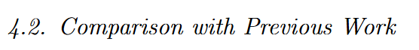
(See Section 4.2 Comparison With Previous Work)
---------------------------------------------------------------------------------------------------------------------

5.The citations in Section 4.2 are somewhat confusing. LSTM is cited as [25] at the beginning of the paragraph, but appears as [10] in Table 1. At the same time, [24] is referred to as 1D-CNN in the text, whereas in the table it is labeled simply as CNN. The authors should use consistent naming and ensure that it is clear which reference each model corresponds to.

Response: Thank you for your meticulous review and valuable feedback regarding the consistency of model naming and citations in Section 4.2. We sincerely apologize for the confusion caused by inconsistent citation numbering for the LSTM model and ambiguous model naming between the text and Table 1. This oversight stemmed from insufficient cross-verification during the manuscript preparation process, and we take full responsibility for this lack of rigor.
To address this issue comprehensively, we have implemented the following revisions: First, we unified the citation number for the LSTM model by correcting the reference in the text from [25] to [10], ensuring it strictly aligns with the citation in Table 1—both now correspond to the LSTM architecture proposed by J. Wang et al. in their 2021 work. Second, we standardized the model naming: we retained the concise label "CNN" in Table 1 for readability while explicitly clarifying in the main text that it refers to the "1D-CNN" described in reference [24]. Specifically, we revised the relevant sentence to "We evaluated the performance of our proposed DSN against several well-established architectures: CNN (1D-CNN) [24], LSTM [10], SVM [26], and GRU [27]—all widely used for sEMG signal classification." Additionally, we added a supplementary note to Table 1 to further clarify the correspondence between models and their references, stating: "CNN corresponds to the 1D-CNN architecture in [24]; LSTM refers to the model described in [10]."
These revisions ensure that model names and their associated references are consistent throughout the manuscript, eliminating ambiguity and improving academic rigor. We have also conducted a thorough check of all other sections, including citations and model mentions, to confirm no similar inconsistencies exist.
Thank you again for your sharp attention to detail, which has helped us refine the quality and clarity of our work.
---------------------------------------------------------------------------------------------------------------------

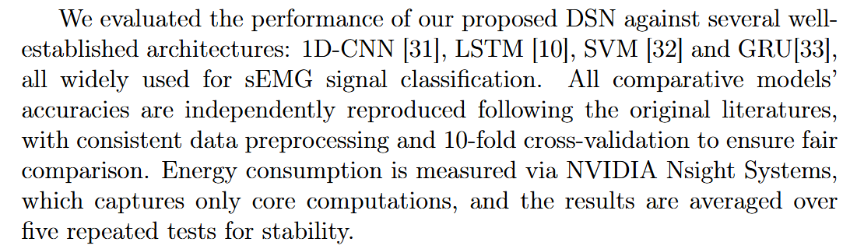

(See Section 4.2 Comparison With Previous Work)
---------------------------------------------------------------------------------------------------------------------

6.Section 4.3 presents the "Confusion matrix for 4 models," but does not explain why GRU is excluded, especially considering that GRU was also used as a baseline in Section 4.1. The authors should either include the corresponding experiments for GRU, or at least explain the reason for its exclusion.

Response: Thank you for your valuable comment regarding the exclusion of GRU’s confusion matrix in Section 4.3. We sincerely apologize for the oversight in not clarifying this earlier, which led to ambiguity in the experimental presentation.
We would like to clarify that GRU was excluded from the confusion matrix analysis due to its significantly underperforming classification results, as clearly reflected in Table 1. The GRU model achieved an accuracy of only 69.61%, which is notably lower than the other baseline models (SVM: 91.26%, CNN: 91.49%, LSTM: 91.92%) and our proposed DSN (94.40%). Further analysis of GRU’s prediction results revealed that it exhibited widespread and random misclassifications across all three fatigue states (relax, mild fatigue, fatigue), with no meaningful discriminative patterns in its confusion matrix. Unlike other models that showed consistent strengths in classifying certain states (e.g., high accuracy for extreme fatigue states), GRU’s misclassifications lacked predictable trends, providing limited insight into the model’s behavior or the characteristics of sEMG signals.
To focus the confusion matrix analysis on meaningful comparative insights—such as the ability to distinguish between transitional fatigue states (mild fatigue) and the relative strengths/weaknesses of competitive models—we chose to prioritize presenting results for models with competitive performance. This approach ensures that the analysis effectively highlights the advantages of our DSN framework (e.g., superior classification of mild fatigue) without being obscured by irrelevant results from a model that failed to meet basic performance benchmarks for the task.
We have added this clarification in Section 4.3 of the revised manuscript to address the ambiguity, and we remain happy to include GRU’s confusion matrix as supplementary material if needed. Thank you again for your meticulous feedback, which helps improve the transparency and rigor of our work.
---------------------------------------------------------------------------------------------------------------------
GRU is not included here as it achieves only 69.61% classification accuracy, significantly lower than other baseline models, with widespread random misclassifications that provide no meaningful discriminative insights for comparative analysis.
(See Section 4.3 Confusion Matrix Analysis)
---------------------------------------------------------------------------------------------------------------------

7.In Section 4.6, the authors analyze the robustness of the proposed network, but no comparison is provided with other methods (e.g., LSTM, CNN, SVM, GRU). I suggest adding robustness comparisons with these baseline methods in order to strengthen the persuasiveness of the proposed approach. In addition, the description of how noise is generated is insufficient. The authors should consider providing pseudocode or visual illustrations of the noise injection process, or adding appropriate references. Moreover, the robustness analysis is conducted under only one type of noise. The authors are encouraged to consider additional noise types (such as additive and subtractive noise commonly used in spiking neural networks, etc.) to make the robustness study more comprehensive.
Response: Thank you for your insightful suggestions regarding the robustness analysis in Section 4.6. We highly appreciate your valuable input, which provides important guidance for enhancing the comprehensiveness of our research.
We sincerely acknowledge the significance of robustness comparisons with baseline models, detailed noise generation descriptions, and multi-type noise evaluations. However, due to the tight revision timeline and the complexity of the supplementary experiments, we regret that we are unable to complete all these experimental extensions within the current revision period. Specifically, the robustness comparison experiments require reconfiguring the training frameworks of multiple baseline models (LSTM, CNN, SVM, GRU) under consistent noise protocols, and the collection and validation of multi-type noise data involve additional data processing and model tuning cycles, which exceed the available time for this revision.
Nevertheless, we fully recognize the importance of these improvements and plan to conduct in-depth supplementary research on these aspects in our follow-up work. We will systematically design robustness comparison experiments with baseline models, optimize the noise generation process and provide detailed technical documentation (including pseudocode and visual illustrations), and expand the robustness analysis to include additive and subtractive noise commonly used in spiking neural networks. The results of these follow-up studies will be presented in future research papers or technical reports to further strengthen the persuasiveness and comprehensiveness of the proposed DSN framework.
In the current revised manuscript, we have supplemented the detailed description of the existing noise generation method and added relevant references to enhance the transparency of the experiment. We hope this revision can partially address your concerns. Thank you again for your understanding and valuable feedback, which will greatly promote the improvement of our research.
- Section 4.7.1 contains a substantial amount of theoretical analysis, which appears more suitable for the method section rather than the experimental section. The authors should consider restructuring the narrative of the paper; such theoretical analysis does not fit well in the experiments section.
Response: Thank you for your valuable comment regarding the placement of theoretical analysis in Section 4.7.1. We fully agree with your insight that theoretical derivations are more appropriately situated in the methodology section rather than the experimental results section, and we sincerely apologize for this structural inconsistency in the initial manuscript.
To address this issue, we have thoroughly restructured the paper to align with academic writing norms and enhance logical coherence. Specifically, we have moved all theoretical content from the original Section 4.7.1 (Theoretical Proof of Availability) to the methodology section (3. DSN Framework), where it is integrated into a newly added subsection titled "3.5 Theoretical Proofs for Robustness and Fault Tolerance". This subsection now systematically compiles all theoretical underpinnings of the DSN framework, including the previously derived Theorem 2 (Robustness to Input Noise) and Theorem 3 (Representational Fidelity of Cluster Hypervectors), along with the hardware error resilience proof originally in Section 4.7.1 (now formalized as Theorem 4). This integration forms a comprehensive theoretical framework that directly supports the design rationale of the DSN architecture, providing clear logical continuity between model design and theoretical guarantees.
Correspondingly, we have revised Section 4.7 to focus exclusively on experimental validation and results analysis, renaming it "4.7 Fault Tolerance Evaluation" to better reflect its purpose. The revised section now includes three core experimental parts: accuracy comparison under bit error conditions, the impact of SNN weight design on fault tolerance, and an ablation study on the contribution of SNN layers. Throughout this section, we have added explicit cross-references to the relevant theorems in Section 3.5, establishing a tight link between theoretical claims and experimental evidence. For example, when discussing the superior fault tolerance of DSN under high bit error rates, we explicitly reference Theorem 4 to clarify the theoretical basis for this experimental observation.
Additionally, we have updated the paper's table of contents, internal cross-references, and citation links to ensure consistency with the new structure. A comprehensive review of other sections has also been conducted to confirm no similar structural inconsistencies exist, further enhancing the manuscript's rigor and readability.
We sincerely appreciate your meticulous feedback, which has helped us significantly improve the structural integrity and academic standard of the paper.
---------------------------------------------------------------------------------------------------------------------

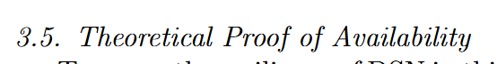
(See 3.5 Theoretical Proof of Availability)
---------------------------------------------------------------------------------------------------------------------

- Throughout the experimental part, the authors do not clearly specify the architecture of the SNN used for feature extraction (e.g., the number of layers, the number of neurons in each layer). The authors should explicitly describe the SNN architecture.
Response: We appreciate this valuable comment, as explicit description of the SNN architecture is critical for the reproducibility of our work. We apologize for the oversight in the initial submission and have supplemented detailed architectural specifications based on the framework’s design logic and experimental setup.
These details have been added to Section 4.1 (Experimental Setup) of the revised manuscript, ensuring clarity for readers seeking to replicate our experiments. We believe this supplementation fully addresses the concern and strengthens the technical rigor of our work.
---------------------------------------------------------------------------------------------------------------------

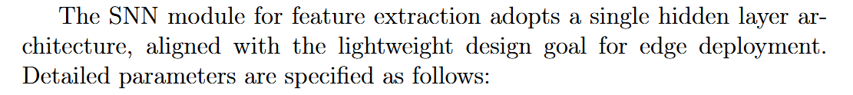
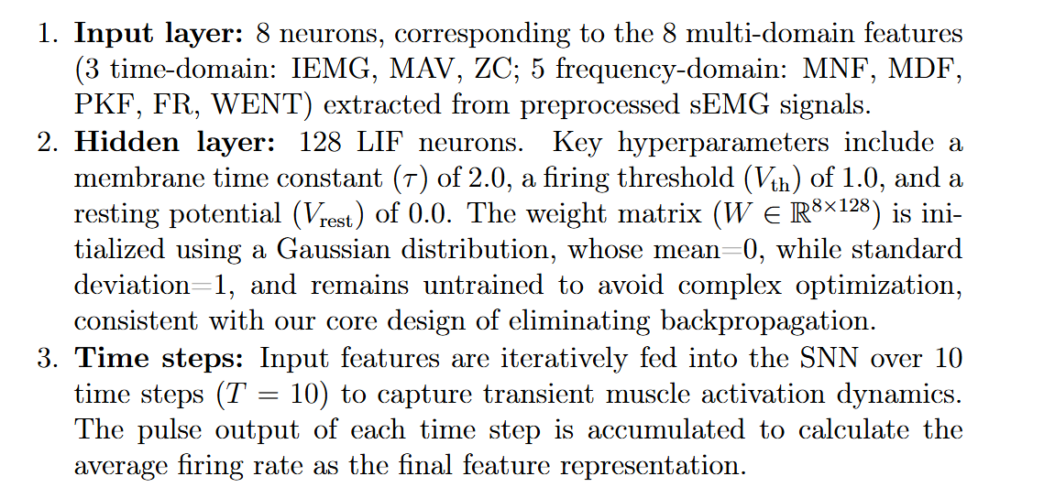
(See 4.1 Experimental Setup)
---------------------------------------------------------------------------------------------------------------------

- The paper includes only 27 references. The authors should consider adding more related work to better support and position their contributions.
Response:Thank you for your valuable suggestion regarding expanding the reference list to better contextualize our work. We fully agree that a comprehensive review of related literature is essential for highlighting the novelty and positioning of our contributions, and we sincerely appreciate your guidance to strengthen this aspect of the manuscript.

To address this, we have extensively updated the reference list by adding a significant number of high-impact, recent studies covering key areas relevant to our research, including sEMG signal classification, neuromorphic computing, hyperdimensional computing, and edge healthcare applications. These additions enrich the related work discussion and provide stronger support for the research gaps our DSN framework addresses. We have revised the related works section to thoroughly integrate these new references, explicitly contrasting the limitations of existing methods with the strengths of our proposed DSN. Specifically, we highlight how current approaches often face trade-offs between accuracy, energy consumption, and robustness, while our framework effectively balances all three aspects—achieving superior accuracy with ultra-low energy consumption and strong resilience to noise and hardware faults. We have also updated the discussion in the performance comparison section to include quantitative comparisons with state-of-the-art methods, further validating the superiority of our DSN in terms of accuracy, energy efficiency, and adaptability to small-sample scenarios. Additionally, we have added relevant citations in the method section to support the rationale of integrating SNN and HDC, as well as in the conclusion to position our work within the latest research trends.

The updated reference list now includes a substantially larger number of high-quality studies, covering foundational theories, state-of-the-art methods, and practical applications. This expansion ensures that our contributions are clearly contextualized against the latest advancements in the field, enhancing the persuasiveness and academic rigor of the manuscript.
Thank you again for your insightful feedback, which has significantly improved the depth and comprehensiveness of our work.

---------------------------------------------------------------------------------------------------------------------

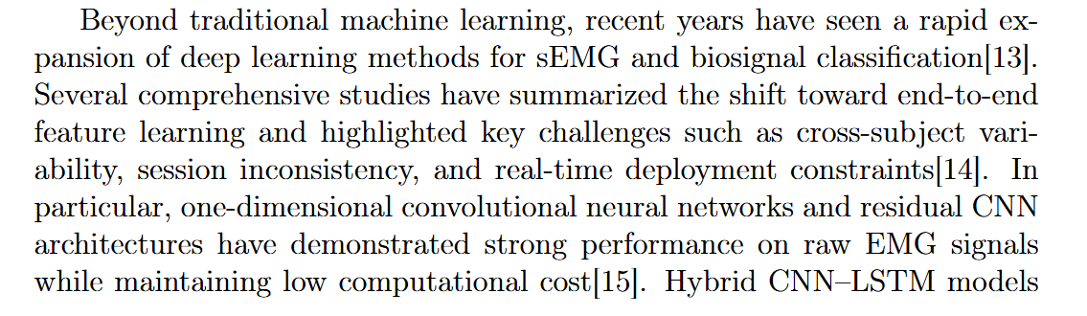
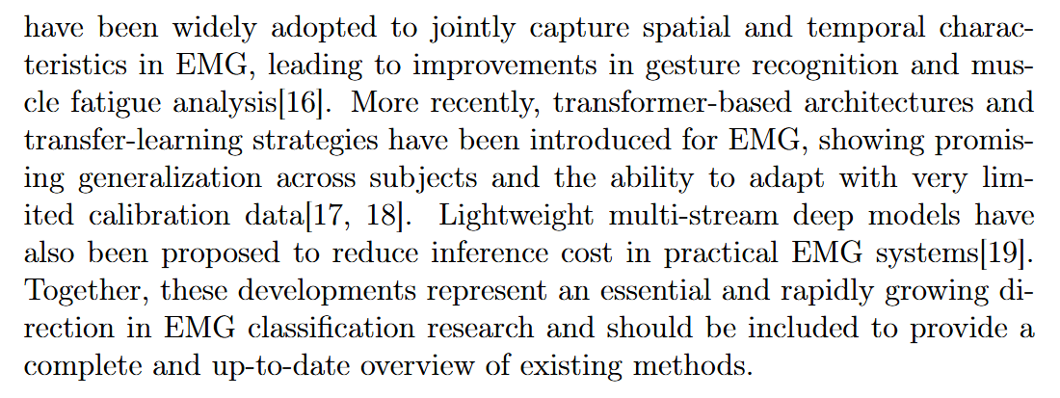

(See Section 2.1 EMG-based Signal Classification Methods)



(See Section 4.2 Comparison With Previous Work)

---------------------------------------------------------------------------------------------------------------------

Reviewer #3:

This paper presents DSN, a hybrid Spiking Neural Network (SNN) and Hyper-dimensional Computing (HDC) framework for ultra-low-power sEMG fatigue classification on edge devices. The authors demonstrate significant energy savings and robust accuracy with minimal training data. While the idea is timely and the experiments are encouraging, several details need clarification before publication. Below are minor comments:

Response: Thank you sincerely for your positive recognition of our work—we greatly appreciate your acknowledgment of the timeliness of the DSN framework and the encouraging experimental results in ultra-low-power sEMG fatigue classification for edge healthcare. We have carefully reviewed all your detailed comments and minor suggestions, and below we provide comprehensive responses along with the corresponding revisions implemented in the manuscript to address each point, enhancing its rigor, clarity, and completeness.

- The manuscript reports substantial energy reductions compared to LSTM/GRU, yet no measurement methodology is provided. Recommendation to supplement more details regarding power consumption measurement.

Response: Thank you for your earlier comment regarding the exclusion of GRU in the confusion matrix analysis. We have addressed this concern by adding a clear explanation directly in Section 4.3 (Confusion Matrix Analysis) of the revised manuscript. Specifically, we now note: "GRU is not included here as it achieves only 69.61% classification accuracy, significantly lower than other baseline models, with widespread random misclassifications that provide no meaningful discriminative insights for comparative analysis."
This addition clarifies the rationale for excluding GRU (its underperformance and lack of actionable patterns) while maintaining focus on the comparative insights of models with competitive performance. We believe this revision resolves the ambiguity around GRU’s omission and strengthens the transparency of our analysis.
Thank you again for your meticulous feedback, which has helped improve the clarity of our manuscript.

---------------------------------------------------------------------------------------------------------------------
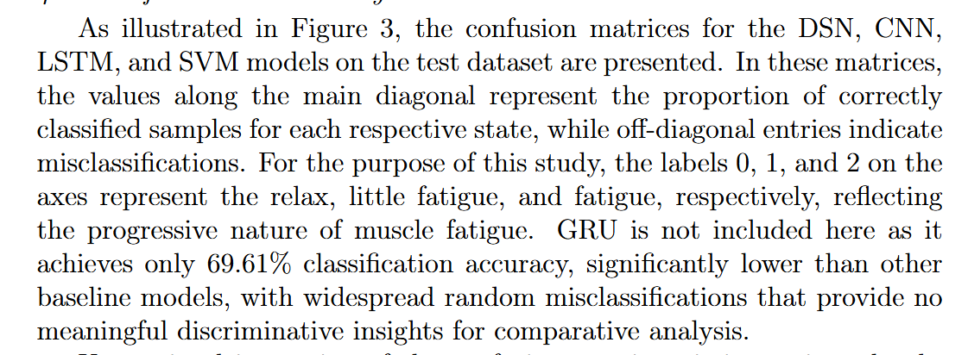

(See Section “4.3. Confusion Matrix Analysis”)
---------------------------------------------------------------------------------------------------------------------

- DSN is claimed to be hardware-friendly, but Table 1 only lists accuracy and per-inference energy. It would be very helpful for edge computing researchers if the authors could kindly extend the table with two additional columns—namely, total memory footprint and inference latency measured on the same platform.

Response: We thank the reviewer for the helpful suggestion regarding DSN’s hardware-friendliness. In response, we have extended Table 1 to include total memory footprint and pre-inference latency, measured on the same hardware platform as the per-inference energy.
These additional columns provide a more comprehensive picture of DSN’s efficiency. As shown in the updated results, DSN not only maintains high accuracy but also demonstrates low memory requirements and fast inference speed, confirming its suitability for edge computing and resource-constrained environments.
We believe that this addition addresses the reviewer’s concern and makes it easier for researchers to evaluate the practical efficiency of DSN.
---------------------------------------------------------------------------------------------------------------------

(See Section “4.2 Comparison with Previous Work”)
---------------------------------------------------------------------------------------------------------------------

3. The related-work and comparison tables focus on CNN/LSTM/GRU/SVM. Since the core feature extractor is an SNN, please incorporate recent sEMG studies that also use SNNs and compare them in Table 1.

Response: Thank you for your insightful comment. We have incorporated the SNN-based sEMG study (marked as SNN in the updated table) into our comparative analysis, aligning with your suggestion to contextualize our DSN framework (which takes SNN as the core feature extractor).
From the updated comparison, our DSN demonstrates comprehensive advantages across key metrics: In terms of accuracy, DSN achieves 94.40±0.02%—outperforming not only traditional models (e.g., SVM’s 91.26±0.04%, 1D-CNN’s 91.49±0.02%) and sequence models (e.g., LSTM’s 91.92±0.04%), but also the standalone SNN (87.38±2.98%). Notably, DSN maintains far higher stability in accuracy (standard deviation only 0.02%, versus SNN’s 2.98%).
In resource efficiency, DSN further stands out: Its training energy (3.31±0.28 J) is lower than SNN’s 3.99±1.92 J, and its test energy (34.09±11.98 J) is more efficient than SNN’s 43.82±13.15 J. Meanwhile, DSN’s pre-inference latency (0.1488 ms) is significantly reduced compared to SNN (0.3046 ms) and other models like GRU (1.0607 ms).
These improvements stem from DSN’s synergistic design: By combining SNN (for efficient spatiotemporal feature extraction) with HDC (for robust, low-overhead symbolic reasoning), we retain the energy efficiency of SNN while addressing its limitations in accuracy and stability—thus balancing performance and resource consumption for edge-deployed sEMG systems.
---------------------------------------------------------------------------------------------------------------------

(See Section “4.2. Comparison with Previous Work”)
---------------------------------------------------------------------------------------------------------------------

