
华中科技大学
人工智能与自动化学院

数据结构实验报告

实验人员：
专业班级：自动化创新实验2401班
学 号：U202410203
姓 名：孟宪喆

- 实验题目
题目 1
用户菜单权限配置菜单配置表：菜单项 ID、菜单项名称、菜单项动作、菜单项层级关系（至少有 2 级菜单）等设置；
用户角色分配表：给用户分配角色（例如系统管理员、普通用户等）；
角色权限配置表：按角色设置菜单的操作权限（例如菜单项可见或者可点击等）
用户登录后给出菜单的显示，并依据用户的角色权限实现菜单的操作：有菜单操作权限的弹出一个窗口，无菜单操作权限的弹出提示信息
题目 2
随机生成不少于50个节点的路网，包括节点数量和连边权值，选择、计算两点之间的最短路径；
可设置途径点（1个或多个，对于多个途径点可设置途径顺序），计算两点之间的最短路径。
- 设计思路
题目一：用户菜单权限配置系统
本程序的核心问题是如何组织多级菜单、用户和权限三者的关系。菜单天然具有层级结构，因此选用多叉树作为菜单的存储结构，每个节点存储菜单ID、名称和操作动作，子节点指针数组存储下级菜单，通过递归遍历树即可完整展现菜单层级。
权限控制不将权限直接绑定到用户，而是先给用户分配角色，再给角色配置可操作的菜单ID列表。判断权限时只需检索当前角色的允许列表，逻辑清晰，扩展性强。新增角色或调整权限时无需修改用户数据。
用户登录时遍历用户表匹配账号密码，成功后将当前用户绑定的角色对象载入内存。菜单展示阶段遍历菜单树，对每个节点调用权限查询函数，有权限的节点正常显示、可操作，无权限的节点灰色显示但保留可见，点击后弹出提示。这样设计是为了让用户感知到该功能的存在，而非完全隐藏，符合实际系统的交互习惯。
图形界面使用 WinAPI GDI 实现，采用双缓冲（内存DC + BitBlt）避免重绘闪烁，消息循环驱动界面响应鼠标和键盘输入。

题目二：路网最短路径
本程序的核心数据结构是带权无向图，使用邻接矩阵存储，适合本题节点规模（50个）且便于直接读取两点间边权。
路网随机生成时需保证连通性，采用的方案是先打乱节点顺序，依次将每个节点与前驱中的随机节点相连，构成一棵随机生成树（生成树本身保证连通），再随机补充若干条额外边增加路网密度，最终形成一个稠密的连通图。
最短路径使用 Dijkstra 算法求解。维护距离数组和前驱数组，每轮从未访问节点中贪心选取当前距离最小的节点进行松弛，直到目标节点确定最短距离。前驱数组记录了每个节点在最短路径树中的父节点，通过递归回溯即可还原完整路径。
途径点的处理是本题的关键扩展点。多个途径点的约束等价于将路径拆分为若干段：将起点、各途径点、终点按顺序排成停靠序列，对相邻停靠点逐段调用 Dijkstra 求最短路，依次拼接结果并累加距离，即得满足途径约束的全程路径。这一思路本质上是将复杂约束问题分解为多个独立子问题，逐步求解。
图形界面同样采用 WinAPI GDI 双缓冲绘制，节点和边实时渲染在地图区，路径结果以高亮颜色区分，鼠标点击交互完成起点、终点、途径点的选择。

- 代码
题目一

#include <windows.h>
#include <string.h>
#include <stdio.h>
#include <stdlib.h>

/* ========== 颜色与尺寸常量 ========== */
#define C_BG RGB(245,247,250)
#define C_SIDEBAR RGB(28, 54, 100)
#define C_DISABLED RGB(120,140,170)
#define C_WHITE RGB(255,255,255)
#define C_ACCENT RGB(46, 117,182)
#define C_TEXT RGB(33, 37, 41)
#define C_TEXTLT RGB(120,130,150)
#define C_GREEN RGB(40, 167, 69)
#define C_RED RGB(210, 50, 50)
#define C_TITLEBG RGB(28, 54,100)
#define C_YELLOW RGB(255,200, 50)

#define WIN_W 960
#define WIN_H 640
#define TOPBAR_H 50
#define SIDEBAR_W 210
#define ITEM_H 40
#define PANEL_X (SIDEBAR_W+10)
#define PANEL_Y (TOPBAR_H+10)
#define PANEL_W (WIN_W-SIDEBAR_W-20)
#define PANEL_H (WIN_H-TOPBAR_H-20)

/* ========== 数据结构 ========== */
#define MAX_NAME 64
#define MAX_MENUS 50
#define MAX_CH 10
#define MAX_ROLES 10
#define MAX_USERS 20

typedef struct MenuItem {
int id;
char name[MAX_NAME];
char action[32];
int level;
struct MenuItem *ch[MAX_CH];
int ch_cnt;
} MenuItem;

typedef struct { int id; char name[MAX_NAME]; int allowed[MAX_MENUS]; int a_cnt; } Role;
typedef struct { int id; char uname[MAX_NAME]; char pwd[MAX_NAME]; int role_id; } User;

/* ========== 全局数据 ========== */
MenuItem menus[MAX_MENUS]; int menu_cnt=0;
MenuItem *roots[MAX_CH]; int root_cnt=0;
Role roles[MAX_ROLES]; int role_cnt=0;
User users[MAX_USERS]; int user_cnt=0;

User *cur_user=NULL;
Role *cur_role=NULL;

int cur_page=0; // 0=登录, 1=主界面
int sel_root=-1;
int cur_panel=-1; // 0=权限配置,1=用户管理,2=修改密码,3=系统日志,4=备份恢复,5=基础查询,6=高级查询

char ln_user[MAX_NAME]="", ln_pass[MAX_NAME]="", ln_err[64]="";
int ln_focus=0; // 0=用户名, 1=密码

/* ---------- 权限配置面板 ---------- */
int perm_role_sel=0; // 当前选择角色索引
int perm_temp[MAX_MENUS]={0}; // 临时勾选状态，1=有权限，0=无

/* ---------- 用户管理面板 ---------- */
char um_new_uname[MAX_NAME]="", um_new_pwd[MAX_NAME]="";
int um_new_role=0;
int um_sel_user=-1;
int um_input_focus=0; // 0=用户名, 1=密码

/* ---------- 修改密码面板 ---------- */
char cp_old_pwd[MAX_NAME]="", cp_new_pwd[MAX_NAME]="", cp_msg[128]="";
int cp_input_focus=0; // 0=旧密码, 1=新密码

HWND g_hwnd;
HFONT fnt_normal, fnt_bold, fnt_small, fnt_title;

/* ========== 初始化数据 ========== */
static void add_menu(int id, const char* nm, const char* act, int lv, MenuItem** out) {
MenuItem* m = &menus[menu_cnt++];
m->id = id; strcpy(m->name, nm); strcpy(m->action, act);
m->level = lv; m->ch_cnt = 0;
if (out) *out = m;
}
void init_data() {
MenuItem *m1,*m2,*m3,*tmp;
add_menu(1,"系统管理","sys",1,&m1);
add_menu(2,"用户管理","user_mgr",1,&m2);
add_menu(3,"数据查询","query",1,&m3);
add_menu(11,"权限配置","perm_config",2,&tmp); m1->ch[m1->ch_cnt++]=tmp;
add_menu(12,"系统日志","sys_log",2,&tmp); m1->ch[m1->ch_cnt++]=tmp;
add_menu(13,"备份恢复","backup",2,&tmp); m1->ch[m1->ch_cnt++]=tmp;
add_menu(21,"新增用户","user_add",2,&tmp); m2->ch[m2->ch_cnt++]=tmp;
add_menu(22,"删除用户","user_del",2,&tmp); m2->ch[m2->ch_cnt++]=tmp;
add_menu(23,"修改密码","chg_pwd",2,&tmp); m2->ch[m2->ch_cnt++]=tmp;
add_menu(31,"基础查询","basic_query",2,&tmp); m3->ch[m3->ch_cnt++]=tmp;
add_menu(32,"高级查询","adv_query",2,&tmp); m3->ch[m3->ch_cnt++]=tmp;
roots[root_cnt++]=m1; roots[root_cnt++]=m2; roots[root_cnt++]=m3;

Role *r;
r=&roles[role_cnt++]; r->id=1; strcpy(r->name,"系统管理员"); r->a_cnt=0;
int a1[]={1,2,3,11,12,13,21,22,23,31,32};
for(int i=0;i<11;i++) r->allowed[r->a_cnt++]=a1[i];
r=&roles[role_cnt++]; r->id=2; strcpy(r->name,"普通用户"); r->a_cnt=0;
int a2[]={3,31}; for(int i=0;i<2;i++) r->allowed[r->a_cnt++]=a2[i];
r=&roles[role_cnt++]; r->id=3; strcpy(r->name,"操作员"); r->a_cnt=0;
int a3[]={2,3,21,23,31,32}; for(int i=0;i<6;i++) r->allowed[r->a_cnt++]=a3[i];

User *u;
u=&users[user_cnt++]; u->id=1; strcpy(u->uname,"admin"); strcpy(u->pwd,"admin123"); u->role_id=1;
u=&users[user_cnt++]; u->id=2; strcpy(u->uname,"zhangsan"); strcpy(u->pwd,"zs123"); u->role_id=2;
u=&users[user_cnt++]; u->id=3; strcpy(u->uname,"lisi"); strcpy(u->pwd,"ls456"); u->role_id=3;
}

/* ========== 辅助函数 ========== */
Role *find_role(int id) { for(int i=0;i<role_cnt;i++) if(roles[i].id==id) return &roles[i]; return NULL; }
int has_perm(Role *r, int id) { if(!r)return 0; for(int i=0;i<r->a_cnt;i++) if(r->allowed[i]==id)return 1; return 0; }
MenuItem *find_menu(int id) { for(int i=0;i<menu_cnt;i++) if(menus[i].id==id) return &menus[i]; return NULL; }
User *find_user(const char *uname) { for(int i=0;i<user_cnt;i++) if(strcmp(users[i].uname,uname)==0) return &users[i]; return NULL; }

/* ========== 绘图基础工具 ========== */
static void fill_rect(HDC dc, int x,int y,int w,int h, COLORREF c) {
HBRUSH b=CreateSolidBrush(c); RECT r={x,y,x+w,y+h}; FillRect(dc,&r,b); DeleteObject(b);
}
static void draw_text(HDC dc, int x,int y, const char* t, COLORREF c, HFONT f) {
SelectObject(dc,f); SetTextColor(dc,c); SetBkMode(dc,TRANSPARENT);
TextOut(dc,x,y,t,(int)strlen(t));
}
static void draw_border(HDC dc, int x,int y,int w,int h, COLORREF c, int thick) {
HPEN p=CreatePen(PS_SOLID,thick,c); HPEN old=(HPEN)SelectObject(dc,p);
HBRUSH nb=(HBRUSH)GetStockObject(NULL_BRUSH); HBRUSH ob=(HBRUSH)SelectObject(dc,nb);
Rectangle(dc,x,y,x+w,y+h); SelectObject(dc,old); SelectObject(dc,ob); DeleteObject(p);
}
static void fill_rrect(HDC dc, int x,int y,int w,int h, int r, COLORREF c) {
HBRUSH b=CreateSolidBrush(c); HPEN p=CreatePen(PS_SOLID,1,c);
HBRUSH ob=(HBRUSH)SelectObject(dc,b); HPEN op=(HPEN)SelectObject(dc,p);
RoundRect(dc,x,y,x+w,y+h,r,r); SelectObject(dc,ob); SelectObject(dc,op); DeleteObject(b); DeleteObject(p);
}
static int in_rect(int mx,int my, int x,int y,int w,int h) { return mx>=x&&mx<=x+w&&my>=y&&my<=y+h; }

/* ========== 权限配置面板：初始化 perm_temp ========== */
void load_perm_temp() {
Role *r = &roles[perm_role_sel];
for(int i=0;i<menu_cnt;i++) {
perm_temp[i] = 0;
if(menus[i].level==2 && has_perm(r, menus[i].id))
perm_temp[i] = 1;
}
}

/* 保存权限：用 perm_temp 更新角色 */
void save_permissions() {
Role *r = &roles[perm_role_sel];
r->a_cnt = 0;
for(int i=0;i<menu_cnt;i++) {
if(menus[i].level==2 && perm_temp[i]) {
r->allowed[r->a_cnt++] = menus[i].id;
}
}
}

/* ========== 用户管理操作 ========== */
void add_user() {
if(strlen(um_new_uname)==0||strlen(um_new_pwd)==0) return;
if(find_user(um_new_uname)) {
MessageBox(g_hwnd,"用户名已存在","错误",MB_OK|MB_ICONERROR);
return;
}
if(user_cnt>=MAX_USERS) return;
User *u=&users[user_cnt++];
u->id=user_cnt+100; // 简单避免ID重复
strcpy(u->uname,um_new_uname); strcpy(u->pwd,um_new_pwd);
u->role_id=roles[um_new_role].id;
strcpy(um_new_uname,""); strcpy(um_new_pwd,"");
}

void delete_user(int idx) {
if(idx<0||idx>=user_cnt) return;
if(strcmp(users[idx].uname,cur_user->uname)==0) {
MessageBox(g_hwnd,"不能删除当前登录用户","错误",MB_OK|MB_ICONERROR);
return;
}
for(int i=idx;i<user_cnt-1;i++) users[i]=users[i+1];
user_cnt--;
}

void change_password() {
if(strcmp(cp_old_pwd,cur_user->pwd)!=0) {
strcpy(cp_msg,"旧密码错误"); return;
}
if(strlen(cp_new_pwd)==0) {
strcpy(cp_msg,"新密码不能为空"); return;
}
strcpy(cur_user->pwd,cp_new_pwd);
strcpy(cp_msg,"密码修改成功！"); strcpy(cp_old_pwd,""); strcpy(cp_new_pwd,"");
}

/* ========== 绘制登录界面 ========== */
void draw_login(HDC dc) {
fill_rect(dc,0,0,WIN_W,WIN_H,C_TITLEBG);
int cx=WIN_W/2-150, cy=WIN_H/2-190;
fill_rrect(dc,cx,cy,300,380,10,C_WHITE);
draw_text(dc,cx+50,cy+20,"菜单权限管理系统",C_TITLEBG,fnt_title);
draw_text(dc,cx+70,cy+52,"数据结构实验 2026",C_TEXTLT,fnt_small);
draw_border(dc,cx+15,cy+78,270,1,RGB(220,225,235),1);
draw_text(dc,cx+18,cy+88,"用户名",C_TEXT,fnt_normal);
COLORREF ub = (ln_focus==0)?C_ACCENT:RGB(200,205,215);
draw_border(dc,cx+15,cy+108,270,30,ub, ln_focus==0?2:1);
draw_text(dc,cx+22,cy+112, ln_user[0]?ln_user:"请输入用户名", ln_user[0]?C_TEXT:C_TEXTLT,fnt_normal);
draw_text(dc,cx+18,cy+148,"密 码",C_TEXT,fnt_normal);
COLORREF pb = (ln_focus==1)?C_ACCENT:RGB(200,205,215);
draw_border(dc,cx+15,cy+168,270,30,pb, ln_focus==1?2:1);
char stars[MAX_NAME]=""; int pl=(int)strlen(ln_pass);
for(int i=0;i<pl&&i<32;i++) strcat(stars,"*");
draw_text(dc,cx+22,cy+172, stars[0]?stars:"请输入密码", stars[0]?C_TEXT:C_TEXTLT,fnt_normal);
if(ln_err[0]) draw_text(dc,cx+18,cy+208,ln_err,C_RED,fnt_small);
fill_rrect(dc,cx+15,cy+234,270,38,6,C_ACCENT);
draw_text(dc,cx+112,cy+246,"登 录",C_WHITE,fnt_bold);
draw_text(dc,cx+10,cy+288,"测试账号:",C_TEXTLT,fnt_small);
draw_text(dc,cx+10,cy+308,"admin / admin123 (管理员)",C_TEXTLT,fnt_small);
draw_text(dc,cx+10,cy+326,"zhangsan / zs123 (普通用户)",C_TEXTLT,fnt_small);
draw_text(dc,cx+10,cy+344,"lisi / ls456 (操作员)",C_TEXTLT,fnt_small);
}

/* ========== 绘制主界面 ========== */
void draw_main(HDC dc) {
fill_rect(dc,0,0,WIN_W,WIN_H,C_BG);
fill_rect(dc,0,0,WIN_W,TOPBAR_H,C_TITLEBG);
draw_text(dc,16,12,"菜单权限管理系统",C_WHITE,fnt_bold);
char info[128]; sprintf(info,"当前用户: %s | 角色: %s", cur_user->uname, cur_role->name);
draw_text(dc,WIN_W-420,16,info,RGB(180,200,230),fnt_small);
fill_rrect(dc,WIN_W-76,10,64,30,5,C_RED);
draw_text(dc,WIN_W-60,16,"退出",C_WHITE,fnt_normal);

fill_rect(dc,0,TOPBAR_H,SIDEBAR_W,WIN_H-TOPBAR_H,C_SIDEBAR);
int y=TOPBAR_H+8;
for(int i=0;i<root_cnt;i++){
MenuItem *root=roots[i];
int perm=has_perm(cur_role,root->id);
int open=(sel_root==i);
if(open) fill_rect(dc,0,y,SIDEBAR_W,ITEM_H,C_ACCENT);
if(open) fill_rect(dc,0,y+4,4,ITEM_H-8,C_YELLOW);
fill_rect(dc,14,y+12,16,16, perm?(open?C_WHITE:C_ACCENT):C_DISABLED);
draw_text(dc,38,y+10,root->name, perm?C_WHITE:C_DISABLED,fnt_normal);
if(perm) { char s[2]={open?'-':'+',0}; draw_text(dc,SIDEBAR_W-20,y+10,s,C_WHITE,fnt_bold); }
y+=ITEM_H;
if(open){
for(int j=0;j<root->ch_cnt;j++){
MenuItem *sub=root->ch[j];
int sp=has_perm(cur_role,sub->id);
fill_rect(dc,0,y,SIDEBAR_W,ITEM_H,RGB(22,46,88));
fill_rect(dc,24,y+18,8,8, sp?C_ACCENT:C_DISABLED);
draw_text(dc,40,y+10,sub->name, sp?C_WHITE:C_DISABLED,fnt_normal);
if(!sp) draw_text(dc,SIDEBAR_W-50,y+10,"无权限",C_DISABLED,fnt_small);
y+=ITEM_H;
}
}
}

fill_rrect(dc,PANEL_X,PANEL_Y,PANEL_W,PANEL_H,8,C_WHITE);

switch(cur_panel) {
case 0: {
draw_text(dc,PANEL_X+20,PANEL_Y+20,"角色权限配置",C_TITLEBG,fnt_bold);
draw_text(dc,PANEL_X+20,PANEL_Y+55,"选择角色:",C_TEXT,fnt_normal);
RECT r1={PANEL_X+120,PANEL_Y+52,PANEL_X+220,PANEL_Y+78};
FillRect(dc,&r1,CreateSolidBrush(RGB(240,244,252)));
draw_border(dc,PANEL_X+120,PANEL_Y+52,100,26,C_ACCENT,1);
draw_text(dc,PANEL_X+128,PANEL_Y+55,roles[perm_role_sel].name,C_TEXT,fnt_normal);
draw_text(dc,PANEL_X+232,PANEL_Y+55,"??",C_ACCENT,fnt_small);

int px=PANEL_X+20, py=PANEL_Y+100;
for(int i=0;i<menu_cnt;i++){
if(menus[i].level==2){
int mid=menus[i].id;
int allowed = perm_temp[i]; // 使用临时状态
RECT box={px,py,px+20,py+20};
FillRect(dc,&box,CreateSolidBrush(allowed?C_GREEN:C_RED));
draw_text(dc,px+26,py+2,menus[i].name,C_TEXT,fnt_small);
py+=28;
}
}
fill_rrect(dc,PANEL_X+20,PANEL_Y+PANEL_H-60,100,30,4,C_ACCENT);
draw_text(dc,PANEL_X+48,PANEL_Y+PANEL_H-52,"保存权限",C_WHITE,fnt_normal);
break;
}
case 1: {
draw_text(dc,PANEL_X+20,PANEL_Y+20,"用户管理",C_TITLEBG,fnt_bold);
draw_text(dc,PANEL_X+20,PANEL_Y+55,"用户名:",C_TEXT,fnt_normal);
draw_border(dc,PANEL_X+100,PANEL_Y+52,140,26, um_input_focus==0?C_ACCENT:RGB(200,205,215), um_input_focus==0?2:1);
draw_text(dc,PANEL_X+106,PANEL_Y+55,um_new_uname[0]?um_new_uname:"输入用户名",um_new_uname[0]?C_TEXT:C_TEXTLT,fnt_small);
draw_text(dc,PANEL_X+260,PANEL_Y+55,"密码:",C_TEXT,fnt_normal);
draw_border(dc,PANEL_X+320,PANEL_Y+52,140,26, um_input_focus==1?C_ACCENT:RGB(200,205,215), um_input_focus==1?2:1);
draw_text(dc,PANEL_X+326,PANEL_Y+55,um_new_pwd[0]?um_new_pwd:"输入密码",um_new_pwd[0]?C_TEXT:C_TEXTLT,fnt_small);
draw_text(dc,PANEL_X+480,PANEL_Y+55,"角色:",C_TEXT,fnt_normal);
RECT r2={PANEL_X+540,PANEL_Y+52,PANEL_X+660,PANEL_Y+78};
FillRect(dc,&r2,CreateSolidBrush(RGB(240,244,252)));
draw_border(dc,PANEL_X+540,PANEL_Y+52,120,26,C_ACCENT,1);
draw_text(dc,PANEL_X+546,PANEL_Y+55,roles[um_new_role].name,C_TEXT,fnt_small);
fill_rrect(dc,PANEL_X+680,PANEL_Y+52,60,26,3,C_GREEN);
draw_text(dc,PANEL_X+694,PANEL_Y+55,"新增",C_WHITE,fnt_small);

draw_text(dc,PANEL_X+20,PANEL_Y+100,"现有用户:",C_TEXTLT,fnt_small);
int uy=PANEL_Y+130;
for(int i=0;i<user_cnt;i++){
RECT bar={PANEL_X+20,uy,PANEL_X+PANEL_W-20,uy+30};
FillRect(dc,&bar,CreateSolidBrush(um_sel_user==i ? RGB(200,220,255) : C_BG));
char buf[256]; sprintf(buf,"%s (角色: %s)",users[i].uname, find_role(users[i].role_id)->name);
draw_text(dc,PANEL_X+30,uy+5,buf,C_TEXT,fnt_small);
if(um_sel_user==i) {
fill_rrect(dc,PANEL_X+PANEL_W-100,uy+2,70,26,3,C_RED);
draw_text(dc,PANEL_X+PANEL_W-90,uy+5,"删除",C_WHITE,fnt_small);
}
uy+=35;
}
break;
}
case 2: {
draw_text(dc,PANEL_X+20,PANEL_Y+20,"修改密码",C_TITLEBG,fnt_bold);
draw_text(dc,PANEL_X+20,PANEL_Y+60,"旧密码:",C_TEXT,fnt_normal);
draw_border(dc,PANEL_X+120,PANEL_Y+58,200,28, cp_input_focus==0?C_ACCENT:RGB(200,205,215), cp_input_focus==0?2:1);
draw_text(dc,PANEL_X+126,PANEL_Y+61,cp_old_pwd[0]?cp_old_pwd:"输入旧密码", cp_old_pwd[0]?C_TEXT:C_TEXTLT,fnt_normal);
draw_text(dc,PANEL_X+20,PANEL_Y+100,"新密码:",C_TEXT,fnt_normal);
draw_border(dc,PANEL_X+120,PANEL_Y+98,200,28, cp_input_focus==1?C_ACCENT:RGB(200,205,215), cp_input_focus==1?2:1);
draw_text(dc,PANEL_X+126,PANEL_Y+101,cp_new_pwd[0]?cp_new_pwd:"输入新密码", cp_new_pwd[0]?C_TEXT:C_TEXTLT,fnt_normal);
fill_rrect(dc,PANEL_X+120,PANEL_Y+150,100,30,4,C_ACCENT);
draw_text(dc,PANEL_X+148,PANEL_Y+158,"确认修改",C_WHITE,fnt_normal);
if(cp_msg[0]) draw_text(dc,PANEL_X+20,PANEL_Y+200,cp_msg,C_RED,fnt_small);
break;
}
case 3: draw_text(dc,PANEL_X+20,PANEL_Y+30,"系统日志：暂无日志记录",C_TEXTLT,fnt_normal); break;
case 4: draw_text(dc,PANEL_X+20,PANEL_Y+30,"备份恢复：点击备份按钮执行模拟备份",C_TEXTLT,fnt_normal); break;
case 5: draw_text(dc,PANEL_X+20,PANEL_Y+30,"基础查询：请输入查询条件...",C_TEXTLT,fnt_normal); break;
case 6: draw_text(dc,PANEL_X+20,PANEL_Y+30,"高级查询：请输入SQL语句（模拟）",C_TEXTLT,fnt_normal); break;
default: draw_text(dc,PANEL_X+20,PANEL_Y+30,"请点击左侧菜单项进行操作",C_TEXTLT,fnt_normal); break;
}
}

/* ========== 菜单点击 → 面板索引 ========== */
int menu_to_panel(const char* action) {
if(strcmp(action,"perm_config")==0) return 0;
if(strcmp(action,"user_add")==0||strcmp(action,"user_del")==0) return 1;
if(strcmp(action,"chg_pwd")==0) return 2;
if(strcmp(action,"sys_log")==0) return 3;
if(strcmp(action,"backup")==0) return 4;
if(strcmp(action,"basic_query")==0) return 5;
if(strcmp(action,"adv_query")==0) return 6;
return -1;
}

/* ========== 登录验证 ========== */
void try_login() {
ln_err[0]=0;
for(int i=0;i<user_cnt;i++){
if(strcmp(users[i].uname,ln_user)==0 && strcmp(users[i].pwd,ln_pass)==0){
cur_user=&users[i]; cur_role=find_role(cur_user->role_id);
cur_page=1; sel_root=-1; cur_panel=-1; return;
}
}
strcpy(ln_err,"用户名或密码错误");
}

/* ========== 窗口过程 ========== */
LRESULT CALLBACK WndProc(HWND hw,UINT msg,WPARAM wp,LPARAM lp) {
static HDC memDC=NULL;
static HBITMAP memBmp=NULL;
switch(msg) {
case WM_CREATE: {
HDC dc=GetDC(hw);
memDC=CreateCompatibleDC(dc);
memBmp=CreateCompatibleBitmap(dc,WIN_W,WIN_H);
SelectObject(memDC,memBmp);
ReleaseDC(hw,dc);
fnt_normal=CreateFont(18,0,0,0,FW_NORMAL,0,0,0,DEFAULT_CHARSET,0,0,DEFAULT_QUALITY,0,"宋体");
fnt_bold =CreateFont(18,0,0,0,FW_BOLD, 0,0,0,DEFAULT_CHARSET,0,0,DEFAULT_QUALITY,0,"宋体");
fnt_small =CreateFont(14,0,0,0,FW_NORMAL,0,0,0,DEFAULT_CHARSET,0,0,DEFAULT_QUALITY,0,"宋体");
fnt_title =CreateFont(22,0,0,0,FW_BOLD, 0,0,0,DEFAULT_CHARSET,0,0,DEFAULT_QUALITY,0,"宋体");
SetTimer(hw,1,50,NULL);
break;
}
case WM_TIMER:
case WM_PAINT: {
if(cur_page==0) draw_login(memDC);
else draw_main(memDC);
PAINTSTRUCT ps; HDC dc=BeginPaint(hw,&ps);
BitBlt(dc,0,0,WIN_W,WIN_H,memDC,0,0,SRCCOPY);
EndPaint(hw,&ps);
break;
}
case WM_LBUTTONDOWN: {
int mx=LOWORD(lp), my=HIWORD(lp);
if(cur_page==0) {
int cx=WIN_W/2-150, cy=WIN_H/2-190;
if(in_rect(mx,my,cx+15,cy+108,270,30)) ln_focus=0;
else if(in_rect(mx,my,cx+15,cy+168,270,30)) ln_focus=1;
else if(in_rect(mx,my,cx+15,cy+234,270,38)) try_login();
InvalidateRect(hw,NULL,FALSE);
} else {
if(in_rect(mx,my,WIN_W-76,10,64,30)) {
cur_page=0; ln_user[0]=ln_pass[0]=ln_err[0]=0; sel_root=-1; cur_panel=-1;
InvalidateRect(hw,NULL,FALSE); break;
}
// 左侧菜单点击
int hit_id=0;
int y=TOPBAR_H+8;
if(mx>=0&&mx<SIDEBAR_W) {
for(int i=0;i<root_cnt;i++){
if(my>=y&&my<y+ITEM_H) { hit_id=-(i+1); break; }
y+=ITEM_H;
if(sel_root==i){
for(int j=0;j<roots[i]->ch_cnt;j++){
if(my>=y&&my<y+ITEM_H) { hit_id=roots[i]->ch[j]->id; break; }
y+=ITEM_H;
}
if(hit_id) break;
}
}
}
if(hit_id<0) {
int idx=(-hit_id)-1;
if(has_perm(cur_role,roots[idx]->id))
sel_root=(sel_root==idx)?-1:idx;
else MessageBox(hw,"您没有访问此菜单的权限","权限不足",MB_OK|MB_ICONWARNING);
cur_panel=-1;
} else if(hit_id>0) {
MenuItem *item=find_menu(hit_id);
if(!has_perm(cur_role,hit_id)) {
MessageBox(hw,"您没有执行此操作的权限","权限不足",MB_OK|MB_ICONWARNING);
} else {
int panel=menu_to_panel(item->action);
if(panel==0) {
perm_role_sel=0;
load_perm_temp(); // 初始化临时权限
} else if(panel==1) {
um_new_role=0; um_input_focus=0;
} else if(panel==2) {
cp_old_pwd[0]=cp_new_pwd[0]=cp_msg[0]=0; cp_input_focus=0;
}
cur_panel=panel;
}
}
// 右侧面板交互
if(cur_panel==0) {
if(in_rect(mx,my,PANEL_X+232,PANEL_Y+55,40,26)) {
perm_role_sel=(perm_role_sel+1)%role_cnt;
load_perm_temp();
}
// 点击权限方块切换状态
int px=PANEL_X+20, py=PANEL_Y+100;
for(int i=0;i<menu_cnt;i++){
if(menus[i].level==2){
if(in_rect(mx,my,px,py,20,20)) {
perm_temp[i] = !perm_temp[i];
break;
}
py+=28;
}
}
if(in_rect(mx,my,PANEL_X+20,PANEL_Y+PANEL_H-60,100,30)) {
save_permissions();
MessageBox(hw,"权限已保存","提示",MB_OK|MB_ICONINFORMATION);
}
}
else if(cur_panel==1) {
if(in_rect(mx,my,PANEL_X+540,PANEL_Y+52,120,26)) {
um_new_role=(um_new_role+1)%role_cnt;
}
if(in_rect(mx,my,PANEL_X+680,PANEL_Y+52,60,26)) {
add_user();
}
// 切换输入焦点
if(in_rect(mx,my,PANEL_X+100,PANEL_Y+52,140,26)) um_input_focus=0;
if(in_rect(mx,my,PANEL_X+320,PANEL_Y+52,140,26)) um_input_focus=1;
// 用户列表选择
int uy=PANEL_Y+130;
for(int i=0;i<user_cnt;i++){
if(in_rect(mx,my,PANEL_X+20,uy,PANEL_W-20,30)) {
um_sel_user=(um_sel_user==i)?-1:i;
break;
}
uy+=35;
}
// 删除按钮 —— 修复：动态计算当前选中用户的 Y 坐标
if(um_sel_user!=-1) {
int del_y = PANEL_Y + 130 + um_sel_user * 35 + 2; // +2 与绘制时 uy+2 对应
if(in_rect(mx,my,PANEL_X+PANEL_W-100, del_y, 70, 26)) {
delete_user(um_sel_user);
um_sel_user=-1;
}
}
}
else if(cur_panel==2) {
if(in_rect(mx,my,PANEL_X+120,PANEL_Y+58,200,28)) cp_input_focus=0;
if(in_rect(mx,my,PANEL_X+120,PANEL_Y+98,200,28)) cp_input_focus=1;
if(in_rect(mx,my,PANEL_X+120,PANEL_Y+150,100,30)) {
change_password();
}
}
InvalidateRect(hw,NULL,FALSE);
}
break;
}
case WM_CHAR: {
if(cur_page==0) {
char ch=(char)wp;
char *buf=(ln_focus==0)?ln_user:ln_pass;
int len=(int)strlen(buf);
if(ch=='\b') { if(len>0) buf[len-1]=0; }
else if(ch=='\t') ln_focus=1-ln_focus;
else if(ch=='\r') { if(ln_focus==0) ln_focus=1; else try_login(); }
else if(len<MAX_NAME-1) { buf[len]=ch; buf[len+1]=0; }
InvalidateRect(hw,NULL,FALSE);
} else {
char ch=(char)wp;
if(cur_panel==1) {
char *buf = (um_input_focus==0) ? um_new_uname : um_new_pwd;
int len=(int)strlen(buf);
if(ch=='\b') { if(len>0) buf[len-1]=0; }
else if(len<MAX_NAME-1) { buf[len]=ch; buf[len+1]=0; }
InvalidateRect(hw,NULL,FALSE);
} else if(cur_panel==2) {
char *buf = (cp_input_focus==0) ? cp_old_pwd : cp_new_pwd;
int len=(int)strlen(buf);
if(ch=='\b') { if(len>0) buf[len-1]=0; }
else if(len<MAX_NAME-1) { buf[len]=ch; buf[len+1]=0; }
InvalidateRect(hw,NULL,FALSE);
}
}
break;
}
case WM_DESTROY:
DeleteObject(fnt_normal); DeleteObject(fnt_bold); DeleteObject(fnt_small); DeleteObject(fnt_title);
DeleteDC(memDC); DeleteObject(memBmp);
PostQuitMessage(0); break;
default: return DefWindowProc(hw,msg,wp,lp);
}
return 0;
}

int WINAPI WinMain(HINSTANCE hi,HINSTANCE hp,LPSTR cmd,int show) {
init_data();
WNDCLASS wc={0};
wc.lpfnWndProc=WndProc; wc.hInstance=hi; wc.lpszClassName="MenuSys";
wc.hbrBackground=(HBRUSH)(COLOR_WINDOW+1); wc.hCursor=LoadCursor(NULL,IDC_ARROW);
RegisterClass(&wc);
g_hwnd=CreateWindow("MenuSys","菜单权限管理系统 - 数据结构实验",
WS_OVERLAPPED|WS_CAPTION|WS_SYSMENU|WS_MINIMIZEBOX,
CW_USEDEFAULT,CW_USEDEFAULT,WIN_W,WIN_H,NULL,NULL,hi,NULL);
ShowWindow(g_hwnd,show); UpdateWindow(g_hwnd);
MSG m; while(GetMessage(&m,NULL,0,0)){ TranslateMessage(&m); DispatchMessage(&m); }
return 0;
}
题目二

#include <windows.h>
#include <stdio.h>
#include <stdlib.h>
#include <string.h>
#include <math.h>
#include <time.h>
#include <limits.h>

/* ============================================================
* 颜色
* ============================================================ */
#define C_BG RGB(18, 26, 46)
#define C_PANEL RGB(28, 36, 60)
#define C_PANEL2 RGB(38, 50, 80)
#define C_EDGE RGB(55, 80,120)
#define C_PATH RGB(255,200, 50)
#define C_NODE RGB(50, 120,200)
#define C_SRC RGB(40, 180, 70)
#define C_DST RGB(210, 50, 50)
#define C_WP RGB(170, 70,220)
#define C_TEXT RGB(220,230,255)
#define C_TEXTLT RGB(130,150,200)
#define C_ACCENT RGB(255,200, 50)
#define C_BTN_CALC RGB(40, 160, 60)
#define C_BTN_SRC RGB(40, 160, 60)
#define C_BTN_DST RGB(200, 50, 50)
#define C_BTN_WP RGB(160, 60,200)
#define C_BTN_GEN RGB(60, 80,130)
#define C_WHITE RGB(255,255,255)
#define C_STATUS RGB(10, 18, 35)

/* ============================================================
* 尺寸
* ============================================================ */
#define WIN_W 1060
#define WIN_H 660
#define PANEL_W 240
#define MAP_W (WIN_W-PANEL_W)
#define MAP_H WIN_H
#define MAP_PAD 45
#define STATUS_H 26

/* ============================================================
* 数据结构
* ============================================================ */
#define MAX_N 60
#define MAX_WP 8
#define INF INT_MAX

typedef struct {
int n;
int dist[MAX_N][MAX_N];
float x[MAX_N], y[MAX_N];
} Graph;

Graph g;
int src_nd=-1, dst_nd=-1;
int waypoints[MAX_WP], wp_cnt=0;
int full_path[MAX_N*MAX_WP+4], path_len=0, total_dist=0;
int has_result=0;

/* UI */
int select_mode=0; /* 0=src,1=dst,-1=none */
int add_wp_mode=0;
int hover_nd=-1;
char status_msg[160]="点击「设置起点」后，点击地图节点选择起点";

HWND g_hwnd;
HFONT fnt_n, fnt_b, fnt_s, fnt_t;

/* ============================================================
* 路网生成
* ============================================================ */
void gen_graph(int n){
srand((unsigned)time(NULL)^(unsigned)clock());
g.n=n;
for(int i=0;i<n;i++){
g.x[i]=(float)(rand()%880+60)/1000.0f;
g.y[i]=(float)(rand()%580+60)/1000.0f;
}
for(int i=0;i<n;i++) for(int j=0;j<n;j++) g.dist[i][j]=(i==j)?0:INF;
/* 随机生成树 */
int ord[MAX_N]; for(int i=0;i<n;i++) ord[i]=i;
for(int i=n-1;i>0;i--){ int j=rand()%(i+1),t=ord[i]; ord[i]=ord[j]; ord[j]=t; }
for(int i=1;i<n;i++){
int u=ord[i], v=ord[rand()%i], w=3+rand()%47;
g.dist[u][v]=g.dist[v][u]=w;
}
for(int k=0;k<(int)(1.5*n);k++){
int u=rand()%n,v=rand()%n; if(u==v||g.dist[u][v]!=INF) continue;
int w=3+rand()%47; g.dist[u][v]=g.dist[v][u]=w;
}
src_nd=dst_nd=-1; wp_cnt=0; path_len=0; has_result=0; select_mode=0;
strcpy(status_msg,"路网已生成，点击「设置起点」后选择节点");
}

/* ============================================================
* Dijkstra
* ============================================================ */
void dijkstra(int src,int*d,int*prev){
int vis[MAX_N]={0};
for(int i=0;i<g.n;i++){d[i]=INF;prev[i]=-1;} d[src]=0;
for(int it=0;it<g.n;it++){
int u=-1;
for(int i=0;i<g.n;i++) if(!vis[i]&&(u==-1||d[i]<d[u])) u=i;
if(u==-1||d[u]==INF) break; vis[u]=1;
for(int v=0;v<g.n;v++){
if(g.dist[u][v]==INF||vis[v]) continue;
long long nd=(long long)d[u]+g.dist[u][v];
if(nd<d[v]){d[v]=(int)nd;prev[v]=u;}
}
}
}
int recon(int*prev,int from,int to,int*path){
if(to==from){path[0]=from;return 1;}
if(prev[to]==-1) return 0;
int len=recon(prev,from,prev[to],path);
if(!len) return 0; path[len]=to; return len+1;
}
void compute_path(void){
if(src_nd<0||dst_nd<0){strcpy(status_msg,"请先设置起点和终点！");return;}
int stops[MAX_WP+2],sc=0;
stops[sc++]=src_nd;
for(int i=0;i<wp_cnt;i++) stops[sc++]=waypoints[i];
stops[sc++]=dst_nd;
path_len=0; total_dist=0;
int d[MAX_N],prev[MAX_N],seg[MAX_N*2];
for(int s=0;s<sc-1;s++){
int from=stops[s],to=stops[s+1];
dijkstra(from,d,prev);
if(d[to]==INF){sprintf(status_msg,"路径不可达！"); has_result=0; return;}
int len=recon(prev,from,to,seg);
int st=(path_len>0)?1:0;
for(int i=st;i<len;i++) full_path[path_len++]=seg[i];
total_dist+=d[to];
}
has_result=1;
sprintf(status_msg,"路径已找到！总距离: %d 节点数: %d",total_dist,path_len);
}

/* ============================================================
* 坐标转换
* ============================================================ */
int nx(int i){ return (int)(g.x[i]*(MAP_W-2*MAP_PAD)+MAP_PAD); }
int ny(int i){ return (int)(g.y[i]*(MAP_H-STATUS_H-2*MAP_PAD)+MAP_PAD); }

int node_at(int mx,int my){
for(int i=0;i<g.n;i++){
int dx=mx-nx(i),dy=my-ny(i);
if(dx*dx+dy*dy<=144) return i;
}
return -1;
}
int on_path(int u,int v){
for(int i=0;i<path_len-1;i++)
if((full_path[i]==u&&full_path[i+1]==v)||(full_path[i]==v&&full_path[i+1]==u))
return 1;
return 0;
}

/* ============================================================
* 绘图工具
* ============================================================ */
static void fill_rc(HDC dc,int x,int y,int w,int h,COLORREF c){
HBRUSH b=CreateSolidBrush(c); RECT r={x,y,x+w,y+h};
FillRect(dc,&r,b); DeleteObject(b);
}
static void fill_rr(HDC dc,int x,int y,int w,int h,int r,COLORREF c){
HBRUSH b=CreateSolidBrush(c); HPEN p=CreatePen(PS_SOLID,1,c);
SelectObject(dc,b); SelectObject(dc,p);
RoundRect(dc,x,y,x+w,y+h,r,r);
DeleteObject(b); DeleteObject(p);
}
static void dtext(HDC dc,int x,int y,const char*t,COLORREF c,HFONT f){
SelectObject(dc,f); SetTextColor(dc,c); SetBkMode(dc,TRANSPARENT);
TextOut(dc,x,y,t,(int)strlen(t));
}
static void draw_circle(HDC dc,int cx,int cy,int r,COLORREF fill,COLORREF border,int bw){
HBRUSH b=CreateSolidBrush(fill);
HPEN p=CreatePen(PS_SOLID,bw,border);
SelectObject(dc,b); SelectObject(dc,p);
Ellipse(dc,cx-r,cy-r,cx+r,cy+r);
DeleteObject(b); DeleteObject(p);
}
static void draw_line_c(HDC dc,int x1,int y1,int x2,int y2,COLORREF c,int w){
HPEN p=CreatePen(PS_SOLID,w,c);
HPEN op=(HPEN)SelectObject(dc,p);
MoveToEx(dc,x1,y1,NULL); LineTo(dc,x2,y2);
SelectObject(dc,op); DeleteObject(p);
}

/* ============================================================
* 绘制图
* ============================================================ */
void draw_graph(HDC dc){
fill_rc(dc,0,0,MAP_W,MAP_H,C_BG);

/* 普通边 */
for(int i=0;i<g.n;i++)
for(int j=i+1;j<g.n;j++){
if(g.dist[i][j]==INF) continue;
if(on_path(i,j)) continue;
draw_line_c(dc,nx(i),ny(i),nx(j),ny(j),C_EDGE,1);
}

/* 路径边（高亮） */
if(has_result){
for(int i=0;i<path_len-1;i++){
int u=full_path[i],v=full_path[i+1];
draw_line_c(dc,nx(u),ny(u),nx(v),ny(v),C_PATH,3);
/* 边权标注 */
int mx2=(nx(u)+nx(v))/2, my2=(ny(u)+ny(v))/2;
char wt[8]; sprintf(wt,"%d",g.dist[u][v]);
dtext(dc,mx2-6,my2-9,wt,C_ACCENT,fnt_s);
}
}

/* 节点 */
for(int i=0;i<g.n;i++){
COLORREF nc=C_NODE;
if(i==src_nd) nc=C_SRC;
else if(i==dst_nd) nc=C_DST;
else{ for(int k=0;k<wp_cnt;k++) if(waypoints[k]==i){nc=C_WP;break;} }
if(has_result&&nc==C_NODE)
for(int k=0;k<path_len;k++) if(full_path[k]==i){nc=C_PATH;break;}

int r=(i==src_nd||i==dst_nd)?12:(i==hover_nd?10:7);
/* 光晕 */
draw_circle(dc,nx(i),ny(i),r+4,RGB(GetRValue(nc)/4,GetGValue(nc)/4,GetBValue(nc)/4),C_BG,0);
/* 节点 */
draw_circle(dc,nx(i),ny(i),r,nc,C_WHITE,i==hover_nd?2:1);
/* 标号 */
char lab[8]; sprintf(lab,"%d",i);
dtext(dc,nx(i)-5*(int)strlen(lab),ny(i)-6,lab,C_WHITE,fnt_s);
}
/* 途径点序号 */
for(int k=0;k<wp_cnt;k++){
int i=waypoints[k];
char wl[8]; sprintf(wl,"P%d",k+1);
dtext(dc,nx(i)+13,ny(i)-8,wl,C_WP,fnt_b);
}

/* 状态栏 */
fill_rc(dc,0,MAP_H-STATUS_H,MAP_W,STATUS_H,C_STATUS);
dtext(dc,10,MAP_H-STATUS_H+5,status_msg,C_ACCENT,fnt_s);
}

/* ============================================================
* 绘制控制面板
* ============================================================ */
void draw_panel(HDC dc){
int px=MAP_W;
fill_rc(dc,px,0,PANEL_W,WIN_H,C_PANEL);
/* 标题 */
fill_rc(dc,px,0,PANEL_W,44,RGB(18,26,50));
dtext(dc,px+12,10,"路网最短路径",C_TEXT,fnt_t);

int y=54;
char tmp[80];
sprintf(tmp,"节点: %d",g.n); dtext(dc,px+12,y,tmp,C_TEXTLT,fnt_s); y+=18;
int ec=0; for(int i=0;i<g.n;i++) for(int j=i+1;j<g.n;j++) if(g.dist[i][j]!=INF) ec++;
sprintf(tmp,"边数: %d",ec); dtext(dc,px+12,y,tmp,C_TEXTLT,fnt_s); y+=22;

/* 选点状态 */
fill_rc(dc,px,y,PANEL_W,1,C_PANEL2); y+=8;
dtext(dc,px+12,y,"选点状态",C_TEXT,fnt_b); y+=22;

/* 起点 */
COLORREF sc2=has_result||src_nd>=0?C_SRC:(select_mode==0?C_ACCENT:C_PANEL2);
fill_rc(dc,px+8,y,4,36,sc2);
fill_rc(dc,px+16,y,PANEL_W-24,36,C_PANEL2);
dtext(dc,px+24,y+2,"起点",C_TEXTLT,fnt_s);
if(src_nd>=0){sprintf(tmp,"节点 V%d",src_nd); dtext(dc,px+24,y+16,tmp,C_SRC,fnt_b);}
else dtext(dc,px+24,y+16,"未选择",C_TEXTLT,fnt_b);
y+=44;

/* 终点 */
COLORREF dc2=has_result||dst_nd>=0?C_DST:(select_mode==1?C_ACCENT:C_PANEL2);
fill_rc(dc,px+8,y,4,36,dc2);
fill_rc(dc,px+16,y,PANEL_W-24,36,C_PANEL2);
dtext(dc,px+24,y+2,"终点",C_TEXTLT,fnt_s);
if(dst_nd>=0){sprintf(tmp,"节点 V%d",dst_nd); dtext(dc,px+24,y+16,tmp,C_DST,fnt_b);}
else dtext(dc,px+24,y+16,"未选择",C_TEXTLT,fnt_b);
y+=44;

/* 途径点列表 */
fill_rc(dc,px,y,PANEL_W,1,C_PANEL2); y+=8;
dtext(dc,px+12,y,"途径点",C_TEXT,fnt_b); y+=20;
if(wp_cnt==0){ dtext(dc,px+16,y,"（无途径点）",C_TEXTLT,fnt_s); y+=18; }
for(int k=0;k<wp_cnt;k++){
sprintf(tmp,"P%d: 节点V%d",k+1,waypoints[k]);
dtext(dc,px+16,y,tmp,C_WP,fnt_s); y+=18;
}
y+=6;

/* 结果 */
fill_rc(dc,px,y,PANEL_W,1,C_PANEL2); y+=8;
if(has_result){
dtext(dc,px+12,y,"路径结果",C_TEXT,fnt_b); y+=20;
int lx=px+12;
for(int i=0;i<path_len;i++){
char seg[8]; sprintf(seg,"V%d",full_path[i]);
dtext(dc,lx,y,seg,C_PATH,fnt_s);
lx+=8*(int)strlen(seg)+2;
if(i<path_len-1){ dtext(dc,lx,y,">",C_TEXTLT,fnt_s); lx+=10; }
if(lx>px+PANEL_W-20){lx=px+12;y+=16;}
}
y+=22;
sprintf(tmp,"总距离: %d",total_dist);
dtext(dc,px+12,y,tmp,C_ACCENT,fnt_b); y+=26;
}

/* 按钮 */
y=WIN_H-5*44-28; /* 向上移动了24像素 */
fill_rr(dc,px+8,y,PANEL_W-16,34,6,select_mode==0?C_ACCENT:C_SRC);
dtext(dc,px+60,y+8,"设置起点",select_mode==0?C_BG:C_WHITE,fnt_b); y+=42;

fill_rr(dc,px+8,y,PANEL_W-16,34,6,select_mode==1?C_ACCENT:C_DST);
dtext(dc,px+60,y+8,"设置终点",select_mode==1?C_BG:C_WHITE,fnt_b); y+=42;

fill_rr(dc,px+8,y,PANEL_W-16,34,6,add_wp_mode?C_ACCENT:C_BTN_WP);
dtext(dc,px+40,y+8,add_wp_mode?"点图中节点...":"添加途径点",add_wp_mode?C_BG:C_WHITE,fnt_b); y+=42;

fill_rr(dc,px+8,y,PANEL_W-16,34,6,C_BTN_CALC);
dtext(dc,px+46,y+8,"计算最短路径",C_WHITE,fnt_b); y+=42;

fill_rr(dc,px+8,y,PANEL_W-16,34,6,C_BTN_GEN);
dtext(dc,px+46,y+8,"重新生成路网",C_TEXT,fnt_b);

/* 右键提示 */
dtext(dc,px+8,WIN_H-STATUS_H-22,"右键: 删除最后途径点/清除",C_TEXTLT,fnt_s);
dtext(dc,px+8,WIN_H-STATUS_H-8,"ESC 退出",C_TEXTLT,fnt_s);
}

/* ============================================================
* WndProc
* ============================================================ */
LRESULT CALLBACK WndProc(HWND hw,UINT msg,WPARAM wp,LPARAM lp){
static HDC memDC=NULL;
static HBITMAP memBmp=NULL;

switch(msg){
case WM_CREATE:{
HDC dc=GetDC(hw);
memDC=CreateCompatibleDC(dc);
memBmp=CreateCompatibleBitmap(dc,WIN_W,WIN_H);
SelectObject(memDC,memBmp);
ReleaseDC(hw,dc);
fnt_n=CreateFont(16,0,0,0,FW_NORMAL,0,0,0,GB2312_CHARSET,0,0,DEFAULT_QUALITY,0,"微软雅黑");
fnt_b=CreateFont(16,0,0,0,FW_BOLD, 0,0,0,GB2312_CHARSET,0,0,DEFAULT_QUALITY,0,"微软雅黑");
fnt_s=CreateFont(13,0,0,0,FW_NORMAL,0,0,0,GB2312_CHARSET,0,0,DEFAULT_QUALITY,0,"微软雅黑");
fnt_t=CreateFont(20,0,0,0,FW_BOLD, 0,0,0,GB2312_CHARSET,0,0,DEFAULT_QUALITY,0,"微软雅黑");
SetTimer(hw,1,50,NULL);
break;
}
case WM_TIMER:
InvalidateRect(hw,NULL,FALSE); break;
case WM_PAINT:{
draw_graph(memDC);
draw_panel(memDC);
PAINTSTRUCT ps; HDC dc=BeginPaint(hw,&ps);
BitBlt(dc,0,0,WIN_W,WIN_H,memDC,0,0,SRCCOPY);
EndPaint(hw,&ps); break;
}
case WM_MOUSEMOVE:{
int mx=LOWORD(lp),my=HIWORD(lp);
if(mx<MAP_W) hover_nd=node_at(mx,my);
else hover_nd=-1;
break;
}
case WM_LBUTTONDOWN:{
int mx=LOWORD(lp),my=HIWORD(lp);
int px2=MAP_W;
if(mx>=px2){
/* 面板按钮 */
int by=WIN_H-5*44-28; /* 与绘图时Y坐标保持一致 */
if(my>=by&&my<by+34){ select_mode=0; add_wp_mode=0; strcpy(status_msg,"点击地图节点设置起点"); } by+=42;
if(my>=by&&my<by+34){ select_mode=1; add_wp_mode=0; strcpy(status_msg,"点击地图节点设置终点"); } by+=42;
if(my>=by&&my<by+34){
add_wp_mode=!add_wp_mode; select_mode=-1;
strcpy(status_msg,add_wp_mode?"点击地图节点添加途径点（右键删除）":"途径点模式关闭");
} by+=42;
if(my>=by&&my<by+34) compute_path(); by+=42;
if(my>=by&&my<by+34){ gen_graph(50+rand()%11); }
} else {
int clicked=node_at(mx,my);
if(clicked>=0){
if(add_wp_mode){
if(wp_cnt<MAX_WP&&clicked!=src_nd&&clicked!=dst_nd){
int dup=0; for(int k=0;k<wp_cnt;k++) if(waypoints[k]==clicked){dup=1;break;}
if(!dup){waypoints[wp_cnt++]=clicked; sprintf(status_msg,"已添加途径点P%d: V%d",wp_cnt,clicked);}
else sprintf(status_msg,"V%d已在途径点中",clicked);
}
} else if(select_mode==0){
src_nd=clicked; has_result=0; path_len=0;
sprintf(status_msg,"起点: V%d，请设置终点",clicked); select_mode=1;
} else if(select_mode==1){
if(clicked==src_nd) strcpy(status_msg,"终点不能与起点相同！");
else{ dst_nd=clicked; has_result=0; path_len=0;
sprintf(status_msg,"终点: V%d，可添加途径点或点「计算」",clicked); select_mode=-1; }
}
}
}
InvalidateRect(hw,NULL,FALSE); break;
}
case WM_RBUTTONDOWN:{
if(wp_cnt>0){ wp_cnt--; sprintf(status_msg,"已删除途径点P%d",wp_cnt+1); }
else{ src_nd=dst_nd=-1; path_len=0; has_result=0; select_mode=0; strcpy(status_msg,"已清除，请重新选择起点"); }
InvalidateRect(hw,NULL,FALSE); break;
}
case WM_KEYDOWN:
if(wp==VK_ESCAPE) DestroyWindow(hw);
break;
case WM_DESTROY:
DeleteObject(fnt_n); DeleteObject(fnt_b);
DeleteObject(fnt_s); DeleteObject(fnt_t);
DeleteDC(memDC); DeleteObject(memBmp);
PostQuitMessage(0); break;
default: return DefWindowProc(hw,msg,wp,lp);
}
return 0;
}

/* ============================================================
* WinMain
* ============================================================ */
int WINAPI WinMain(HINSTANCE hi,HINSTANCE hp,LPSTR cmd,int show){
gen_graph(50);
WNDCLASS wc={0};
wc.lpfnWndProc=WndProc; wc.hInstance=hi;
wc.lpszClassName="PathSys";
wc.hCursor=LoadCursor(NULL,IDC_ARROW);
RegisterClass(&wc);
g_hwnd=CreateWindow("PathSys","路网最短路径 - 数据结构实验",
WS_OVERLAPPED|WS_CAPTION|WS_SYSMENU|WS_MINIMIZEBOX,
CW_USEDEFAULT,CW_USEDEFAULT,WIN_W,WIN_H,NULL,NULL,hi,NULL);
ShowWindow(g_hwnd,show); UpdateWindow(g_hwnd);
MSG m; while(GetMessage(&m,NULL,0,0)){ TranslateMessage(&m); DispatchMessage(&m); }
return 0;
}
- 运行结果
实验一
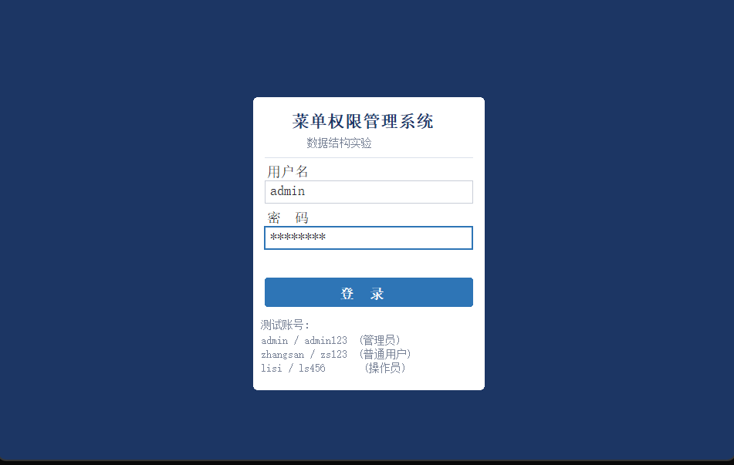

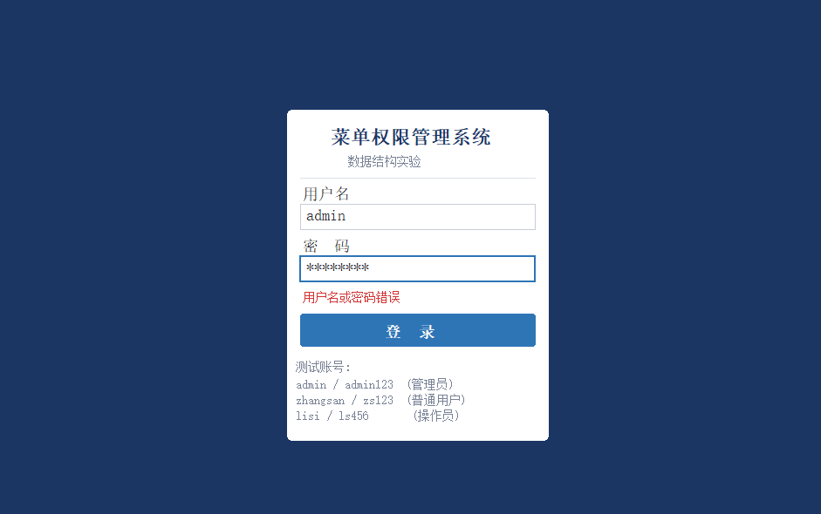
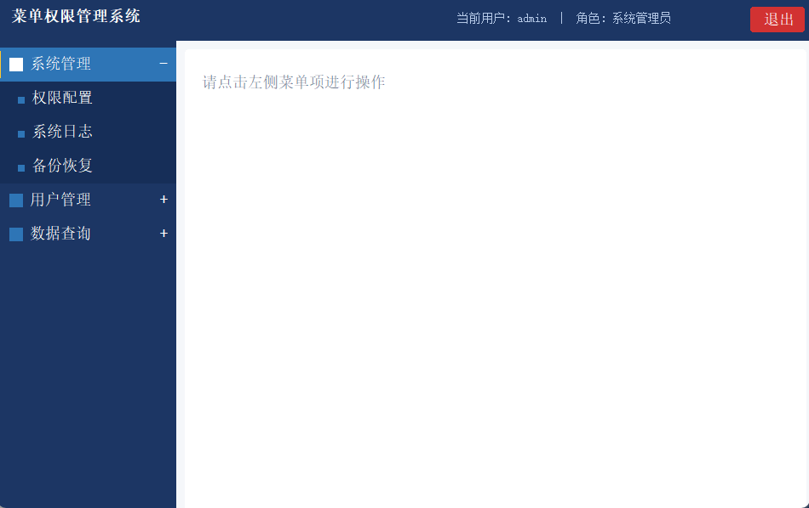
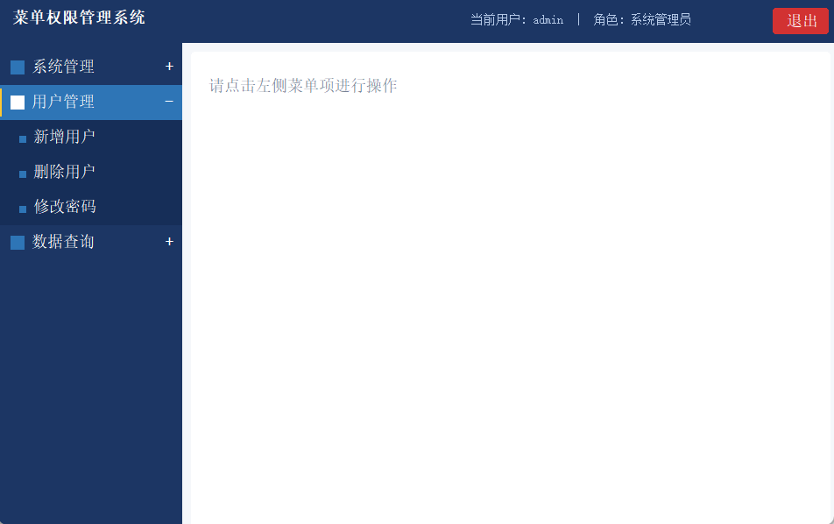
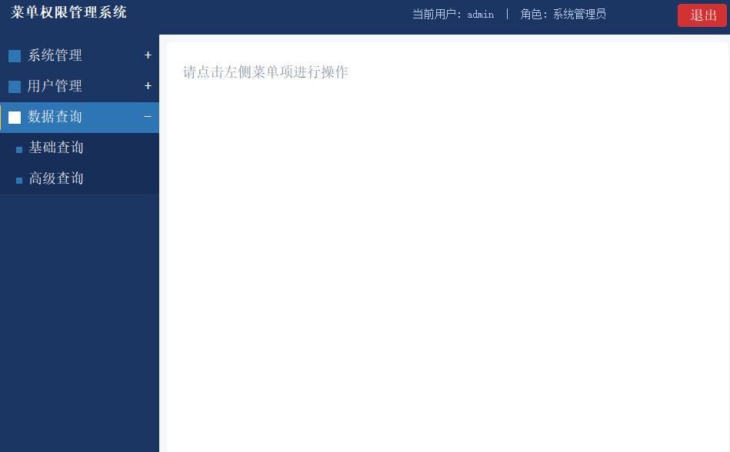
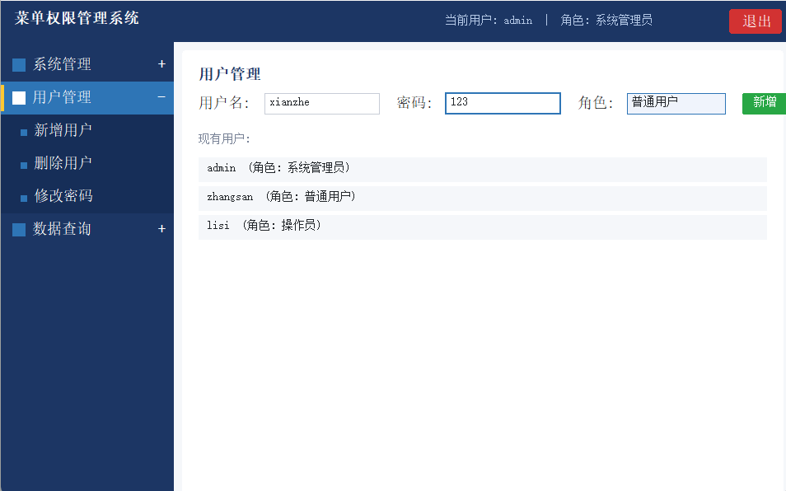
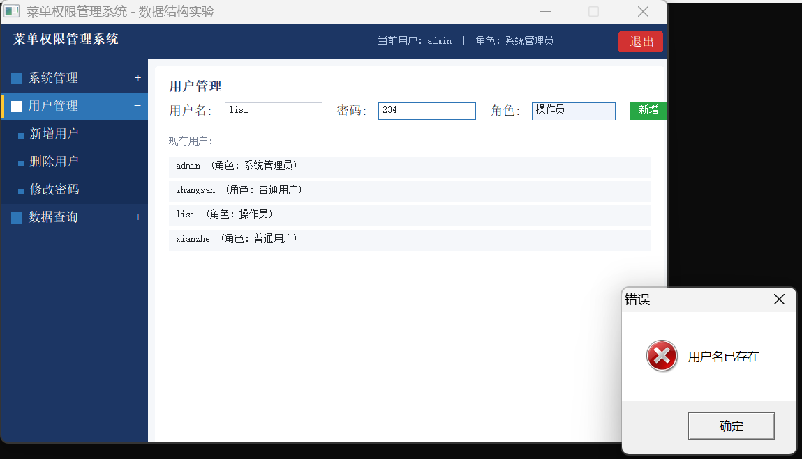
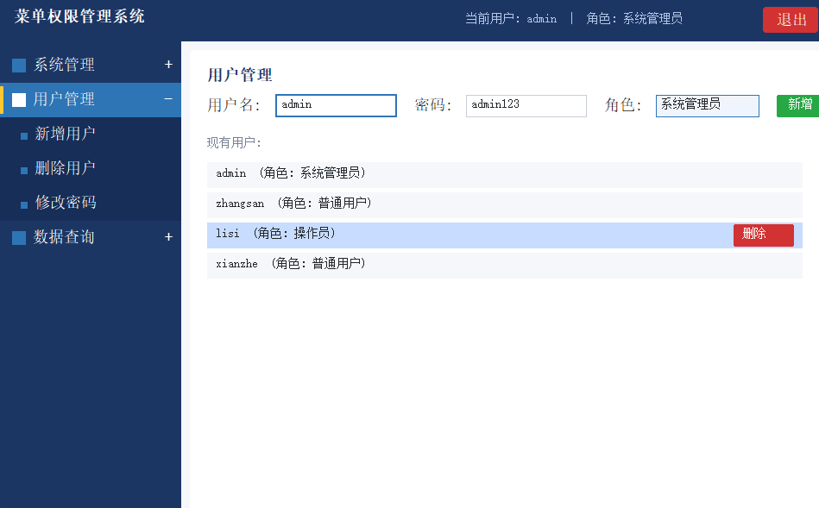
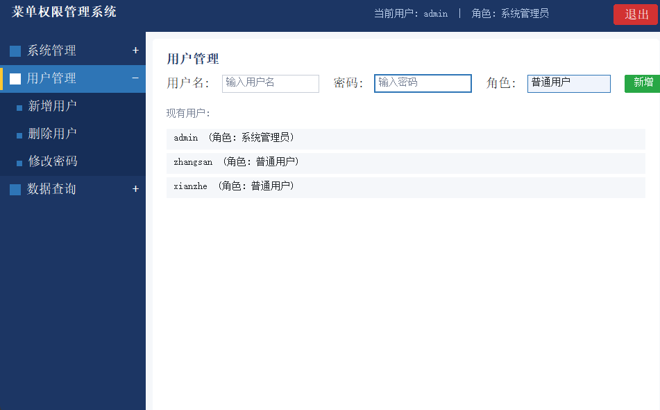
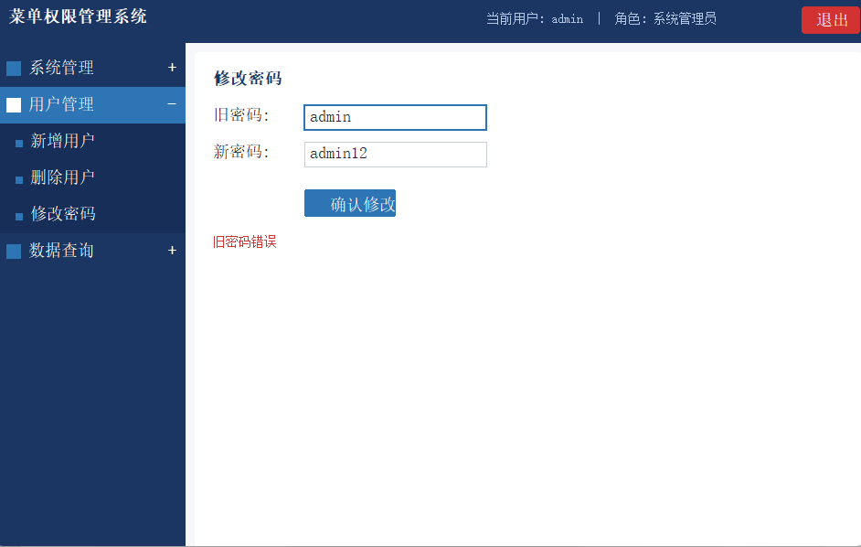

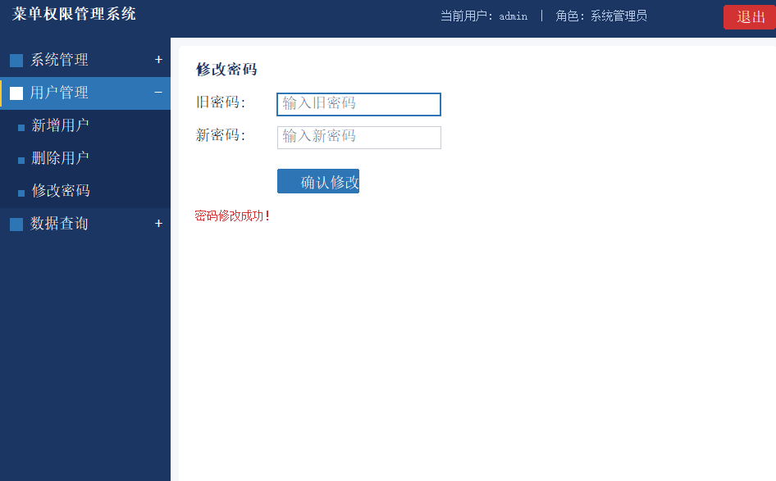

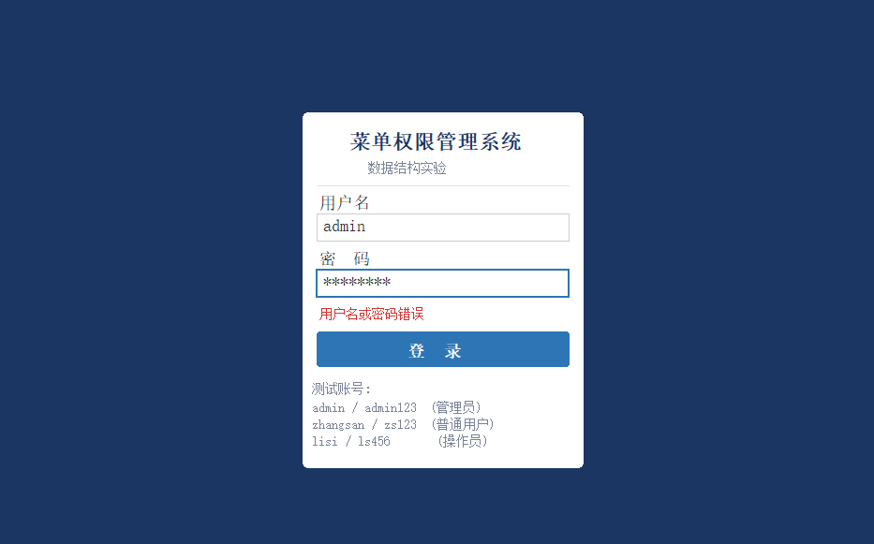
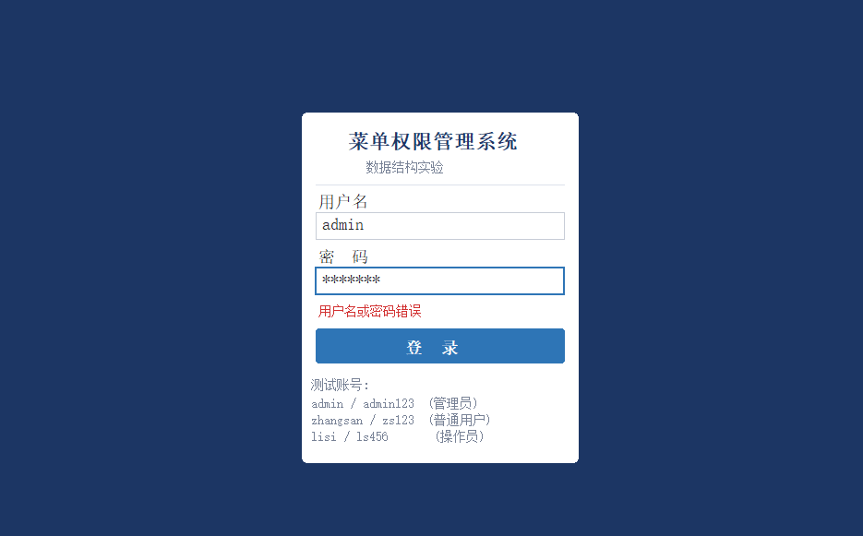
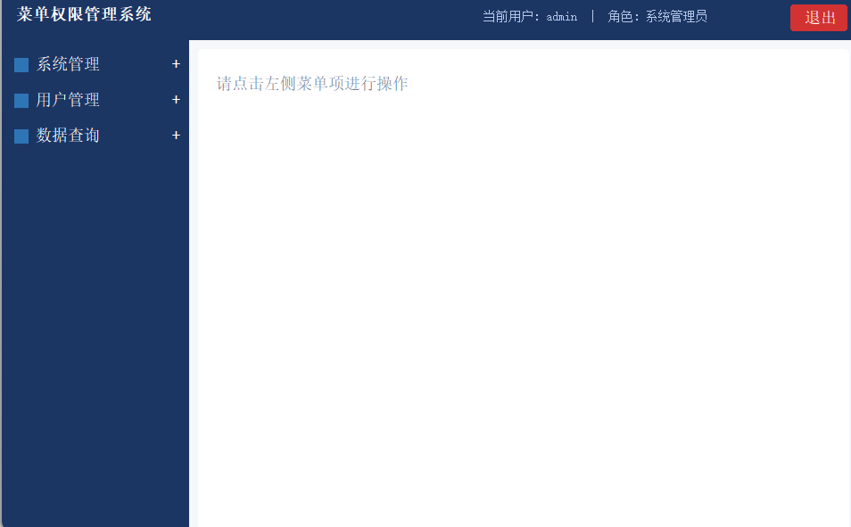
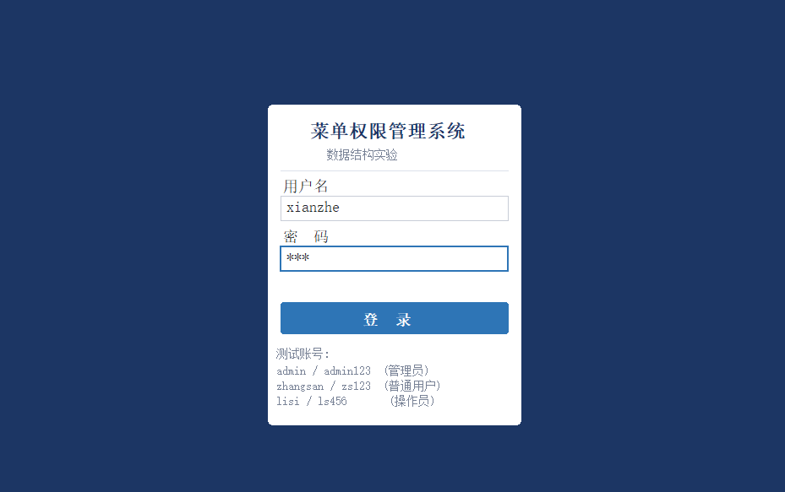
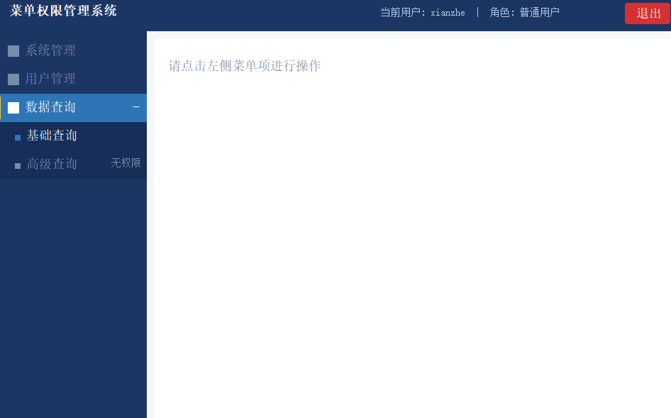
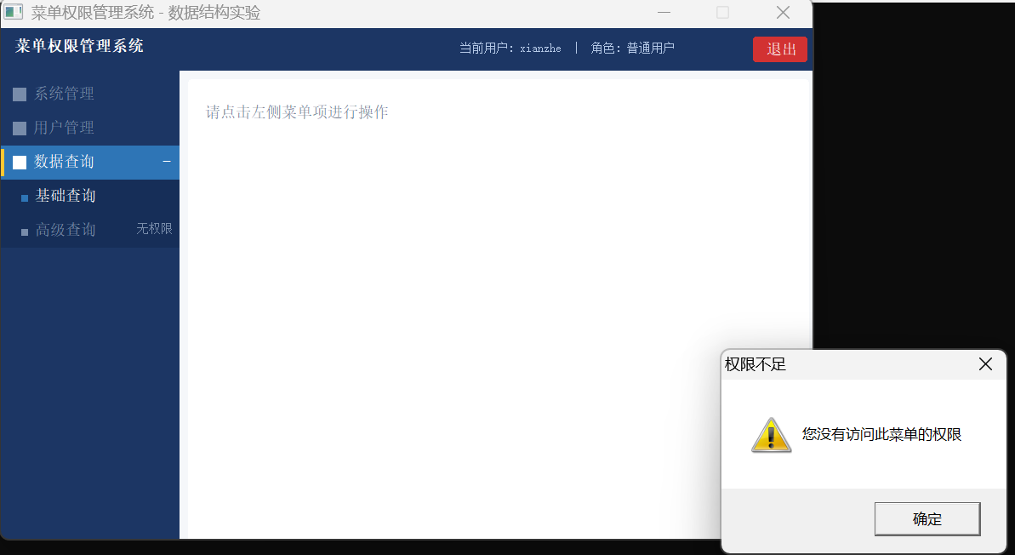

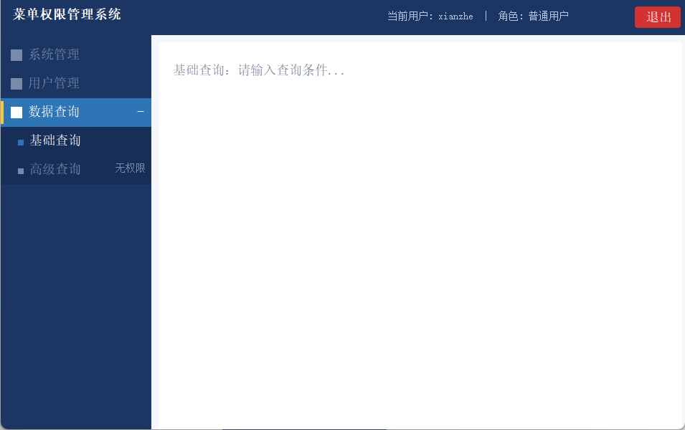
重新运行，这时候还有李四
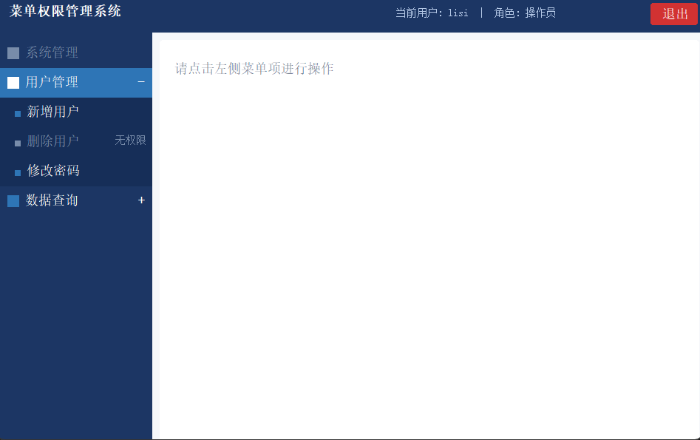

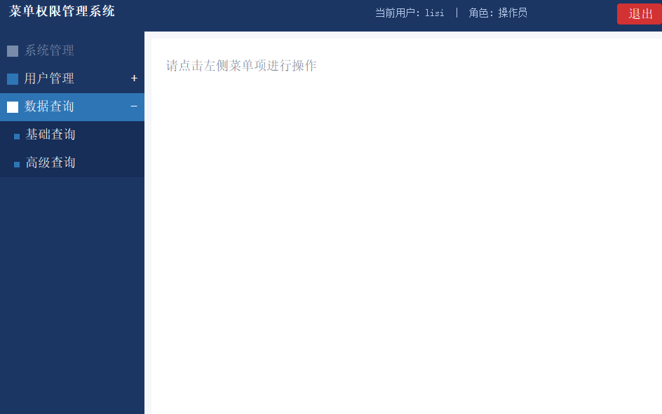
实验二
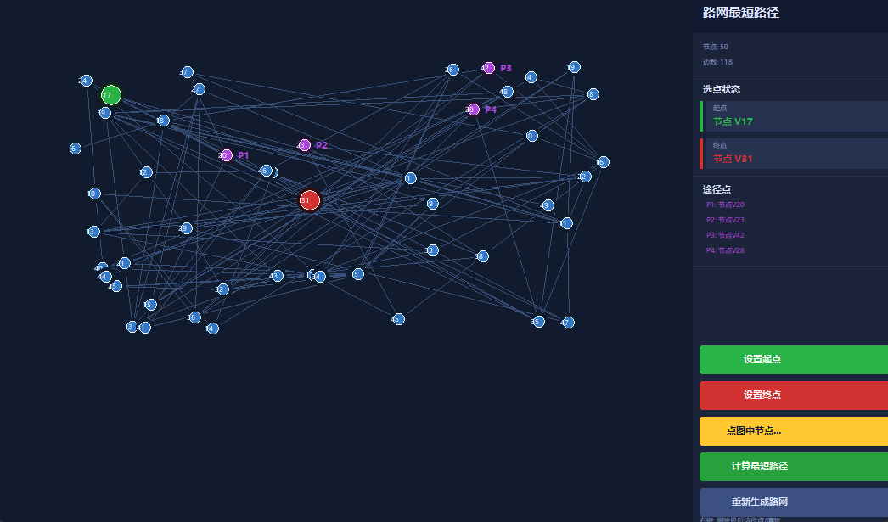
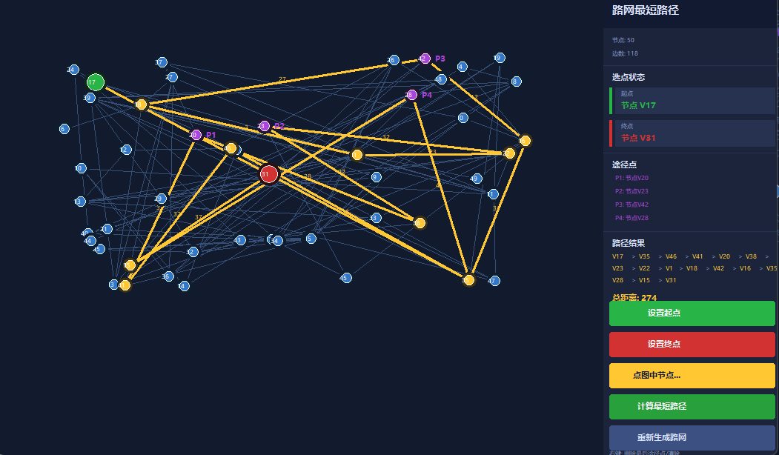
点重新生成，下面就生成了
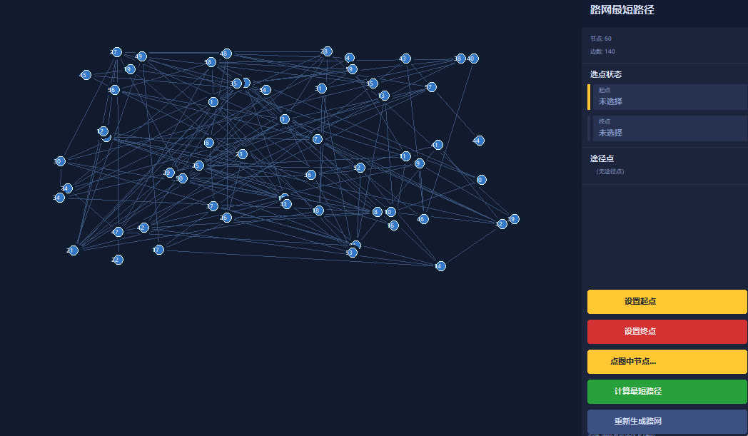
- 实验收获
通过本次实验，对数据结构课程中学过的树和图有了更直观的理解。以前在课堂上学多叉树、邻接矩阵、Dijkstra的时候总觉得比较抽象，这次真正动手把它们用在一个完整的程序里，才发现理论和实现之间还是有不小的距离——比如菜单树的节点怎么连、途径点怎么拆解成子问题、路径怎么从前驱数组里回溯出来，这些细节都是自己一点一点调通的。经过这次实验，对这几个核心数据结构的理解比单纯刷题要深得多，也真正体会到了选对数据结构对程序设计的重要性。

除了算法本身，这次实验也是第一次在Dev-cpp上做UI，从零学会了WinAPI的窗口创建、消息循环、GDI绘图这一套流程，踩了不少坑，比如显示乱码、双缓冲的写法、鼠标坐标和菜单区域的命中判断等等，最后都一一解决了。整个过程虽然花了不少时间，但完成之后看到程序跑起来、界面响应正常、路径高亮显示出来的时候，还是很有成就感的。这次实验让我意识到，编程能力的提升不只是靠看代码，真正自己去做一个有一定规模的项目，才是进步最快的方式。

