Introduction on using the Interactive Segmentation Tool (IST)

The simple Interactive Segmentation Tool (IST) is in the file ‘IntercSegmenTool’. In the file ‘SegmentedExample’ a short video frame sequence has been segmented using the IST software and the sample results have been stored in its “GT” file, which is supposed to help you have a clearer mind of what the segmentation results should be like. There are three sequences, Fish01, Fish02, and Fish03, to be segmented. Please complete segmenting all the images one by one in the three files.

1. Preparation:

To use the Interactive Segmentation Tool, Java is required to be installed in your computer. There are two steps to install Java: Install and verify. A simple video example on how to install and verify Java can be found in the following website.

<https://www.youtube.com/watch?v=Y5KLgpaexJg>

1. Install Interactive Segmentation Tool:

Double click on the “InteracSegmenTool_1.3.4_win32.exe” inside the folder ‘IntercSegmenTool’, and installation will process automatically.

You can also download the executable file “InteracSegmenTool_1.3.4_win32.exe” from <http://kspace.cdvp.dcu.ie/public/interactive-segmentation/downloads.html>

1. Using IST:

The video “ist_demo.ogv “ inside the folder ‘IntercSegmenTool’ briefly shows how to use the Interactive Segmentation Tool.

* 1. double click on the icon 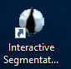 of the IST on the desktop or from all installed programs after installation to start the IST.
  2. Drag frames in a file to the IST, choose “combined” in the drop down menu of “View” on the top right corner;

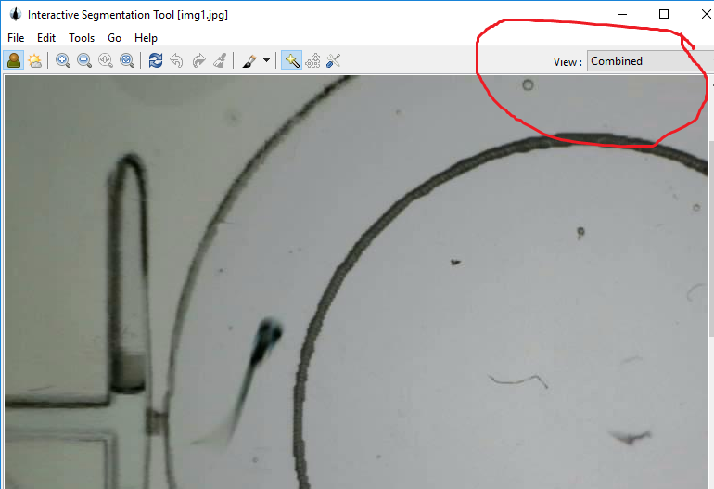

* 1. Choose “Seeded Region Growing Segmenter” in the Tools drop down menu.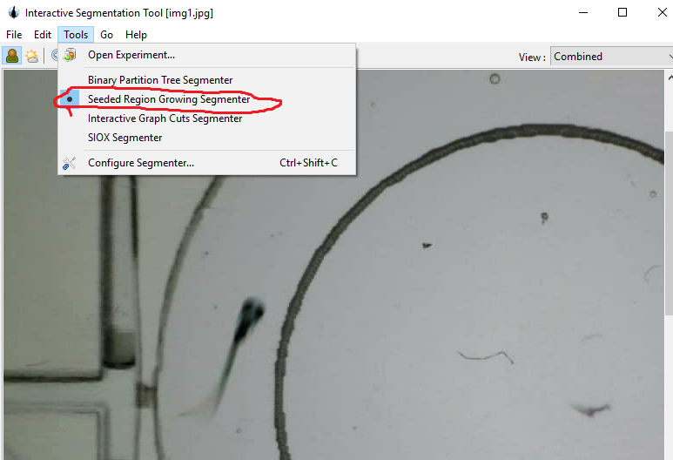
  2. hold the left click of mouse and draw a red line inside the fish or the fly, then hold the right key of mouse and draw a blue line inside the background. It helps to draw the red line until the end of fish tails for generating more accurate segmentation; while it doesn’t matter of the length of the blue line as long as the result can separate the fish from background. When there is blur at fish tail, please ignore the blur and choose the clearer tail position. Don’t select two tails for a fish.

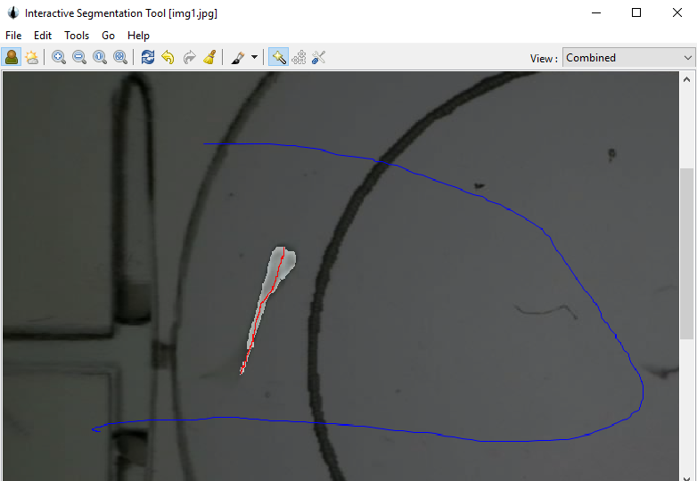

Example of selecting single zebrafish against its background

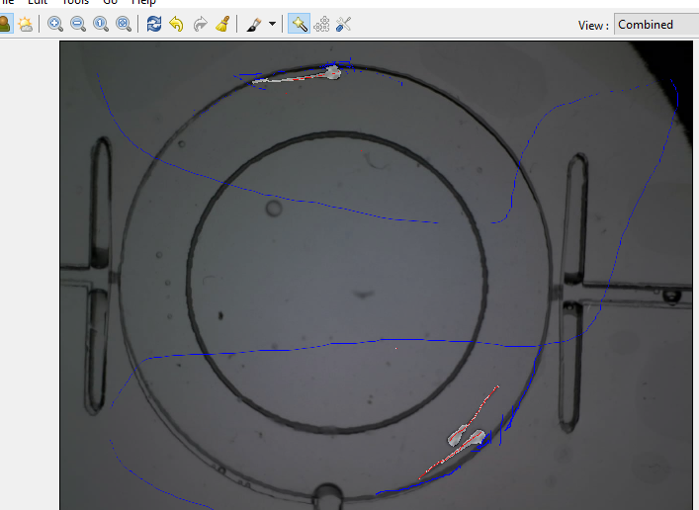

Example of selecting multiple zebrafish against its background

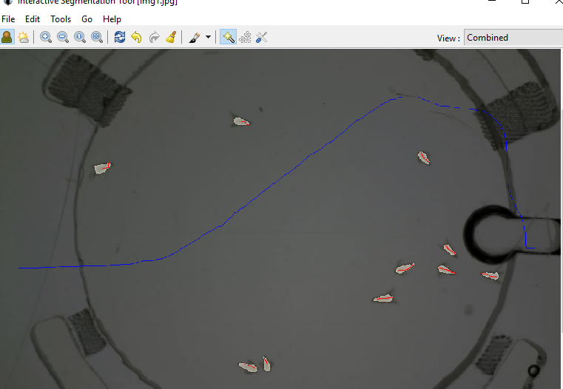

Example of selecting flies against its background

* 1. Adjustment

Adjustment sometimes need to be done to obtain accurate object positions. Especially when the object is near the edge of well, you need to carefully select more lines, as an example in the following figure (as highlighted by the yellow line):

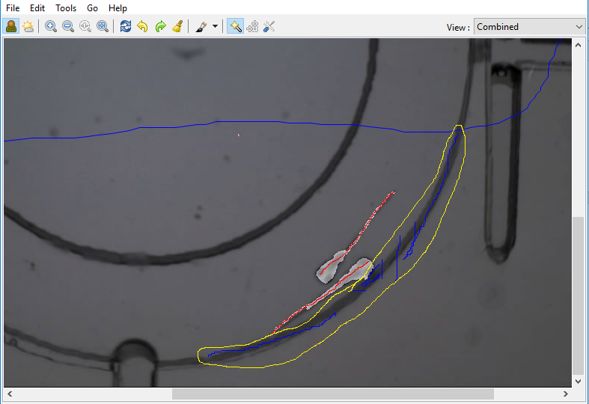

* 1. Zoom in and Zoom out can be used to get more accurate selection

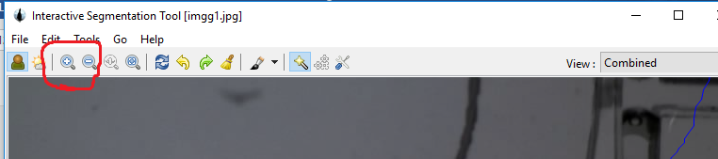

4 Output

After select objects and background, choose “Mask” in the “View” dropdown menu and the black and white image that showing the objects position is the required result.

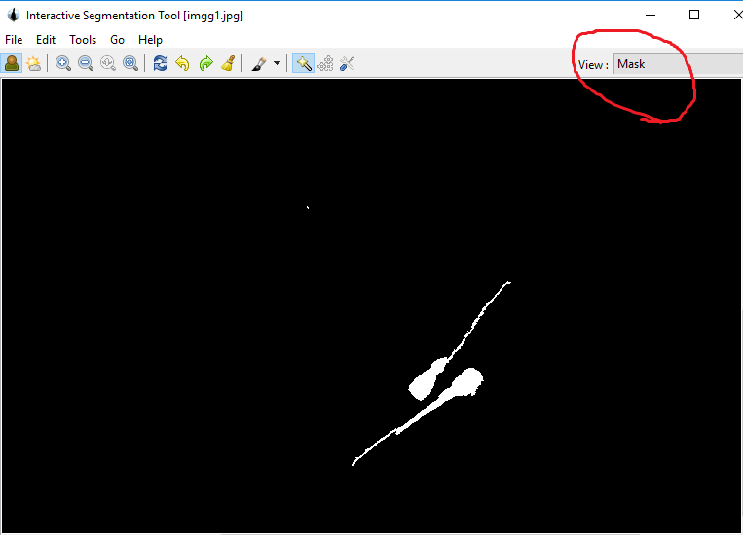

5 Export results

Under the “File” menu, select “Export”, then select “Current View”. You will find a file called “GT” inside each frame file, export the black and white image result in the “GT” file in each frame file.

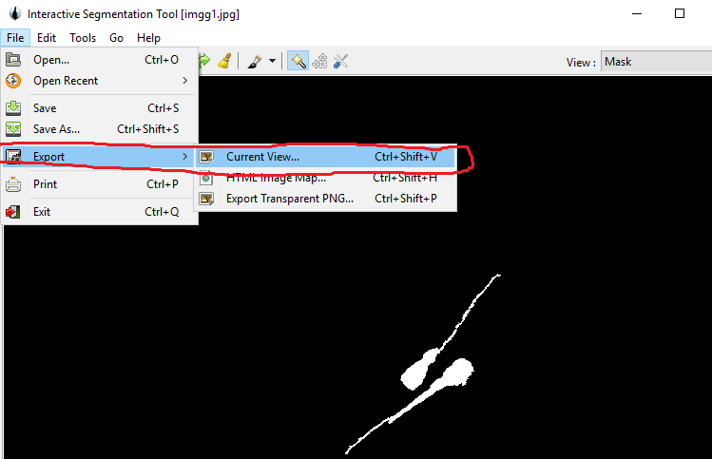

In the file ‘SegmentedExample’ a short video frame sequence has been segmented using the IST software and the sample results have been stored in its “GT” file, which is supposed to help you have a clearer mind of what the segmentation results should be like.

6 The simply trick to easily and quickly get accurate result

There is a trick to generate much more accuracy segmentation results, which is zoom in the original image a lot inside the interactive segmentation tool, then choose the fish, as shown by the attached images:

"Fig1" in following is the original looking inside the interactive segmentation tool, "Fig2" is the looking of the same image after zoom in by the yellow circled button 1, and you can move the image by moving the side bar labelled by the yellow circle 3 (there is also a corresponding left and right moving bar at bottom like 3); after selecting all the fish, then just click the button labelled by yellow circle 2, the image will go back to its original size, you can choose the background.

You will get much accurate results then. Hope this will help.

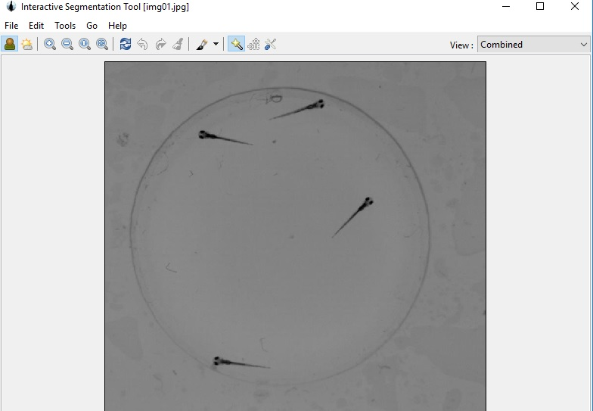

Fig1

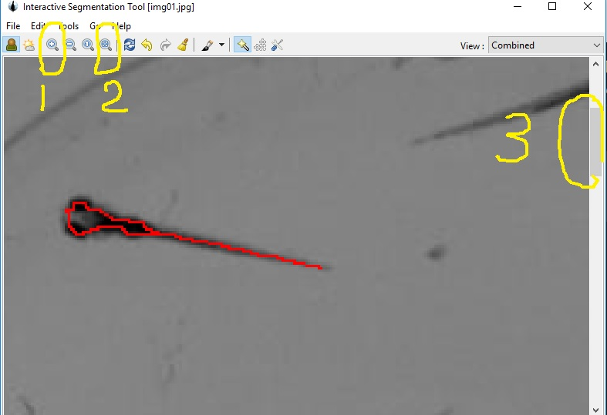

Fig2