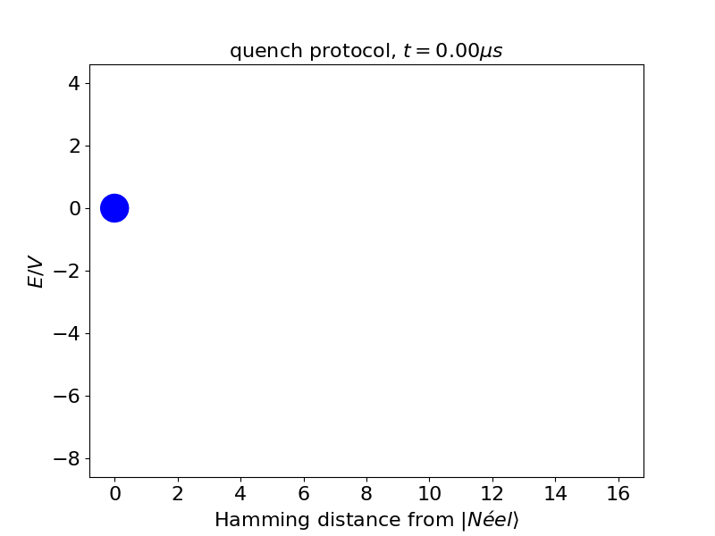
Figure R7: The energy landscape of the product states at $V/Δ_{l} ≈ 2$ (the resonance condition for$L=2$bubbles). Each blue dot in the landscape represents a manifold of product states, grouped by their Hamming distance from the $|Néel⟩$ state and their relative static energy $E/V$. The area of each dot is proportional to the occupation probability of the state manifold at different times $t$ after a quench ($Ω/2π =1.8 MHz$).

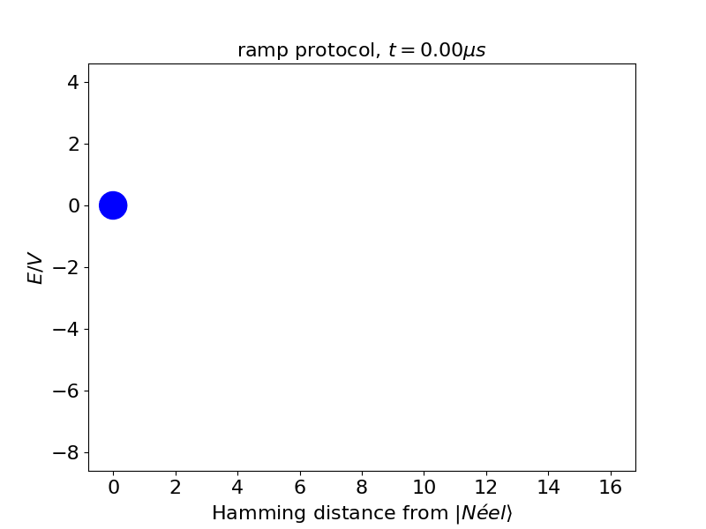
Figure R8: Similar to figure R7, but the Rabi frequency $Ω$ is slowly ramped up in $1 μs$.

