libevent使用文档
版本：(wifi_video_master)https://gitee.com/Jieli-Tech/fw-AC792_SDK.git
板级：AC7926AF开发板
环境：window+windsurf(vscode)

vscode终端
  - cd tools
  - .\make_prompt.bat
  - make ac792n_wifi_camera

- 添加头文件和库
在wifi_camera/board/wl83/Makefile
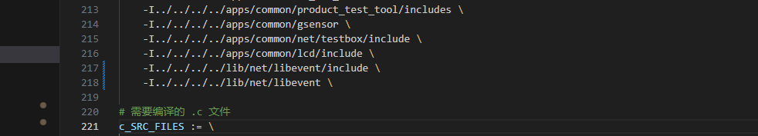


- 依赖lwip库，lwip需要重新编译，需要loop和ip6的支持
- #define CONFIG_LWIP_IPV6_ENABLE
- #define LWIP_NETIF_LOOPBACK 1
- #define LWIP_HAVE_LOOPIF 1

- 测试例子,需要留意，必须要lwip初始化之后，调用libevent_timer_test
- /* Timer callback function */
- static void timer_test_cb(evutil_socket_t fd, short events, void *arg)
- {
- struct event *ev = arg;
- static int count = 0;

- printf("Timer triggered #%d, event type: %s%s%s\n",
- ++count,
- (events & EV_TIMEOUT) ? "TIMEOUT " : "",
- (events & EV_READ) ? "READ " : "",
- (events & EV_WRITE) ? "WRITE " : "");

- /* Stop event loop after 5 timer events */
- if (count >= 5) {
- event_base_loopbreak(event_get_base(ev));
- printf("Timer reached 5 triggers, exiting event loop\n");
- }
- }

- /* libevent timer test function */
- void libevent_timer_test(void)
- {
- struct event_base *base;
- struct event *ev = NULL;
- struct timeval tv;

- /* Initialize libevent */
- base = event_base_new();
- if (!base) {
- printf("Failed to initialize libevent\n");
- return;
- }

- printf("Using libevent backend method: %s\n", event_base_get_method(base));

- /* Create persistent timer */
- ev = event_new(base, -1, EV_PERSIST, timer_test_cb, event_self_cbarg());
- if (!ev) {
- printf("Failed to create timer event\n");
- event_base_free(base);
- return;
- }

- /* Set 1-second interval */
- evutil_timerclear(&tv);
- tv.tv_sec = 1;
- tv.tv_usec = 0;
- if (event_add(ev, &tv) < 0) {
- printf("Failed to add timer event\n");
- event_free(ev);
- event_base_free(base);
- return;
- }

- printf("Periodic timer added, will trigger every 1 second\n");
- printf("Starting event loop...\n");

- /* Start event loop until no events or explicitly broken */
- event_base_dispatch(base);

- /* Clean up resources */
- event_free(ev);
- event_base_free(base);

- printf("Event loop exited, timer test completed\n");
- }

- int getpid(void)
- {
- return 0;
- }
- 测试debug，这里循环了5次的例子
