**1. EOP Data Handling**

**Data Source**：IERS finals2000A.all Bulletin B

**Time Span**:

12:00:00 UTC in Every Day From 2000 to 2010 for EOP Data

12:00:00 UTC in Every Day From 2010-01-01 to 2010-01-07 for C2T Matrix

**Interpolation**: Lagrange 9-th Order Interpolation

**(1) Regularization**

First, assess the regularization effect on UT1mUTC.

As it can be seen from the following figures, the difference of UT1Mutc caused by regularization is rather small (figure 1-1), and the differences of C2T Matrix caused by regularization achieve to 1e-10 (figure 1-2), which corresponds to a position error of about 3mm for GPS satellites.

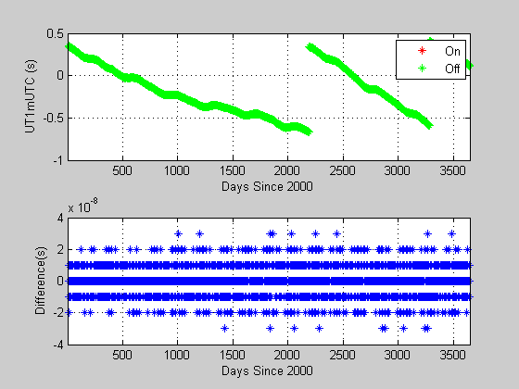

**Figure 1-1 Regularization Effect on UT1mUTC**

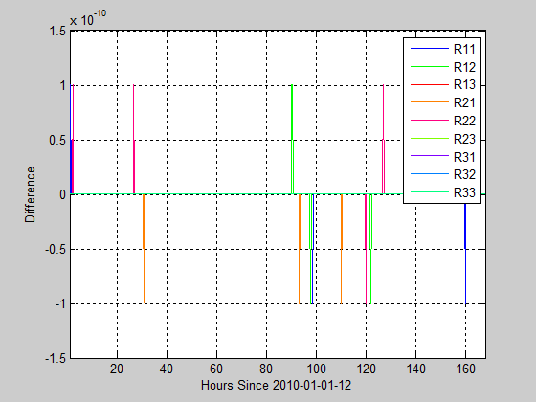

**Figure 1-2 Regularization Effect on C2T Matrix**

**(2) Ocean Tides**

Second, assess the effect of ocean tides on polar motion and UT1mUTC interpolation. As it can be seen from the following figures, the differences of polar motion and UT1mUTC caused by ocean tides are rather large (figure 1-3,1-4,1-5), and the differences of C2T Matrix caused by ocean tides achieve to 6e-9 (figure 1-6), which corresponds to a position error of about 15cm for GPS satellites.

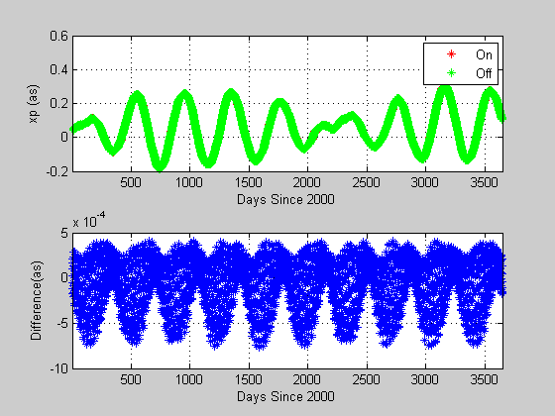

**Figure 1-3 Ocean Tides Effect on X Polar Motion**

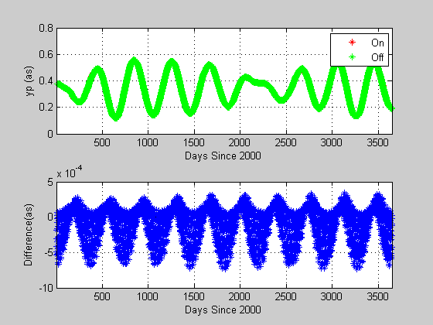

**Figure 1-4 Ocean Tides Effect on Y Polar Motion**

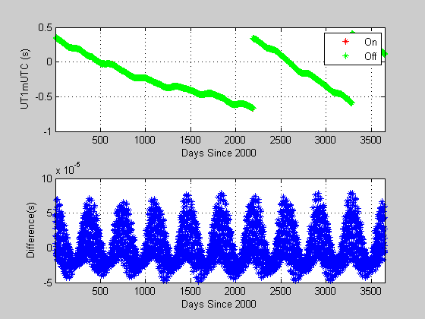

**Figure 1-5 Ocean Tides Effect on UT1mUTC**

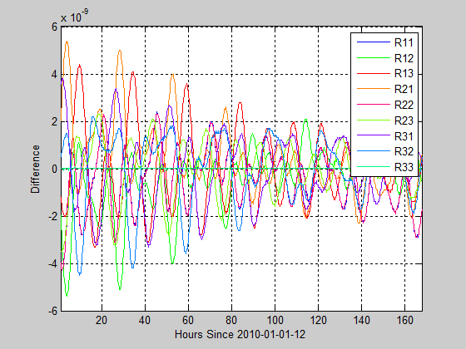

**Figure 1-6 Ocean Tides Effect on C2T Matrix**

**(3) Libration**

Third, assess the effect of libration on polar motion and UT1mUTC interpolation.

As it can be seen from the following figures, the differences of polar motion and UT1mUTC caused by libration are smaller than that caused by ocean tides, but is still rather large (figure 1-7,1-8,1-9) and the differences of C2T Matrix caused by libration achieve to 3e-10 (figure 1-10), which corresponds to a position error of about 8cm for GPS satellites.

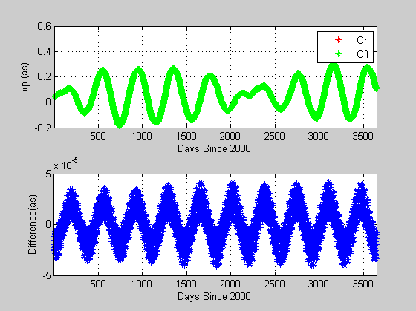

**Figure 1-7 Libration Effect on X Polar Motion**

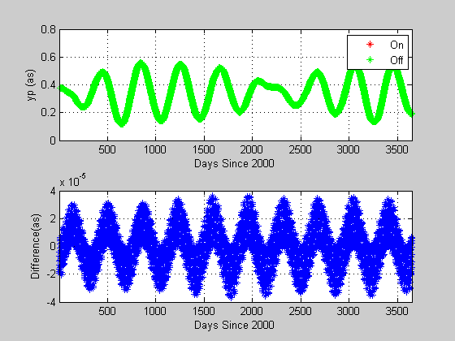

**Figure 1-8 Libration Effect on Y Polar Motion**

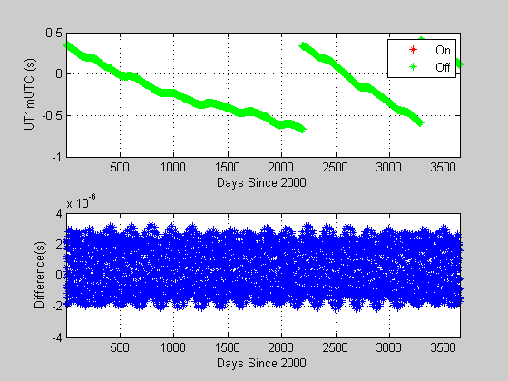

**Figure 1-9 Libration Effect on UT1mUTC**

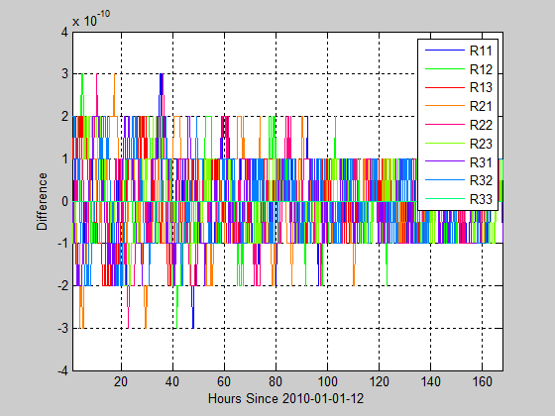

**Figure 1-10 Libration Effect on C2T Matrix**

**2. Transformation Matrix Comparison**

**Time Span:** 2015-01-01 and 2015-07-01, Every 900s, Extend 3.5h on each side.

The Day 2015-07-01 is chosen to check if the leap second handing during data interpolation are properly considered.

First, assess the effect of ocean tides and libration on T2C Matrix in GAMIT.

As it can be seen from the following figures (figure 1-11,1-12), the effect of ocean tide and libration on T2C Matrix is rather large, and is consistency with the tests above.

Then assess the T2C matrix difference between IERS website, SOFA software and GAMIT.

The IERS T2C Matrix which comes from the following website is used as reference.

<http://hpiers.obspm.fr/eop-pc/index.php?index=matrice&lang=en#description>

The SOFA T2C Matrix fully complies with the IERS Conventions 2010.

As it can be seen from the following figures, the difference between IERS and GAMIT can achieve 1e-7 (figure 1-13), which I have mentioned in emails before. The difference between IERS and SOFA can achieve 4e-9 (figure 1-14) and it is also rather large. However, if we use the IERS EOP C04 08 data, the difference can reduce to less than 6e-10 (figure 1-15). Considering that the accuracy of T2C Matrix given on the IERS website above is 5e-10. The SOFA results are reliable.

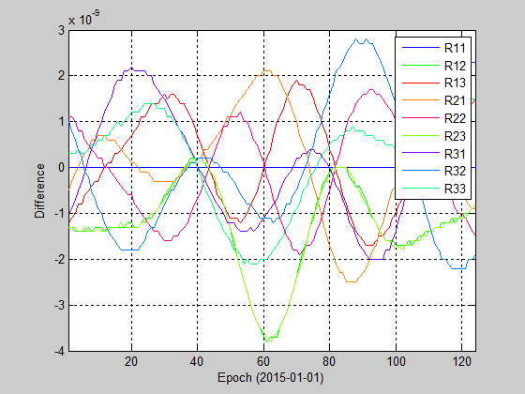

**Figure 1-11 Ocean Tides and Libration Effect on T2C Matrix in GAMIT**

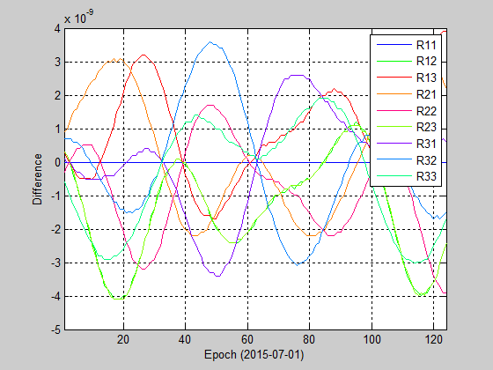

**Figure 1-12 Ocean Tides and Libration Effect on T2C Matrix in GAMIT**

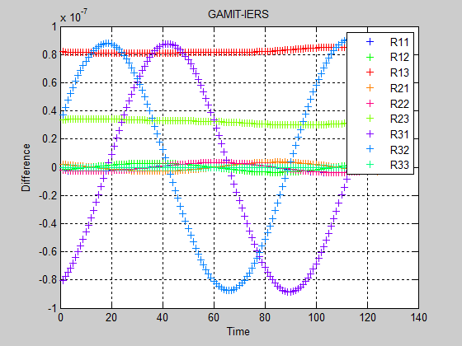

**Figure 1-13 Difference of T2C Matrix between GAMIT and IERS**

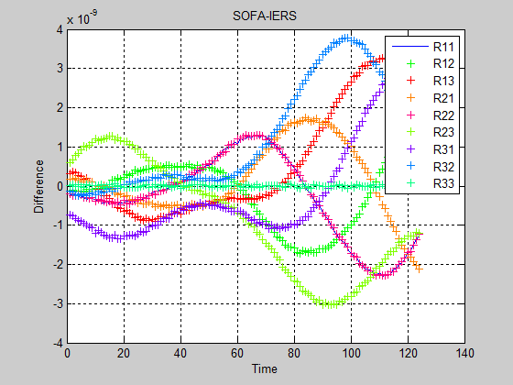

**Figure 1-14 Difference of T2C Matrix between SOFA and IERS**

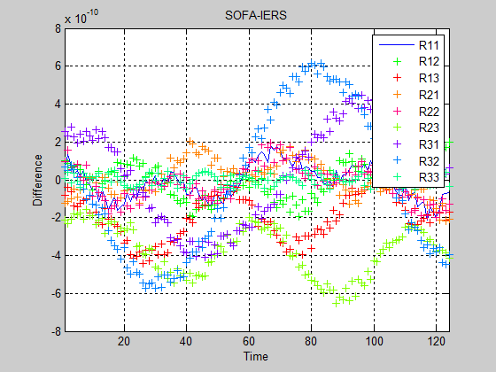

**Figure 1-15 Difference of T2C Matrix between SOFA and IERS**

**3. Orbit Fit**

**Data Source:** igs18254.sp3

**Satellite:** all GPS satellites

If we turn off the scale (set the scale in subroutine norm_solve to 1.0) and then run the script sh_sp3fit, the normal matrix is ill-conditioned, the rcond0 value is 0.7e-16, the Postfit RMS is about 0.5m, and the Overall fit (rms) to external orbit is about 0.5m.

If we turn on the scale and then run the script sh_sp3fit, the normal matrix is not ill-conditioned, the Postfit RMS is about 5.0e-3m, and the Overall fit (rms) to external orbit is about 0.004m.

**4. Conclusion**

From the above tests, we can draw a conclusion as following:

1. The regularization step can be ignored when handing EOP data;
2. The ocean tides cannot be ignored when handling EOP data;
3. Whether correct the libration are depends, but it is recommended by IERS;
4. The GAMIT earth orientation matrix differs very large from the IERS ones, which should be examined in my opinion. (The result of ARC is not affected, which maybe contribute to the consistency.)
5. The scale of normal matrix is very important in ORBFIT and should be implemented.