1. Servlet封装类用于装饰Request和Response

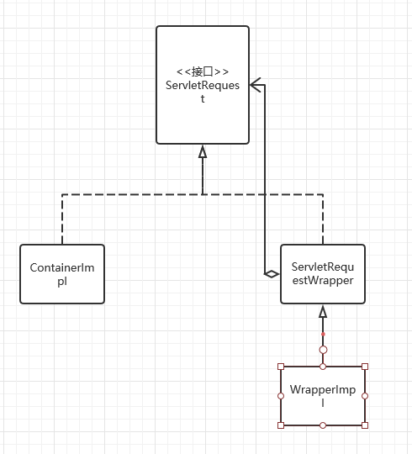

1. 在Servlet API 里面有4个：

ServletRequestWrapper,ServletResponseWrapper

HttpServletRequestWrapper,HttpServletResponseWrapper

它们提供ServletRequest和ServletResponse接口的默认实现，使用它们可以使编码时不用去重复实现那些你不需要包装的方法，只需要你去实现那些你需要包装的方法。

示例：

@WebFilter(filterName = "AutoCorrectFilter", urlPatterns = {"/\*"})  
public class AutoCorrectFilter implements Filter {  
 @Override  
 public void init(FilterConfig filterConfig) throws ServletException {}  
 @Override  
 public void doFilter(ServletRequest servletRequest, ServletResponse servletResponse, FilterChain filterChain) throws IOException, ServletException {  
 AutoCorrectHttpServletRequestWrapper wrapper = new AutoCorrectHttpServletRequestWrapper((HttpServletRequest) servletRequest);  
 }  
 @Override  
 public void destroy() {}  
 class AutoCorrectHttpServletRequestWrapper extends HttpServletRequestWrapper {  
 private HttpServletRequest httpServletRequest;  
 public AutoCorrectHttpServletRequestWrapper(HttpServletRequest httpServletRequest) {  
 super(httpServletRequest);  
 this.httpServletRequest = httpServletRequest;  
 }  
 @Override  
 public String getParameter(String name) {  
 return super.getParameter(name);  
 }  
 }  
}

