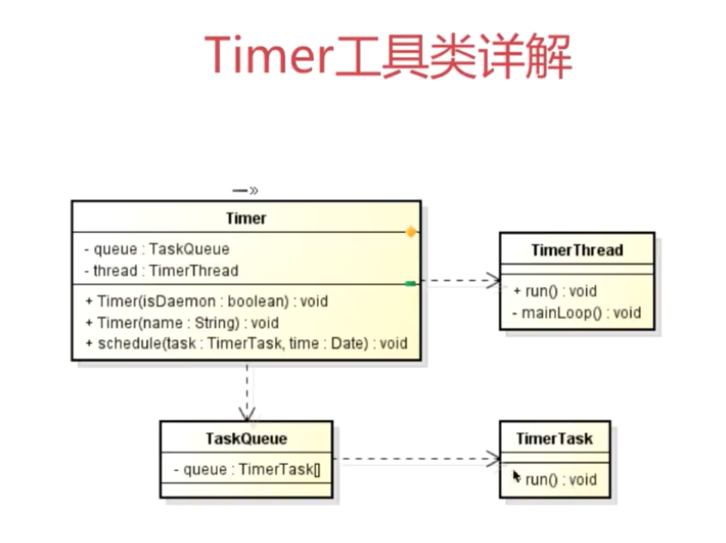

1. 示例：

@Component  
public class CleanQrCodeTask extends TimerTask {  
  
 private static final Logger *logger* = LoggerFactory.*getLogger*(CleanQrCodeTask.class);  
  
 @Autowired  
 private JedisPool jedisPool;  
  
 */**  
 * 使成为bean时自动生效  
 */* public CleanQrCodeTask() {  
 Timer timer = new Timer();  
 timer.schedule(this, 3600000, 3600000);  
 }  
  
 @Override  
 public void run() {  
 Jedis jedis = jedisPool.getResource();  
 Map<String, String> times = jedis.hgetAll("duty_sign_in");  
 Long now = new Date().getTime();  
 for (Map.Entry<String, String> time : times.entrySet()) {  
 if (Long.*valueOf*(time.getValue()) + Const.QrCode.*EXPIRY_TIME* < now) {  
 jedis.hdel("duty_sign_in", time.getKey());  
 *logger*.info("qrcode:" + time.getKey() + " be clean");  
 }  
 }  
 jedis.close();  
 }  
  
}