🔍 Self-Supervised Image Representation Learning with SimCLR
📌 Project Overview
This project explores self-supervised representation learning using the SimCLR framework on the CIFAR-10 dataset.
Instead of relying on labeled data, the model learns meaningful visual representations through contrastive learning, where different augmented views of the same image are treated as positive pairs.
The goal is to investigate:
- Whether useful features can be learned without labels
- How model architecture affects representation quality
- How well learned features align with semantic categories

🧠 Methodology
1️⃣ Framework: SimCLR
I adopt the Contrastive Learning paradigm:
- Apply strong data augmentations to generate two views of each image
- Train a neural network to maximize similarity between positive pairs
- Use negative samples from the same batch for contrast

2️⃣ Model Architecture
I experimented with two backbones:
- ResNet18
- ResNet50
Both models are implemented using PyTorch and followed by a projection head for contrastive training.

3️⃣ Evaluation Strategy
Since the training is unsupervised, I evaluate learned representations using:
🔹 KNN Classification
A K-Nearest Neighbors algorithm classifier is trained on extracted features to measure classification accuracy.
🔹 t-SNE Visualization
I applied t-SNE to visualize high-dimensional representations in 2D.
t-SNE visualizations are not directly comparable in absolute layout, but demonstrates relative cluster structure and class separability.
Two types of visualizations are generated:
- True Labels → ground truth categories
- Cluster Labels → unsupervised grouping via KMeans

📊 Experimental Results
🔢 Quantitative Results
Model | Epochs | Batch Size | KNN Accuracy
ResNet18 | 50 | 512 | 61%
ResNet50 | 50 | 512 | 60%

📈 Qualitative Analysis (t-SNE)
🔹 True Label Visualization
- Reveals the underlying semantic structure
- Shows whether samples from the same class cluster together
🔹 Cluster Label Visualization
- Shows how the model groups data without supervision
- Evaluates whether clustering aligns with real categories
🔹Visualized Graph Comparison
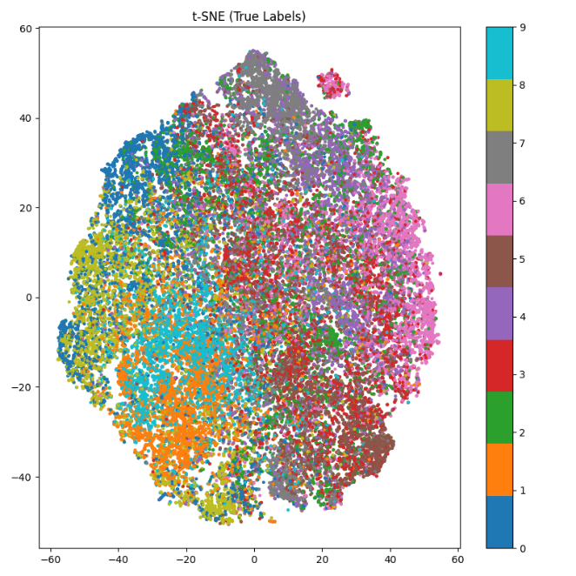
- ResNet-18 (1.1: True Label 1.2: Cluster Label)
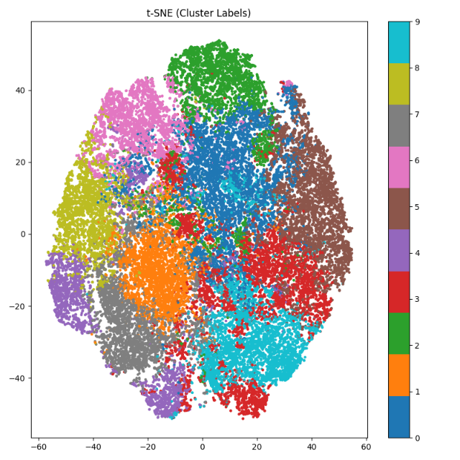

1.1 1.2
- ResNet-50 (2.1: True Label 2.2: Cluster Label)
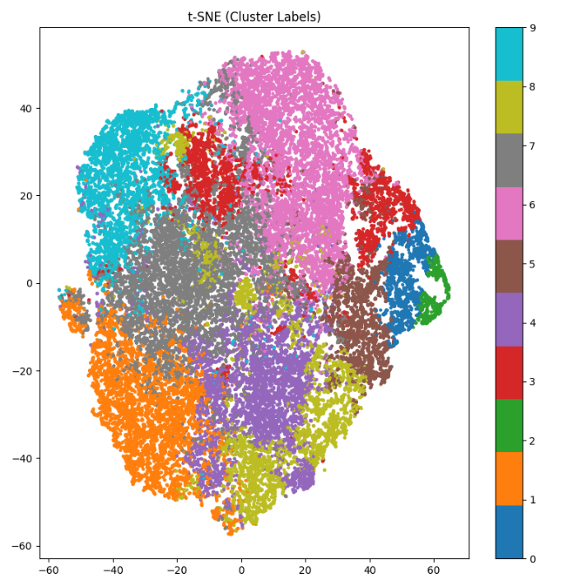
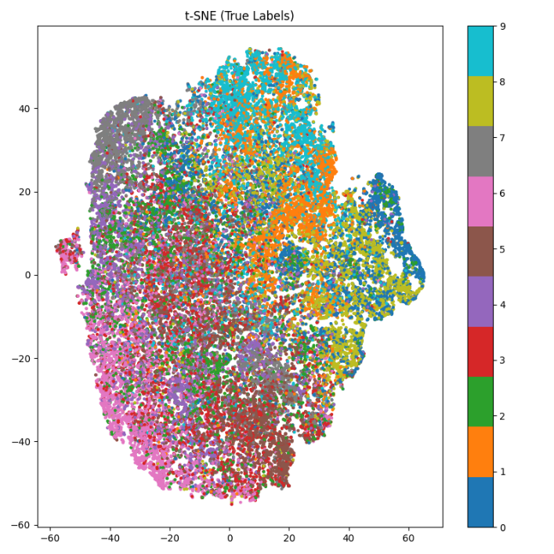

2.1 2.2

🔍 Key Findings
1️⃣ Effective Representation Learning
The model significantly outperforms random baseline (10%), achieving over 60% accuracy using KNN, demonstrating that meaningful features are learned without labels.

2️⃣ Model Size vs Performance
Interestingly, ResNet18 slightly outperforms ResNet50 under the same training configuration.
This suggests:
- Larger models do not necessarily produce better representations
- Model capacity must match dataset scale and training conditions

3️⃣ Representation Quality Analysis
From t-SNE visualizations:
- ResNet18 exhibits more compact clusters and clearer separation
- ResNet50 shows more entangled representations
- KMeans clustering partially aligns with semantic labels
This indicates that:
The learned representations capture some semantic structure but remain imperfectly separable.

🧠 Insights
This project highlights an important principle:
Better representations are not solely determined by model size, but by the balance between model capacity, data scale, and training dynamics.

⚙️ Implementation Details
- Framework: PyTorch
- Dataset: CIFAR-10
- Training epochs: 50
- Batch size: 512
- Optimization: Adam
- Hardware: Nvidia Geforce RTX 5070 Laptop GPU (CUDA-enabled)

📁 Project Structure
project/
│
├── train.py # Training pipeline
├── tsne_vis.py # Visualization script
├── checkpoints/ # Saved models
├── graphs/ #Saved pictures for data analysis
└── README.md

🎯 Conclusion
This project demonstrates that self-supervised learning can extract meaningful representations from unlabeled data, while also revealing the limitations of model scaling under constrained settings.
It provides both:
- Empirical results (KNN accuracy)
- Visual evidence (t-SNE analysis)
forming a complete and interpretable evaluation pipeline.

