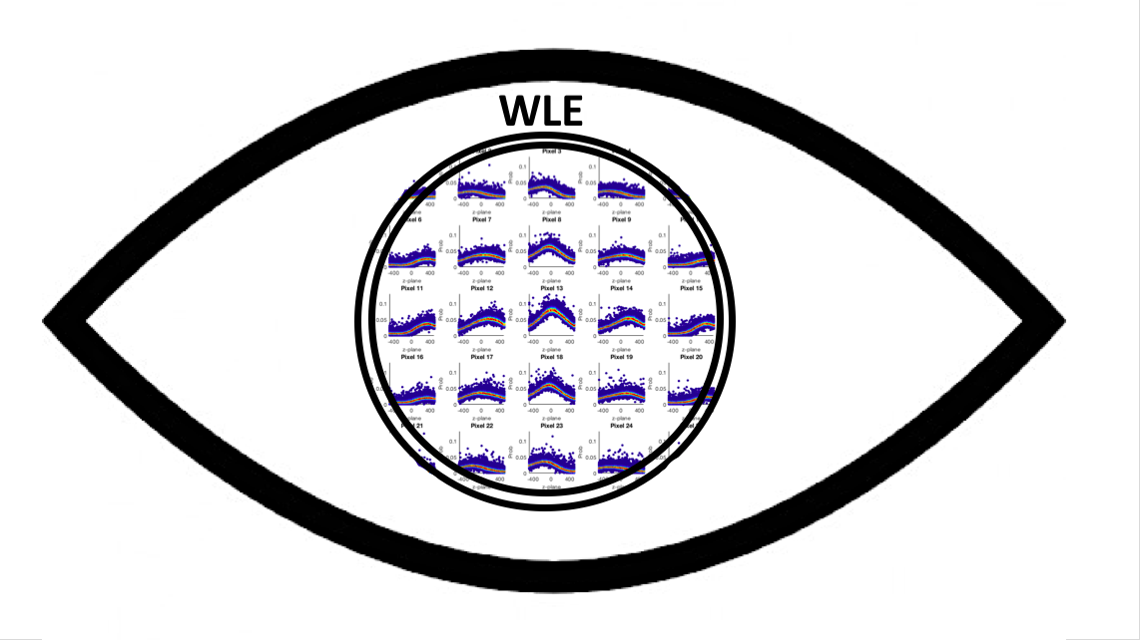A Brief User Guide For Using WLE
Christopher H. Bohrer (cbohrer1@jhu.edu)
Introduction: Here I will run through a quick example, utilizing the WLE methodology to determine the Z-plane of individual emitters (From Simulation). I will walk you through, the regions of code and discuss what is happening at each step (In this document or within the code itself).
WLE: The WLE methodology uses a numerically determined weighted maximum likelihood estimator to determine the z-position of an emitter. When an emitter’s PSF deviates from an ideal gaussian shape, methodologies that depend upon this assumption are more error prone than WLE, as the WLE methodology utilizes the information within all the pixels contributing the signal of the emitter and compares it to a calibration PSF (Determined from a bead sample) to determine the z-plane of the emitter. Please see the main text demonstrating the advantages of utilizing this methodology and for specific derivations and assumptions.
Example: Here we will show you how to use some sample code to analyze some synthetic (Provided) data using the WLE methodology. A prerequisite to utilize this sample code is that MATLAB (2015 and newer) is installed and ready to go on your computer. We also recommend that you utilize a computer with as many cores as possible, as the WLE methodology performs the majority of the analysis in parallel and can be computationally expensive at times. For all of the computation in the main text demonstrating this methodology we utilized 24 cores for 8hr to analyze each of the SNRs for each condition using the MARCC cluster. Though, here we will not be analyzing some many emitters and it will go “much quicker.”
The example data we will be analyzing is synthetic data generated from the experimental PSF II described in the main text explaining/demonstrating the WLE methodology. (Though we will only be analyzing a fraction of the total number of emitters, based off of the computational resources available to you.) Please make sure you have downloaded the folder named Exp_PSF2_Files, the folder should contain 12 files in all. We will be conducting all the analysis of this User Guide within this folder. Inside this folder you will see a ‘*.m’ file with the name: Run_Script_Final_Sim.m. Open this script to start the analysis with the WLE methodology. This file contains everything that you need to know about the code used for WLE, though we will still, none the less, guide you.
Figure 1: The results of completing step 1 of the User Guide.
Step 1: Here we will load in the experimental emitters and store the scaling factors and the background distribution. For you to do this all you must do is run the section for Step 1. This will calculate the background and Alpha arrays, storing the data. Once this calculation has finished two histograms will appear showing the distributions of scaling terms and the background intensity. You should see the following two histograms, Fig. 1.
Step 2: To run this step you can simply run this section. Here we are simulating the experimental calibration emitters at each z-plane. All of this computation takes place within the function: Sim_Calibration_Emitters.m, which takes in the calculated scaling factors and background terms you determined in Step 1.

Here we will briefly go through the sections within the function Sim_Calibration_Emitters.m.

2A: Here we first calculate the background of the bead images. Second, we subtract the mean background from each pixel of every cropped bead image and normalize each bead image by the total signal from the bead. Third, we then take the mean of all normalized bead images for each z-plane. This is what we refer to as the PSF for each z-plane.

2B: By randomly sampling values from the previously determined arrays we generate an emitter with the PSF determined in (2A) with Poisson noise with a mean equal to a random scaling factor multiplied by the PSF for each pixel.

We then add in random background terms to each pixel and subtract the mean background from each pixel. Finally, we divide each pixel by the same random scaling factor, normalizing the signal. We then determine the centroid of the simulated emitter and store a cropped (13x13) image, with the centroid at the exact center (Using a linear translation). We do this for each z-plane.

At the end of this step you can generate a plot of how the normalized intensity within the center pixel varies with z-plane, it should look like Fig. 2.
Figure 2: Mean normalized intensity for the center pixel. Determined from the results of section 2 of this user guide.

Step 3: Here we will finally generate the PDM that is utilized to calculate the likelihood. Here we simply take the experimental calibration emitters generated in the last step and create probability distributions with this data. Here we define the bin width to be a value that allows 15% of the total number of observations to be in one bin. Depending upon the number of experimental calibration emitters you generate, you can change this value. The code is commented in this step and is self-explanatory.
Figure 3: The final figure generated at the end of Step 3. This figure shows the signal (y-axis) vs. z-plane (x-axis) vs. probability (z-axis, color red=high, blue=low) for all of the pixels being utilized for the calculation of the z-plane.

At the end of this step you can investigate how these probability distributions vary for each pixel for each z-plane. To generate this “cool” looking figure run the function at the end of the section of code for Step 3.

Step 4: Finally, we are at the last step of this Brief User Guide, where we are going to determine the weight of each pixel, which is going to in turn determine the optimal z-plane of each emitter. Here we are going to perform a simple phase space search in order to minimize the Score, which is basically the distances between blinks. (Please see the SI of the main text for a more in depth description of the phase space search and the Scoring function.)
Figure 4:A figure that shows the effect of the phase space search.

4A: Here we start with the importance/weight of each pixel set to 1, imp(). This is equivalent to the regular/traditional MLE approach. Here we are only going to be analyzing 200 emitters (for the sake of time) 2 emitters for each z-plane. We enter the for loops and subtract out the background and normalize by the integrated signal, as listed before in the previous steps.

4B: Here we feed in the normalized image and the PDM to determine the z-position of the emitter. This is simple enough, as we simply calculate the weighted likelihood at each z-plane and determine which one gives the highest value. Note: Here if the calculation of the likelihood cannot be determined for all z-planes, aka -INF. We add a small value to each bin of the PDM to allow us to make the calculation.

4C: Here we calculate the Score and see if it is the smallest Score we have observed. If it is we same out the data. We then randomly choose an element of imp() to modify and choose its value based off of a uniform random number (at the beginning of the for loops).

This can be computationally expensive so you may want to let this run overnight. Once it is finished you can plot the Score vs. Error, for all of the iterations by running the last segment of the code. You should see something similar to Figure 4.

