Wordcount

STOpword

Lab 5

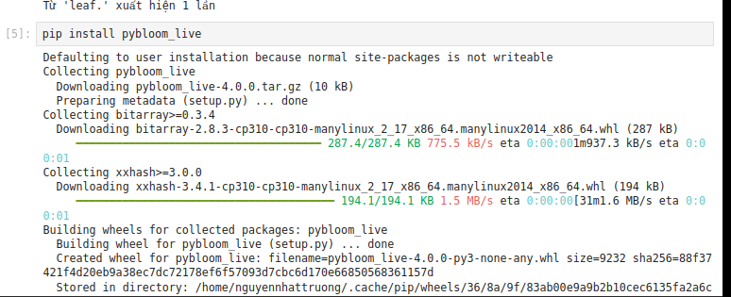

Lab 6



