

**DEPARTMENT OF** BUSINESS, ADVANCED MANUFACTURING & LOGISTICS

ICT50220 Diploma of Information Technology

**Learner Resource**

*[Insert Unit Code and Title]*

**Department:** Business, Advanced Manufacturing & Logistics

**Course:** ICT50120 Diploma of Information Technology

**Unit of Competency:** BSBXTW401 Lead and facilitate a team



Prepared by: Logesvary Krishnasamy, Department of Business, Advance Manufacturing and Logistics, Melbourne Polytechnic

Document creation date: November 2021

Version: 1.0

**© Melbourne Polytechnic 2021   
National Provider no. 3075**

**Author**: Logesvary Krishnasamy, Lead Teacher, IT, Melbourne Polytechnic

**Disclaimer Statement:  
PLEASE NOTE that by clicking on a link you may be directed to a third party’s site.**   
**You should respect the intellectual property on that site. You may be leaving the Melbourne Polytechnic website.**   
**Melbourne Polytechnic does not endorse a linked site or guarantee the accuracy or currency of any information contained on the third party linked site.**

**Acknowledgments**National training packages attributed as ***‘© Commonwealth of Australia 2013’***   
Training packages are copied and communicated under [Creative Commons Attribution-Non Derivative 3.0 Australia](https://creativecommons.org/licenses/by-nd/3.0/au/) ([CC BY-ND 3.0 AUS](https://creativecommons.org/licenses/by-nd/3.0/au/)) license.

**For information regarding material in this document, contact:**

Uday Vaidya

Program Lead

Business, Advanced Manufacturing & Logistics  
udayvaidya[@melbournepolytechnic.edu.au](mailto:aaronsmith@mp.edu.au)

Contents

Unit Descriptor 5

Application 5

Elements and performance criteria 6

Required Skills and Knowledge 7

Overview 8

Glossary 9

Introduction 11

Effective, legitimate leadership 13

Professional Behaviour and Core Leadership Skills 14

1 Plan team outcomes 18

1.1 Identifying common objectives, responsibilities and outcomes 18

1.2 Establishing expected outcomes, goals, and behaviours for individual team members 21

Governance Rules, Policies and Procedures 21

Establish Team / INDIVIDUAL PERFORMANCE Plan 31

1.3 Strategies to support team members to be accountable 36

Accountability 36

Hold Team Members responsible and accountable 36

1.4 Plan for contingencies that could impact the team 37

2 Coordinate team and individuals 40

2.1 Communicate common team objectives and responsibilities to team members 40

Communication method 40

Communication Tools 40

Team Cohesion 42

2.2 Task Allocation based on staff expertise or developmental potential and provide instructions 43

Team Leader 43

Keys to Successfully Allocate Task 45

Lead without dominating 47

Role MoDEl 47

2.3 Open and respectful communication and collaboration 49

Communication 49

Why is it important to know your communication style 50

different methods and styles of communication 50

principles of cross-cultural communication and communication with individuals with special needs or disabilities 55

Other Strategies to faciliate open COMMUNICATIOn with a diverse team 57

2.4 Identify opportunities for cross collaboration amongst external and internal teams and individuals 58

3 Support team 60

3.1 Coach to staff to enhance workplace culture 60

coaching 60

MENTORING VS COACHING 62

3.2 Support individuals according to organisation’s common team goals 62

3.3 Facilitate team to identify, brainstorm, report and resolve task related issues and inefficiencies 63

team Faciltation 63

3.4 Use problem solving skills in teams 64

Problem Solving 64

CONFLICT RESOLUTION & NEGOTIATION 65

teamwork challenges relevant to performance evidence: 67

Managing difficulties to achieve positive outcomes 67

strategies for conflict resolution and negotiation 69

4 Monitor team performance 70

4.1 Measure team member performance against agreed work plans 70

Team Performance 70

4.2 Providing feedback to team members 71

4.3 Specific learning and development opportunities to improve team and individual performance and behaviours 74

Training for staffs 74

4.4 Implement action plans to address individual and team training needs 75

References 76

Unit Descriptor

## Application

This unit describes the skills and knowledge required to effectively lead and facilitate a team in a workplace within any industry.

This unit has a specific focus on the teamwork skills required for team leader or supervisor level (depending on organisational structure) workers with responsibility for others or teams.

No licensing, legislative or certification requirements apply to this unit at the time of publication.

## Elements and performance criteria

|  |  |
| --- | --- |
|  | Plan team outcomes |
|  | Identify common objectives of workplace team, responsibilities and required outcome(s) |
|  | Use performance plans to establish expected outcomes, goals, and behaviours for individual team members in accordance with team objective and relevant policies |
|  | Select appropriate strategies to ensure team members are accountable for their roles and responsibilities |
|  | Plan for contingencies that could impact the team |

|  |  |
| --- | --- |
| 2 | Coordinate team and individuals |
| 2.1 | Communicate common team objectives and responsibilities to team members |
| 2.2 | Allocate tasks to team members based on staff expertise or development potential and provide appropriate instructions |
| 2.3 | Facilitate open and respectful communication and collaboration between team members, considering the needs of those from diverse backgrounds |
| 2.4 | Identify opportunities for cross collaboration amongst external and internal teams and individuals |

|  |  |
| --- | --- |
| 3 | Support team |
| 3.1 | Provide coaching to staff to enhance workplace culture |
| 3.2 | Support individuals according to organisational requirements to work towards common team goals |
| 3.3 | Facilitate team to identify, brainstorm, report and resolve task related issues and inefficiencies |
| 3.4 | Use problem solving skills to deal with any team, task or individual challenges |

|  |  |
| --- | --- |
| 4 | Monitor team performance |
| 4.1 | Measure team member performance against agreed work plans |
| 4.2 | Provide timely and constructive performance feedback to team members according to expected organisational standards |
| 4.3 | Identify specific learning and development opportunities to improve team and individual performance and behaviours |
| 4.4 | Implement action plans to address individual and team training needs |

© Commonwealth of Australia 2013, BSBXTW401 Lead and facilitate a team, <https://training.gov.au/Training/Details/BSBXTW401> [Creative Commons Attribution-Non Derivative 3.0 Australia](https://creativecommons.org/licenses/by-nd/3.0/au/) ([CC BY-ND 3.0 AUS](https://creativecommons.org/licenses/by-nd/3.0/au/)) licence.

# Required Skills and Knowledge

This unit describes the skills and knowledge required to effectively lead and facilitate a team in a workplace within any industry. This unit has a specific focus on the teamwork skills required for team leader or supervisor level (depending on organisational structure) workers with responsibility for others or teams.

#### Required Skills/Performance Evidence The candidate must demonstrate the ability to complete the tasks outlined in the elements, performance criteria, and foundation skills of this unit, including on at least one occasion, evidence of the ability to:

* assign tasks to team members with appropriate instruction and considering any required contingencies
* provide feedback and assistance to team members
* collate feedback on individual and team performance
* identify and implement development opportunities for others
* manage conflicts and challenges according to organisational requirements.

#### Required Knowledge/Knowledge Evidence The candidate must be able to demonstrate knowledge to complete the tasks outlined in the elements and performance criteria of this unit. This includes knowledge of:

* organisational requirements relevant to workplace teams:
* workplace policies
* codes of conduct
* organisational reputation and culture
* legislative requirements relevant to the workplace
* facilitation techniques to encourage team cohesion and effectiveness
* mentoring and coaching techniques to support team members
* strategies for conflict resolution and negotiation
* different methods and styles of communication
* key principles of cross-cultural communication and communication with individuals with special needs or disabilities
* professional behaviours to role model as a leader
* typical workplace contingencies that can impact teams:
* unplanned leave or absence of workers
* re-allocation of work tasks
* succession planning for important team roles
* teamwork challenges relevant to performance evidence:
* difficulties performing tasks
* conflicts with clients or team members
* potential risks or safety hazards
* unethical or inappropriate behaviour.

© Commonwealth of Australia 2013, BSBXTW401 Lead and facilitate a team, <https://training.gov.au/Training/Details/BSBXTW401> [Creative Commons Attribution-Non Derivative 3.0 Australia](https://creativecommons.org/licenses/by-nd/3.0/au/) ([CC BY-ND 3.0 AUS](https://creativecommons.org/licenses/by-nd/3.0/au/)) licence.

Overview

Welcome to the unit of competency **BSBXTW401 Lead and facilitate a team**

This unit describes the skills and knowledge required for a team leader or supervisor to effectively lead and facilitate a team in a workplace.

# Glossary

|  |  |
| --- | --- |
| **Word** | **Description** |
| **Brainstorming** | Brainstorming is a group session where team members/learners contribute their ideas for solving a problem or meeting a company objective without fear of retribution or ridicule. |
| **Conflict** | Refers to some form of friction, disagreement, or discord arising within a group when the beliefs or actions of one or more members of the group are either resisted by or unacceptable to one or more members of another group. |
| **Coaching** | training method in which a more experienced or skilled individual provides an employee with advice and guidance intended to help develop the individual's skills, performance and career |
| **Culture** | The accepted and traditionally patterned ways of behaving and a set of common understandings shared by members of a group or community. Includes land, language, ways of living and working artistic expression, relationships and identity. |
| **Cultural awareness** | Cultural awareness is sensitivity to the similarities and differences that exist between two different cultures and the use of this sensitivity in effective communication with members of another cultural group. |
| **Key Performance Indicator** | Key Performance Indicators (KPIs) are the critical (key) indicators of progress toward an intended result. KPIs provides a focus for strategic and operational improvement, create an analytical basis for decision making and help focus attention on what matters most. |
| **Leadership** | A person or number of people responsible for leading a team or group of people, usually in some sort of organized body or company, or the direction of a smaller team in a specific project or situation |
| **Leader** | Someone who leads, sets example, inspires, motivates, etc - technically having the personal qualities which attract followers for given situations. |
| **Manager** | A person who is in charge of a project, department, group, team, etc |
| **Mentor** | An individual—usually older and always more experienced—who helps and guides another individual’s personal or professional development. This  guidance is not done for personal gain. A good mentor is like a coach: always challenging, inspiring and demanding the best. |
| **Mission Statement (use Vision Statement – see below)** | A broad statement that describes the overall purpose and direction of a group or organisation. It clearly identifies what the organisation or group does, why it does it, and for whom it does it. A mission should be an enduring statement that helps members, stakeholders and the public understand why your organisation or unit exists and continues to operate. |
| **Objective** | An objective is a concrete statement that describes what the project is trying to achieve. The objective should be written at a low level, so that it can be evaluated at the conclusion of a project to see whether it was achieved. Project success is determined based on whether the project objectives were achieved. A technique for writing an objective is to make sure it is Specific, Measurable, Attainable/Achievable, Realistic, and Timebound (SMART). |
| **Operational plan** | A detailed plan used to provide a clear picture of how a team, section or department will contribute to the achievement of the organisation's strategic goals. |
| **Organisational culture** | The internal culture of shared values, shared behaviours and standards of an organisation. An organisational structure is built up over time, may be negative or positive, and can change. Organisational culture has been shown to significantly enhance individual and collective performance, and create a greater shared commitment to an organisation’s strategic vision and goals. |
| **Organisational governance** | The arrangements by which an organisation is governed, directed and controlled, including its financial and information management, program administration, legal responsibilities, rules, policies, and principles and procedures. The governance structure specifies the way that powers, responsibilities and accountability of different participants in the organisation are arranged (including the governing body, managers and staff). |
| **Outcomes** | The results that your group, organisation, program or plan aims to achieve; the changes (intended or not) that occur as a result; and the difference that is made. When defining outcomes, consider how an outcome touches the lives of individuals, groups, families, households, organisations or communities. |
| **Role Model** | is one who inspires those who work for him or her, as well as exhibits managerial excellence in many aspects of the business. |

Introduction

*If your actions inspire others to dream more, learn more, do more and become more, you are a leader. – John Quincy Adams*

The English terms ‘leadership’ and ‘leader’ are foreign or unknown in many languages, including Aboriginal and Torres Strait Islander languages. There is often no precisely equivalent word.

There are Aboriginal and Torres Strait Islander leaders—men and women—but their leadership is exercised according to different values and criteria than it is in the wider Australian society.

toolkit.aigi.com.au. [4.1 Aboriginal and Torres Strait Islander leadership](https://toolkit.aigi.com.au/toolkit/4-1-indigenous-leadership) | Indigenous Governance Toolkit.

**Definition**

1. The individuals who are the leaders in an organisation, regarded collectively.
2. The activity of leading a group of people or an organisation or the ability to do this.

Businessdictionary.com. (2019). Online Business Dictionary - BusinessDictionary.com.

**Leadership involves:**

* establishing a clear vision,
* sharing that vision with others so that they will follow willingly,
* providing the information, knowledge, and methods to realise that vision, and.
* coordinating and balancing the conflicting interests of all members and stakeholders.

A leader steps up in times of crisis and is able to think and act creatively in difficult situations.

**There are many definitions of leadership, and many different kinds of leaders.**

*“Leaders are essentially creatures of habit. They don’t really do extraordinary things that often.  
They do ordinary things often and consistently and persistently.   
Good leaders keep turning up, they’re there, … at the coalface, they want to take on the challenges, they want to fight the fight, regardless of how overwhelming the opposition seems, from both in and outside.”*

**Source: Mick Dodson, Chair,**[Indigenous Governance Awards](http://www.reconciliation.org.au/iga)**, presentation to Mt Isa Sharing Success Workshop, September 2007**

*“Ultimately, a genuine leader is not a searcher for consensus but a moulder of consensus …”*

**Martin Luther King Jr, Speech, ‘Remaining awake through a great revolution’, 31 March 1968**

Leadership is the art of motivating a group of people to act towards achieving a common goal. **Leadership is about providing guidance and direction**. It doesn’t always have to be done from the front; and it’s not an easy thing to achieve.

A leader is someone who has the **style, personal qualities, values, skills, experience, and knowledge** to ‘mould consensus’ and mobilise other people to **get things done together**.

These days, nations, communities, and organisations need to have both—but not all good leaders are good managers and equally, not all managers are good leaders.

Depending on how they exercise power and use their authority, leaders can either undermine their nation or organisation, or they can inspire people and foster commitment and cooperation. The qualities and skills of your leaders are critical to the effectiveness of your governance.

But remember, leadership is not just for people at the top. **Everyone can be a leader** by using individual talents to make a difference each day. Building collective leadership is an important part of nation building and community development.

**toolkit.aigi.com.au.** [4.0 Leadership for governance](https://toolkit.aigi.com.au/toolkit/4-0-your-governing-body-and-leadership) **| Indigenous Governance Toolkit.**

Effective, legitimate leadership

Every society has its strong, visionary leaders, and its weak leaders.

***Effective leadership is about the wise use of power***.

The legitimacy of leaders is stronger and more sustained when they gain the respect and trust of their members, and when there is open communication with these members.

To do that, leaders need to:

* act with a set of shared values and standards of behaviour in mind
* be accountable, and commit to being fair and inclusive in representing their members and followers
* understand and carry out the responsibilities given to them
* inspire people to work together
* recognise their weaknesses and strengths
* understand the limitations to their role
* know when to seek further knowledge or expertise
* help their nation, communities and organisations achieve their goals.

***This kind of leadership better enables a group of people to achieve the things that matter to them.***

*“Community leadership and the legitimacy of this are absolutely essential.  
How leaders marshal resources, engage partners, mobilise assets and generate support to  
enact their visions is at the heart of effective governance.”***(Gary Banks, ‘Elders bring new hope to the Kimberley’, Reconciliation Newsletter, No 25, page 9, December 2012)**

**Write a list of who you consider to be a leader**

**What do they demonstrate and do that makes them a leader in your eyes?**

Professional Behaviour and Core Leadership Skills

Every leader must master four leadership skills to be able to lead an effective team.

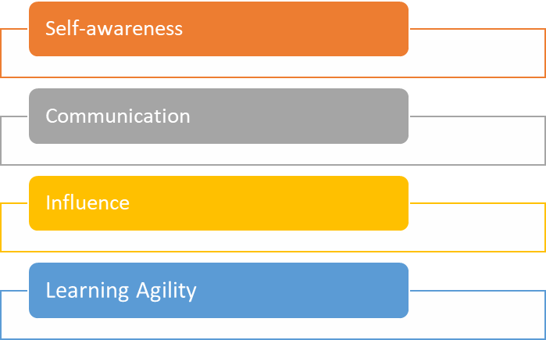

**Let’s explore each one in more detail:**

**Self-awareness**

Self-awareness is about understanding yourself: your strengths, your weaknesses, your emotions, your behaviours and triggers of your emotions and behaviours. This also includes knowing your own leaderships styles, communication styles and in general what makes you tick.

How can you become more self-aware?

* Observe your own feelings and question why you feel that way.
* Observe your own behaviours and question why you behave that way.
* Reflect on past experiences, e.g. a discussion with a team member, and identify how you communicated, behaved, and used problem-solving skills during this interaction.
* Ask others for feedback on your behaviour and interactions with others.

**Communication**

Being a good communicator is one of the most important skills as a leader. You need to ensure that your team understands why we do what we do and how it needs to be done.

Your communication must be clear, but part of good communication are also the following skills:

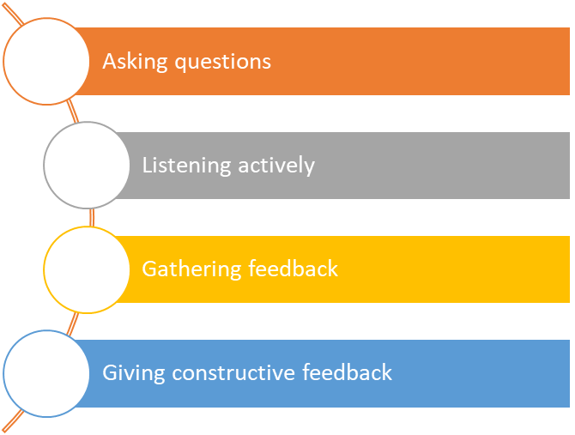

**Influence**

Being able to influence people is critical in the success of a leader, as the purpose of a leader is to lead a team towards a vision. Only if you can influence your team, you will be able to get desired outcomes.

How to gain influence? The most critical factor in gaining influence is trust. Trust must be gained and nurtured. Trust is gained and sustained by:

* Speaking the truth
* Being open and honest
* Showing respect for others
* Treating others fairly and equally
* Admitting your own mistakes
* Putting trust into others
* Valuing other’s ideas and opinions
* Being consistent in your approach
* Helping others

Read more about how to build trust on the following pages on “Building Great Work Relationships”.

**Learning Agility**

Successful leaders are “life-long learners”. This means they are always on the lookout for what could be improved, both in themselves and within their team and team processes.

This is known as Continuous Improvement and is a method of consistent incremental change to bring about big changes.

How can this be done?

The best way to improve, is by learning from mistakes. This first requires that we acknowledge mistakes, are comfortable to admit to them and speak about them, and that we use them as a platform to improve.

Questions need to be asked to investigate the issue and find improvement ideas.

* Why did this happen?
* How often has it happened?
* Where did it happen?
* What could be done to avoid this in the future?

It is crucial that you involve your team in the problem-solving process as they will have many great ideas on how the problem may be solved and prevented in the future.

Center for Creative Leadership. (2017). [The Core Leadership Skills You Need in Every Role](https://www.ccl.org/articles/leading-effectively-articles/fundamental-4-core-leadership-skills-for-every-career-stage/) | CCL.

Video link: Ted Talk: How great leaders inspire action | Simon Sinek

<https://www.youtube.com/watch?v=qp0HIF3SfI4>

This is an informative Ted talk presentation in which Simon Sinek discusses the difference between leaders and those that lead and inspire others.

Published May 5, 2010

Duration 18:34 minutes

Web link: The Importance of Practicing Empathy in the Workplace

[**https://roubler.com/au/resources/blog/empathy-in-the-workplace/**](https://roubler.com/au/resources/blog/empathy-in-the-workplace/)

Empathy is the capacity to comprehend and share another person’s feelings. More than just acting with sympathy, empathy allows us to take a walk in someone else’s shoes, and understand them better as a result. Empathy is a crucial element of every human relationship, and the workplace should be no different. Shared empathy among colleagues and management builds workplace morale. It demonstrates [respect](https://roubler.com/au/respect-in-the-workplace/), and proves a level of care extending beyond the workload. Leaders who display empathy are far more likely to foster a productive and loyal team, and are more highly regarded.

Positive role models are people who others imitate, emulate or look to for guidance. Here are some of the personal attributes of positive role models. They:

* are self-assured and enthusiastic for the job and the organisation
* communicate well and develop rapport with staff
* provide feedback and progress reports
* diffuse personality conflicts when otherwise stable team members are having a ‘bad day’
* are outwardly calm
* bring a sense of ‘team’ versus individual status to the organisation, which improves overall performance
* take a personal interest in staff development
* work through problems, weigh the pros and cons and come to a decision
* apologise and admit mistakes
* follow through
* show respect
* are great learners and challenge themselves to get out of their comfort zones
* are humble
* have exemplary habits that inspire others to improve themselves in life
* have a sense of integrity with strong values.

Video Link: How can leaders learn empathy? | Q+A

<https://www.youtube.com/watch?v=8Yrmopm5Npc>

Simon Sinek discusses how empathy is a learnable skill and the importance of abandoning the theories of the 80's and 90's and start putting the needs of people first.

Published: October 4, 2019

Duration: 6:06 minutes

1. Plan team outcomes

The purpose of a team is to support the organisations strategic vision, goals, and plans. Those can be identified from your workplace vision statement and Strategic Plan

* 1. Identifying common objectives, responsibilities and outcomes

The organisations strategic goals are cascaded down to all levels of the organisation through measurable department and team goals.

As a result, if every team is aligned and working towards achieving their goals, then the organisation as a whole will achieve theirs**.**

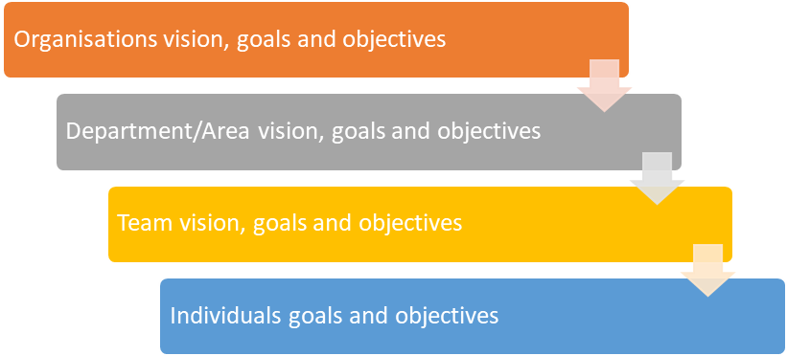

**Team goals** can be further broken down into individual’s goals. This is often done through action plans, whereby tasks are allocated to individual team members.

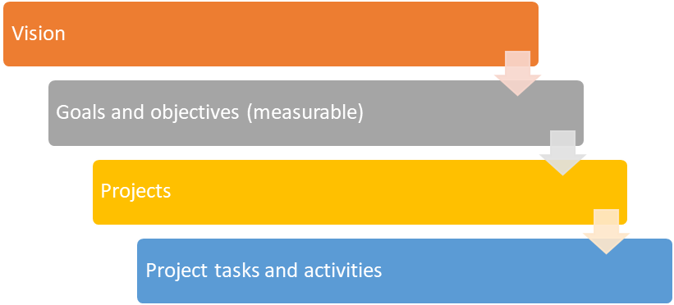

1What gets measured gets done

**Key Performance Indicators (KPIs)** are the critical (key) indicators of progress toward an intended result. KPIs provides a ***focus for strategic and operational improvement***, create an ***analytical basis for decision making*** and help ***focus attention on what matters*** most.

KPIs help to cut the complexity associated with ***performance tracking*** by reducing a large amount of measures into a ***practical number*** of 'key' indicators.

KPIs can be used to track the operational performance of departments, projects or ***individuals against targets*** ***or goals***. They can provide a management tool for ***gaining insight*** and decision making.

**Operational KPIs**

Operational KPIs clearly articulate detailed and timely information that is used to make day to day decisions or take corrective actions on performance or a process.These KPIs are usually complex in nature as they use formulas with data from multiple sources.

**Strategic KPIs**

Strategic KPIs are focused on long term objectives derived from an organisation’s goals**.** They help identify if a strategy is working and if it is on target. As such these KPIs are sometimes referred to as High Level KPIs.

Set performance expectations

Managers should establish and communicate (verbally and in writing) ***clear, detailed goals*** and ***performance*** ***expectations*** to their staff. Performance goals and expectations are different from the duties and responsibilities included in the job description.

***Performance expectations describe*** how the assigned duties and responsibilities should be performed.

***Performance expectations focus*** on the end results desired and help the staff member understand the level of achievement expected.

**Measuring performance** in the workplace must be based on the overall organisational strategy, then made relevant to the individual in their context – their job role (position description) and their team (program).

**Some examples of documentation:**

* Strategic plans
* Performance standards (*can include KPI ‘s*)
* Position descriptions
* Individual work goals
* Team objectives
* Targets- can be financial – consider numerical (*things you can measure by numbers*)

Video Link : How to create a performance management system for organisation

<https://www.youtube.com/watch?v=8ijBfprUNuQ>

This video provides information on how to create a performance management system, or a management control & reporting system (MCRS, LDMS) in your organisation. This animated video provides extensive information on taking a customer centred approach, developing KPI, reporting back information from the team and working towards people working with their strengths and talents with clear understanding about roles and responsibilities.

Published: Mar 28, 2014

Duration 7:32 minutes

* 1. Establishing expected outcomes, goals, and behaviours for individual team members

### Governance Rules, Policies and Procedures

For you and your organisation to manage teams and work effectively and efficiently, standard ground rules, policies and procedures need to be defined for a range of processes including:

* Consultation
* Communication
* Feedback
* Issue Management

What are Governance Rules?

Rules are the authoritative statements or guides for conduct and action that tell us what to do or not do in a specific situation. They tell us, for example, how people should behave towards each other, work together, communicate, and make decisions, and what to do when things go wrong.

**Governance rules set out the framework and ‘ground rules’ for:**

* who has the authority to make decisions, and about what
* how decisions should be made
* who can talk on behalf of others
* how people are to be accountable
* what obligations there are between leaders and their members

The rules of governance can be either formal or informal.

**Formal governance rules include such things as:**

* business codes, charters, or constitutions
* dispute resolution processes
* formally adopted governing procedures and manuals
* performance appraisal criteria
* policies and regulations
* strategic plans
* written codes and laws

**Informal governance rules include such things as:**

* the shared cultural understandings within a group about how authority should be organised and used
* people’s shared values, beliefs, and customs
* behavioural standards and taboos
* gender norms
* moral stories, kinship rules and ceremonial rules

**toolkit.aigi.com.au.** [6.1 What are governance rules?](https://toolkit.aigi.com.au/toolkit/6-1-what-are-governance-rules) **| Indigenous Governance Toolkit.**

What is a Procedure?

A procedure outlines a series of steps to achieve a desired result. Procedures explain how to accomplish a task and is often developed in support of an overarching Policy.

For example,

A Policy may stipulate that performance management must be conducted in an un-biased and culturally sensitive way. A procedure will outline the steps to take to ensure this is achieved, e.g. by using a set of forms, templates, formulas, etc.

What is a Policy?

Policies are the big-picture guidelines that set out, in clear language, what an organisation wants to achieve (such as its long-term vision and goals), and the performance standards and outcomes expected.

They provide the overarching framework under which procedures are then designed to get those big-picture things done.

In any organisation, some policies specifically focus on governance; others address operational, administrative and HR matters.

But whatever the type, in all cases, the final policies must be formally approved by the governing body.

Only decisions made by the governing body as a whole are binding.

Put simply, the governing body develops policy and management implements it.

**toolkit.aigi.com.au.** [6.4 Policies for Organisations](https://toolkit.aigi.com.au/toolkit/6-3-policies-for-organisations) **| Indigenous Governance Toolkit.**

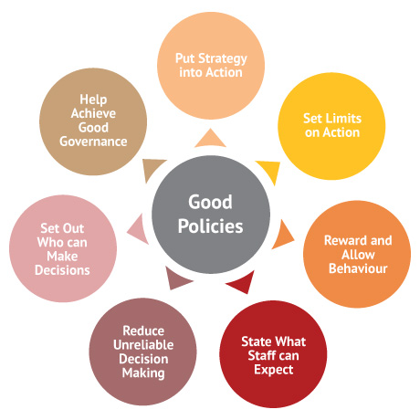

**Image: toolkit.aigi.com.au.** [6.4 Policies for Organisations](https://toolkit.aigi.com.au/toolkit/6-3-policies-for-organisations) **| Indigenous Governance Toolkit.**

**Tips for making and reviewing policies**

A policy usually contains:

* A purpose statement. This outlines why the organisation is issuing the policy and what it should achieve.
* An applicability and scope statement. This describes who the policy affects and what will be affected by the policy. This statement may include or exclude certain people, organisations, behaviours, or activities from the policy requirements.
* An effective date. This states when the policy begins.
* A policy statement. This sets out the specific guideline, regulation, requirement, or modification to people’s and organisational behaviour that the policy is trying to encourage.
* A review and evaluation statement. This explains when and how the policy will be assessed.
* A complaints statement. This sets out the process for how complaints about the content of the policy will be handled, its implementation or impact.
* A communications statement. This talks about how the policy will be communicated to staff, members, the wider community.
* A roles and responsibilities section. This states which people or sections of the organisation are responsible for carrying out particular parts.
* A definitions section. This provides clear meanings for terms and concepts.
* A cultural issues statement. Many Indigenous governance policies contain extra sections setting out cultural issues, goals, values, and traditions that the policy recognises and is supporting, protecting, regulating, or limiting.

To increase the effectiveness and legitimacy of policies, many Indigenous organisations are also including a cultural enforcement statement in their policies. This sets out practical processes and mechanisms that the governing body has identified as something that might help the governing body, management, and staff to implement the policy in the face of challenging cultural pressures.

**toolkit.aigi.com.au.** [6.4 Policies for Organisations](https://toolkit.aigi.com.au/toolkit/6-3-policies-for-organisations) **| Indigenous Governance Toolkit.**

**What about workplace policy?**

Workplace policy is a statement, which underpins how human resource management issues will be dealt within an organisation. It communicates an organisation’s values and the organisation’s expectations of employee behaviours and performance. Workplace policies often reinforce and clarify standard operating procedure in a workplace. Well-written policies help employers manage staff more effectively by clearly defining acceptable and unacceptable behaviour in the workplace, and set out the implications of not complying with those policies. Not all workplace issues require a policy. Many routine matters can be dealt with through simple workplace procedures and processes being put in place.

**Benefits of having workplace policies**

Well-written workplace policies:

* are consistent with the values of the organisation
* comply with employment and other associated legislation
* demonstrate that the organisation is being operated in an efficient and businesslike manner
* ensure uniformity and consistency in decision-making and operational procedures
* add strength to the position of staff when possible legal actions arise
* save time when a new problem can be handled quickly and effectively through an existing policy
* foster stability and continuity
* maintain the direction of the organisation even during periods of change
* provide the framework for business planning
* assist in assessing performance and establishing accountability
* clarify functions and responsibilities

**Types of workplace policies**

Here are some examples of common workplace policies that could assist a workplace:

* recruitment policy
* workplace cultural and diversity policy
* organisational reputation policy
* internet and email policy
* mobile phone policy
* non-smoking policy
* health and safety policy
* anti-discrimination and harassment policy
* grievance handling policy
* discipline and termination policy
* using social media

**https://www.industrialrelations.nsw.gov.au** [6.4 Policies for Organisations](https://www.industrialrelations.nsw.gov.au/employers/nsw-employer-best-practice) **| Workplace Policies and Procedures Checklist.**

**Negative Impact of Organizational Culture**

In a healthy organisation, the impact of organizational culture on employee performance will be positive. Employees recognize that they are valued and appreciate the work environment, so they're ready to give their best effort. A negative culture has the opposite effect:

* An organizational culture that does not value quality work give the employees no reason to aim for excellence at work.
* A culture that tolerates bad behaviour gives other employees the rights to behave the same way.
* Unhealthy organizational culture leaves employees feeling unhappy, with decreased motivation to commit to their roles and responsibility
* An unpleasant culture can increase employee turnover because nobody wants to work in an environment with poor morale. If the culture becomes known outside the company, it may become harder to attract new workers too.
* The organisation may lose client

examples Real LiFE workplace policies

Refer to MP Tech Solution Profile.docx

Diversity and Ethical Values

We have already discussed previously how you can establish trust within your team. Refer to the topic “Core Leadership Skills”.

This is also a process that you can standardise, and not just for you but by agreeing on team ground rules, for all team members, not just yourself.

This will set out the behaviours that:

* should be used and
* those that will not be tolerated.

This should include rules related to:

* Adherence to cultural diversity policies and procedures of the organisation
* Adherence to ethical values of the organisation
* Adherence moral principles (e.g. speaking the truth, not lying)

:

Activity 1: Workplace diversity policies and procedures

Access and review your workplace diversity policies and procedures.

Document below, guidelines provided that relate to the way you and anyone else in the organisation should communicate and behave in a culturally and socially appropriate way that protects each individual’ rights to equality and cultural freedom.

|  |
| --- |
|  |

Activity 2: Workplace ethical values

Access and review workplace documentation that states your organisation’s ethical values. You may find this in your organisations guiding principles and code of conduct. You are likely to find this information on or organisations website in the ABOUT tab.

Document below your organisation’s ethical values.

|  |
| --- |
|  |

You will be required to “translate” the organisational procedures and values into “team-based” procedure, rules, and values.

For example:

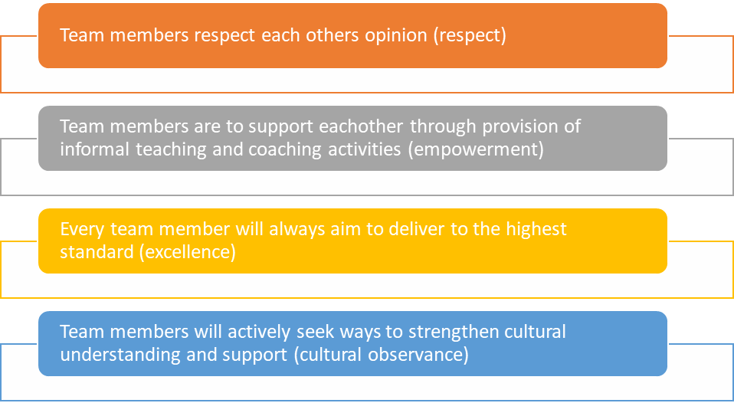

Professional Conduct

Professional conduct is critical in the workplace. As a leader, professional conduct is particularly important, as it will develop trust and confidence of your team members and anyone else you are dealing with, e.g. customers and suppliers.

Part of professional conduct is:

* Following workplace policies and procedures, e.g. communication, diversity, consultation, etc.
* Following agreed team-based standards and procedures, e.g. team ground rules
* Being polite and approachable (not angry, frustrated, disgruntled)
* Treating everyone with respect, courtesy, and fairness
* Doing what you say you will do (e.g. sending a response by 2pm if this is what you promised)
* Complying with the law
* Taking reasonable steps to avoid conflicts of interest and report those that cannot be avoided
* Acting with care and diligence while at work
* Not making improper use of one’s position

Often professional conduct standards are documented in the organisations **Code of Conduct & Ethics**.



Image: Picserver.org. (2020). [Ethical](https://www.picserver.org/images/highway/phrases/ethical.jpg). Copied and shared under Creative Commons Licence [CC BY-SA 3.0](https://creativecommons.org/licenses/by-sa/3.0/)

Code of Conduct

A well-written code of conduct clarifies an organization’s values and principles, linking them with standards of professional conduct. The code of conduct articulates the values the organization want to foster in leaders and employees and, in doing so, defines desired behaviour. As a result, written codes of conduct or ethics can become benchmarks against which team members and organizational performance can be measured.

**Organisational Culture and Reputation**

Organizational culture refers to a company's mission, objectives, expectations and values that guide its employees.

Organisational culture is a system of shared assumptions, values, and beliefs, which govern how people behave in organizations. It includes an organization’s expectations, experiences, philosophy, and values that hold it together and is expressed in its self-image, inner workings, interactions with the outside world, and future expectations. It is based on shared attitudes, beliefs, customs, and written and unwritten rules that have been developed over time and are considered valid. These shared values strongly influence the people in the organization and dictate how they dress, act, and perform their jobs

Businesses with an organizational culture tend to be more successful than less structured companies because they have systems in place that promote employee performance, productivity and engagement. Having a strong company culture motivates everyone to do their best work.

Organisation Culture is important because of the following reasons.

**Increased employee engagement**

A work environment that possesses organizational culture is driven by purpose and clear expectations. This motivates and inspires employees to be more engaged in their work duties and interactions with others. It also leads to high levels of workforce engagement, which drives productivity. Having a strong connection to an organization and its people creates an atmosphere of positivity that is hard to ignore.

**Decreased turnover**

People who feel valued and respected at a company are less likely to leave it. That's why it's essential for brands to foster a winning organizational culture that supports their core values and mission statement. Happy employees mean less turnover, which saves companies time and money in the hiring process. Companies that achieve a strong culture must take steps to maintain and improve it.

**Elevated productivity**

When employees have the resources and tools they need to succeed, it helps increase productivity and performance levels overall. Organizational culture impacts the structure of a workplace in ways that bring people of the same skill set together. Those who share similar backgrounds and skills may work more quickly together when tackling company projects.

**Strong brand identity**

A company's organizational culture represents its public image and reputation. People make assumptions about businesses based on their interactions within and outside of the company. If it lacks organizational culture or has a weak image, customers may hesitate to do business with anyone who is associated with the brand. Businesses with a strong brand identity tend to attract more business and job candidates with similar values who support their mission.

**Transformational power**

Not all businesses have the power to transform ordinary employees into total brand advocates, but those with a strong organizational culture do. Companies that recognize their employees' efforts and celebrate team successes are more likely to notice a change in employees as they experience a sense of accomplishment.

**Top performers**

Companies that promote community in the workplace are more likely to retain their best employees. People who are great at their jobs and know the value of their skills commonly leave negative work environments where they feel undermined and unappreciated. Organizational culture builds a high-performance culture that strengthens the work of people within the company, resulting in a positive employee experience overall.

**Effective on boarding**

More and more, businesses with an organizational culture are relying on effective on boarding practices to train new hires. On boarding practices that include orientation, training and performance management programs help new employees access the right resources and better transition into their roles. This promotes employee longevity and loyalty and reduces the amount of frustration some employees experience when they don't have the information needed to do their job well. On boarding is a great way for companies to ensure new hires understand the core values of their business.

**Healthy team environment**

Organizational culture helps improve workflows and guides the decision-making process. It also helps teams overcome barriers of ambiguity. Team members who are informed and knowledgeable about certain processes are often more motivated to finish projects. Having a clear culture that unifies employees and promotes organized work structures helps people work together with purpose.

LEGISLATIve REQUIREMENTS

Legislative Requirement means Acts, ordinances, regulations, subordinate legislation, by-laws, orders, awards and proclamations and delegated legislation (whether national, state, territory or local) applicable where the Subcontractor's Activities or any part thereof are being performed.

By complying with relevant legislation, both employers and their staff members can ensure that their hiring processes, dismissal processes, and their workplace as a whole, are fair for every individual. Employment law also helps us combat discrimination, and effectively promote equality at work.

Successful employers ensure that their workplaces are free from discrimination, sexual harassment and bullying.

**Workplace Law**

In Australia some of the relevant workplace legislative requirements includes-

1. Fair work Act 2009 [ <https://www.legislation.gov.au/Details/C2017C00323>]
2. Equal Opportunity Act 2010 [https://www.legislation.vic.gov.au/in-force/acts/equal-opportunity-act-2010/020]
3. Workplace Gender Equality Act 2012 [https://www.legislation.gov.au/Details/C2016C00895]
4. Privacy Act 1988 [http://www8.austlii.edu.au/cgi-bin/viewdb/au/legis/cth/consol_act/pa1988108/]
5. Occupational Health and Safety Act 2004 [ <https://www.legislation.vic.gov.au/in-force/acts/occupational-health-and-safety-act-2004/034>]
6. Workplace Injury Rehabilitation and Compensation Act 2013 [https://www.worksafe.vic.gov.au/workplace-injury-rehabilitation-and-compensation-act-and-regulations]

Source : https://www.humanrights.vic.gov.au/legal-and-policy/legal-resources/

### Establish Team / INDIVIDUAL PERFORMANCE Plan

In order to support organisational objectives, your team needs to be aligned in their activities. As discussed earlier on, strategic goals need to be cascaded down to each individual of the organisation.

Once you have identified from your organisations strategic plan what the vision, goals, plans, and objectives are, then you can identify together with you team, which team-based goals, plans, and objectives can support those high-level strategic goals.

Activity 3: Identify Strategic Goals

Access your organisations strategic plans and identify the organisation’s short, medium, and long-term goals.

|  |
| --- |
|  |

Ensure to define aligned team goals in consultation with your team, using defined consultation processes and procedures. Your team will be a great source of ideas and also a good gauge on how achievable some of the ideas may be.

It is important that you document agreed plans and how they align with the organisation’s strategic goals. Use a **Team Performance Plan** to document and plan the activities.

A Team Performance Plan needs to identify:

* Organisation’s strategic goals, plans, and objectives
* Aligned team’s strategic goals, plans, and objectives
* Measurable Key Performance indicators to track progress and gauge success
* Action Plan, including responsibilities (who is implementing it) and due dates (by when)

Key Performance Indicators (KPIs)

KPI is a type of measure that is used to evaluate the performance of an organization against its strategic objectives. KPIs help to cut the complexity associated with performance tracking by reducing a large amount of measures into a practical number of 'key' indicators.​

KPI that measure team performance are usually linked to the following:-​

* Budget and spending​
* Absenteeism​
* Wastage​
* Time taken​
* Employee turnover​
* Disruption / Downtime​
* Employee morale

An example of KPI

Measurable targets are crucial in being able to track progress. Imagine we set a goal to “speed up the process”. What does that mean? By how much? How fast is it now? How fast should it be?

This is a very unclear target and is unlikely to drive improvements effectively.

Instead the target should read:

*Reduce the current time it takes to process […] from 3 days to 2 days by 10/10/2020.*

Web Link: Key Performance Indicator

<https://www.klipfolio.com/resources/articles/what-is-a-key-performance-indicator>

This site provides additional information about what is a KPI and how to measure performance against key business objectives.

Setting SMART Goals

Ensure that all team goals are using the SMART Technique.

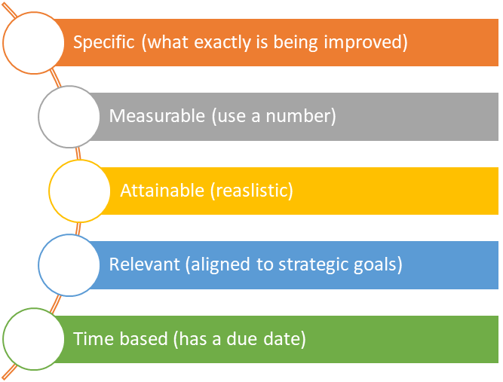

**Consensus**

Consensus refers to everyone in the team agreeing to a plan.

Ideally team performance plans are developed in a way that everyone agrees with the goals and plans. If so, then this will ensure maximum buy-in and provide a much higher chance for success.

Strategies you can use for gaining consensus amongst your team include:

* Allowing sufficient time for decision making for individuals and as a team, not rushing the process of coming to a mutual agreement
* Providing opportunities for every individual in the team to explain their point of view to the group
* Exploring ideas as a team where everyone can contribute their ideas
* Gathering all facts (e.g. pros, cons of each idea) and making sure everyone has all the information to make an informed decision
* Asking everyone to agree or disagree to the plan
* The planning continues until everyone agrees to the plan

Performance Plan​

Performance Plan refer to individual performance plan linked to team goals or to team plans based on work assignment and responsibilities. Performance plan includes

* Goal/objectives​
* Expected outcomes / Key Performance Indicator
* Strategies for Accountability ​
* Results Achieved
* Comments
* Competency & Related Expectation
* Behaviours & Actions
* Competency Gap
* Summary of Performance ​

**Measuring Performance**

The team collectively agree on the KPIs that will be used to measure each objective and then ascribe a standard that must be achieved. Example: the prototype will have 100% functionality and be capable of operating for a minimum of 10 minutes. Performance goal creates a sense of urgency and challenge each member of the team to commit themselves

**Individual Performance Plan**

|  |  |  |  |  |  |  |  |  |  |  |  |  |  |  |  |  |  |  |
| --- | --- | --- | --- | --- | --- | --- | --- | --- | --- | --- | --- | --- | --- | --- | --- | --- | --- | --- |
| **Individual Performance Plan Form** | | | | | | | | | | | | | | | | | | |
| **Member Name** | | |  | | | | | | | **Supervisor Name** | | | | | |  | | |
| **Plan Period** | | | **From** | | | |  | | | **To** | | | | | |  | | |
| **Work Plan** | | | | | | | | | | | | | | | | | | |
| **Objectives / purpose / goal of workplace team** | | | **Expected Outcomes / Key Performance Indicators** *(Describe the results expected and how they be will assessed]* | | | **Deadline / When is it due** | | | | **Accountability Strategies** | | | | **Result Achieved**  *( Yes / No – to be filled in based on the due date specified in KPI*) | | | **Comments** | |
|  | | |  | | |  | | | |  | | | |  | | |  | |
|  | | |  | | |  | | | |  | | | |  | | |  | |
|  | | |  | | |  | | | |  | | | |  | | |  | |
| **Competency Objectives** | | | | | | | | | | | | | | | | | | |
| **Competency & Related Expectation**  *(Competencies refers to knowledge, skills and attributes [either technical or behavioural) that are important to demonstrate in order to perform the work objective effectively.* | | | | | **Behaviours / Actions**  *( Provide examples of behaviours or action that show how this competency level has been achieved )* | | | | | | | | **Competency Gap** | | | | | |
|  | | | | |  | | | | | | | |  | | | | | |
|  | | | | |  | | | | | | | |  | | | | | |
|  | | | | |  | | | | | | | |  | | | | | |
|  | | | | |  | | | | | | | |  | | | | | |
|  | | | | |  | | | | | | | |  | | | | | |
| **Summary of Performance – Supervisor Comments** | | | | | | | | | | | | | | | | | | |
|  | | | | | | | | | | | | | | | | | | |
| **Assessment Scale** | | | | | | | | | | | | | | | | | | |
| **Does Note Meet Requirements** | | **Meets Some Requirements** | | | | | | **Fully Achieves Expectations** | | | **Exceeds Expectations** | | | | | **Outstanding** | | |
| *Performance does not meet requirements and timely significant improvement is required, as identified in the performance plan*  ❑ NM | | *Some results were achieved but not all. Gaps with expectations have been identified in the performance assessments.*  ❑ DV | | | | | | *Results, quality of work and contributions to positive work environment were fully achieved*  ❑ AE | | | *Results, quality and contribution to a positive work environment exceeded expectation in most cases*  ❑ EE | | | | | *Results, quality of work, and contribution to a positive work environment, exceeded expectations in all cases. Influence and contribution extended to the organisation as a whole.*  ❑ OS | | |
| **Planning Meeting** | | | | | | | | | | | | | | | | | | |
| **Team Member Signature** |  | | | **Date** | | |  | | **Supervisor Signature** | | |  | | | **Date** | | |  |
| **Review Meeting** | | | | | | | | | | | | | | | | | | |
| **Team Member Signature** |  | | | **Date** | | |  | | **Supervisor Signature** | | |  | | | **Date** | | |  |

* 1. Strategies to support team members to be accountable

Accountability

Accountability is the obligation or willingness to accept responsibility for our own action. Accountability takes place when a worker reliably deliver on their commitments, showing others they can be trusted to do what they say they’ll do. It is demonstrated by taking responsibility for the outcome of the actions and decisions and successfully transforming effort into results.

**Responsibility VS Accountability**

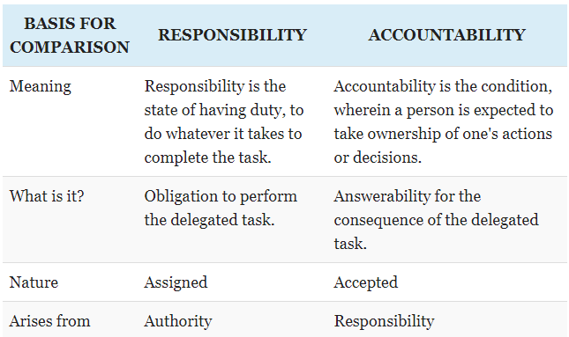

Source : <https://keydifferences.com/difference-between-responsibility-and-accountability.html#ComparisonChart>

### Hold Team Members responsible and accountable

Another important team morale booster is when each team member is putting in an effort to achieve the team goals. There is nothing more demotivating than when a team member does not pull his/her weight, and even worse yet, when this is tolerated by the team leader. So, it is paramount that you hold team members accountable and responsible for their agreed tasks.

You can do this by putting policies and procedures in place that outline how each individual’s performance will be measured and managed. For instance, in addition to holding a weekly team meeting to review the progress on team goals, you can also hold a performance review with each individual of your team to review their progress against their individual targets, e.g. a specific tasks they are meant to implement by a certain date as per action plan. Because this meeting is held in private with the individual, it allows you to discuss individual performance issues, that you should not discuss within the team environment.

You can then develop plans and actions to help the individual to improve their performance, which may include formal and informal training, coaching or changes to the individuals work role.

A simple procedure to manage an individual’s performance may look like this:

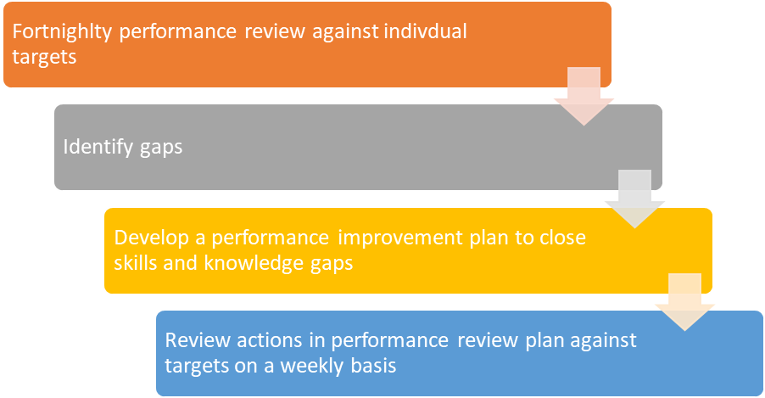

**Strategies to support team members**

Offering support and assisting team member with skills issues:

* Coaching
* Mentoring
* Training and development opportunities
* Long term and short team plans
* Meeting / Brainstorming ideas
  1. Plan for contingencies that could impact the team

Contingency Plan

Risk management is the process whereby an organisation weighs the costs of activities against the benefits. Contingency planning is an integral part of an organisation’s risk management. In all of life’s activities, there is an element of risk—physical and psychological. So it is also with organisations and their operations. Risk management processes enable organisations to identify potential risk situations, to analyse the dimensions of the risk and to assess the organisation’s capacity to cope with and/or manage that risk. They enable functions and processes to be put in place to compensate for situations in which either internal or externally generated conditions might cause interruptions to operations and/or have a destructive impact on service continuity

They are important to management plans in all environments and circumstances. The time critical nature of community service operations requires backup plans to enable quick reaction to operational failures or changes in the social or physical environment. Environmental scanning (internal and external) is the process by which organisations generate comprehensive analyses of risk factors.

Contingency and backup plans should be incorporated into the entire organisation’s planning processes, and should identify flexible options, adaptable to specific situations. It is not possible to foresee every possible contingency; therefore, flexibility and adaptability become the keystone of effective contingency management. It is necessary to consider what might go wrong—worst-case scenarios—and be prepared if such events do occur. Events could involve things like staff shortages, lack of response to volunteer recruitments, massive power shutdowns, cash flow shortages or funding anomalies etc.

Plans should address several broad areas where system or other failures, might affect the ability to deliver products/ services effectively according to the standard plan.

Other contingency needs might relate to:

* materials resources shortages caused by particular materials or equipment not arriving on schedule or general logistics failures and disruptions in transport, mail or communication systems, or even by theft
* staffing changes or shortages; e.g. staff failing to report for duty, or experienced staff leaving to work for other organisations at short notice
* machinery and equipment failure; e.g. maintenance, breakdown and obsolescence problems
* health and safety; e.g. safety issues, legislative changes, accidents which interrupt work
* severance of communications links (technological or personal); eg worker conflicts, inability of computer systems to perform to expectations, loss of power or other environmental impacts which affect communication
* physical or social environment disasters which might include fire, flood, earthquake, social upheaval, or other disturbances
* emergency situations such as fire

Contingency plans should identify issues of:

* the nature or potential of the contingency
* the operational impacts of the contingency
* the feasible responses
* the financial implications of the responses
* the likely effects on other processes in the organisation

Web Link: Business Contingency Plan

<https://creately.com/blog/business/business-contingency-plan-templates/>

This site provides additional information about what is writing a Business Contingency Plan.

typical workplace contingencies that can impact teams:

1. **unplanned leave or absence of workers**

This is a scenario where workers call in sick during the last minute of their work hours /day. It not only impacts the remaining members with risk of giving the others more work to complete, but also delay the project.

Web Link: 5 ways to deal with unplanned absences

<https://www.saviom.com/blog/project-managers-manage-unplanned-leaves/>

This site provides additional information on how to deal with unplanned absences.

1. **re-allocation of work tasks**

This situation arises where unplanned absence cause the work to delegated to other members of the team and it leads to overload of work.

Ways to overcome : To provide a realistic timeline for task considering that members might have to take over another team member’s task. We could also hire more during a peak period to handle additional work.

1. **succession planning for important team roles**

Succession planning is the process whereby an organization ensures that employees are recruited and developed to fill each key role within the company. In this process, you ensure that you will never have a key role open for which another employee is not prepared. Success planning can be risk if it is carried out poorly when the person in charge is not informed.

Web Link: 7 tips for effective succession planning strategy

<https://www.sagepeople.com/about-us/news-hub/succession-planning-strategy-effective/>

This site provides additional information to carry out an effective succession planning strategy.

1. Coordinate team and individuals

Coordinating or achieving unity of effort refers to all actions taken by managers leading to the achievement of results by a number of different people. Good coordination can be achieved by getting people to work well together. This means integrating their activities, communicating well, displaying leadership and team building.

Coordination is crucial because it balances inequalities and restores teamwork. Through coordination, we enforce teamwork and achieve the goal of the organisation.

* 1. Communicate common team objectives and responsibilities to team members

Effective communication in the workplace is important to ensure that the team objectives and responsibilities are fully understood by all team member. When you communication well with your team, it will enhance the coordination between team members and allow team member to get the work done on timely manner.

### Communication method

**Open Meeting**

It is easier to communicate your passion and how you feel to your team via open meetings. In this kind of forum, they will not only hear what you are saying, they will also see and feel it. This approach remains one of the best approaches to communicate effectively with a team.

**Emails**

In official settings, communication via email remains potent. It will enable you to pass messages to members of your team without pulling them out of their workstations.

**One to One**

Experts have been able to prove that some people understand better, when you take them aside and talk to them on a one-on-one basis. Ensure that you maintain eye contact with them to enable the message to sink in.

**Communication via Training**

Your training should be tailored towards communicating certain information to your team members. Most employees take training serious, especially when it is part of their appraisal.

### Communication Tools

**Display Confidence and Seriousness**

Ensure that you display confidence and seriousness to ensure that you will not be taken for granted. When your team members notice any uncertainty and lack of seriousness when you are communicating with them, they are likely to treat the information with disdain or disregard.

**Use Simple Words**

The truth is that not everybody can be on same page when it comes to vocabulary. Therefore, to be effective in your communications with your team members, use words that can be easily understood. When ambiguous words are used, you can be misunderstood and/or waste precious time having to explain yourself.

**Use Visuals**

Place visuals at strategic positions around the workstations of your team. They should not just hear the message, they should also see it. This gives room for better comprehension.

**Listen to Your Team Members**

Communication is intended to be a two way street. Do not just talk because you are the leader without listening to anyone else. Encourage them to open up so you can be well guided when communicating in the future with them. You have two ears and one mouth –so you must listen more than you speak.

**Use Body Language**

Your body language will pass your message faster and better. Master the art of using body language when communicating with your team. Stand/sit up straight, use smiles, handshakes and eye contact.

**Use the Appropriate Tone of Voice**

One word can mean a different thing when said in a different tone of voice. Make sure you use the appropriate tone of voice to communicate your message to your team so that you will not be misunderstood and discourage or demotivate members or cause them to shut down completely out of fear.

A**void Unnecessary Repetition**

If you want your team members to take you serious, never sound like a broken record and do not beat a dead horse. Tell your team members what you want them to know or do and ask them if they are clear about it. If they are not, only then do you repeat what you have said.

**Use Presentations**

Some people grasp messages easily when pictures and sounds are involved. Using presentations like Microsoft PowerPoint to communicate with your team will give them the opportunity to refer back to it if they aren’t clear about certain things.

**Be Humorous**

Using friendly jokes when communicating with your team members will help pass your message along in a more relaxed way. This method of communication has been proven a highly effective way of dousing tension. When the atmosphere is unfriendly and intense, being humorous does the trick. If you must use jokes, please don’t overdo it. Remember, you are not a stand-up comedian.

**Be Articulate**

Communication is indeed a skill that must be learned by all, especially if you want to lead any group of people. Being articulate when you communicate to your team members makes it easier for them to understand your message.

**Encourage Feedback**

Do not just talk and walk away. Give room for feedback so that you can measure the effectiveness of your style of communication. It will also afford you the privilege of knowing if your message was well understood.

**Gesticulate**

Use your hands to demonstrate your message. Make hand motions and signals to establish the seriousness of your subject matter when communicating with your team members. This shows that you understand what you are trying to relay to them. Just do not let your body movement become too exaggerated and intense.

Source : https://smallbiztrends.com/2013/11/20-ways-to-communicate-effectively-in-the-workplace.html

### Team Cohesion

Cohesiveness refers to the bonding of group member or unity, feeling of positive attraction and want to remain part of the group .Team cohesion is a critical element for your team to work effectively and efficiently. A cohesive team corporate well, communicates effectively and supports each other.

Factors that promotes group cohesiveness includes agreement on group goals, frequency of interaction, personal attraction (personality), inter-group competition and favourable evaluation

This behaviour however is based on trust in each other which must be gained over time and maintained as discussed earlier in this resource.

You can do your part to foster team cohesion by:

• Forming a team based considering their individual personality styles and current relationships (avoid putting individuals together that don’t get along if it can be avoided)

• Set ground rules for team interactions to avoid conflict

• Align the team through documented team performance plans so each person understands their role and the common goal to be achieved

• Take prompt action if you observe inappropriate behaviour amongst team members (e.g. using inappropriate language, including body-language)

• Continuously rewards your team member for their efforts so far, and continue to motivate them to continue the good work

• Encourage their feedback and input into decisions to be made

• Facilitate positive and productive conversations amongst your team members through regular meetings

**GroupThink**

* Highly cohesive group may also be more vulnerable to groupthink
* Groupthink occurs when members of a group consensus in a decision making
* Groupthink results in careless judgments, unrealistic appraisals of alternative courses of action, and a lack of reality testing.

Strategies to facilitate team cohesion

* Ensure team have clear goal and mutual understanding of how to achieve the goal
* Establish a good structure of the team
* Ensure that each member know the roles and responsibilities
* Development of policies and procedures which encourage or mandate participation

**Other Strategies to facilitate team cohesion**

* Ask for input and make time to listen
* Engage it reflective listening
* Greet employees when you see them
* Get to know team members beyond the role
* Provide forum for information and opinion exchange
* Establish eye contact and pay attention
* Recognise employees for their contribution
* Schedule regular times for small meetings
* Mentoring and ‘buddy’ system to support team members in providing input
* Training and development activities
* Holding regular meeting
* Make time to appreciate others
* Celebrate success
  1. Task Allocation based on staff expertise or developmental potential and provide instructions

### Team Leader

A Team Leader is responsible for getting the best performance out of their team possible through delegation (allocation of task), reward and coaching. A team leader is someone who oversees the functionality of a work group by providing guidance and instruction. These individuals can have many roles, including:

**Manager or supervisor**: Responsible for overseeing all activities within a team.

**Strategist**: Responsible for deciding how to approach tasks and develop a plan to accomplish them.

**Communicator**: Responsible for distributing information to team members and stakeholders.

**Organiser**: Responsible for keeping track of and structuring various tasks, employees and documents.

**Goal setter**: Responsible for determining the goals that members will work toward.

Each role includes responsibilities that can overlap with others. For example, a manager and communicator both include discussing strategies with a team and giving verbal directions to complete tasks.

Team leader responsibilities

Responsibilities of a team leader include decision-making, coaching, mentoring, developing the team’s skills and managing conflict. Learning these important team leader skills is an ongoing process that requires regular practise and use. Here are five important responsibilities of a team leader:

**1. Coach team members**

An effective team leader coaches members on achieving goals and developing necessary skills that get results. Coaching involves developing team members’ performance, offering feedback and demonstrating the desired skills and expected work ethic. A coach-style team leader works alongside its members to develop their skills.

**2. Develop team strengths and improve weaknesses**

It is also the responsibility of the team leader to identify the team’s strengths and weaknesses. By determining which team member excels at which task, you can delegate the required tasks to the appropriate person. It’s also helpful to determine areas of opportunity and the appropriate steps to improve on them.

**3. Identify team goals and evaluate team progress**

In order to measure team success, it’s important to identify what success means. Evaluating goals and determining how the team will measure success can prevent miscommunication. This also gives team members a clear understanding of what they are expected to complete. Setting clear team goals and evaluating progress along the way allows teams to work collaboratively.

**4. Resolve conflict**

Because teams are made up of different personalities, work traits and motivations, conflict can sometimes occur. The team leader is responsible for preventing conflict where possible and resolving it when it does arise. By setting ground rules and clearly assigning tasks, you can prevent many sources of conflict. If you notice conflict, it is best to resolve it before it escalates. Meeting with both team members can give you insight into the cause of the issue. Conferring with the members as a team can give everyone the opportunity to come up with a solution that works for both sides.

**5. Organise team initiatives**

Organisation is necessary when there are multiple team members working on a single goal. Individual projects, goals, communications and important documents should remain clear and accessible. It is the responsibility of the team leader to organise team meetings, topics of discussion and the progress toward the goal.

Important traits of a team leader

Because the team leader is responsible for not only managing but also organising the workplace, resolving conflict and planning tasks, the following traits are important:

**Verbal and nonverbal communication skills**: Communication is crucial when working with and leading a team because you will have to communicate with both your team and your supervisors. A team leader communicates in a way that is clear, effective and directive.

**Organisational skills**: Organisation is important when you have multiple team members working on one project. Strong organisational skills will help you monitor progress and keep team members motivated.

**Ability to delegate** **/ Task allocation**: Team leaders must delegate tasks to individual team members. This requires the team leader to trust in the abilities of the team.

**Integrity**: Team leaders should lead by example. A team leader who has integrity is not only more likely to be trusted by their team members, but also will often be respected and appreciated by the team.

**Confident work ethic**: Team members often mimic the work ethic of the team leader. Displaying confidence in the task and the team itself can help to instill confidence in team members.

Source : <https://au.indeed.com/career-advice/career-development/responsibilities-of-a-team-leader>

### Keys to Successfully Allocate Task

As the leader of a high-performing team, how you distribute and balance work across the members of that team is a critical success factor. It needs to be done fairly. Work allocation needs to be done fairly because you want your team to operate on the basis of equality. You want people to work on things they are good at but also that they are excited by. There are five criteria to think about as you think about distributing work.

**1. Priority**

Consider the work’s priority. Priority needs to drive everything. If you have been rigorous in your prioritization process, start at the top of the list and begin allocating work from there. That list should be based on the team’s and the organization’s goals. This has to be the first consideration in terms of how you distribute work. If a project is a top priority and somebody is available to do that work, they should be tasked with that work.

**2. Skill Sets**

Evaluate the skill set of the people who you’re thinking about distributing the work to. If they have the right skill set, you are going to get a high quality result. The product will be something that meets your customer’s needs. This also reduces the likelihood of people failing because you are not giving them work that they do not have the skill set to perform. You are giving them something they can be successful with.

**3. Availability**

The next consideration for allocating work is a person’s availability. All things being equal in terms of priority and skill set, who is free to do the work? Who has the bandwidth? You should not be shifting resources from one project to another when you have available resources to pick up that new project.

If you start shifting resources around between projects when you have available resources elsewhere, you’re going to lose momentum on that first project and that project might fail. Additionally, the people who are on the project are going to be very frustrated. They had the resources they needed and all of a sudden they don’t. It’s going to seem like it was at a whim to just move somebody around. The person who will be most frustrated is the person who has the resource taken off the project they are succeeding on and put onto something new.

**4. Development**

Next, you have to think about the development opportunity this project might present for that person. You should be constantly upgrading your team’s skill set. A way to do that is to give them new work where they’re going to learn new skills. Put them in situations where they’re going to be a little bit uncomfortable. Give them projects where they’re going to have to step up and learn, be taught, and be open to feedback and coaching. That’s how you’re going to take your team to the next level of performance.

**5. Interest**

The last consideration in terms of which person gets the work when it needs to be allocated is does somebody have an interest in performing that particular task? If someone is really interested and passionate about a project, you should let him or her take it on. They are going to be motivated, excited to do it, and hopefully their performance will follow. One caveat here – make sure people do not only gravitate to the work they enjoy doing and they stay away from things that they are not comfortable with. If you let that happen, they are going to end up being pigeonholed and they will be very narrow in their focus.

Source : <https://www.thoughtleadersllc.com/2014/09/5-keys-to-successfully-allocating-work-across-your-team/>

### Lead without dominating

“The key to successful leadership today is Influence Not Authority” – Kenneth Blanchard

* High performing teams have a leader who influence rather than to direct/dominate
* Committed to ensure their personal actions are taken in the best interested of the group
* Serve to bring out the best in all team members, while aiming to achieve team goal
* Provide flexibility and autonomy

Leading VS Dominating

|  |  |
| --- | --- |
| **Team Leading Behaviours** | **Team Dominating Behaviours** |
| Suggesting | Demanding |
| Steering | Directing |
| Asking probing questions | Asking rhetorical and/or closed questions |
| Summarising points of view | Giving own point of view |
| Pointing out consequences | Telling |
| Asking for ideas | Controlling |

### Role MoDEl

A role model manager is one who inspires those who work for him or her, as well as exhibits managerial excellence in many aspects of the business. While having all the traits befitting of a leadership role model is not very common, the seven skills that can help you lead, inspire and garner respect can easily be learned and improved upon.

**1. Present a Positive Attitude**

No one is saying that you are not allowed to have a bad day now and then, but if you can exhibit strength, calm and perseverance even during stressful times and a good, positive attitude overall, you will instill the same within your employees. A positive team will be better able to troubleshoot problems and overcome adversity in the workplace.

**2. Earn and Build Trust**

A role model manager must be trustworthy. Your team will not feel inclined to show you much respect if you aren’t true to your word and honest with your employees. As The Guardian points out, the characteristics, traits and behaviours of an ideal role model are often personal and may change over time.

**3. Exhibit Integrity**

A good manager will make decisions for the betterment of the business as a whole and not just for him or herself. Employees will respect a manager that genuinely cares about the business and those who work within the organization. Give credit where credit is due and take responsibility for your actions.

**4. Lead and Inspire**

A good leader motivates his team rather than criticizes them and strives to inspire team members to reach their full potential. Keep in mind that leadership role models don’t come to lead overnight. Audit your skills and habits. What do you need to develop? Harvard Business Review suggests acting as an “organizational anthropologist.” Look for a person skilled in the area in which you need to develop and learn from them.

**5. Make Time for Employees**

Communication is always important for any organization to run smoothly. Make sure you always have time for employee concerns or questions and offer your advice and wisdom, if applicable.

**6. Learn About Your Employees**

Your employees are your biggest assets and they have lives outside of the workplace. They have families, interests and occasionally problems that might interfere with their performance. Take time during lunch or after work to get to know them better and plan company activities and outings. Doing so shows that you respect your employees as individuals both in and out of the workplace.

**7. Offer Support and Encouragement**

Just as you might have a bad day, so too might some of your employees. Offer support and encouragement by creating a healthy workplace environment and taking the time to understand any problems or difficulties your employees may be having.

All of the above traits combined are what make a role model manager that employees can look up to. Working for such a manager leads employees to strive to do better themselves and positively affects the company as a whole

* 1. Open and respectful communication and collaboration

### Communication

Good communication skills are integral to any team's success and the overall success of the business. The benefits of good communication includes:

**Clear and Reachable Goals**

Good communication is the crucial component of making goals reachable. The team leader communicates project expectations to all the players, and work is divided fairly based on each person's unique strengths and qualifications. This means nobody has to be responsible for or able to do everything. While one person excels at client care, another person has stellar presentation skills and yet another can organize computer documents in her sleep. Clear communication makes these things evident so that deadlines are less stressful and objectives are met and exceeded with ease.

**Greater Efficiency, Better Solutions**

When each team player knows his or her role in serving clients or meeting a deadline, all are free to focus on only their own tasks, without worrying about what everyone else is doing. Clear communication also means communicating with teammates when you are not able to complete your tasks, so the team can come up with solutions before the situation escalates and the team process breaks down. Communication helps you maintain efficiency under a variety of circumstances and conditions.

**Positive Work Relationships**

This communication skills foster trust between teammates and this creates an environment for positive professional relationships to take root and grow. When teammates know each other well, they become acquainted with each other’s' strengths, weaknesses, tendencies and thought processes, which makes it easier to work together toward a common goal and plan for future projects. Positive work relationships add a sense of fulfilment and satisfaction to the job, which can aid in employee retention and a stable work environment.

**Creating a Culture of Celebration**

Good team communication skills are not simply about assigning tasks or troubleshooting problems. Communication is also about creating a culture of celebration in the workplace. Teammates and team leaders who notice achievements of their peers and employees take the time to communicate and celebrate together. Improvement is noticed, congratulated and encouraged, as well, which creates an environment where employees want to be their best on the job and maintain a growth mindset.

**Reducing and Diffusing Conflict**

Whenever a group of people work toward a common goal, conflict is likely to arise at one time or another. Whether conflict is due to unfair expectations, irresponsibility or plain misunderstanding, good team communication skills let everyone have a voice and feel heard. When it is safe to express thoughts clearly, honestly and tactfully, it is easier to move forward with a solution that has everyone's best interest at heart. Once on the other side of conflict, a team with good communication skills may even feel stronger for overcoming the hurdle.

### Why is it important to know your communication style

Communication system needs to be open, honest & each person makes the effort to overcome barriers. We need to check that the communication is understood and intended. It is good to ask for feedback/responses that demonstrate clear understanding.

Understanding your own communication behaviours or style and how it differs from others helps good communication. Making allowance for diversity whereby we learning to communicate in ways that are natural to those with whom you are attempting to communicate

For example, the way you communicate to an individual that is elderly, from a different culture, or has a disability, will need to vary. You will need to identify the individual’s cultural needs and adjust your communication to those needs, while also adhering to the organisations policies and procedures.

The way you communicate will also differ depending on whether you know them or you do not. Whether they are a colleague, or the supervisor, manager, or owner of the business. Whether, they are fluent in English, or not. Etc.

This is important because, good communication develops trust and confidence and ensures that the receiver understands the information.

Good communication skills need to be learned over time through practice. The more you deal with different cultures and types of individuals, the better you will get at communicating to them in the most appropriate way.

You also should be aware the fact that your general style of communication is very personal and linked to your personality profile. There are a few different personality profile definitions; however, the DISC profile is a commonly accepted one.

Every person has a unique communication style, a way in which he or she interact and exchange information with others.

### different methods and styles of communication

There are four basic communication styles: passive, aggressive, passive-aggressive and assertive.

It is important to understand each communication style, and why individuals use them. For example, the assertive communication style has been found to be most effective, because it incorporates the best aspects of all the other styles.

When we break down these four styles, we will better understand the characteristics of each style, standard phrases and what makes them unique.

**Passive**

Individuals who use the passive communication style often act indifferently, yielding to others. Passive communicators usually fail to express their feelings or needs, allowing others to express themselves. Frequently, a passive communicator’s lack of outward communication can lead to misunderstanding, anger build-up or resentment. At the same time, these communicators can be safer to speak with when a conflict arises, because they most likely will avoid a confrontation or defer to others.

Passive communicators often display a lack of eye contact, poor body posture and an inability to say “no.” Passive communicators also act in a way that states, “people never consider my feelings.”

However, passive communicators are also easy to get along with as they follow others and “go with the flow.”

Examples of phrases that those who use a passive communication style would say or may believe include:

* “It really doesn’t matter that much.”
* “I just want to keep the peace”

**Aggressive**

It is often apparent when someone communicates in an aggressive manner. You will hear it. You will see it. You may even feel it.

The aggressive communication style is emphasized by speaking in a loud and demanding voice, maintaining intense eye contact and dominating or controlling others by blaming, intimidating, criticizing, threatening or attacking them, among other traits.

Aggressive communicators often issue commands, ask questions rudely and fail to listen to others. However, they can also be considered leaders and command respect from those around them.

Examples of phrases that an aggressive communicator would use include:

* “I’m right and you’re wrong.”
* “I’ll get my way no matter what.”
* “It’s all your fault.”

**Passive-Aggressive**

Passive-aggressive communication style users appear passive on the surface, but within he or she may feel powerless or stuck, building up a resentment that leads to seething or acting out in subtle, indirect or secret ways.

Most passive-aggressive communicators will mutter to themselves rather than confront a person or issue. They have difficulty acknowledging their anger, use facial expressions that don’t correlate with how they feel and even deny there is a problem.

Passive-aggressive communicators are most likely to communicate with body language or a lack of open communication to another person, such as giving someone the silent treatment, spreading rumours behind people’s backs or sabotaging others’ efforts. Passive-aggressive communicators may also appear cooperative, but may silently be doing the opposite.

Ultimately, passive-aggressive communicators are aware of their needs, but at times struggle to voice them.

Examples of phrases that a passive-aggressive communicator would use include:

* “That’s fine with me, but don’t be surprised if someone else gets mad.”
* “Sure, we can do things your way” (then mutters to self that “your way” is stupid).

**Assertive**

Thought to be the most effective form of communication, the assertive communication style features an open communication link while not being overbearing. Assertive communicators can express their own needs, desires, ideas and feelings, while also considering the needs of others. Assertive communicators aim for both sides to win in a situation, balancing one’s rights with the rights of others.

Assertive communicators can express their own needs, desires, ideas and feelings, while also considering the needs of others.

One of the keys to assertive communication is using “I” statements, such as “I feel frustrated when you are late for a meeting,” or, “I don’t like having to explain this over and over.” It indicates ownership of feelings and behaviours without blaming the other person.

Examples of phrases an assertive communicator would use include:

* “We are equally entitled to express ourselves respectfully to one another.”
* “I realize I have choices in my life, and I consider my options.”
* “I respect the rights of others.”

**How to Become an Assertive Communicator**

Understanding how others communicate can be key to getting your message across to them. In order to develop a more assertive communication style, here are a few tips to keep in mind:

* Take ownership (use “I” statements)
* Maintain eye contact
* Learn to say “no”
* Voice your needs and desires confidently

**The DISC Model**

The [DiSC model](http://www.everythingdisc.co.uk/), based on the work of psychologist William Moulton Marston in the 1920s, is a popular, straightforward, standardized, and relatively easy way to assess behavioural styles and preferences. The tool classifies people's behaviour into four types - Dominance, Influence, Steadiness, and Conscientiousness. Based on a person’s DISC profile, we can learn their communication style as well.

|  |  |
| --- | --- |
| **Dominance** | **Influence** |
| Build respect to avoid conflict | Be social and friendly with them, building the relationship |
| Focus on facts and ideas rather than the people | Listen to them talk about their ideas |
| Have evidence to support your argument | Help them find ways to translate the talk into useful action |
| Be quick, focused and to the point | Don’t’ spend much time on the details |
| Ask what not how | Motivate them to follow through to complete tasks |
| Talk about how issues may hinder their goals | Recognise their accomplishments |
| Show them how they can succeed |  |

|  |  |
| --- | --- |
| **Conscientiousness** | **Steadiness** |
| Warn them in time and generally avoid surprises | Be genuinely interested in them as a person |
| Be prepared | Create a human working environment for them |
| Be logical, accurate and use clear data | Give them time to adjust to change |
| Show how things fit into the bigger picture | Clearly define goals for them and provide ongoing support |
| Be specific in disagreement and focus on the facts | Recognise and appreciate their achievement |
| Be patient, persistent and diplomatic | Avoid hurry and pressure |
|  | Present new ideas carefully |

Activity 4: Identify your Personality Profile

a)

Review the descriptions of each DISC profile on the previous page and identify your main profile type. You may find that you have a combination of profiles depending on the situation. That is totally normal.

For example, you may be an influential person at home, but can change to be a dominant person at work to get the job done.

What is your profile or profile combination?

__________________________________________________________________________________

b)

Now reflect on your communication style that goes with your personality profile.

How do you communicate in which type of situations at work?

__________________________________________________________________________________

__________________________________________________________________________________

__________________________________________________________________________________

__________________________________________________________________________________

c)

Finally, identify where you could adjust your communication style in a particular workplace situation to build more trust with a particular individual. For this, pick an individual you work with frequently, i.e. someone in your team, identify their DISC profile and the best way to communicate with them based on their profile.

For example, if they are a dominant person, then they will prefer facts and down to the point information, whereas an influential person will be interested in a little small talk to start off the conversation.

__________________________________________________________________________________

__________________________________________________________________________________

_______________________________________________________________________________________________________________________________________________________________

You as a leader need to also ensure that your team communicates appropriately. You may need to assist them in adapting their communication styles if you witness communication issues.

What you can do:

* Observe your team during formal and informal communications
* Train team member in personality profiles, assist them in identifying their own personality profile and communication styles and those of others they are constantly working with
* Coach team members in adapting communication styles (individually or as a team, as appropriate)
* Be a good role model, by ensuring your communication styles are adopted to the audience

### principles of cross-cultural communication and communication with individuals with special needs or disabilities

Social And Cultural Diversity

Effective communication considers social and cultural diversity. If you look around an organisation you will see:

• people from different lands

• People from different backgrounds

Some differences will be minor, such as the way people dress, whilst other differences will be major, such as gender role expectations.

Managers and leaders need to be aware of differences in order to interact positively and effectively with all staff members as much of the time as possible.

Communication with people with disabilities

**General tips for communicating with people with a disability**

* Speak to a person with a disability as you would speak to anyone else. Speak in an age-appropriate tone and treat adults as adults.
* If a person with a disability is accompanied by another person, such as a carer, you should still speak directly to the person with disability.
* Put the person first, not their disability. For example, use the term ‘a person with disability’ rather than ‘a disabled person’.
* Try to avoid negative phrases such as ‘suffers from’ and ‘crippled’. Use the phrase ‘people who use a wheelchair’ rather than ‘wheelchair bound’.

**Communicating with people with a vision impairment**

* When you meet people, who have a vision impairment, always address them by name and introduce yourself.
* The person may have some sight so do not presume they are totally blind
* Speak clearly and in a normal voice
* If there are written documents ask if they need to be in braille or in a large font if the person has some sight
* A person with a vision impairment can’t rely on the same visual cues so ensure you verbalise any thoughts or feelings.
* If a person is accompanied by a guide dog, don’t pat it, feed it or distract it while it’s in a harness working.
* Let the person know if you are leaving or entering the room so that they won’t be embarrassed by speaking to an empty space.

**Communicating with people with a hearing impairment**

* Gain the person’s attention before speaking. Try a wave or some other visual signal to get the person’s attention.
* The person may have some hearing so do not presume they are deaf
* Face the person directly and maintain eye contact.
* Keep your volume at a natural level – don’t shout.
* Make sure your mouth is visible
* Look directly at the person while speaking and don’t speak too fast or too slow.
* Don’t exaggerate your mouth movements – this will only make it more difficult to lip-read.
* Use short sentences
* Prior to a meeting ask if you need to arrange an interpreter
* Place closed captions on video clips or have documents also written

Communicating with people with physical disabilities

* If a person uses a wheelchair try to find something to sit on to be at eye level with them
* Allow time for a person to respond
* A person’s space can include their assistance aide so do not lean on the person’s wheelchair or move them without their permission

**Communicating with people with an intellectual disability**

Make sure you have the person’s attention before you start talking.

Keep your questions simple and your answers easy to understand.

Allow time for them to respond

Remember that your body language is important because people with an intellectual disability often rely on visual cues.

Use visual information or to get visual information from people with an intellectual disability.

Be specific and direct. Avoid talking using abstracts, acronyms, metaphors or puns

**Communicating with people experiencing mental illness**

Mental illness is a health issue that can significantly affect how a person feels, thinks, behaves and interacts with other people.

* Be respectful to the person.
* Be aware of personal space as some people may need more body space than you.
* Instead of directing the conversation at them with ‘you’ statements, use ‘I’ statements instead.
* Speak in a relaxed and calm manner
* Provide time for them to respond
* Be honest
* Set clear limits – such as how much time you can spend with them, what you can do to assist

Learning Activity 5 Incorporating individual differences

|  |
| --- |
| How can you incorporate individual differences in a positive way in your work? |

### Other Strategies to faciliate open COMMUNICATIOn with a diverse team

**Expand Your Cultural Understanding**

The first step in effectively communicating with others who are different from you is to understand their cultural norms and expectations. People from differing backgrounds tend to vary in the ways they communicate and have different expectations for formality and politeness (even in the U.S., those from the South are more likely to use—and expect the use of—“sir” and “ma’am” than those from the North). While you don’t need to take a master class on the cultural norms of every person in your office, you should be aware of the basic differences. Understanding those differences can help you communicate in ways that avoid offending or confusing your audience.

**Be Aware of Your Own Influences**

The flip side of understanding the cultures of others is being aware of your own cultural influences. Consider how your upbringing may be affecting the way you speak and the way you interpret the communications of others. While it’s easy for us to think of our own style of communication as “normal,” we should recognize that we are just as influenced by our own race, gender, national origin, etc., as anyone else. When you are aware of your influences, you’re more capable of adjusting your communication style to best suit the situation and audience.

**Keep It Straightforward**

The goal of business communication is to be clear and concise. It is not to be funny. It is not to be philosophical. In addition, it is certainly not to make political or religious statements. Instead, keep your communications straightforward so you can keep a diverse group focused on the tasks and goals ahead of you. There is nothing wrong with building personal relationships in the workplace, but when you add humour, asides, or personal opinions to your business communications, you can inadvertently confuse or upset some members of a diverse audience.

**Be Respectful**

In a diverse workplace, people will celebrate different religious holidays, eat different foods, spend their free time on different activities, date and marry different types of people, and generally live differing lives. Unless any of that is directly affecting the tasks and goals of the business, there is no need to even address it. In addition, if it is affecting the business? Handle the matter respectfully, with the understanding that the employee’s choices may be extremely important to him or her. By communicating respectfully with a diverse workforce, you can avoid unneeded conflict and address real conflict in ways that are conducive to finding mutually agreeable solutions.

**Be Receptive**

Communication is, as they say, a two-way street. If you want to succeed in your communications with a diverse workforce, you need to do more than just speak. You need to listen too. Make yourself available to answer questions so that you can quickly clear up any misunderstandings. Additionally, pay attention to the concerns others may voice about the tasks they’ve been assigned. There are often ways for your business’ leadership to adjust tasks to better suit the individual needs of diverse employees. You have a better chance of keeping everyone working efficiently if you are receptive to their concerns and are available to help them through any confusion.

* 1. Identify opportunities for cross collaboration amongst external and internal teams and individuals

Workplace networks are vital in the success of you and your team.

Networks can be internal and external to the organisation, such as other areas of the business, customers, suppliers, government bodies, councils, community services, etc.

Depending on the work you are completing, the networks and their purpose will change. You and your team may use networks to:

* Gather information
* Seek input and feedback
* Try out new systems and processes
* Help solve problems
* Get answers to questions
* To access other networks

Just as you can develop communication plans for your team using a **Communication Plan**, so you can use the same tool to plan and implement communications with your internal and external networks.

Internal networks by need to be updated on the progress of your teams work and can therefore be included in the team’s Communication Plan. External networks may also be included in the same plan or a separate communication plan may need to be developed for the sole purpose of communicating with external networks.

For example, you may plan a communication with a legislative body on a 6-monthly basis to identify whether there have been any updates in relevant legislations that you need to know about, and so that you can update your internal policies and procedures to reflect those changes.

Those plans, as discussed earlier, are only as good as their implementation. Ensure those communication plans are front and centre to ensure they are actioned. You may use technology, such as Outlook, to schedule those communications so they are triggered and not forgotten

1. Support team

A team that lack proper leadership and support tend to falter when it comes to achieving team or organizational objectives of any kind. In contrast, when team members understand what is expected of them, the goals they’re trying to meet, and provided with continious support from the leader and each other, they are better positioned to achieve their goals.

* 1. Coach to staff to enhance workplace culture

### coaching

Coaching refers to a training method in which a more experienced or skilled individual provides an employee with advice and guidance intended to help develop the individual's skills, performance and career. Coaching is distinguished from similar HR competencies of mentoring and counselling (as a step in a progressive discipline system).

Coaching is a highly individualized process that depends on both the nature of the client and the coach's knowledge, skills and abilities. However, coaches have several recognized techniques and tools to draw on in almost any coaching situation. A team leader can apply the technique of coaching to assist the team member to improve work habits or even to overcome specific obstacles at work.

The benefits of coaching includes

* Improved team functioning
* Increased engagement
* Increased productivity
* Improved team member relations
* Faster leadership development

Some strategies for coaching includes:

**Ask guiding questions**

Open-ended, guiding questions lead to more detailed and thoughtful answers, which lead to more productive coaching conversations. As a leader, it is critical that you develop strong relationships with your team members. This will help you determine if your team members are curious, have the capacity to perform and improve, and what kind of attitude they have towards their work.

This is where communication skills and emotional intelligence really come into play. Team leader must guide conversations by both asking questions and listening, not by giving directives. Team members learn and grow the most when they uncover the answers themselves.

**Recognize what’s going well**

Coaching well requires a balance of criticism and praise. If your coaching conversations are completely focused on what’s not working and what the team members has to do to change, that’s not motivating, it’s demoralizing.

Your recognition of the things your team members is doing well can be a springboard into how they can build from that to improve. We’re not talking about the compliment sandwich here, though, because that coaching technique often devolves into shallow praise that comes off as insincere.

Giving compliments that you don’t actually mean can have a worse effect than not giving any at all, so take the time to think about specific things that are going well, and let your team members know that you see and appreciate them.

**Listen and empower**

Coaching requires both encouragement and empowerment. As a manager and a leader, your job is to build one-on-one relationships with team members that result in improved performance.

Your team members are likely to have a lot of input, questions, and feedback. It’s important for them to know you care enough to listen to what they have to say, so encourage them to share their opinions.

Some team members will have no problem speaking their mind, while others will need a LOT of encouragement before they share an opinion with you openly. Once they do open up, be sure to respect those opinions by discussing them, rather than dismissing them.

**Understand their perspective**

When you are coaching team members to improve performance and engagement, approaching things from their perspective, rather than your own, will help enormously with seeing the changes and results you want.

Everyone has different motivations, preferences, and personalities, so if you ask questions to help you understand where their “why” comes from and what their preferred “how” looks like, then you can tailor your coaching conversations to align the way they work best with the improvements you’re both aiming for.

**Talk about next steps**

Coaching conversations are meant to yield changes and results, so be sure to clearly define and outline what needs to happen next. This will ensure you and your team members are on the same page with expectations, and provide them with a clear understanding of the practical steps they can take to make changes and improve. Also, these next steps should be mutually agreed upon – talk about what is reasonable to expect given their workload and the complexity of the changes being made.

**Coach in the moment**

If a team member comes to you with a question about a process or protocol, use this opportunity to teach them something new. If you’re not able to stop what you’re doing right away, schedule time with them as soon as possible to go over it.

### MENTORING VS COACHING

Mentoring - Mentoring is an indefinite, relationship based activity with several specific but wide-ranging goals. It does not have to be a formal process. The mentor is a facilitator who works with either an individual or a group of people over an extended time. The agenda is open and continues to evolve over the longer term. Mentoring seeks to build wisdom – the ability to apply skills, knowledge and experience to new situations and processes.

Coaching - The focus is on meeting very specific objectives within a set period. Coaching is mainly concerned with performance and the development of certain skills. It usually takes place on a one-to-one basis and has a very specific purpose. There is usually a planned programme with a much shorter timeframe than in mentoring, so the learning goals are usually determined in advance. Mentoring and coaching can be ‘standalone’ activities, but they can also be used to complement each other.

* 1. Support individuals according to organisation’s common team goals

Providing individual support to each team member is essential to ensure that each of them performs their part towards the common team goals. It is to recognise that they are part of the mission that the team need to achieve.

Individuals in a team can be supported using the following techniques:

**Reviewing work frequently**

Meet with each members of the team frequently and be sure to check in with the team early. Leaving your team to work alone until you come in and criticise their work will lead to increased stress and potentially a lot of rework. Book regular progress meetings to understand how your team members are progressing, and if they need assistance.

**Sticking Up For Them**

At times, others will criticize you team. Whilst it is important that you try to understand any issues, your default position should be that you stand up for your team. If you do not, then you probably have trust issues, which need to be fixed. Of course, you cannot just ignore problems your team may have caused. Even so, your team needs to see that you are willing to stick up for them, when needed. If your team sees you back off or contradict them at the first sign of conflict, they will begin to feel exposed.

**Communicating Accountability**

When you delegate accountability to someone in your team, it needs to be communicated clearly. The worst thing you can do is tell your team member that they are accountable, but not tell anybody else. This puts them in a situation where roles and responsibilities are unclear.

Make it easy for your team member when you delegate accountability to them. Tell the team member they are accountable. Then tell the people they are working with. This removes a lot of infighting that can occur as part of delegating accountability.

Accountability is a key ingredient in team performance, and it can be frustrating when team members do not take ownership of their work.

**Setting Standards**

Working in a team without any standards is difficult for everybody. It’s difficult for you, the leader, because team members will produce variable outcomes. It’s difficult for your team members because they don’t have direction. You need to support your team by setting standards for the work that you do. If your team works on technical tasks, make sure technical standards are in place.

On creative tasks, standardise the process, rather than the creative output. This will increase their confidence and give them some “guard rails” to follow. When you have performance standards in place, you can more easily see whether your team is meeting them. Anything below the line is a cause for concern and may indicate an area where you need to provide more support.

* 1. Facilitate team to identify, brainstorm, report and resolve task related issues and inefficiencies

### team Faciltation

STEPS to resolve issues/Ineffciencies

In order to resolve any task related issues and inefficiencies, a team can apply the following steps:-

**Step 1: Identify the Issue / Inefficiencies**

Clearly define the problem that you want to solve, and lay out any criteria that you must meet. Make it clear that that the meeting's objective is to generate as many ideas as possible.

**Step 2: Conduct a brainstorming session**

Give the team members plenty of quiet time at the start of the session to write down as many of their own ideas as they can.

**Step 3: Reporting**

Then, ask them to share their ideas, while giving everyone a fair opportunity to contribute. Encourage everyone to contribute and to develop ideas, including the quietest people, and discourage anyone from criticizing ideas.

**Step 4: Resolve Issue**

Once everyone have shared their ideas, start a group discussion to develop other people's ideas, and use them to create solution to resolve the issues. Refine the solution to the best possible action.

* 1. Use problem solving skills in teams

### Problem Solving

Every team can benefit from having good problem solving skills as all encounter problems on a daily basis. Some of these problems are obviously more severe or complex than others. It would be wonderful to have the ability to solve all problems efficiently and in a timely fashion without difficulty, unfortunately though there is no one way in which all problems can be solved.

Interpersonal relationships fail and businesses fail because of poor problem solving. This is often due to either problems not being recognised or being recognised but not being dealt with appropriately.

Problem solving skills are highly sought after by employers as many companies rely on their employees to identify and solve problems. A lot of the work in problem solving involves understanding what the underlying issues of the problem really are - not the symptoms. Dealing with a customer complaint may be seen as a problem that needs to be solved, and it is almost certainly a good idea to do so.

PROBLEM SOLVING SKILLS

In order to be effective at problem solving you are likely to need some other key skills, which include:

**Creativity**

Problems are usually solved either intuitively or systematically. Intuition is used when no new knowledge is needed - you know enough to be able to make a quick decision and solve the problem, or you use common sense or experience to solve the problem. More complex problems or problems that you have not experienced before will likely require a more systematic and logical approach to solve, and for these you will need to use creative thinking. See our page on Creative Thinking for more information.

**Researching Skill**

Defining and solving problems often requires you to do some research: this may be a simple Google search or a more rigorous research project using a reliable and trusted source for ideas.

**Team Working**

Many problems are best defined and solved with the input of other people. Team working may sound like a 'work thing' but it is just as important at home and school as well as in the workplace.

**Emotional Intelligence**

It is worth considering the impact that a problem and/or its solution has on you and other people. Emotional intelligence, the ability to recognise the emotions of yourself and others, will help guide you to an appropriate solution.

**Risk Management**

Solving a problem involves a certain amount of risk - this risk needs to be weighed up against not solving the problem.

**Decision Making**

Problem solving and decision-making are closely related skills, and making a decision is an important part of the problem solving process, as you will often be faced with various options and alternatives.

Other Problem solving skills

1. analytical skills
2. innovative and creative thinking
3. a lateral mindset
4. adaptability and flexibility
5. level-headedness
6. initiative
7. resilience (in order to reassess when your first idea doesn’t work)
8. team working (if problem solving is a team effort)
9. Influencing skills (to get colleagues, clients and bosses to adopt your solutions).

### CONFLICT RESOLUTION & NEGOTIATION

**1. Embrace conflict.**

When conflict arises, do not avoid it or pretend nothing has happened. As time goes on, tension will build -- and the conflict only will get worse. Deal with these uncomfortable issues as soon as possible, before problems and bad feelings become embedded in everyday work.

If you notice a conflict between employees, encourage them to find a way to work it out. If conflict develops between two teams, it's a good time to improve interdepartmental communication. If you have a conflict with one of your employee, address it head on and in private.

**2. Talk together**

Set up a time and place so you can talk for an extended span without outside interruptions.

When you do meet, each person should have adequate time to say what he or she believes the other party needs to hear. Don't let any individual monopolize the conversation or control the topic. Each person should talk about the disagreements and how he or she feels about the situation.

Remember, this is not the time to attack or assign blame. Focus on the problem, not your opinion of the other person’s character.

**3. Listen carefully.**

It's essential to give your complete attention to the person who is talking. Do not interrupt the other person. Make sure you're getting the message he or she intends to send. Rephrase and repeat back what you've heard to confirm understanding. You might say something along the lines of, “Let me make sure I understand. You’re upset about _____ because _____.”

Ask clarifying questions if needed. You can request that the other person repeat a central idea or reword his or her frustrations in a way that makes sense to you.

Listening always should be about gaining understanding. Don’t let yourself become reactionary to the other person's words.

**4. Find agreement.**

Your conversation primarily will focus on the disagreements, but resolution is possible only when you find points of agreement. You should emerge from the experience with some positives instead of all negatives. Shed light on commonalities. Share examples or instances in which you agree with the other person or can see another point of view. For example, if you disagree on new sales tactics, you might share what you liked about the other person’s idea or the motivation to work harder for the team.

Looking for agreement demonstrates your willingness to seek out common ground and build a relationship around those trust elements.

**5. Provide guidance**

If you're in a leadership position, there are times you may need to mediate work conflict. Don’t take sides, ever. Realize you are there simply to help your employees work out their problems.

You might need to guide the conversation. And if hurt feelings run high, it's likely you'll need to redirect the topic so your employees return to the real problem. If you're in a position to give advice on next steps, highlight the positive aspects of the process and suggest related topics or actions they can work through after the meeting.

**6. Be quick to forgive**

Every conflict needs a clear resolution that acknowledges hurt feelings and finds a solution that begins to mend them.

1. **Apologise**

Tell the other person you're truly sorry for any ill words or actions -- and mean it. You'll also need to forgive the other person. Agreeing solely for the sake of appearances can lead to grudges that deepen over time, undoing any progress you've made together.

### teamwork challenges relevant to performance evidence:

Performance issues can be a common issue when leading a team.

Causes of poor performance may relate to:

* Difficulties performing tasks
* Conflicts with clients or team members
* Potential risks or safety hazards
* Unethical or inappropriate behaviour.

### Managing difficulties to achieve positive outcomes

Anyone that has led a team and project will tell you that it is normal to encounter difficulties along the way. Good planning will always avoid a lot of difficulties and therefore, it is recommended to take your time to plan team activities in great detail.

A good guideline is:

*80% planning and 20% doing*

However, no matter how good your planning is, usually there is some aspect of the work that cannot be predicted. Therefore, there is a possibility that you will encounter some kind of difficulty along the way, which you need to address.

Typical workplace contingencies that can impact teams:

* unplanned leave or absence of workers
* re-allocation of work tasks
* succession planning for important team roles

A good leader will not be discouraged by such difficulties but will take swift action to address them.

When a difficulty arises, you should:

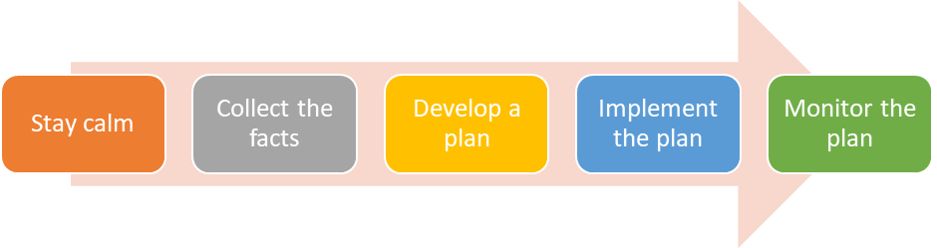

**What to do?**

1. First of all, stay calm

There is no need to get worries and worked up. By getting emotional you will not resolve the issue. Anger and fear will cloud your mind and prevent you from solving the problem in the most efficient and effective way.

If you believe you need help, then ensure to seek help from the most appropriate people in your organisation. You may need to form a team to address the issue, which may involve other areas of your workplace, e.g. HR, Finance Team, or other.

1. Collect the facts

Usually if there is a problem, you will need to gather information. For example, if there is a conflict between two team members, then you will need to consult with each individual to find out their view of the situation, what happened, and what they believe should be done.

1. Develop a plan

Next is to develop a plan to address the issues. Here you should involve other stakeholders as needed to ensure that the actions are agreed and appropriate to resolve the issue.

Ensured the plan has defined action items, due dates, and responsibilities so it can be monitored.

1. Implement the plan

Depending on the action plan, you or others may need to implement the actions. Ensure that this takes place by scheduling the activities and following up with the required people on a regular basis. You may need to hold review meetings with stakeholders to check their status and provide support.

1. Monitor the plan

During the implementation you need to monitor, but also at the end. Once all steps are implemented, you need to check whether or not the solutions put in place are affective. You can test the new process and seek feedback from others to identify if they are satisfied with the solutions.

### strategies for conflict resolution and negotiation

Strategies you can use to address performance issue include:

* Address the issue privately if needed, e.g. for individual performance issues
* Gather facts on performance and performance gaps
* Don’t blame the person and provide opportunity to explain themselves and why performance targets could not be met
* Openly discuss the facts with the other person in an objective and positive manner
* Use active listening to listen to what the other person has to say
* Be empathetic, meaning put yourself into their shoes to understand their position
* Identify and agree solutions to address the performance issue together and document this in a performance plan
* Regularly monitor the performance plan actions

1. Monitor team performance
   1. Measure team member performance against agreed work plans

### Team Performance

Team performance management involves the recurring activities to establish team goals, monitor progress toward the goals, and make adjustments to achieve those goals more effectively and efficiently. From a systems perspective, the overall goal of team performance management is to ensure that the team and all of its members are working together in an optimum fashion to achieve the results desired by the supervisor of the team.

Measuring Team Performance

Measuring team-related performance can be approached in at least four ways. Two of those approaches measure performance at the individual level and two measure performance at the team level.

**Individual Level: An Individual's Contribution to the Team**

Individual Behaviour : Individual team member can be measured on how well they work with team members. Examples of these types of measures could include the degree to which: the employee participates in team meetings; the employee volunteers for team projects; the employee communicates with members in a constructive and non-threatening manner; other members find that the employee is pleasant to work with and fosters cooperation.

Individual Result: Employee work products that contribute to the final team product or service can be assessed and verified. Examples of these types of measures could include error rates, the timeliness of the product, the number of suggestions made, or the accuracy of the data provided.

**Team Level: Measuring the Team's Performance**

The Team's Processes: The team can be measured on its internal group dynamics. These types of measures could address: how well the team works together as a group; the effectiveness of team meetings; the ability of the team to reach consensus; and the team's problem-solving techniques.

The Team's Results: The team can be measured on its work results or products. These types of measures could include: the number of cases completed; the use, acceptance, and understandability of the team's final report; the number of customer requests for the team's report; the subscription rate of the team's newsletter.

These types of measures can be applied with the three types of performance elements that can be used in the performance appraisal process.

A critical element is a work assignment or responsibility of such importance that unacceptable performance on the element would result in a determination that an employee's overall performance is unacceptable. Because critical elements are limited to addressing individual performance, only the individual level measures of contribution to the team and individual results could be used as critical elements.

Non-critical elements can be a dimension or aspect of individual, team, or organizational performance that is measured and used in assigning a summary level. In the past, "non-critical" meant "not as important." However, programs can be designed so that non-critical elements have as much weight or more weight than critical elements in determining the final summary level. Since it is only through non-critical elements that group or team level performance can be factored into an employee's summary level determination, using non-critical elements can be a useful tool for setting group goals, planning group work, measuring group performance, and providing feedback on group performance.

Additional performance elements address a dimension or aspect of individual, team, or organizational performance that is not used in determining summary levels. Additional elements are used for various other purposes, such as setting goals, providing feedback on individual or group performance, and recognizing individual or group achievements.

* 1. Providing feedback to team members

Positive feedback is one of the best ways to motivate your team. Giving feedback is a skill and it will take practice to get it right.

When giving feedback it is important that:

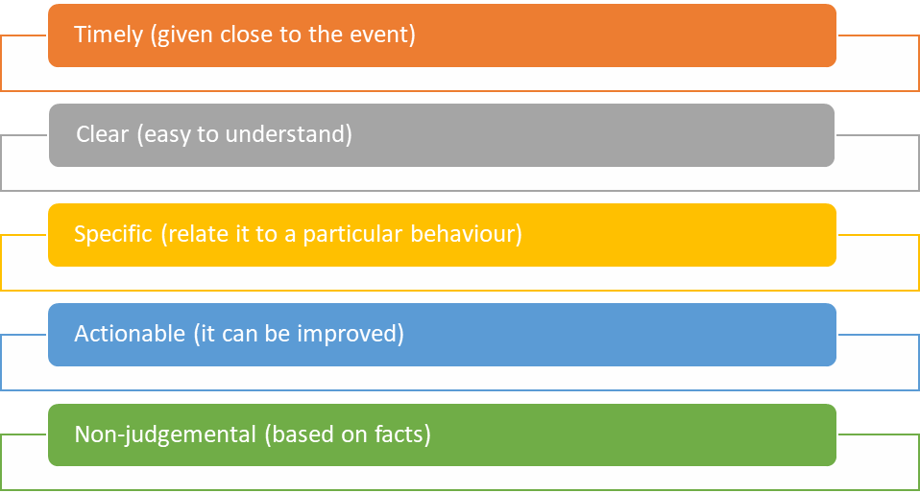

Video Link: Giving Feedback

Video Title:Constructive Feedback for Managers: Giving Feedback Effectively

Video content: This video provides information on the importance and strategies on giving feedback.

Video Link: <https://www.youtube.com/watch?v=gi5UfSIf0BM>

Published by: Forward Focus, Published: Nov 28, 2016, Duration: 5:06mins

Types of Feedback

**Praise**

Praise is the expression of appreciation, approval or admiration for the work that is completed. When praising, consider the following points:

* Decide what you want encourage
* Think small
* Be relentless
* Be specific
* Be impartial (neutral)
* Make it personal
* Be prompt
* Vary your praise

**Constructive Feedback**

Constructive feedback is providing useful comments and suggestions that contribute to a positive outcome, a better process or improved behaviours. It provides encouragement, support, corrective measures and direction to the person receiving it. Knowing how to give constructive feedback is a valuable skill. Feedback sandwich is a type of feedback approach.

Steps for Constructive Feedback includes:

1. Plan your feedback
2. Be aware of your body language, tone and the words that you use when giving feedback
3. Consider the receiver of the feedback’s frame of reference
4. Be specific
5. Your thoughts
6. Your Feelings
7. State the expected outcome
8. Check understanding

**What is Feedback Sandwich?**

We often speak of the feedback sandwich approach for giving feedback.

This means that we provide feedback in the following order:

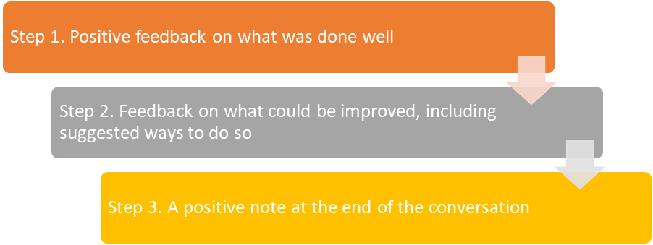

Why are those three feedback steps so important?

**Step 1:**

By providing positive feedback on what was done well we can open the conversation in a positive way and ensure the attention of the other person and we can remove any fear they may have about the feedback coming their way.

Remember that everyone is always completing work well, and never just badly. Ensure to first focus on the positive aspects of the work and provide some praise.

**Step 2:**

Provide feedback on what was not done well. This is the hardest part and this needs to be delivered in a way that focuses on the facts. Don’t say “I don’t like how you did this.” but say “By doing it the way you did, this results in …”.

The feedback is not about how you feel, but about what the performance means in the practical business sense. The individual needs to understand the consequences of their doing or not doing something in a certain way.

The other important part of this feedback is that it needs to be constructive. This means that you are required to help identify how the task could be done in a better way. It will not be extremely helpful for the individual if you only tell them that it was not good. You also need to do them what they can do to improve it.

Then the conversation needs to focus on agreeing on a set of actions that can be taken by the individual from now on to correct their behaviour or work outcome.

**Step 3:**

It is crucial that you both leave the performance discussion in a positive frame of mind. Thank the person for their open discussion and willingness to improve. Also, let them know that you are there to help and that they should not hesitate to reach out when needed.

* 1. Specific learning and development opportunities to improve team and individual performance and behaviours

### Training for staffs

Opportunities for staff development and training are regularly promoted to staff according to company requirements.

It is important to adopt a systematic approach to provide the training or learning and development opportunities to improve team and individual performance.

**Formal Training**

Formal training refers to structured learning that is planned using training plans and conducted using a formal classroom environment.

Structured learning can be conducted using:

* Face-2-face teaching
* Demonstration
* Videos
* Reading materials
* Case Studies
* Participation in forums

Formal training may be delivered within the workplace or through a third party provider.

Often, formal training is acknowledged in some way, e.g. through a certificate of attendance, a qualification, or licence.

Formal training usually takes several hours to several days or can even span over many months.

**Informal Training**

Informal training is the opposite of formal training and is conducted in a less structured or non-structured way. It is often used sporadic when the opportunity arises, e.g. when you see someone struggle with a task. Then you may provide on-the-stop coaching to assist this person.

In your role as a leader, you should make use of informal training of your staff which you can do in team meetings, for individuals, or the entire team all at once.

For this type of training you will usually use:

* Verbal instructions
* Demonstrations
* Examples
* Team building activities

Informal training sessions are usually short and sharp, usually lasting no more than an hour at a time.

* 1. Implement action plans to address individual and team training needs

A good team member training and development plan will help energize your company and facilitate greater employee engagement.

The benefits of action plan for training needs includes:

* Training lead to greater productivity - If your team member are kept up to date with the latest developments in your field, they are far more likely to have better output. There is nothing like new ideas to freshen up your approach to your tasks.
* Team members feels more engaged - A good training program will address the individual member’s needs in relation to their work, helping them to feel more confident in the importance and value of what they produce.
* Provide opportunity to nurture and develop talent - Good training and employee development will identify and enhance the talent that already exists in your organization, bringing benefits to your company and the employee

# References

“6.1 What Are Governance Rules?” *Indigenous Governance Toolkit*, toolkit.aigi.com.au/toolkit/6-1-what-are-governance-rules. Accessed 18 Jan. 2021.

NSW Government. “Workplace Policies and Procedures Checklist.” *NSW Industrial Relations*, 17 Sept. 2019, www.industrialrelations.nsw.gov.au/employers/nsw-employer-best-practice/workplace-policies-and-procedures-checklist/. Accessed 18 Jan. 2021.

“Difference between Responsibility and Accountability (with Comparison Chart).” *Key Differences*, 22 June 2016, keydifferences.com/difference-between-responsibility-and-accountability.html#ComparisonChart. Accessed 18 Jan. 2021.

“Legal Resources.” *Victorian Equal Opportunity and Human Rights Commission*, www.humanrights.vic.gov.au/legal-and-policy/legal-resources/. Accessed 17 Jan. 2021.