Assessment Task 2: Design a Website

|  |  |
| --- | --- |
| Course code and title | **ICT50220 Diploma of Information Technology** |
| Unit code and  title | **ICTWEB513 Build dynamic websites** |
| Due date | 28/05/2024 |
| Resources  required | • ICTWEB513 and ICTWEB517 Moodle Site  • Access to computer and internet  • Learner resource |
| Decision making rules | To achieve an overall satisfactory result for this assessment task:   * Learners must achieve a satisfactory result for each item in the **Assessment Checklist** |
| Learner  instructions | This task involves completing a design brief, sitemap and storyboard for a website. Refer to the Project Scenario below for more details.  For this task you will:   * Complete it individually. * Write answers to all questions by completing the design brief template, providing a site map and a storyboard. * Complete it in the class or your own time and submit it by the due date. * Have time to read and review the assessment task in class. * Submit your answers electronically via Moodle. * Answer electronically and save the document as Assessment Task2StudentID.docx.   You must agree with the assessment submission terms and conditions by clicking on the ‘I confirm’ radio button in Melbourne Polytechnic Moodle prior to the submission.  If you have any questions about the task or concerns about your ability to complete the task, please discuss this with your Assessor. |

# Project Scenario: The Melbourne Public Library

Melbourne Public Library has contracted you to create a new website. They want a simple, effective website to provide information to users about their membership options.

In this task, you must read the below email from the Project Manager and complete the design brief, sitemap and storyboard.

|  |
| --- |
| *Dear Web Developer*  *Thank you for taking on this project. Our users are the general public looking for further information about the library and membership options.*  *We require a new 4- page website with the following:*   * Home page – should include clear links to other features of the system that the users can access via a navigation bar. * About us page – include the following blurb:   *“Melbourne Public Library is an institution dating back to 1929. We have a range*  *of books, CDs, DVDs, magazines as well as a large range of downloadable content.”*   * Membership page – include membership information. Membership is free and gives them access to the library’s full catalogue. It should include an online form to apply for membership. The form must include name, email address and phone number. * Contact us page – should include the following contact information:   + *Telephone 1300 000 000*   *Our ICT Manager has stated he would like the following technical specifications within the website:*   * Create an attractive, uniform theme to be used throughout the website. It must look professional. * Use advanced CSS techniques (you must use version CSS3) when placing various elements on web pages:   + *CSS techniques must apply to all pages of the website and there must be only 1 CSS file.*   + *Use CSS style to format the HTML elements (you must use HTML version 5).*   + *Use at least 1 advanced CSS style for position and layout of the web pages, such as flexbox etc.*   + *Use an advanced CSS style to create attractive visual effects, including shadows, transform, and round corner of the box model.*   + *Use CSS style and ensure website suitability for PC and mobile.* * A form aligned correctly with appropriate labels ad controls. * New features of HTML, including <article>, <header>, <footer> * 3 images with appropriate alternative text (alt attributes). * An unordered list. * A functional navigation bar. * A video (embed a YouTube video of your choosing, please follow the copyright policy). * New HTML elements, such as grids, to load the website on Mobile and PC. * Functions should be clear and easily accessible. * A single data storage * Include comments in your code.   *Thank you for your time, I look forward to seeing the final website. We have a very tight timeframe and would like this up and running in 2 days!*  *Kind Regards,*  *Project Manager* |

## Part 1: Complete the Design Brief

Complete the following design brief based on the information you have received from the Project Manager.

|  |  |
| --- | --- |
| **Design Brief** | |
| **Website Purpose** | *Explain the purpose of the website.*  Design a simple, effective website for the Melbourne Public Library that provides information to the general public seeking more information about the library and membership. |
| **Legislative Considerations** | *What legislative considerations do you need to make?*  You should ensure that the website, including images, videos and text, does not infringe any copyright laws.  Websites cannot publish fraud, deception, or other illegal information that requires legal liability.  The website obtains user consent before collecting any personal data to protect user information.  Relevant code needs to be commented as needed to improve readability. |
| **Interface Requirements** | *Explain the interface requirements.*   * Create an attractive, uniform theme to be used throughout the website. It must look professional. * Use advanced CSS techniques (you must use version CSS3) when placing various elements on web pages:   + *CSS techniques must apply to all pages of the website and there must be only 1 CSS file.*   + *Use CSS style to format the HTML elements (you must use HTML version 5).*   + *Use at least 1 advanced CSS style for position and layout of the web pages, such as flexbox etc.*   + *Use an advanced CSS style to create attractive visual effects, including shadows, transform, and round corner of the box model.*   *Use CSS style and ensure website suitability for PC and mobile.* |
| **Target Audience** | *Describe your target audience.*  The general public looking for further information about the library and membership options. |
| **Website Requirements** | *What are the requirements of the website?*  *a new 4- page website with the following:*   * Home page – should include clear links to other features of the system that the users can access via a navigation bar. * About us page – include the following blurb:   *“Melbourne Public Library is an institution dating back to 1929. We have a range of books, CDs, DVDs, magazines as well as a large range of downloadable content.”*   * Membership page – include membership information. Membership is free and gives them access to the library’s full catalogue. It should include an online form to apply for membership. The form must include name, email address and phone number. * Contact us page – should include the following contact information:   + *Telephone 1300 000 000* |
| **Timeframe** | *When does this need to be complete by?*  In 2 days |
| **Digital Technologies and Applications** | *What digital technologies and applications do you need?*  HTML:  HTML is a markup language, including a series of tags. These tags can be used to unify document formats on the Internet.  CSS:  Cascading Style Sheets is a computer language used to express document styles such as HTML or XML.  JS:  JS is mainly used to add interactive behaviors to HTML pages.  Chrome:  A web browser developed by Google.  Sublime Text:  Text editor for writing website code.  Bootstrap:  Bootstrap provides elegant HTML and CSS specifications. |
| **Security** | *What web authentication and security will you use?*  Users do this by entering their username and password, which allows the system to confirm their identity.  During the authentication process, if a match is found in the file, the authentication process is complete and the individual can be pushed to the authorization process.  When users enter information into the form, they need to ensure that they do not enter illegally or affect the security of the website. |
| **Data Storage** | *What are the data storage requirements?*  The website needs to store data related to books and data related to member users.  User information needs to be stored legally and securely.  Important data can be encrypted to avoid clear text transmission and storage. |
| **HTTP/HTTPS** | *Will you use HTTP or HTTPS? Why?*  The handshake process occurs in HTTP only when the connection is established. Therefore, there is no handshake process after the request. This significantly reduces latency in the connection.  HTTP has high flexibility and strong scalability.  Reliable transmission, because the http protocol is an application layer protocol based on the tcp protocol, and the tcp protocol is a reliable transmission protocol. |
| **Copyright and Privacy** | *Are the website contents following the copyright and privacy of legislation standards and procedures*  The website contents following the copyright and privacy of legislation standards and procedures. |

## Part 2: Create a site map

Create a site map that shows the logical page flow and hierarchy of the web pages.

Site map must be similar to the below:

## Part 3: Create a Storyboard

Create a storyboard of how you intend to lay out the web pages to meet the client’s requirements. You must:

* provide basic blocking of content
* label where images are inserted
* ensure that this to a professional standard
* complete this for each of the 4 pages.

Student to supply a storyboard for each page. Sample provided below for about us page:

Index

About Us

图形用户界面, 应用程序

Membership

Contact Us

## Part 4: Confirm with Client

Draft an email to the Project Manager with your design brief, site map and storyboard. In the email, you must negotiate the timeframe.

The Project Manager has requested this to be completed in 2 days; however, your manager has informed you that this is not possible. Your organisation’s policies and procedures mean that you are required to complete the brief, develop the website and test the website. Standard turnaround time for this is 5 business days and it is not possible to shorten this duration.

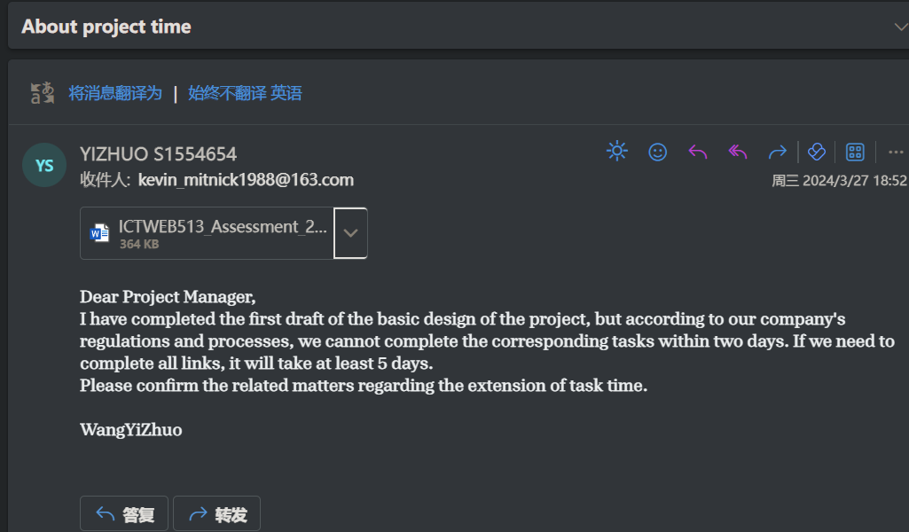

#### Instructions for submission

* Zip the following to a folder titled ‘Task2StudentID’ and include:
  + your design brief
  + your sitemap
  + your storyboard
  + you email to the Project Manager
* Upload the zipped folder into Melbourne Polytechnic LMS site (<https://online.melbournepolytechnic.edu.au>).

# Assessment Checklist: Task 2 - Design a Website

|  |  |  |  |  |  |  |
| --- | --- | --- | --- | --- | --- | --- |
| **Learner name** | | WangYiZhuo | **Student ID** | | S1554654 | |
| **Assessor name** | | Mr. WU | **Date** | | 28/05/2024 | |
| Assessment checklist 1  assessor to complete the following | | | | | | |
|  | | | | | | |
| **The LEARNER has demonstrated the following in Part 1:** | | | | **SATISFACTORY** | | **NOT SATISFACTORY** |
|  | Completed design brief correctly identifying:   * purpose * legislative considerations * interface design requirements * target audience * website requirements * timeframes * digital technologies and applications required * authentication and web security requirements * data storage requirements * identified if will use HTTP or HTTPS. | | |  | |  |
| **Feedback -** Assessor must include feedback about the observed performance | | | | | | |
| *The candidate has basically identified understanding in Part1.* | | | | | | |
| **The LEARNER has demonstrated the following in Part 2:** | | | | **SATISFACTORY** | | **NOT SATISFACTORY** |
|  | Created a site map as per specifications | | |  | |  |
| **Feedback -** Assessor must include feedback about the observed performance | | | | | | |
| *the candidate has briefly created the sitemap.* | | | | | | |
| **The LEARNER has successfully demonstrated the following in Part 3:** | | | | **SATISFACTORY** | | **NOT SATISFACTORY** |
|  | Created a storyboard as per the specifications. | | |  | |  |
| **Feedback -** Assessor must include feedback | | | | | | |
| *the candidate has briefly create the storyboard for each page.* | | | | | | |
| **The LEARNER has successfully demonstrated the following in Part 4:** | | | | **SATISFACTORY** | | **NOT SATISFACTORY** |
|  | Supplied professional email negotiating the timeframes. | | |  | |  |
| **Feedback -** Assessor must include feedback | | | | | | |
| *The candidate has demonstrated professional email negotiation skills.* | | | | | | |

# Assessment Task Summary: Task 2 - Design a Website

| **Trainer/Assessor to complete the following:**  **Needs to be customised for the tasks**  **THE LEARNER:** | | | Yes | No |
| --- | --- | --- | --- | --- |
| 1. | Satisfactorily completed all items in Assessment Checklist | |  |  |
| **FEEDBACK** | | | | |
|  | | | | |
| **OVERALL TASK RESULT** | | | | |
| Satisfactory  Not Satisfactory (resubmission required) – Due date: ____________________________ | | | | |
| **DATE ASSESSMENT RETURNED** | |  | | |
| **TRAINER/ASSESSOR NAME** | |  | | |
| **TRAINER/ASSESSOR SIGNATURE** | | X | | |

| **LEARNER DECLARATION: Please read, tick and sign below** | | | |
| --- | --- | --- | --- |
| I, ___________________________have been advised of the outcome of this assessment task.  PRINT NAME | | | |
| **LEARNER Signature** | X | **Date** | 28/05/2024 |