Assessment Task 3: Develop a Website

|  |  |
| --- | --- |
| Course code and title | **ICT50220 Diploma of Information Technology** |
| Unit code and  title | **ICTWEB513 Build dynamic websites** |
| Due date | 28/05/2024 |
| Resources  required | • ICTWEB513 and ICTWEB517 Moodle Site  • Access to computer and internet  • ICTWEB513 and ICTWEB517 Learner resource  • Notepad++ Program |
| Decision making rules | To achieve an overall satisfactory result for this assessment task:   * Learners must achieve a satisfactory result for each item in the **Assessment Checklist.** * Learners must demonstrate the website to your instructor(s) |
| Learner  instructions | This task requires you to develop the website you designed in Assessment Task 2. Refer to the Task Details below for more information. You must have completed Assessment Task 2 before commencing this task.  For this task you will:   * Complete it individually. * Complete all sections of the assessment. * Complete it in the class and in your own time and submit it by the due date. * Have time to read and review the assessment task in class. * Submit your answers electronically via Moodle, saving the document as Assessment Task 3 StudentID.docx.   You must agree with the assessment submission terms and conditions by clicking on the ‘I confirm’ radio button in Melbourne Polytechnic Moodle prior to the submission.  If you have any questions about the task or concerns about your ability to complete the task, please discuss this with your Assessor. |

# Task Details

# Part 1: Build Web Pages

You are now required to create the website you designed in Assessment Task 2.

Ensure the website meets the following requirements:

* Create an attractive, uniform theme to be used throughout the website. It must look professional.
* Use advanced CSS techniques (you must use version CSS3) when placing various elements on web pages:
  + CSS techniques must apply to all pages of the website and there must be only 1 CSS file.
  + Use CSS style to format the HTML elements (you must use HTML version 5).
  + Use at least 1 advanced CSS style for position and layout of the web pages, such as flexbox etc.
  + Use an advanced CSS style to create attractive visual effects, including shadows, and round corner of the box model.
  + Use CSS style and ensure website suitability for PC and mobile.

Include the following:

* A form aligned correctly with appropriate labels ad controls.
* New features of HTML, including <article>, <header>, <footer>
* 3 images with appropriate alternative text (alt attributes).
* An unordered list.
* A functional navigation bar.
* Json data in a page.
* A video (embed a YouTube video of your choosing, please follow the copyright policy).
* New HTML elements, such as to load the website on Mobile and PC.
* Functions should be clear and easily accessible.
* Include comments in your code.

Learners will submit a copy of their website. Assess this against the Assessment Checklist to ensure it meets all assessment requirements.

## Part 2: Test Your Pages

1. Test your webpages on the browsers indicated in the table below. Record your findings and rectify any incompatibilities you find. Your Assessor will verify the information you record in the table by opening your website in the different browsers and on a mobile device.

Ensure to note:

* Differences between browsers.
* How you managed incompatibilities. Be specific about any rectification you made, e.g. add a meta tag inside head contents to make compatible with Internet Explorer: <meta http-equiv="X-UA-Compatible" content="IE=edge">

|  |  |  |  |  |
| --- | --- | --- | --- | --- |
| **Browsers display correctly (Yes/No)** | **Google Chrome (Yes/No)** | **Mozilla Firefox**  **(Yes/No)** | **Internet Explorer**  **(Yes/No)** | **Rectifications** |
| **Homepage** | Yes | Yes | Yes |  |
| **About Us** | Yes | Yes | Yes |  |
| **Memberships** | Yes | Yes | Yes |  |
| **Contact Us** | Yes | Yes | Yes |  |

***Please note that you may have the pages that are not the same in the table above***

1. Test your website on a mobile device. Open your website on a mobile device and complete the following checklist. Record your findings and rectify any incompatibilities. Your Assessor will open your website on a mobile device to verify your findings:

|  |  |  |
| --- | --- | --- |
| **Item** | **Yes/No** | **Changes made** |
| **Each section of website is accessible on a mobile device** | YES |  |
| **Pages load correctly on mobile devices** | YES |  |
| **Web content is accessible to screen readers** | YES |  |

## Part 3: Validate Your Code

Use the online tools below to validate your HTML and CSS code against W3C standards. You are required to submit these completed validation reports.

Validate your HTML code at <http://validator.w3.org>

Index

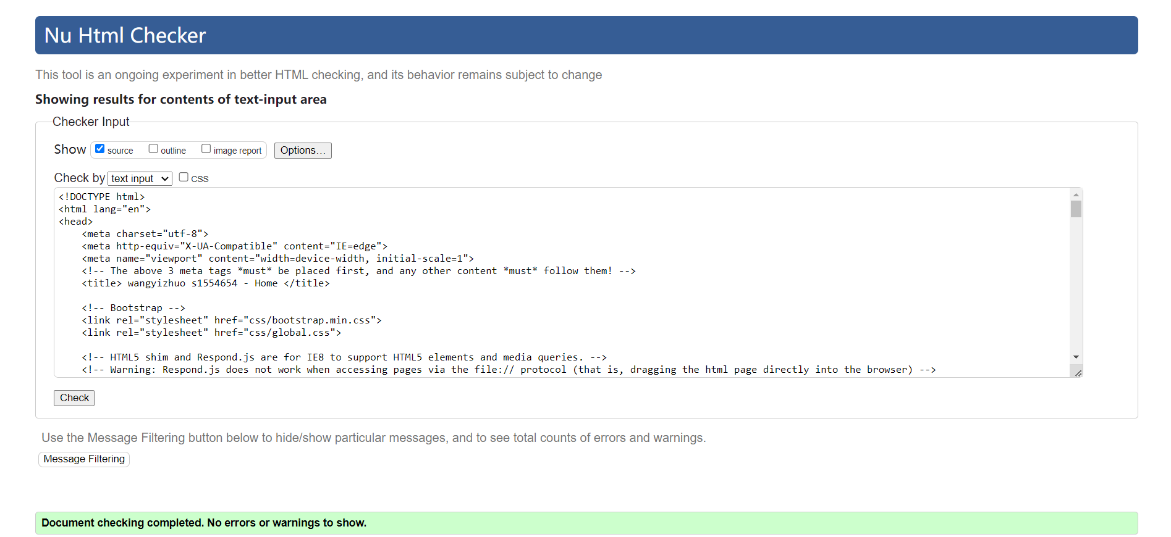

About Us

Memberships

Contact Us

Validate your CSS code at <https://jigsaw.w3.org/css-validator/>

CSS

Learners are required to validate one HTML page and one CSS file, and screenshot of the validation results, and paste it into part 3.

## Part 4: Demonstrate the website and getting feedback from your client

The learner must demonstrate the website to the instructors (clients) and getting feedback from them, update the website accordantly.

## Instructions for submission

* Zip the following to a folder titled ‘Task3StudentID’ and include:
  + your website
  + The **Task 3 StudentID.docx** word document including all the answers.
* Upload the zipped folder into Melbourne Polytechnic LMS site (<https://online.melbournepolytechnic.edu.au>).

# Assessment Checklist: Task 3 - Develop a Website

|  |  |  |  |  |  |  |
| --- | --- | --- | --- | --- | --- | --- |
| **Learner name** | | wangyizhuo | **Student ID** | | s1554654 | |
| **Assessor name** | | Mr. WU | **Date** | | 28/05/2024 | |
| Assessment checklist  assessor to complete the following | | | | | | |
|  | | | | | | |
| **The LEARNER has demonstrated the following in Part 1:** | | | | **SATISFACTORY** | | **NOT SATISFACTORY** |
|  | Website has attractive uniform theme and an overall professional standard. | | |  | |  |
|  | Used advanced CSS technique to ensure 1 file across all pages is:   * applied to all pages * used for position and layout e.g. a flexbox * used shadow, transform and round corner. | | |  | |  |
|  | Ensured suitability across PC and Mobile | | |  | |  |
|  | Included correct use of:   * form * new features of HTML * at least 3 images * an unordered list * Json data * functional navigation bar * a video (embedded). | | |  | |  |
|  | Copy of developed website provided. | | |  | |  |
| **Feedback -** Assessor must include feedback about the observed performance | | | | | | |
| *The candidate has completed all aspect of the above requirements, and basically meet the needs of the client.* | | | | | | |
| **The LEARNER has demonstrated the following in Part 2:** | | | | **SATISFACTORY** | | **NOT SATISFACTORY** |
|  | Tested the web pages on a variety of browsers, identified and fixed any issues and recorded the results.  Assessor tested on web browsers and confirmed results. | | |  | |  |
|  | Tested the webpages on a mobile device, identified and fixed any issues and recorded the results.  Assessor tested on mobile device and confirmed results. | | |  | |  |
| **Feedback -** Assessor must include feedback about the observed performance | | | | | | |
| *The candidate has test the website over browsers and mobile devices.* | | | | | | |
| **The LEARNER has successfully demonstrated the following in Part 3:** | | | | **SATISFACTORY** | | **NOT SATISFACTORY** |
|  | Tested HTML and CSS code using W3C validation tools. | | |  | |  |
|  | Provided error free validation reports for HTML and CSS code | | |  | |  |
| **Feedback -** Assessor must include feedback | | | | | | |
| *The candidate has validated both html and css code.* | | | | | | |

# Assessment Task Summary: Task 3 - Develop a Website

|  |  |  |  |  |
| --- | --- | --- | --- | --- |
| Trainer/Assessor to complete the following:  **THE LEARNER:** | | | Yes | No |
| 1 | Satisfactorily completed all items in Assessment Checklist | |  |  |
| feedback **-** Assessor must include feedback | | | | |
|  | | | | |
| OVERALL TASK result | | | | |
| Satisfactory  Not Satisfactory (resubmission required) – Due date: ____________________________ | | | | |
| Date Assessment Returned | |  | | |
| Trainer/assessor Name | |  | | |
| Trainer/Assessor signature | | X | | |

|  |  |  |  |
| --- | --- | --- | --- |
| **LEARNER DECLARATION**: Please read, tick and sign below | | | |
| I, ____________________________ have been advised of the outcome of this assessment task.  PRINT NAME | | | |
| LEARNER Signature | X | Date |  |