Assessment Task 3: Create a website

|  |  |
| --- | --- |
| Course code and name | ICT50220 Diploma of Information Technology |
| Unit code and name | ICTWEB514 Create Dynamic Web Pages |
| Due date | 28 / 5 / 2024 |
| Resources required | * Notepad++ program * Learner resource * Access to computer and internet |
| Decision making rules | Demonstration of competency will be made by your assessor against the observable criteria included in this book |
| Instructions | * It is to be completed in the learner’s own time. * You have four weeks to complete this task. * You MUST demonstrate to the assessor before uploading your work * You need to zip your folder and upload it onto Moodle * Ensure have recorded the due date * At this time any of you can discuss any require reasonable adjustments required with the teacher/assessor. Reasonable adjustment may include an extension of time, oral questions and answers etc. * You must upload your task on Moodle and tick the student declaration. * All questions must be answered |

# Assessment Instrument

The purpose of this Website is to allow users to browse through a range of pre-determined consumer products and register to view products.

While all viewers can view the basic information and search a product on the Website, only registered users are permitted to view the tracking table after they log into the system, the user also can update the password.

Part 1: designing a web application

Outline design principles for your Dynamic website, and complete the following tasks:

1. List out the technique requirements that you need for this web application.

查询资料描述下列技术，**请删除本提示信息**

HTML:

CSS:

JavaScript:

PHP:

MySQL:

1. Identify the client-side contents in your website.

选择下列五个进行参考、整理、并用英文回答，**请删除本提示信息**

1. 主页界面展示轮播图效果
2. 注册表单页面展示注册信息的收集表单
3. 登录表单页面展示登录信息的表单
4. 搜索页面可以供用户提供信息的搜索
5. 密码修改表单页面提供了密码修改的表单
6. 关于我们页面展示了商店的宣传视频
7. 联系我们页面展示了商店的联系信息
8. 搜索结果页面展示了搜索的结果
9. Identify the server-side contents in your website.

对下列五个后端功能用自己的话进行内容的扩展、并用英文回答，**请删除本提示信息**

1. 注册账号
2. 登录账号
3. 产品搜索
4. 热门词汇查询
5. 密码更改
6. List the web page where the session and cookie apply.

打开代码，依次打开每一个.php结尾的php文件，分别搜索cookie和session，将包含cookie或session的php文件名字按分类填写，**请删除本提示信息**

Cookie:

Session:

1. Identify the legislative and organisational standards and procedures related to the website.

Note: Legislative: what data can be saved locally or remotely using client-side or server-side data storage techniques such as cookie, session, database?

根据下列参考资料，用自己的话描述，并用英文作答，**请删除本提示信息**

用户的浏览查询记录可以保存在服务器的数据库中，用户的会话数据可以使用session进行保存，可以使用cookie维持会话，其他所有数据都不允许非法存储。

代码结构必须清晰，使用文件夹划分不同的代码文件，例如：css, JavaScript，图片资源等，需要按需注释相关代码以提高阅读性。

Part 2: create database

The database for the Website is to be named as **your own full name** (without any spaces) and is to include two tables as follows:

1. An **accounts** table to store the details of users that register with the Website. This table is to include four fields as follows:
   1. **userId**: An **automatically** generated integer number used to uniquely identify a user record.
   2. **userEmail**: The unique e-mail address of the user that acts as the username for the account, and is used as part of the login process.
   3. **userPassword**: A user defined combination of a minimum of 4 characters that are used as part of the login process.
   4. **userCountry**: The name of the country of the user that is registering with the Website.
2. A **products** table to store the details of products that are available for review. The table is to include four fields as follows:
   1. **productId**: An **automatically** generated integer number used to uniquely identify a product.
   2. **productName**: A text field to hold the name of the listed product.
   3. **productDescription**: A text field to store a description and features of the product.
   4. **productImage**: A field to hold the name (including extension) of an image file that can be used to display a picture of the product.
3. A **tracking** table to store the search details that the viewer entered the search box. The table is to include two fields as follows:
   1. **trackingId**: An **automatically** generated integer number used to uniquely identify a user record.
   2. **tracking_details**: recording the words that the viewer entered the search box

Part 3: web application requirements

1. A **Shared Template** should be created in order to provide consistent navigations, copyright part, etc.
2. A **home** page to display the information about the website.
   1. you need to insert a client-site content such as a slideshow for the banner images on this page.
   2. You need to have a session variable to pass into this page when the user logged in, and a message to display whoever has logged in on this page.
3. A **registration** page to allow the user creating his/her account
4. **A login** page that allows the user to log in, you need to create a session and cookie once the user logs in. You need to use Cookie to set up the log time, such as the user will be logged out if they didn’t do anything on the website within 5 minutes.
5. **A search page** that allows the viewers to search a product by entering the name of the product.
6. A **view all tracking details page**, **only** the registered user can view the **list** of words viewers entered into the search box.
7. A **change password** page to allow registered users to change their password, the user has to login first and then they can update their password.
8. A **logout** option that allows a logged in user to logout of the Website and return to the home page of the website, you need to use sessions and cookies to complete this question.
9. Adding **comments** inside the coding page to explain the main functionalities.
10. Make sure codes are **clean and neat** follow consistent coding style.
11. Make sure comments follow consistent **commenting conventions**.
12. Make sure no client-side or server-side data storage techniques are used for saving **unauthorised personal data**

Part 4: Test the website

1. Debug and test the website in a variety of browsers such as:

* Firefox
* Chrome
* Edge (*if applicable*))
* Internet Explorer

Test the learner’s website in a variety of devices such as:

* PC
* Pad
* Mobile phone

Did the learners notice any difference between them? Did the learners need to fix any browser bugs? If so, what did the learners do? Did the learners add some comments to their code to note this?

Please fill the test details for each browser in the table below:

下列表格需要在浏览器中查看所有具有前端页面的网页代码效果跨浏览器表现是否一致，打开每一个.php文件，里面包含html代码的文件都要检测，**请删除本提示信息**

|  |  |  |  |  |
| --- | --- | --- | --- | --- |
| **Pages** | **Google Chrome** | **Mozilla Firefox** | **Internet Explorer** | **Comparison of Three Browsers** |
| **.php文件名** | √ | √ | √ | 浏览器表现基本一致 |
|  | √ | √ | √ | 浏览器表现基本一致 |
|  | √ | √ | √ | 浏览器表现基本一致 |
|  | √ | √ | √ | 浏览器表现基本一致 |
|  | √ | √ | √ | 浏览器表现基本一致 |
|  | √ | √ | √ | 浏览器表现基本一致 |
|  | √ | √ | √ | 浏览器表现基本一致 |
|  | √ | √ | √ | 浏览器表现基本一致 |
|  | √ | √ | √ | 浏览器表现基本一致 |

Please fill the test details for each device in the table below:

下列表格需要在浏览器中查看所有具有前端页面的网页代码效果跨终端表现是否良好，打开每一个.php文件，里面包含html代码的文件都要检测，**请删除本提示信息**

|  |  |  |  |  |
| --- | --- | --- | --- | --- |
| **Pages** | **PC** | **PAD** | **Mobile Phone** | **Comparison of Three Devices** |
| **.php文件名** | √ | √ | √ | 多终端表现良好 |
|  | √ | √ | √ | 多终端表现良好 |
|  | √ | √ | √ | 多终端表现良好 |
|  | √ | √ | √ | 多终端表现良好 |
|  | √ | √ | √ | 多终端表现良好 |
|  | √ | √ | √ | 多终端表现良好 |
|  | √ | √ | √ | 多终端表现良好 |
|  | √ | √ | √ | 多终端表现良好 |
|  | √ | √ | √ | 多终端表现良好 |

Please fill the test details for each security and organizational procedures in the table below:

将所有的.php文件填入下列表格，**请删除本提示信息**

|  |  |  |  |  |
| --- | --- | --- | --- | --- |
| **Pages** | **Not use eval for user input** | **Not use inline event handler** | **Codes are clean and neat** | **Comments are consistent** |
| **.php文件名** | √ | √ | √ | √ |
|  | √ | √ | √ | √ |
|  | √ | √ | √ | √ |
|  | √ | √ | √ | √ |
|  | √ | √ | √ | √ |
|  | √ | √ | √ | √ |
|  | √ | √ | √ | √ |
|  | √ | √ | √ | √ |
|  | √ | √ | √ | √ |
|  | √ | √ | √ | √ |
|  | √ | √ | √ | √ |
|  | √ | √ | √ | √ |
|  | √ | √ | √ | √ |
|  | √ | √ | √ | √ |

1. Validate the learners HTML code at <http://validator.w3.org>

* Correct any errors and make sure every page the learners are submitting contains only valid code

**Note:** There is a table for validating the learner’s HTML code in the template

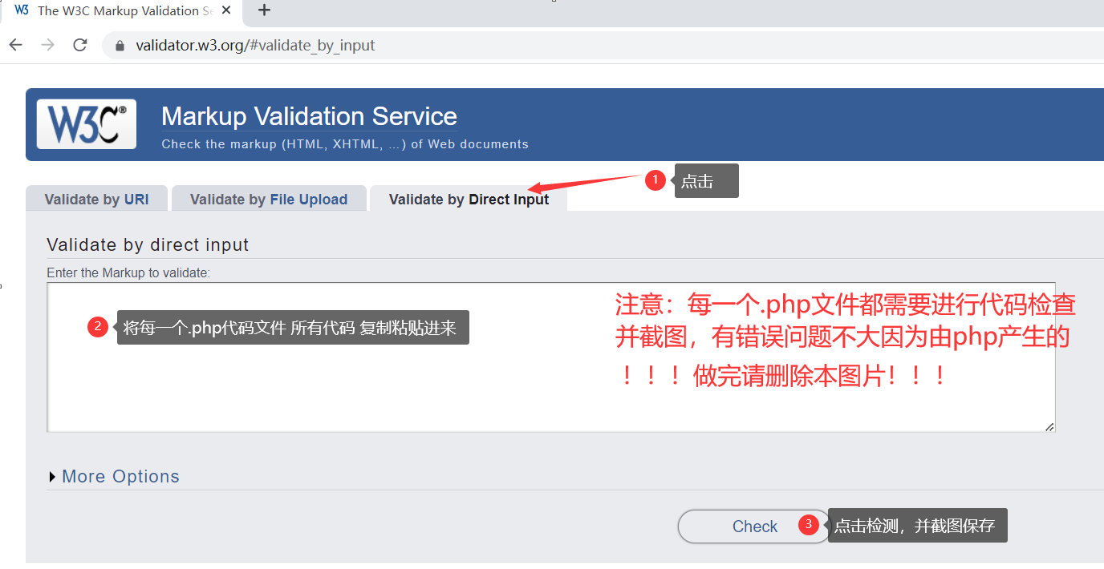

1：

2：

3：

4：

5：

6：

7：

8：

9：

10：

11：

12：

13：

14：

1. Validate the learners CSS code at <https://jigsaw.w3.org/css-validator/>

* Correct any errors

**Note:** The learner may ignore errors or warnings about browser prefixes

**Note:** There is a table for validating the learners CSS code in the template

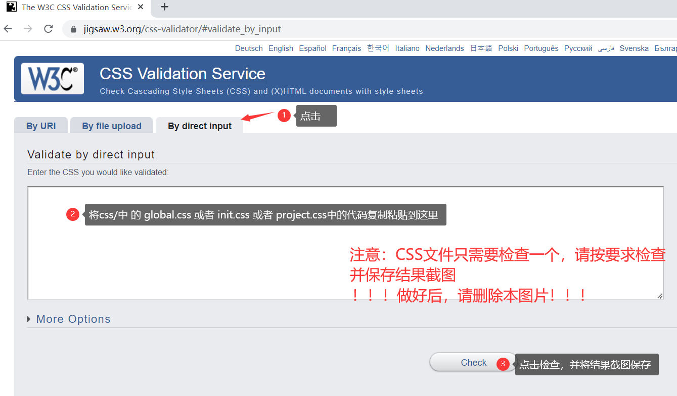

1. Identify gaps between specifications and requirements and markup language document. Evaluate web page functionality results and amend as required.

The functions and interfaces of all websites basically meet the project requirements.

Part 5: Demonstrate work and show foundation skills

Learners may be asked to demonstrate their work on their computer and will be asked questions regarding their code and design. Upon answering all questions to a satisfactory level, the learner will be graded as SC.

Learners may show their abilities throughout the assignment progress:

* Reading and upstanding the requirements
* Writing the text contents for the website
* Communicate with your assessor, and answer the questions of the assessor(s)
* Get assignment done within due date

The learner should obtain sign-off from required personnel to confirm requirements are met and finalise documentation according to organisational procedures, and complete the sign-off table below.

|  |
| --- |
| Thank you for meeting with me to discuss your project.  I have reviewed your website and document and confirmed that it was satisfied and met the given requirements.  Thank you for your great work. |
| SIGNATURE: YUPENG WU |

Upload and submit all files

The learner will need to ZIP all project files into one folder named “**Assessment_Task_3_s1234567**” (where Student ID is the student number) and upload the files to the Assessment Task on LMS. (<https://online.melbournepolytechnic.edu.au>)

The learner must agree (via an ‘I confirm’ radio button) with the assessment submission terms and condition in Melbourne Polytechnic LMS prior to the submission.

## Student Declaration

|  |  |  |  |
| --- | --- | --- | --- |
| Please read, tick and sign below | | | |
| ☑I declare that the attached assessment I have submitted is my own original work and any contributions from and references to other authors are clearly acknowledged and noted.  ☑This document has been created for the purpose of this assessment only and has not been submitted as another form of assessment at Melbourne Polytechnic or any other tertiary institute.  ☑I have retained a copy of this work for my reference in the event that this application is lost or damaged.  ☑I give permission for Melbourne Polytechnic to keep, make copies of and communicate my work for the purpose of investigating plagiarism and/or review by internal and external assessors.  ☑I understand that plagiarism is the act of using another person’s idea or work and presenting it as my own. This is a serious offence and I will accept that penalties will be imposed on me should I breach Melbourne Polytechnic’s plagiarism policy. | | | |
| Student Signature |  | Date | 28-5-2024 |
| Please note that your assignment will not be accepted unless you have:   * Completed all sections of the assignment * Acknowledged all sources of other people’s contributions including references and Students’ names for group work assessments * Completed all areas of this Student assignment cover sheet. | | | |

## Marking Guide

|  |  |  |  |
| --- | --- | --- | --- |
| Trainer/Assessor to complete the following: | | Yes | No |
| The learner has correctly awnsered all questions | |  |  |
| The learner has correctly submitted all required files | |  |  |
| Comments and feedback | | | |
|  | | | |
| result | | | |
| ☐ Satisfactory  ☐ Not Satisfactory (resubmission required) – Due date: ____________________________ | | | |
| Date Assessment Returned |  | | |
| Trainer/assessor Name |  | | |
| Trainer/Assessor signature | X | | |