AI Capstone HW1
112550169 潘仰祐

1. Implementation

Task 1: Data Collection
I successfully collected the data in the simulated environment.
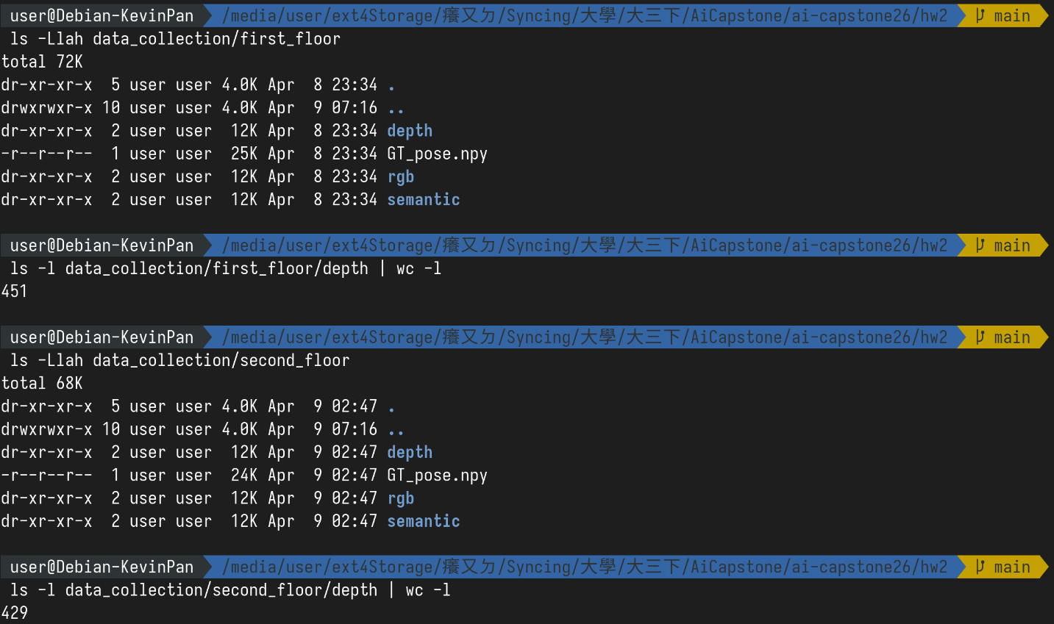
There is no TODO inside `load.py`, so I didn't modify it.

Task 2: ICP Alignment & 3D Map Reconstruction
I wrote the pipeline (reconstruct()) overview in Task 3, please check there.

1. Unprojection
I implemented it according to the instructions in the template code. Differently in TODO, I added a minus (-) in the y's equation, since we typically treats +y as the direction up in the 3D world, while we treat +v as the direction down (i.e., which row) for images.
Also, I removed those points with depth = 0, which have no depth value and may affect the reconstruction as noise.
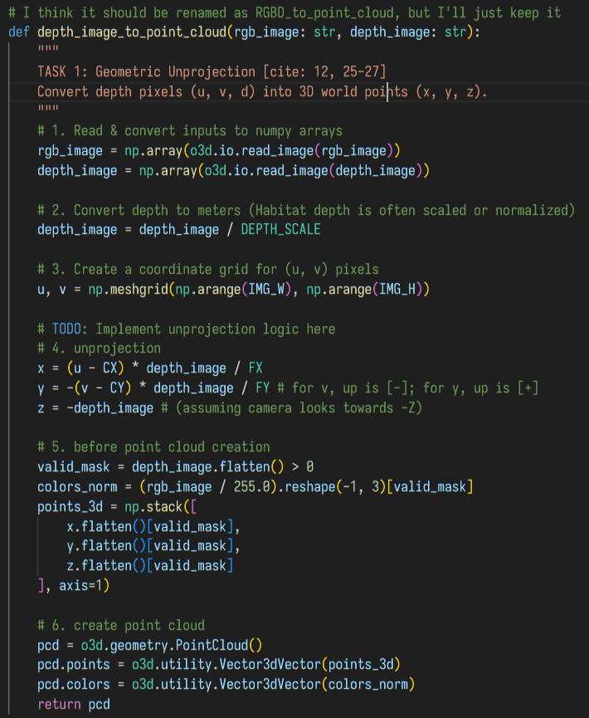

2. Preprocessing: Downsampling, Estimate Normals, and Compute FPFH
The downsampling code was already written in the template, but I learnt the reason to use it. Then, to estimate normals, the code will use the 30 nearest neighbours in 2.5x voxel_size away.
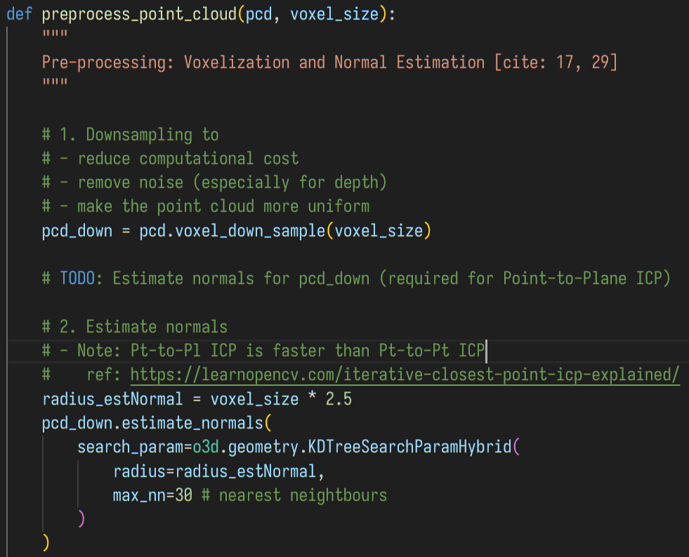
Then, I use the code directly from the template to fetch fpfh data:
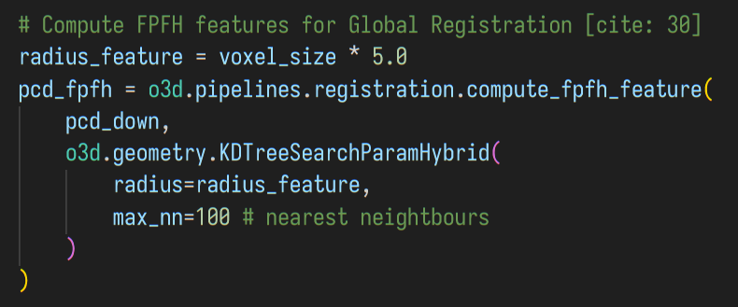
But more than that, I do a hack to inject the colour information into FPFH such that RANSAC can be more confident when it matches things correctly. However, if we need to use the code to reconstruct data collected from the real world, the code should convert the RGB space to HSL/HSV etc.: although the environment light sources should not change a lot and fast, shadows may temporarily reduce the lightness, so hue and saturation are the only two reliable factors.

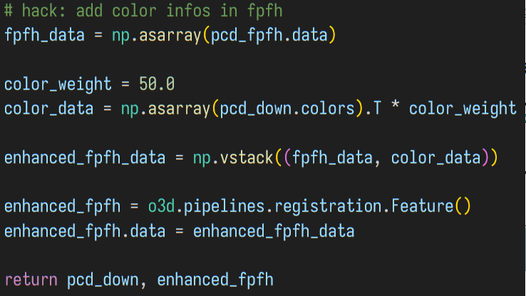

Global Registration (RANSAC)
I wrote a loop that tries 50 times to do RANSAC and ICP. The core logic of execution and validation are in separate functions, reconstruct__ransac() and reconstruct__icp(). I tried to use o3d.utility.random.seed() to make the result deterministic, but it doesn't work. I guess it runs in parallel in background.
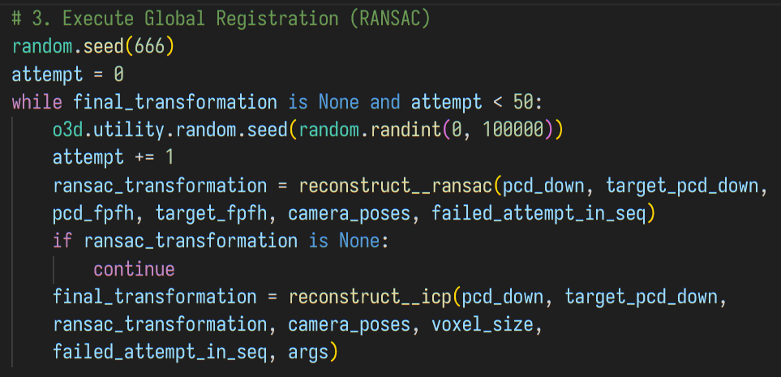
In reconstruct__ransac(), the core is to execute this function. It tries 100000 times to find a match with confidence=0.9.
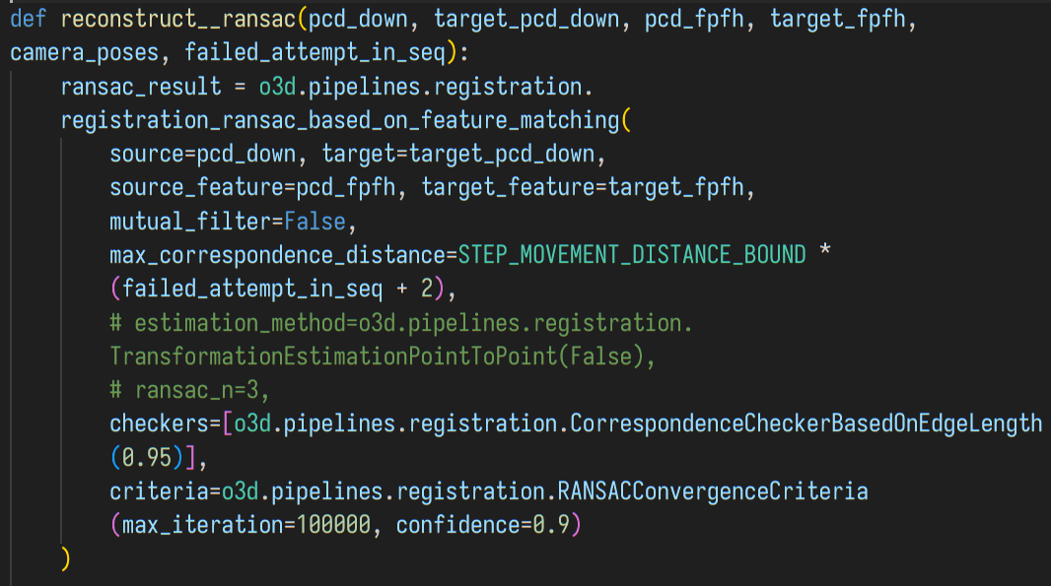
After that, the result is checked to ensure it's not a bad start point. (See Q2 "Assumption and Validation" for more detailed explanation.)
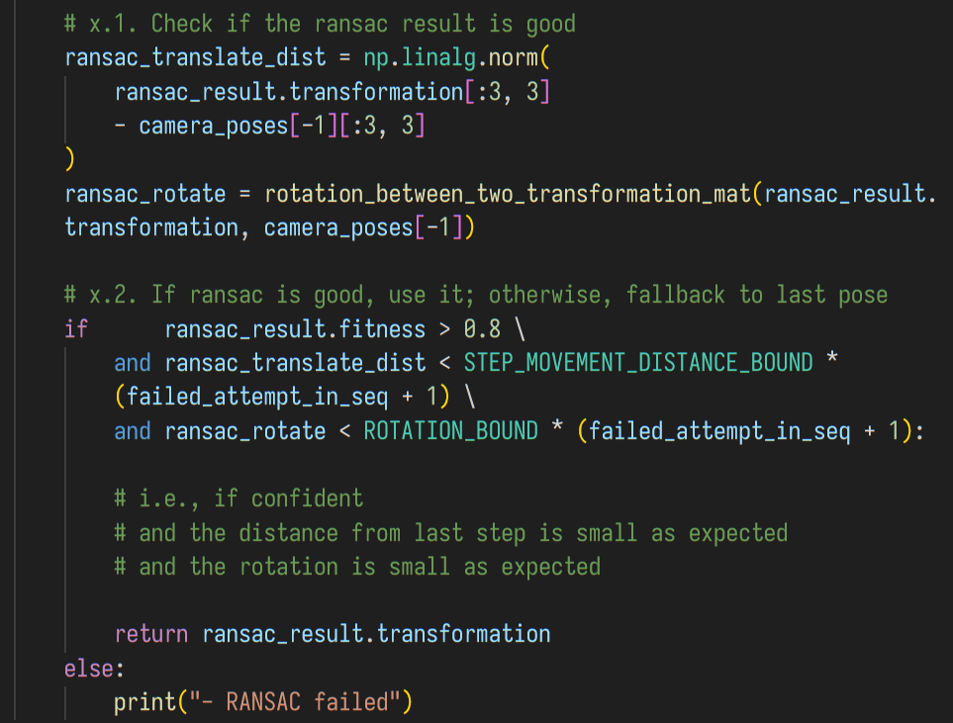
In reconstruct__icp(), it follows a similar procedure. First it executes (my_)local_icp_algorithm() to run the point-to-plane ICP.
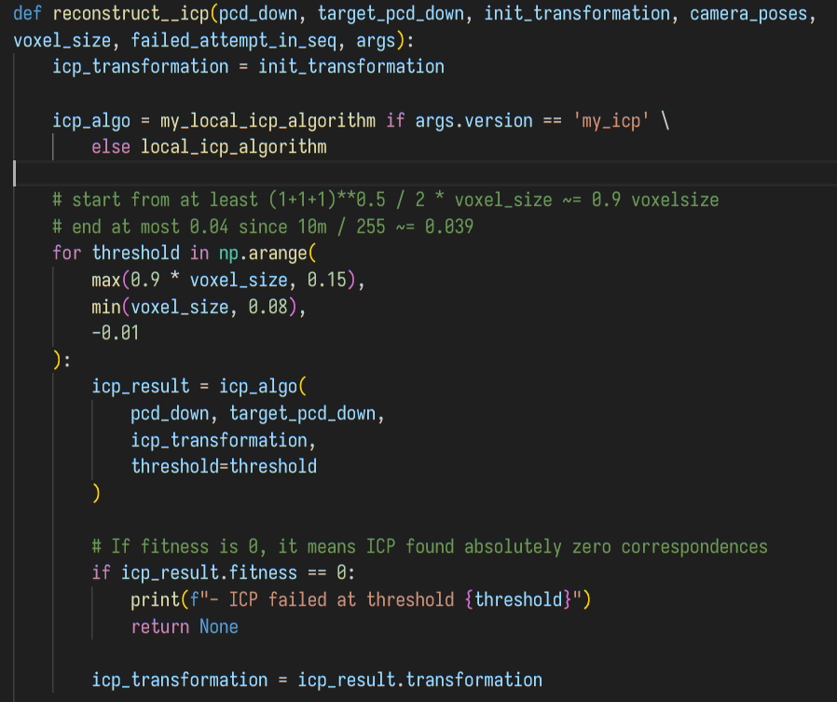
Then, it will check the result. (Still, see Q2 "Assumption and Validation".)
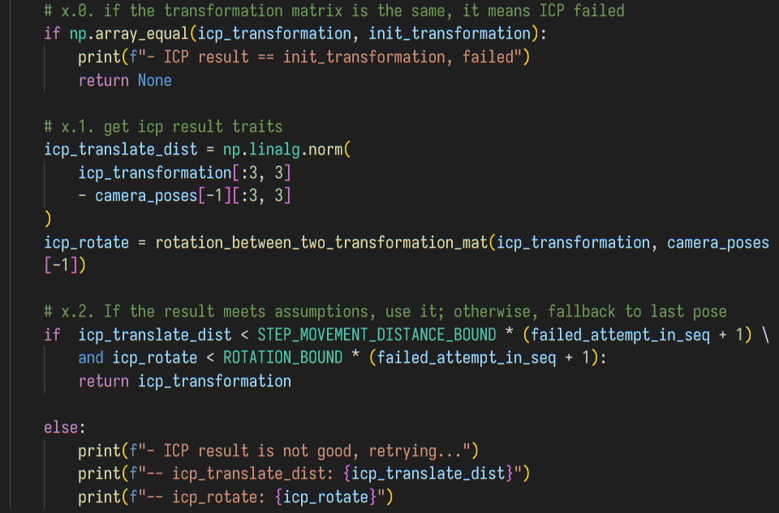
In my code, local_icp_algorithm() and my_local_icp_algorithm() shares the same parameter format with different logic. The prior directly calls the o3d's point-to-plane ICP function, with 0.001 relative_fitness, 0.001 relative_rmse and 50 iterations at max as the termination criteria.
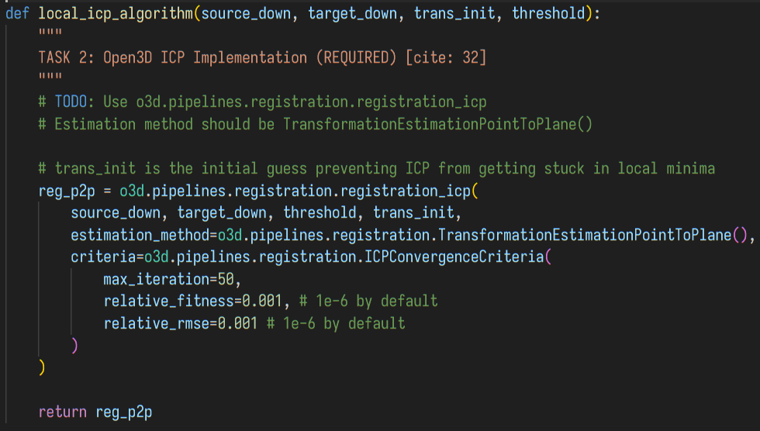
In my_local_icp_algorithm(), my code first create a K-D Tree for the search of the target point cloud later.
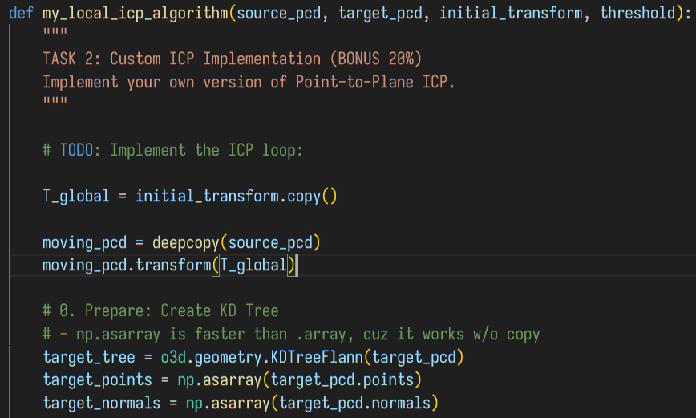

Then, for each point in the source point cloud, it find the nearest neighbour in the target point cloud through the tree. Here, in order to boost, I tried to preallocate the spaces with np.zeros(), but the contribution to the speed is not significant. The code also runs 50 iterations at most.
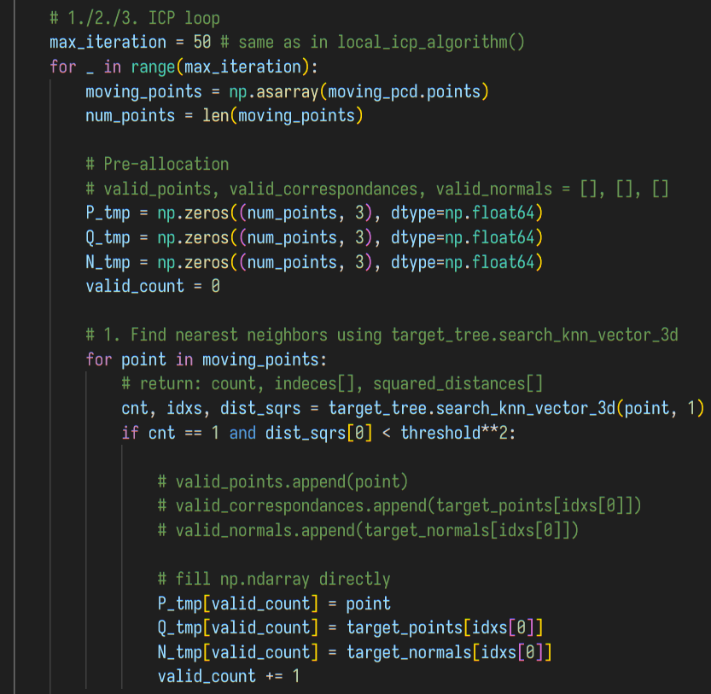
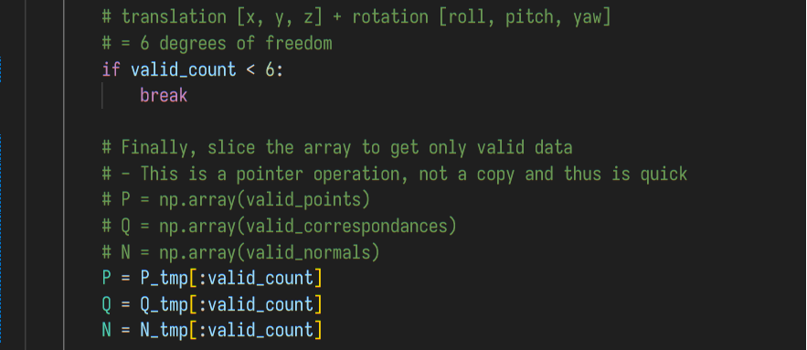
Then, I built and solved the linear system . I didn't use the formula provided by the code template. Instead, I simply use np.linalg.lstsq(), because it use other methods that don't directly get the inverse of , which is more stable for ill-conditioned matrices. The formulae derivation is collapsed in the code, encapsulated with an empty {}.
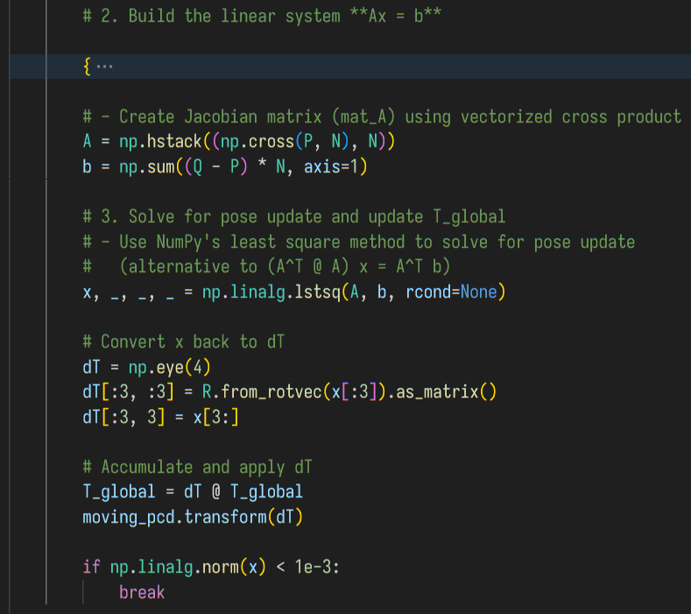
Then, a result mimicking open3d's is generated and returned.
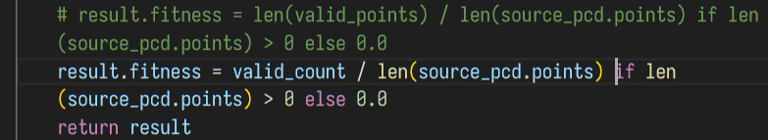

Task 3: Camera Pose Estimation & Visualization

Scene: reconstruct() Overview & Cloud Accumulation & Ceiling Cut
In my code, I have two voxel_sizes: one is for the registration process, and the other is for displaying. First I load the files and sort them with the number (note: the sorting key function is added, different from the template.)
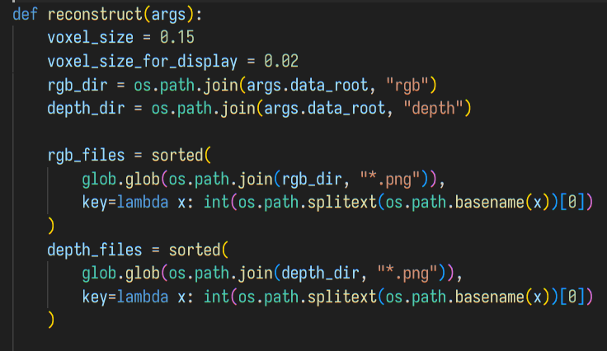
The Load Ground Truth Poses code is omitted since it's the same as the template. Then, I maintain two point clouds: one is for registration, one is for display.
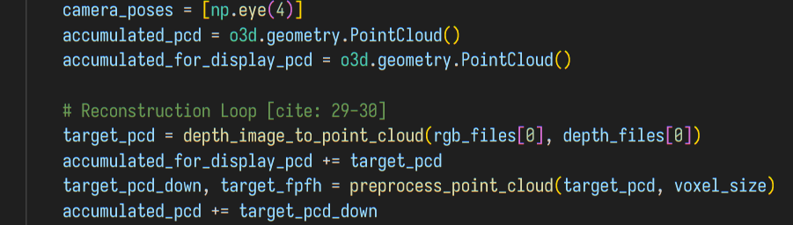

Then, the reconstruct loop calls each function mentioned in Task 2 for each frame.
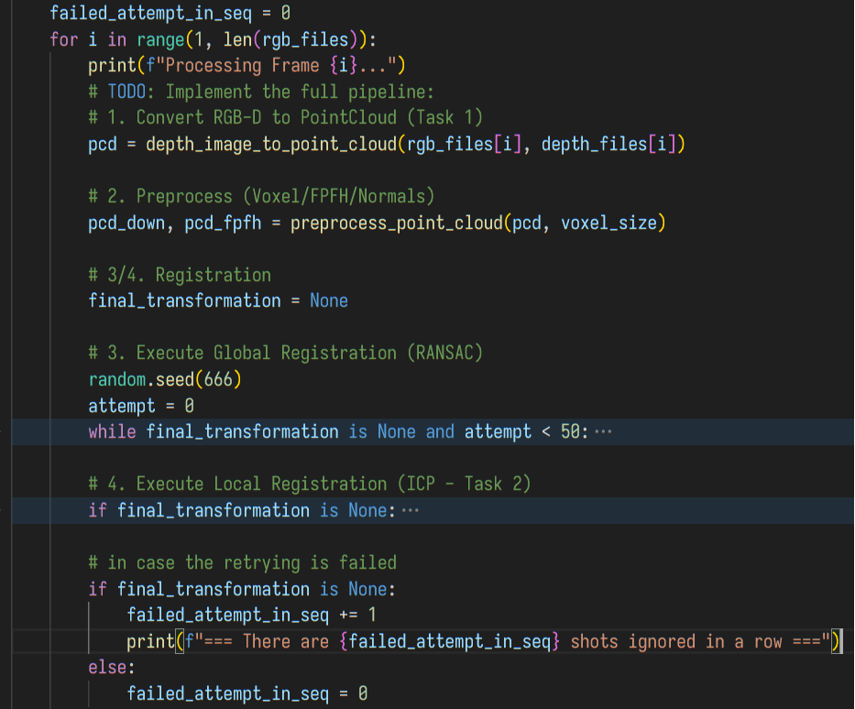
(5. Update camera_poses is described in next section) After each iteration, it clip a box of point cloud centred at the current position from accumulated_pcd (the current frame is not yet stored inside), merge it with the current frame, and generate target_pcd form next iteration.
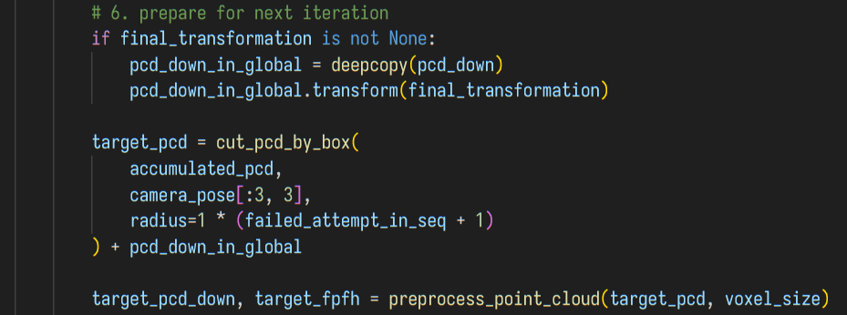
After that, it add the current point cloud into the two accumulated ones. accumulated_pcd use the down-sampled one, while accumulated_for_display_pcd simply use the original one for now.
In the end of each reconstruction iteration, it optionally downsamples the two clouds to prevent out of memory. I think that's because I takes 400~600 shots when collecting data, which is more than 152, 129 or 213 frames mentioned in homework spec.
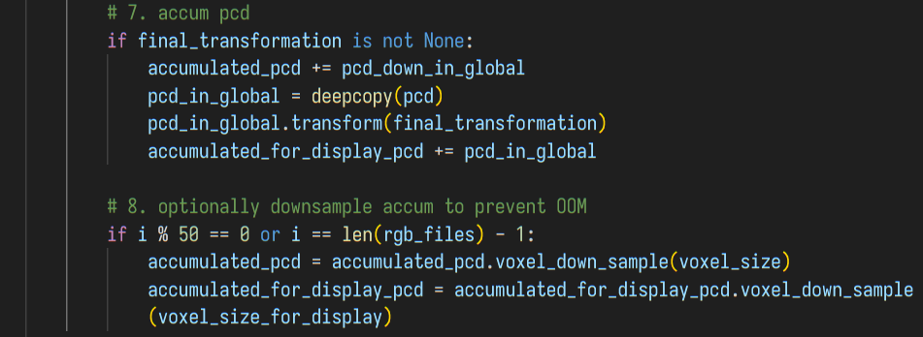
After the reconstruction, the point cloud will be cut to remove the ceiling. (I also returned the uncut one for easily debugging.)
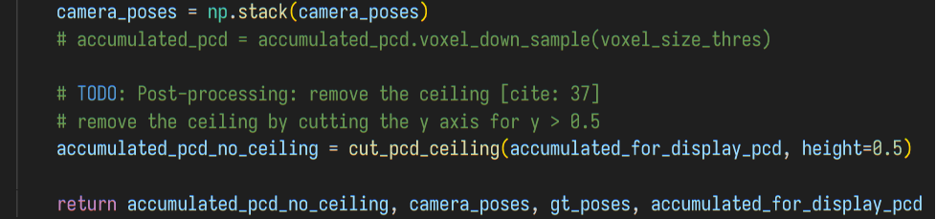
Here are the functions to cut. cut_pcd_by_box() is to get a cube of points from the accumulated_pcd for the next reconstruction iteration, while cut_pcd_ceiling() removes the ceiling. (Height is 0.5 in the end of reconstruct().)
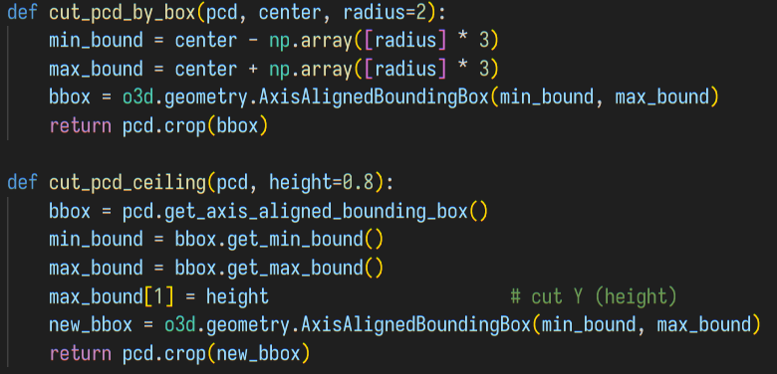

Trajectory & Camera Pose Estimation
For each shot, if ICP failed, the camera pose estimation directly uses the last pose. Otherwise, it uses the transformation calculated by ICP.
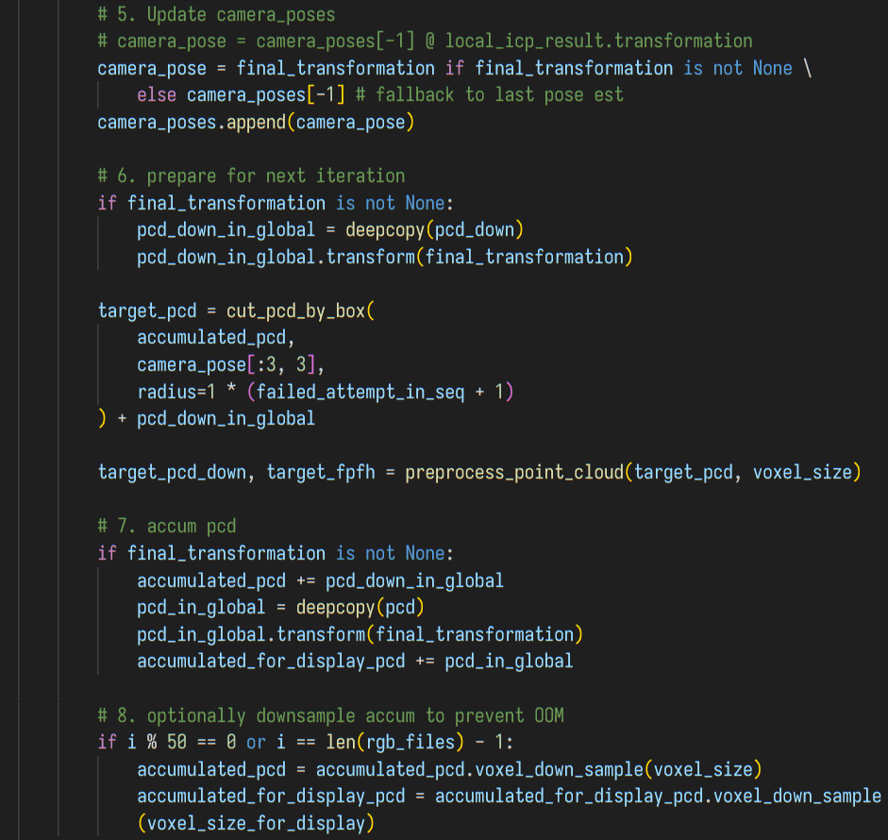
Later in visualize_and_evaluate(), the translation is extracted from the local-to-global transformation matrix. (Ground truth follows the same procedure; omitted in this report.)
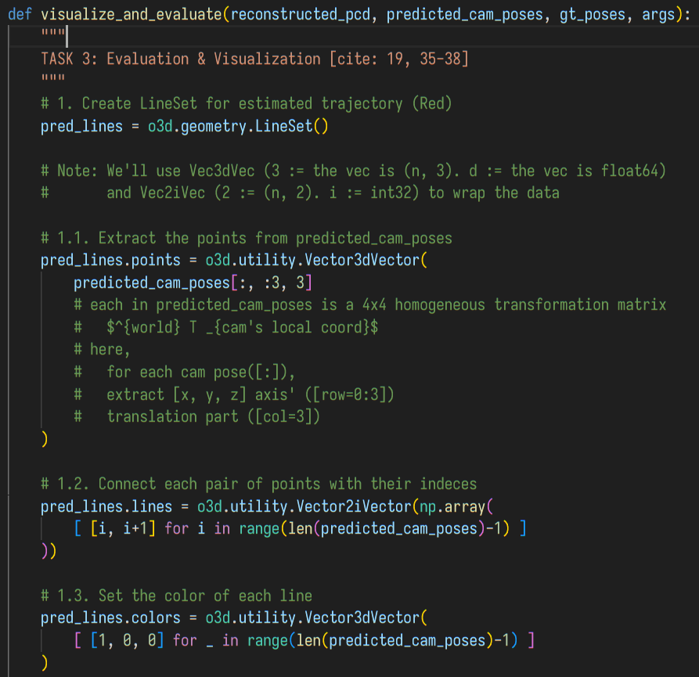

Evaluation & Visualization
The Mean L2 distance is calculated as .
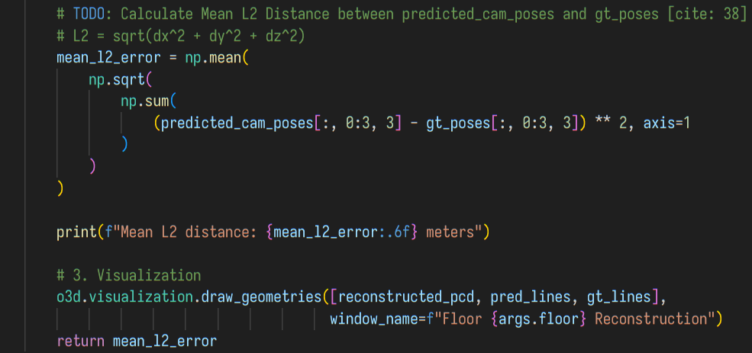
In the main block, the execution time is displayed (this is the code from template). By the way, I added argument checks to warn the user if there's any typo.
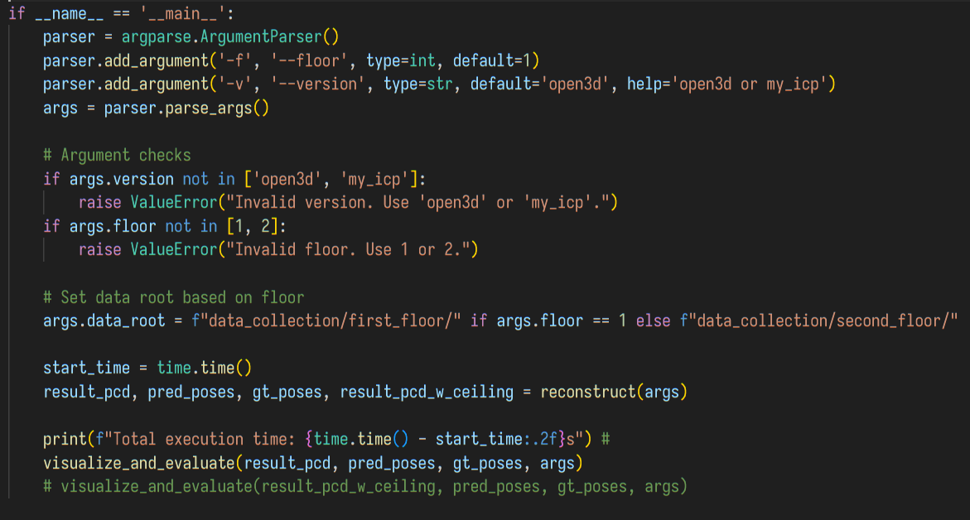

Result & Discussion

Screenshots of apartment_0 Floor 1 reconstruction
Here are the screenshots of my reconstruction. These use the open3d version (Test 1 in the table below):
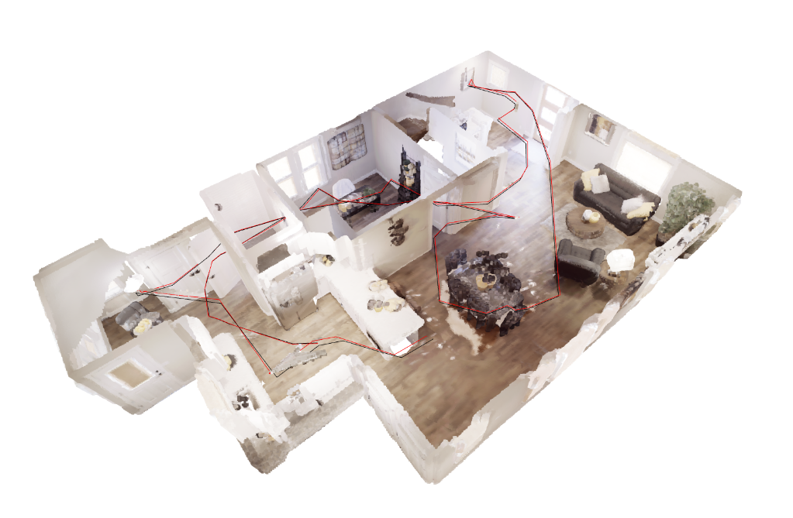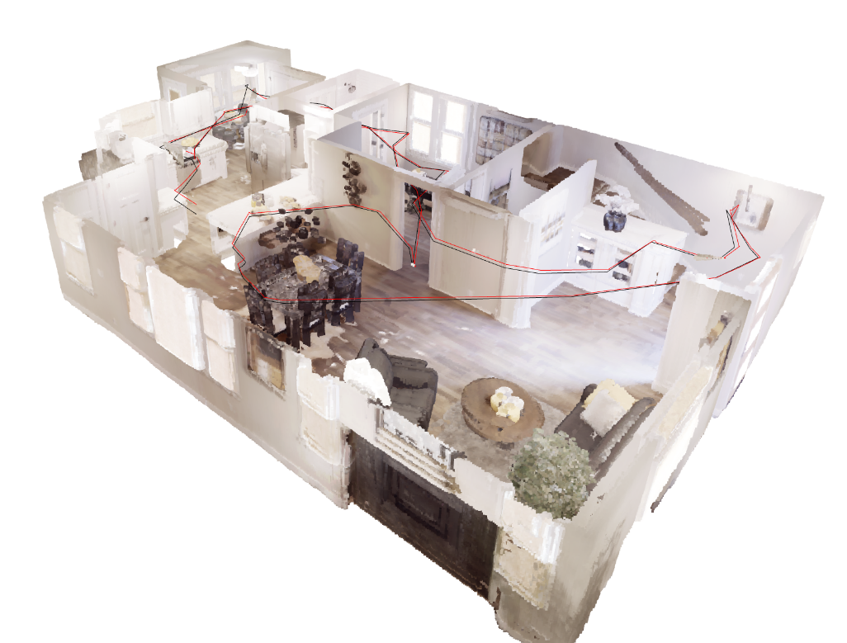
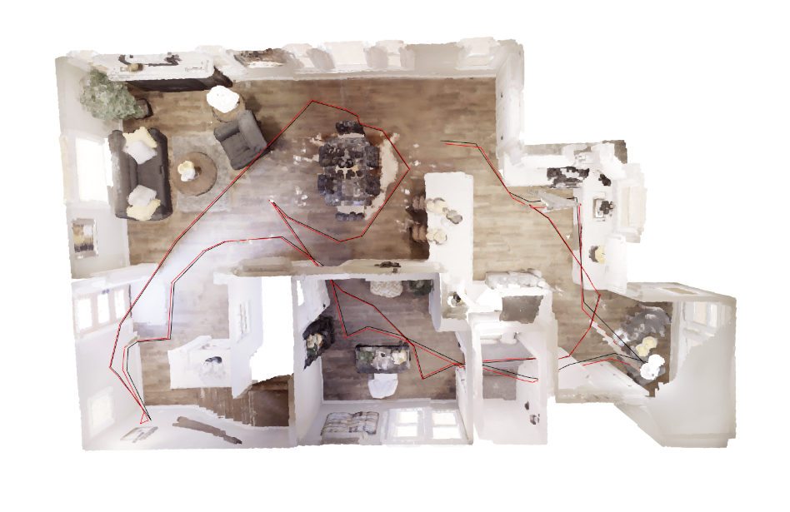

While these use the my_icp (Test 2 in the table below):
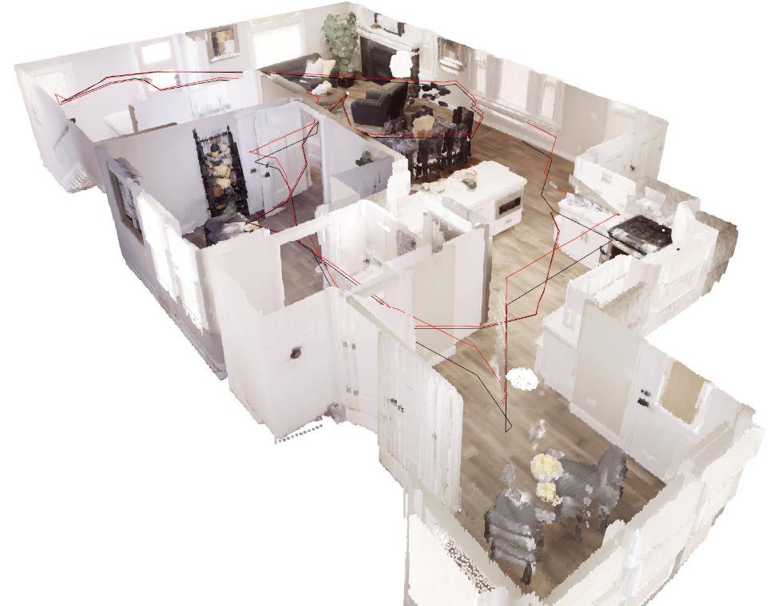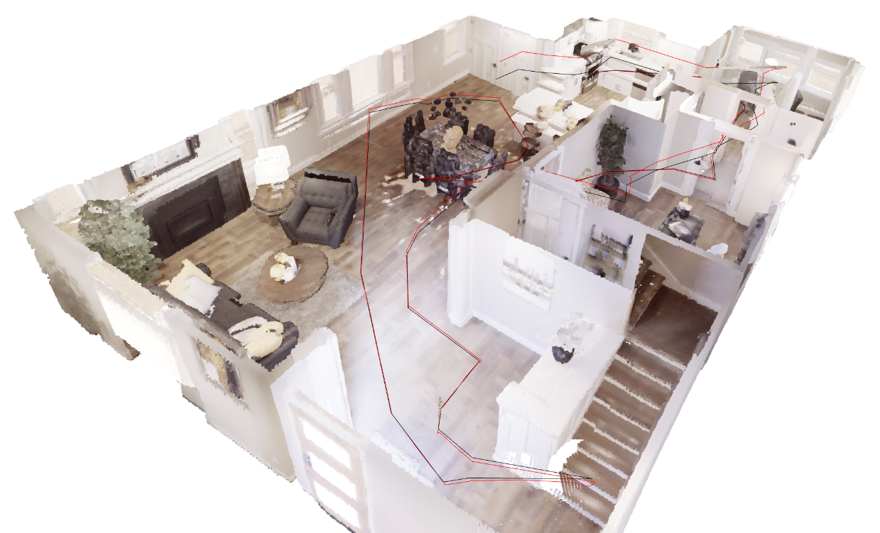
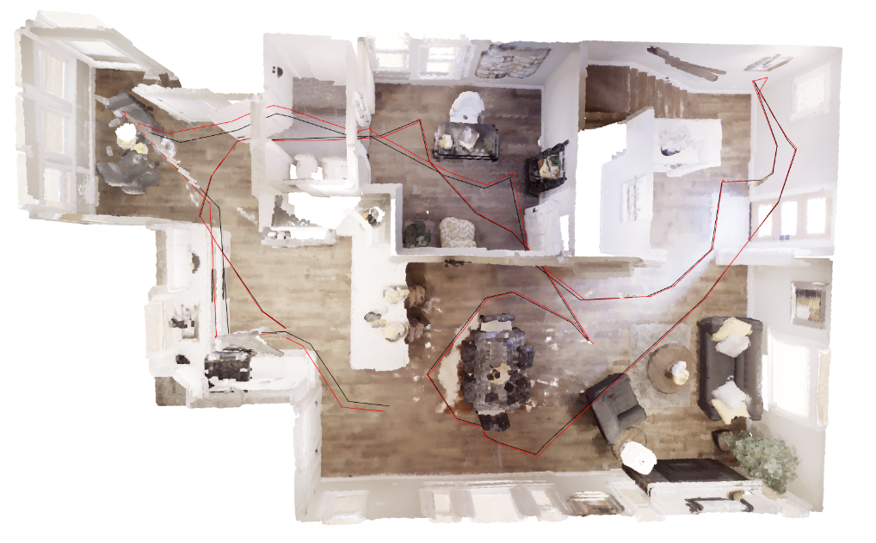
They are reconstructed from 449 different camera shots.

A comparison table (of Hyperparameters and outcomes)
I've tested so many times, but here lists four of them with the same 449-shot collected dataset:
 | Test 1 | Test 2 | Test 3 | Test 4
Voxel Size | 0.15 | 0.15 | 0.15 | 0.25
Voxel Size  for Display | 0.02 | 0.02 | 0.02 | 0.02
Normal Estimation | radius=2.5 * voxel_size, max_nn=30
FPFH Extraction | radius=radius_feature, max_nn=100
FPFH Color Weight | 50
Tolerance ratio of assumptions | 1.5
Assume Max Movement | 0.25m
Assume Max Rotation | 10°
ICP Version | open3d | my_icp | my_icp | open3d
ICP Convergence Criteria  (open3d): [fitness, rmse]  (my_icp): step size L2 norm | max_iteration=50.
 | [0.001]*2 | 0.0001 | 0.001 | [0.001]*2
Multi-step ICP  with threshold  [start, end, gap] | [ max(0.9 * voxel_size, 0.15),  min(voxel_size, 0.08),  -0.01 ]
RANSAC Random Seed | 666
RANSAC Convergence Criteria | max_iteration=100000, confidence=0.9
RANSAC Max Retry | 50
Downsample Accum.  per {} Iterations | 50
Cut Ceiling Height | 0.5
Execution Time | 83.20s | 139.96s | 200.09s | 74.87s
Mean L2 Distance | 0.302346m | 0.355584m | 0.315211m | 0.503479
Is visually good? | Yes | Yes | Yes | No  (See below)

Discuss the result

Voxel Size and visual result
It took me a long time to achieve a visually good result. When there are more shots, the chance to have a broken reconstruction increase. For example, this is a screenshot from Test 4 in the table above:
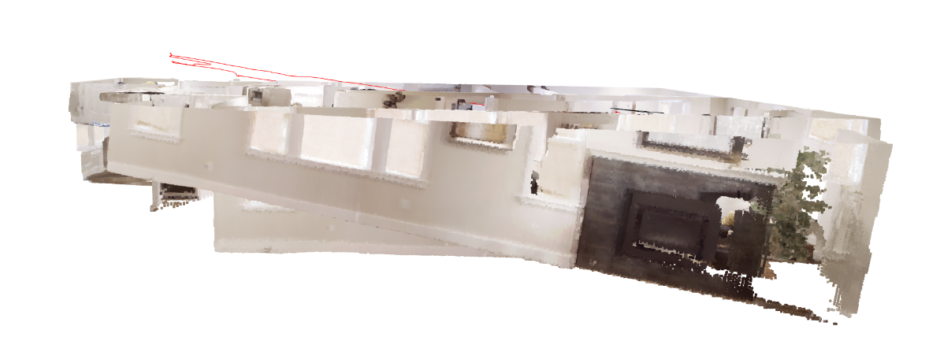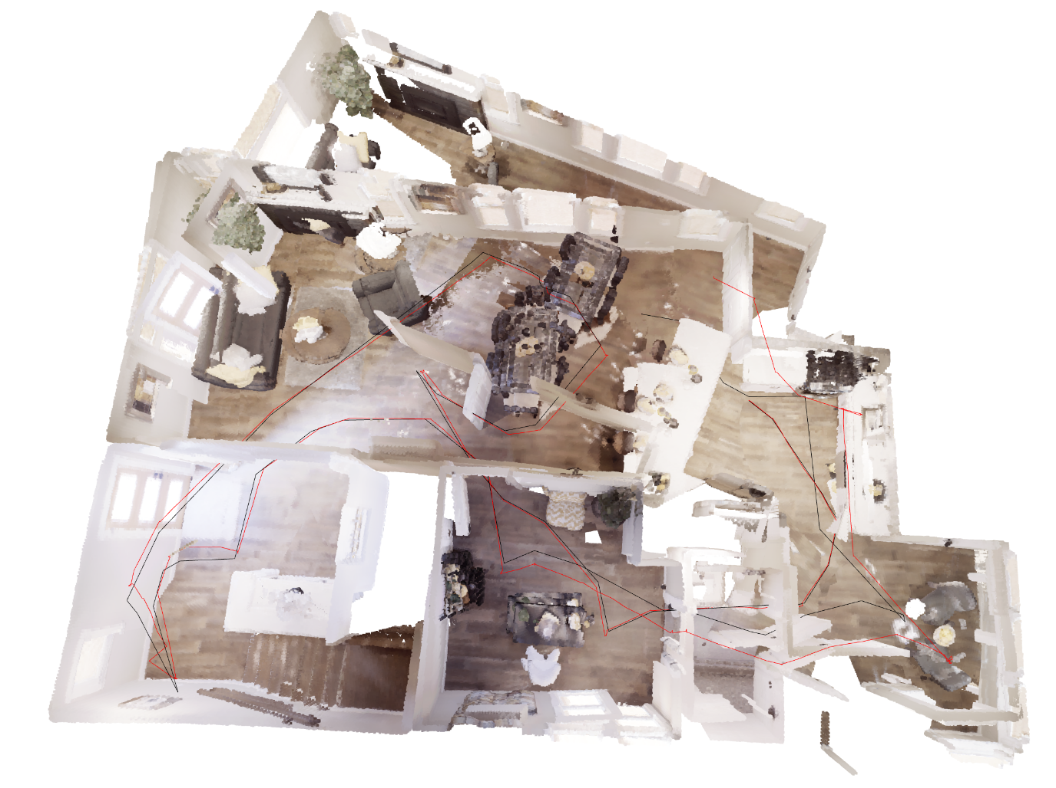
As you can see, with a higher voxel_size during registration, the shots fail to align with each other. I didn't find an efficient way to fix it under any voxel size, but I found that voxel_size = 0.15 is a great balance between speed and performance.

my_icp and open3d
To reduce the execution time, I learnt to use np.asarray() over np.array() or np.stack() for pcd.points, for it can directly use the data without copy, which obviously boost the progress. Also, I used space pre-allocation with np.zeros() to prevent list .append() and np.array() conversion, but this didn't boost that much as I observe.
So, the final result is,
- To achieve a similar precision as open3d's Point-to-Plane ICP Algorithm, it takes approximately 2.5x the time.
- To achieve a similar speed as open3d's algorithm, mine has a higher (but still tolerable) Mean L2 distance between the trajectory prediction and ground truth.
I think the main reason for this is that, Python itself is a script language that interpretation and type checking cause overheads, which my ICP algorithm implemented upon it also inevitably needs to bear with. In contrast, open3d's algorithm is implemented in C/C++ and compiled beforehand, and thus it's pretty fast.

2. Questions

Q1: What happens if you perform ICP without Global Registration (RANSAC)? Why?
In my experience, it fails when I directly use the last camera pose estimation (transformation) as the initial transformation, which results in a much worse visual output and meter-level Mean L2 distance between the predicted and ground-truth trajectories. I think there mainly are two reasons:
- ICP falls into local minima. An initial value that's not good enough cause ICP trying to align objects with a wrong one.
- Registration without the global information (which is cut to a 1m³ size from the accumulation point cloud in my code) accumulates the error.

Q2: Describe any tricks used to improve your ICP stability (e.g., Voxel size, Huber loss, etc.).
To increase the stability, I used these tricks:
- Multi-iteration of ICP with Progressive Thresholds:
  - ICP only pair points between which the distances are within a threshold. In my implementation, the threshold shrinks from max(0.9 * voxel_size, 0.15) to min(voxel_size, 0.08). The result is a much finely aligned world, which is also more stable.
- Aid with global data:
  - If we RANSAC and ICP with only the reconstructed point cloud of last frame, the error accumulates.
  - If we RANSAC and ICP with the whole accumulated point cloud (the world), it will be so slow for sure, and RANSAC will take a long time trying to match points far away from each other if it's not set up correctly.
  - Instead of simply using either of thme, I merge it with a 1m³ cube of point cloud cut from the accumulated point cloud. This gives RANSAC and ICP more information and increases the probability of successful registration, while controls the execution time in an acceptable range.
- Assumption and Validation: (about translation and rotation)
  - Investigating into load.py, I know that the default step size for "move_forward" is 0.25m, while the default rotation for "turn_left" and "turn_right" is 10°.
  - Therefore, I assume the result rotation and translation should be within 1.5x the values, where I call the 1.5x as the tolerance.
  - If the RANSAC or ICP result is not within the assumption, my code recalls RANSAC for up to 50 times to get another initial guess and falls back to the last camera_pose estimation (transformation matrix). If both of these don't work, it skips this shot and temporarily increases failed_attempt_in_seq to loosen the tolerance and use more global data.
I believe this is a reasonable operation - in the real world, inertia measurement units (IMU) may be used to estimate the movement and rotation, while technologies like ultra wide band (UWB) can be use to estimate the indoor position with a precision fine to 10cm level.

