AI Capstone HW4
112550169 潘仰祐

Task 1

your_fk() Explanation
In your_fk(), first I defined an helper function that generates the transformation in Classic D-H procedure. Those rotations and transformations can be represented as homogeneous coordinate matrices and can be multiply together into a single matrix.
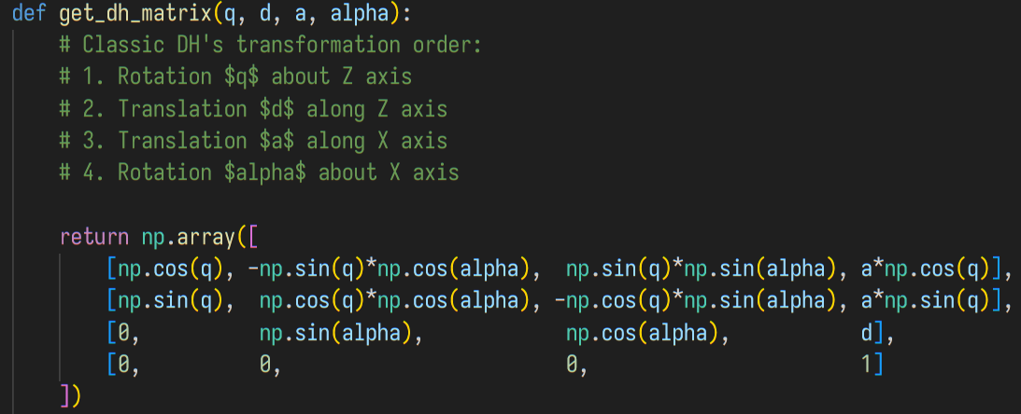
Then, I implemented the core of Classic D-H procedure. I found it more easy to think of it as "creating local coordinate systems (frames)" for each joints because as the 3D animation mentioned, the origins may not be within the physical actuators.
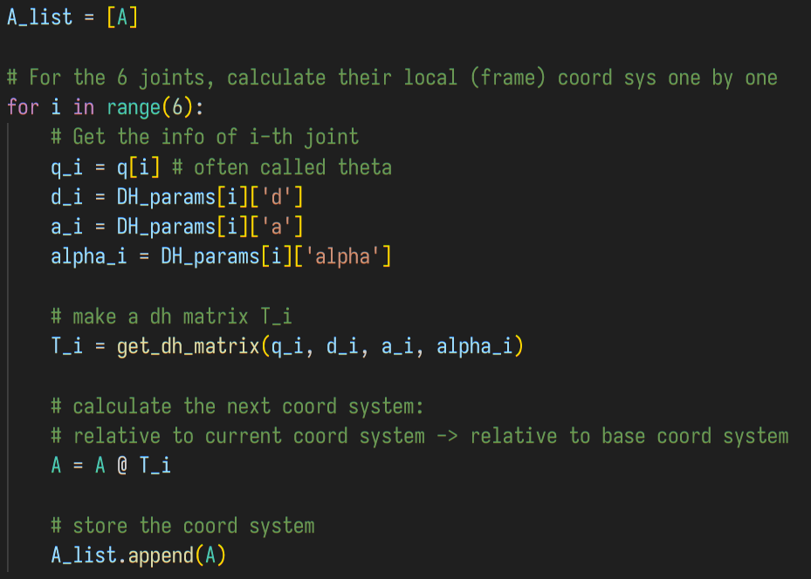
The part for Jacobian will be mentioned in Task 2.

Classic D-H Convention vs. Modified (Craig's) D-H Convention
I found it more easier for me to understand the differences through pseudo codes that transforms the physical positions of joints from the local coordinate system (bind to joints; their z-axes are the rotational centre axes of joints) to the base coordinate system.
# Modified D-H
A_list = [A_base]
global_pos = []
for i in range(6):
T[i] = modified_dh(q[i], d[i], a[i], alpha[i])
A = A_list[-1] @ T[i]

A_list.append(A) # i.e. A_list[i+1] := A

local_pos = ... # load it from URDF, etc.
global_pos.append(A @ local_pos) # i.e.,
# global_pos[i] := A_list[i+1] @ local_pos

def modified_dh(q, d, a, alpha):
# Modified DH's transformation order:
# 1. Translation $a$ along X axis
# 2. Rotation $alpha$ about X axis
# 3. Rotation $q$ about Z axis
# 4. Translation $d$ along Z axis
return Mat(1.) @ Mat(2.) @ Mat (3.) @ Mat(4.)

# Classic D-H
A_list = [A_base]
global_pos = []
for i in range(6):
T[i] = classic_dh(q[i], d[i], a[i], alpha[i])
A = A_list[-1] @ T[i]

A_list.append(A) # A is A_list[i+1]

local_pos = ... # load it from URDF, etc.
global_pos.append(A_list[i] @ local_pos) # i.e.,
# global_pos[i] := A_list[i] @ local_pos

def classic_dh(q, d, a, alpha):
# Classic DH's transformation order:
# 1. Rotation $q$ about Z axis
# 2. Translation $d$ along Z axis
# 3. Translation $a$ along X axis
# 4. Rotation $alpha$ about X axis
return Mat(1.) @ Mat(2.) @ Mat (3.) @ Mat(4.)

But they share the same spirits: aligning the x-axis to the common perpendicular segment between the two z-axes of neighbour revolute joints. And therefore, the D-H parameters are indeed very similar, with a slight offset and compensation by zeros. For example, extracting and modifying the parameters of ur5 from fk.py:
Classic D-H Parameter table
Index
1
2
3
4
5
6
Modified D-H Parameter table
Index
1
2
3
4
5
6

D-H Table for Franka (7 DoF)
Given the Classic D-H convention following this procedure at step :
- Move along Z-axis by and rotate about Z-axis by , to make X-axis align to the common perpendicular segment. (In 3D space, around the same axis, the order between rotation and translations are interchangeable.)
- Move along X-axis by and rotate about Z-axis by to align the Z-axes.
Assume the values , , and are all positive values and we need to add signs to indicating the translation and rotational directions. Then, the table for Franka's setting will be as the below (left).
Index
1
2
3
4
5
6
7

Index
1
2
3
4
5
6
7
If we put the real values of Franka's D-H parameters online (ref1, ref2), we can get another table as the above (right).
- Notice that in ref1, the tables is a Modified D-H table, and the flange and joint 7 are splitted.
- Notice that in both refs, the frames have different local coordinate systems and thus the signs are different in joint 1 and 2.

Task 2

your_ik() implementation
First, to form a Jacobian matrix indicating the instant velocity (linear and angular), we need to gather the information from the frames (local coordinate systems) during the FK process. Thus, I modified your_fk() to just calculate it there. I follows the formulae mentioned by Professor Yi-Ting's Lecture 8, which calculates the linear velocity part of Jacobian with a cross product of z-axis vector (the rotational center) and a vector from current frame to end effector, both are represented in the base coordinate system.
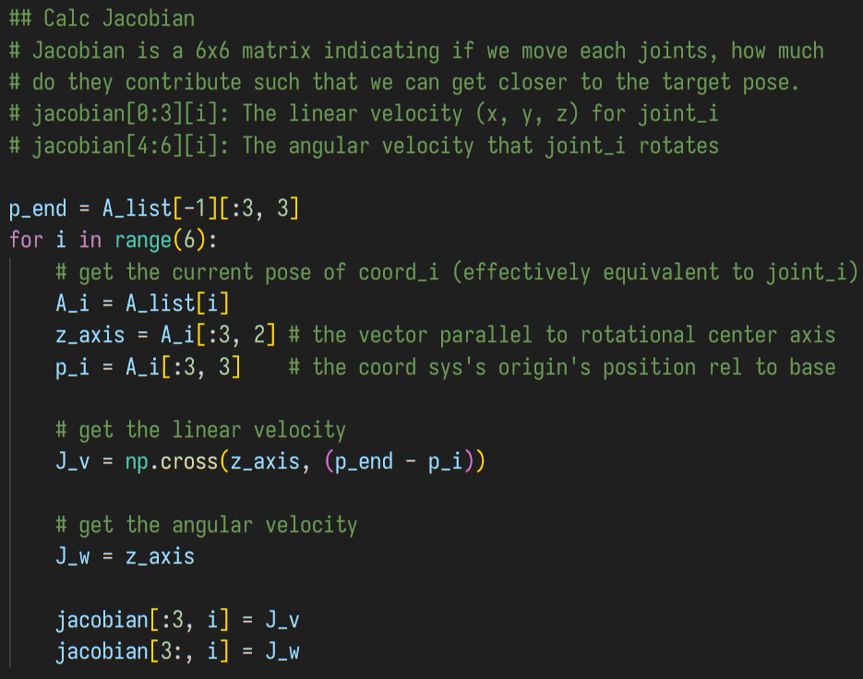
Then, the list of thetas (list of q) is calculated by iteratively optimizing the error between the new_pose and current_pose of the end effector. This is the Jacobian Pseudo-Inverse method.
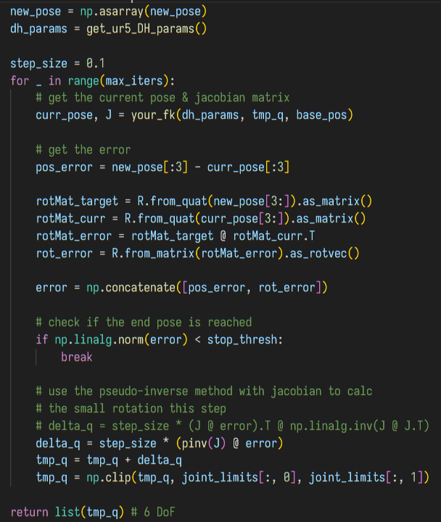

Problems I've Encountered
The main problem of this homework are almost all about setting up the environment. First, I tried the uv environment on Glows.ai, but it just won't work and multiple segmentation error happens.
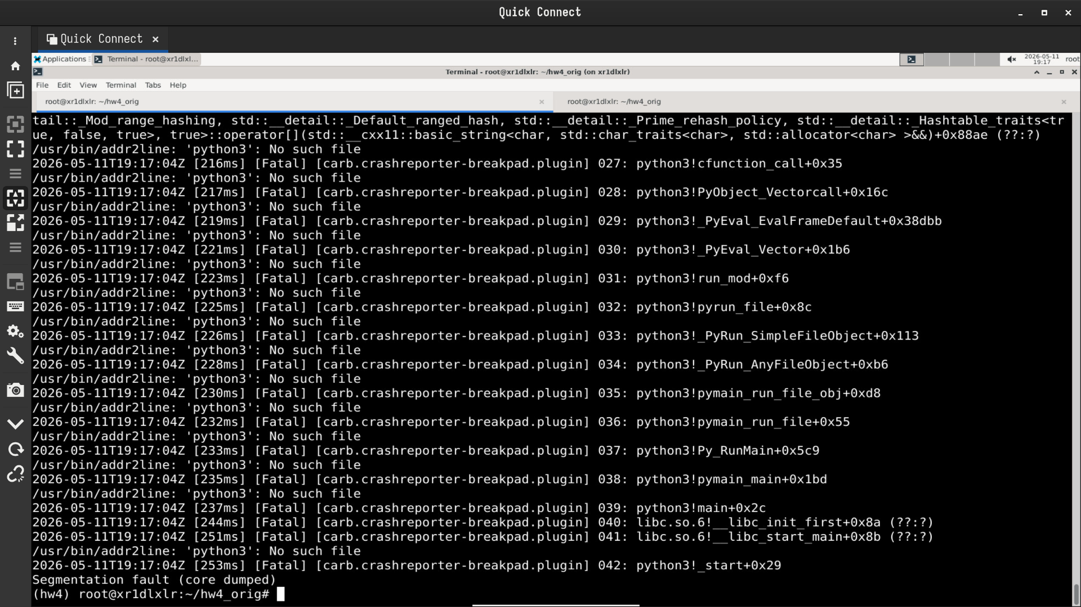
Then, I've tried the docker method on the Glows.ai instance. However, it is time consuming and is a waste of the precious 1 point credit. It takes like half an hour without success, so I stopped it and turned to find other solutions.
Glad that, I have good friends, who know how to debug. By setting this list of environmental variables, I can successfully fix the errors and proceed:
- export VK_ICD_FILENAMES=/etc/vulkan/icd.d/nvidia_icd.json
-> This tells Vulkan to use Nvidia's Driver
- export OMNI_KIT_ARGS="--/renderer/multiGpu/enabled=false --/app/renderer/activeGpu=0 --/rtx/verifyDriverVersion/enabled=false"
-> This tells Glows.ai to use a specific single graphic card and bypass
driver version checks
- export OMNI_KIT_DISABLE_DRIVER_VERSION_CHECK=1
- export OMNI_DISABLE_DRIVER_CHECK=1
-> The last two also disables version checks.
With these patches, I could succesfully run both fk.py and ik.py within minutes.

No Bonus
I found it actually time consuming to understand the algorithms and set up the development environment, which takes me about two whole days.

The Screenshots about Passing Task 1 & 2
These two images shows that I have successfully connected to a temporary instance on glows.ai and runs the task1's testcase under uv. The commands are (in the uv environment, .venv): "python fk.py --headless" and "python fk.py". I didn't wait till the latter stops because it is so time consuming to render GUI.
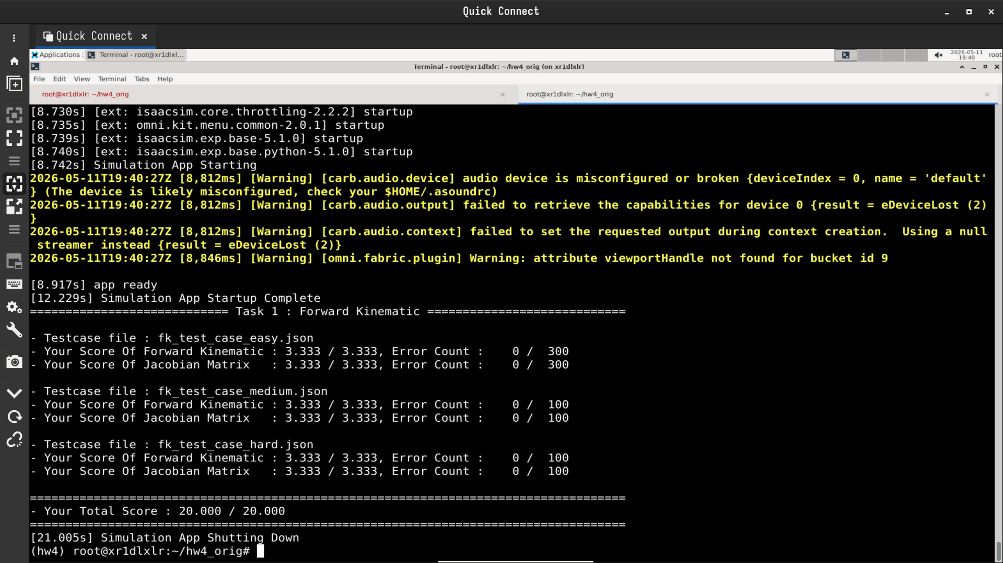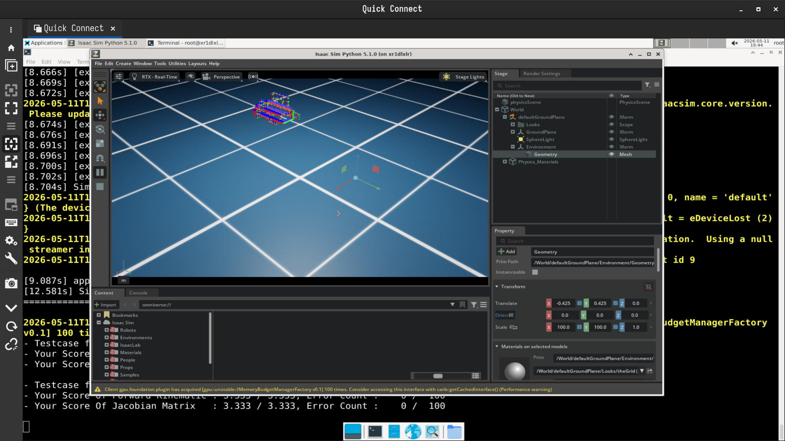
Then, these two are for task2. The commands are (also in the uv environment .venv):
"python ik.py --headless" and "python ik.py". I also didn't wait till the GUI stops.
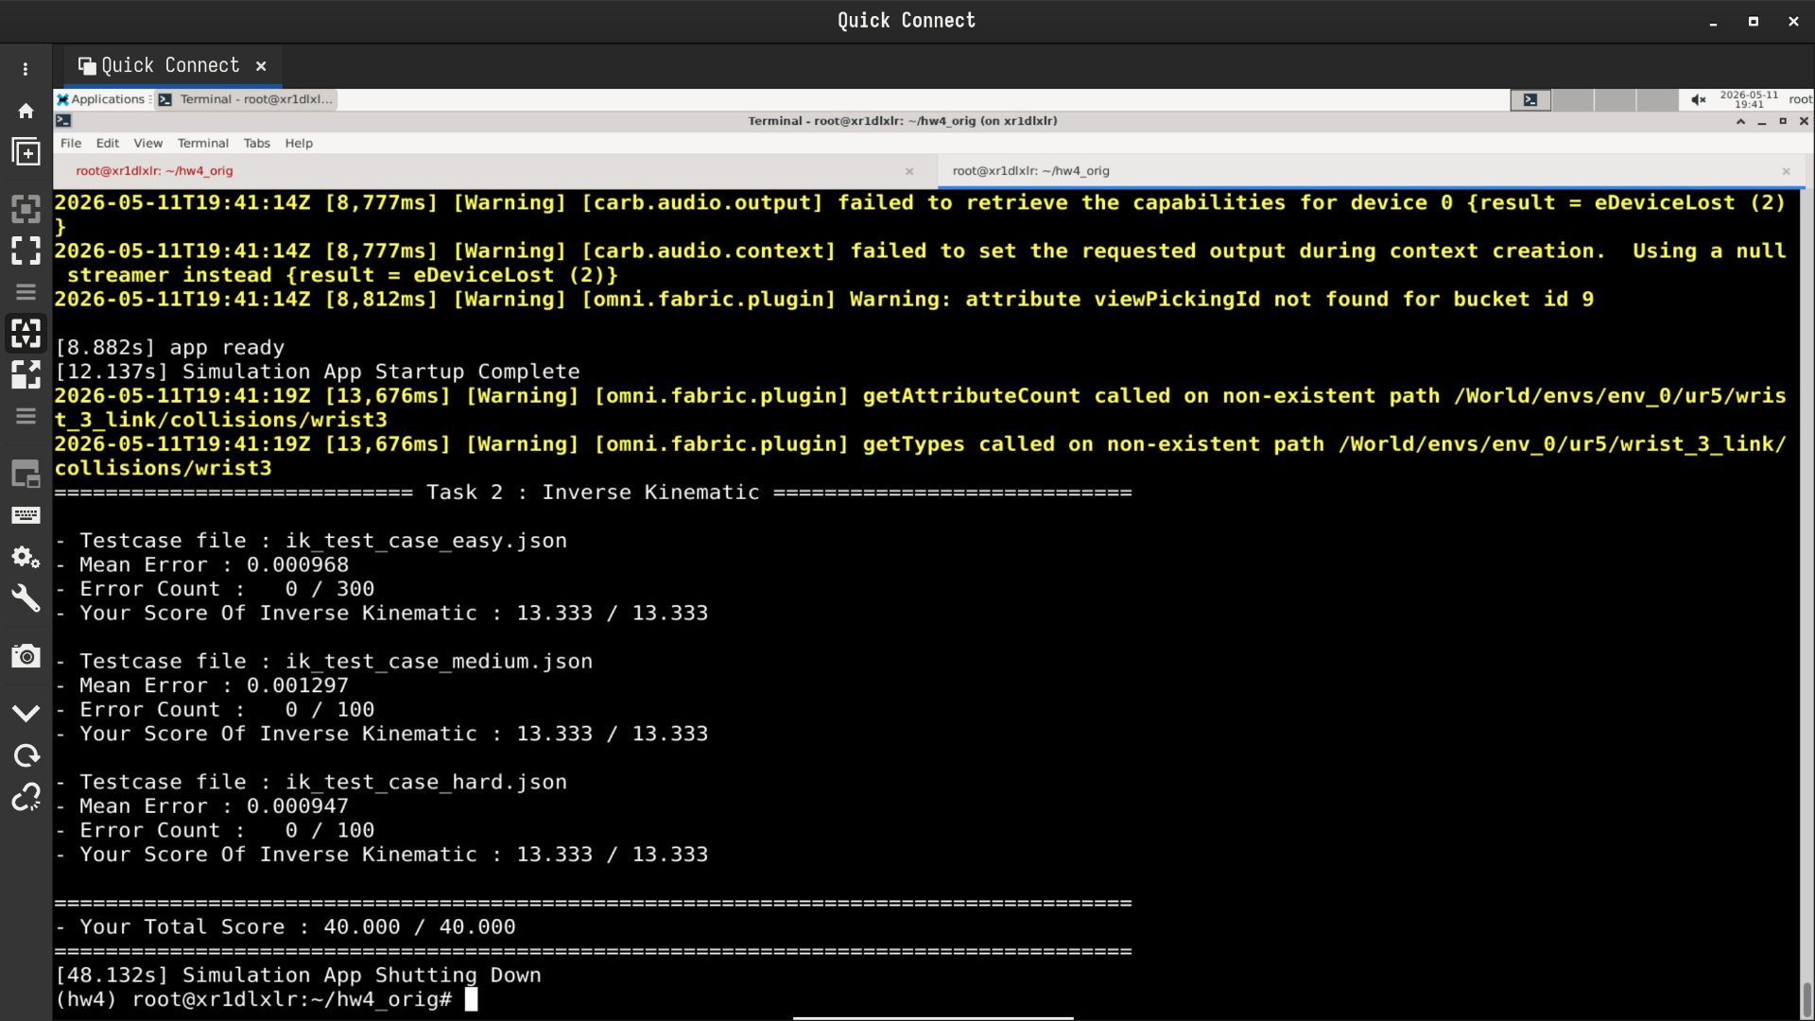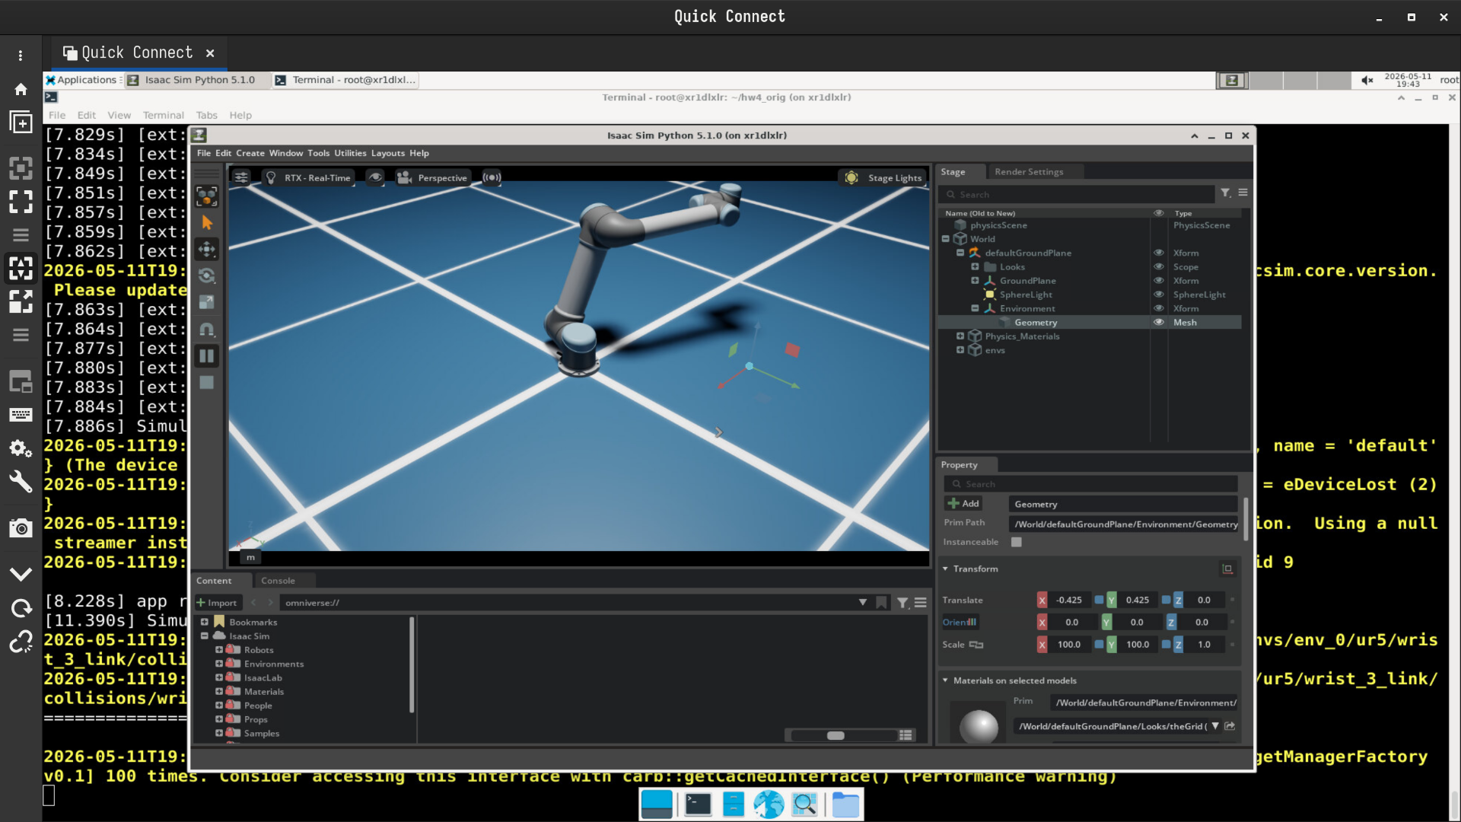

References
I mainly referenced these materials:
- Professor Yi-Ting Chen's recorded Lecture 8
- The slide that's suggested to read while implementing IK. The link in HW4_spec_2026 is outdated (the original file is removed), and I can only find it from Internet Archive's Wayback Machine.
- A 3D animation of D-H that's mentioned both in Professor Yi-Ting's lecture and the slides suggested to read.
- The ur5 robot arm's URDF and STL files stored in the old commits of this course's official Github repository, ai-capstone26. The file ur5.urdf is mentioned in the code template of fk.py, but it is removed in the newest version.\
- Franka's URDF and STL files.
- An open-source URDF visualizer on Github. I used it to open the URDF and STL files mentioned above. Repo Demo
- A D-H Parameter table online.

