AI Capstone HW1
112550169 潘仰祐

1. Implementation
I modified the template instead of starting from zero.

Part 1. 2D semantic map construction
In `main.py`'s `main()` function, we can see TODO 1-2. Where I used color01.npy since the spec implies this is expected if no floating-point error occurs.
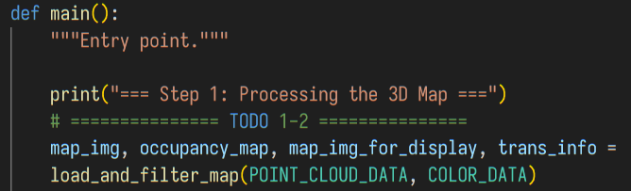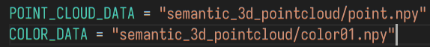
In `map_processor.py`, I didn't use the colours to remove ceiling and floor but cut the height instead. Also, I set the map resolution to have 20 px per meter.
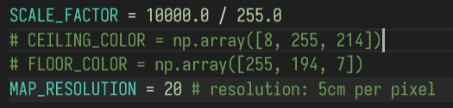
Then, in TODO 1-1, I keep the space between y = -1.3~0.3. This can effectively cut the ceiling and floor (where y = 0 should be the sensor at 1.5m-height in the 2.5m-height floor). Also, this sorting is to reduce the noise of cushion points because I don't know how to remove them more better.
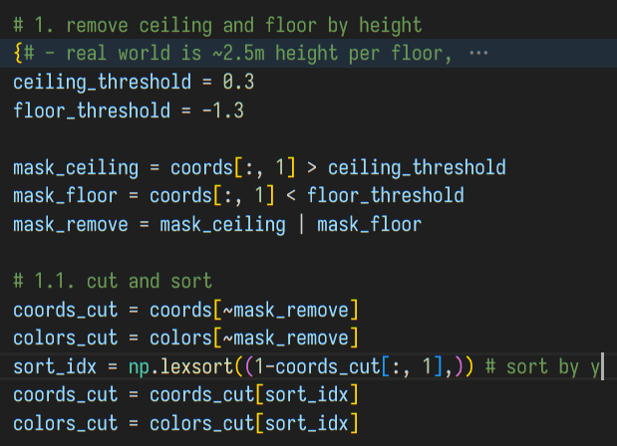
Then, a projection to the 2D space is done to form a map with semantic colours. The map is initially black-backgrounded.
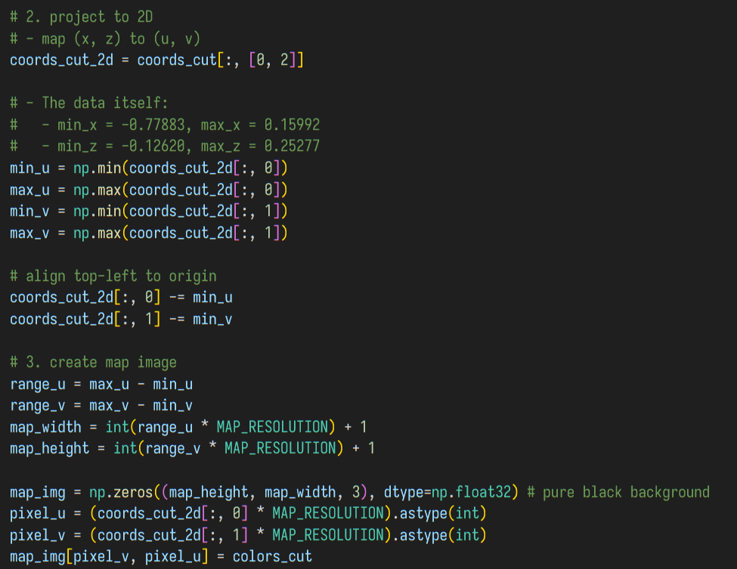
Then, isolated points removal is done for areas < 20 since they are likely to be noises. Then, the background is made white.
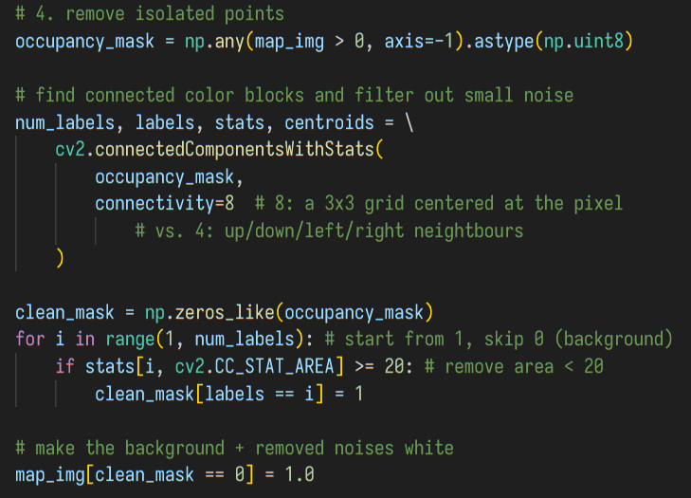
But the isolated point removal accidentally remove some walls. So, we add manual patches (black lines) to prevent RRT explore outside later.
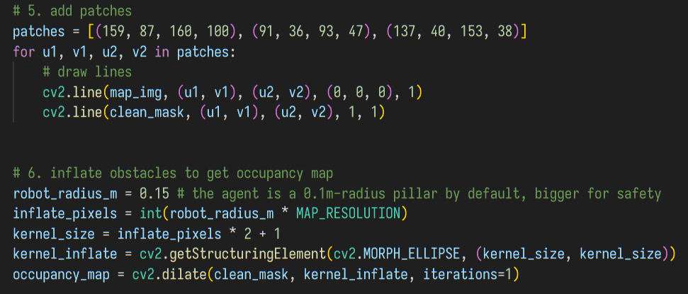
After that, a occupancy map is drawn by obstacle inflation. Also, to visualize it, a map_img_for_selection is generated. (Despite this naming, I also use this image for path visualization later.) The projectional constant are also returned for unprojection from the pixel coordinate to the world later.
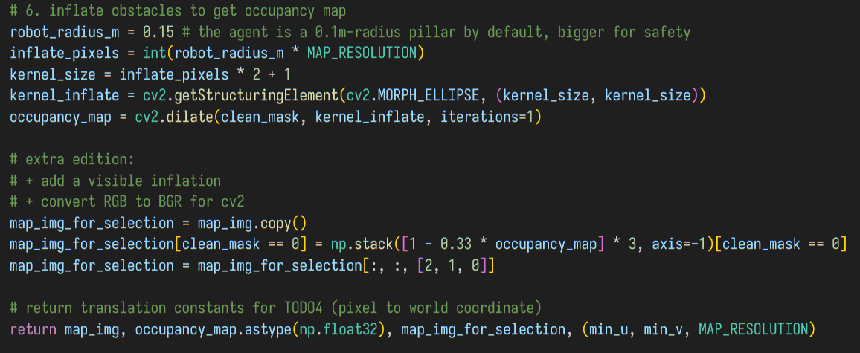
The function `select_start()` and `get_goal_pixels()` are not modified, and this is the end of `map_processor.py`.
After this part, in `main.py`'s `main()`, I used the map_img_for_selection to display in selection.
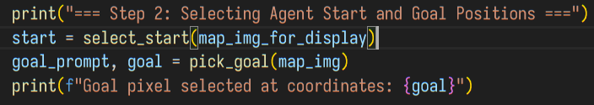

Part 2. RRT algorithm implementation
In this part, I wrotes the main content in `plan_path()` as the instruction. Here the returning values are:
- tree, parents: a list of nodes and a dictionary of child-parent pairs. This is from the basic RRT.
- leave_obstacle_path: a list of nodes in the RRT path, but adjusted to leave obstacles.
- simple_path: a list of nodes, which is last path's simplifcation.
- path: the final path, which is the last path adjusted to leave obstacles.
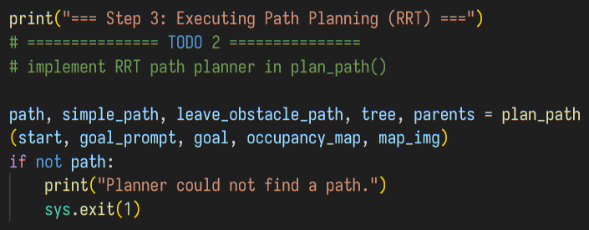
This function, `plan_path()`, is written in `main.py`. Here is the preparation for RRT, where I use 0.1m steps and 0.4m radius tolerance. The code executes at most 50000 times before giving up.
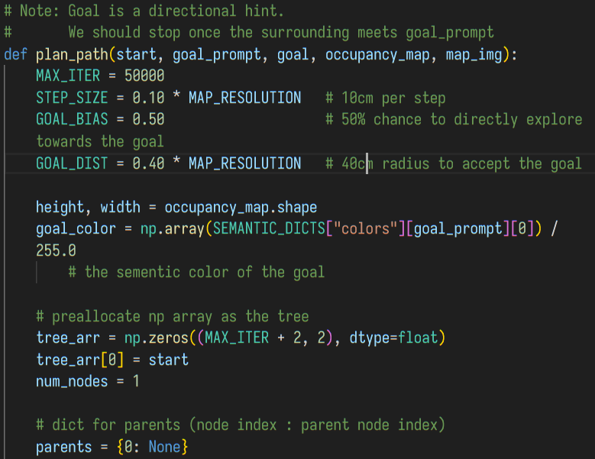

Then, the beginning part of my `plan_path()` follows the procedure of a basic RRT. First it randomly samples some points, find the nearest point, and try to step from that point.
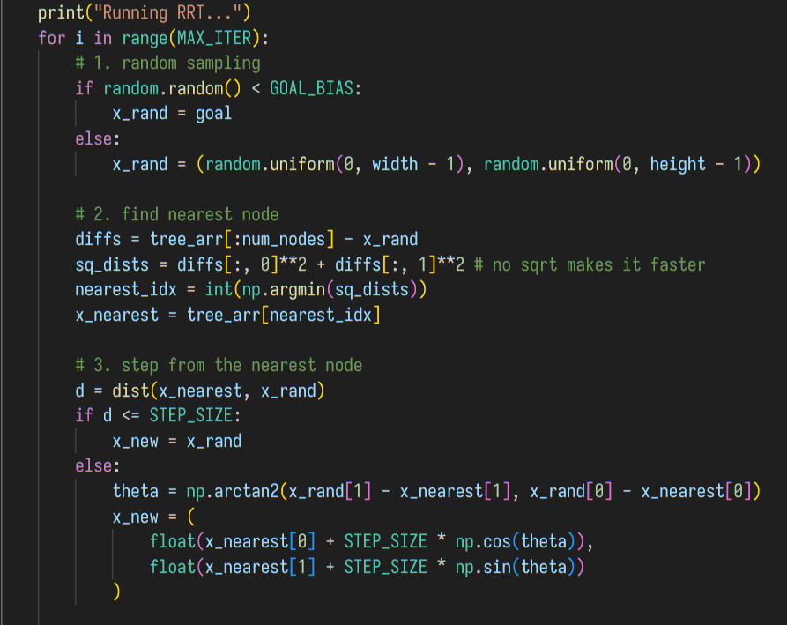
If there is a collision, give up the stepping and enter next round. Otherwise, the successful step is added to the tree.
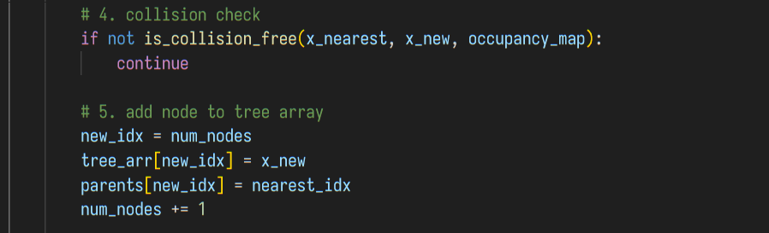
And then, it checks if the goal is reached. I loosen the checking because the chosen goal point is not always "reachable" under the tolerance, but the same semantic-coloured points are often reachable.
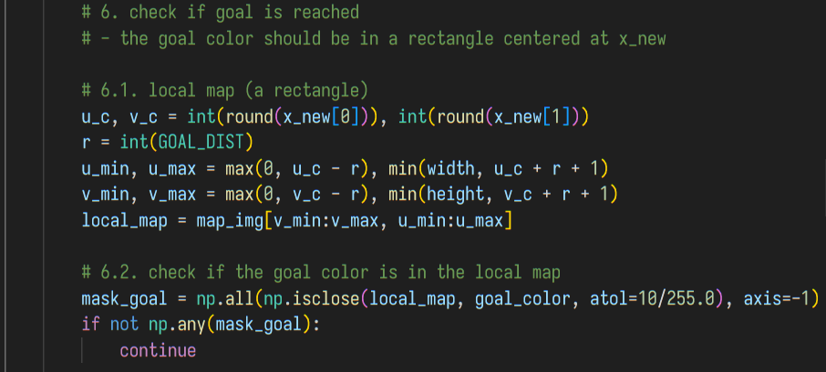
However, there is also a pitfall that some cushion points are on the desk in the study room. My way to mitigate this is to use the euclidean distance instead. In the end, the RRT path is generated. No matter what, I updates the goal point as new_goal.
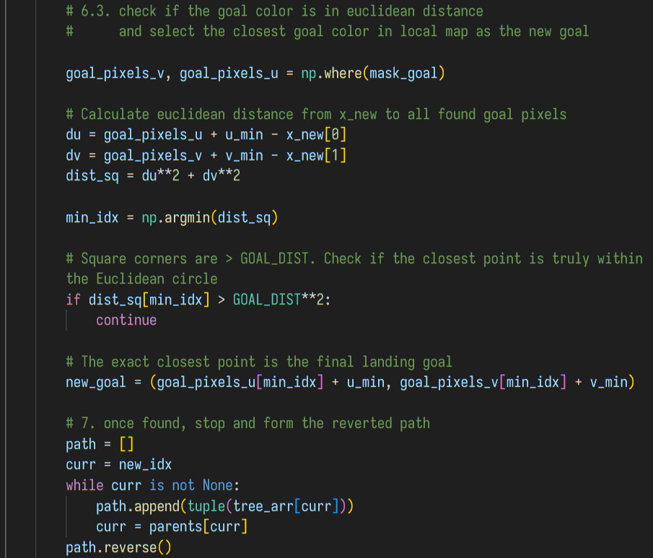

(Bonus) Extra Modification to Enhance RRT
(Continue from last section.) Then, I append the new goal point to the path because in the simulated world, this ensures the agent can be nearer and turn to the object. If it's in the physical world, a modification will be required.
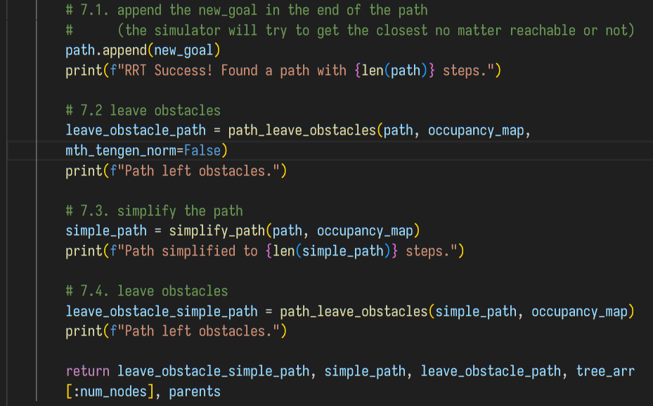
From the code above, I process the RRT path by moving away from obstacles -> simplifying -> moving away from obstacles again. Here are the functions:

(Bonus 1) Reduce the chance of collision
`path_leave_obstacles()` can move the nodes in the direction of "norm", a normalized vector perpendicular to the "tangent line" (i.e., a vector from the previous node to the next node ), and/or in a direction determined by the obstacle , a normalized vector that's . It aims to reduce the chance that agents are blocked by the obstacles.
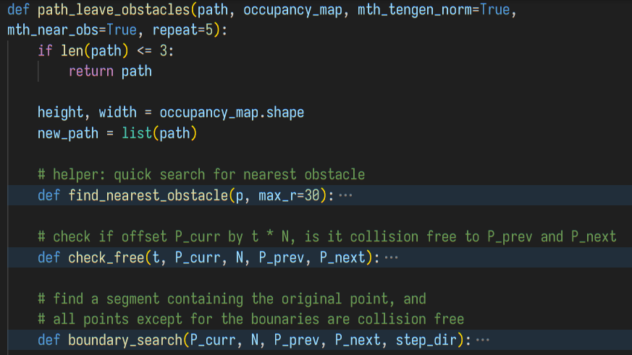
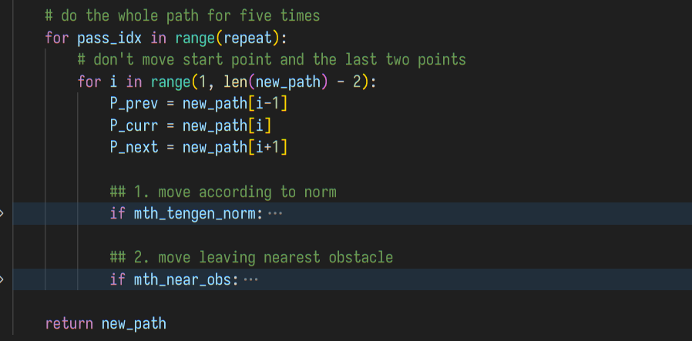
For either direction, it finds a segment of movable range (i.e., in this range, the path to the last and next points are collision free), where the original unmoved situation is contained, and the boundaries are binary-searched to touch the "collision" situation.
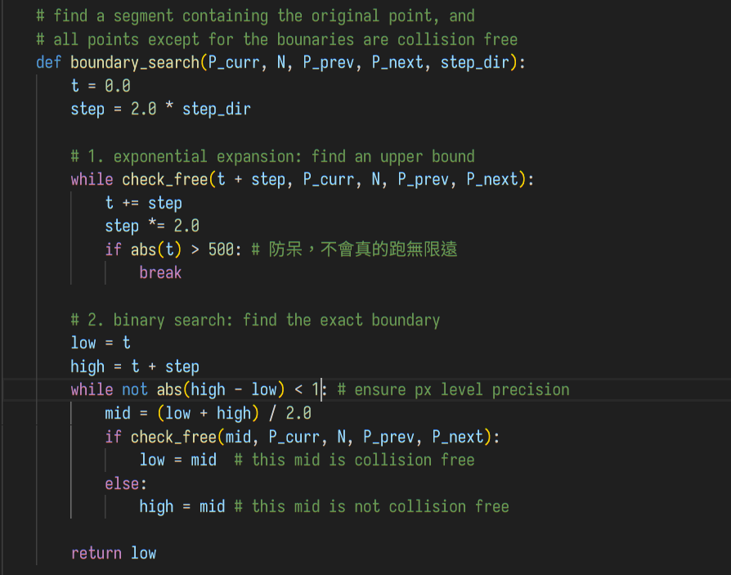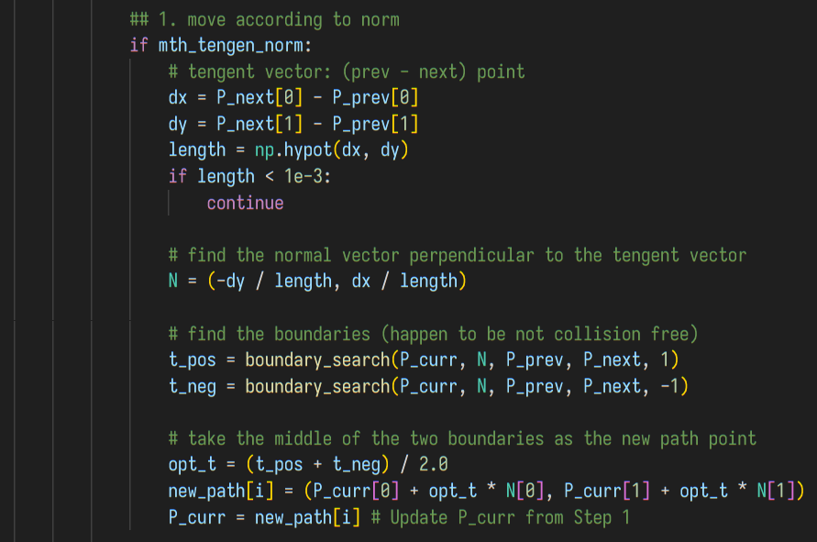
This way, we can use the middle point in this segment as the new position for that point to reduce the chance of collision.

(Bonus 2) Simplify the Path to Speed Up Navigation
`simplify_path()` is another function that enhance the result. An observation is that, shorter step-size in RRT makes it easier to go through complicated and tortuous pathways. However, in the simulation, the path formed by multiple steps with different directions causes a long time to stop and turning left and right.
To fix that, this function tries to reduce the extra nodes in broad areas. For each point , it aggresively finds another node from the path end to the current node, to see if the connection from to is collision free. If it is, the nodes in between are skipped.
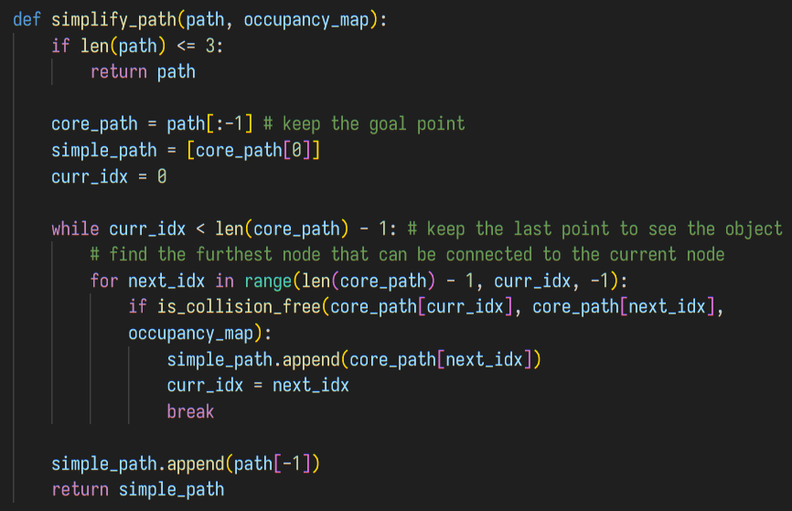

(Bonus 3) Rewritten of RRT with Numpy
This is not algorithmic improvements, but a reconsidered implementation. I was using Python's native list for the `tree` array, and use a for loop to calculate the nearest point on the tree. However, it significantly slows down (taking 3~5 seconds) for `MAX_ITER = 10000`, and becomes unbearable when `MAX_ITER = 50000`. The overhead should stem from the interpreter of code and the incontiguous memory allocation due to frequent `.append()`. Using a preallocated numpy array can ensure the contiguity of memory and thus utilize the spatial locality of cache, while the vectorized methods from numpy move the calculation to the native zone, preventing the overhead of interpreters.

Part 3. Robot navigation
Here is the code to visualize the planned navigation path. I used cv2 to draw the lines and nodes. The basic RRT's tree, the adjusted RRT path to move away from obstacles, the simplified of the previous path, and the adjusted one of the previous path to leave the obstacles are all drawn. Also, the destination is drawn as a black big circle.
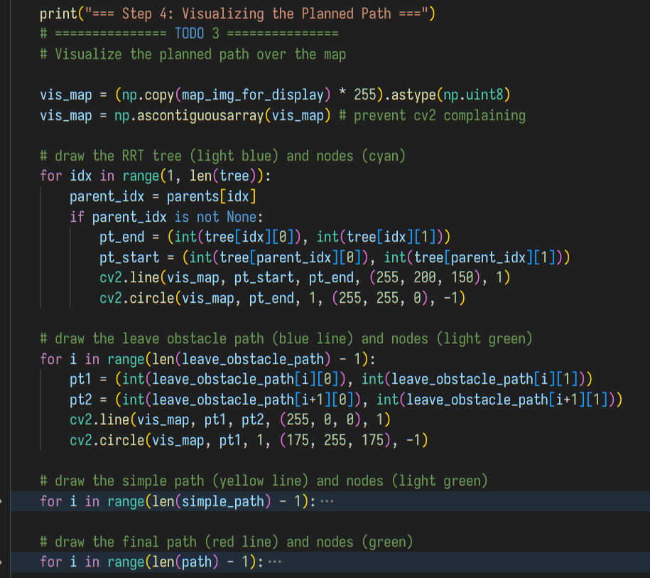
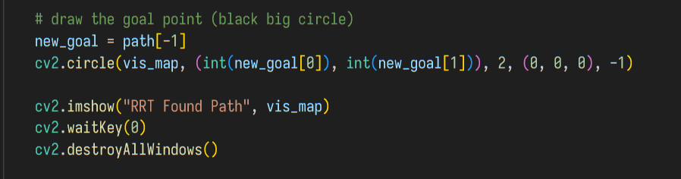

Then it's about the navigation in simulation. I didn't heavily modify navigator.py, only reduced the MOVE_AMOUNT to 0.05 (m). Here is the `main()`'s TODO 4 in `main.py`.
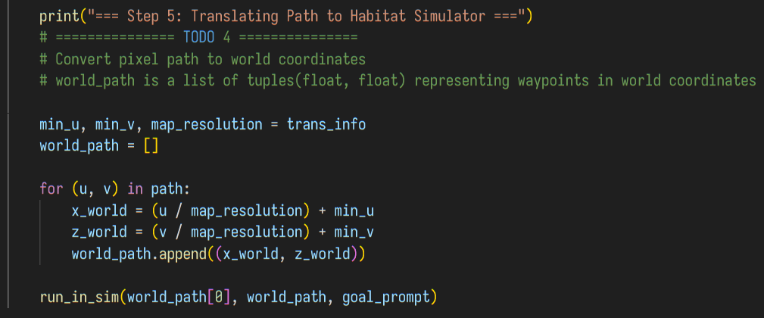
This is my semantic dictionary and `run_in_sim()` function. I tried to solve the multiple cushion problem - they are listed in the mentioned JSON file, but I couldn't understand the coordinate system in that file. In the end, I decided to hard-code the most often goal point as the index (id) for cushion. The abandoned code is collapsed in the function.
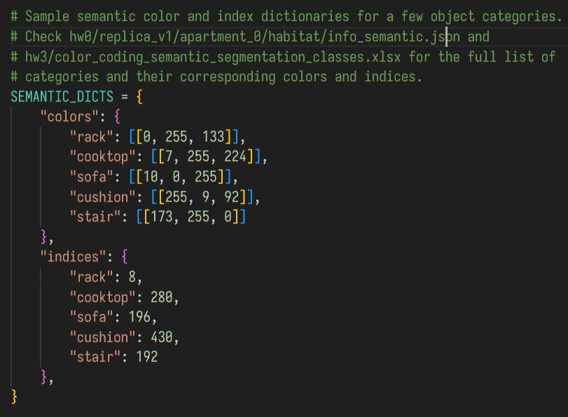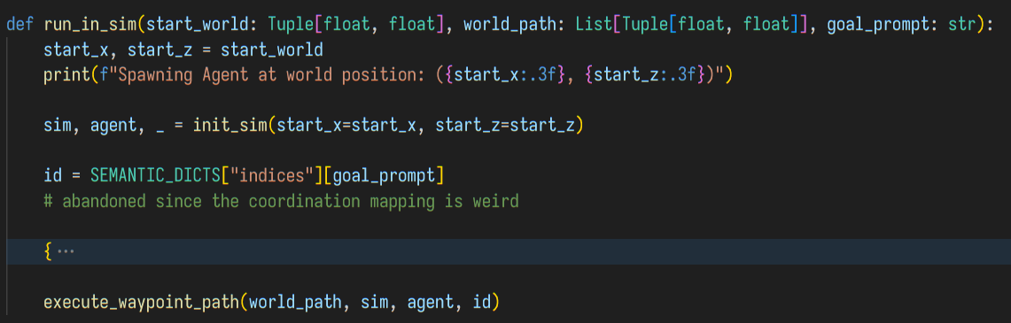

Result and Discussion
Here are the `path_plan()` function's outputs.
- Light Blue lines and Cyan points are the RRT tree.
- Blue lines and Light Green points are the RRT path adjusted to leave obstacles.
- Yellow lines and Light Green points are the path simplified from last path.
- Red lines and Green points are the final path, which is the last path adjusted again to leave obstacles.
- The Black big dot are the goal points.
- Grey is the inflation of obstacles.
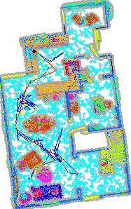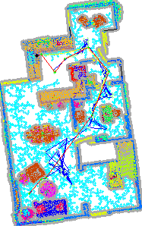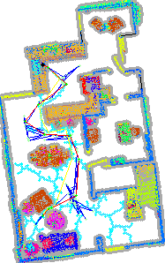
The left three starts from the narrow area to the cooktop. Thanks to the numpy optimization
(in Bonus 3), they all plan the path in seconds. The path can go through the tortuous pathway due to small step size
(= 10cm).

In my `path_plan()`, the destination it finds is often the nearest instance of the class. For example, the below executions set "cushion" as the destinations.
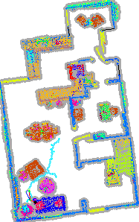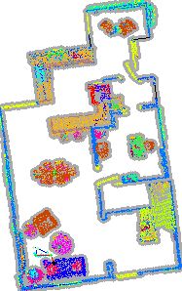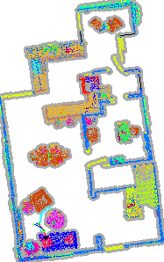
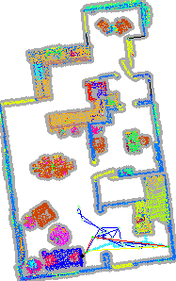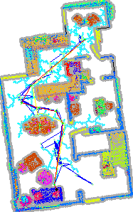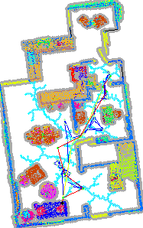
Also, we can observe from the above. With the path simplification feature
(Bonus 2), 100~200 steps can often be reduced to < 15 steps, which significantly boosts the simulation. For each execution above, path planning takes no more than 5 seconds.
To prove rack, sofa and stair can also be reached, here are the screenshots:
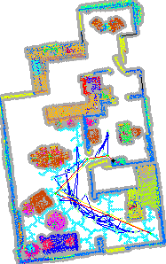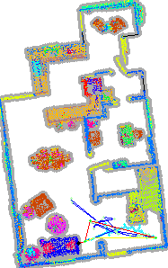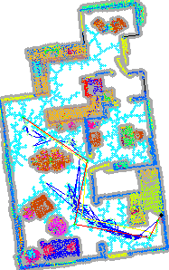
My code used to face the problem that, although a path is generated and looks good on the map, but due to the gap between our map and the simulation, it still fails. However, with my `path_leave_obstacles()` function (Bonus 1), such a situation is rare to meet again. It can be observed that blue and red lines often have more spaces than the light blue and yellow lines.

Reference
The main reference is "Lecture 7 - path planning.pdf" from our course. Also, I talked to Gemini (Antigravity) for some implementation details. There are no other references.

2. Questions

Q1. In the RRT algorithm, you can adjust the step size and bias (the number balance between exploration and exploitation). Please explain how the two numbers affect the RRT sampling result.
A higher step size can significantly increase the speed of RRT, but it is not good for going through complicated and narrow pathways. A smaller step size can fix this by generating multiple short steps to go through that pathway, but it also takes much longer time when the starting point is far away.
A higher bias creates a more straight path when there is no obstacles from the current point to the goal point. However, when RRT needs to bypass obstacles, it has a hard time struggling, and this also causes the RRT prone to generate a path along the edge of obstacles. Besides, although a higher bias boost the exploration when it's near to the goal point with less obstacles around, it makes the exploration really slow and often give up due to max iteration reach when the starting point is far away with many obstacles in between.

Q2. If you want to apply the indoor navigation pipeline in the real world, what problems may you encounter?
First, how to efficiently do SLAM and build a map? HW2 provides an example for 3D space (point cloud) reconstruction from photos and, but what I wrote is not good enough to put into the real world, because the point clouds often fail to align, especially when entering narrow spaces like the bathrooms, or looking at featureless objects like the walls. SLAM algorithm may also need to know what are the moving elements (like human objects) that may change in the map.
Second, how to do semantic/instance/panoptic segmentation, and label them with some identifiers? A good model and some techniques may be required, such that the agent knows which pillow to get, instead of randomly choosing once of them.
Third, what if the robot falls down? As discussed above, the inflation of obstacles (configuration space) may not always be accurate due to the low quality construction of obstacle map. Then, the robot may bump into the wall, accidentally make a cup fall, or even stumble due to the floor removal in my implementation (which uses the height to cut).
In the end, how to compensate for errors? The pipeline cannot be directly used in the physical world where offsets are generated everywhere. The robot can hardly follow our instruction to turn to a direction and walk for a distance precisely. Thus, there must be something like SLAM (or at least, registration from HW2) or other indoor localization infrastructures like UWB.

