Experiment 2
Name: Prem  Class: [Your Class]  Roll No: [Your Roll No]  Subject : SE | DOP: [DD/MM/YY]  DOS: [DD/MM/YY]  Batch: [Your Batch]  Sign:
AIM: To study the use case diagram for FitTrack: A Smart Fitness Tracking and Personalised Workout Management System
THEORY : Use Case Diagram
A use case is a methodology used in system analysis to identify, clarify, and organize system requirements. In this context, the term "system" refers to something being developed or operated, such as a mail-order product sales and service Website. Use case diagrams are employed in UML (Unified Modeling Language), a standard notation for the modeling of real-world objects and systems.
Use case diagrams are valuable for visualizing the functional requirements of a system that will translate into design choices and development priorities. They also help identify any internal or external factors that may influence the system and should be taken into consideration. They provide a good high level analysis from outside the system. Use case diagrams specify how the system interacts with actors without worrying about the details of how that functionality is implemented.
Basic Use Case Diagram Symbols and Notations
System
Draw your system's boundaries using a rectangle that contains use cases. Place actors outside the system's boundaries.
- The boundary, which defines the system of interest in relation to the world around it.
Example: FitTrack System
Use Case
Draw use cases using ovals. Label the ovals with verbs that represent the system's functions.
- The use cases, which are the specific roles played by the actors within and around the system.
Examples:
- Register
- Login
- Set Fitness Goals
- Create Workout Plan
- Track Fitness Progress
Actors
Actors are the users of a system. When one system is the actor of another system, label the actor system with the actor stereotype.
- The actors, usually individuals involved with the system defined according to their roles.
Examples:
- User
- Administrator
Relationships
Illustrate relationships between an actor and a use case with a simple line. For relationships among use cases, use arrows labeled either "uses" or "extends." A "uses" relationship indicates that one use case is needed by another in order to perform a task. An "extends" relationship indicates alternative options under a certain use case.
- The relationships between and among the actors and the use cases.
Actors present in our Proposed System:
User
- Register account
- Login
- Set fitness goals
- Create personalized workout plan
- Log workout sessions
- Track fitness progress
- Monitor health metrics
- Get personalised workout recommendations
- Update profile
Administrator
- Login
- Manage users
- Manage workout templates
- Manage exercise library
- View user reports
Relationships
- Create Workout Plan <<include>> Set Fitness Goals
- Track Fitness Progress <<include>> Log Workout
- Get Personalised Recommendations <<include>> Monitor Health Metrics
Use cases and Associations present in our proposed system:
User:
- User can register into the system.
- User can login using credentials.
- User can set personal fitness goals.
- User can create a personalized workout plan.
- User can log completed workout sessions.
- User can track fitness progress over time.
- User can monitor health metrics such as weight, BMI, and heart rate.
- User can receive personalised workout recommendations.
- User can update profile details.
Administrator
- Admin can login into the system.
- Admin can manage user accounts.
- Admin can manage workout templates.
- Admin can manage the exercise library.
- Admin can view user reports.
Use Case Diagram:
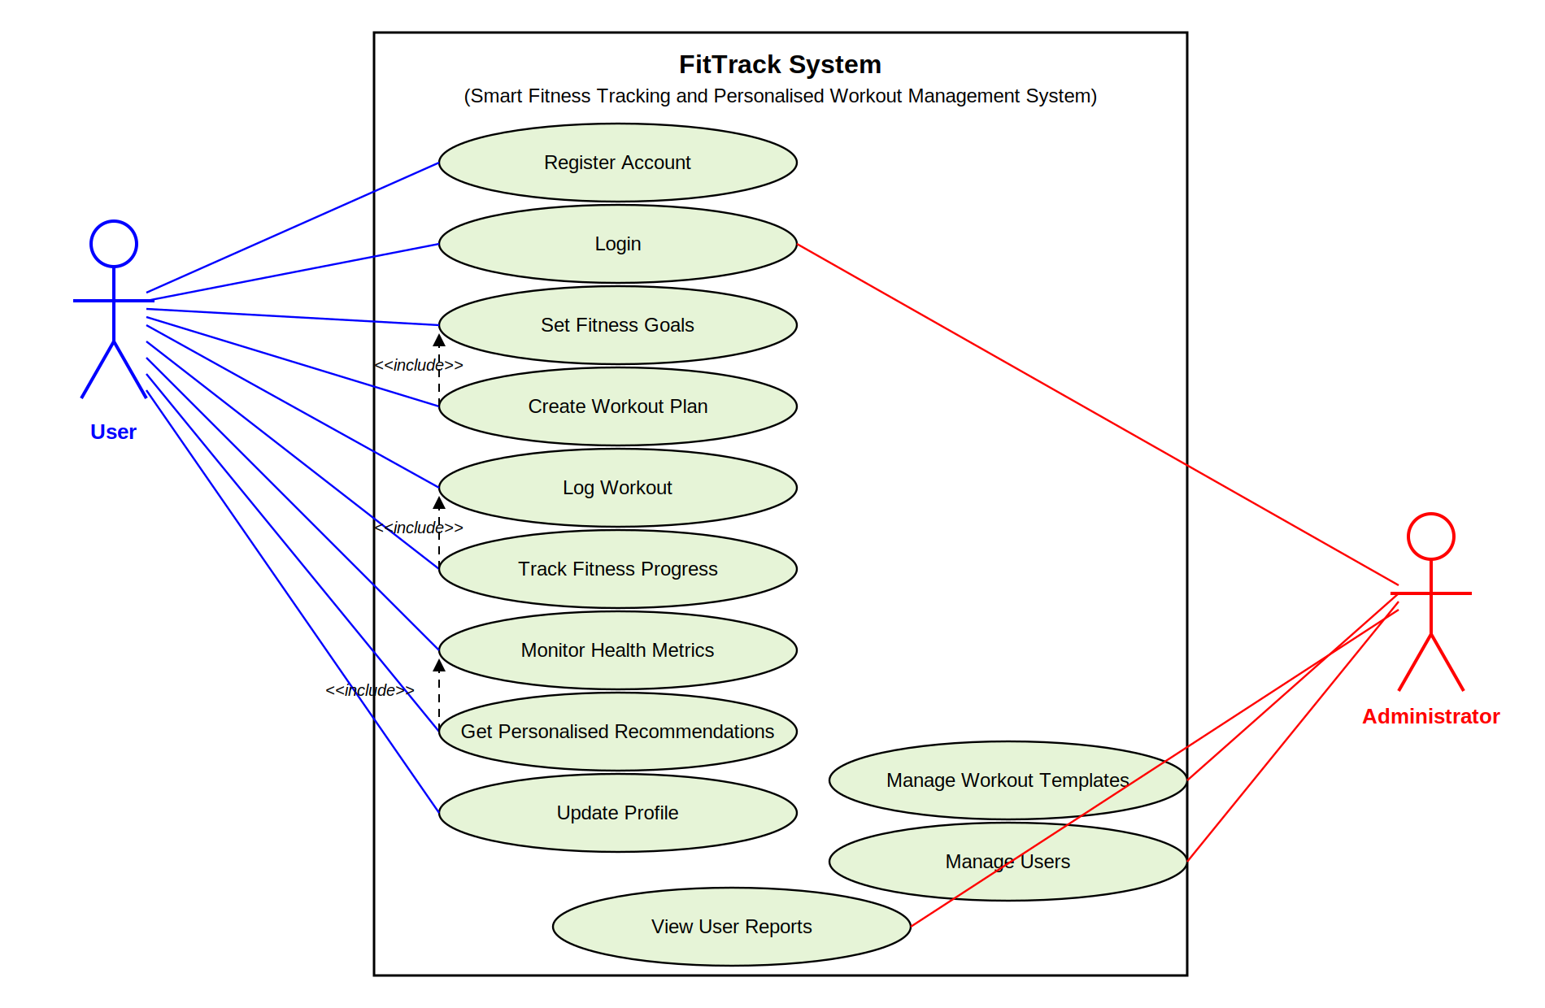
Main objectives are:
- Provide personalized workout plans.
- Enable tracking of fitness progress and health metrics.
- Recommend workouts based on user data and goals.
- Maintain user fitness records securely.
- Reduce dependency on complex or paid fitness applications.
- Improve consistency and motivation in fitness routines.
- Provide a simple, user-friendly fitness platform.
Conclusion: Hence, the Use Case Diagram for the FitTrack: Smart Fitness Tracking and Personalised Workout Management System was successfully designed and studied. It clearly represents the interactions between users, administrators, and the system functionalities using standard UML notations.

