Experiment 3
Class and Object Diagram
Name: Prem  Class: [Your Class]  Roll No: [Your Roll No]  Subject : SE | DOP: [DD/MM/YY]  DOS: [DD/MM/YY]  Batch: [Your Batch]  Sign:
Aim: To study class diagram and Object diagram for FitTrack: A Smart Fitness Tracking and Personalised Workout Management System.
Theory:
Class diagrams are the most popular UML diagrams used for construction of software applications. It is very important to learn the drawing procedure of class diagram. Class diagrams have a lot of properties to consider while drawing but here the diagram will be considered from a top level view.
Class diagram is basically a graphical representation of the static view of the system and represents different aspects of the application. A collection of class diagrams represent the whole system. The following points should be remembered while drawing a class diagram −
The name of the class diagram should be meaningful to describe the aspect of the system. Each element and their relationships should be identified in advance.
Responsibility (attributes and methods) of each class should be clearly identified
For each class, minimum number of properties should be specified, as unnecessary properties will make the diagram complicated.
Use notes whenever required to describe some aspect of the diagram. At the end of the drawing it should be understandable to the developer/coder.
Finally, before making the final version, the diagram should be drawn on plain paper and reworked as many times as possible to make it correct.
In software engineering, a class diagram in the Unified Modeling Language (UML) is a type of static structure diagram that describes the structure of a system by showing the system's classes, their attributes, operations (or methods), and the relationships among objects.
The class diagram is the main building block of object-oriented modeling. It is used for general conceptual modeling of the systematic of the application, and for detailed modeling translating the models into programming code. Class diagrams can also be used for data modeling. The classes in a class diagram represent both the main elements, interactions in the application, and the classes to be programmed.
In the diagram, classes are represented with boxes that contain three compartments:
The top compartment contains the name of the class. It is printed in bold and centered, and the first letter is capitalized.
The middle compartment contains the attributes of the class. They are left-aligned and the first letter is lowercase.
The bottom compartment contains the operations the class can execute. They are also left-aligned and the first letter is lowercase.
In the design of a system, a number of classes are identified and grouped together in a class diagram that helps to determine the static relations between them. With detailed modelling, the classes of the conceptual design are often split into a number of sub classes.
Relationships:
A relationship is a general term covering the specific types of logical connections found on class and object diagrams. UML defines the following relationships: Association, Inheritance, Realization/Implementation, Dependency, Aggregation, and Composition.
Instance-level relationships
Dependency is a semantic connection between dependent and independent model elements. It exists between two elements if changes to the definition of one element (the server or target) may cause changes to the other (the client or source). This association is uni-directional.
Association
An association represents a family of links. A binary association (with two ends) is normally represented as a line. An association can link any number of classes. An association with three links is called a ternary association. An association can be named, and the ends of an association can be adorned with role names, ownership indicators, multiplicity, visibility, and other properties.
There are four different types of association: bi-directional, uni-directional, aggregation (includes composition aggregation) and reflexive. Bi-directional and uni-directional associations are the most common ones.
For instance, a user class is associated with a workout plan class bi-directionally. Association represents the static relationship shared among the objects of two classes.
Aggregation
Aggregation is a variant of the "has a" association relationship; aggregation is more specific than association. It is an association that represents a part-whole or part-of relationship. As a type of association, an aggregation can be named and have the same adornments that an association can. However, an aggregation may not involve more than two classes; it must be a binary association.
Furthermore, there is hardly a difference between aggregations and associations during implementation, and the diagram may skip aggregation relations altogether.
Aggregation can occur when a class is a collection or container of other classes, but the contained classes do not have a strong lifecycle dependency on the container. The contents of the container still exist when the container is destroyed.
In UML, it is graphically represented as a hollow diamond shape on the containing class with a single line that connects it to the contained class. The aggregate is semantically an extended object that is treated as a unit in many operations, although physically it is made of several lesser objects.
Example: Workout Plan and Exercise. Here an exercise can exist without a workout plan, so the relation between them is aggregation.
Composition
The UML representation of a composition relationship shows composition as a filled diamond shape on the containing class end of the lines that connect contained class(es) to the containing class.
Differences between Composition and Aggregation
Composition relationship
1. When attempting to represent real-world whole-part relationships, e.g. an engine is a part of a car.
2. When the container is destroyed, the contents are also destroyed, e.g. a university and its departments.
Aggregation relationship
1. When representing a software or database relationship, e.g. a specific exercise may be part of more than one workout plan.
2. When the container is destroyed, the contents are usually not destroyed, e.g. a workout plan is deleted but its exercises remain in the exercise library.
Thus the aggregation relationship is often "catalog" containment to distinguish it from composition's "physical" containment.
Class-level relationships
Generalization/Inheritance
It indicates that one of the two related classes (the subclass) is considered to be a specialized form of the other (the super type) and the superclass is considered a Generalization of the subclass. In practice, means that any instance of the subtype is also an instance of the superclass. The relationship is most easily understood by the phrase 'an A is a B'.
The UML graphical representation of a Generalization is a hollow triangle shape on the superclass end of the line (or tree of lines) that connects it to one or more subtypes.
The generalization relationship is also known as the inheritance or "is a" relationship. Generalization can only be shown on class diagrams and on use case diagrams.
Realization/Implementation
In UML modelling, a realization relationship is a relationship between two model elements, in which one model element (the client) realizes (implements or executes) the behavior that the other model element (the supplier) specifies. Realizations can only be shown on class or component diagrams.
Multiplicity
This association relationship indicates that (at least) one of the two related classes make reference to the other. This relationship is usually described as "A has a B" (a user has a workout plan, a workout plan has exercises).
The UML representation of an association is a line connecting the two associated classes. At each end of the line there is optional notation — an arrowhead to indicate navigability, ownership by placement of a ball, role names, and multiplicity of instances participating in the association.
Object diagram
In the Unified Modeling Language (UML), an object diagram focuses on some particular set of objects and attributes, and the links between these instances. A correlated set of object diagrams provides insight into how an arbitrary view of a system is expected to evolve over time.
An object diagram is a graph of instances, including objects and data values. A static object diagram is an instance of a class diagram; it shows a snapshot of the detailed state of a system at a point in time. The use of object diagrams is fairly limited, namely to show examples of data structure.
Object diagrams and class diagrams are closely related and use almost identical notation. Both diagrams are meant to visualize the static structure of a system. While class diagrams show classes, object diagrams display instances of classes (objects). Object diagrams are more concrete than class diagrams. They are often used to provide examples or act as test cases for class diagrams.
To capture a particular system, the number of class diagrams is limited. However, if we consider object diagrams then we can have an unlimited number of instances, which are unique in nature. Only those instances are considered, which have an impact on the system.
Before drawing an object diagram, the following things should be remembered and understood clearly −
- Object diagrams consist of objects.
- The link in the object diagram is used to connect objects.
- Objects and links are the two elements used to construct an object diagram.
Implementation:
Class Diagrams are among the most commonly used UML diagrams for designing software applications. They represent the static structure of a system by showing classes, their attributes, methods, and relationships with other classes.
In the FitTrack: Smart Fitness Tracking and Personalised Workout Management System, the Class Diagram represents the main entities such as User, Health Metric Tracker, Workout Plan, Recommendation Engine, Exercise, Progress Tracker, and Administrator. These classes work together to provide personalized fitness management services to users.
The following points should be considered while drawing a Class Diagram:
- The class names should clearly represent the system entities.
- Attributes and methods of each class should be identified properly.
- Relationships between classes should be clearly defined.
- Only necessary attributes and methods should be included.
- The diagram should be simple and understandable.
In software engineering, a Class Diagram is a static structure diagram that describes the structure of a system by showing:
- Classes
- Attributes
- Methods
- Relationships among classes
The Class Diagram serves as the foundation of object-oriented design and helps developers understand the overall structure of the system before implementation.
Classes Present in the Proposed System
User
Attributes
- userID
- name
- email
- password
- age
- weight
- height
Methods
- register()
- login()
- updateProfile()
- setFitnessGoal()
Health Metric Tracker
Attributes
- metricID
- bmiValue
- bmiCategory
- heartRate
Methods
- calculateBMI()
- updateMetrics()
- getCategory()
Workout Plan
Attributes
- workoutID
- planName
- exercises
- difficultyLevel
Methods
- generatePlan()
- viewPlan()
Recommendation Engine
Attributes
- recID
- recType
- details
Methods
- generateRecommendation()
- viewRecommendation()
Exercise
Attributes
- exerciseID
- exerciseName
- sets
- reps
- duration
Methods
- addExercise()
- viewExercise()
Progress Tracker
Attributes
- progressID
- weightHistory
- bmiHistory
- date
Methods
- trackProgress()
- generateReport()
Administrator
Attributes
- adminID
- username
- password
Methods
- manageUsers()
- manageWorkoutTemplates()
- manageExerciseLibrary()
- viewReports()
Relationships
- User uses Health Metric Tracker.
- Health Metric Tracker generates Workout Plan.
- Health Metric Tracker generates Recommendation Engine output.
- Workout Plan contains Exercise.
- User tracks fitness through Progress Tracker.
- Administrator manages Users, Workout Plans, Exercise Library, and Recommendations.
Class Diagram:
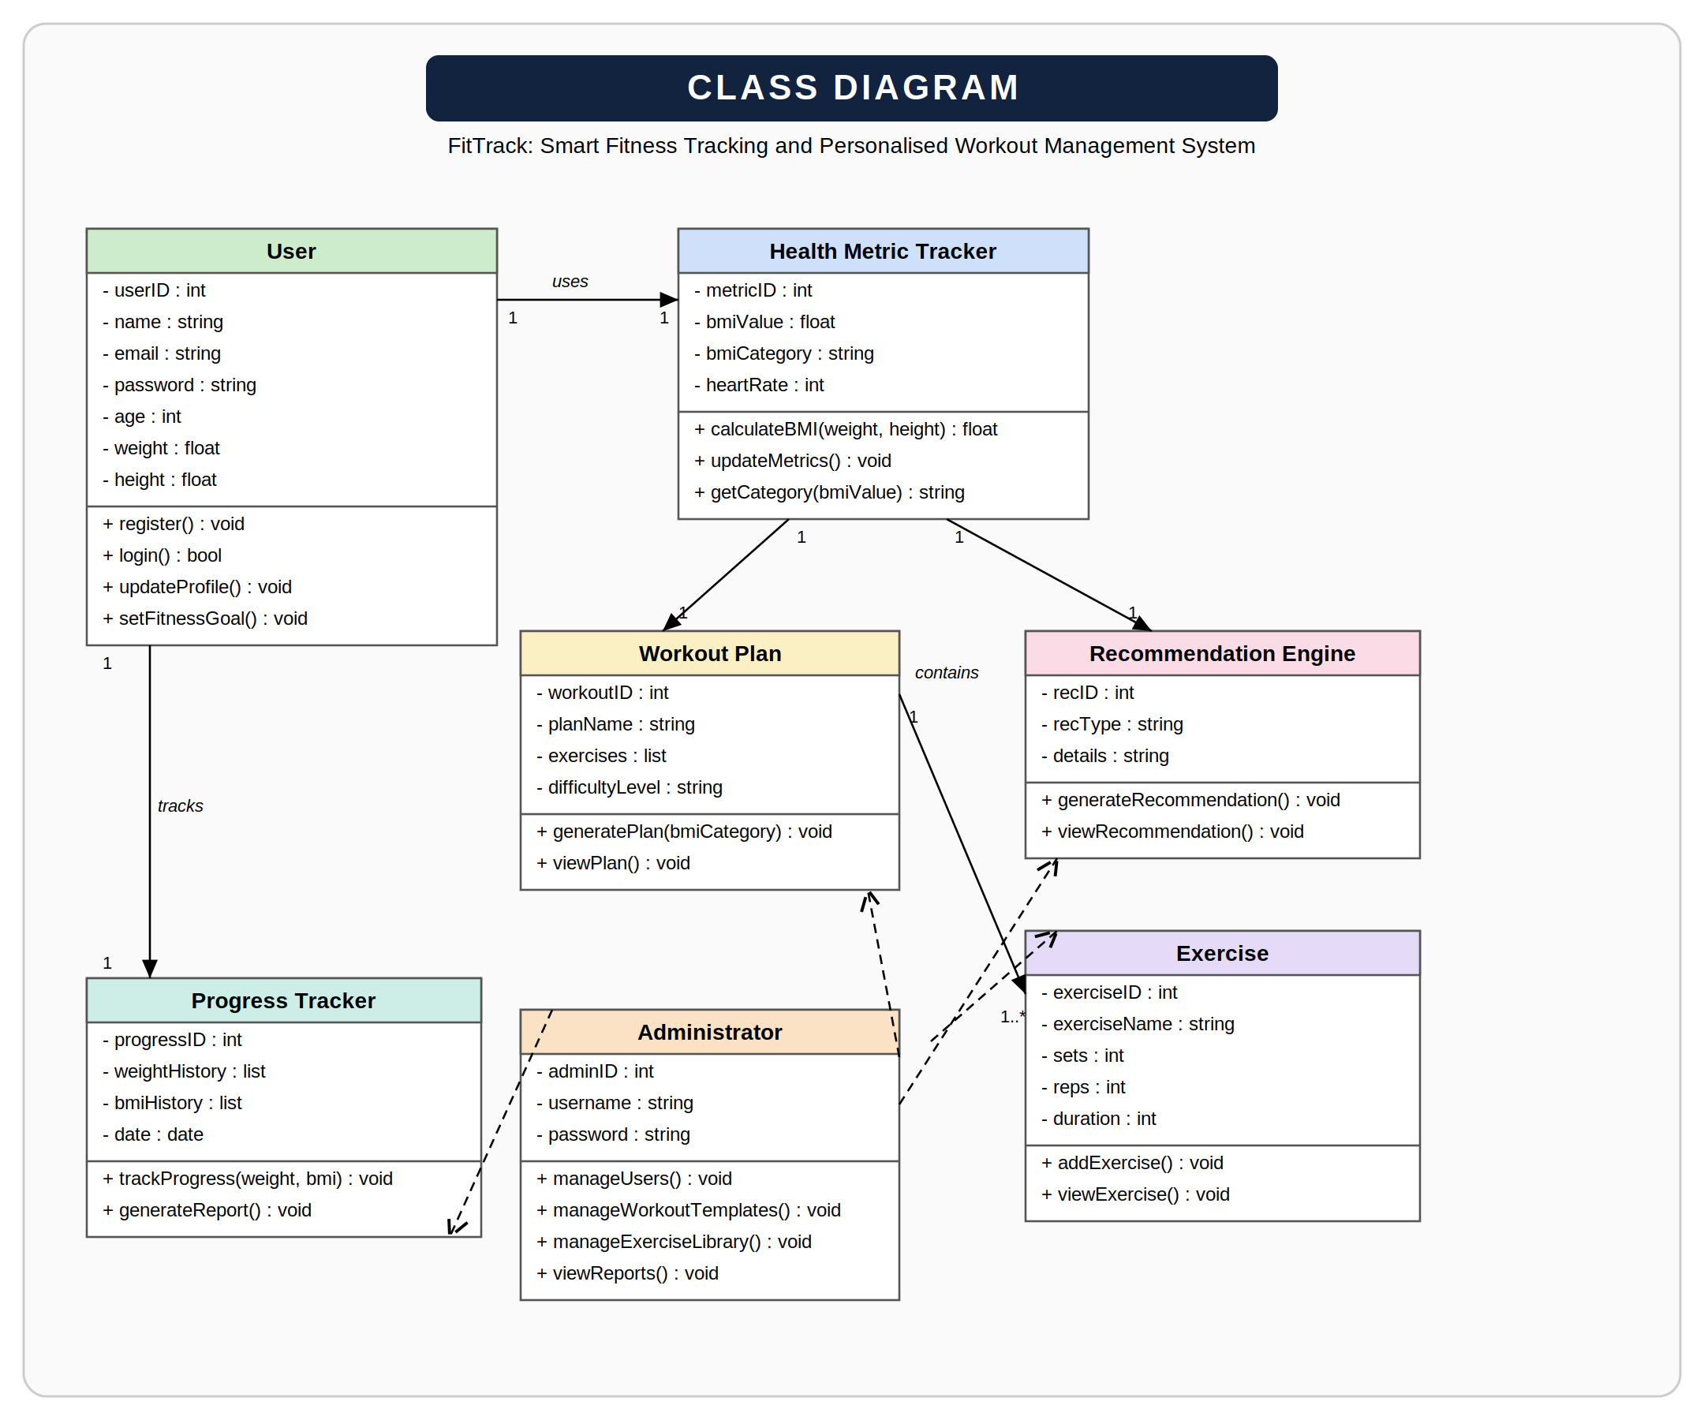
Object Diagram
An Object Diagram represents the snapshot of the system at a particular moment.
Example Objects
- user1 : User
- metric1 : HealthMetricTracker
- workout1 : WorkoutPlan
- rec1 : RecommendationEngine
- exercise1 : Exercise
- progress1 : ProgressTracker
- admin1 : Administrator
These objects show actual instances of classes and their relationships within the FitTrack system.
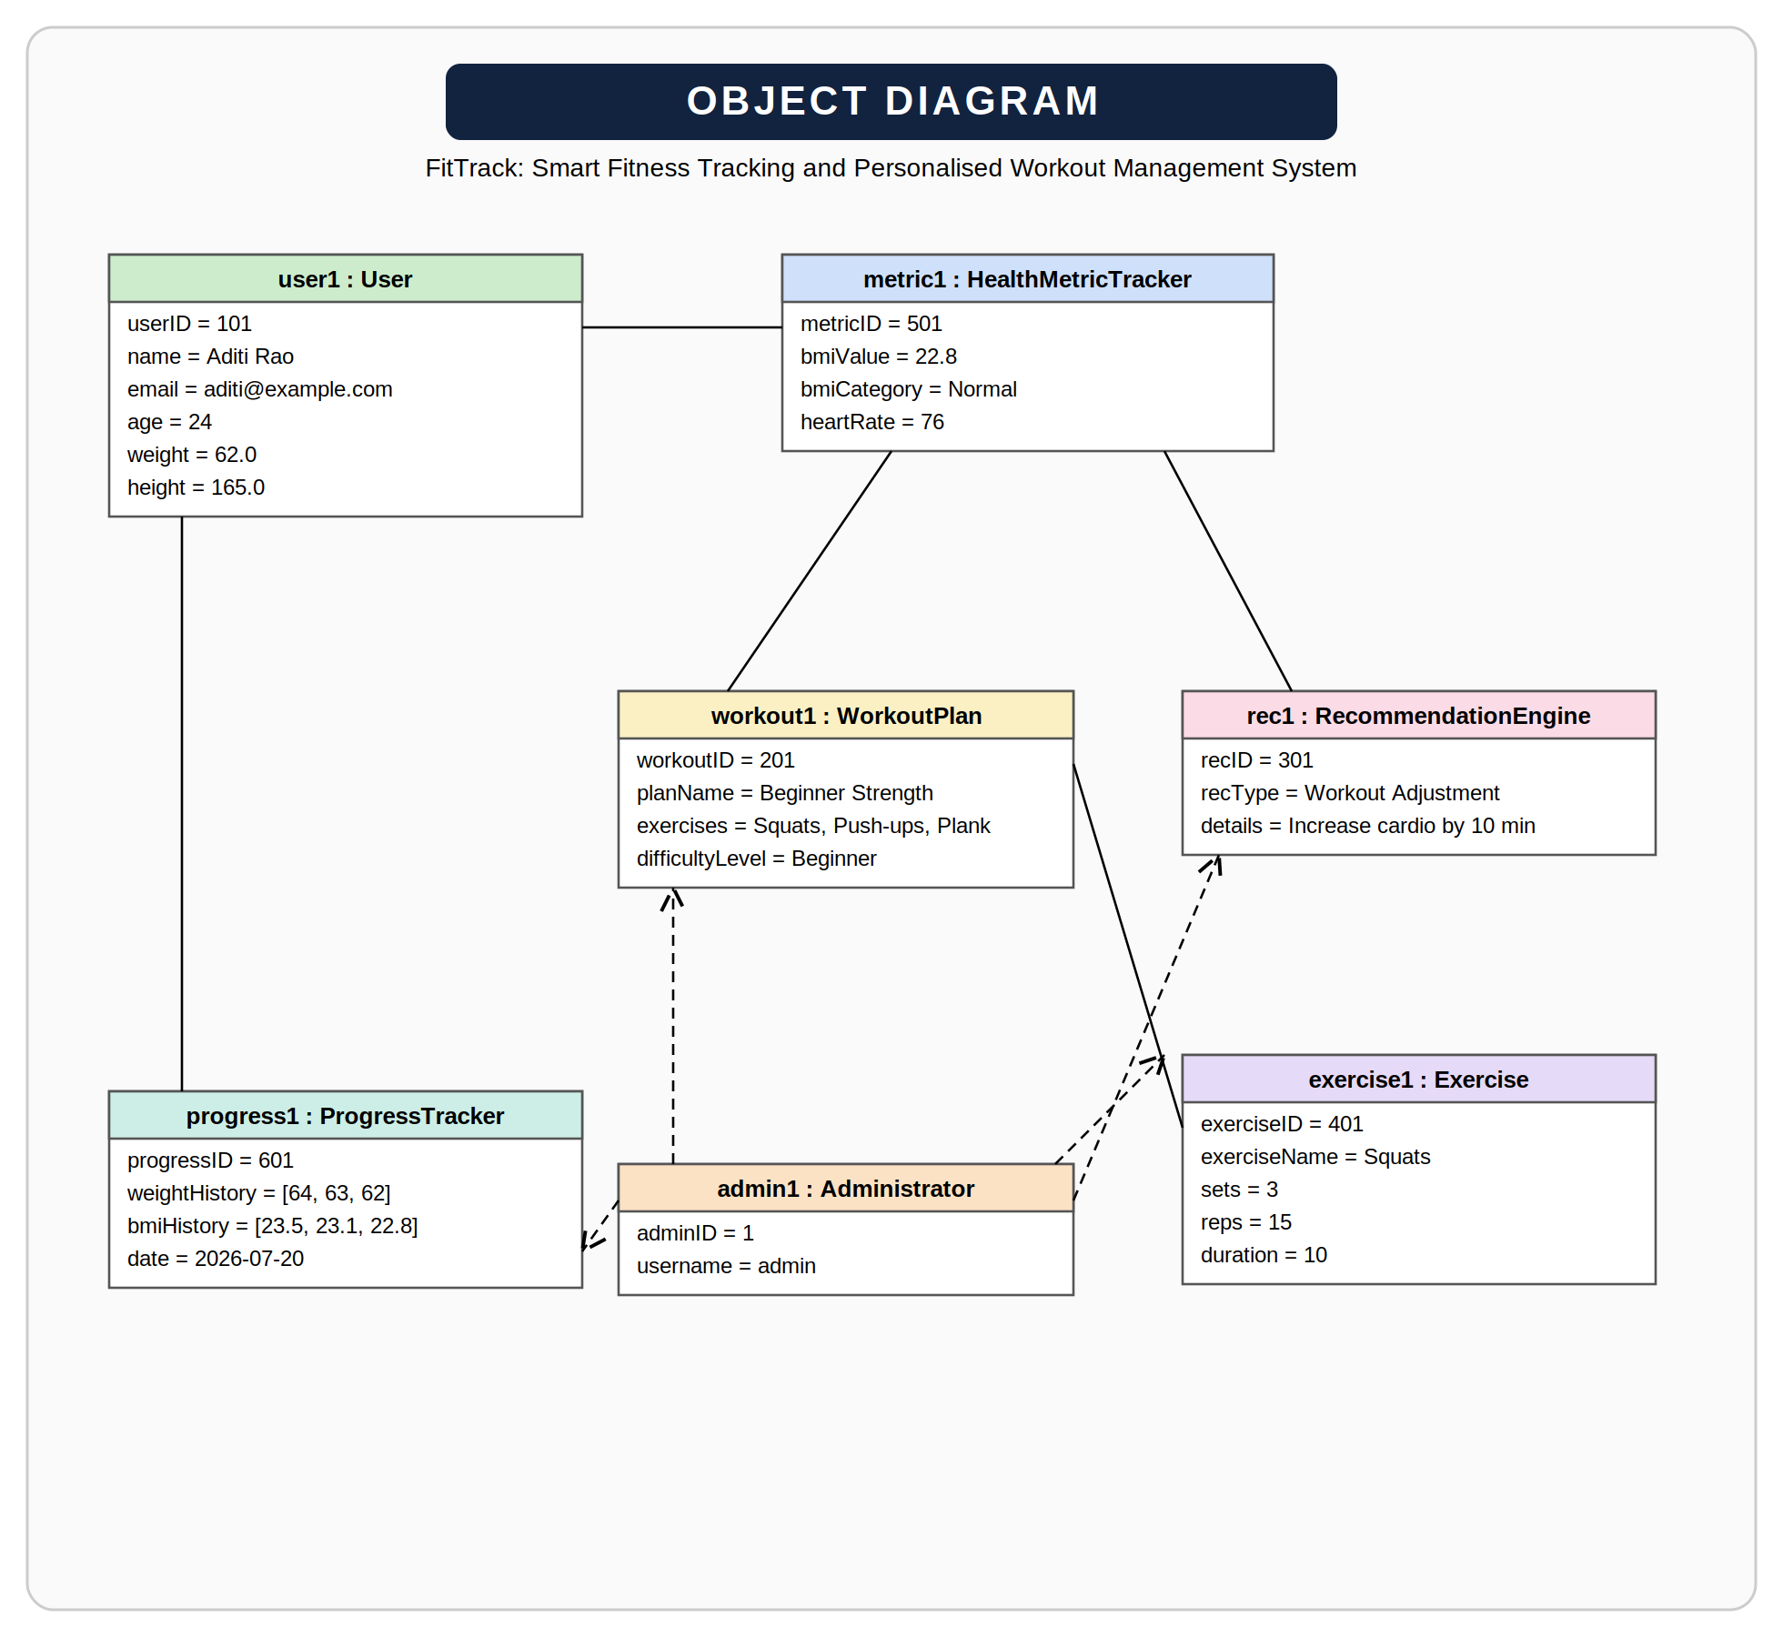
Conclusion: Hence, the Class Diagram and Object Diagram for the FitTrack: Smart Fitness Tracking and Personalised Workout Management System were successfully designed and studied. They clearly represent the static structure of the system, including its classes, objects, attributes, methods, and relationships, providing a clear blueprint for software development.

