Experiment No. 4
Sequence Diagram
Name: Prem  Class: [Your Class]  Roll No: [Your Roll No]  Subject : SCS | DOP: [DD/MM/YY]  DOS: [DD/MM/YY]  Batch: [Your Batch]  Sign:
Classes involved in the scenario and the sequence of messages exchanged between the objects needed to carry out the functionality of the scenario. Sequence diagrams are typically associated with use case realizations in the Logical View of the system under development. Sequence diagrams are sometimes called event diagrams or event scenarios.
A sequence diagram shows, as parallel vertical lines (lifelines), different processes or objects that live simultaneously, and, as horizontal arrows, the messages exchanged between them, in the order in which they occur. This allows the specification of simple runtime scenarios in a graphical manner.
A sequence diagram is the most commonly used interaction diagram.
Interaction diagram –
An interaction diagram is used to show the interactive behavior of a system. Since visualizing the interactions in a system can be a cumbersome task, we use different types of interaction diagrams to capture various features and aspects of interaction in a system.
Sequence Diagrams –
A sequence diagram simply depicts interaction between objects in a sequential order i.e. the order in which these interactions take place. We can also use the terms event diagrams or event scenarios to refer to a sequence diagram. Sequence diagrams describe how and in what order the objects in a system function. These diagrams are widely used by businessmen and software developers to document and understand requirements for new and existing systems.
Sequence Diagram Notations –
1. Actors – An actor in a UML diagram represents a type of role where it interacts with the system and its objects. It is important to note here that an actor is always outside the scope of the system we aim to model using the UML diagram.
We use actors to depict various roles including human users and other external subjects. We represent an actor in a UML diagram using a stick person notation.
2. Lifelines – A lifeline is a named element which depicts an individual participant in a sequence diagram. So basically each instance in a sequence diagram is represented by a lifeline. Lifeline elements are located at the top in a sequence diagram. The standard in UML for naming a lifeline follows the following format – Instance Name : Class Name
We display a lifeline in a rectangle called head with its name and type. The head is located on top of a vertical dashed line (referred to as the stem). If we want to model an unnamed instance, we follow the same pattern except now the portion of lifeline's name is left blank.
Difference between a lifeline and an actor – A lifeline always portrays an object internal to the system whereas actors are used to depict objects external to the system.
3. Activation boxes:
- A thin rectangle on a lifeline represents the period during which an element is performing an operation.
- The top and the bottom of the rectangle are aligned with the initiation and the completion time respectively.
4. Messages
Call Message
- A message defines a particular communication between Lifelines of an Interaction.
- Call message is a kind of message that represents an invocation of operation of target lifeline.
Return Message
- A message defines a particular communication between Lifelines of an Interaction.
- Return message is a kind of message that represents the pass of information back to the caller of a corresponding former message.
Self Message
- A message defines a particular communication between Lifelines of an Interaction.
- Self message is a kind of message that represents the invocation of a message of the same lifeline.
Recursive Message
- A message defines a particular communication between Lifelines of an Interaction.
- Recursive message is a kind of message that represents the invocation of a message of the same lifeline. Its target points to an activation on top of the activation where the message was invoked from.
Create Message
- A message defines a particular communication between Lifelines of an Interaction.
- Create message is a kind of message that represents the instantiation of (target) lifeline.
Destroy Message
- A message defines a particular communication between Lifelines of an Interaction.
- Destroy message is a kind of message that represents the request of destroying the lifecycle of the target lifeline.
Duration Message
- A message defines a particular communication between Lifelines of an Interaction.
- Duration message shows the distance between two time instants for a message invocation.
Benefits of sequence diagrams
Sequence diagrams can be useful references for businesses and other organizations. Try drawing a sequence diagram to:
- Represent the details of a UML use case.
- Model the logic of a sophisticated procedure, function, or operation.
- See how objects and components interact with each other to complete a process.
- Plan and understand the detailed functionality of an existing or future scenario.
Collaboration Diagram
A collaboration diagram, also called a communication diagram or interaction diagram, is an illustration of the relationships and interactions among software objects in the Unified Modeling Language (UML). The concept is more than a decade old although it has been refined as modeling paradigms have evolved.
A collaboration diagram resembles a flowchart that portrays the roles, functionality and behavior of individual objects as well as the overall operation of the system in real time. Objects are shown as rectangles with naming labels inside. These labels are preceded by colons and may be underlined. The relationships between the objects are shown as lines connecting the rectangles. The messages between objects are shown as arrows connecting the relevant rectangles along with labels that define the message sequencing.
Collaboration diagrams are best suited to the portrayal of simple interactions among relatively small numbers of objects. As the number of objects and messages grows, a collaboration diagram can become difficult to read. In the collaboration diagram, the method call sequence is indicated by some numbering technique. The number indicates how the methods are called one after another.
Method calls are similar to that of a sequence diagram. However, the difference being the sequence diagram does not describe the object organization, whereas the collaboration diagram shows the object organization.
To choose between these two diagrams, emphasis is placed on the type of requirement. If the time sequence is important, then the sequence diagram is used. If organization is required, then collaboration diagrams are used. Collaboration diagrams (known as Communication Diagrams in UML 2.x) are used to show how objects interact to perform the behavior of a particular use case, or a part of a use case.
Why Collaboration Diagrams?
Unlike a sequence diagram, a collaboration diagram shows the relationships among the objects. Sequence diagrams and collaboration diagrams express similar information, but show it in different ways. Because of the format of the collaboration diagram, they tend to be better suited for analysis activities, specifically for depicting simpler interactions of smaller numbers of objects. However, if the number of objects and messages grows, the diagram becomes increasingly hard to read.
Use cases for a collaboration diagram:
- Model collaborations between objects or roles that deliver the functionalities of use cases and operations.
- Model mechanisms within the architectural design of the system.
- Capture interactions that show the messages passing between objects and roles within the collaboration.
- Model alternative scenarios within use cases or operations that involve the collaboration of different objects and interactions.
- Support the identification of objects (hence classes) that participate in use cases.
- Each message in a collaboration diagram has a sequence number.
- The top-level message is numbered 1. Messages sent during the same call have the same decimal prefix but suffixes of 1, 2, etc. according to when they occur.
Notations of Collaboration Diagram
Objects
An object is represented by an object symbol showing the name of the object and its class underlined, separated by a colon: Object_name : class_name
- Each object in the collaboration is named and has its class specified.
- Not all classes need to appear.
- There may be more than one object of a class.
- An object's class can be unspecified. Normally you create a collaboration diagram with objects first and specify their classes later.
- The objects can be unnamed, but you should name them if you want to discriminate against different objects of the same class.
Actors
- Each Actor is named and has a role.
- One actor will be the initiator of the use case.
Links
Links connect objects and actors and are instances of associations and each link corresponds to an association in the class diagram.
- A link is a relationship among objects across which messages can be sent. In collaboration diagrams, a link is shown as a solid line between two objects.
- An object interacts with, or navigates to, other objects through its links to these objects.
- A link can be an instance of an association, or it can be anonymous, meaning that its association is unspecified.
- Message flows are attached to links.
Messages
A message is a communication between objects that conveys information with the expectation that activity will ensue. In collaboration diagrams, a message is shown as a labeled arrow placed near a link.
- The message is directed from sender to receiver.
- The receiver must understand the message.
- The association must be navigable in that direction.
Purpose of Interaction Diagrams
The purpose of interaction diagrams is to visualize the interactive behavior of the system. Visualizing the interaction is a difficult task. Hence, the solution is to use different types of models to capture the different aspects of the interaction. Sequence and collaboration diagrams are used to capture the dynamic nature but from a different angle.
The purpose of an interaction diagram is −
- To capture the dynamic behaviour of a system.
- To describe the message flow in the system.
- To describe the structural organization of the objects.
- To describe the interaction among objects.
Implementation
Scenario:
A user logs into the FitTrack system, sets fitness goals, enters height and weight to calculate health metrics, receives a personalized workout plan and workout recommendations, views recommended exercises, and tracks fitness progress. The Administrator manages users and updates workout plans and the exercise library.
Objects (Sequence Diagram)
- User
- FitTrack System
- Authentication Module
- Health Metric Tracker
- Workout Plan
- Recommendation Engine
- Exercise
- Progress Tracker
- Administrator
Sequence of Messages
- User → FitTrack System : Register()
- User → Authentication Module : Login()
- Authentication Module → User : Login Successful
- User → Health Metric Tracker : Enter Height & Weight
- Health Metric Tracker → User : Display BMI & Category
- Health Metric Tracker → Workout Plan : Generate Workout Plan
- Workout Plan → User : Display Workout Plan
- Health Metric Tracker → Recommendation Engine : Generate Recommendation
- Recommendation Engine → User : Display Recommendation
- Workout Plan → Exercise : Fetch Exercises
- Exercise → User : Display Exercises
- User → Progress Tracker : Update Progress
- Progress Tracker → User : Display Progress Report
- Administrator → FitTrack System : Manage Users
- Administrator → Workout Plan : Update Workout Plan
- Administrator → Exercise : Update Exercise Library
Objects (Collaboration Diagram)
- user1 : User
- auth : Authentication
- metricCalc : HealthMetricTracker
- workout : WorkoutPlan
- rec : RecommendationEngine
- exercise : Exercise
- progress : ProgressTracker
- admin : Administrator
Message Sequence (Collaboration Diagram)
- 1 register()
- 2 login()
- 3 login successful
- 4 calculateMetrics(height, weight)
- 4.1 generateWorkoutPlan(bmiCategory)
- 4.2 generateRecommendation(bmiCategory)
- 5 fetchExercises(workoutID)
- 7 updateProgress(progressData)
- 8 generateReport()
- 9 manageUsers()
- 10 manageWorkoutPlans()
- 11 manageExerciseLibrary()
Implementation Steps
- Create the User and Administrator modules.
- Implement user registration and login.
- Accept height and weight from the user.
- Calculate BMI and health metrics and determine BMI category.
- Generate personalized workout plans.
- Generate personalized workout recommendations.
- Fetch and display exercises according to the workout plan.
- Store and display fitness progress.
- Allow the Administrator to manage users, workout plans, and the exercise library.
Expected Output
- User successfully registers and logs in.
- Health metrics and BMI are calculated correctly.
- Workout plan is displayed.
- Workout recommendations are displayed.
- Recommended exercises are shown.
- Fitness progress is updated.
- Administrator manages system data successfully.
Sequence Diagram:
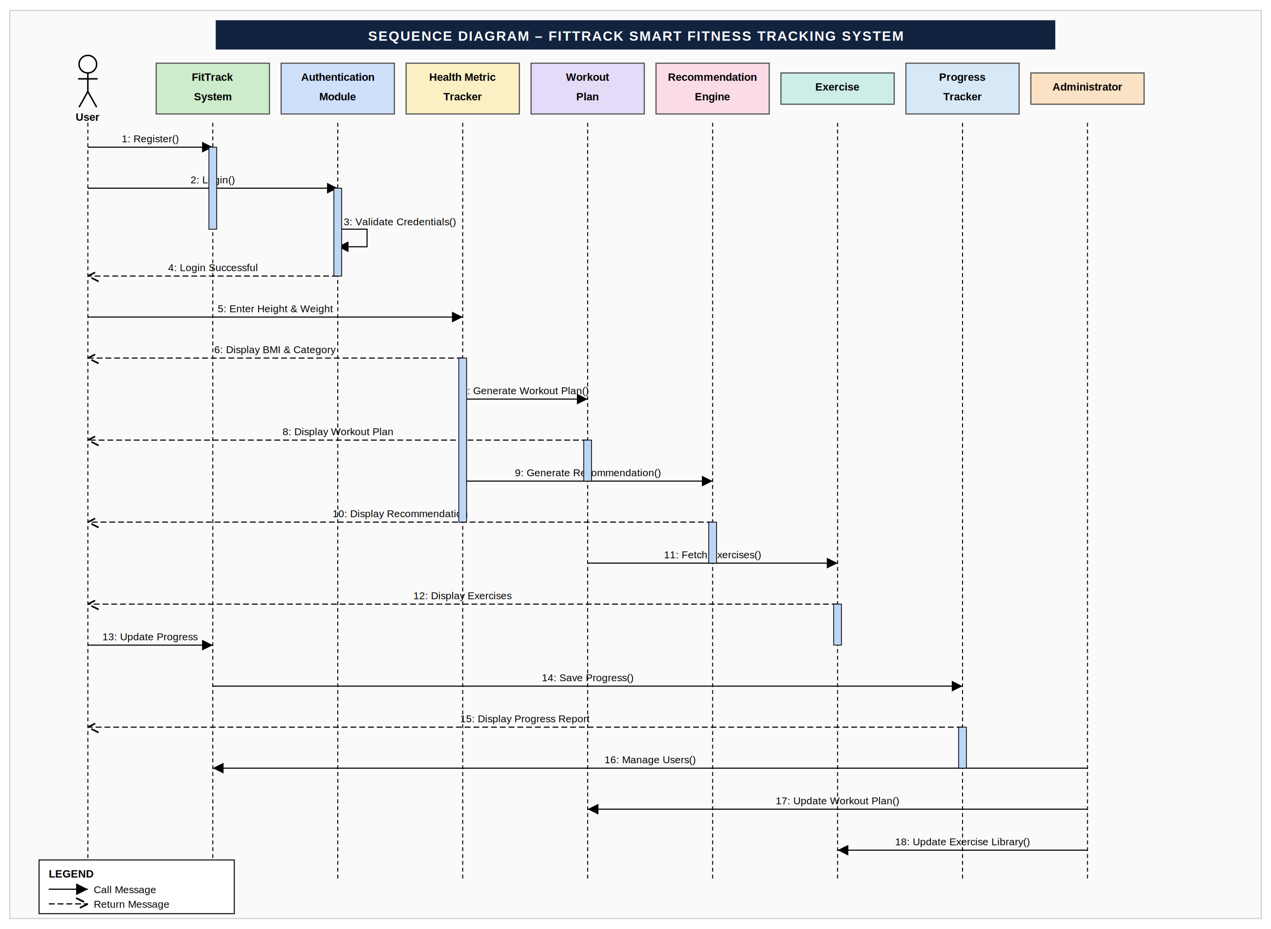
Collaboration Diagram:
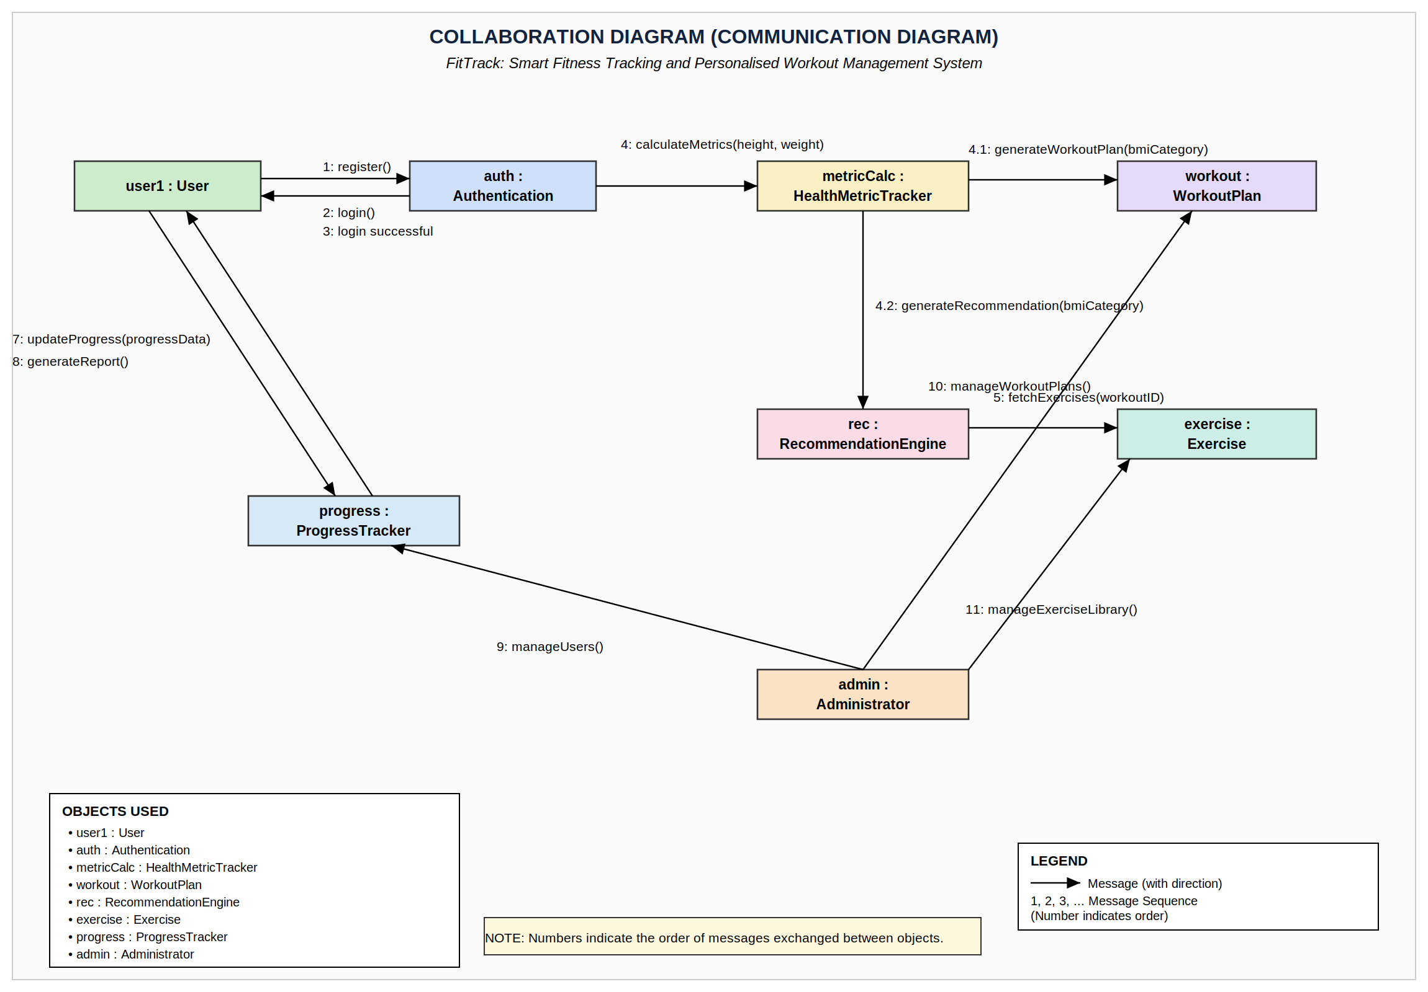
Conclusion: Hereby we have studied sequence and Collaboration diagrams which are combined known as Interaction diagrams.

