## Data Extraction

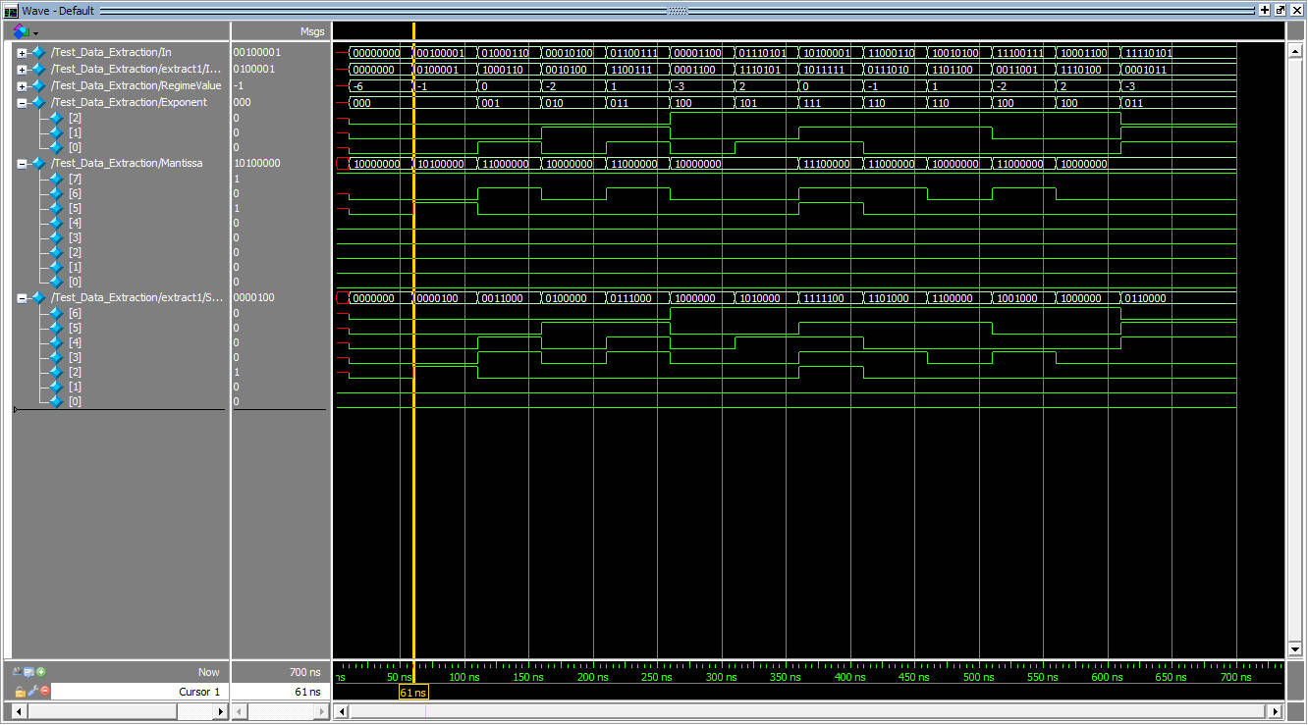

When the input is positive, the InRemain just the input without the sign bit. The RegimeValue is m-1 when RegimeCheck (The MSB of InRemain, the second bit of In) is 1 and it is -m when RegimeCheck is 0.

For negative input, the InRemain is the two’s compliment of the input without sign bit. Take care that the RegimeValue and other components are corresponding to the InRemain for negative input NOT THE ORIGINAL INPUT.

### Posit Arithmetic

Data Alignment

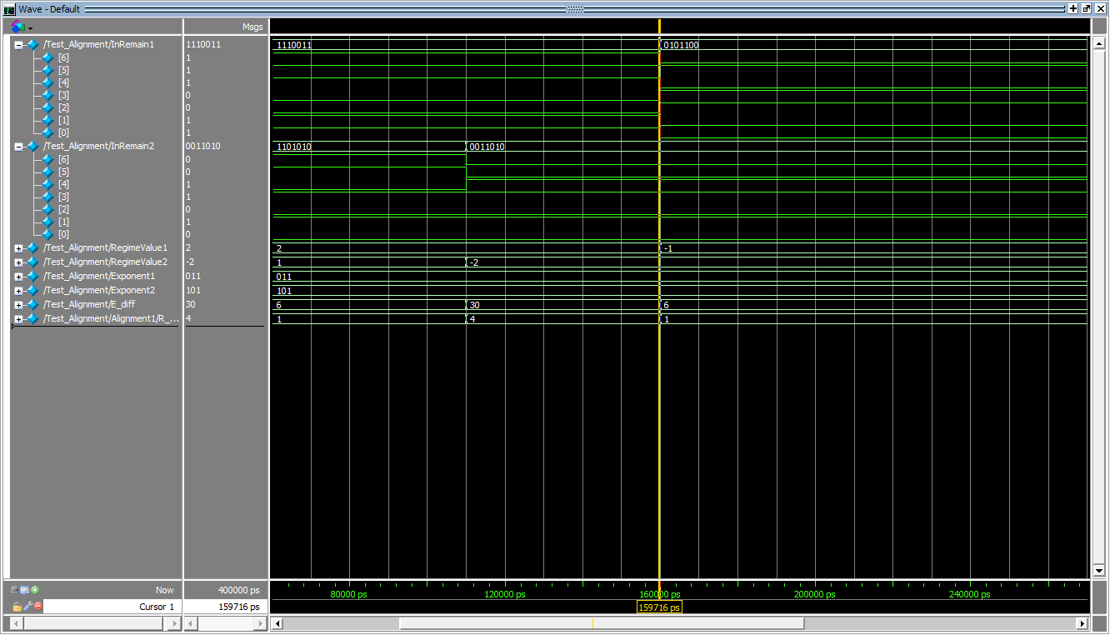

There are three sets of inputs, the first set has both input with positive regime, the second one has the one input with positive regime and another with negative regime, the third set has both input with negative regime.

As it can be seen from the graph, for 1st set, the input is 1110_011 and 110_101_0, which has regime value of 2 and 1, exponent value of 3 and 5 respectively, giving a total 6 E_diff. For 2nd set, the input is 1110_011 and 001_101_0, which has regime value of 2 and -2, exponent value of 3 and 5 respectively, giving a total E_diff of 30. For 3rd set, the input is 01_011_00 and 001_101_0, which has regime value of -1 and -2, exponent value of 3 and 5 respectively, giving a total E_diff of 6.