Pet Care Management System
Xiaobo Zhan

1. System Planning

1.1 Business Case
Build a multi‑window desktop application to streamline pet care operations — owners, pets, appointments, vaccinations — reducing manual errors and improving service speed for veterinary staff.

1.2 SWOT Analysis
• Strengths: Centralized data, improved accuracy, simplified pet/appointment/vaccination tracking.
• Weaknesses: Initial training; dependency on Windows and SQL Server.
• Opportunities: Add billing, medical history, SMS reminders, analytics.
• Threats: Data-entry mistakes; hardware downtime; competing systems.

1.3 Preliminary Investigation
Clinics often rely on spreadsheets or paper notes. Issues include lost records, inconsistent information, manual duplication, and difficulty tracking upcoming vaccinations.

1.4 Feasibility Study
Operational: WinForms UI is easy to learn.
Technical: .NET 6 WinForms + SQL Server.
Economic: Low cost; time savings reduce administrative overhead.
Schedule: Agile iterative delivery.

1.5 Project Management
Phase I: Requirements & planning.
Phase II: UI mockups & basic CRUD structure.
Phase III: Repository implementation, database integration.
The following Gantt chart illustrates the timeline using Agile iterative development:

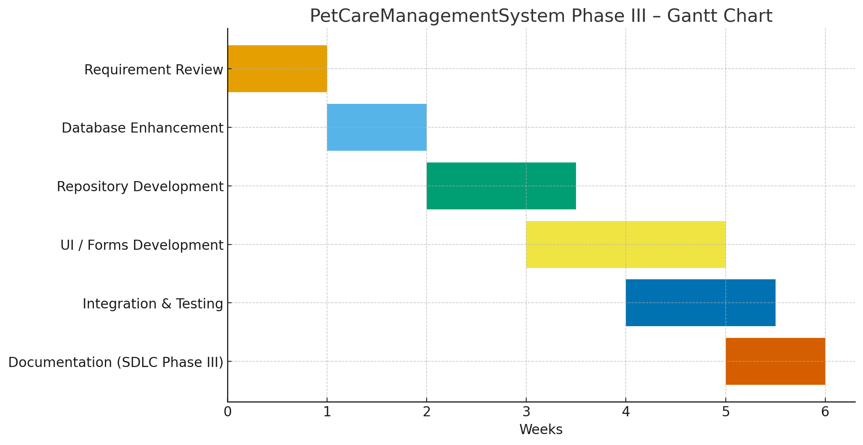

2. System Analysis

2.1 Requirement Modeling
Inputs: Owner details, pet details, appointment time, vaccination info.
Processes: CRUD operations, appointment scheduling, vaccination recording.
Outputs: Appointment list, vaccination history, pet profiles.

2.2 Functional Decomposition Diagram (FDD)

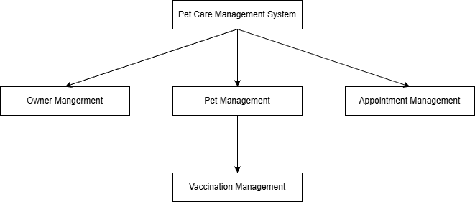

2.3 Data Flow Diagrams (DFD)

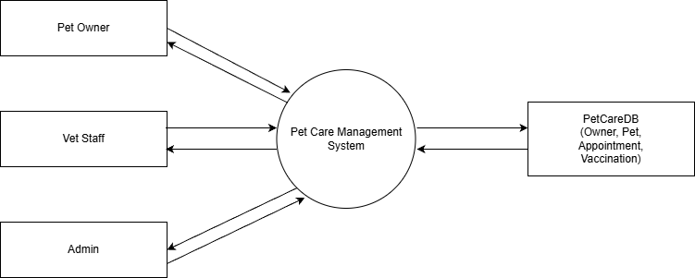

2.4 Object Modeling (UML)

2.4.1 Use Case Diagram
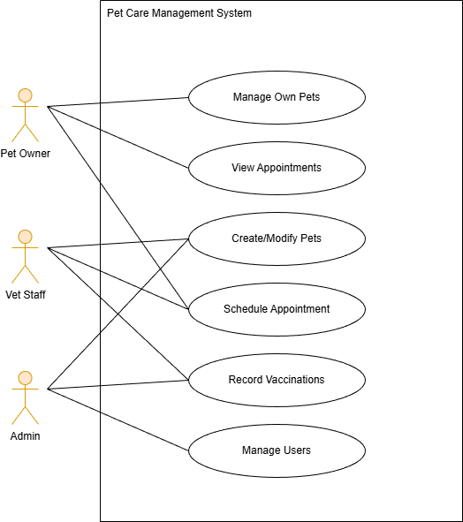

2.4.2 Sequence Diagram – Add Pet

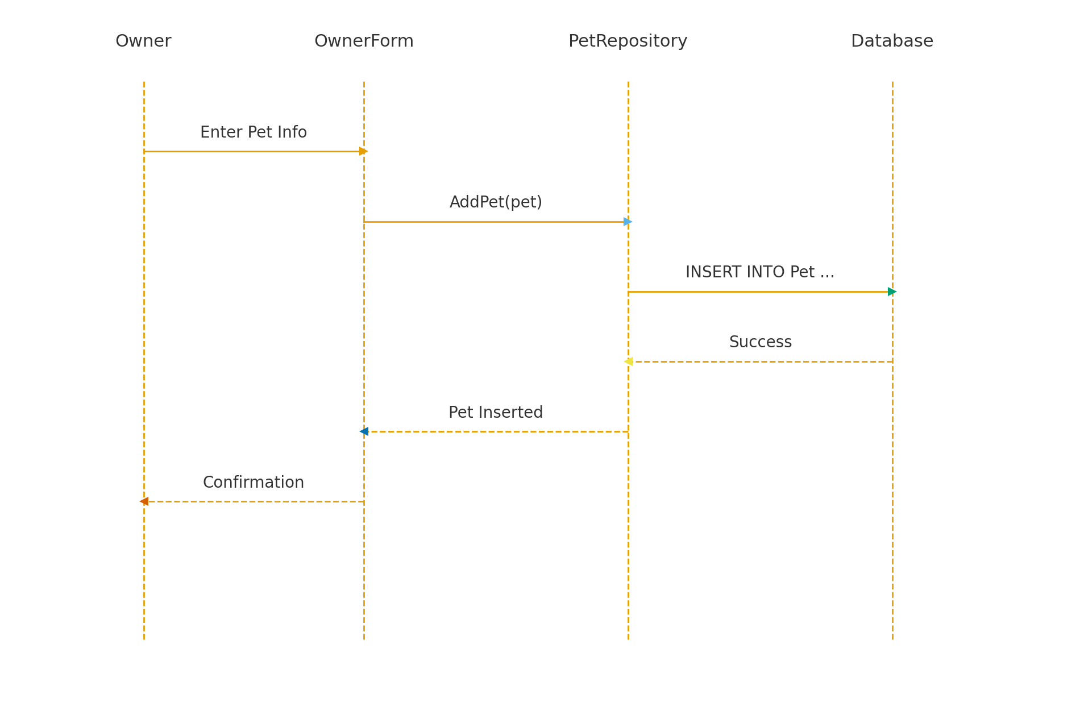

2.4.3 Class Diagram
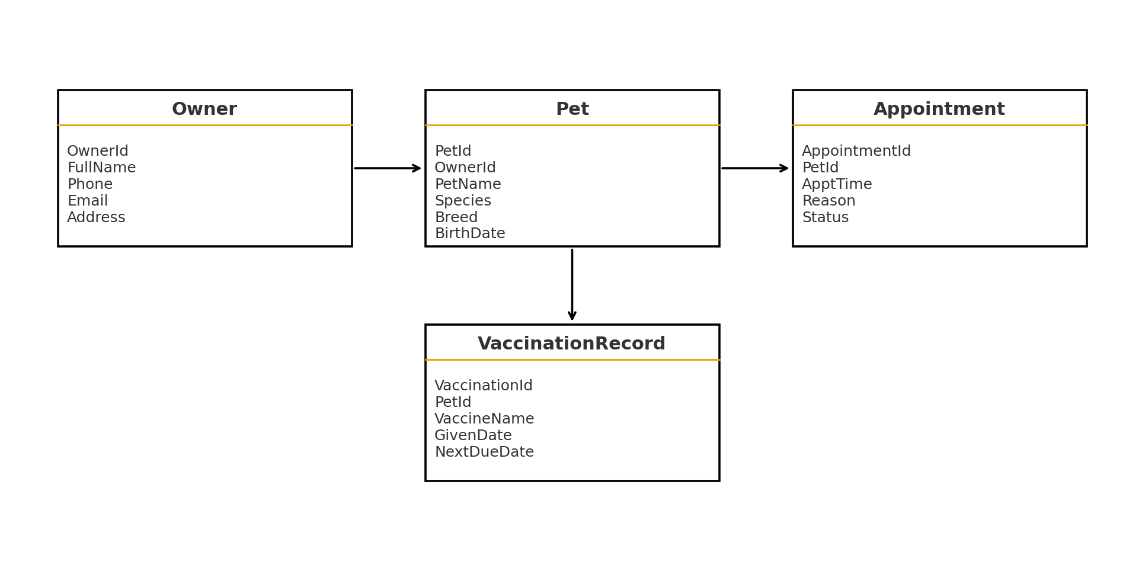

3. System Design

3.1 Development Strategy
WinForms desktop app with modular CRUD windows. Repository pattern used to isolate SQL code.

3.2 User Interface Design
Main window contains navigation buttons: Owner, Pet, Appointment, Vaccination.
Each module uses text fields, buttons, and a DataGridView for CRUD operations.

3.3 Data Design
Database stored in SQL Server, following proper normalization.

3.4 ERD
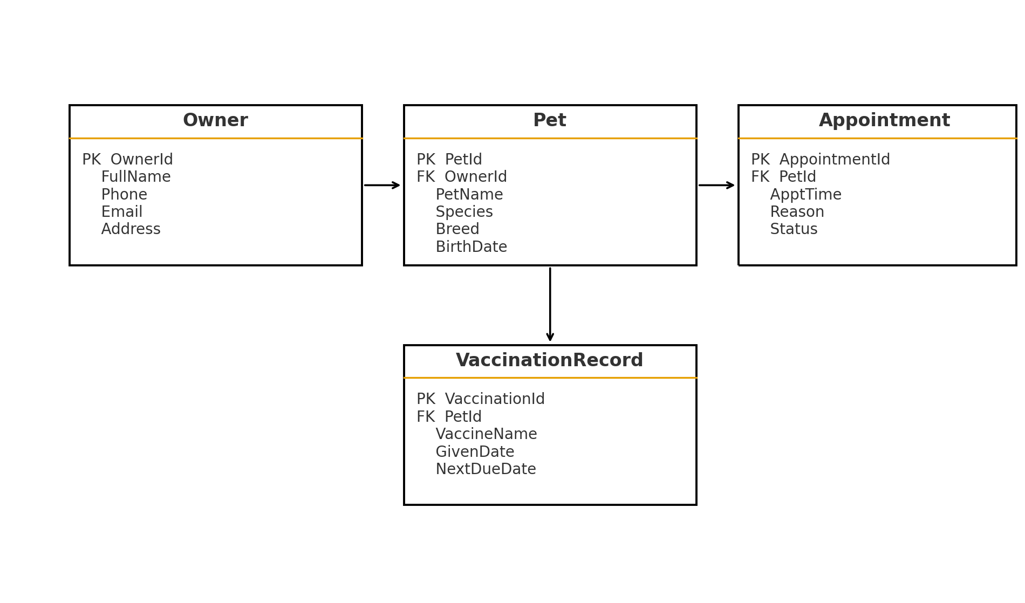

3.5 Output Design
Outputs include appointment listings, vaccination schedules, and pet profiles.
DataGridViews allow sorting and inspection.

4. System Implementation
Implementation includes:
• UI Forms (OwnerForm, PetForm, AppointmentForm, VaccinationForm)
• Repository classes for all SQL operations
• Central connection string
• Data validation and exception handling

5. System Testing
• CRUD operations validated for all modules.
• Foreign key integrity tested (Owner → Pet, Pet → Appointment/Vaccination).
• DateTimePicker handling verified.
• SQL queries validated using SSMS.
• UI tests performed for field validation.

6. Agile Iteration Plan (Phase III)
Goals:
• Complete CRUD modules with SQL Server backend.
• Validate data consistency.
• Improve UI usability.

7. Screenshots / Demo

