Restaurant Online Food Ordering Application

1.System Planning

1.1 Business Case
Build a multi-window desktop application to streamline restaurant operations—customers, menu, orders, payments, daily reporting—reducing manual errors and improving service speed.

1.2 SWOT Analysis
Strengths: Unified workflow, reduced errors, fast order-to-payment turnaround.
Weaknesses: Initial training; dependency on desktop environment.
Opportunities: Add delivery/online ordering; analytics.
Threats: Third‑party platforms competition; data-entry mistakes; hardware downtime.

1.3 Preliminary Investigation
Existing process involves paper tickets and Excel tiles. Issues: duplication of effort, inconsistent totals, slow daily close.

1.4 Feasibility Study
Operational: GUI fits staff workflow with minimal learning curve.
Technical: Python GUI stack; text/DB storage; Windows 10+ compatible.
Economic: Low cost; productivity gains from fewer voids and faster checkout.
Schedule: Iterative Agile delivery with 2‑week sprints.

1.5 Project Management
We adopt Agile iterations:
• Iteration 1 (Phase I): Core order model & CLI prototype.
• Iteration 2 (Phase II): Multi‑window GUI (Customers, Menu, Orders, Payments), text storage
• Iteration 3 (Phase III): Harden workflows, add Manager Search and Daily Report, use DB storage, improve reporting, error handling, and persistence.
The following Gantt chart illustrates the timeline using Agile iterative development:
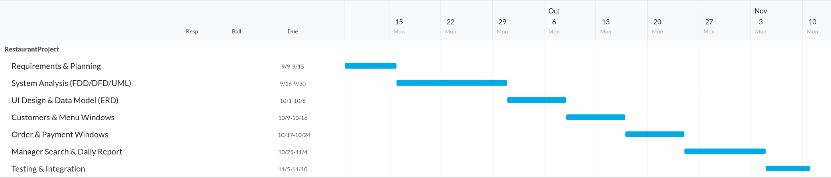

2. System Analysis

2.1 Requirement Modeling
Inputs: Customer info, Menu items, Order items & quantities, Payment details.
Processes: CRUDs, order creation, subtotal/tax/total computation, payment capture, daily report, manager search.
Outputs: Order confirmation, receipt, daily sales summary, query results.

2.2 Functional Decomposition Diagram (FDD)

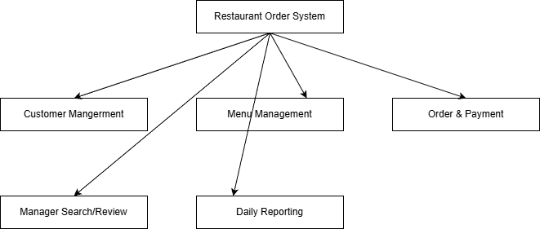
Figure: FDD – decomposes system capabilities into manageable functions.

2.3 Data Flow Diagrams (DFD)
Level 0 overview and Level 1 (Order Processing) detail:
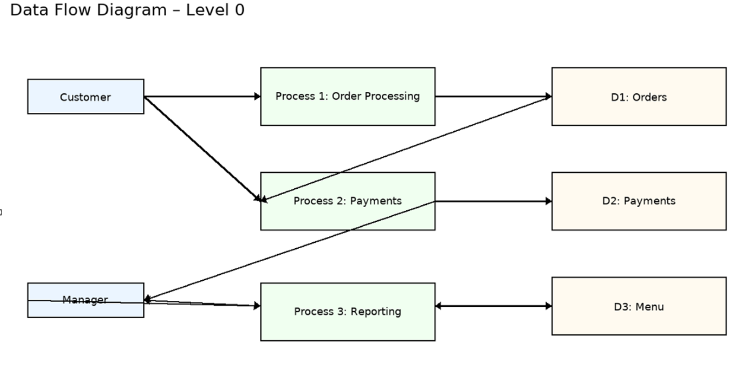
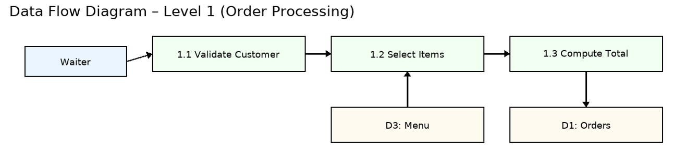

2.4 Object Modeling (UML)

2.4.1 Use Case Diagram
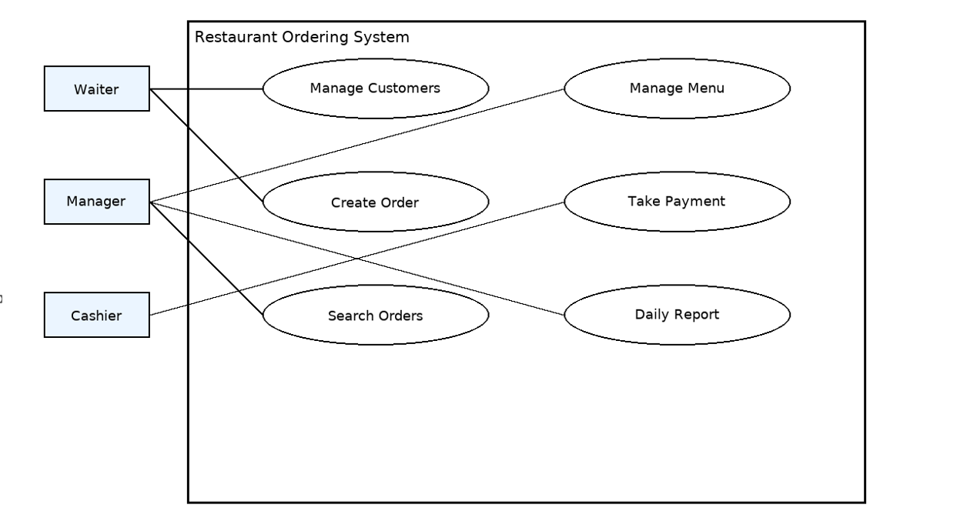

2.4.2 Sequence Diagram – Place Order & Pay
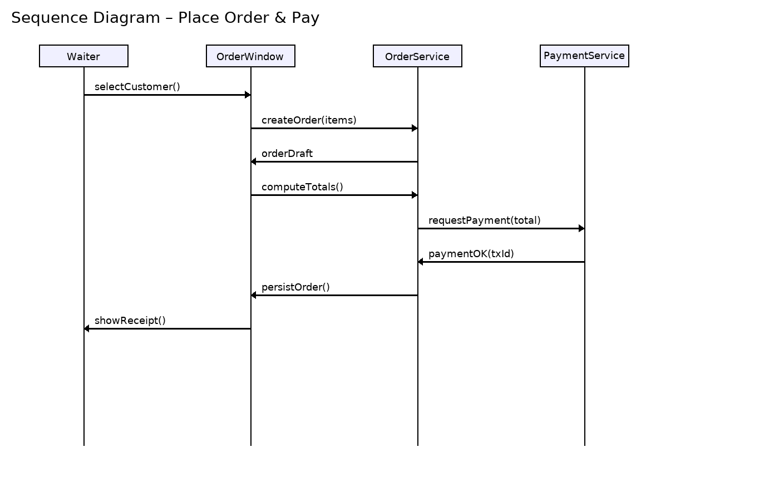

2.4.3 Class Diagram
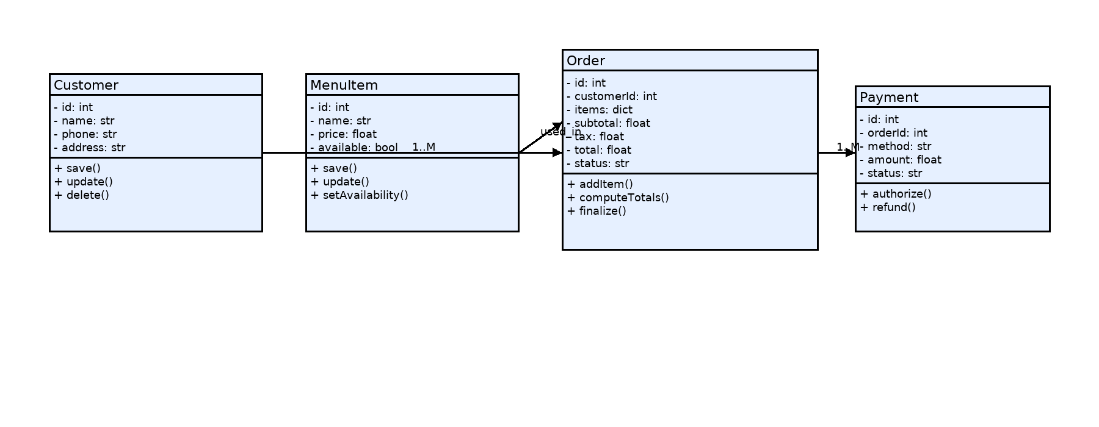

3. System Design

3.1 Development Strategy
Desktop app with modular windows. Clean separation of UI (windows) and domain logic (services/models).

3.2 User Interface Design
Main window → Customers / Menu / Orders & Payment / Daily Report / Manager Search buttons.
Customers & Menu windows expose CRUD tables. Order window provides item selection and live totals. Payment window confirms method & amount. Daily Report summarizes totals; Manager Search filters by date/status/id.

3.3 Data Design
MySQL for multi-user access.
Normalization: Order–OrderItem separates header and lines; MenuItem independent; Payment references Order.

3.4 ERD
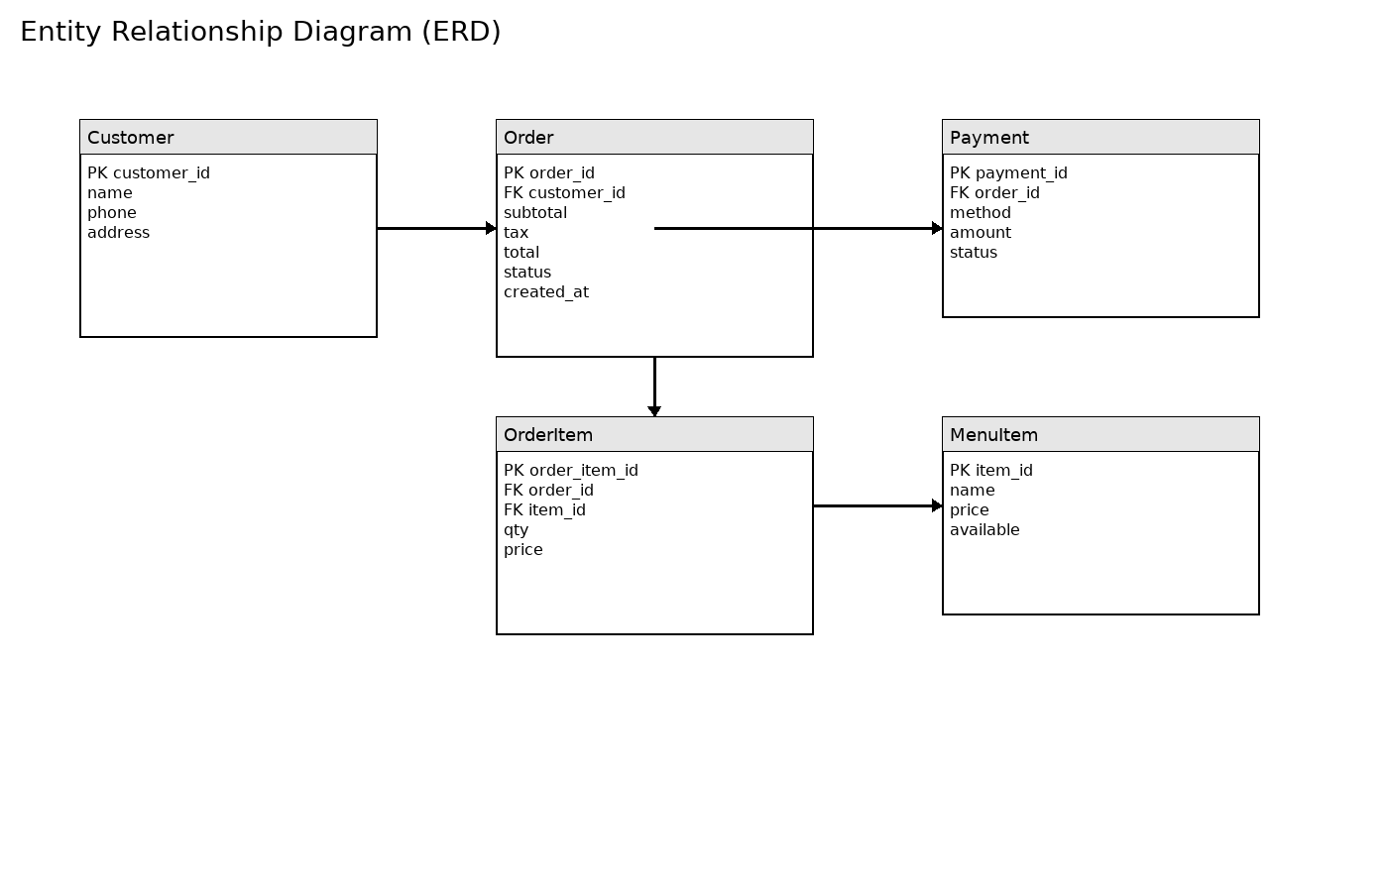

3.5 Output Design
Receipts with transaction id, method, amount; Daily Report with order count, gross, net, taxes.

4. System Implementation
Layers: UI windows (PyQt), Services (OrderService, PaymentService), Repositories (CustomerRepo, MenuRepo, OrderRepo, PaymentRepo).
Error handling: input validation, duplicate checks, payment amount mismatch. Persistence through file or DB adapters.

5. System Testing
Unit tests for repositories & services; integration flow for place‑order‑pay; UAT with staff.
Test cases include: adding customer/menu, computing totals with tax, partial/multiple payments, date‑range report, manager search by id/status/date.

6. Agile Iteration Plan (Phase III)
Goals:
• Robust Manager Search (by OrderID / Customer / Date range / Status).
• Enhanced Daily Report (gross, taxes by type, payments by method).
• Input validation and error messages across all windows.
• Repository refactor for text/DB switch using strategy pattern.
Deliverables: updated GUI windows, services, repositories, and test evidence (screenshots/logs).

7. Screenshots / Demo
