吉林大学

DB2 实验报告

班级：计科 4 班姓名：马兆星
学号：21230415

姓名 | 马兆星 | 学号 | 21230415
实验项目 | 2. Creating databases and data placement
实验性质 | □演示性实验 □验证性实验  - 操作性实验 □综合性实验
实验地点 | 计楼 A210 | 机器编  号
指导教师 | 康辉 | 实验时  间 | 2025 年 10 月 26 日 8 时 00 分

一、实验综述
- 实验目的及要求
During this lab, you will create your database and your table spaces. Also in this lab, you will select information on table spaces from the system catalog (SYSCAT) views.
At the end of the lab, students should be able to:
  - Create a database
  - Create a table space
  - Execute a script file to create multiple table spaces
  - Access the SYSCAT views containing table space information
  - List table space information
  - List container information
- 实验设备、软件
PC, windows XP Professional, DB2 9 Express-c
二、实验过程（实验步骤、记录、数据、分析）
Section 1 - Creating the Database
- Creating a database can be done with the DB2 command create database. Use the online help facility to display the DB2 command syntax for create database. Show your work below by printing screen.
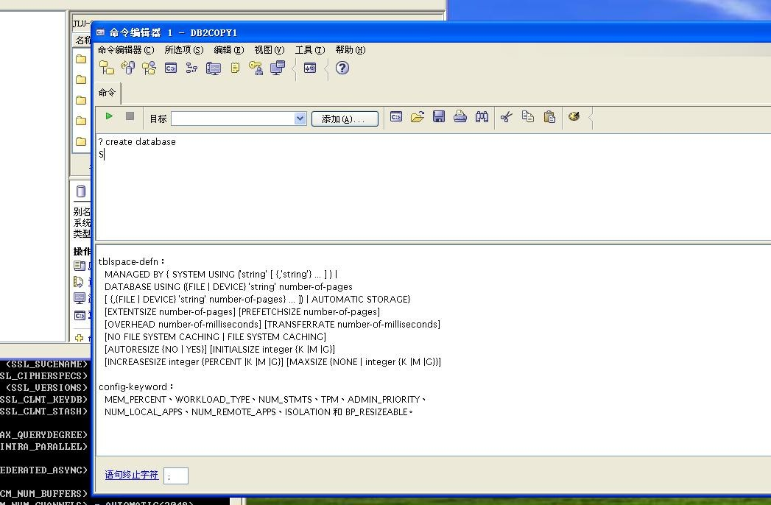
- What information can you specify on the create database command?

The name of the database, the location of the database, an alias name, the codeset and territory for storing the data, a collating sequence, a default extent size, automatic storage, and table space information can be specified on the create database command.

- Based on what you learned in lecture, what table spaces are created when a database is created?
SYSCATSPACE, USERSPACE1, and TEMPSPACE1
Depending on what you specify when you create the database, there may be a fourth tablespace created with a name of SYSTOOLSPACE. This is created if you specify With Automatic Maintenance instead of Standard when you create the database.

- What type of table space, SMS or DMS, will your database use by default for these default table spaces?
DMS table spaces for SYSCATSPACE and USERSPACE1, and SMS for TEMPSPACE1. Note that in DB2 UDB V8.2 and earlier the default table spaces are SMS.

- Before we create our MUSICDB database, remember what you learned in lecture about what some of the defaults will be.
  - What is the default path that the database will be created on?
  - What will be the default table space type (SMS or DMS) for the table spaces that will be created to house User Tables, Catalog Tables, and Temporary Tables?
  - What are the default Extent and Prefetch sizes?
  - What are the default Territory, Code Set and Collating Sequence values?
  - The database will be created on the D:\DB2 path by default.
  - The default table space type for User Tables and Catalog Tables is DMS, and for Temporary Tables is SMS.
  - The default Extent and Prefetch sizes are 32 4KB pages each.
  - The default Territory and Code Set is dependent on your local system settings

- Create your database with a Database name of MUSICDB using the default settings. It will take a few minutes to create the database.
Show your work below by printing screen for the last step.

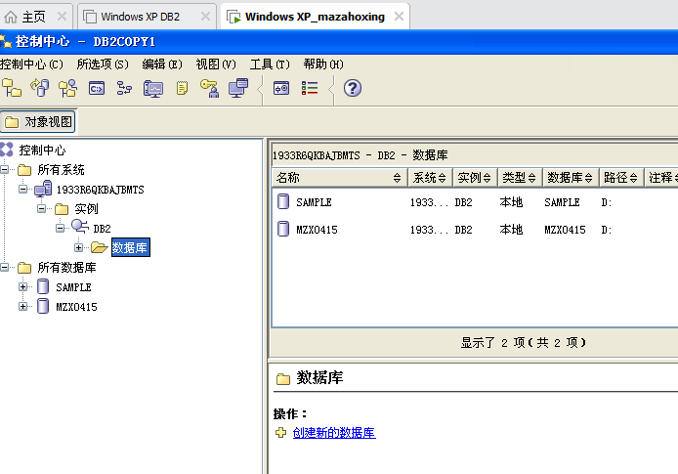
7. You should now have your MUSICDB database created. The System Database Directory contains an entry for all databases known by this instance. Check the System Database Directory for an entry for the MUSICDB database by issuing the list db directory command.
Show your work below by printing screen.
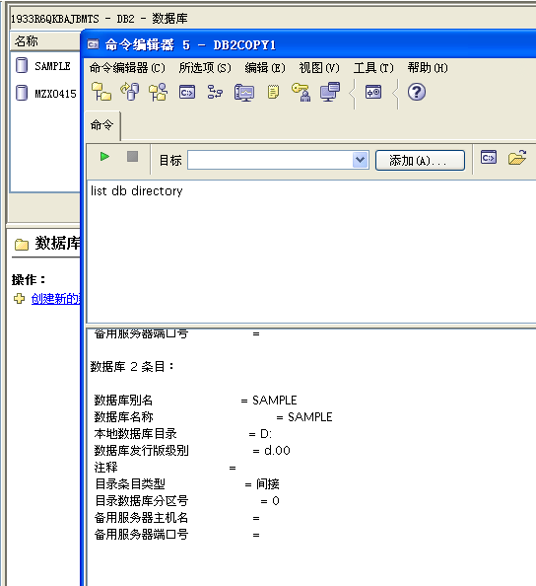

- What is the Database alias name and where did it come from?
The Database alias name is MUSICDB. It defaulted to the database name since no alias was specified when the database was created.

- What does a Directory entry type of Indirect mean?
A Directory entry type of Indirect means the database is located on this system, and that the local database directory can be found here. You will see this if you issue the list database directory command from your telnet window.

- What does a Directory entry type of Remote mean?
A Directory entry type of Remote means the database is located on another system. You will see this if you issue the list database directory command from the Windows client.

- It's time to connect to your MUSICDB database. Check your current connection state with the get connection state command.

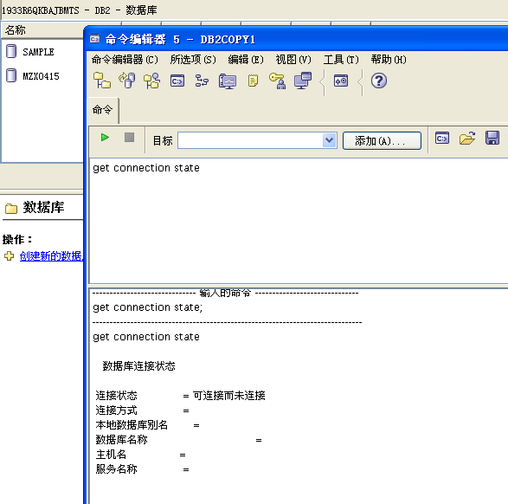

- What is the connection state?
Show your work below by printing screen.


- Connect to your MUSICDB database.
- Did you get connected to your MUSICDB database?

Show your work below by printing screen.
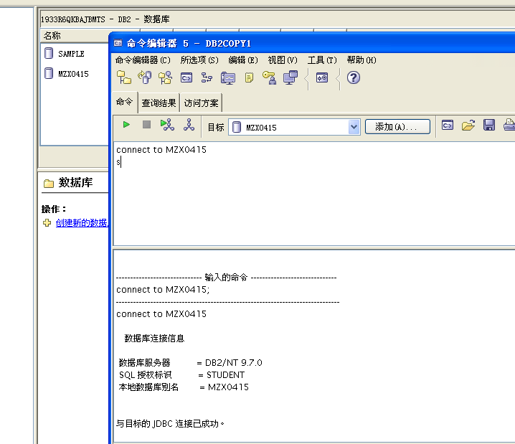

15. Check your connection state again. What does it show?
Show your work below by printing screen.

15. Check your connection state again. What does it show?
Show your work below by printing screen.

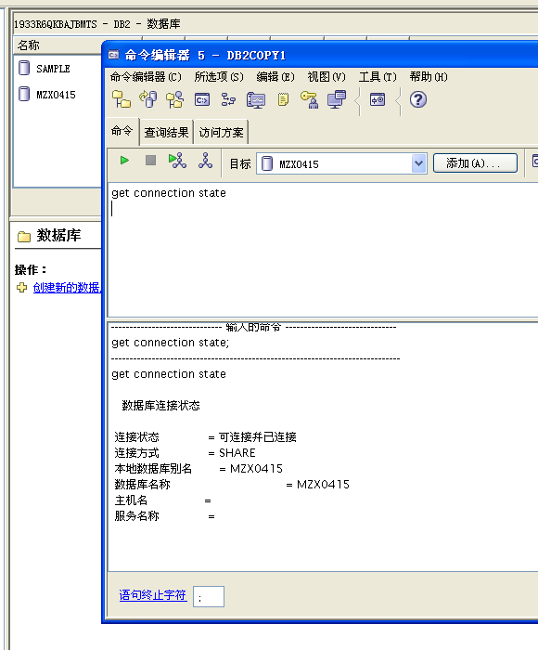

16. Every database has its own Database Configuration file that contains information about the database and tuning parameters. Look at the Database Configuration file for your MUSICDB database.
Show your work below by printing screen.

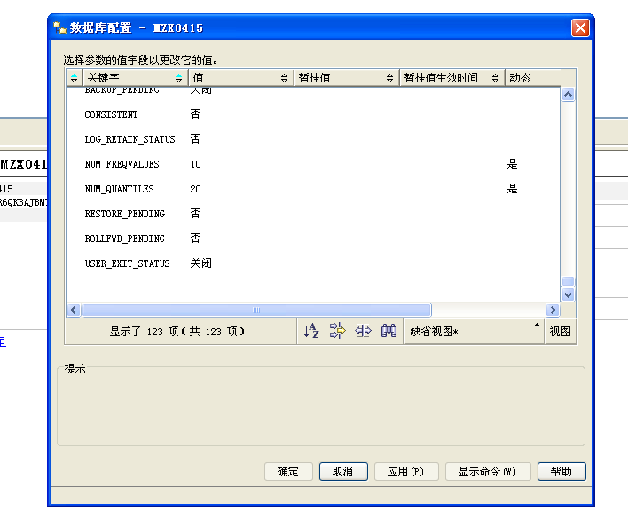

17. Find the default values for two specific configuration parameters for your database, LOCKLIST and MAXLOCKS. Since there are a large number of configuration parameters, we can use grep to find the specific ones we want when using a local connection (the equivalent for DB2 on Windows is: ... | find /i “lock”)
— the option “i” means case insensitive.
Show your work below by printing screen.

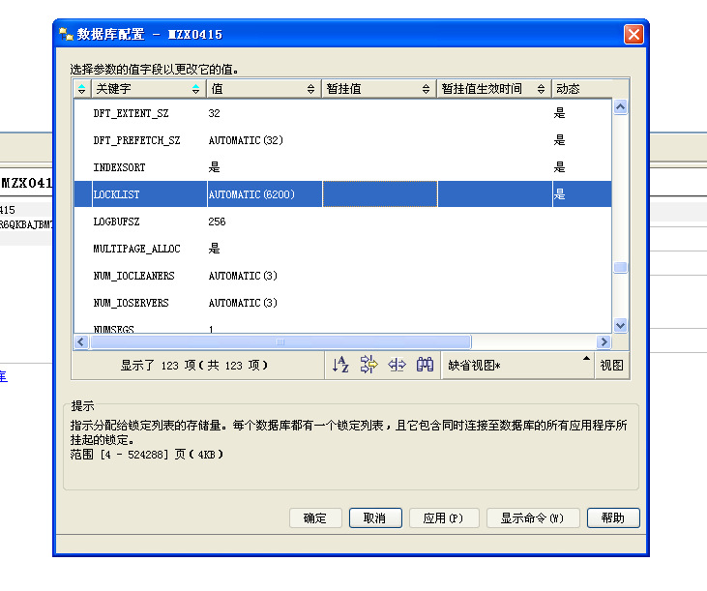

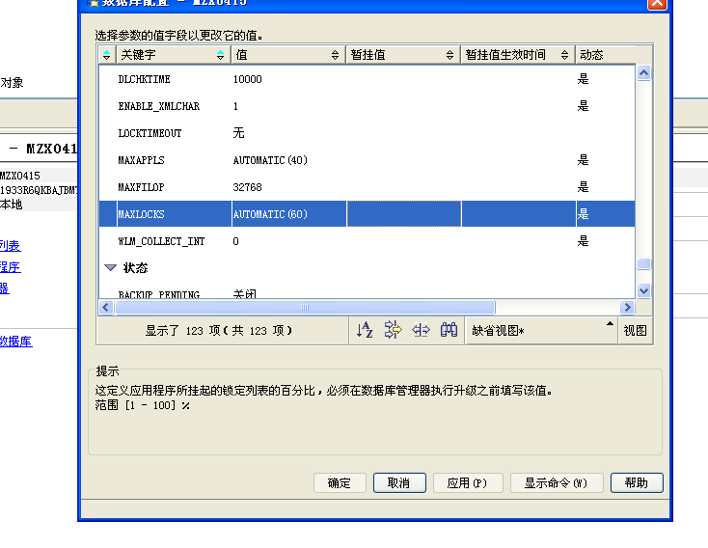
- Values of some of the parameters can be changed. Update the following parameters and specify the values shown.
  - Change maxlocks to 20
  - Change num_freqvalues to 12
Show your work below by printing screen.
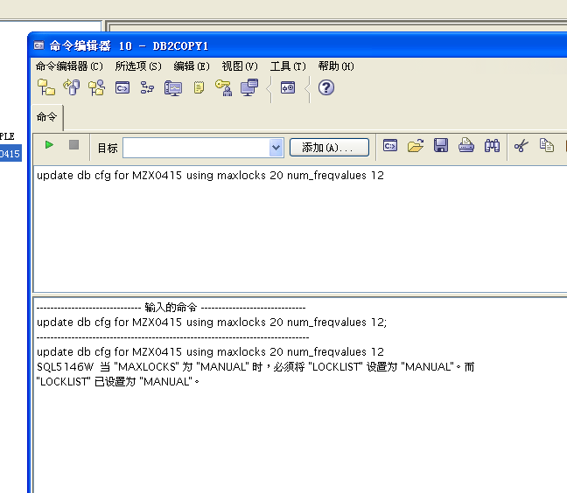
- When do these database configuration file changes take effect?
For these configuration parameters, the change takes effect immediately. Note that when you changed the value for MAXLOCKS, the default value for
LOCKLIST is also changed — from automatic to an appropriate manual value.
- Check to see if the Current and Delayed Values are the same for maxlocks and num_freqvalues.
Show your work below by printing screen.

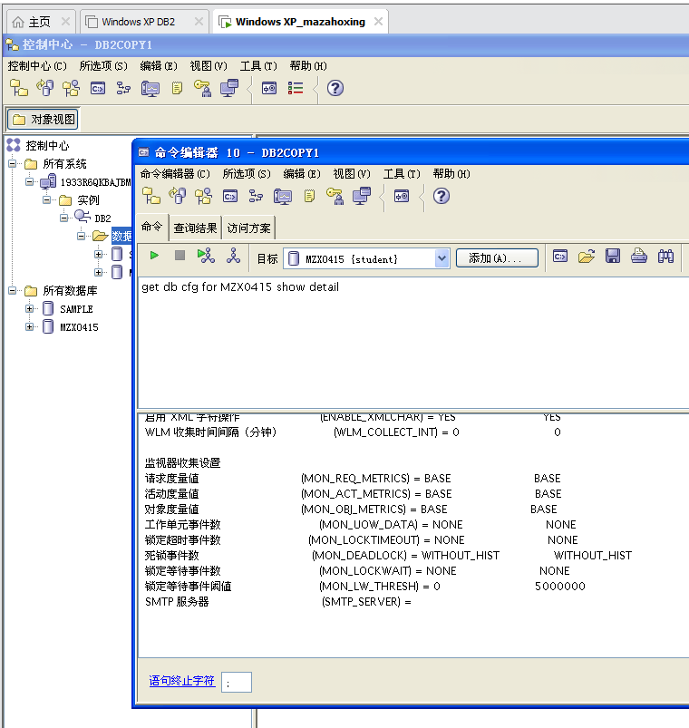

- Repeat Step #17 above, and record here the new values of LOCKLIST and MAXLOCKS.
- Some default table spaces were created during creation of the database. List the table space information.
Show your work below by printing screen.
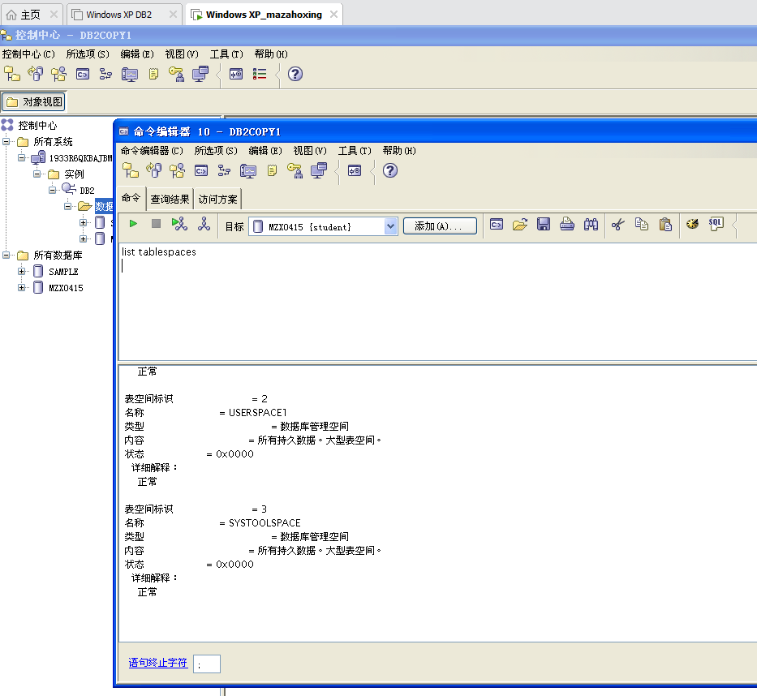

- What are the table space names and what ID number is associated with the table space?
SYSCATSPACE — ID 0 TEMPSPACE1 — ID 1 USERSPACE1 —ID 2 SYSTOOLSPACE — ID 3
Since you queried the database size info, the fourth table space named SYSTOOLSPACE was created for you.

There are four cases that SYSTOOLSPACE will be automatically created on an active database starting with V8.2:
- DB Summary View of the database is displayed in the Control Center, or similar information is displayed from the command line by issuing:
db2 "CALL GET_DBSIZE_INFO(?, ?, ?, -1)"
- Create a database with automatic maintenance.
- Turn on automatic maintenance for a standard database (in the DB CFG file).
- For a standard database without automatic maintenance, which has not been connected to through the Control Center, hmon (the health monitor) will create one when it starts evaluating health indicators (by default every 2 hrs).
Instructor Exercises Guide with hints
Course materials may not be reproduced in whole or in part without the prior written permission of IBM.
4-10 DB2 9 DB Admin Workshop for Windows © Copyright IBM Corp. 1999, 2007
Thus, eventually, a V9.1 database will have a minimum of four table spaces. The automatic statistics collection and reorganization features — available starting with DB2 UDB V8.2 — store working data in tables in your database. These tables are created in the SYSTOOLSPACE table space. The SYSTOOLSPACE table space is created automatically with default options.
Storage requirements for these tables are proportional to the number of tables in the database and should be calculated as approximately 1 KB per table. If this is a significant size for your database, you may want to drop and re-create the table space yourself and allocate storage appropriately. The automatic maintenance and health monitor tables in the table space are automatically
re-created. Any history captured in those tables is lost when the table space is dropped.

- Table space container information can be displayed with the list tablespace containers command. Use the Help facility to show the DB2 command syntax. Show your work below by printing screen.
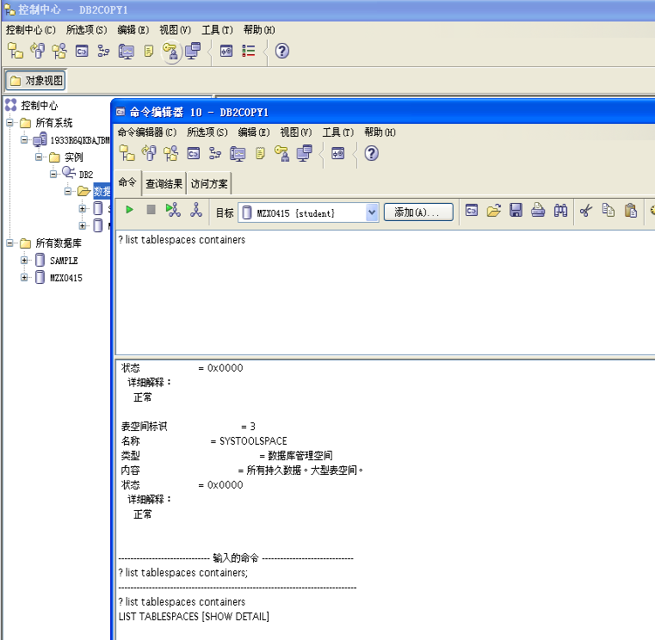

- Show the container information for table space ID 0. What type of container is this and where is it located?
Show your work below by printing screen.
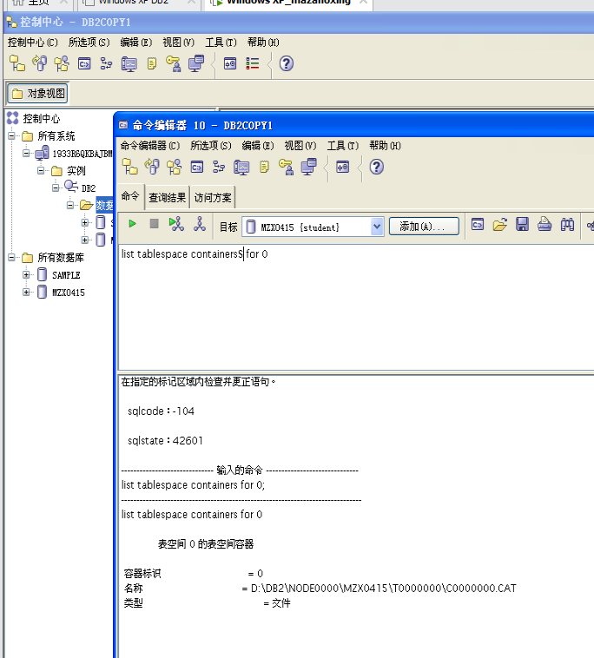

26. List the names of the system catalog tables. What are these tables?
Show your work below by printing screen.

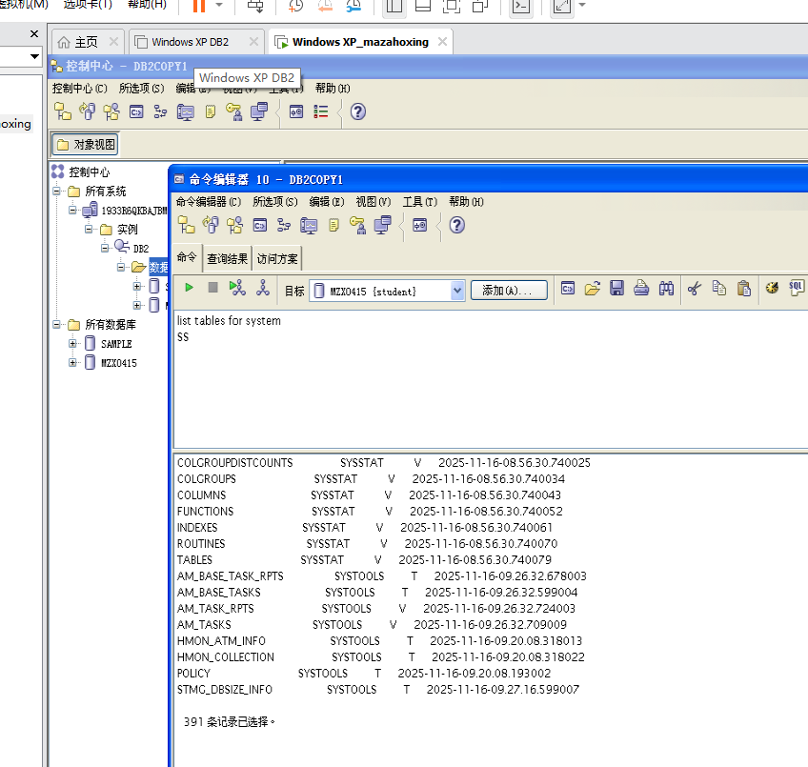

- Get more detailed information for the table spaces and indicate which table spaces are set to automatic size increase.
Show your work below by printing screen.

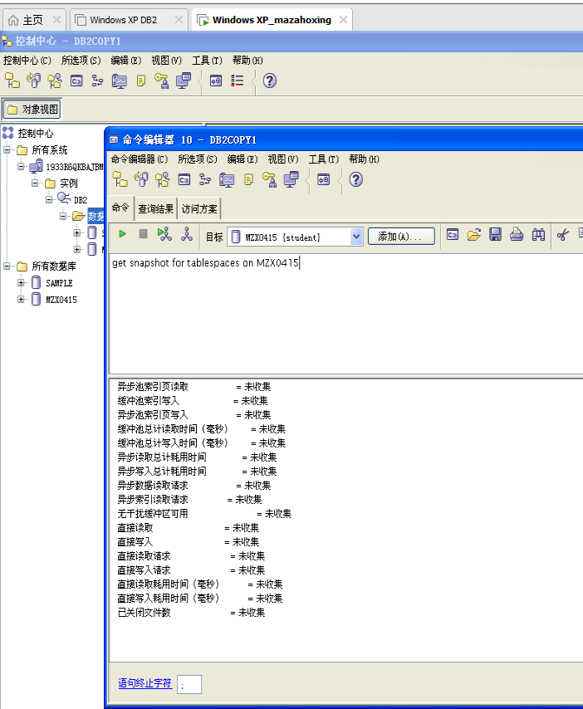
- Verify which default path containers are associated with the temporary table space and the default user table space.
Show your work below by printing screen.

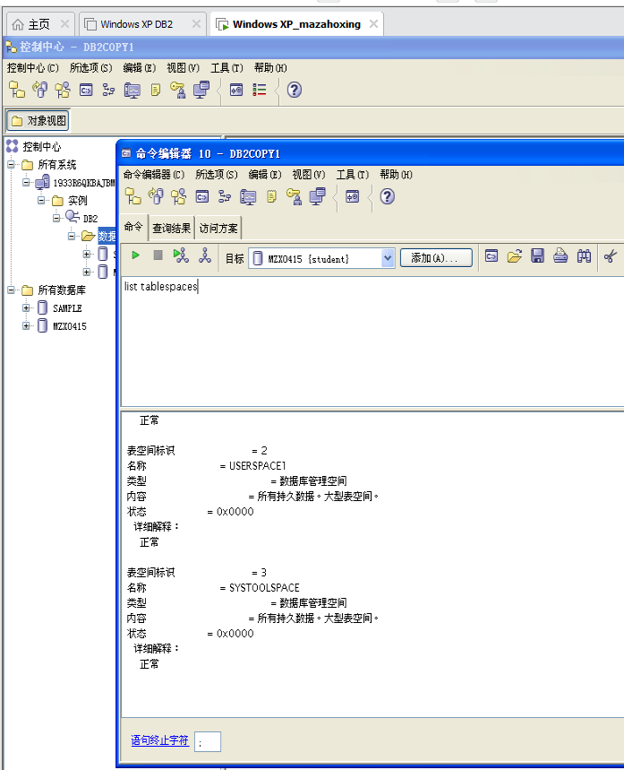

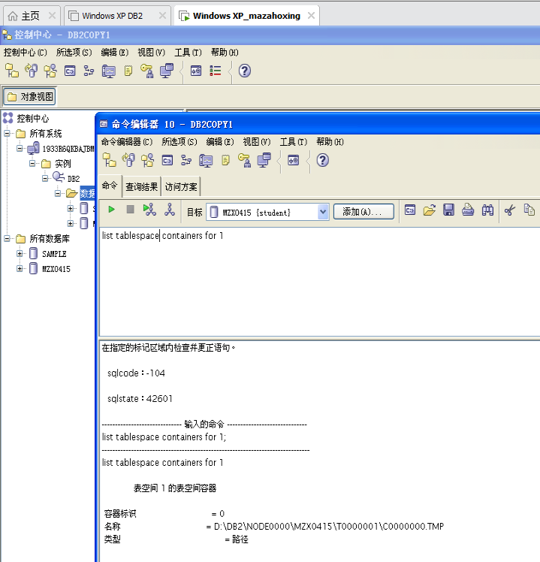

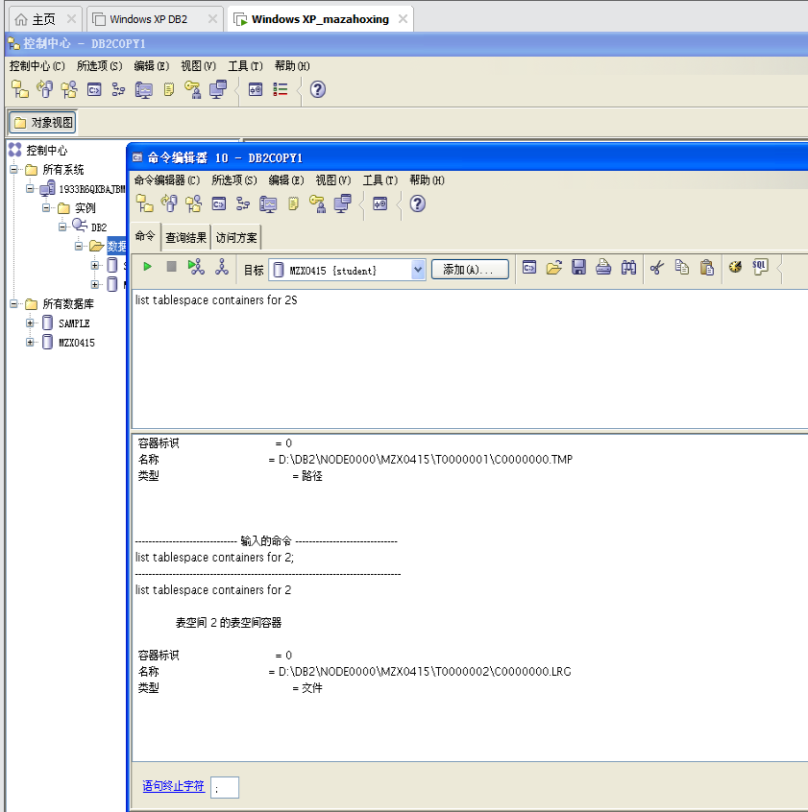
29. Retrieve detailed container information from the Catalog tables. What is the container types for each container?
Show your work below by printing screen.

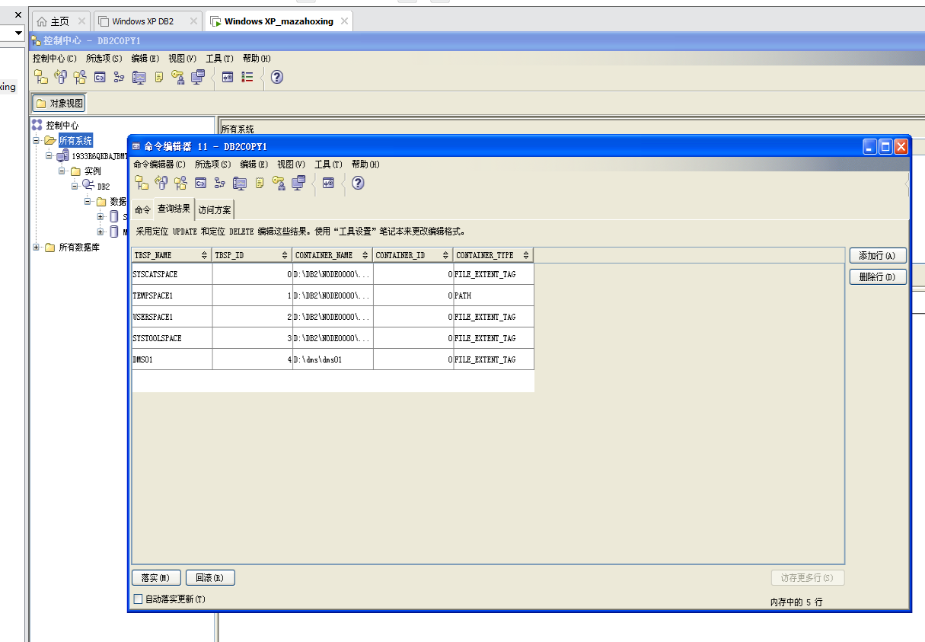
Section 2 - Creating Table Spaces
- Create your first table space. It should have the following characteristics:
  - Table space name is DMS01
  - Table Space Type is Regular
  - Buffer Pool should be IBMDEFAULTBP (which is also the default)
  - Table Space management is DMS (also called high performance)
  - Container size should be 1006 pages with 4 KB pages
  - Container should be a File
  - Container path and filename should be C:\dms\dms01 (Windows)
  - Table space extent size and prefetch size should be 4
Show your work below by printing screen for the last step.

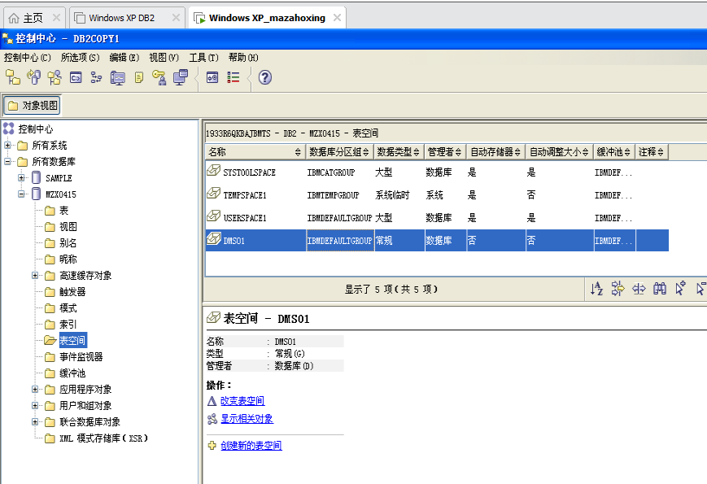

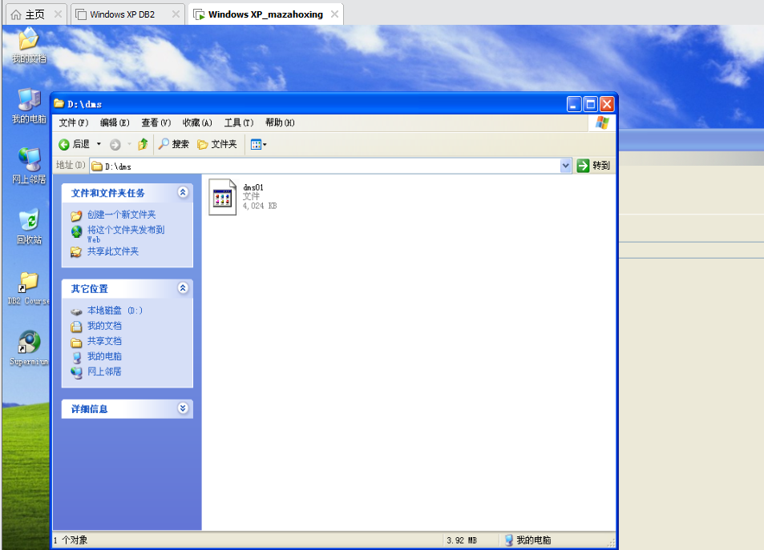

- Verify your new table space (DMS01) by listing table spaces.
Show your work below by printing screen.
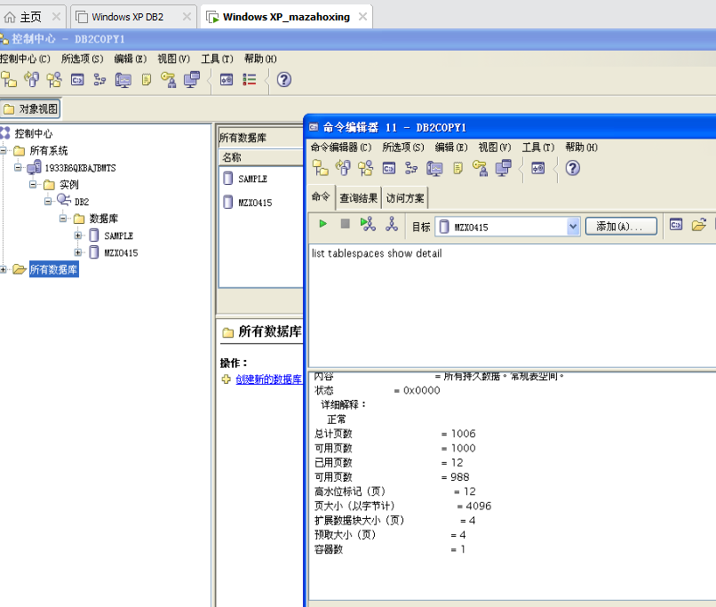

- On your Windows Database Server, a script file named crtblsp contains SQL statements to create your additional table spaces.
- Execute the script file to create your remaining table spaces.
Make sure you have the following options set before executing the script:
  - Auto commit should be enabled.
  - Execution should be stopped if there is an error.
  - Commands and statements should be echoed back to the screen.
  - A semicolon should be used as the termination character.
Show your work below by printing screen.

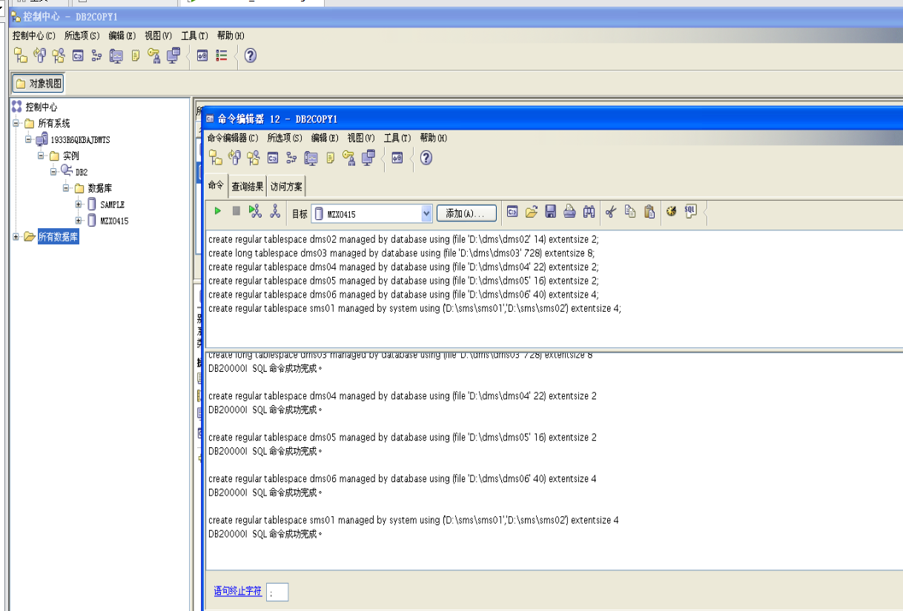

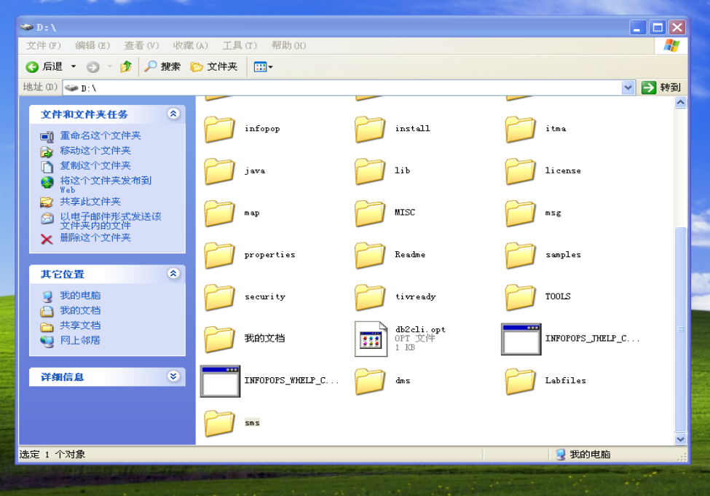

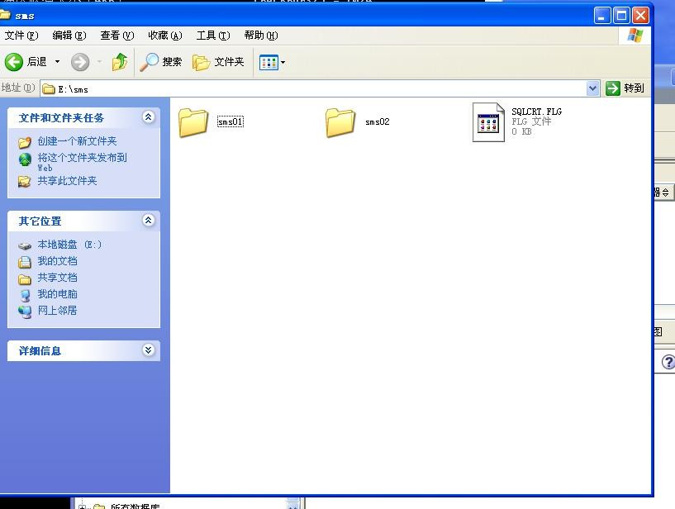

- Confirm that the additional six table spaces are present. Are your new table space names listed?
Show your work below by printing screen.
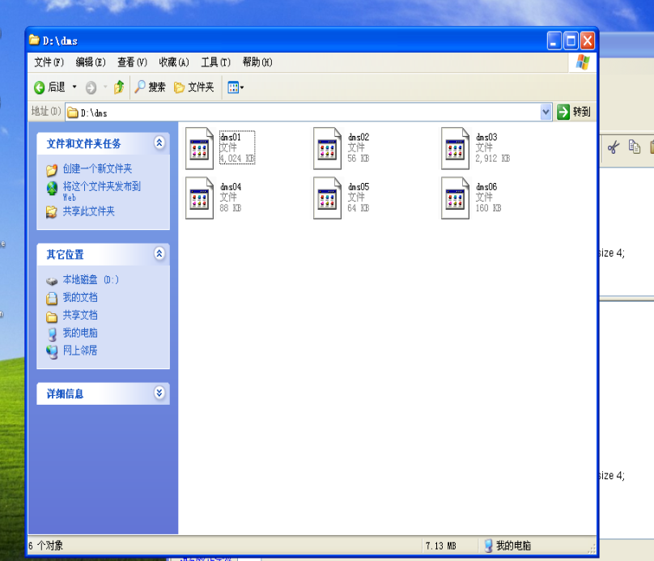
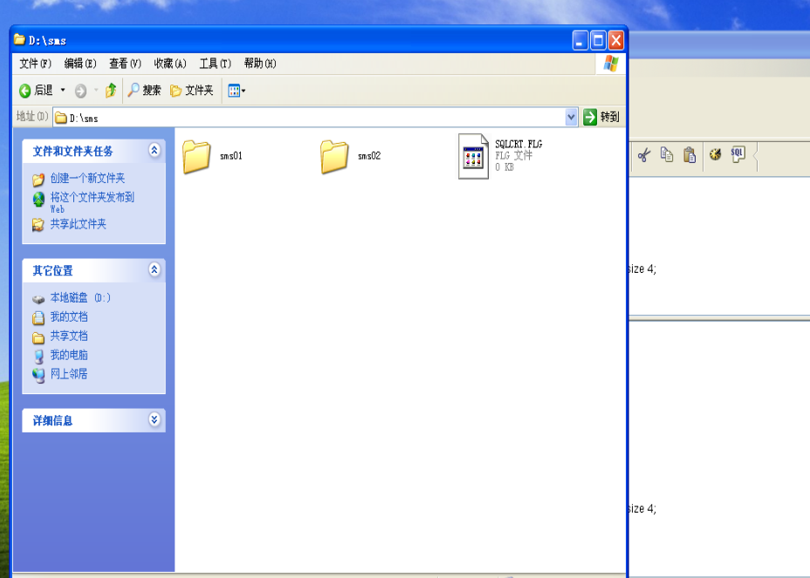

- From your command window, change directories to C:\dms and do a list of the files.
cd D:\dms dir
- What are these files?
Show your work below by printing screen.
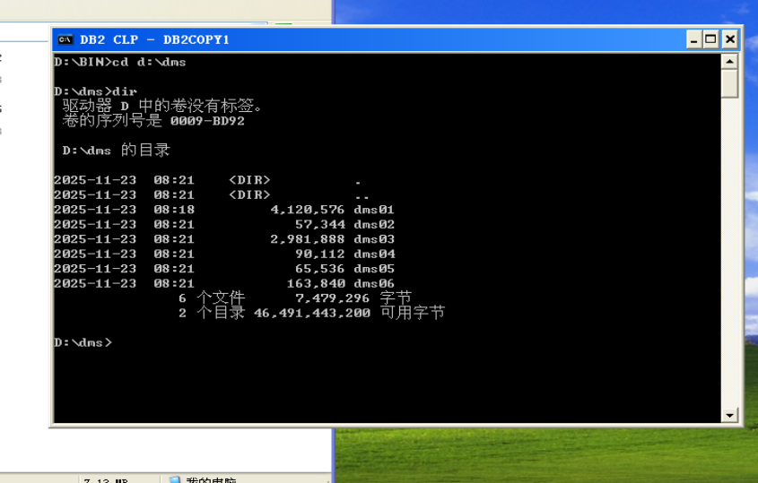

- Display detailed information about the table spaces. You must be connected to the database first.
Show your work below by printing screen.
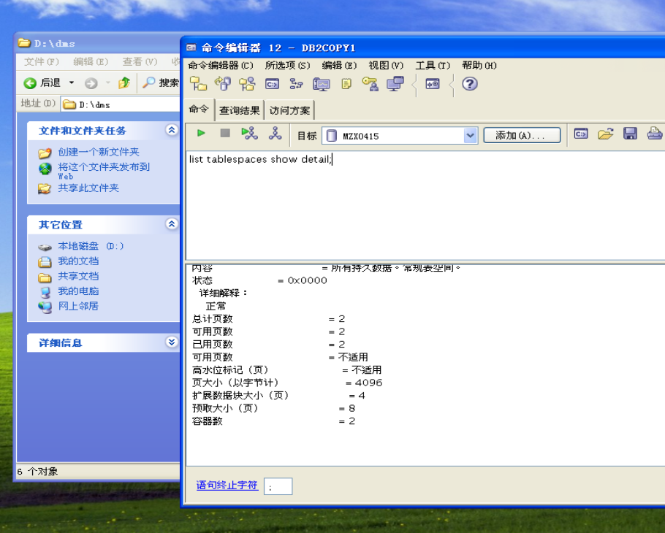

- What ID numbers are associated with each of the table spaces? How many usable pages are there in the DMS table spaces? List a few differences between SMS and DMS table spaces.
SYSCATSPACE — ID 0 TEMPSPACE — ID 1 USERSPACE1 — ID 2 SYSTOOLSPACE — ID 3 DMS01 — ID 4 — 1000
DMS02 — ID 5 — 12
DMS03 — ID 6 — 720
DMS04 — ID 7 — 20
DMS05 — ID 8 — 14
DMS06 — ID 9 — 36 SMS01 — ID 10
SMS table spaces do not use preformatted containers. Space will be allocated until the file system is full. DMS table spaces preallocate all space.
- Show the container information for table space ID 4. What type of container is this and where it is located?
Show your work below by printing screen.
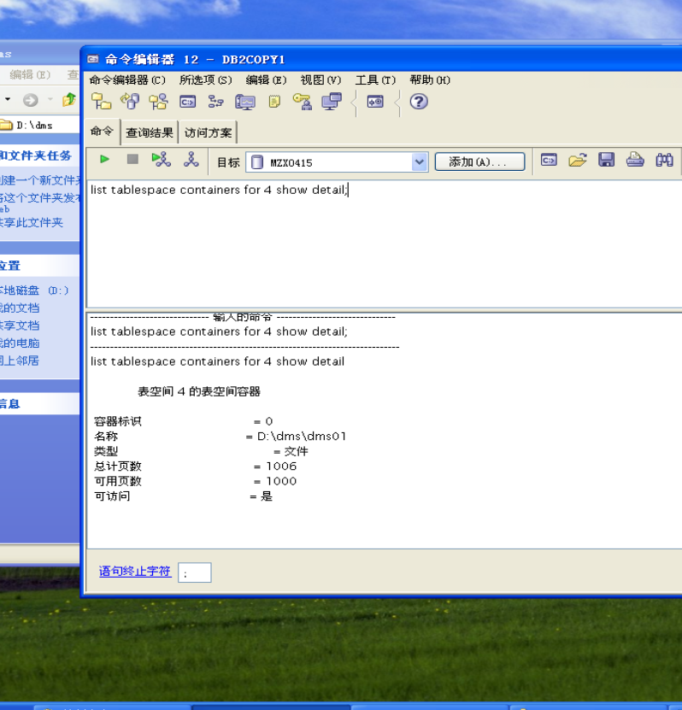

- Show the container information for your SMS table space ID 10. What type of

containers are being used and where are they?
Show your work below by printing screen.
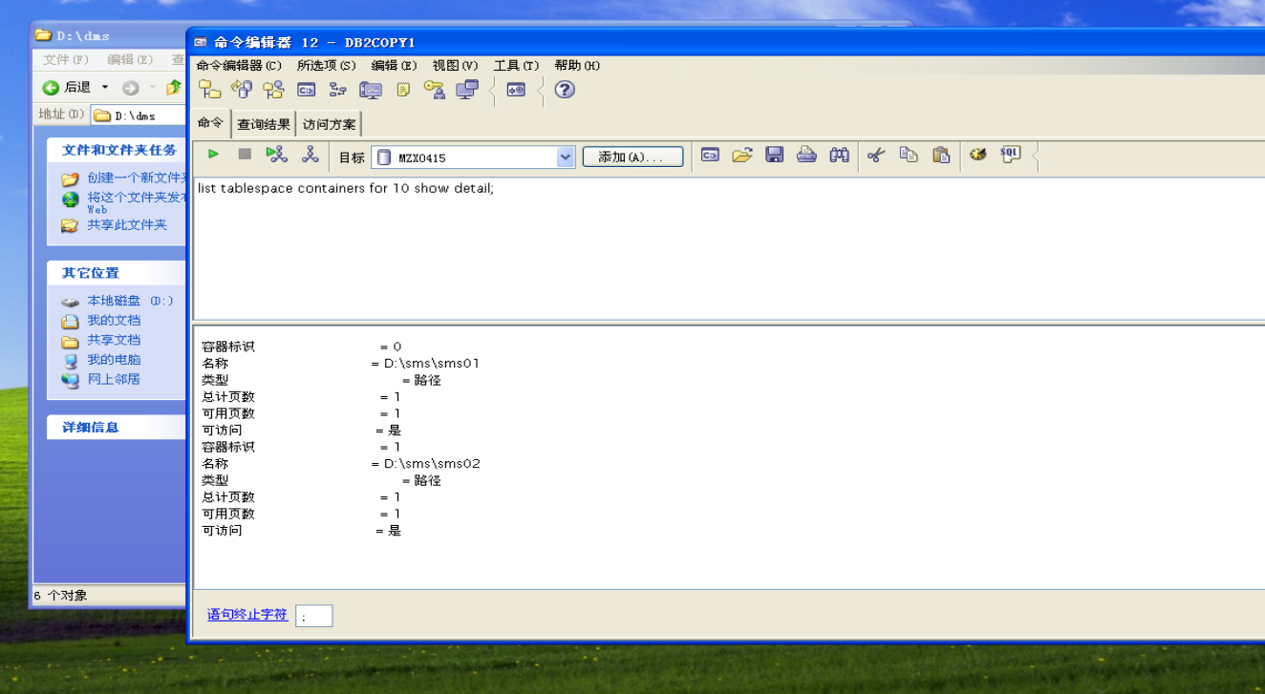
- From your command window, change directories to SQLT0000.0 and list the directory.
cd
cd D:\sms01 dir
- Table data is stored in .DAT files, indexes in .INX files, and LOB info in .LB and .LBA files. And there is an SQLTAG.NAM file that holds overhead information about this container, and the tables that are found there.
Show your work below by printing screen.

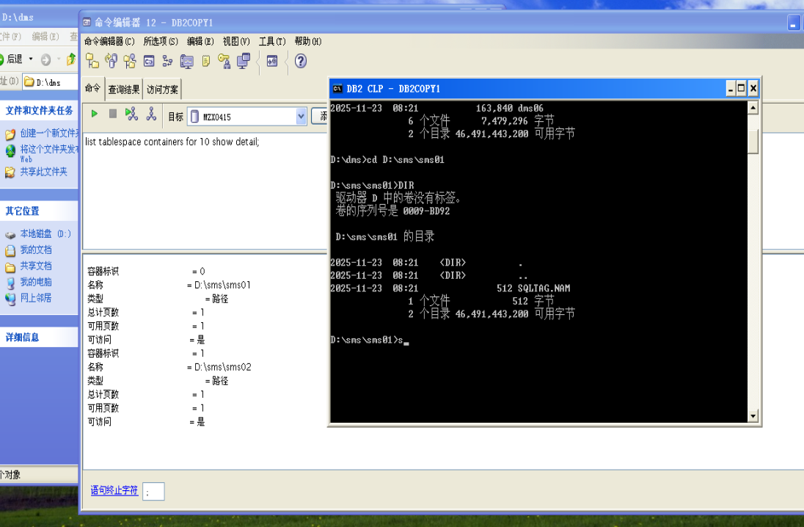

14. From your ssh/telnet session to the database server, create a table and an index on that table in this table space. And then list the contents of the directory again. What do you see now? Are the new files named after the table name?
You will see two new files: SQL00002.DAT and SQL00002.INX, one for the table and one for all indexes on that table.
No — the files not named after the table (t). Note the this first table is numbered 00002 and the file containing the index (and all indexes, if there
were more than one) has the same numbering. The next table created would be named SQL00003.DAT.

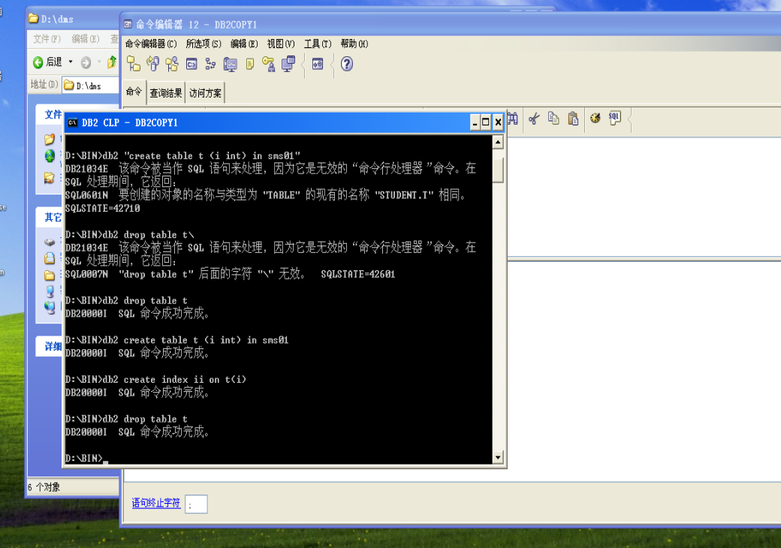

15. Drop table t as it is no longer needed.
Show your work below by printing screen.

- Table space information is accessible through a view with the name SYSCAT.TABLESPACES. The fields that contain table space information are:
  - TBSPACE — Name of primary table space for this table
  - DEFINER — Authid of table space creator
  - TBSPACEID — Internal table space identifier
  - TBSPACETYPE — Type of table space. D for DMS or S for SMS.
  - DATATYPE — Type of data that can be stored in the table space.
L for long data only, A for all types of permanent data, or T for temporary tables only. Issue a select from SYSCAT.TABLESPACES to answer the following questions.
select substr(tbspace,1,18) as tbspace, substr(definer,1,10) as definer, tbspaceid, tbspacetype, datatype from syscat.tablespaces
Show your work below by printing screen.

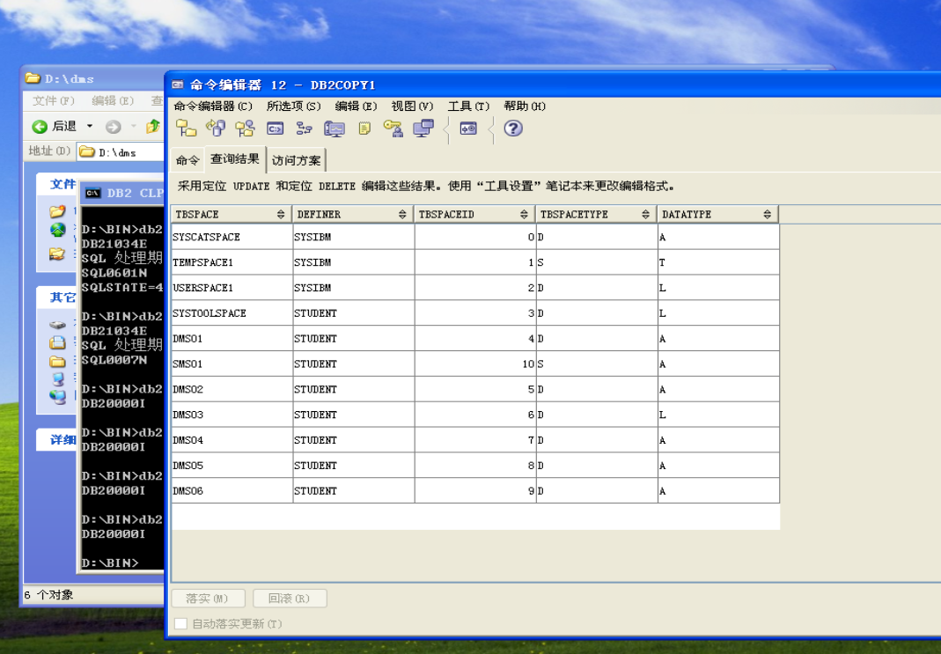
- What is the authorization ID of table space definer for the default table spaces? DEFINER=SYSIBM

- Which of the various table spaces allows long data types?
USERSPACE1, SYSTOOLSPACE, and DMS03 table spaces allow long data.

- Which table space only allows temporary table data? TEMPSPACE1 only allows temporary table data.

- Table space information for individual tables can be accessed through the SYSCAT.TABLES view. The fields that contain table space information are:
  - TBSPACEID — Table space ID of primary table space for this table
  - TBSPACE — Name of primary table space for this table
  - INDEX_TBSPACE — Table space containing the indexes for this table
  - LONG_TBSPACE — Table space containing LONG or LOB data for this table List the table space information for the table SYSIBM.SYSTABLES.
Show your work below by printing screen.

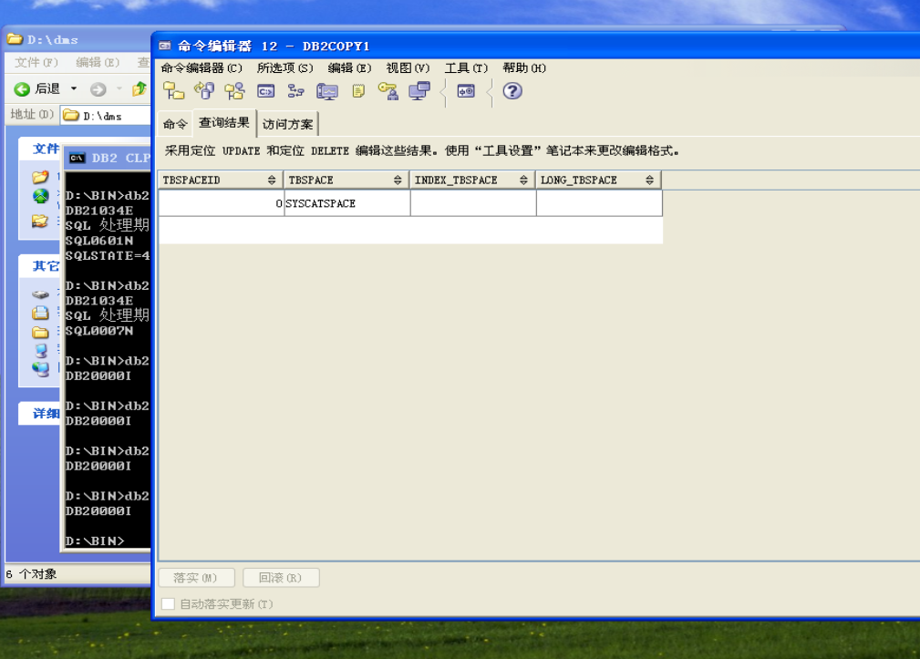
- Is the SYSIBM.SYSTABLES table divided between different table spaces? No. But this is not something you can easily determine from the information that you are viewing.
In previous releases (V8.2 and earlier), the answer would be easier, since with those releases, catalog tables were stored in SYSCATSPACE and that table space was SMS. And, a table cannot be divided between table spaces if SMS is being used.

- Enter connect reset to break your database connection.
Show your work below by printing screen.

