吉林大学

DB2实验报告

班级：计科 4 班
姓名：马兆星
学号：21230415
姓名 |  | 马兆星 | 学号 | 21230415
实验项目 |  | 3. Create objects
实验性质 |  | □演示性实验 □验证性实验  操作性实验 □综合性实验
实验地点 |  | 计楼 A210 | 机器编号
指导教师 |  | 康辉 | 实验时间 | 2025年 11月30日 8时30分
一、实验综述
1. 实验目的及要求
This exercise is an online lab in which you load your tables with data using the load utility and import utility.
At the end of the lab, students should be able to:
• Use the import utility to insert data from a file into a table
• Use the load utility to fast load data from a file into a table
• Create exception tables
• Manage check constraints, triggers, and check pending status
2. 实验设备、软件
PC, windows XP Professional, DB2 9 Express-c
二、实验过程（实验步骤、记录、数据、分析）
Section 1 - Import Data in Tables
1. Import data into your ARTISTS table. For the IMPORT command, the data must be locally available to the machine from which you issue the import.
The import should specify the following:
• The import file name is artists.exp • The import file is in ixf format
• Import in insert mode • Write any messages to a file called art.msg
Show your work below by printing screen.
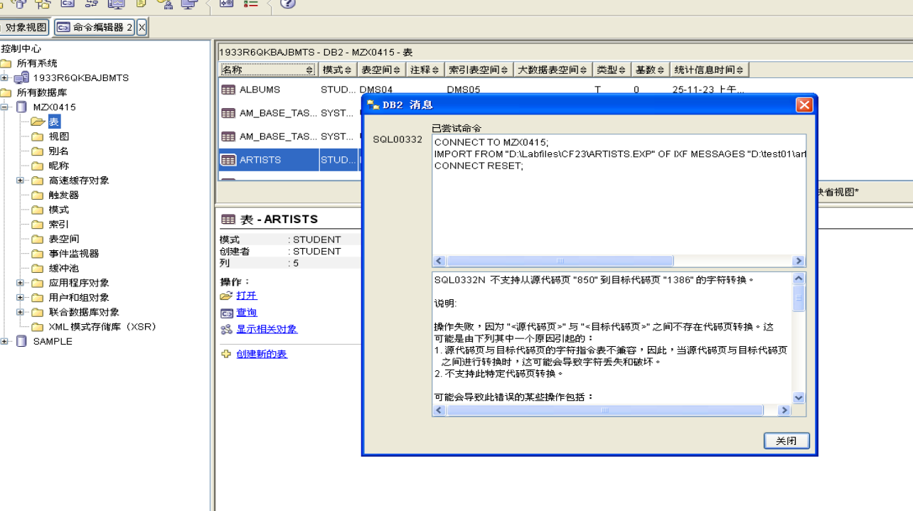
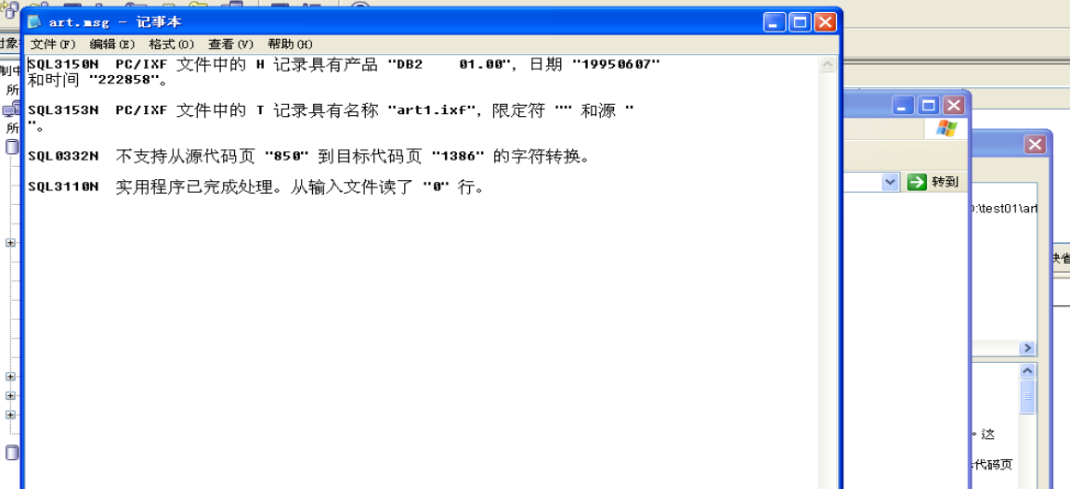
2. Look at the file art.msg to determine how many rows were inserted and any error or warning messages that may have been generated.
Show the Number of Rows Committed and messages below by printing screen.
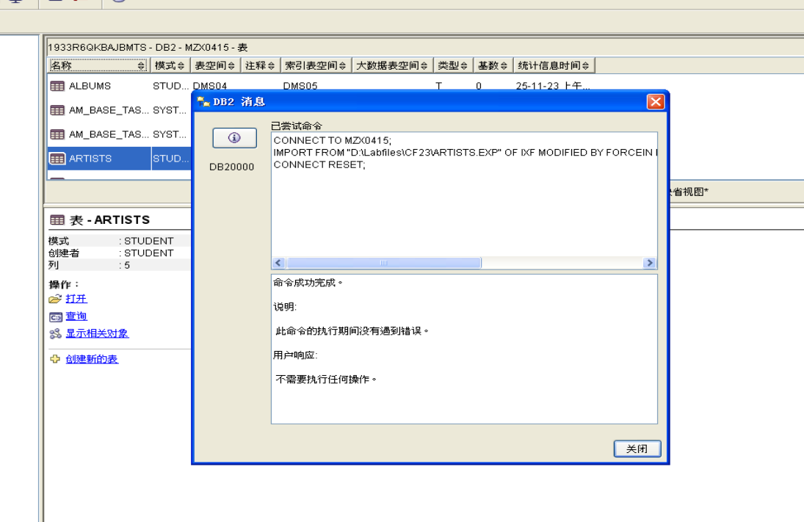
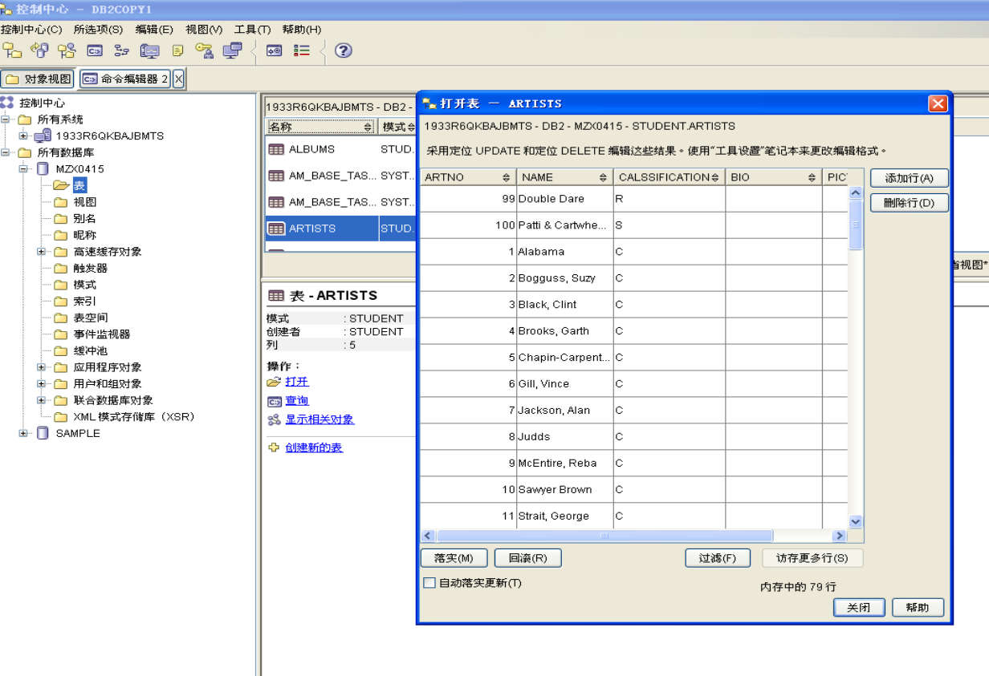
3. Now you will import data into the ALBUMS and STOCK tables using script files. The file you will use to import data into the ALBUMS table is called imp_albu.
Show your work below by printing screen.
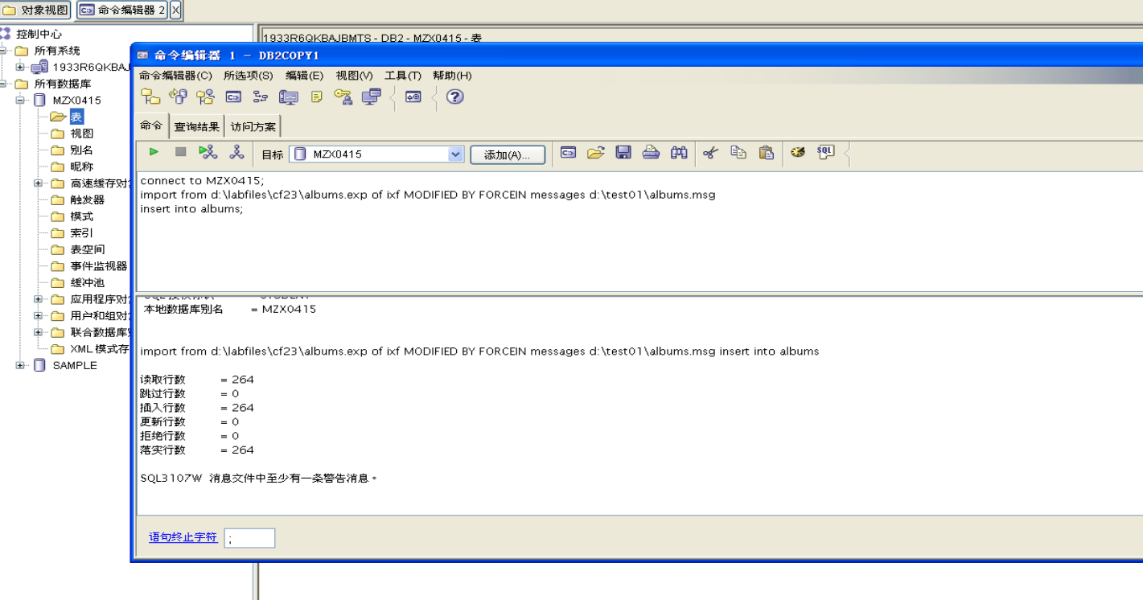

4. Record the number of rows committed. Check albums.msg to see if any additional messages occurred.
Show your work below by printing screen.
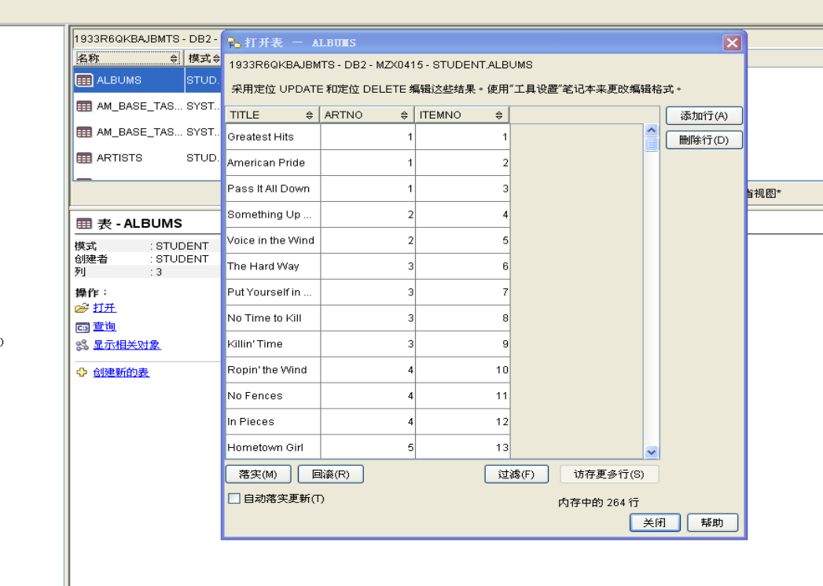

5. The file you will use to import data into the STOCK table is called imp_sto.
Show your work below by printing screen.

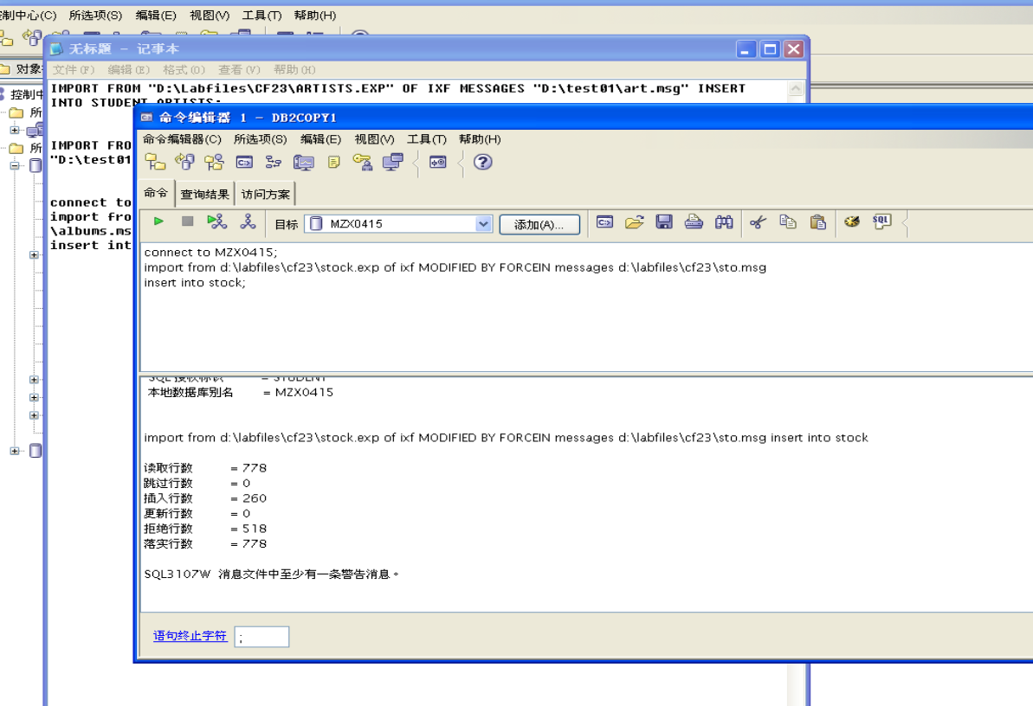
6. Record the number of rows committed. Check sto.msg to see if any additional messages occurred.
Show your work below by printing screen.
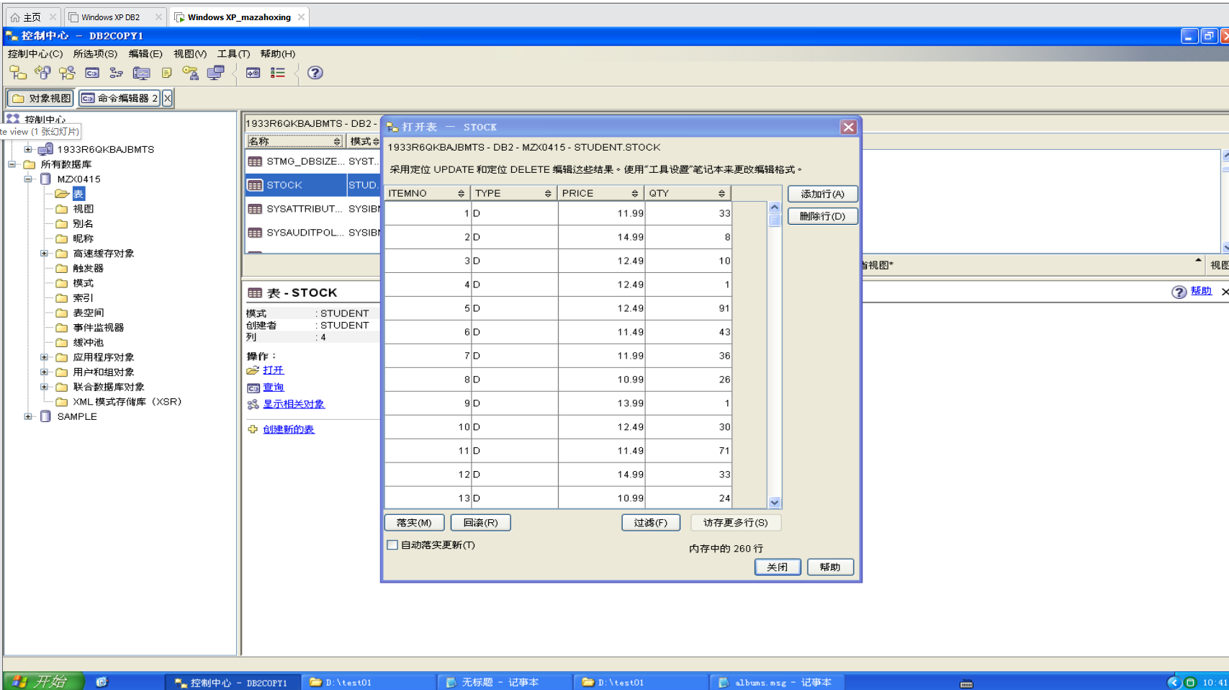

7. For all the imports, where was the source file located that was being imported, on the Windows machine or on the UNIX Database Server?
The source file was located on the machine where the IMPORT command was
issued
8. Remember that at the end of the previous lab, you created a trigger on the STOCK table that should put rows into the REORDER table if any rows were updated to have a quantity of less than or equal to 5 in the STOCK table.
Check to see if the trigger was fired during the Import utility.
Show your work below by printing screen.
Explain what is returned.
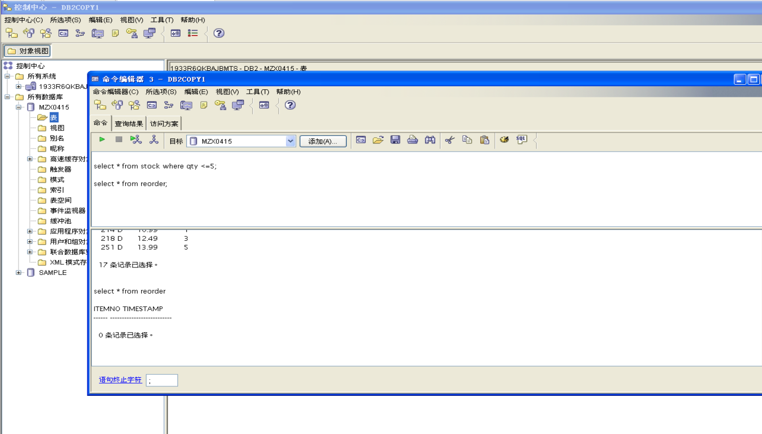

Section 2 - Create Exception Tables - ARTISTS, ALBUMS, STOCK
1. We have provided a script named crexptab that will create exception tables for ARTISTS, ALBUMS, and STOCK. Make sure each table is created successfully.
Show your work below by printing screen.
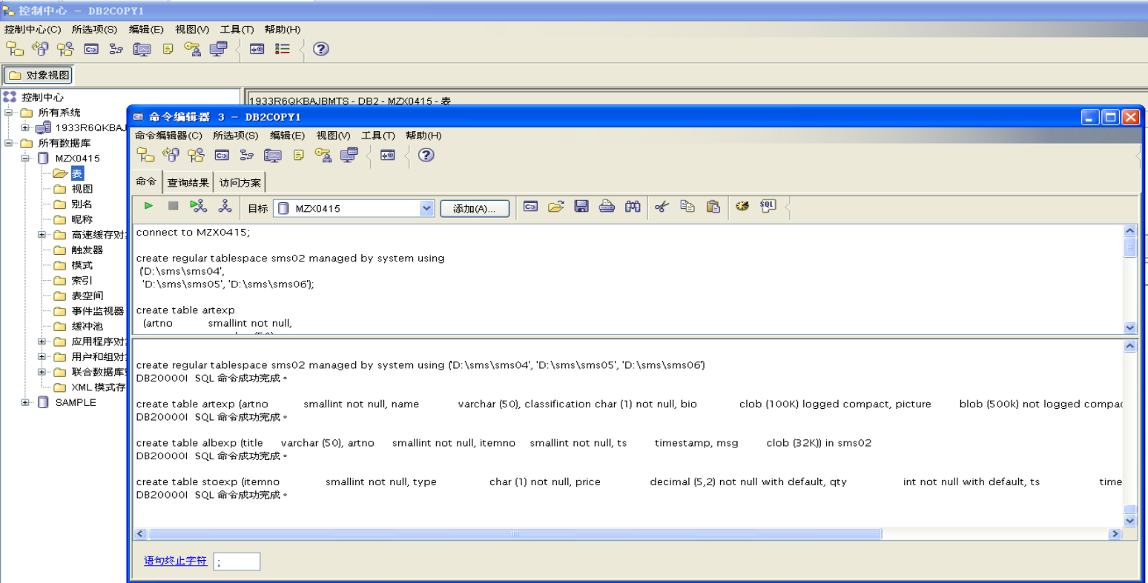
Note that the table space SMSEXP is being created to store all of the exception tables. Also note that the exception tables mimic the base table plus two additional columns.
What are the exception table names? What are the two additional columns and their attributes? Are they optional?
ARTEXP is the exception table for ARTISTS, ALBEXP is the exception table
for ALBUMS, and STOEXP is the exception table for STOCK.
The n+1 column is optional. It is called ts and must be a TIMESTAMP. The n+2
column is also optional. It is called msg and must be CLOB (32 KB) or greater
in length. Both ts and msg are user-defined column names.

Section 3 - Backup Database
1. The backup will be done against your database server and will use a directory path of C:\backup. Using your Command Window, enter the following commands:
cd mkdir backup
db2 force application all
db2 "backup db musicdb to C:\backup"
The backup will take several minutes to run.
Show your work below by printing screen.
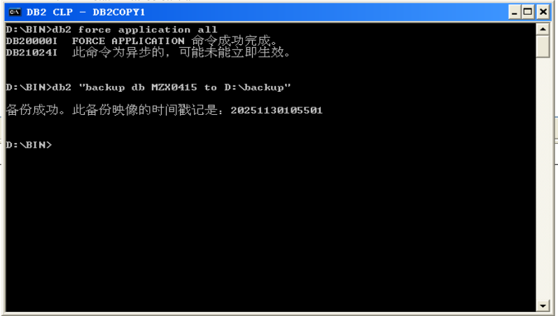
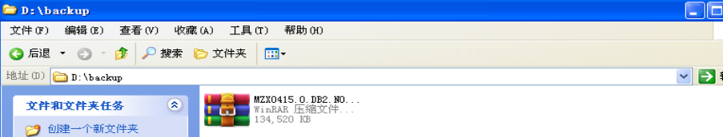
2. Verify the backup completed successfully by checking the messages that appear on your screen. What is its status?
Show your work below by printing screen.
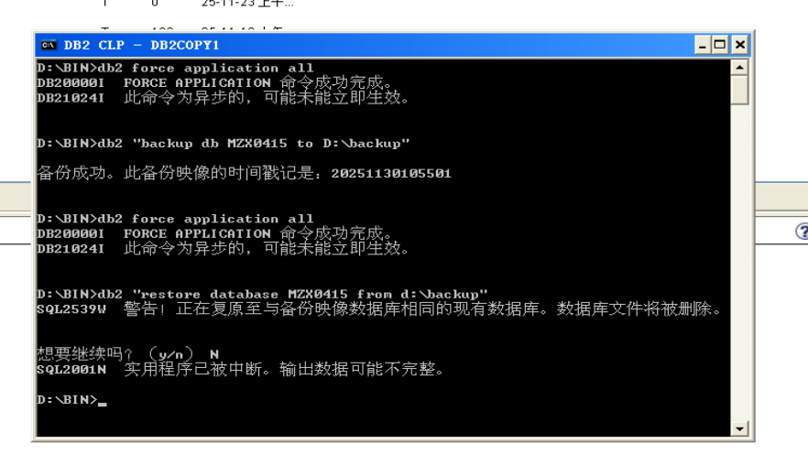

Section 4 - Load Data with INSERT option into CONCERTS
1. LOAD data into your CONCERTS table.
The load should specify the following:
•Work with files in the path C:\labfiles\cf23
•The load file name is concerts.exp
•The import file is in ixf format
•Load in insert mode
•Write any messages to a file called concerts.msg
Show your work below by printing screen.

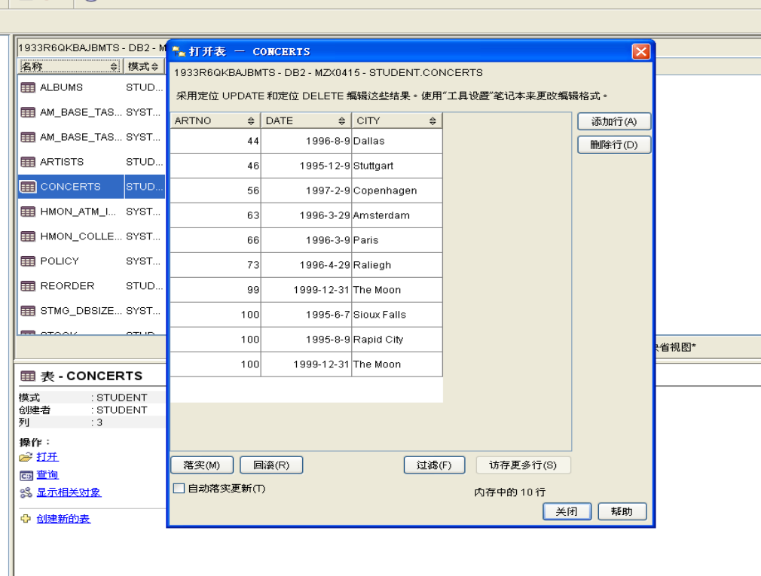
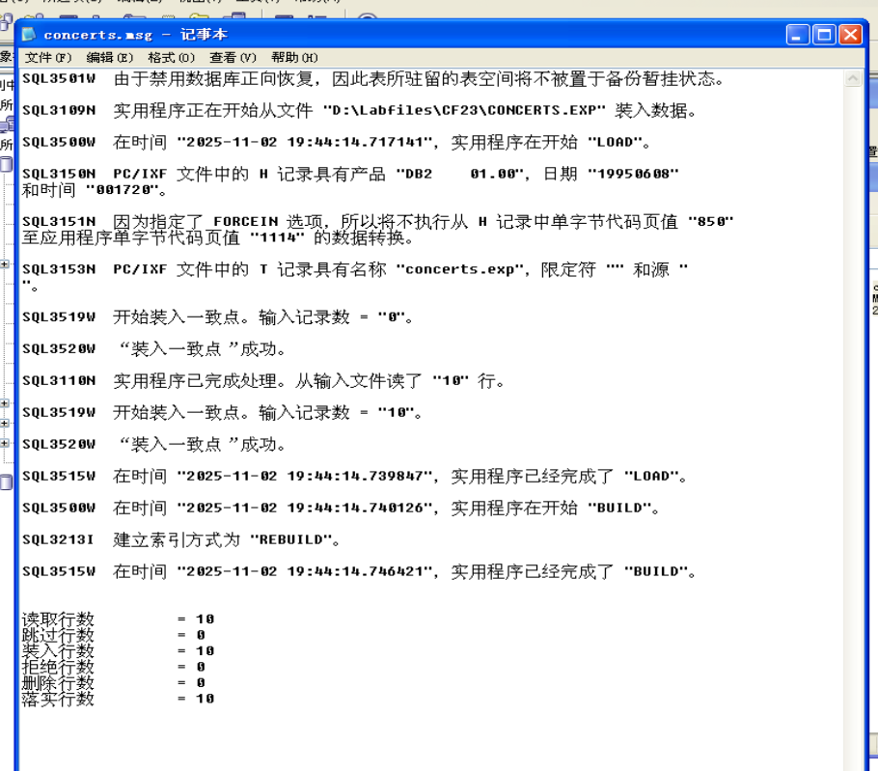

2. Record the number of rows successfully loaded and committed from the messages file.
Show your work below by printing screen.


Section 5 - Load Data with REPLACE option into ARTISTS
1. LOAD data into the ARTISTS table using a script file named load_art.
Show your work below by printing screen.
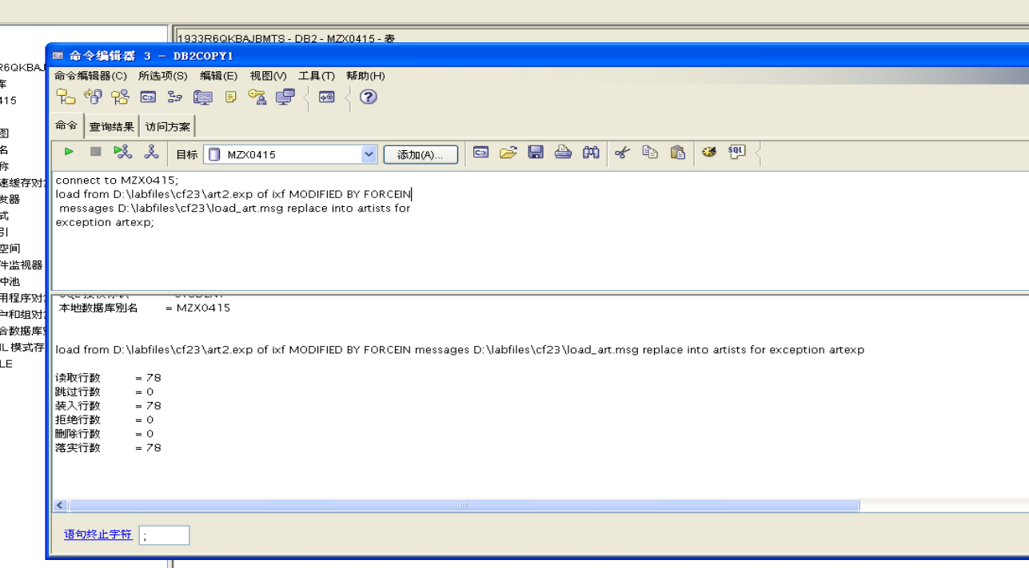

2. The LOAD command loads rows into the ARTISTS table using a different IXF input file from the earlier IMPORT.
Note that it uses the REPLACE option to replace the previously imported rows in the ARTISTS table. The artexp table is specified to contain exception rows for the ARTISTS table during the load with the FOR EXCEPTION OPTION.
What type of violations will be stored in this table during the load?
Unique key violations will be stored in the exception table during the load

3. Record the number of rows committed.
Number of Rows Committed: 78

4. Check the ARTEXP table to see if any exception rows violated the unique key index on the ARTISTS table. Use the script file selexp.
Show your work below by printing screen.
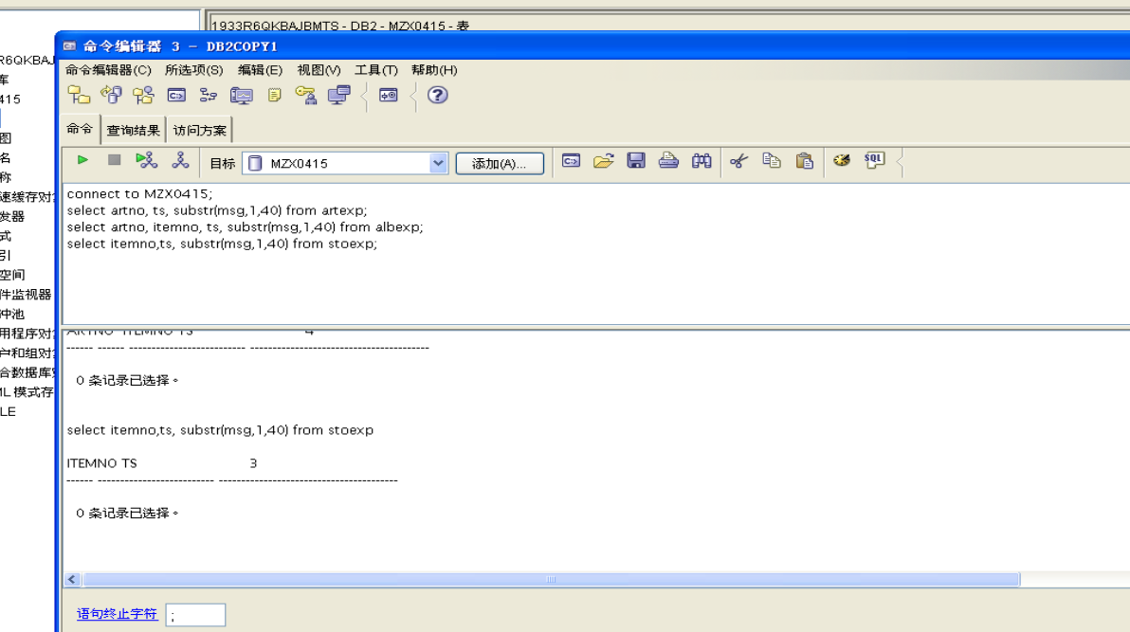

5. Check the load_art.msg file for messages.
Show your work below by printing screen.
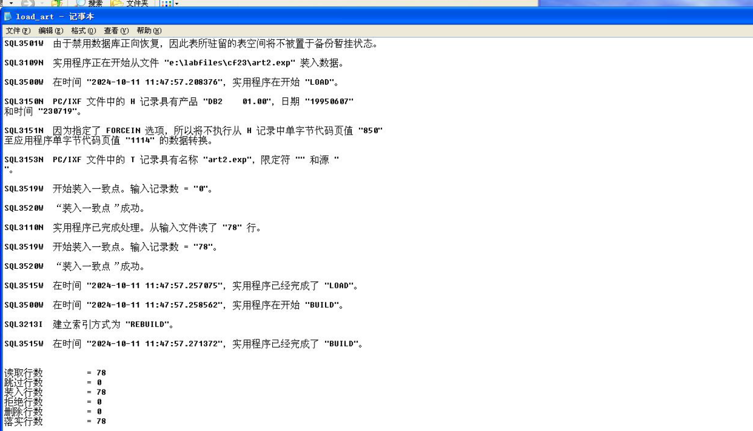

Section 6 - Examining the SET INTEGRITY PENDING State
1. Try to select from the ARTISTS, STOCK, and ALBUMS tables using the script seltab.
Show your work below by printing screen.
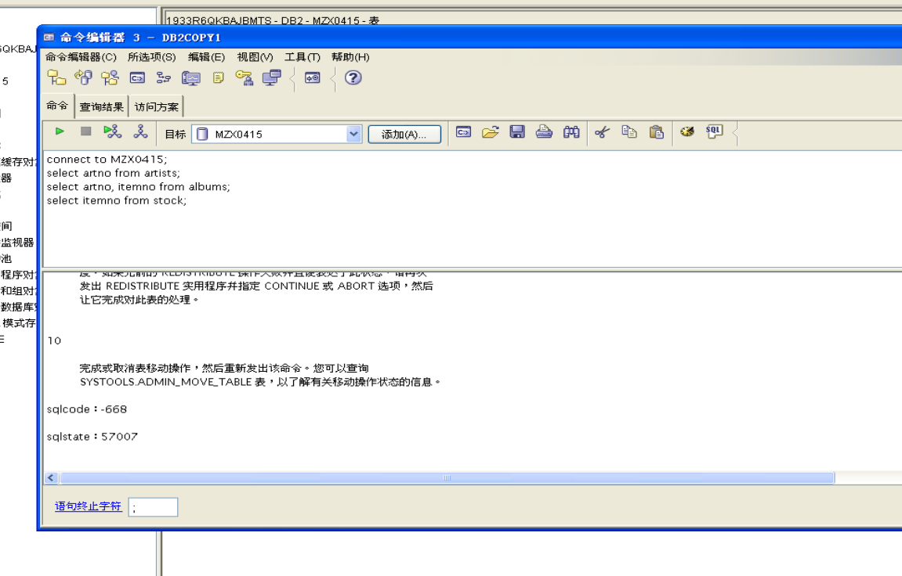

2. What SQL code did you get on the first select statement? Check the meaning of the SQL code using the online help facilities. What action do you need to take to clear this status?
Answer question and show your work below by printing screen.

Received SQL0668 reason code 1 when trying to access the ARTISTS table.
You are not allowed to access the recently loaded table with DML because it is
in a check pending state. The SQL0668 message tells you similar information.
This indicates that you need to run the SET INTEGRITY command against the
ARTISTS table.

3. Check the check constraints status of the tables by executing the script listtbst and record the status.
Show your work below by printing screen.
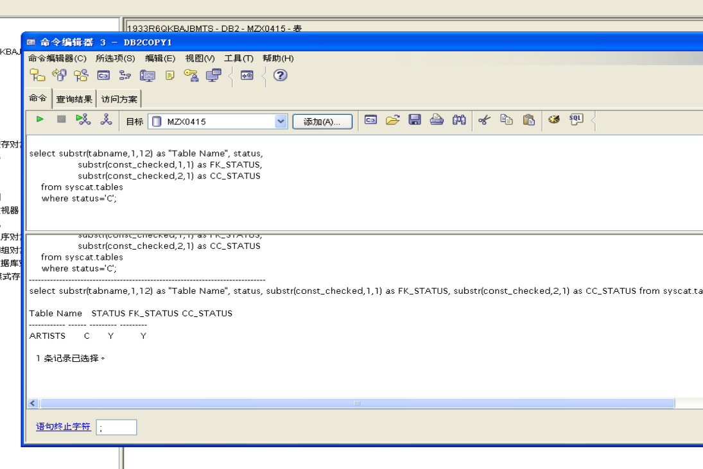
4. The SET INTEGRITY SQL statement can be used to check for referential constraint exceptions. Exception tables should be specified for all tables in a check pending state (in this case, just ARTISTS).
Run the script setcsts_art to check for referential constraint exceptions in the ARTISTS table.
Show your work below by printing screen.
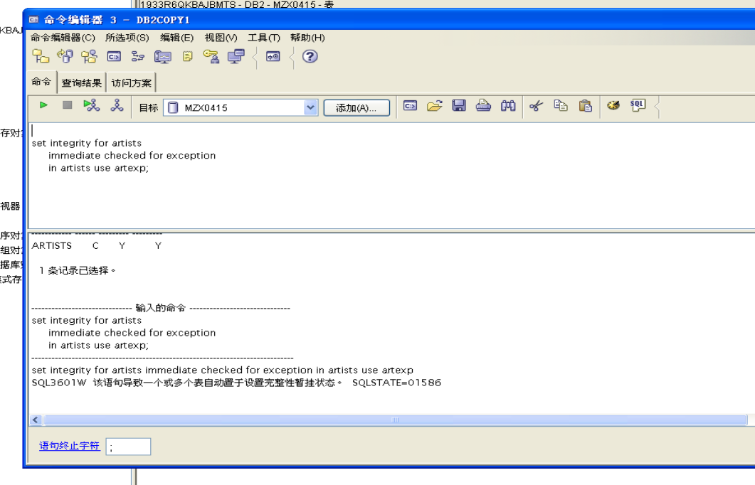
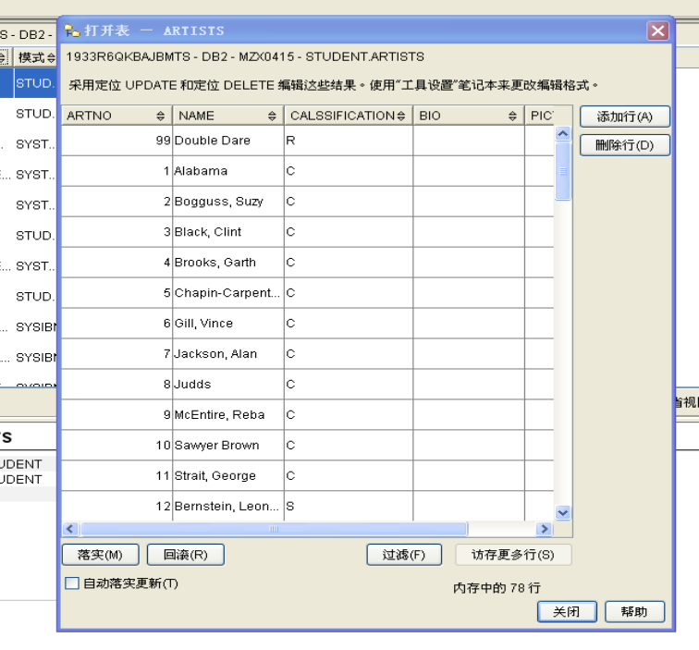
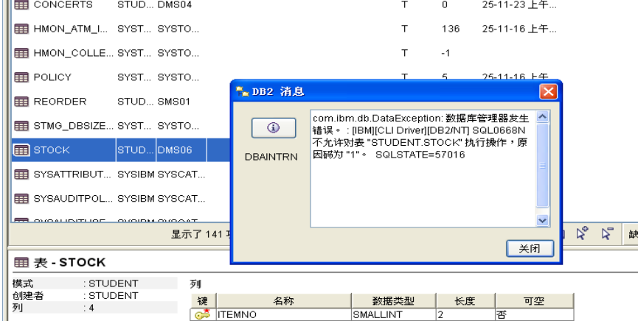
5. What does the warning SQL3601 mean?
Show your work below by printing screen.

(telnet or Command Window) db2 "? sql3601"
or
(Command Editor) ? sql3601
SQL3601 indicates that the SET INTEGRITY statement caused one or more
tables to be placed in the check pending status.

6. Check the check constraints status of the tables by executing the script listtbst and record the status.
Show your work below by printing screen.
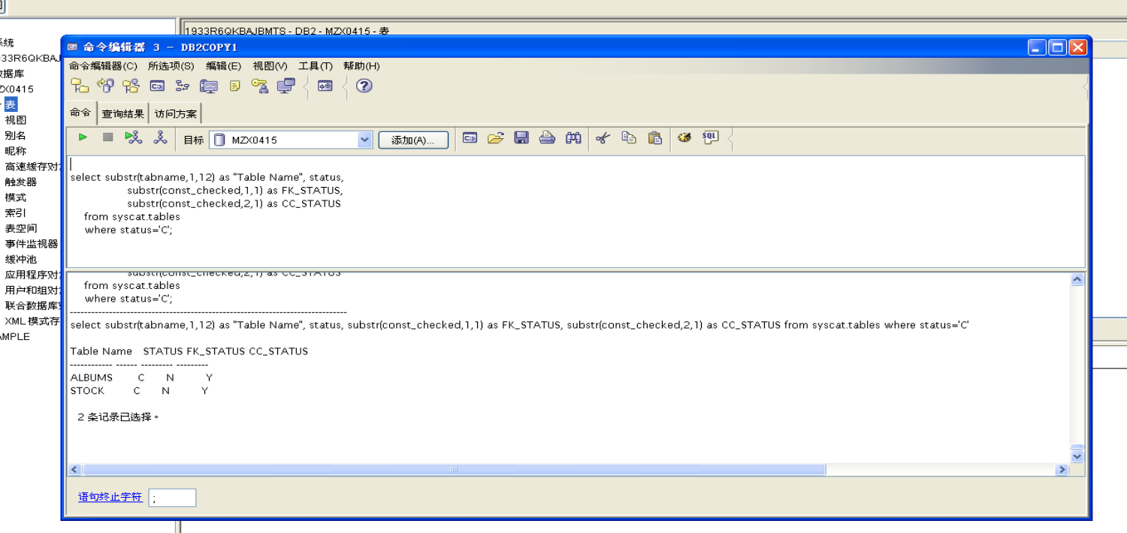

7. The SET INTEGRITY SQL statement can be used to check for referential constraint exceptions. Exception tables should be specified for all tables in a check pending state (in this case, ALBUMS and STOCK). Run the script setcsts_2 to check for referential constraint exceptions in the ALBUMS and STOCK tables.
Show your work below by printing screen.

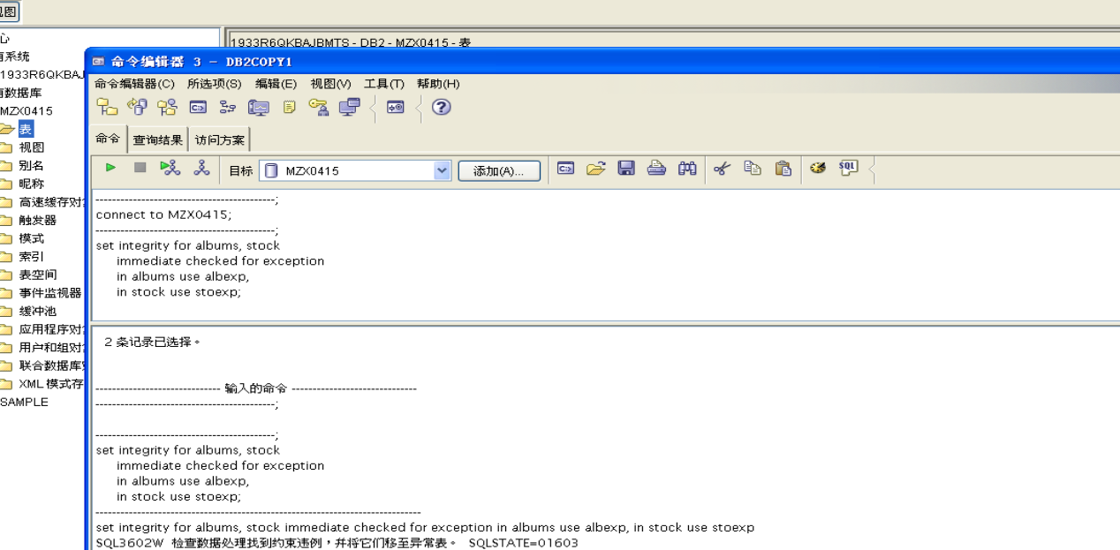

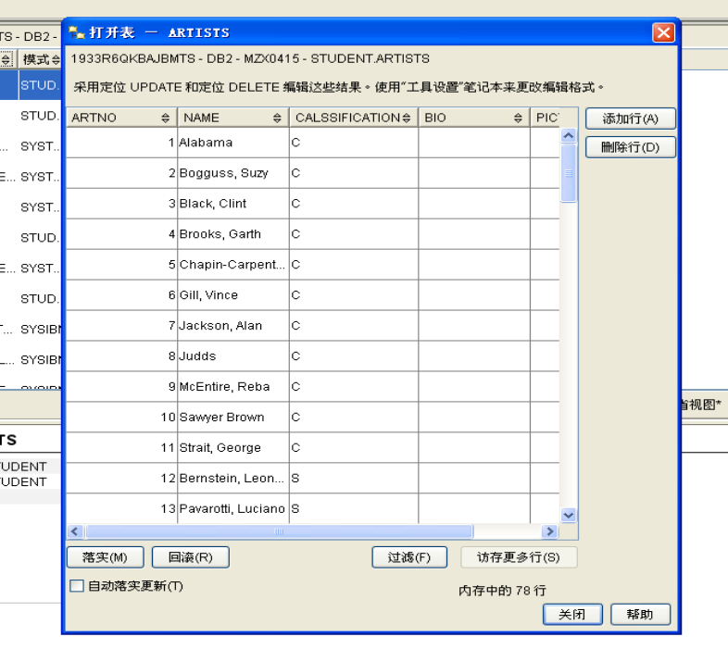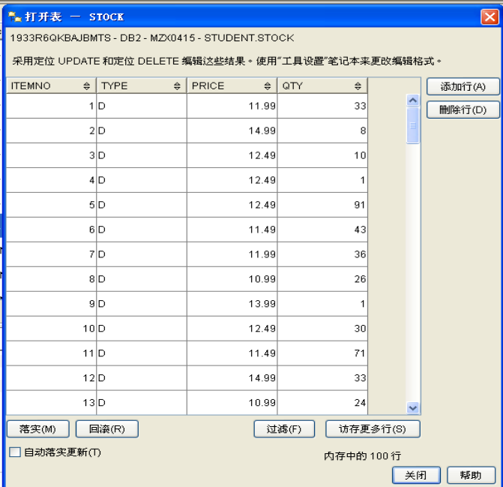
8. Select from the tables to verify that the check pending status has been removed from the tables. Run the scripts listtbst and seltab.
Were there any constraint pending conditions?
Answer question and show your work below by printing screen.
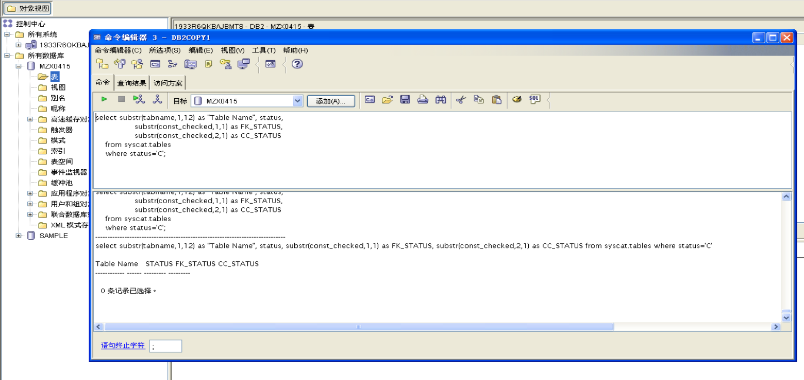
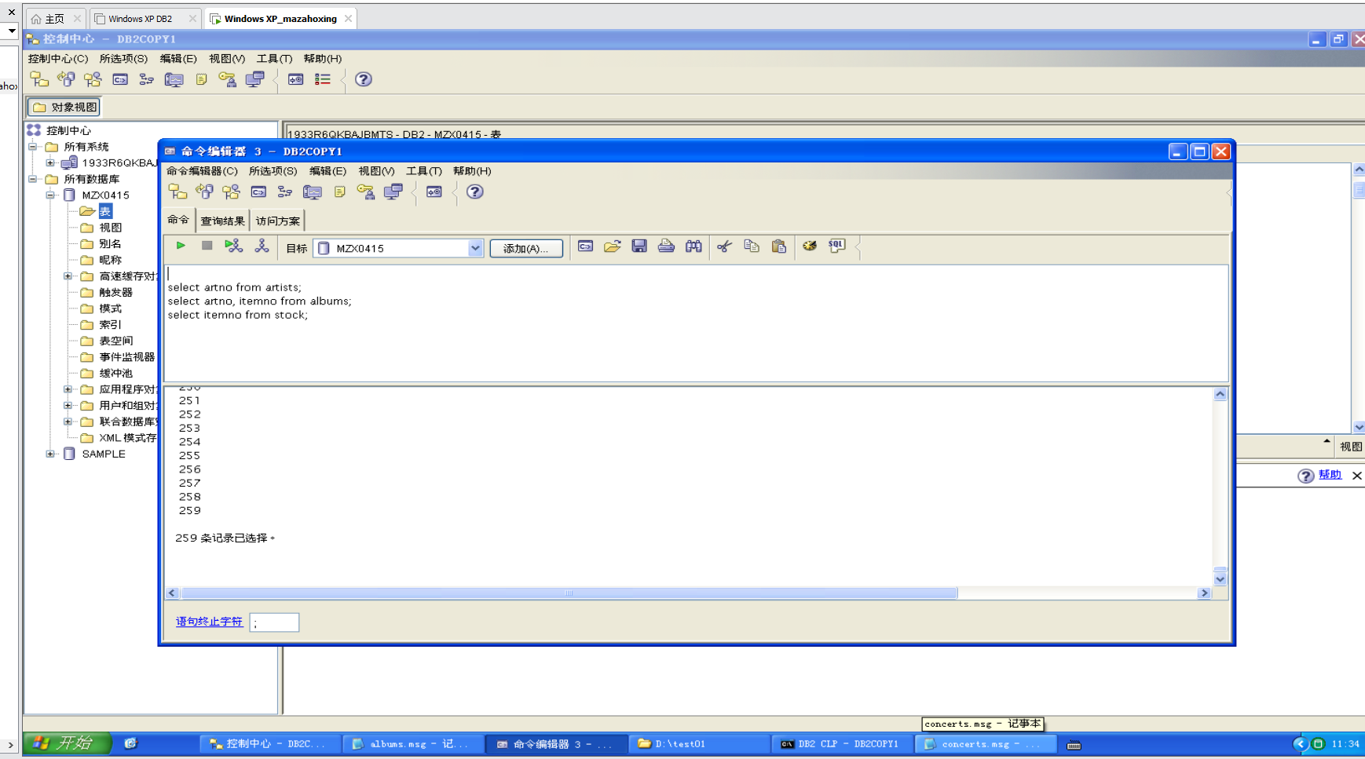
9. Where are the rows that were moved out of the tables in order to get the table out of constraint pending? How can you see them?
Show your work below by printing screen.
The rows would have been moved into the exception tables.
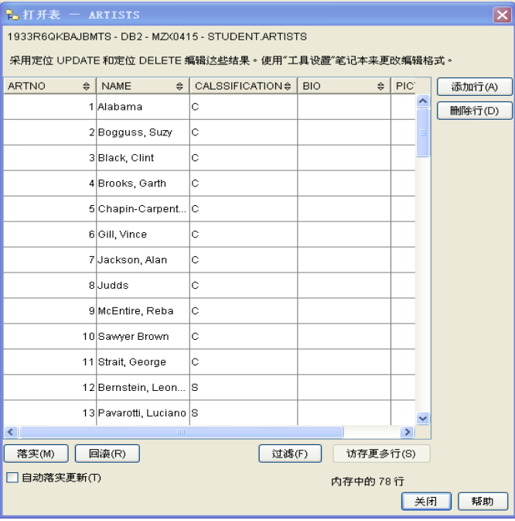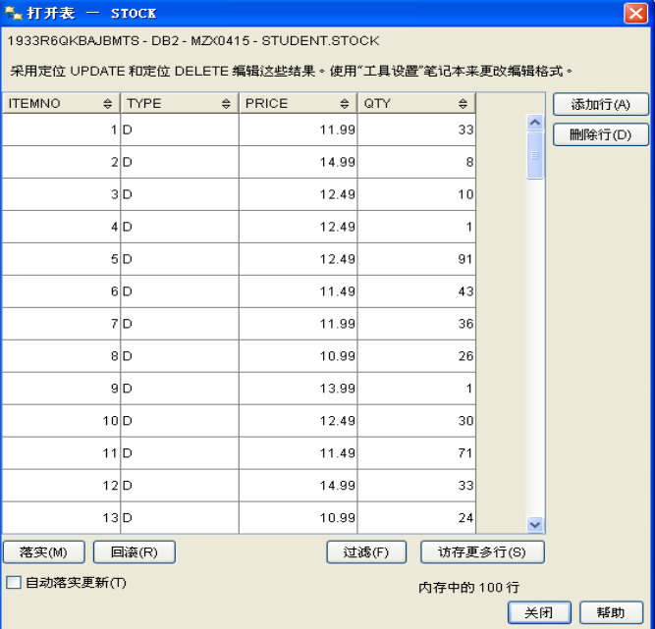

10. Examine the rows that were moved to your exception tables using the script file selexp.
Show your work below by printing screen.

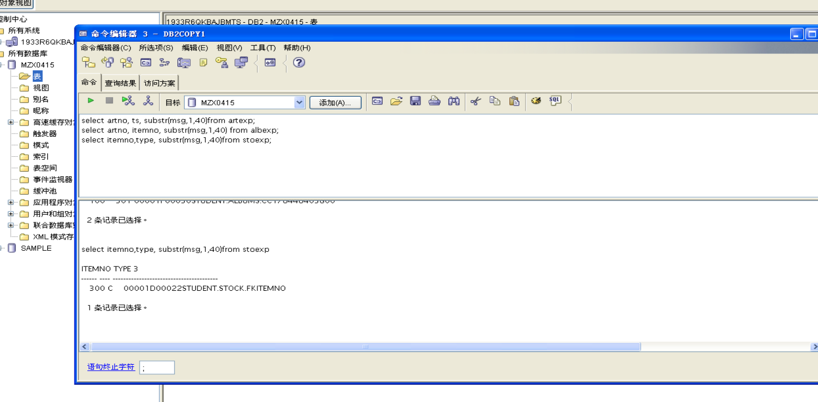

11. The rows that were moved from the STOCK table to STOEXP and from the ALBUMS table to ALBEXP were foreign key rows that did not have a matching parent key row in the ARTISTS table. You wish to carry this artist's work. Execute SQL to insert a row for item number 100, title of “Patti & Cart Wheels”, classification of “S” into the ARTISTS table.
Show your work below by printing screen.


12. Now you wish to use the exception table rows in STOEXP and in ALBEXP to insert rows into the STOCK and ALBUMS tables, respectively. View the rows that are in the two exception tables by using the script called selexp. Note that you do not want to insert the N+1 and N+2 columns into the STOCK and ALBUMS tables. Examine the MSG column in the two exception tables.
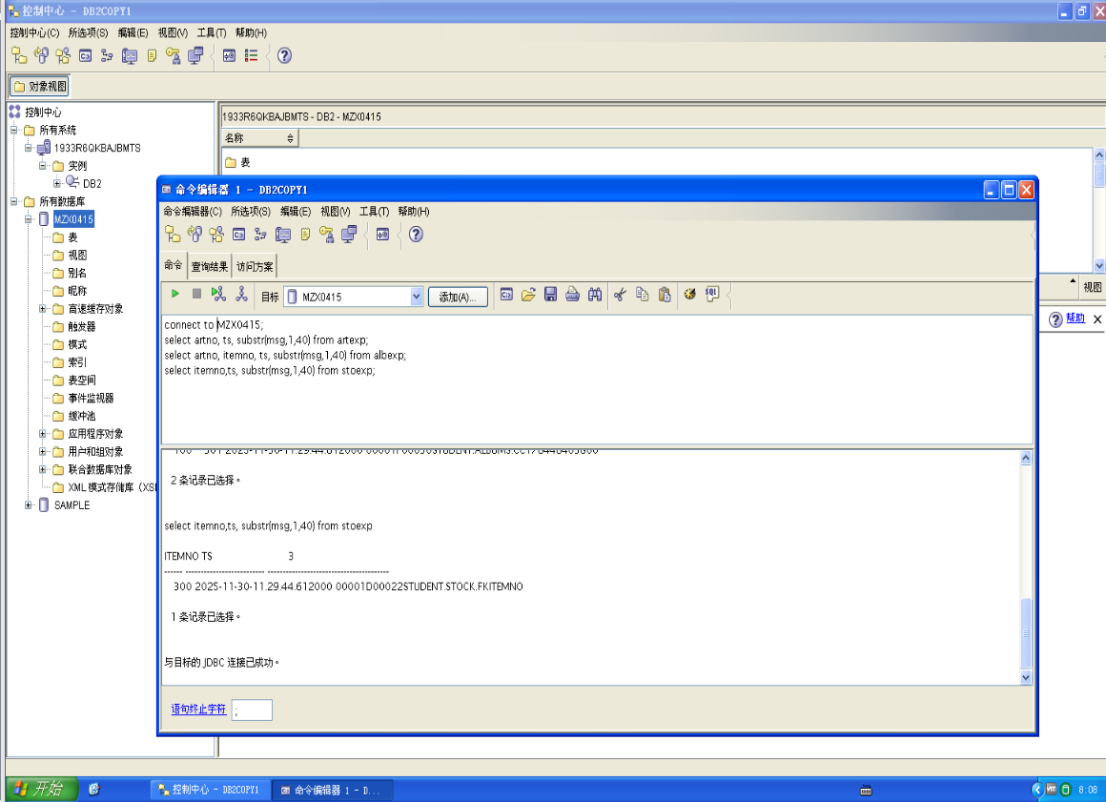

13. Run a script called insexp to insert the rows in the exception tables into the STOCK and ALBUMS tables. The script also selects from the ALBUMS and STOCK tables to see if the rows were inserted properly.
Show your work below by printing screen.
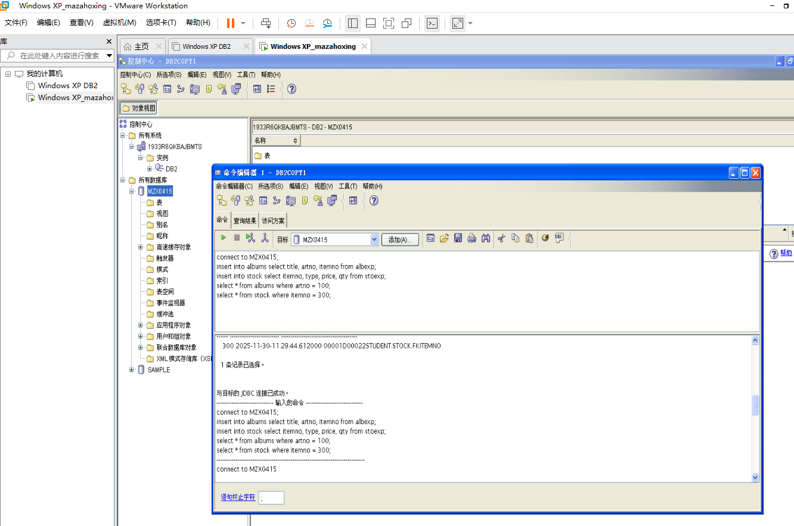

Section 7 - Understanding CHECK CONSTRAINT Enforcement
1. Previously you created a check constraint on the TYPE column in the STOCK table. Review the constraint requirements.
Show your work below by printing screen.
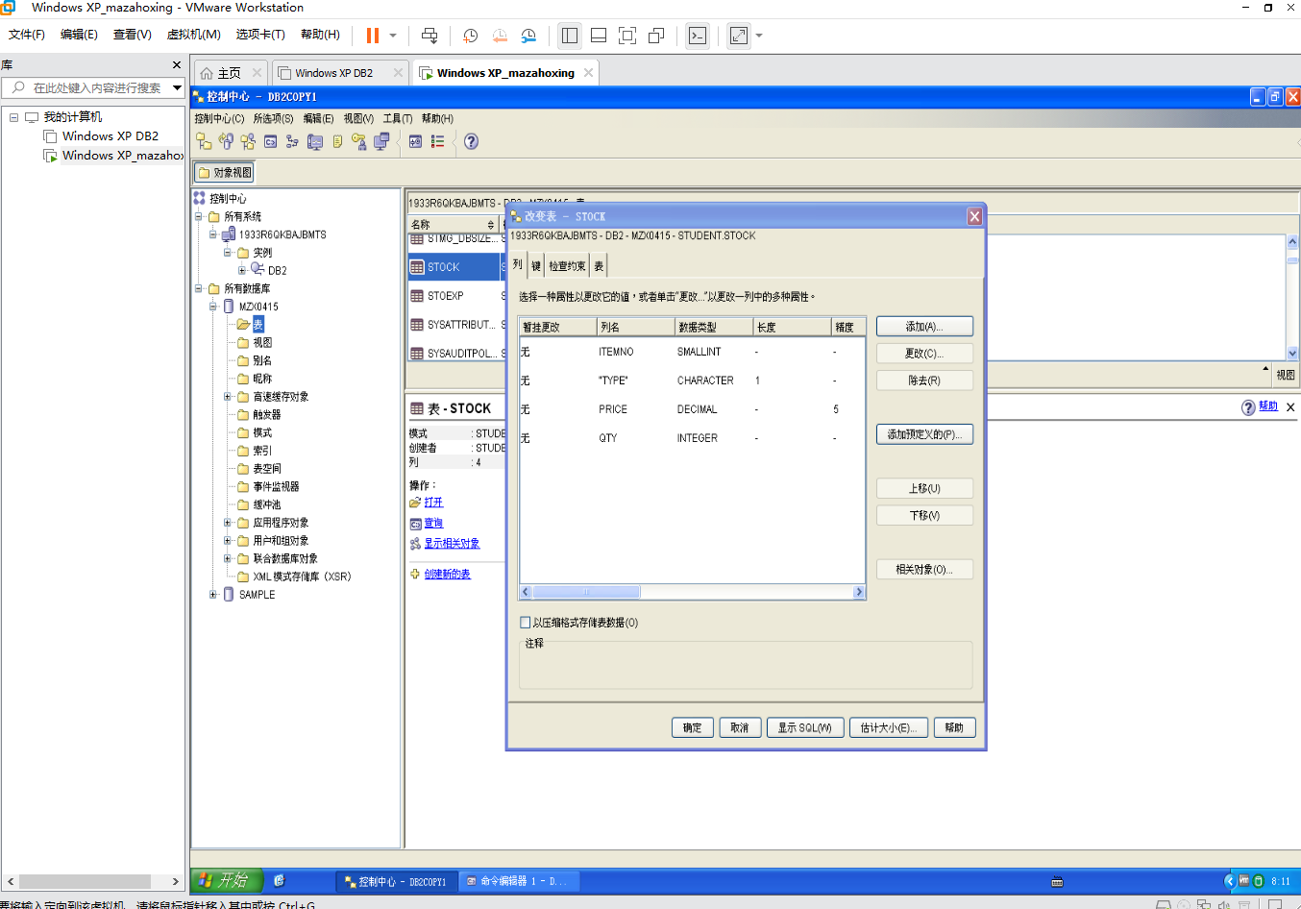
2. The hot new band, Double Dare, has made a Music Video that they want you to carry. Connect to the database and attempt to insert stock data for this artist with an ITEMNO of 302, TYPE of V, PRICE of 100.00, and QTY of 20.
Why did you get the message SQL0545N?
Show your work below by printing screen.
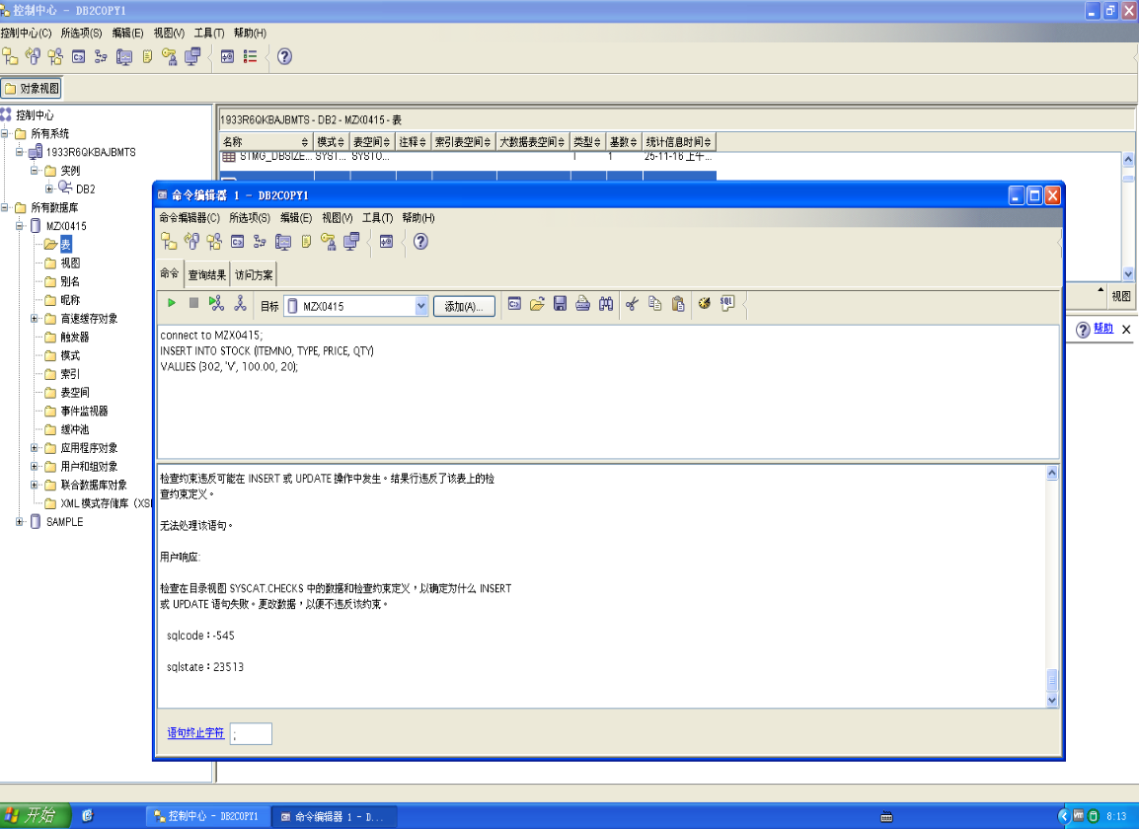

SQL0545 means the requested operation is not allowed because a row does
not satisfy the check constraint .STOCK.CCTYPE

3. Reissue the insert SQL statement with the TYPE = 'C'. You have decided to only carry the CD type.
Show your work below by printing screen.

This insert should work since C is a valid type defined in the CHECK
CONSTRAINT on the TYPE column in the STOCK table.

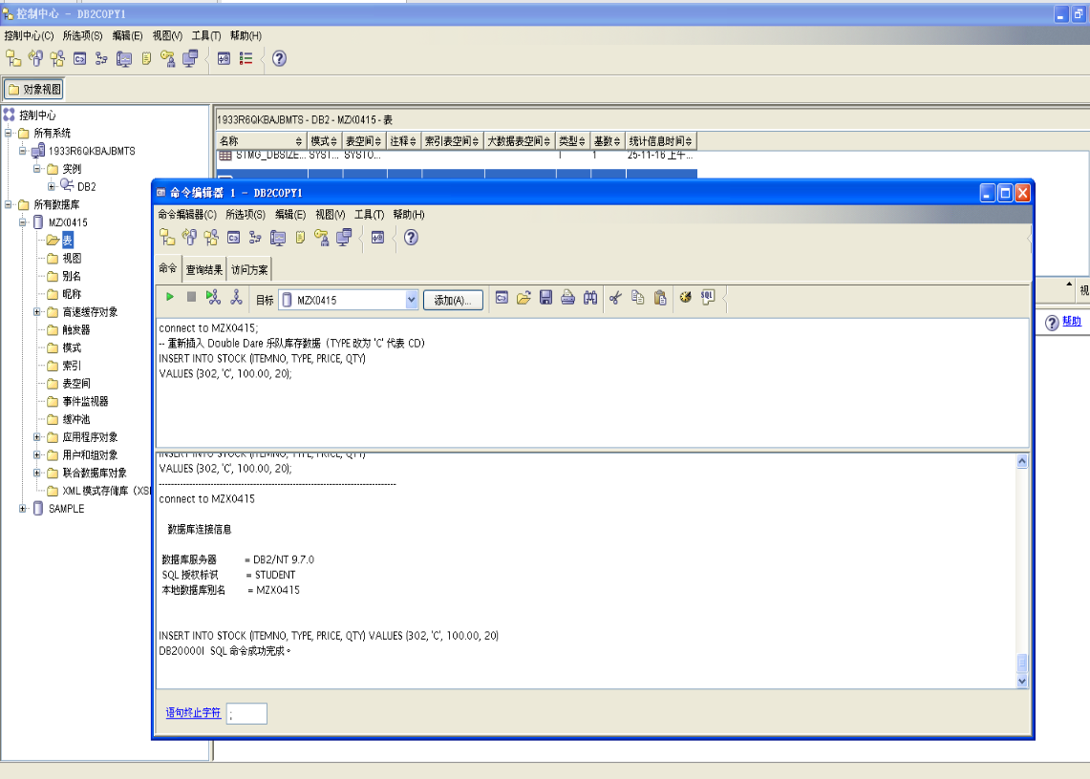

Section 8 - Understanding TRIGGER Enforcement
1. Previously you created a trigger on the QTY column in the STOCK table. Review the trigger requirements, by selecting from the SYSCAT.TRIGGERS view. Under what conditions would the trigger be fired?
Answer question and show your work below by printing screen.

The trigger is fired when an update to the QTY column of the STOCK table
causes the value to be equal to or less than 5. The action is to insert a row into
the REORDER table.
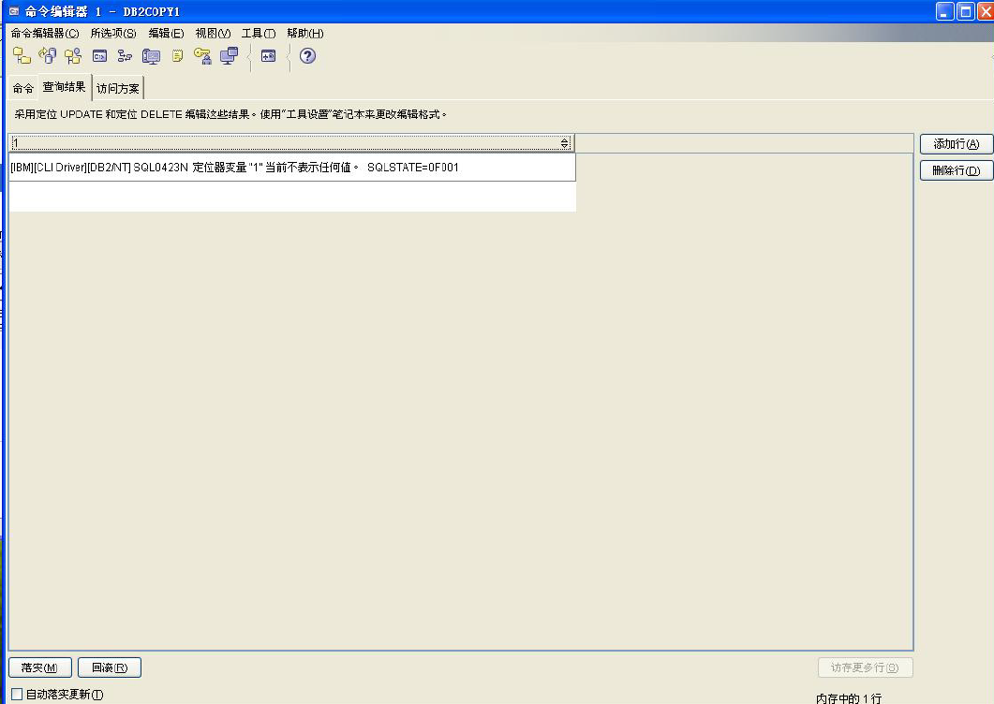

2. The Double Dare CD, ITEMNO 302, entitled “I Dare You” is selling very fast. Update the STOCK table to reflect the current inventory of 3. Note that no messages occur when a trigger is fired.
Show your work below by printing screen.
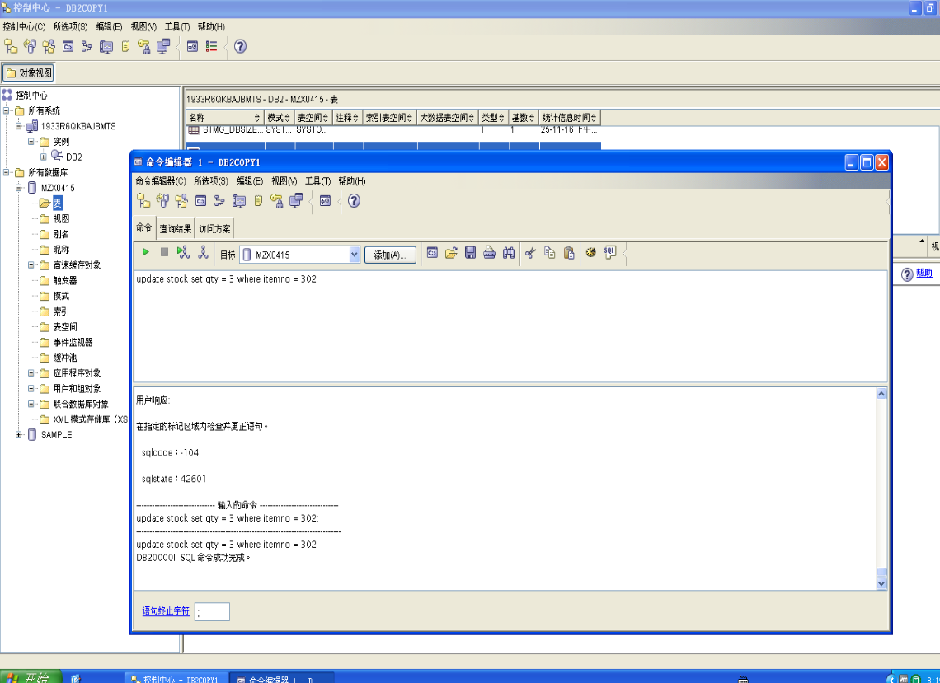

3. Query the REORDER table to see if the TRIGGER was fired during the previous update to the QTY in the STOCK table for ITEMNO 302.
Show your work below by printing screen.
When implementing triggers, you probably would implement a job that
periodically queried the REORDER table and placed orders for new stock
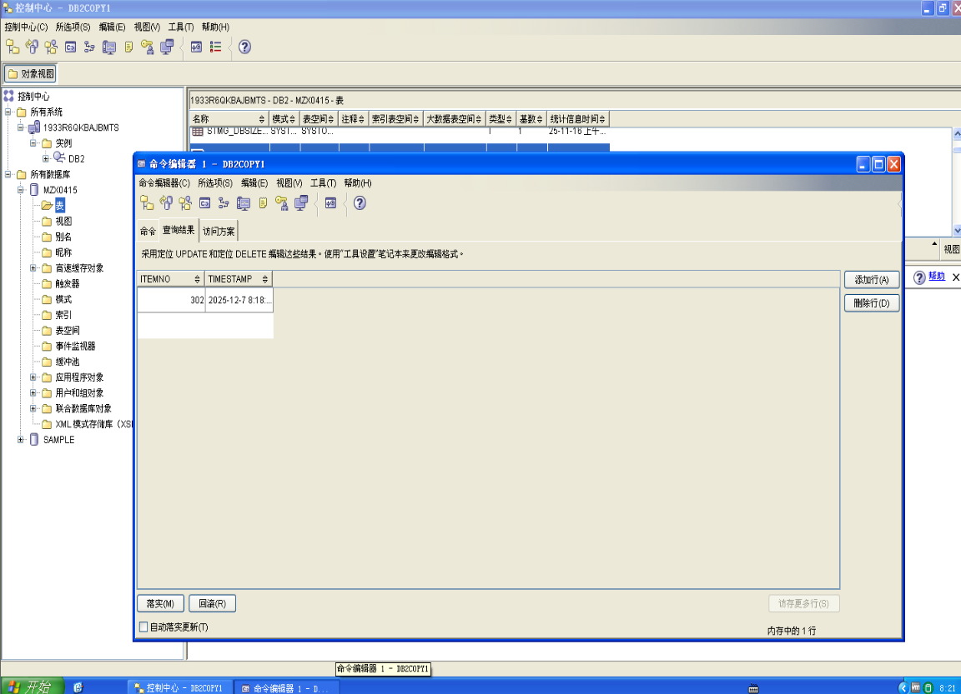

4. Previously you created an alias called EMPTYSTOCK for the REORDER table. Does it give the same results as querying directly against REORDER?
Answer question and show your work below by printing screen.
YES, the alias EMPTYSTOCK is a nickname for REORDER and gives the
same results.
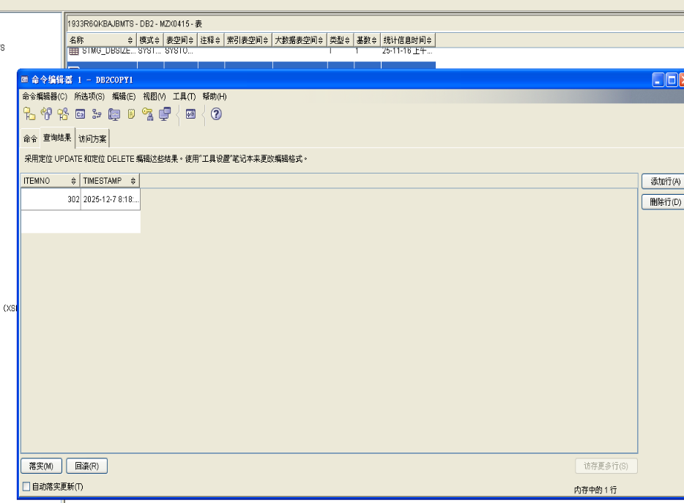

Section 9 - Using the db2look tool
1. This is a command line tool you will use to extract the DDL for the ARTISTS table into a file. You would do this to create a look-alike table in another database, or to store the structure away for future use.
Show your work below by printing screen.
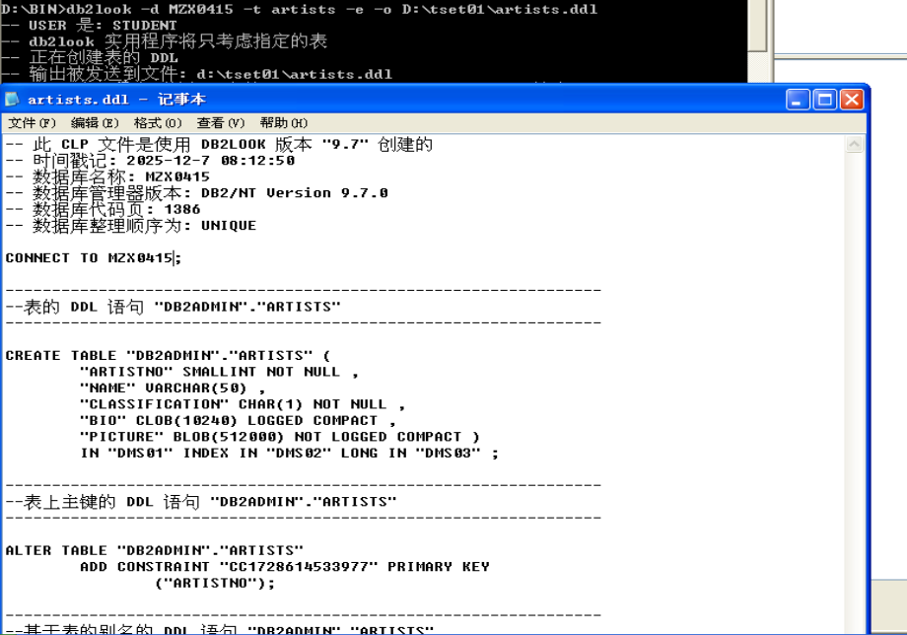

2. Use the DB2 DESCRIBE tool and compare the results with the DDL file.
Show your work below by printing screen.
