吉林大学

DB2实验报告

班级：计科 4 班
姓名：马兆星
学号：21230415
姓名 |  | 马兆星 | 学号 | 21230415
实验项目 |  | 3. Create objects
实验性质 |  | □演示性实验 □验证性实验  操作性实验 □综合性实验
实验地点 |  | 计楼 A210 | 机器编号
指导教师 |  | 康辉 | 实验时间 | 2025年 12月7日 8时30分
一、实验综述
1. 实验目的及要求
This exercise is an online lab where the database MUSICDB will be used for backup and recovery. During this lab the students will prepare the database for archival logging, create a backup and restore and recover the database to the current as well as to a prior point in time.
At the end of the lab, students should be able to:
• Create backup images of a database and of table spaces
• Restore a database from a backup image
• Roll forward a database or table spaces to perform full recovery
• Perform actions to reactivate databases in exception states
2. 实验设备、软件
PC, windows XP Professional, DB2 9 Express-c
二、实验过程（实验步骤、记录、数据、分析）
Section 1 - Determining Log Configurations
1. Before beginning this lab, you need to make sure some of your database configuration parameters are set to the values required by this lab. Do this by running the script recovrst.
Show your work below by printing screen.
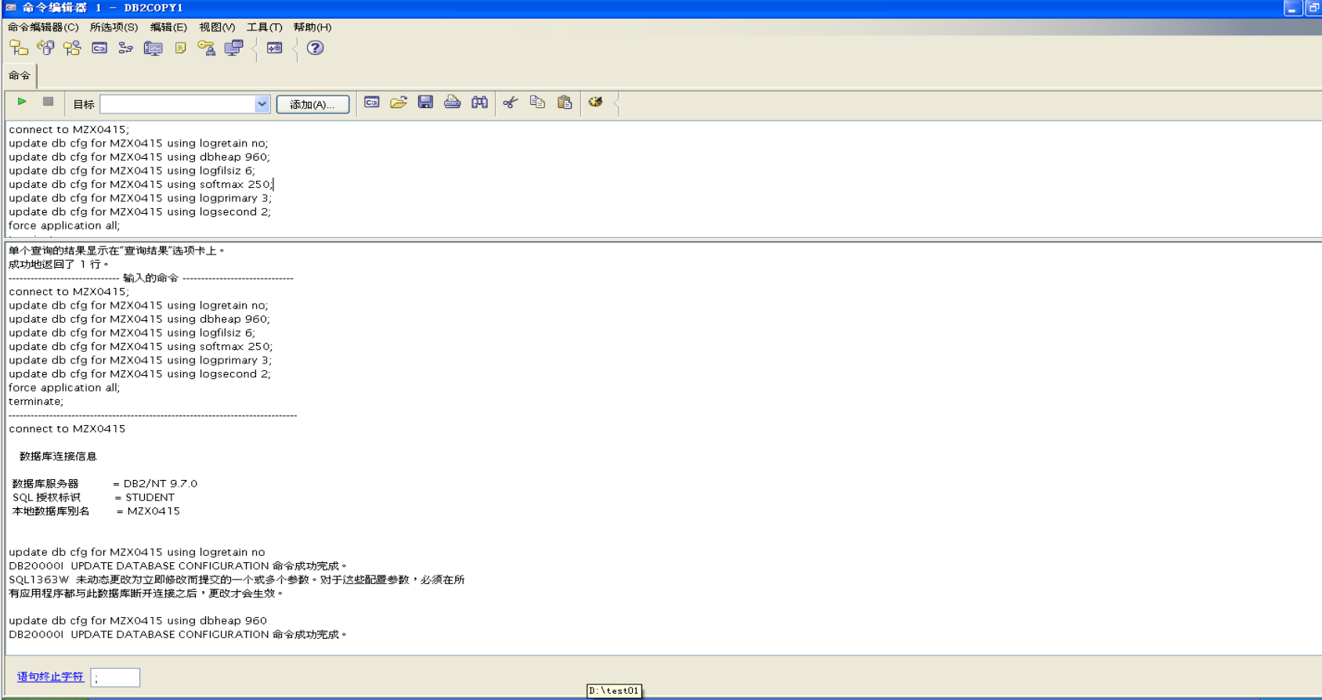
2. Connect to MUSICDB to activate the database.
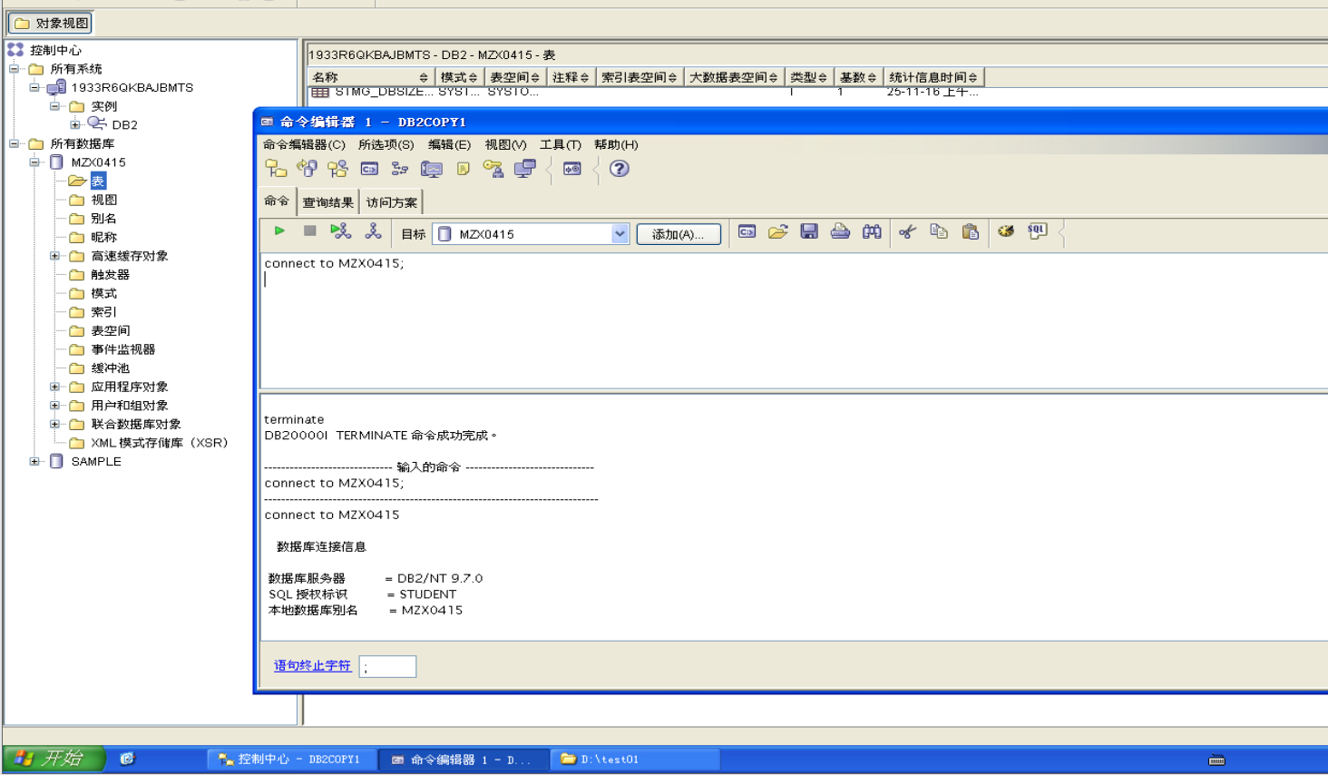
3. Examine your db cfg file for MUSICDB.
How large are the log files? Is this amount in pages or bytes?

The log file size is given in 4KB pages via the parameter LOGFILSIZ. In this
lab, the log files are fairly small — six 4KB pages per file. This small size would
not be typical in an active installation. It is used to facilitate the class environment.

Show your work below by printing screen and answer the question.
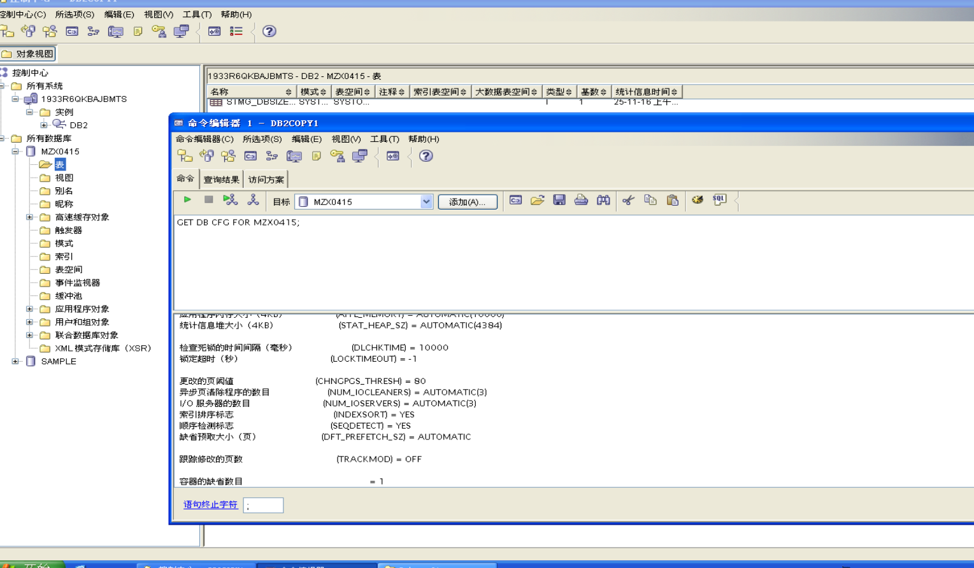
4. How many primary log files will be allocated? When will these files be allocated?

Three log files that are considered primary will be allocated when the database is
created. DB2 will increase the LOGFILSIZ by two pages for overhead, hence a
total for three primary logfiles of (6+2) pages of 4KB makes (3*(6+2)*4KB) =
3*32KB = 96KB of space, which will be allocated for the primary logs.

5. How many secondary log files will be allocated? When will these files be allocated?
Secondary log files will be allocated when needed. This will occur if the primary
logs become full due to uncommitted units of work. The number of secondary log
files allowed is limited by the parameter LOGSECOND. In this case, a maximum
of two secondary log files is permitted.

6. For which type of logging is your database currently configured (log retention or circular)? What parameters provide this information?

The database is currently configured for circular logging. The LOGRETAIN and
USEREXIT DB2 parameters designate whether log retention logging is being used
or not. In your case, the values of both of these parameters is 0 (OFF), which
means both parameters are turned off. Since both of these fields are set to OFF,
Log retention logging is not being used, therefore circular logging is being used. If
one or both were set to 1 (ON), archival logging (logretention logging) would have
been used. Note that the configuration parameters LOGRETAIN and USEREXIT
indicate the type of logging that will be used when all applications disconnect from
the database and then one connects.

7. Which types of recovery are supported by this type of logging — Crash, Version, or Roll forward?

Crash and Version recovery are supported with this type of recovery. Roll forward
recovery is not supported.

8. Where do the log files reside?

D:\ NODE0000\SQL00001\SQLOGDIR\

9. Assume the database manager was active. A short interruption of power made it necessary to perform a crash recovery. Will manual intervention be required to cause this crash recovery? What configuration parameter relates to this issue?

On the GUI, check under the Recovery heading. Then click Cancel to close
your Configure Parameters window.
The failure situation described requires a crash recovery. Since the
AUTORESTART parameter is set to ON, this recovery will be automatic when
the database is accessed. If this parameter was 0 (OFF), manual intervention
would be required.

10. From your Command Window session, change your current directory to the log path, but exclude the SQLOGDIR directory from your command.
Note: Do NOT EDIT these files!
Show your work below by printing screen.
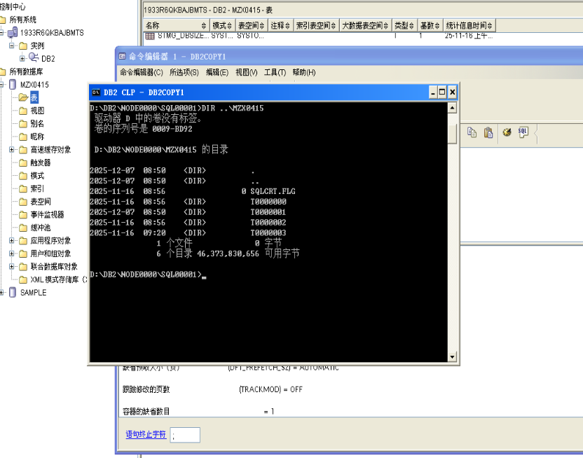
11. Determine the contents of this directory.
What are T0000000, T0000001, T0000002?
These are the names of the DMS table space containers for SYSCATSPACE,
TEMPSPACE1, and USERSPACE1.

12. Is it appropriate to keep the log files in the same path? (Consider the type of recovery currently supported in your answer.)

You will hear different answers to this question, and several may be correct. The
answer needs to account for other considerations in the installation. An installation
supporting primarily read only applications that populate decision support DB2
tables from extracts of other systems may satisfy logging requirements with the
default. On the other hand, an installation with high change activity may determine
it necessary to move the logs to a different file system, even if that installation does
not elect to support roll-forward recovery.

13. Now, list the contents of SQLOGDIR.
Show your work below by printing screen.
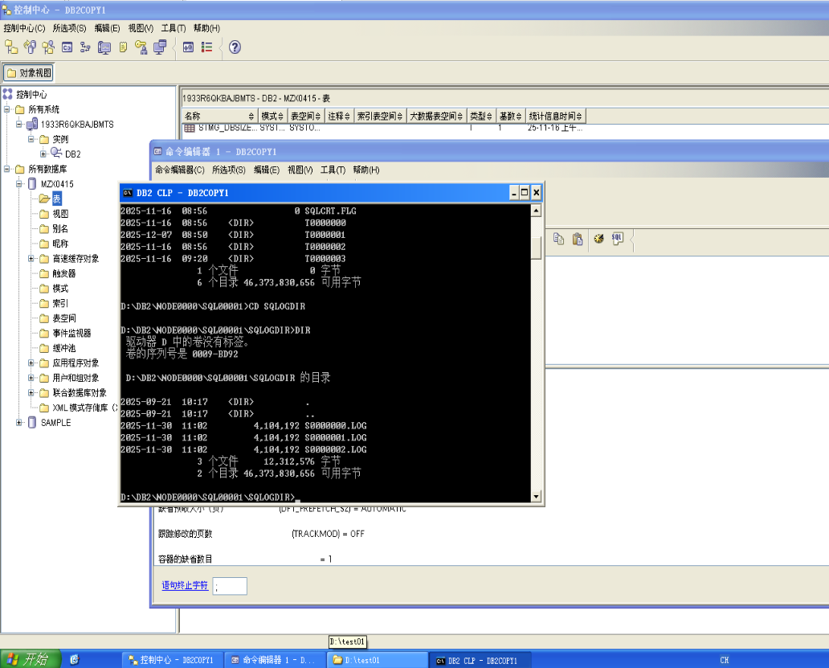14. How many log files are in this directory? Does this match what you expected considering your configuration file? Why or why not?
There are three log files in the directory. This matches the number of primary
log files in the configuration. This is appropriate since primary log files are
allocated when the database is created.

15. Increase the quantity in the STOCK table by 1 but do not commit the update. If you are not certain how to turn off auto-commit, check the solutions.
Show your work below by printing screen.
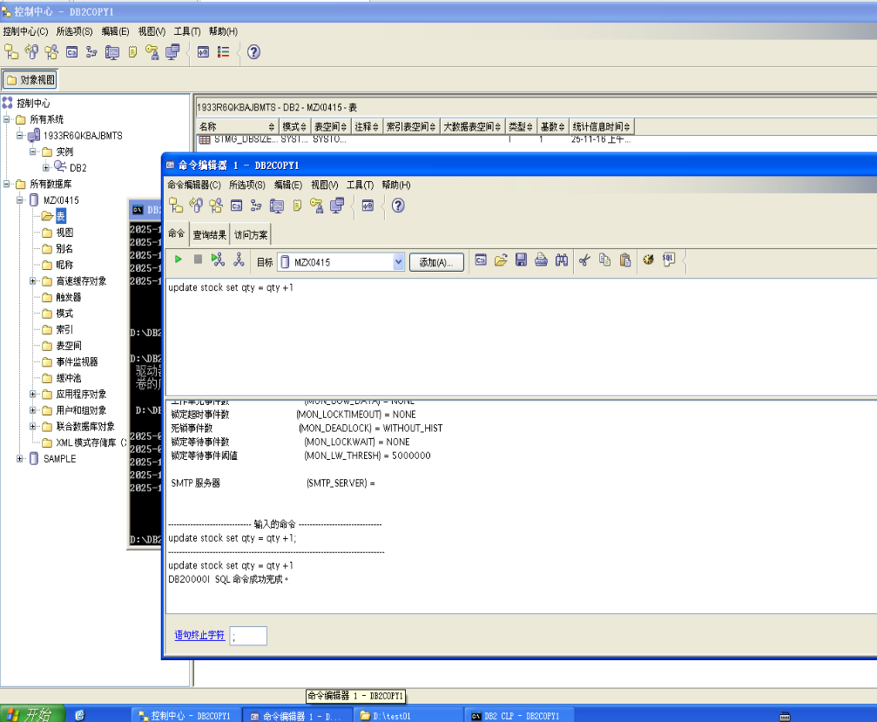

16. If you encounter an error, go to the next question. If you did NOT encounter any error, decrease the quantity in the STOCK table by 1.
Show your work below by printing screen.
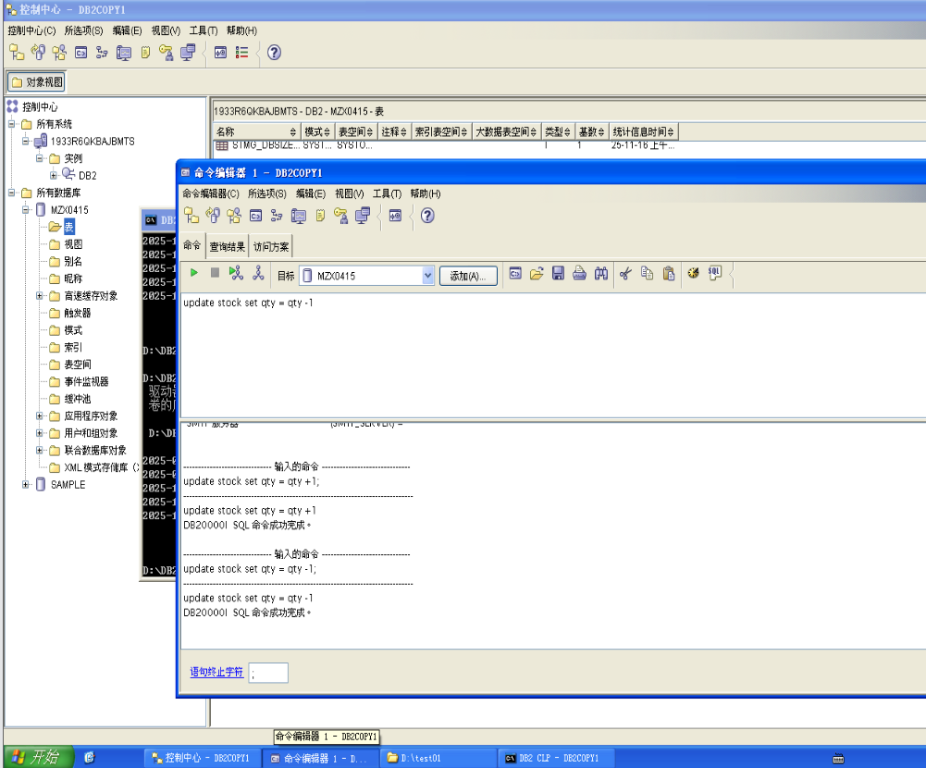

17. What did you observe? What was the SQL code you received?

The statement failed with an SQL code of -964. (You may see that the trigger is
identified as causing the error.)

18. Issue a command to retrieve help on the SQL code. Why did the statement fail?
Show your work below by printing screen.
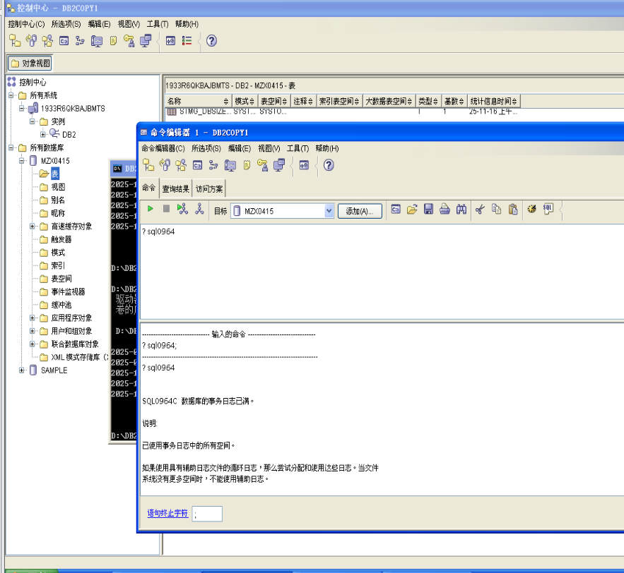
SQL0964C The transaction log for the database is full.
Cause: All space in the transaction log is being used.
If a circular log with secondary log files is being used, an attempt has been
made to allocate and use them. When the file system has no more space,
secondary logs cannot be used.
The statement failed because you encountered a log file full condition.
Note that if you saw the trigger identified as causing the error, that the inserts
being done by the trigger are also logged.

19. Since the unit of work could not complete successfully, issue a rollback.
Show your work below by printing screen.
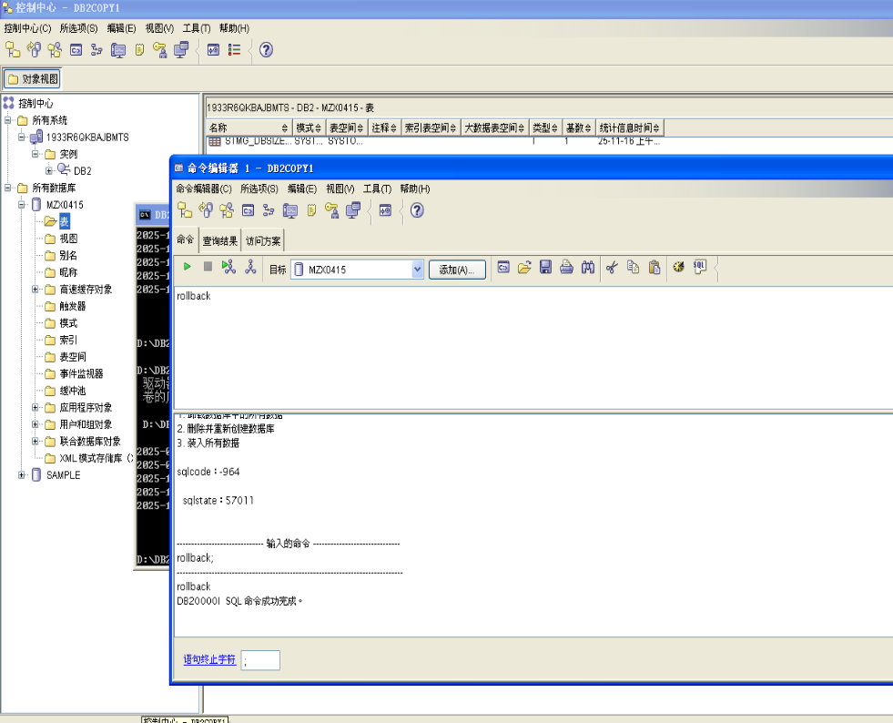
20. From your telnet session, determine the number of log files allocated at this point. How many are there?
There are five currently allocated.

21. What accounts for the additional files?
When circular logging is used and the primary log files fill up, secondary log
files are allocated. The additional log files are secondary log files.

22. Change to your home directory in your Command window.
cd\

23. From your telnet session, create a directory that will contain backups of your database: mkdir restore
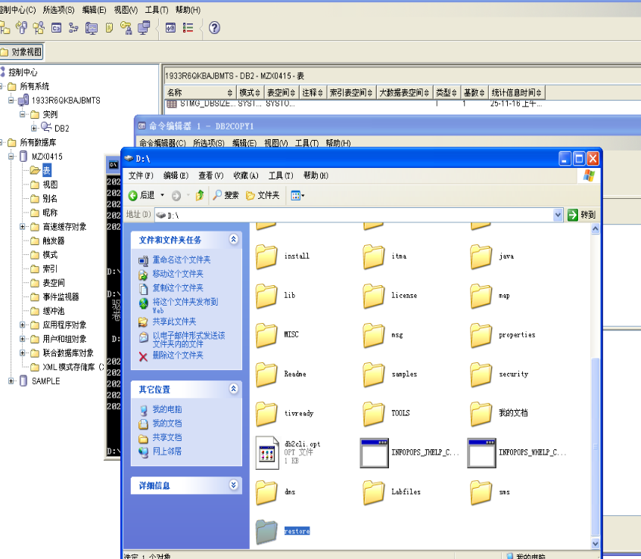

Section 2 - Backup/Restore Support with Circular Logging
1. Connect to your musicdb database from the new command window.
Show your work below by printing screen.
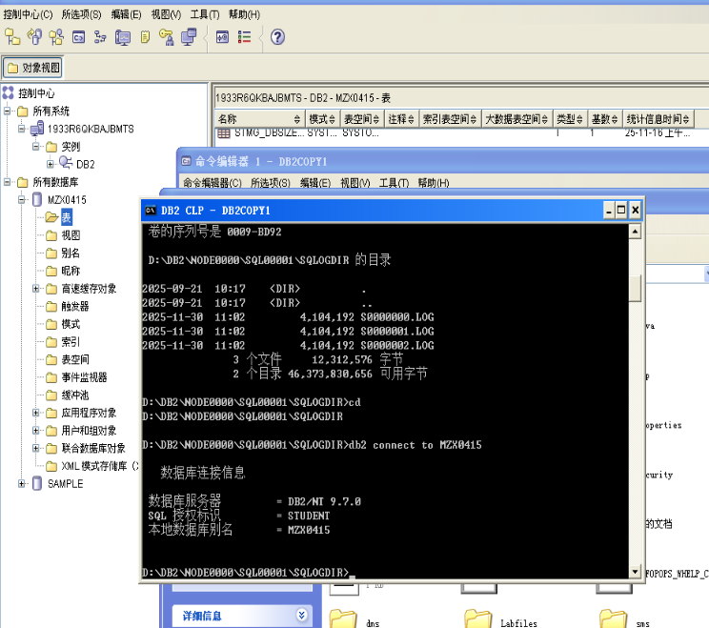

2. Attempt to perform an online backup of your MUSICDB database to the directory of C:\restore. Were you successful in trying to specify an online backup? Explain why or why not.
Show your work below by printing screen and answer the question.
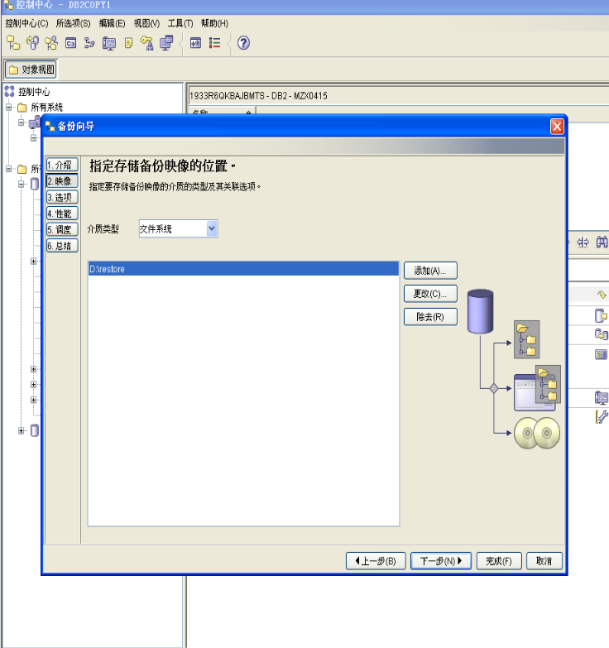
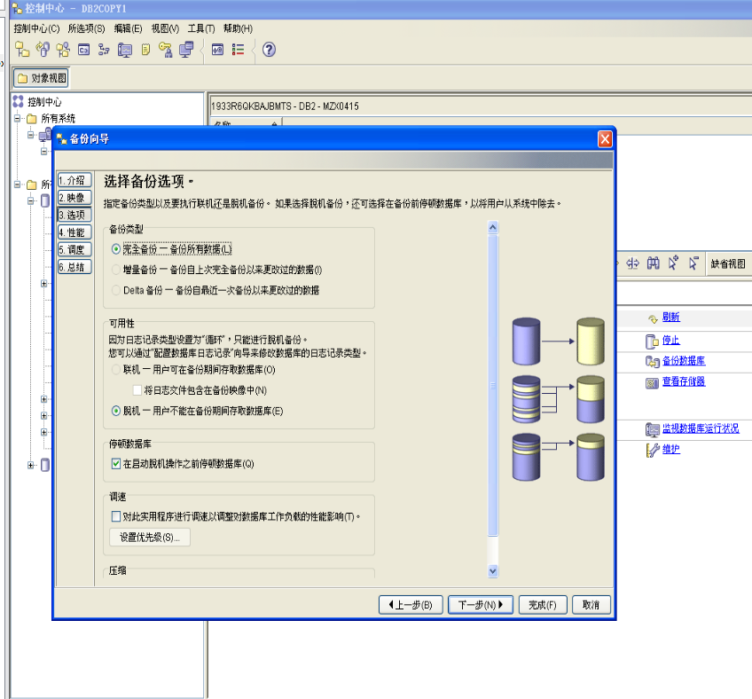
No, you were not able to specify on online backup. In the GUI, DB2 prevented
you from selecting the Online radio button when trying to do your backup. On the
command line, an error message, SQL2413, was returned. An online backup
allows other transactions to be changing the database simultaneously. Therefore,
only a database configured for rollforward recovery can support an online backup.
Otherwise, the integrity of the database would be threatened.

3. Attempt to perform an offline backup instead.
Show your work below by printing screen.
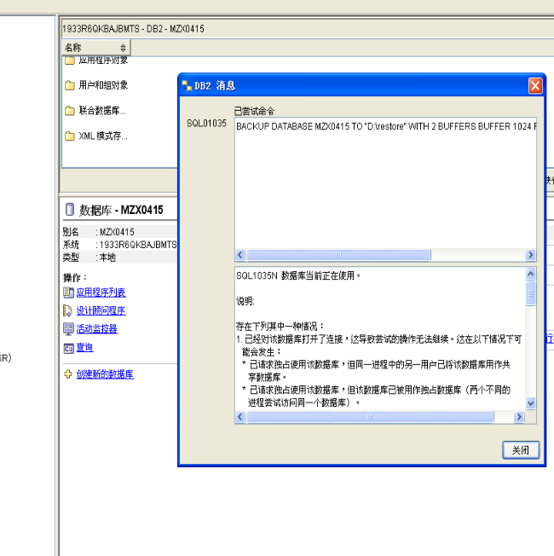

4. Did the backup complete successfully? What did the message say?
The backup did not complete. The message said you can't perform a backup
right now because the database is currently in use (SQL1035N).
It is possible in DB2 9 that the offline backup completed. This indicates that
applications were forced off the database.

5. In order to take an offline backup, do you think that exclusive use of the database is required? Who is currently connected to the database?

An offline backup requires exclusive use of the database. This is the manne in
which integrity is guaranteed. The application that is connected to the database is
your other telnet session which previously connected to the database.

6. Resolve the apparent problem by forcing all applications to end.
Show your work below by printing screen.
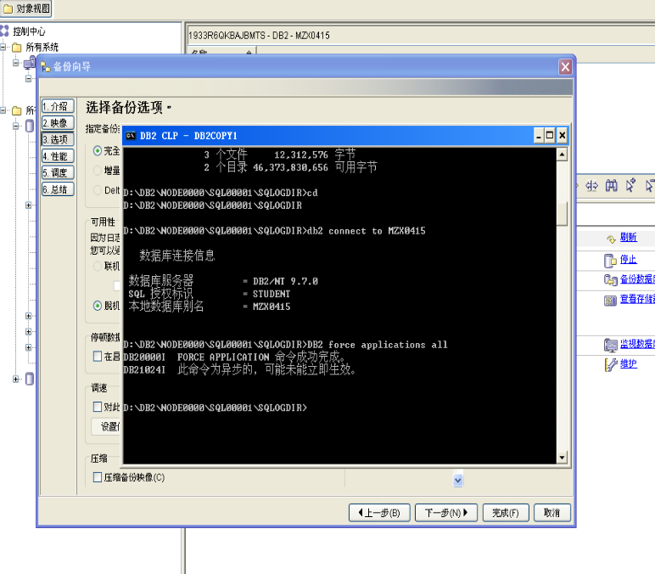

7. Now try your backup again.
Show your work below by printing screen.

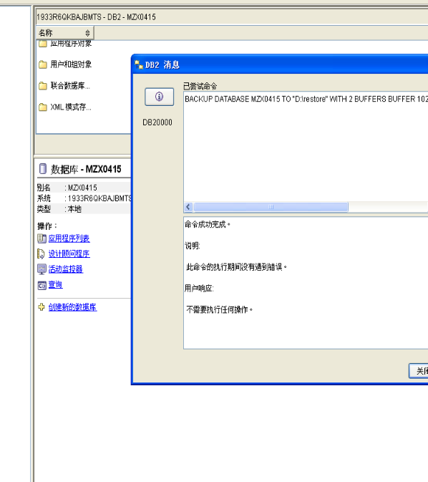

8. Was the backup successful this time?
The backup was successful for this execution.
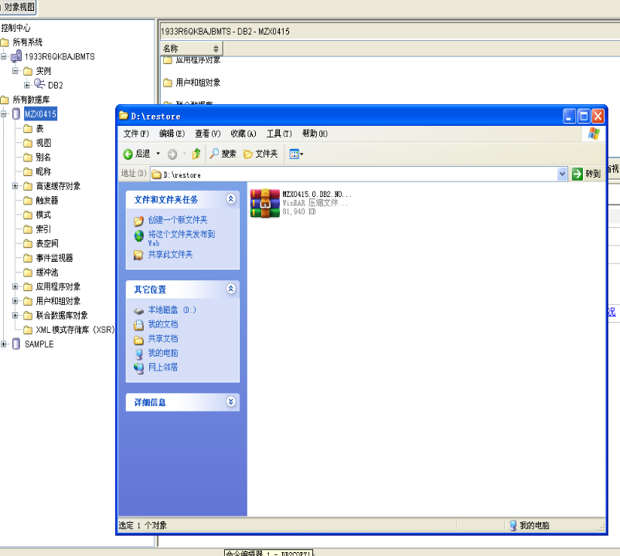

9. The timestamp for a backup image is necessary for restore if you are using the RESTORE command rather than the GUI DB2 Control Center, and multiple images reside in a given source.
When the backup is targeted to disk, the name of the file itself will reflect the timestamp. When tape or TSM managed devices are used, the header in the backup image will contain this information.
10. Look at the backup information through the LIST BACKUP command. Remember that you have a previous backup from an early lab (LOAD lab). Issue the list backup command with the ALL keyword.
Show your work below by printing screen.

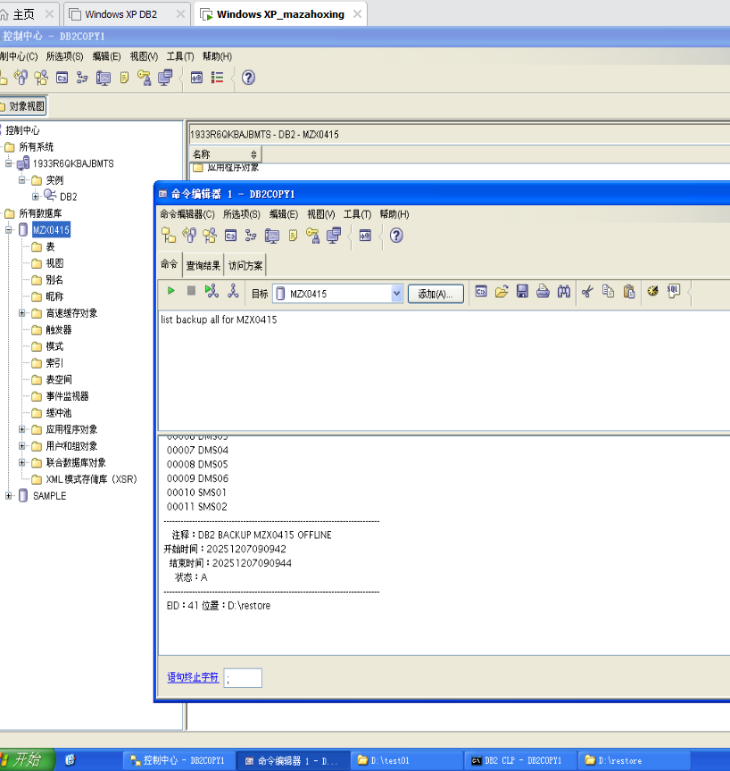

11. Is the timestamp available as part of this information?
The timestamp is available as part of the information presented.

12. Record the start timestamp of the backup.
Start Time: 20241010210552 (Your actual timestamp will not match. This value
is used for the lab solutions.)

13. How many table spaces are included in this backup?
This full database backup contains 11 table spaces.

14. Instead of using the keyword ALL, it is possible to restrict the output of the LIST BACKUP command via a timestamp specification or by object name specification.
Issue a request to get just the backups for today.
You may wish to request online help for this command.
Show your work below by printing screen.
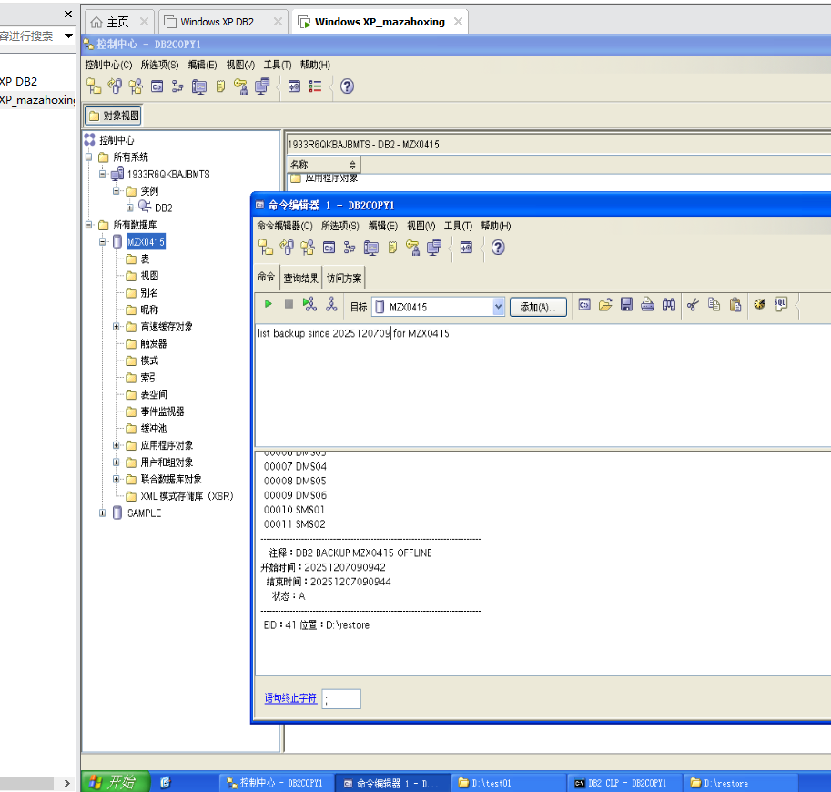
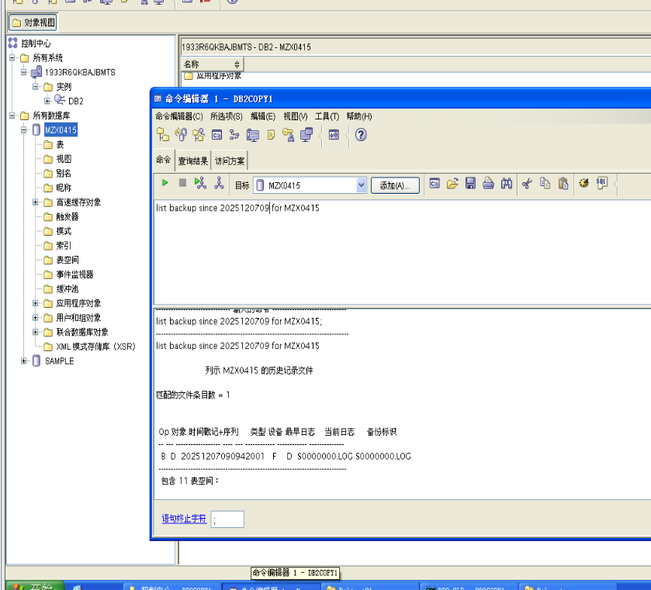

15. The history information regarding backups is maintained by the database manager and can become extensive if it is never removed. Use the ? command to invoke the online help facility to identify a command that can be used to manage the amount of history information retained. Write the name of the command you believe would give you the capability to eliminate old history information.
Show your work below by printing screen.

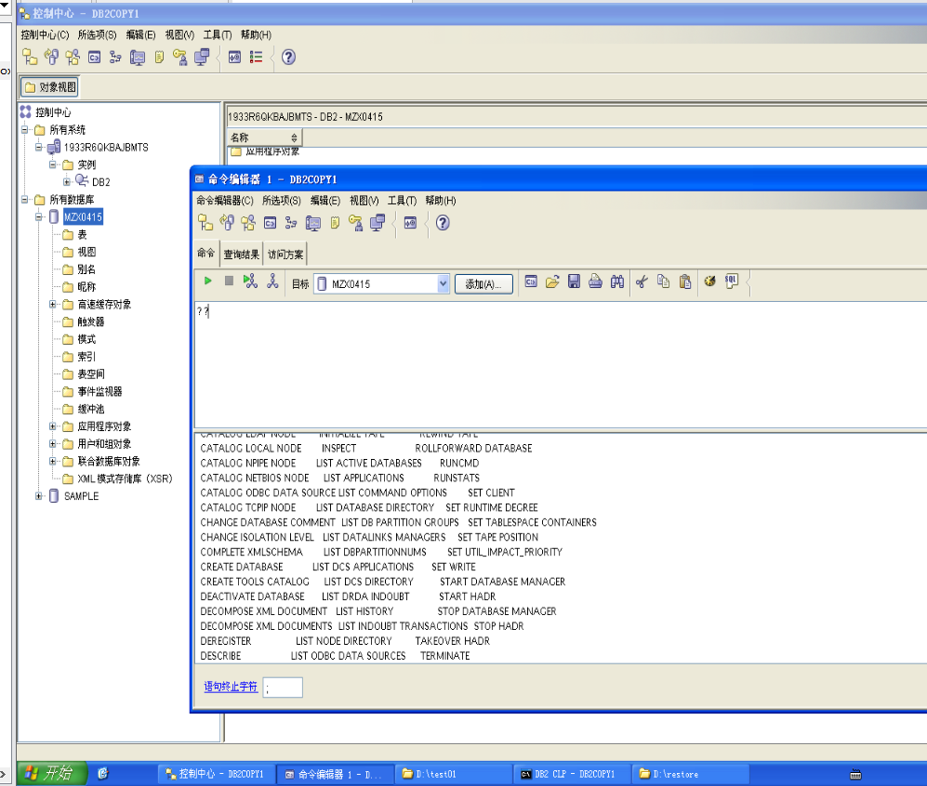

16. From your Command Window, examine the file naming convention used for your backup.
Show your work below by printing screen.
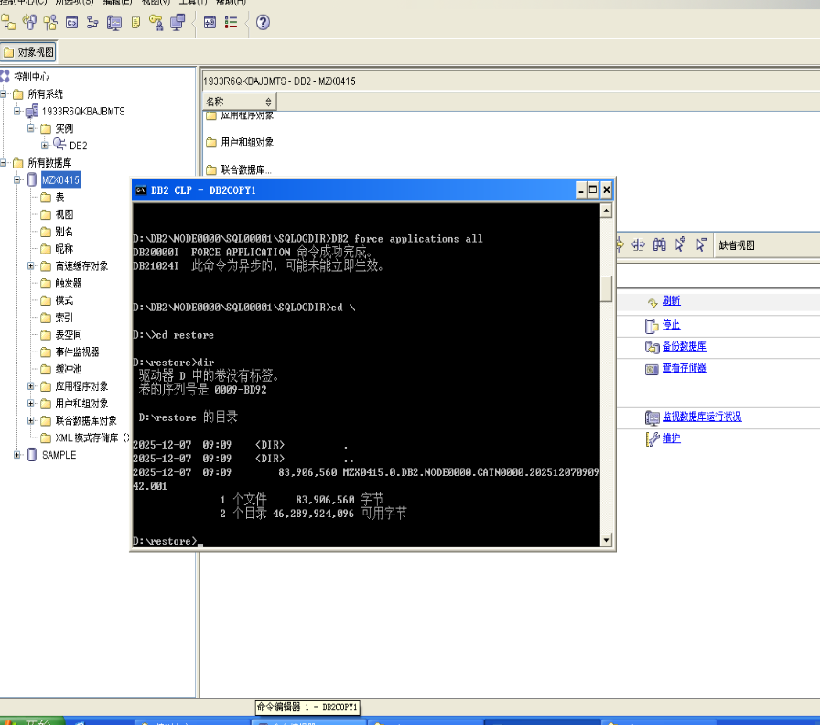

17. The backup image reflects the same data that is currently in your MUSICDB database since you have not issued any SQL to change data since the backup was taken. Select the artist's name and album titles for artist number (ARTNO) 77.
Show your work below by printing screen.
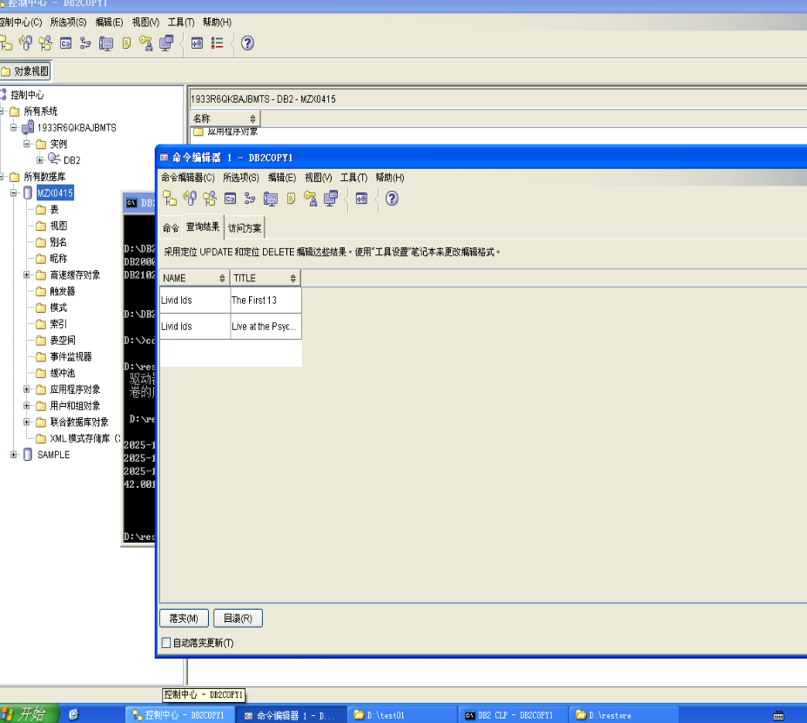
Record Name — __________________ Livid IDs
Record Title 1 — __________________ The First 13
Record Title 2 — __________________ Live at the Psychidelly

18. Change the name of the artist 77 to “Melanie and the Mechanics” and the album title of ITEMNO 261 to “Unmaterial Girl”.
Show your work below by printing screen.

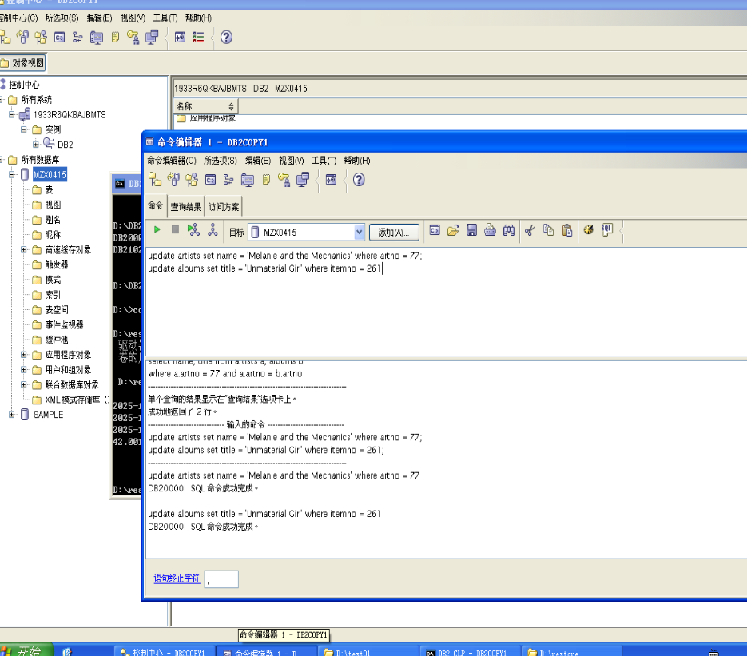
19. Execute a join between ARTISTS and ALBUMS for ARTNO 77 and document the data as it now appears. This reflects a change that occurred after your backup.
Show your work below by printing screen.
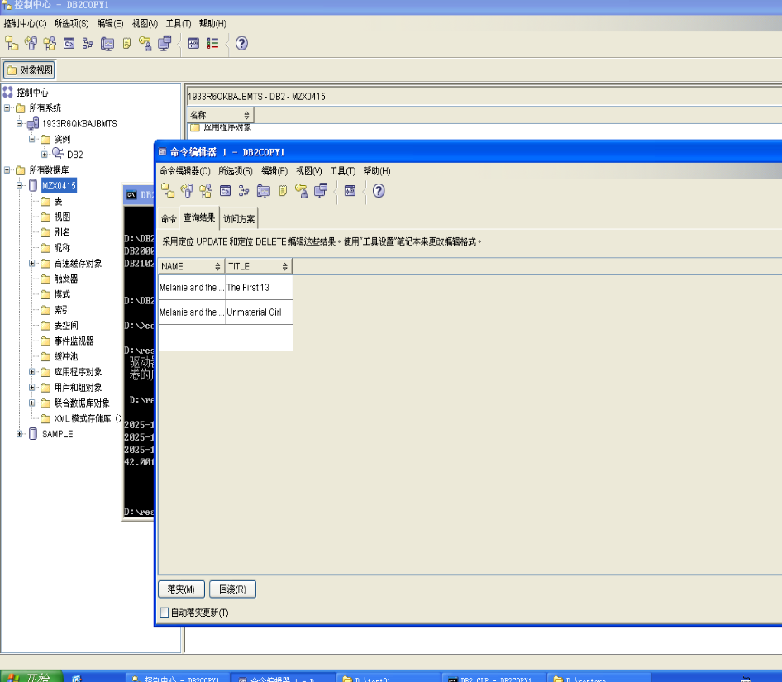

Record Name — __________________ Melanie and the Mechanics
Record Title 1 — __________________ The First 13
Record Title 2 — __________________ Unmaterial Girl

20. Assume the disk containing the MUSICDB database failed. You now have the task to restore the backup image that was made.
Show your work below by printing screen.

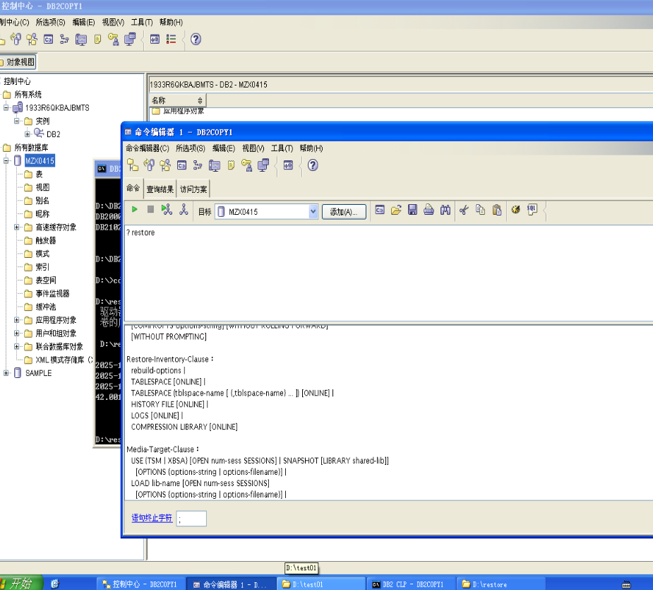

21. First make sure there are no applications are connected to the database.
Show your work below by printing screen.
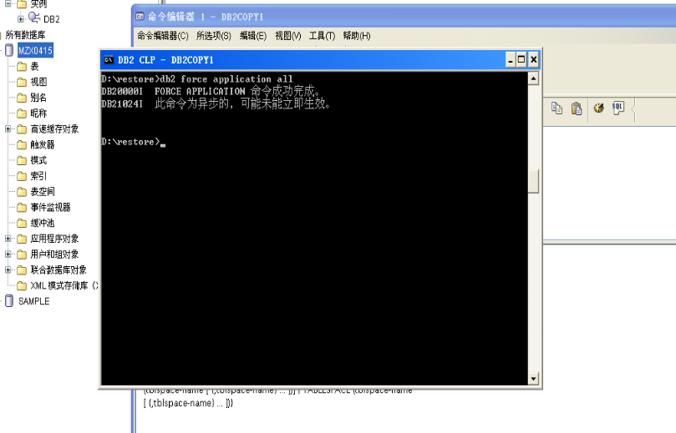

22. Restore the database from the C:\restore directory.
Show your work below by printing screen.

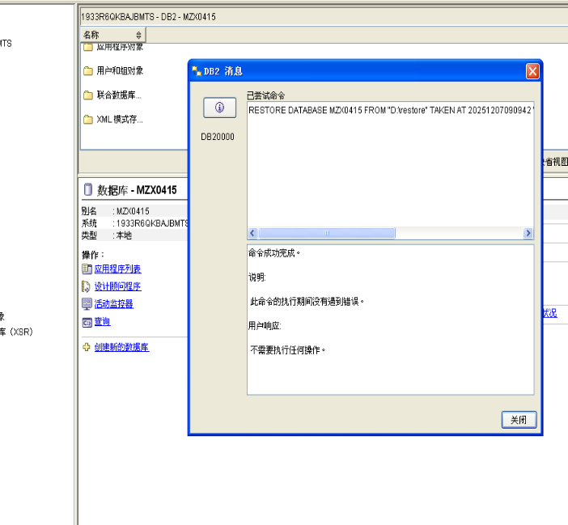

23. Connect to MUSICDB and execute the join between ARTISTS and ALBUMS for ARTNO 77.
Show your work below by printing screen.

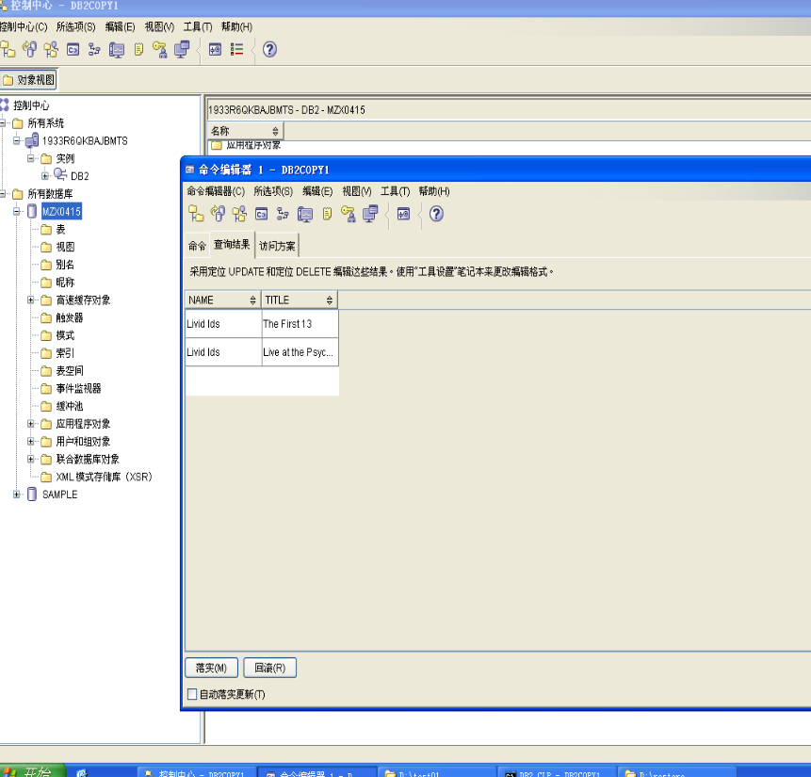
24. Does the data reflect the updates made, or is the original data restored?
The output reflects the original data. The backup has been successfully restored.

25. Assume that you are not in a lab environment. You made your backup three days ago and thousands of transactions have since occurred. Would your current recovery strategy be acceptable?
Normally, it would not be acceptable to lose three days worth of work in an
active database system. Such a system would benefit from a recovery strategy that
supports roll forward recovery.

Section 3 - Backup/Restore Support with Archive Logging
1. Update the database configuration file to indicate that log retention logging is to be used (recovery).
Show your work below by printing screen.
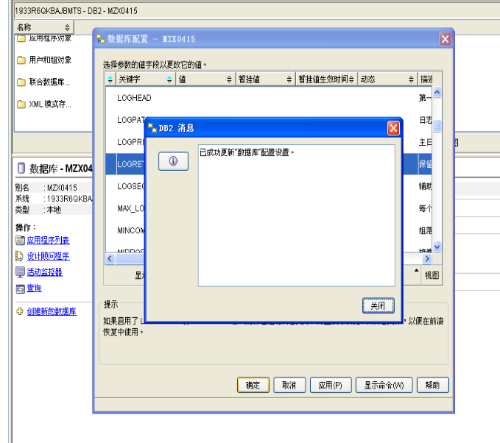
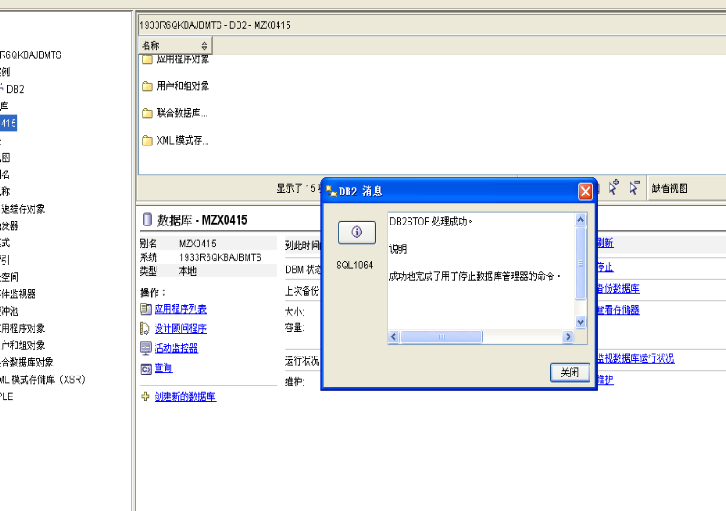
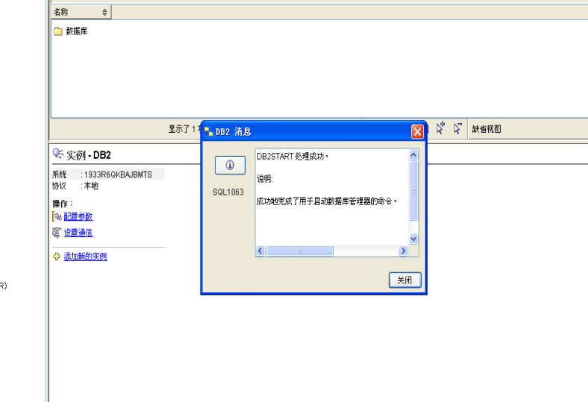

2. Some changes to the db cfg file (including changes to LOGRETAIN) do not take affect until the database is deactivated and becomes active again. Since the database was activated by the first user connect, all applications must end to deactivate the database. Try issuing a DB2 terminate command.
Show your work below by printing screen.
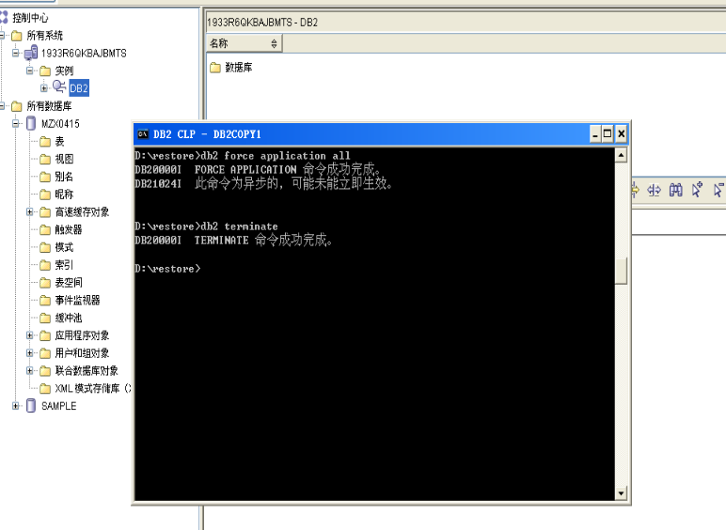
3. To find out for sure if log retention logging is in effect now, look at the Log retain status indicator in the db cfg.
Show your work below by printing screen.
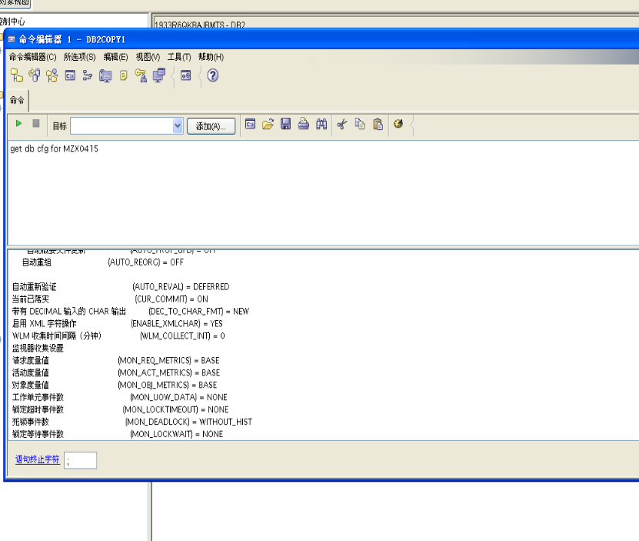4. Did the terminate command change anything concerning the parameters?
The terminate command had no effect on the parameters. The logretain status is
still off. (If using DB2 9, this parameter is changed dynamically, therefore you
may not need to do Steps 5 and 6).

5. Try forcing all applications off the database.
Show your work below by printing screen.
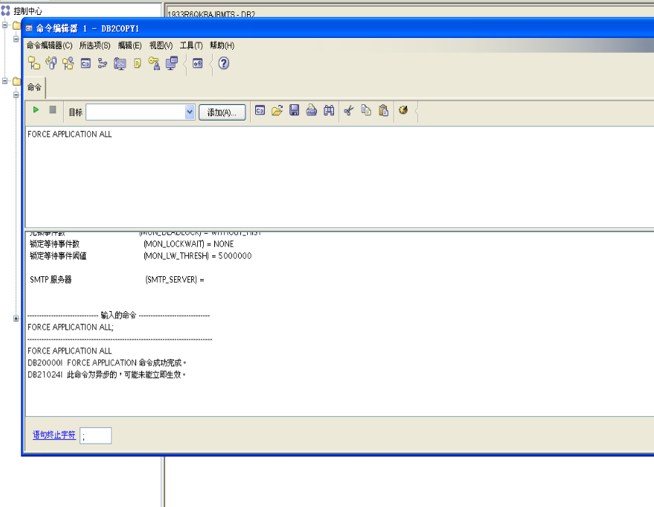

6. Did the Log retain status indicator value change to RECOVERY?
Show your work below by printing screen and answer the question

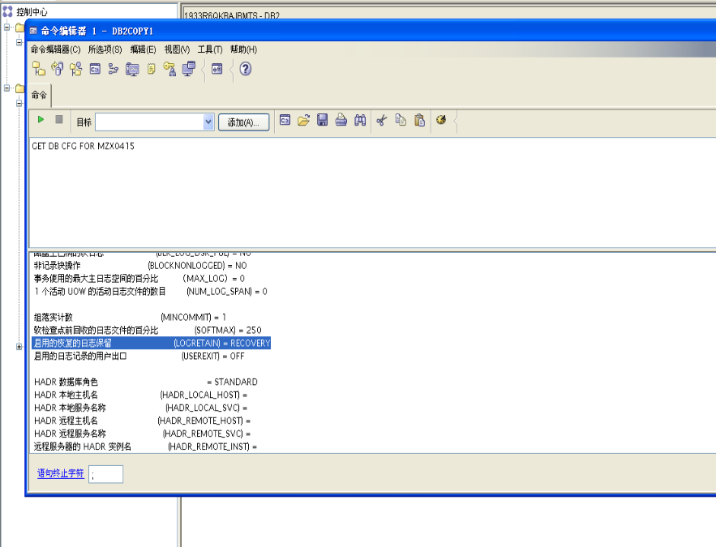
7. Connect to musicdb database. Was the connection successful? What does the SQL message indicate? Why does the database manager require a new backup?
Show your work below by printing screen and answer the question
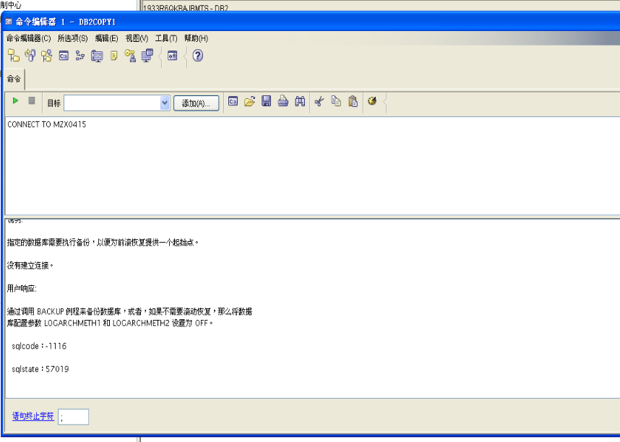
The connection was not successful. The database is in a backup pending status.
Enabling or disabling log retention logging establishes a new recovery point for the
database. The database manager requires an offline backup of your database to
establish this new recovery point.

8. Did the attempt to connect to the database cause log retention to be activated?
Show your work below by printing screen and answer the question
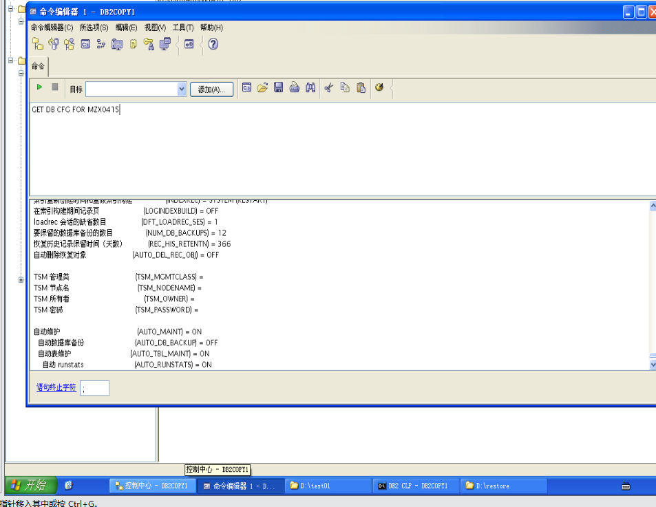
The attempt to connect to the database did cause the log retention change request
to be active. This is indicated by the log retain status indicator equal to 1 or
RECOVERY.

9. Create an offline backup of your database and record the timestamp.
Show your work below by printing screen and answer the question.

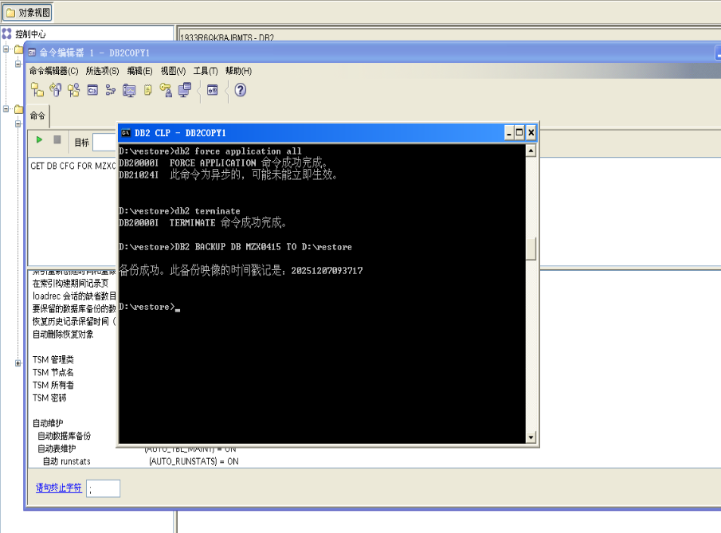

Timestamp — 20251207093717 (Your actual timestamp will not match. This
value is used for the lab solutions.)

10. Complete a series of SQL statements to change data in the ARTISTS table and record points in time associated with these changes.
a.Change the name of ARTNO 77 to "Melanie and the Mechanics".
b.Record the time.
c.Change the name of ARTNO 77 to "Bill Pellett and the Comets".
d.Record the time.
Show your work below by printing screen.
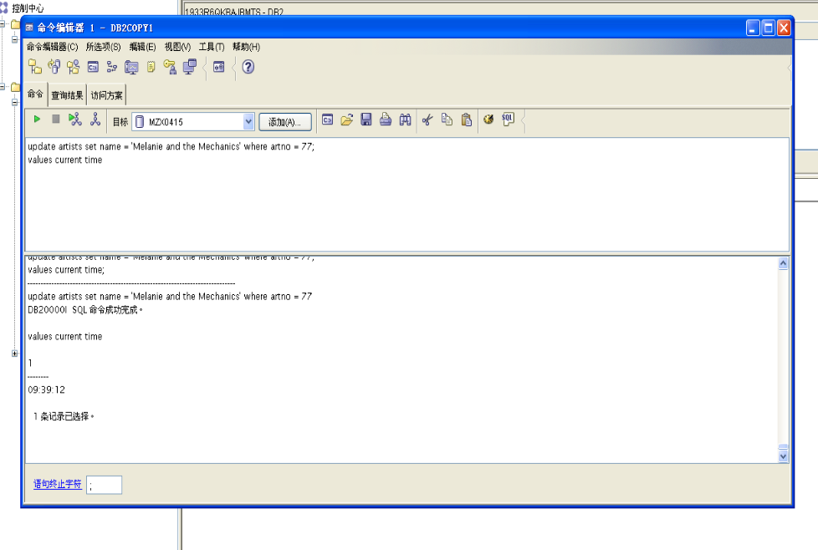

Record time associated with Melanie and the Mechanics - __________________
09:39:12 (your value will be different)

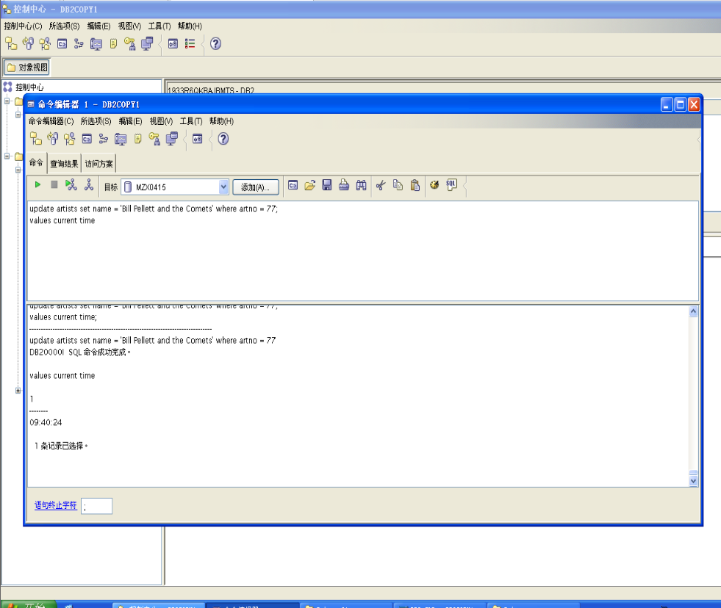

Record time associated with Bill Pellett and the Comets - __________________
09:40:24 — (your value will be different)

11. View the db cfg again. What is the value of the first active log file?
Show your work below by printing screen and answer the question.
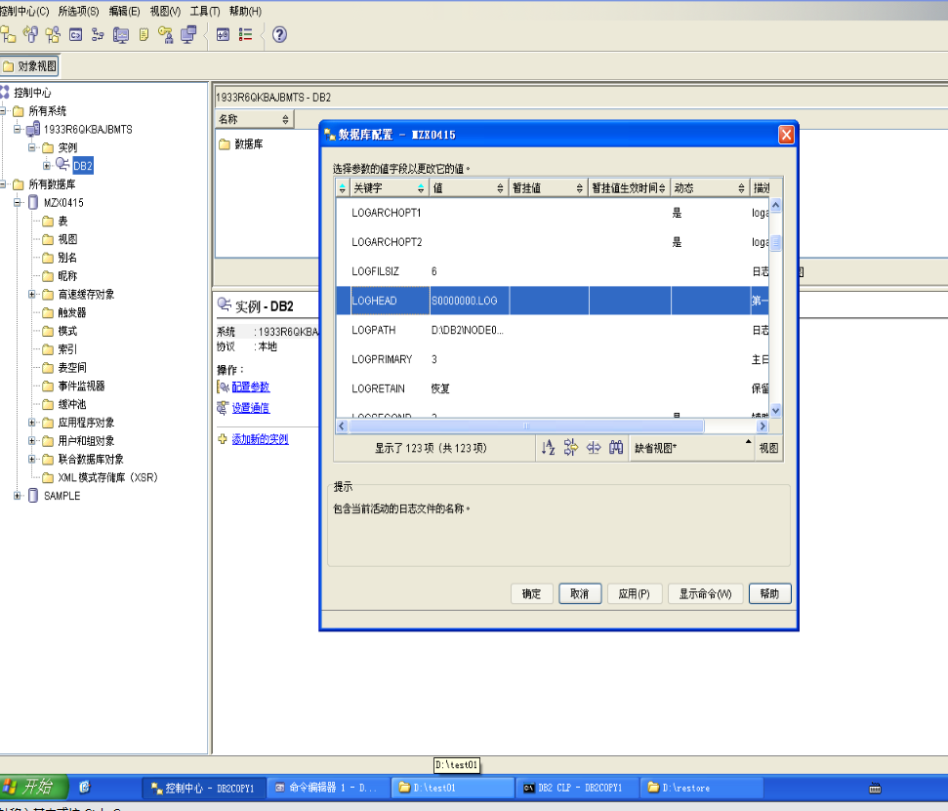
The value for first active log file is S0000000.LOG. This will be the file used to
support logging for the next application.

12. Restore your backup.
Show your work below by printing screen.
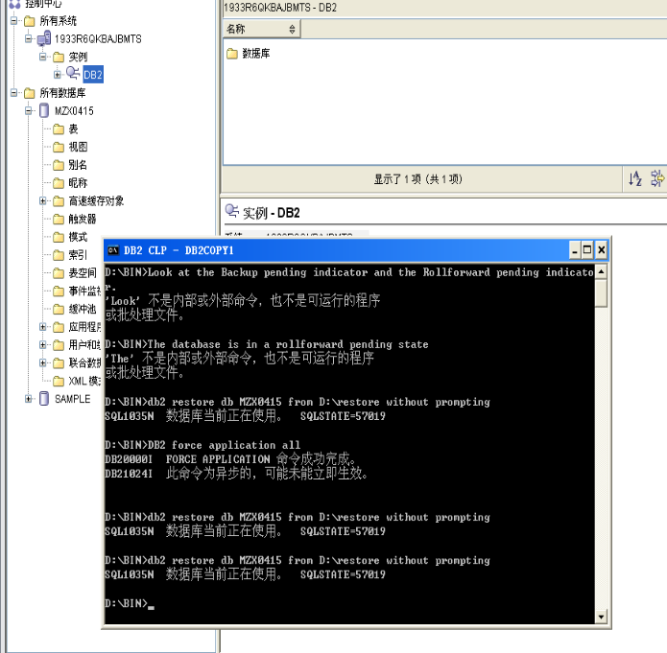

13. Did the restore fail?
If Section 2 was completed before Section 3, then the from directory contains
more than one backup image for the database and this command would have failed.
Since no explicit taken at timestamp was provided, all backups for the database are
candidates.

14. If the directory containing the backup image you wish to restore contains other images for the same database alias, you must specify which image to use with the TAKEN AT option on the restore command. If the previous restore failed, issue the restore command indicating which backup you wish to be restored via the TAKEN AT option.
Show your work below by printing screen.

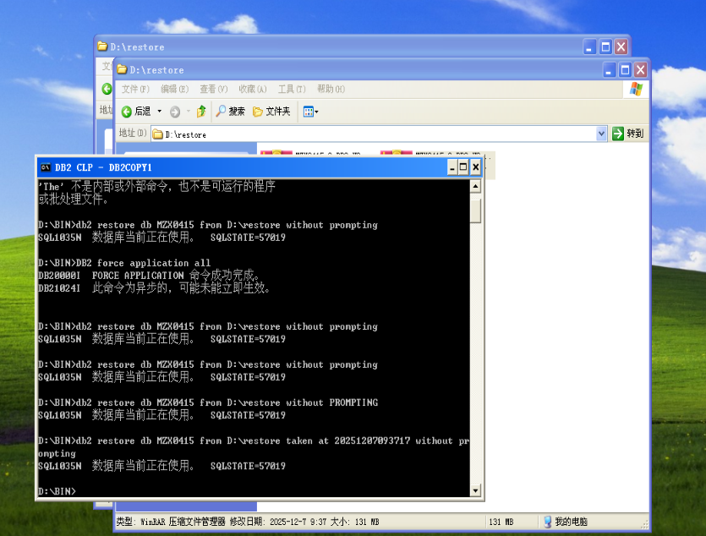

15. Earlier in this lab, you attempted to connect to the database when it was in a backup pending status. You received a message during the connect to indicate this status. There is another method to determine the state of the database. Examine the db cfg again. Check the Recovery Status values.
Show your work below by printing screen.
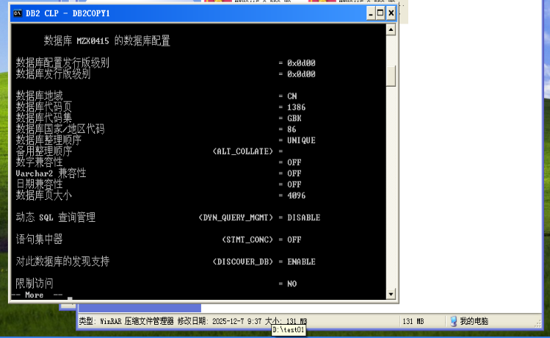

16. Is the database in any pending state?
Look at the Backup pending indicator and the Rollforward pending indicator.
The database is in a rollforward pending state
Look at the Backup pending indicator and the Rollforward pending indicator.
The database is in a rollforward pending state

17. This state will occur if a restore is done to an online backup or a restore is done to an offline backup without specifying the WITHOUT ROLLING FORWARD phrase.
Show your work below by printing screen.
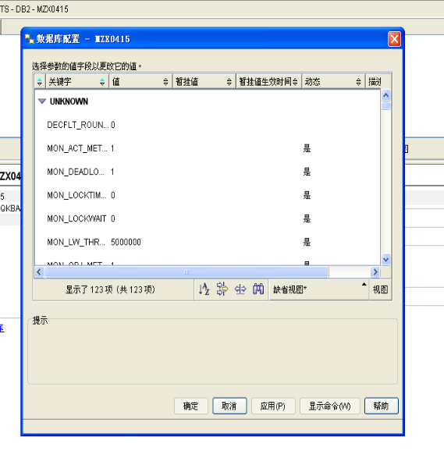
18. Check the db cfg again to see if the Rollforward pending status was removed. Was it?
Show your work below by printing screen and answer the question.
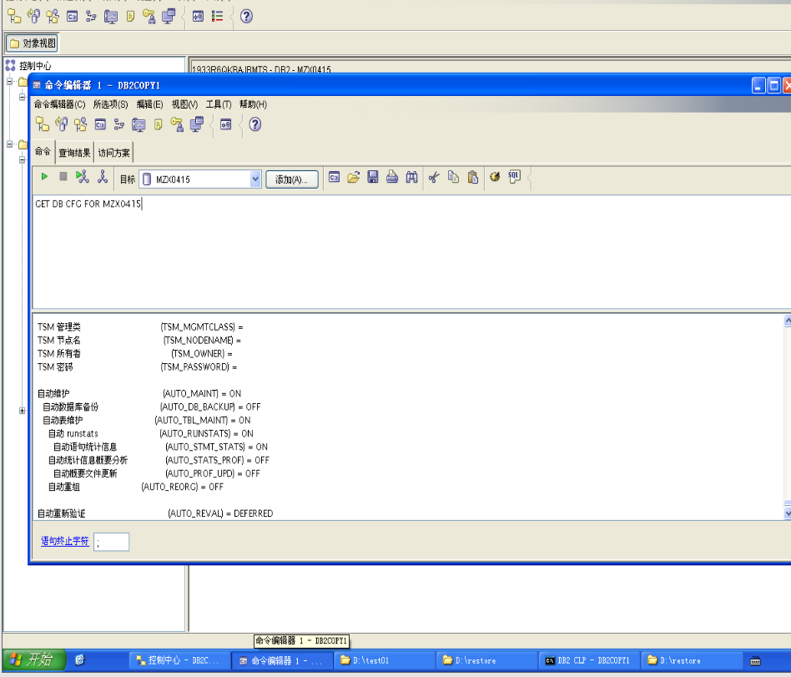

19. Connect to MUSICDB database.
Check the contents of the row you updated earlier (ARTNO 77).
Show your work below by printing screen.
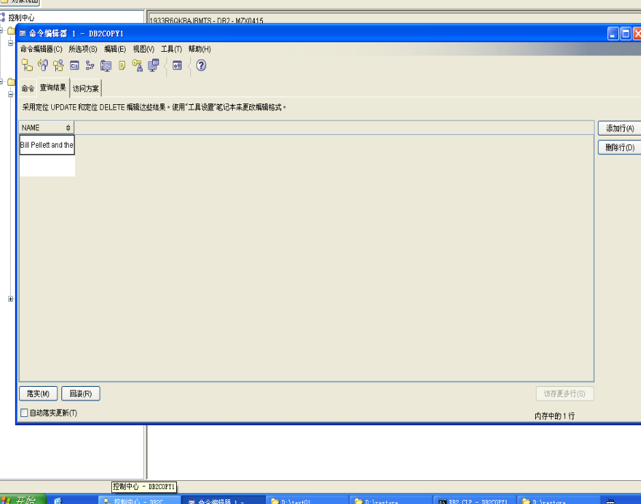

20. What is the value of the name returned? Why?
Melanie and the Mechanics is the name returned. This value corresponds to the
name that was present at the point in time provided during the roll forward process.
The logs were applied up to this point and no further. The log records associated
with the Bill Pellett and the Comets update were never applied.

21. Even though the database manager is configured for roll forward recovery, you are not required to apply log records.
Restore the database backup and indicate that you do not want to roll forward.
Show your work below by printing screen.
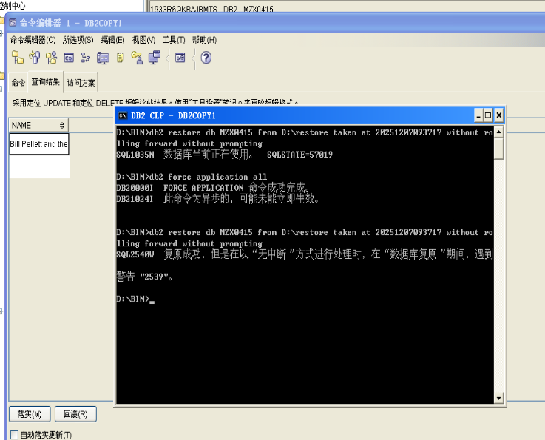

22. Check the pending status of your database by looking at the db cfg.
Is the database in any pending state? Did the value returned to you match what you expected?
Show your work below by printing screen.
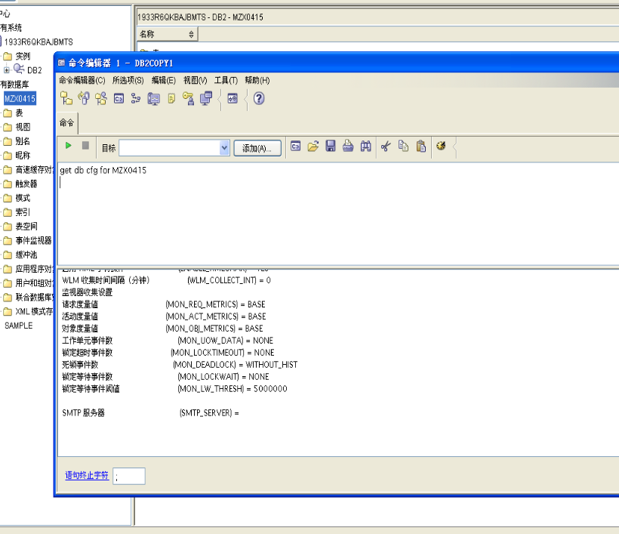

23. Connect to MUSICDB database.
Issue a SELECT statement against the artists row that was previously updated (ARTNO 77).
Did the value returned to you match what you expected?
Show your work below by printing screen and answer the question.
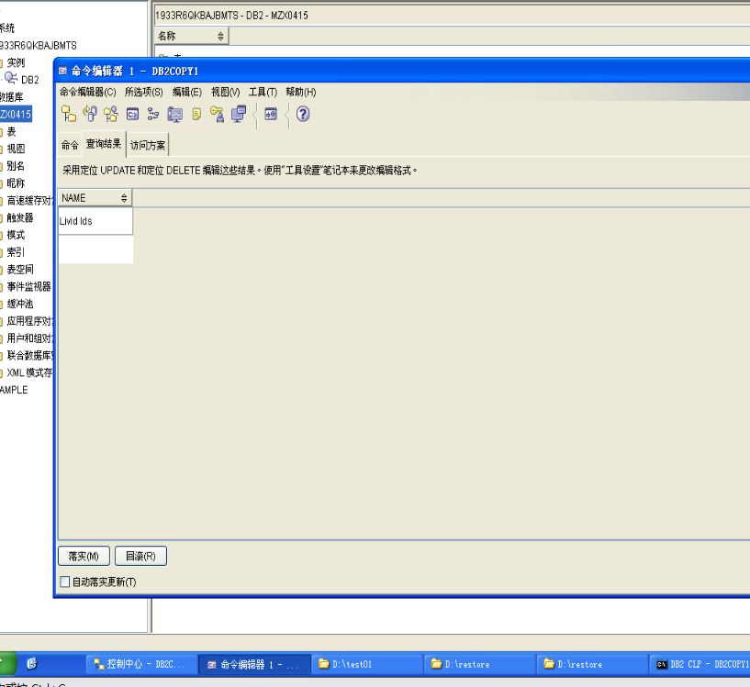

Section 4 - Resetting the Environment
1. Execute the cleanup script clrec.
Show your work below by printing screen.
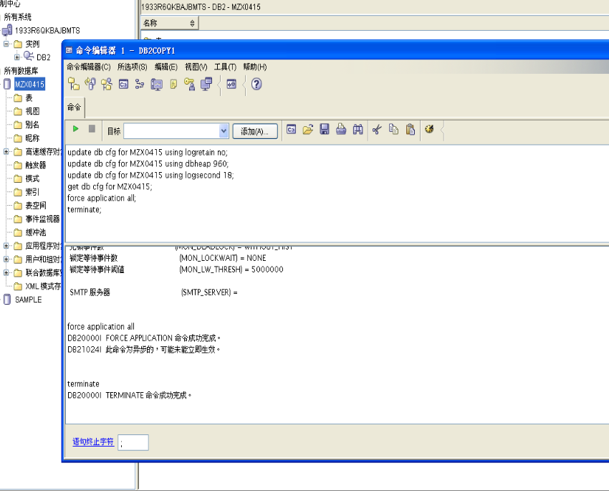

2. Examine your db cfg and verify that your database is now configured for circular logging.
Show your work below by printing screen.
