National Technical University of Ukraine
“Igor Sikorsky Kyiv Polytechnic Institute”
Faculty of Program Systems and Applied Mathematics
Department of Computer Systems Software
Practical 12 Report
The Short-Time Fourier Transform (STFT) & Spectrograms
Course: Harmonic Analysis and Elements of Operational Calculus
Student | Xiaodi Wang
Group | KP-44i
Program | BSc in Software Engineering
University | NTUU KPI
Kyiv, 2026

1. Introduction
This practical work studies the Short-Time Fourier Transform (STFT) and spectrograms. The purpose is to visualize how the STFT represents a non-stationary signal in both time and frequency. Unlike the standard Fourier Transform, which describes the global frequency content of a full signal, the STFT applies a windowed Fourier Transform to short overlapping segments. This allows frequency content to be tracked over time, but it also introduces a fixed time-frequency resolution trade-off.
The practical tasks are: generating a test signal with two different frequency regions, computing the full-signal FFT, computing STFT spectrograms with different window lengths, and explaining the time-frequency trade-off.
Task | Purpose | Main output
Task 1 | Generate a signal with 5 Hz first half and 50 Hz second half. | Time-domain signal plot
Task 2 | Compute standard FFT of the complete signal. | Global frequency spectrum
Task 3 | Compute STFT with long and short windows. | Spectrogram comparison
Task 4 | Analyze the time-frequency trade-off. | Resolution summary table

2. Task 1 — Generate Test Signal
The test signal was constructed with a sampling frequency of 500 Hz and total duration of 2 seconds. The first half contains a 5 Hz sinusoid, while the second half contains a 50 Hz sinusoid. This design creates a deliberately non-stationary signal: the frequency content changes at t = 1 s.
Fs = 500
T = 2
t = np.linspace(0, T, int(Fs*T), endpoint=False)
signal_test = np.zeros_like(t)
signal_test[:len(t)//2] = np.sin(2*np.pi*5*t[:len(t)//2])
signal_test[len(t)//2:] = np.sin(2*np.pi*50*t[len(t)//2:])
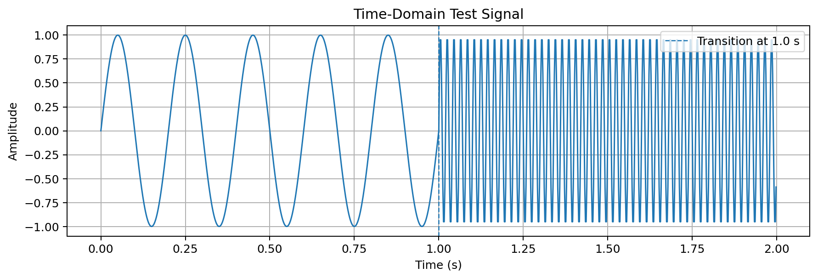
Figure 1. Time-domain test signal with low-frequency and high-frequency regions.
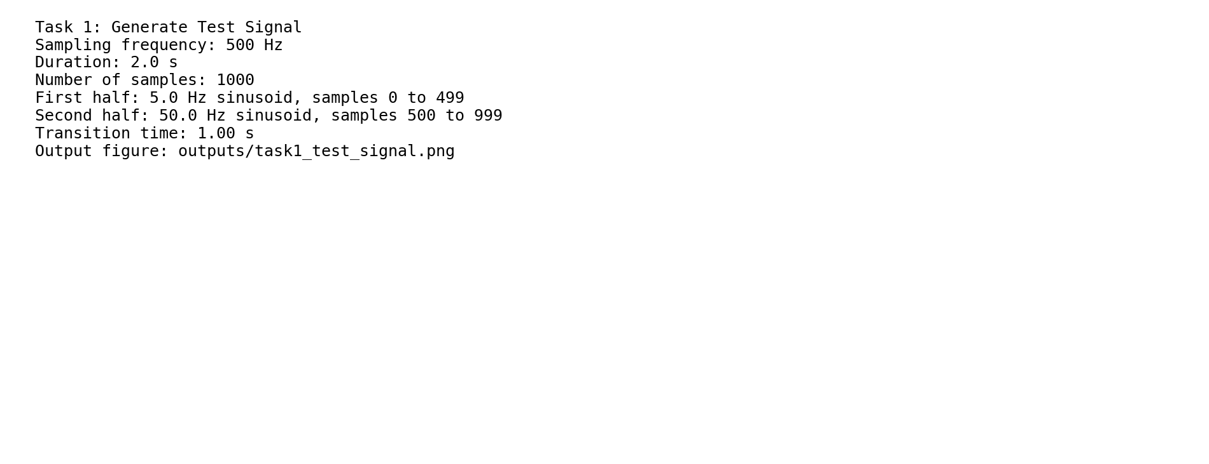
Figure 2. Task 1 console output.
Observation: the first half has slow oscillations because the frequency is only 5 Hz. The second half contains much denser oscillations because the frequency increases to 50 Hz. This makes the signal suitable for demonstrating why ordinary FFT is insufficient for non-stationary data.

3. Task 2 — Standard FFT of the Full Signal
The standard FFT was applied to the complete signal. The FFT converts the whole time-domain signal into a frequency-domain spectrum, but it treats the signal as one complete block. Therefore, it can identify that 5 Hz and 50 Hz components exist, but it cannot specify when they occur.
N = len(signal_test)
freqs = fftfreq(N, 1/Fs)
S = fft(signal_test)
plt.plot(freqs[:N//2], np.abs(S)[:N//2])
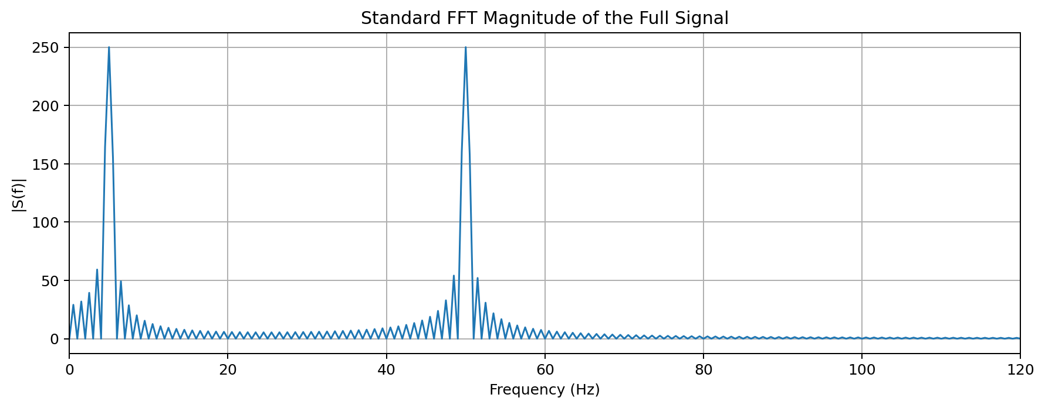
Figure 3. Standard FFT magnitude of the full signal.
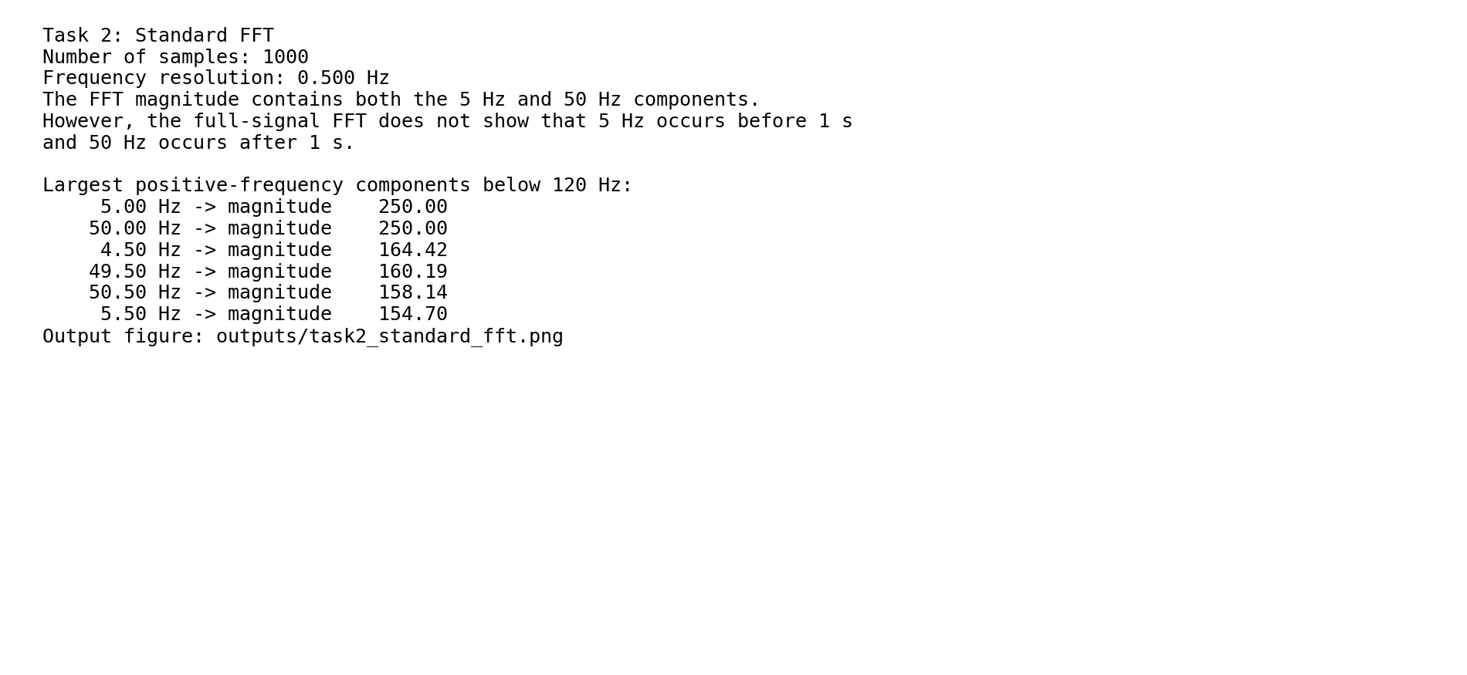
Figure 4. Task 2 console output.
Observation: the magnitude spectrum clearly shows frequency components around 5 Hz and 50 Hz. However, the FFT gives no direct information about the time interval in which each frequency appears. For this reason, a time-frequency method is required.

4. Task 3 — Compute STFT with Long and Short Windows
The STFT divides the signal into overlapping windows and computes a Fourier Transform for each window. In this practical work, two Hann windows were compared: a long window of 256 samples and a short window of 32 samples. The long window provides better frequency resolution, while the short window provides better time localization.
window_lengths = [256, 32]
for win_len in window_lengths:
f, t_stft, Zxx = stft(
signal_test,
fs=Fs,
window='hann',
nperseg=win_len,
noverlap=win_len//2
)
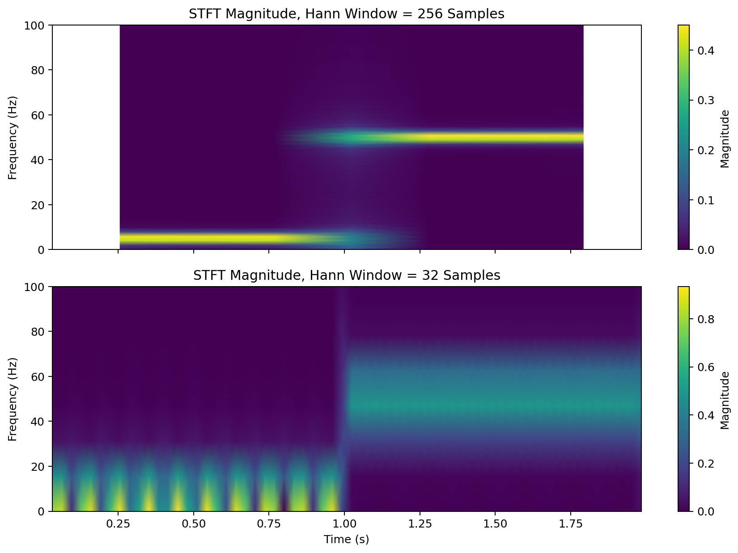
Figure 5. STFT magnitude comparison using 256-sample and 32-sample Hann windows.
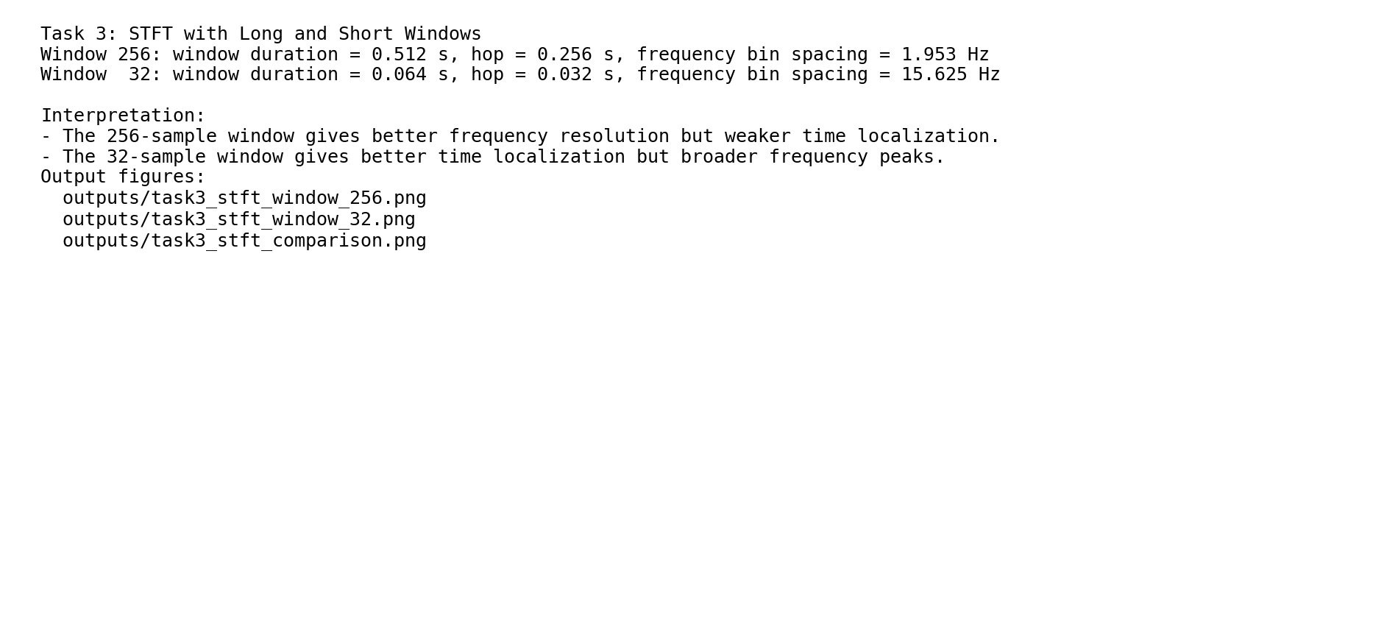
Figure 6. Task 3 console output.
Observation: with the 256-sample window, the frequency bands are narrow and easier to distinguish, but the transition around 1 s is less sharply localized. With the 32-sample window, the transition is localized more clearly in time, but the frequency peaks become wider and less precise.

5. Task 4 — Time-Frequency Trade-Off Analysis
The STFT uses a fixed window length, so its time and frequency resolution are linked. A longer window contains more signal samples and therefore estimates frequency more accurately. However, because it covers a wider time interval, it blurs short-time events. A shorter window reacts faster to time changes but contains fewer samples, so its frequency estimate is less precise.
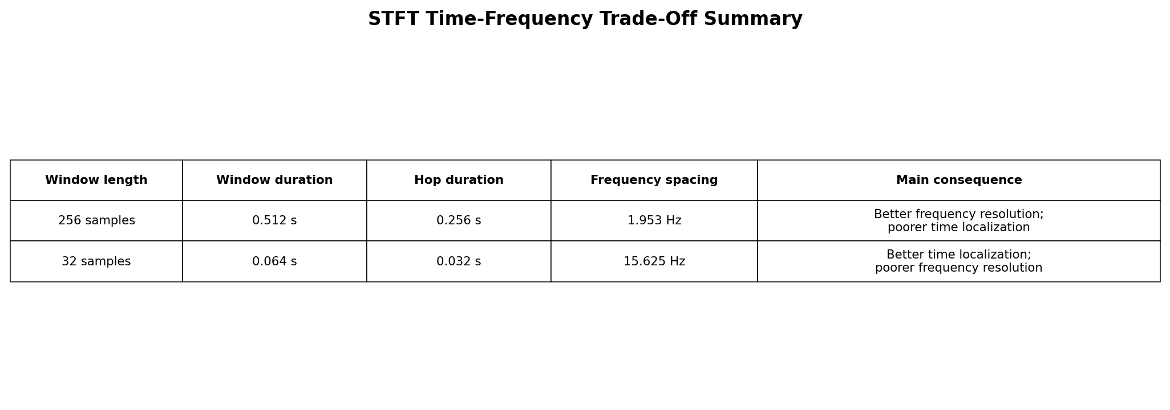
Figure 7. Quantitative summary of the STFT time-frequency trade-off.
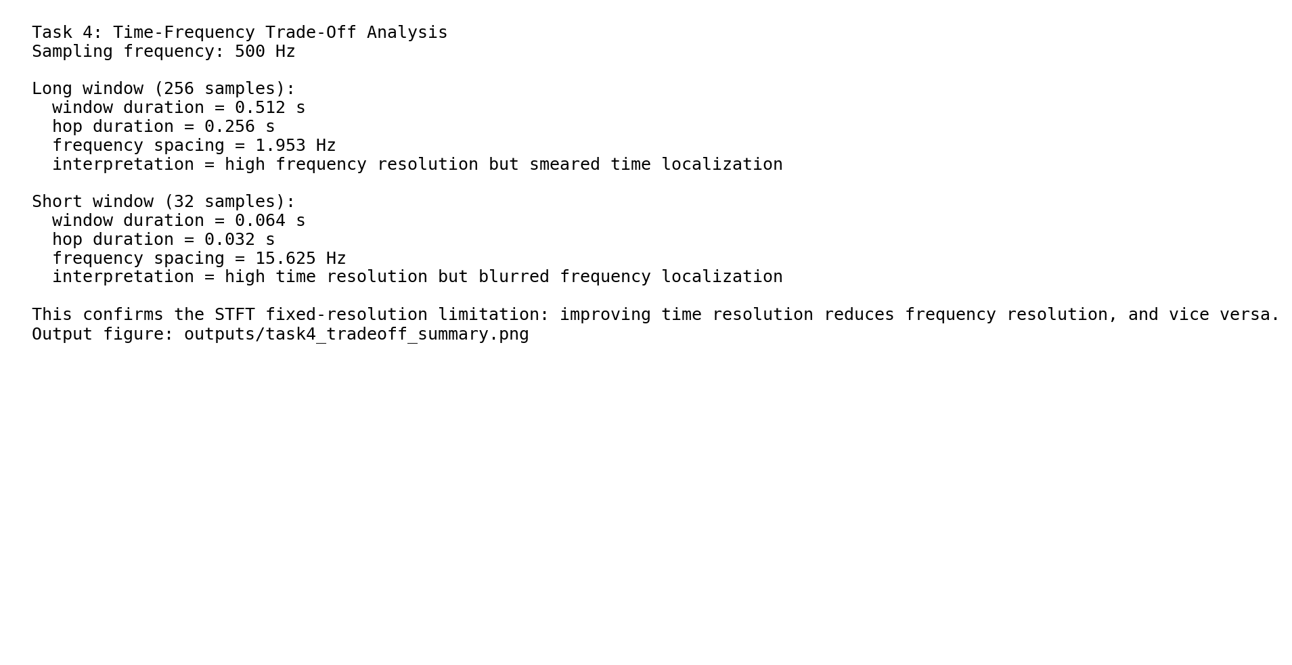
Figure 8. Task 4 console output.
Window | Duration Δt | Frequency spacing Δf | Interpretation
256 samples | 0.512 s | 1.953 Hz | Good frequency resolution, weaker time localization
32 samples | 0.064 s | 15.625 Hz | Good time localization, weaker frequency resolution
The practical result agrees with the signal-processing uncertainty principle: improving time resolution reduces frequency resolution, and improving frequency resolution reduces time resolution. In simplified form, the relationship can be written as Δt · Δf ≳ 1. This is the main limitation of fixed-window STFT.

6. Conclusion
This practical work demonstrated the difference between standard FFT and STFT for a non-stationary signal. The standard FFT successfully detected the 5 Hz and 50 Hz components, but it could not identify when each component occurred. The STFT solved this problem by adding time localization through windowed Fourier analysis.
The experiments also confirmed the fixed-resolution limitation of STFT. A long window produced better frequency resolution but smeared the time transition. A short window localized the frequency change more accurately in time but broadened the frequency peaks. Therefore, the choice of window length is a critical design decision in speech processing, biomedical signal analysis, seismic processing, and audio event detection.
The main engineering conclusion is that STFT is suitable for signals whose frequency content changes over time, but it cannot simultaneously provide arbitrarily high time and frequency precision. For signals requiring adaptive resolution, wavelet transform can be considered as an alternative method.

Appendix A — VS Code on macOS Run Commands
Open the package folder in VS Code, then run the following commands in the integrated terminal:
cd /path/to/Practical12_Xiaodi_Wang_package
python3 -m venv .venv
source .venv/bin/activate
python3 -m pip install --upgrade pip
python3 -m pip install -r requirements.txt
python3 task1_generate_test_signal.py
python3 task2_standard_fft.py
python3 task3_compute_stft.py
python3 task4_time_frequency_tradeoff_analysis.py
For screenshots, capture the terminal output after each command and the generated PNG files in the outputs folder.

Appendix B — Code File Structure
common_stft_utils.py
task1_generate_test_signal.py
task2_standard_fft.py
task3_compute_stft.py
task4_time_frequency_tradeoff_analysis.py
requirements.txt

