**EasyAdapt (EA) – fully supervised**

* EA operates in an augmented space for a pair of source and target domain.
* Source and target features are transformed using feature maps and the augmented feature space. The supervised classifier being used to learn in the augmented space.
* For k domains, the augmented space blows up to R(k+1)d
* For prediction on target data, applying (hc + ht) on x.

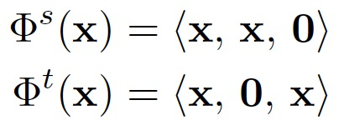

**Problem of EA:** Do not make use of unlabeled target data.

**EA++: Easy Adapt with unlabeled data – both fully supervised and semi-supervised**

The source hypothesis (ws) and target hypothesis (wt) are made to agree on unlabeled data.

EA++ leverages the unlabeled data to improve the performance of EA.

