DAT 201 Final Project Log
Xiaohong Chen

Download .shp file about school districts data from www.pasda.psu.edu
Go to ftp://ftp.pasda.psu.edu/pub/pasda/padot/boundary_layers/historic/PaSchoolDistricts/ and find what you need.
Download PaSchoolDistricts2019_05.zip

Import .shp file into postgresql
Open Terminal (Ctrl + Alt + T)
Type shp2pgsql -c PaSchoolDistricts2019_05.shp | psql -d dat201

Download percent advanced mathematics/Algebra 1 data
Download Future Ready Performance Data for SY 2018-2019
URL:https://futurereadypa.org/Home/DataFiles

Convert Datafile_20182019.xlsx into .csv file and filter the value of Percent Advanced Mathematics/Algebra 1
1. Filter the value of Percent Advanced Mathematics/Algebra 1
2. Convert the type of value column from text into num → Click data → text to columns
3. Save as advanced_Mathematics.csv
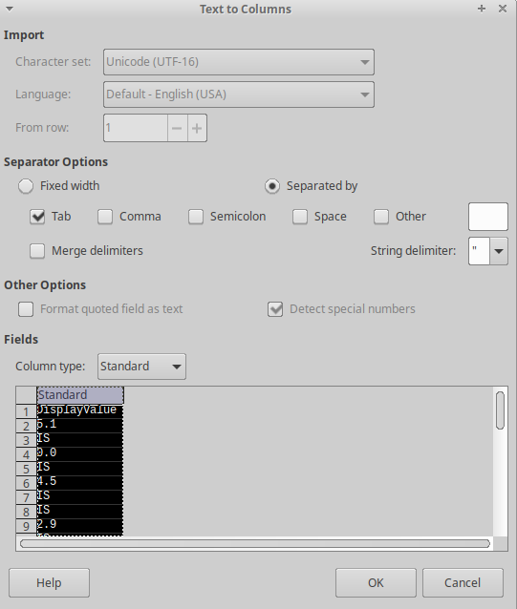

Import advanced_Mathematics.csv file into PostgreSQL
Open Terminal → psql -d dat201 →type:
CREATE TABLE public.advancedMath
(
amid integer NOT NULL DEFAULT nextval('educationdataid_seq'),
districtname text,
schoolname text,
aun text,
schl text,
dataelement text,
value numeric,
CONSTRAINT ampk PRIMARY KEY (amid)
)
\copy advancedMath (districtname, schoolname, aun, schl, dataelement, value) FROM '/home/cogconnect2/Desktop/DAT_201_FinalProject/Data/advanced_Mathematics.csv' WITH (FORMAT CSV, DELIMITER ',', HEADER TRUE);

Download income data from AMERICAN FactFinder
URL: https://factfinder.census.gov/faces/tableservices/jsf/pages/productview.xhtml?pid=ACS_17_5YR_S1902&prodType=table
Download: MEAN INCOME IN THE PAST 12 MONTHS (IN 2017 INFLATION-ADJUSTED DOLLARS)

Filter the value of Mean income(dollar)
Save as ave_Income.csv file
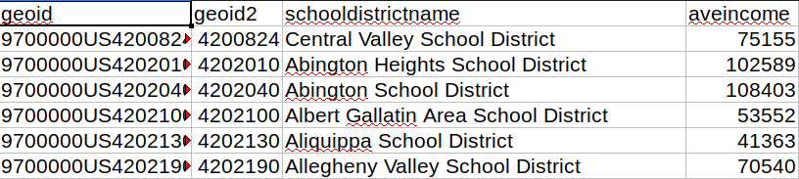

Import ave_Income.csv into PostgreSQL
Open Terminal → psql -d dat201 →type:
CREATE TABLE aveIncome
AS (SELECT aun, avg(incomevalue) from assemble group by aun
)

CREATE SEQUENCE IF NOT EXISTS aveincome_seq
START WITH 1
INCREMENT BY 1
MINVALUE 1
NO MAXVALUE
CACHE 1;

CREATE TABLE public.aveIncome
(
aiid integer NOT NULL DEFAULT nextval('aveincome_seq'),
geoid text,
geoid2 integer,
schooldistrictname text,
aveincome numeric,
CONSTRAINT aipk PRIMARY KEY (aiid)
);

\copy aveIncome (geoid, geoid2, schooldistrictname, aveincome) FROM '/home/cogconnect2/Desktop/DAT_201_FinalProject/Data/ave_Income.csv' WITH (FORMAT CSV, DELIMITER ',', HEADER TRUE);

Create aveMathScore table in Postgresql
CREATE TABLE aveMathScore
AS (Select districtname, aun, avg(value) as avemathpoint from advancedMath where dataelement ='Percent Advanced Mathematics/Algebra 1 (All Student)' group by aun, districtname
);

ALTER TABLE aveMathScore ADD COLUMN amsid SERIAL PRIMARY KEY;

Create assemble table including avemath and aveincome in Postgresql
CREATE TABLE assemble
AS (SELECT aveMathScore.districtname, aveMathScore.aun, aveMathScore.avemathpoint, aveIncome.aveincome FROM aveMathScore INNER JOIN aveIncome on aveMathScore.districtname = aveIncome.schooldistrictname
);

ALTER TABLE assemble ADD COLUMN asseid SERIAL PRIMARY KEY

Connect Qgis to Postgresql
Open qgis → Click Layer →Data Source Manager →PostgreSQL → New → PostGIS

Add assemble date and shape file into QGIS

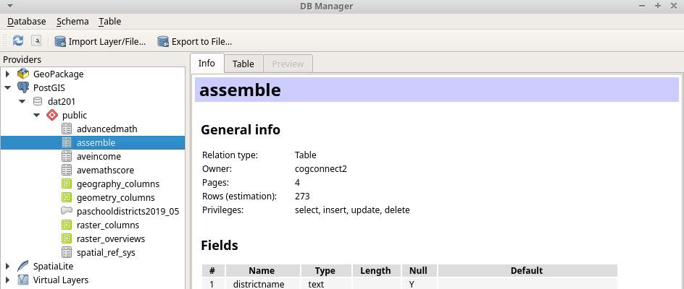

Do joins in QGIS to connect assemble data to shape file data

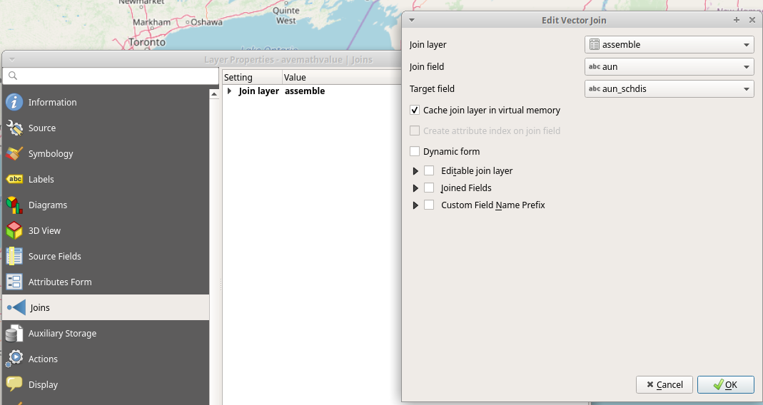

Create circles to represent the value of mean scope of mathematics
Vector → Geometry tools → Centroids → run → double click avemathcircle layer → Symbology → Size → assemble_avemathpoint → assistant → update button → OK

Styling aveincome by choosing different color
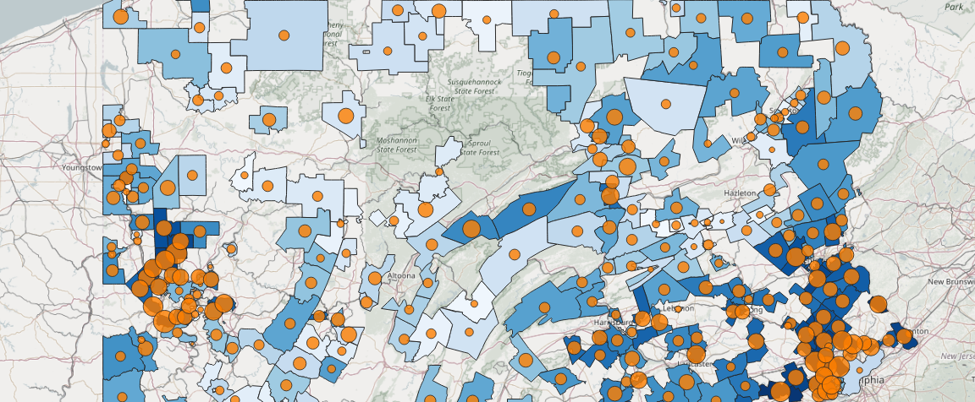
Layer Sytling → Categorized → Column: assemble_aveincome →Color ramp: blues →Classify-Apply

