<https://forms.gle/NPxuuyq4U5n2xFXL7>

**Citizen Feedback Enhancer User Experience**

**We appreciate you using Citizen Feedback Enhancer and would like to get your experience and feedback through this questionnaire. The Citizen Feeback Enhancer is a tool that allows the user to analyze public opinion on a given regulation based on feedback provided to the EU through a chat function.**

**The link to this web app is <https://eufeedback-enhancer.netlify.app/>  
The given questionnaire may take up to five minutes. If you have any questions regarding the survey, please ask Xiaohui Wu at xiaohui.wu@uzh.ch**

**Please state your age**

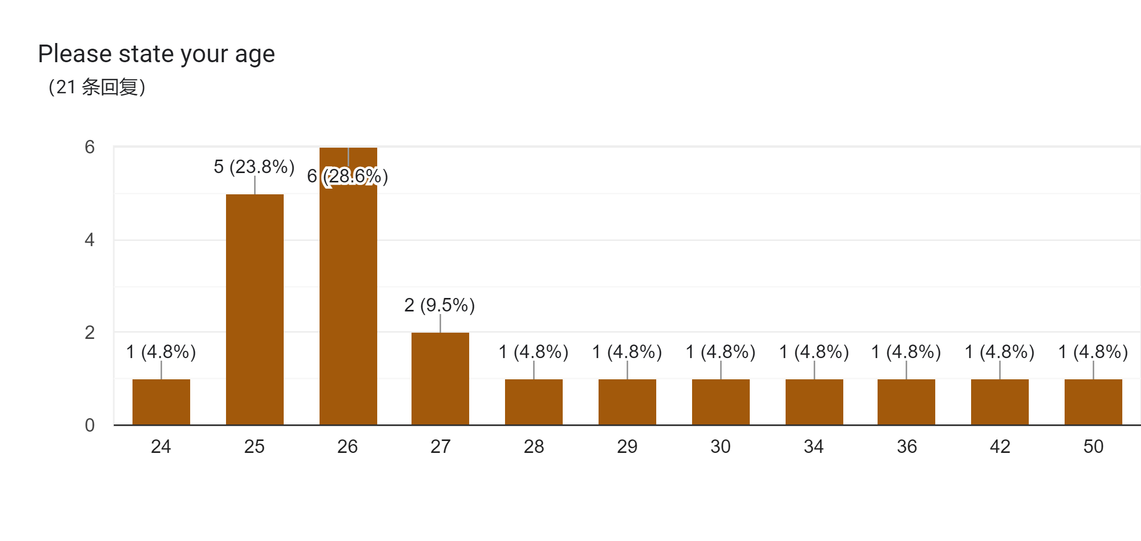

**Please state your highest degree**

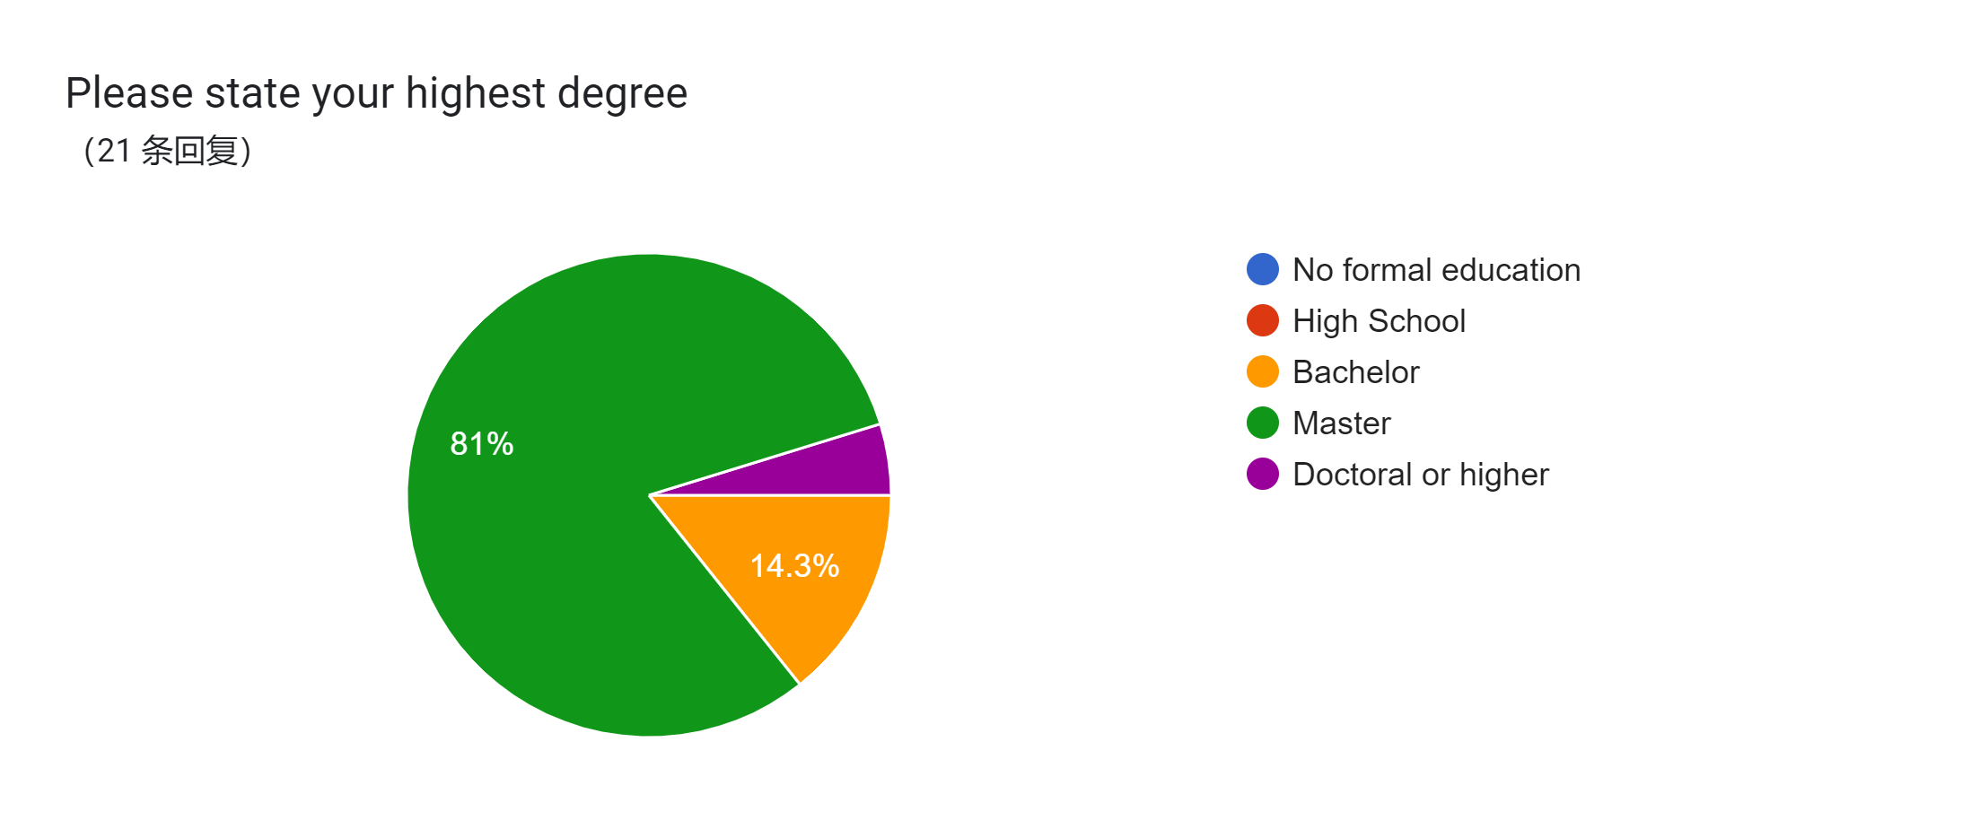

**What is your profession?**

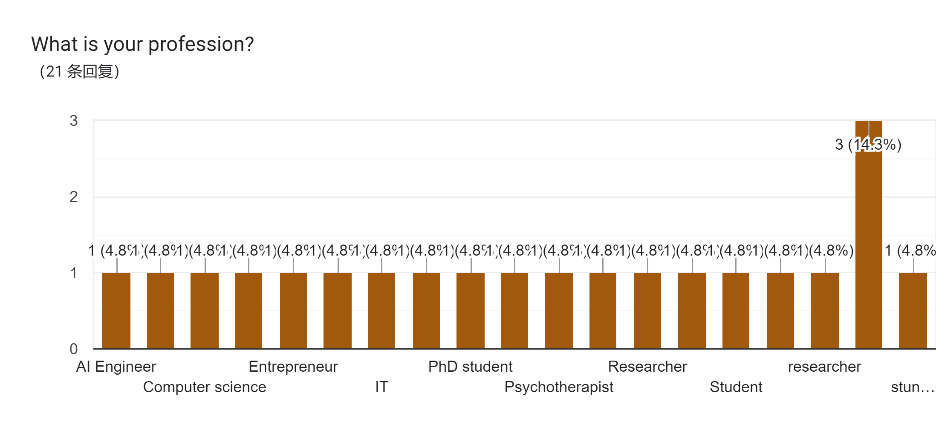

**Please rate the features of the Citizen Feedback Enhancer**

|  |  |  |  |  |  |
| --- | --- | --- | --- | --- | --- |
|  | **Strongly disagree** | **Disagree** | **Neutral** | **Agree** | **Strongly agree** |
| I think that I would like to use this system frequently. |  |  |  |  |  |
| I found the system unnecessarily complex. |  |  |  |  |  |
| I thought the system was easy to use. |  |  |  |  |  |
| I think that I would need the support of a technical person to be able to use this system. |  |  |  |  |  |
| I found the various functions in this system were well integrated. |  |  |  |  |  |
| I thought there was too much inconsistency in this system. |  |  |  |  |  |
| I would imagine that most people would learn to use this system very quickly. |  |  |  |  |  |
| I found the system very cumbersome to use. |  |  |  |  |  |
| I felt very confident using the system. |  |  |  |  |  |
| I needed to learn a lot of things before I could get going with this system. |  |  |  |  |  |

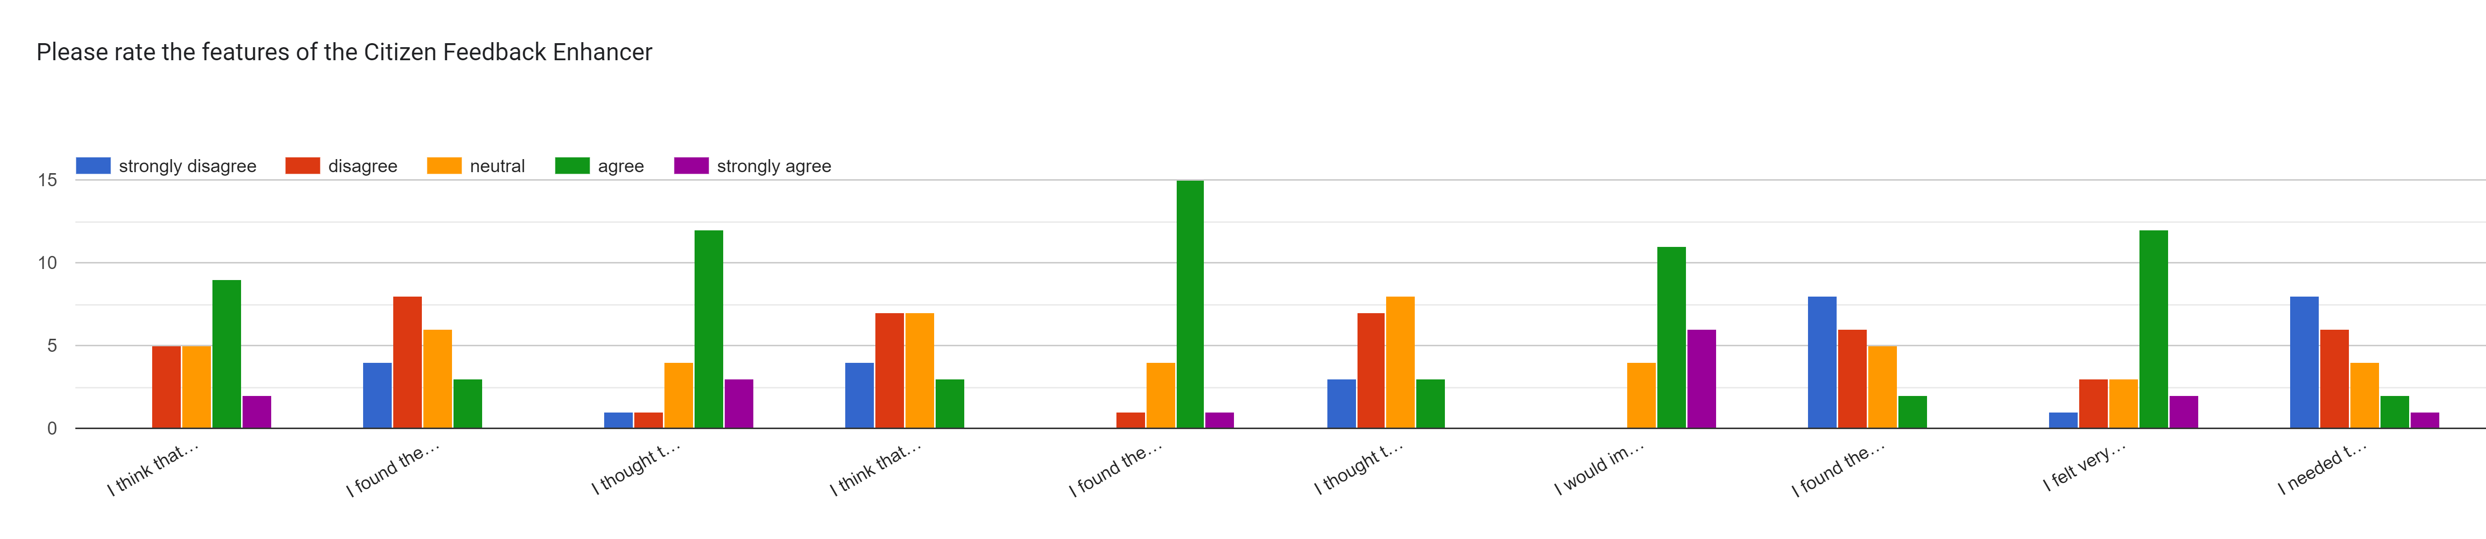

**What is your favorite feature of Citizen Feedback Enhancer? Why？**

Visualizing the context from which the response has been generated

search function

the wide range of political topics you can ask that are relevant.

My favorite feature is its professionalism and relevance. It is related to the EU laws and initiatives.

quickly identifying opinions on EU legislations

It takes little space as an app.

It covers many different topics. The various topics make it useful for different people.

I like how it refernces the sources on the right. Maybe it could highlight the sources a bit more clearly (reference from one sentence to a specific source)

(1) clear UI-design of chatbot (2) I can use the keyword search and get summarization. (3) The chatbot provides clear and accurate answers.

I appreciate that the system provides the sources it relies on to answer my questions, as it adds support to the response. It also shows the three measures of confidence for the answer, which is helpful.

It show you the information source. Because in this case, I can trust your system.

All of them

The sources are listed for the answer generation.

Easy to understand

Topics selection, it helps to find the answers more accurately

I like showing the source feature because I can see where the answer came from.

The adjustable parameters look interesting. You can set the topic to improve the accuracy of the answer.

adjustable parameters

Voice out put system

I can extract some policies and ideas from the areas I am interested in.

I liked that it provided sources.

**Which function of Citizen Feedback Enhancer do you think is unnecessary? Why?**

Having the ability to tweak technical parameters such as Model, # of sources and type of search

none

to list the sources of info, as they are quite important

-

the relevancy and alignment scores on the left are a nice idea, but as they are very intransparent I would not rely on them

Not quite sure, everything is okey at this moment.

I haven't found an unnecessary function.

I do not really get the scores on the right? Is the system rating its own answer?

No

I assume the audience using this system isn’t made up of experts who know the differences between the models available. So, it would be best to use the top model for the system and remove the model selection option from the settings.

The search type is unnecessary. The normal user will not know how to choose this one.

Nothing

The rating is not clearly explained. Why it rates four for relevance or alignment?

Too many difficult words

Model type selection, as a user, I don't care which you are using as long as it works.

the chat, it seems need to wait a little bit time for the response.

Each feature is interesting on its own, but the combination might need some explanation or guidance.

not sure

Starred columns

No idea at the moment

Nothing specific

**Do you experience any problems during use?**

No

Selecting a different (higher or lower than default) number of sources in the settings is not reflected in the sources shown by the side of the bot response

can't step back

not really. just sometimes the paragraph is too long

I should wait the answer for several times.

you need to press the button and can not simply hit enter (small remark); sources do not link to the primary source, so there is still no way to cross-check informatino

Not yet.

No.

I did not have any problems.

I am confused by the three relevance scores on the right. I don't know where the score comes from.

Not yet

Not optimized for mobile

The chatbot's reply is just toooo long. No one wants to read such a long paragraph. The mobile experience is not optimized.

lack information for some specific case for example information about scientific funding.

no

Cannot start a new conversation or return, you can only refresh.

feel hard to think question

No

When reading the answers, I felt that the spacing between the words was inconsistent, and the reading experience was average.

**What additional features would you like to see in future versions of the web app to improve the overall efficiency of feedback analysis?**

Additional filtering params (e.g. date, country, etc.)

improve the response speed

follow-up question

I hope to continuously output results as if it were typing.

links to primary sources; nicer UI for better UX; bullet points instead of text

No idea.

I have no ideas.

I do not know about EU law and regulations, so it would be good to have a section that explains the state of things right now and then have a section with the citizen feedback on this issue. I for example asked about how voting works in the EU and got some feedback explaining what some people think about it without knowing how it works.

(1) When I submit my question, I hope it occurs on the top of the conversation container rather than on the button. (2) Optimize the "More functions are here" design. The keyword search and chatbot are two essential parts of the application. If we position the keyword search in the top right collapse space, users may overlook it. Moreover, when users want to try different configurations (e.g., model type...), they need to expand and collapse multiple times.

Maybe add an info icon for the “more functions are here” section to explain the features a bit, improving the user experience (UX). For example, some people might not know what “id” means. Also, try to integrate all the features on one page in a more convenient way so that people can easily understand and follow.

Although it show you the information source, there is no hyperlink. User need to check the relevant documents by themselves, which is inconvenient.

More hints

The response of chatbot need to be more well structured. Not only a summary of sources, but also topic sentences, highlights, short but concise phrases instead of a long paragraph.

Make it simpler and easy to understand

Provide more concise and specific answers to the questions directly.

I think it would save time if the answers could be streamed out, like popular Chatbot does.

For UI, the more function in the upper left corner can be replaced by some buttons or patterns, which will have a better visual effect. For functions, the source box and id search seem to have some relevance, but for me, their intentions are not well understood at first use.

this app seems to design for professionals in policy areas, but I suggest to make answer look more organized, such as list each points or highlight important part.

Customer service

I hope the developers can add some analytical data graphics so that the results can be seen more intuitively.

I would like to see links to the documents.