**CS 6314.001– Practice Work 1**

**Due date:**  January 24, 2019, 11:59PM

Create below page layout by HTML/HTML5, CSS and optionally Bootstrap.

If you choose to include Bootstrap, use BootstrapCDN.

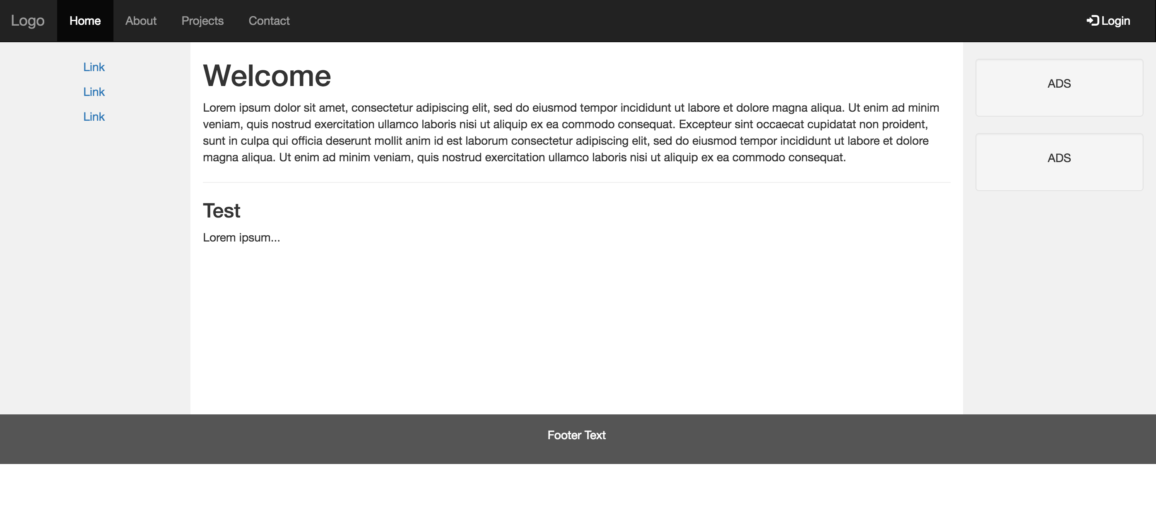

In the header section, you will have “Home”, “Cities” and “Contact Us” as menu items. Links on the left panel will be city names (London, Paris, Tokyo).

The links on the left and top menu should take the user to corresponding sections on the same page (there will be one single html page). You can include any proper content for the right panel or leave it empty. Change the background colors for the left and right panels so they become visible on the page.

You can use below text for different city descriptions. Pictures for the cities should be floated to the left so that city descriptions will wrap around the images. You can find image files for cities within img.zip file. Make sure you use relative path for defining source of each image. (i.e. img/london.jpg)

**Cities:**

**London**

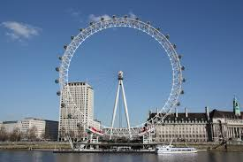London is the capital city of England. It is the most populous city in the United Kingdom, with a metropolitan area of over 13 million inhabitants.

Standing on the River Thames, London has been a major settlement for two millennia, its history going back to it’s founding by the Romans, who named it Londinium.

**Paris**

Paris is the capital and the most populous city of France. It has an area of 105 km² (41 mi²) and a population in 2013 of 2,229,621 within the city limits. Paris was founded in the 3rd century BC by a Celtic people called the Parisii, who gave the city its name. By the 12th century, Paris was the largest city in the western world, a prosperous trading center, and the home of the University of Paris, one of the oldest universities in history. At 17th century is the capital of Europe's major power. In the 18th century, it was the center stage of the French Revolution, and was an important center of finance, commerce, fashion, science, and the arts, a position it still retains today.

**Tokyo**

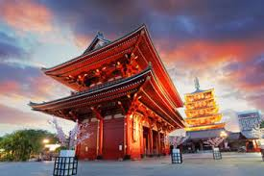

Tokyo, officially Tokyo is one of the 47 prefectures of Japan, and is both the capital and most populous city of Japan. The Greater Tokyo Area is the most populous metropolitan area in the world.