掌握派生类的声明方法和派生类构造函数的定义方法

掌握不同方式下，构造函数与析构函数的执行顺序与构造规则

#include<iostream>

#include<string>

using namespace std;

class MyArray{

public:

MyArray(int length);

~MyArray();

void Input();

void Display(string);

protected:

int \*alist;

int length;

};

MyArray::MyArray(int leng)

{

if(leng<=0)

{

cout<<"error length";

exit(1);

}

alist = new int [length];

length = leng;

if(alist == NULL)

{

cout<<"assign failure";

exit(1);

}

cout<<"MyArray类对象已创建!"<<endl;

}

MyArray::~MyArray()

{

delete [ ] alist;

cout<<"MyArray类对象已撤销!"<<endl;

}

void MyArray::Display(string str)

{

int i;

int \*p=alist;

cout<<str<<length<<"个整数: ";

for(i=0;i<length;i++,p++)

cout<<\*p<<"";

cout<<endl;

}

void MyArray::Input()

{

cout<<"请从键盘输入"<<length<<"个整数:";

int i;

int \*p=alist;

for(i=0;i<length;i++,p++)

cin>>\*p;

}

int main()

{

MyArray a(5);

a.Input();

a.Display("显示已经输入的");

return 0;

}

声明一个SortArray继承类MyArray，在该类中定义一个函数，具有将输入的整数从小到大进行排序的功能

#include<iostream>

#include<string>

using namespace std;

class MyArray{

public:

MyArray(int length);

~MyArray();

void Input();

void Display(string);

protected:

int \*alist;

int length;

};

MyArray::MyArray(int leng)

{

if(leng<=0)

{

cout<<"error length";

exit(1);

}

alist = new int [length];

length = leng;

if(alist == NULL)

{ cout<<"assign failure";

exit(1);

}

cout<<"MyArray类对象已创建!"<<endl;

}

MyArray::~MyArray()

{

delete [ ] alist;

cout<<"MyArray类对象已撤销!"<<endl;

}

void MyArray::Display(string str)

{

int i;

int \*p=alist;

cout<<str<<length<<"个整数: ";

for(i=0;i<length;i++,p++)

cout<<\*p<<"";

cout<<endl;

}

void MyArray::Input()

{

cout<<"请从键盘输入"<<length<<"个整数:";

int i;

int \*p=alist;

for(i=0;i<length;i++,p++)

cin>>\*p;

}

int main()

{

MyArray a(5);

a.Input();

a.Display("显示已经输入的");

return 0;

}

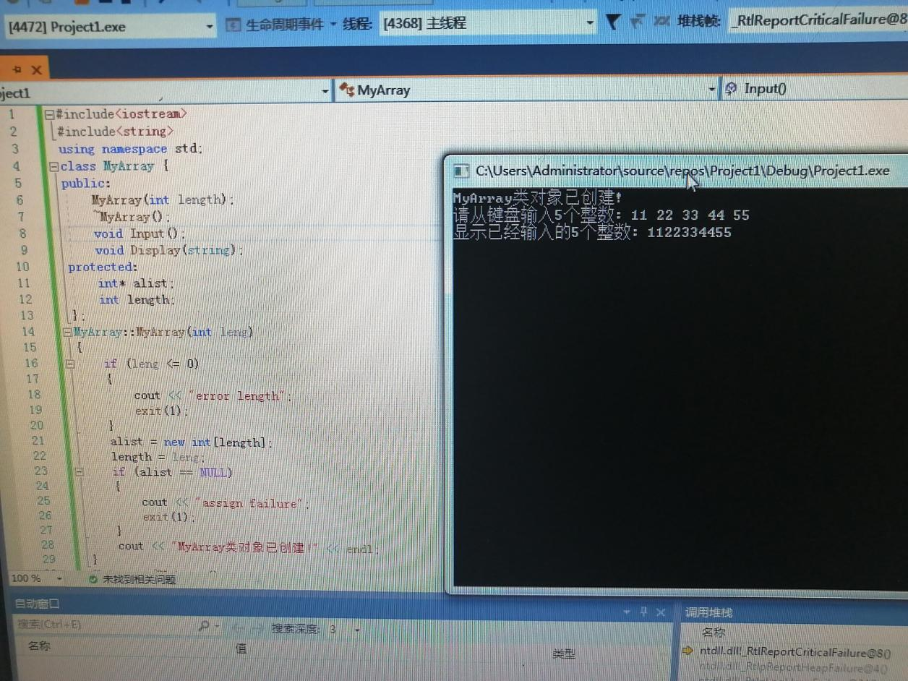

上机心得：继承作用确实好用。

Copyright IMG_2562021-2099 wangzezheng. All rights reserved