源代码：

#include <iostream>

using namespace std;

class Complex

{

public:

Complex(double i = 0, double j = 0)

{

real = i, image = j;

}

void dayin()

{

cout << real << "+i" << image << endl;

}

double real;

double image;

};

Complex operator\*(Complex a, Complex b)

{

Complex temp;

temp.real = a.real \* b.real - a.image \* b.image;

temp.image = a.real \* b.image + a.image \* b.real;

return temp;

}

int main()

{

Complex a(1, 0), b(3, 4), c;

c = a \* b;

c.dayin();

return 0;

}

运行结果：

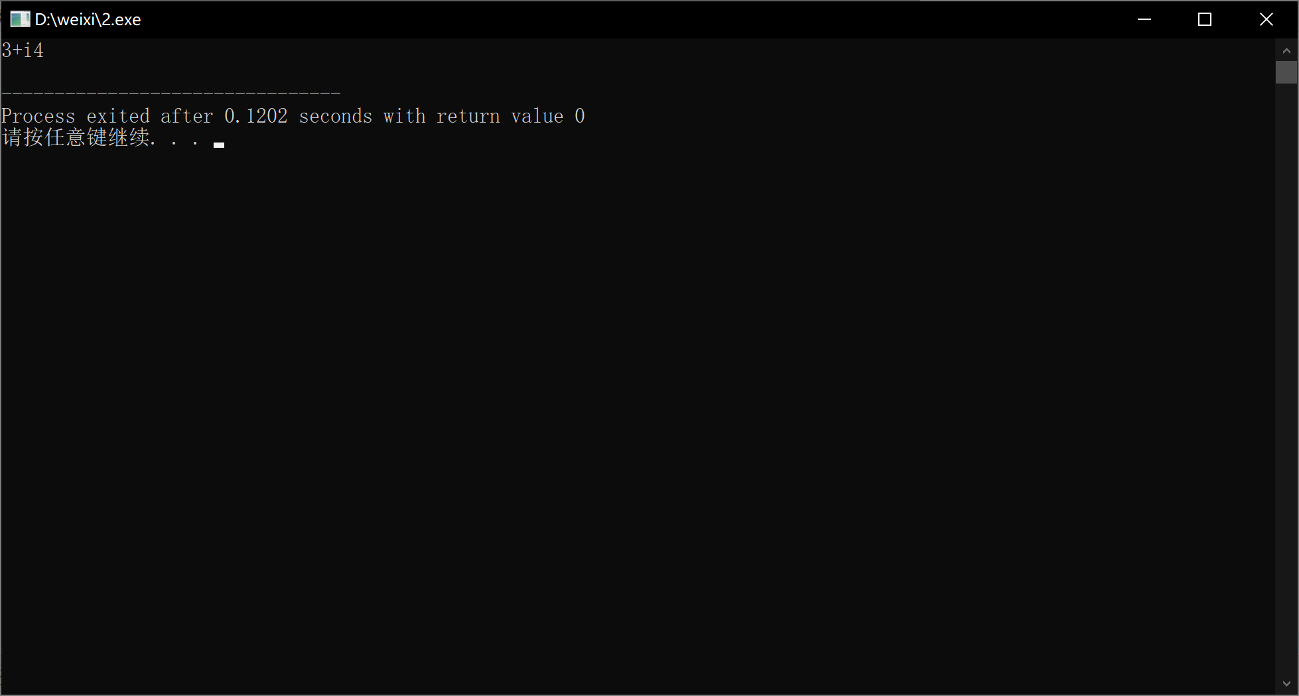

心得体会：

掌握了C++语言多态性的基本概念

掌握了运算符重载函数的声明和定义方法

Copyright ©2021-2099 xiwei.All rights reserved