源代码：

1、

#include<iostream>

using namespace std;

class Coordinate {

public:

Coordinate()

{

times = 2;

cout << "Coordinate construction1 called!" << endl;

}

Coordinate(int times1)

{

times = times1;

cout << "Coordinate construction2 called!" << endl;

}

~Coordinate()

{

cout << "Coordinate destruction called!" << endl;

}

void InputCoord()

{

for (int i = 0; i < times; i++)

{

cout << "Please Input x:" << endl;

cin >> Coord[i][1];

cout << "Please Input y:" << endl;

cin >> Coord[i][2];

}

}

void ShowCoord()

{

cout << "The coord is:" << endl;

for (int i = 0; i < times; i++)

{

cout << "(" << Coord[i][1] << "," << Coord[i][2] << ")" << endl;

}

}

void ShowAvgCoord()

{

float avgx = 0;

float avgy = 0;

for (int i = 0; i < times; i++)

{

avgx = avgx + Coord[i][1];

avgy = avgy + Coord[i][2];

}

avgx = avgx / times;

avgy = avgy / times;

cout << "The AVG coord is:" << endl;

cout << "(" << avgx << "," << avgy << ")" << endl;

}

private:

float Coord[100][100];

int times;

};

int main()

{

Coordinate y(5);

y.InputCoord();

y.ShowCoord();

y.ShowAvgCoord();

return 0;

}

2、

#include <iostream>

using namespace std;

int m;

class student {

private:

double a, b, c;

int n;

char name[100];

public:

student()

{

cout <<"请输入学生名字：";

cin >> name;

cout <<"请输入科目A成绩：";

cin >> a;

cout <<"请输入科目B成绩：";

cin >> b;

cout <<"请输入科目C成绩：";

cin >> c;

}

void showgrades()

{

cout << name << "的各个成绩：";

cout << "A成绩：" << a ;

cout << "B成绩：" << b ;

cout << "C成绩：" << c << endl;

}

void showstudentavg()

{

cout << name << "的";

cout << "平均成绩是：" << (a + b + c) / 3 << endl;

}

void oedergrades()

{

double t,temp[3] = { a,b,c };

int i, j;

for (i = 0; i < 3; i++)

{

for(j=i; j<3; j++)

if (temp[i] < temp[j])

{

t = temp[i];

temp[i] = temp[j];

temp[j] = t;

}

}

cout << name << "的各个成绩排序：";

for (i = 0; i < 3; i++)

{

if (temp[i] == a)

cout << "科目A的成绩：";

else if (temp[i] == b)

cout << "科目B的成绩：";

else if (temp[i] == c)

cout << "科目C的成绩：";

cout << temp[i] << " ";

}

cout << endl;

}

void ABCavg(student a[])

{

int i;

double asum=0, bsum=0, csum=0;

for (i = 0; i < m; i++)

{

asum = a[i].a + asum;

bsum = a[i].b + bsum;

csum = a[i].c + csum;

}

cout << "科目A的平均成绩：" << asum / m << "科目B的平均成绩： " << bsum / m << " 科目C的平均成绩：" << csum / m << endl;

}

};

int main()

{

int i;

cout << "请输入学生人数（100以内）：";

cin >> m;

while (m > 100 || m <= 0)

{

cout << "输入错误，请重新输入" << endl;

cout << "请输入学生人数（100以内）：";

cin >> m;

}

student\* p = new student[m];

for (i = 0; i < m; i++)

{

p[i].showgrades();

}

for (i = 0; i < m; i++)

{

p[i].showstudentavg();

}

for (i = 0; i < m; i++)

{

p[i].oedergrades();

}

p[0].ABCavg(p);

delete p;

return 0;

}

运行结果：

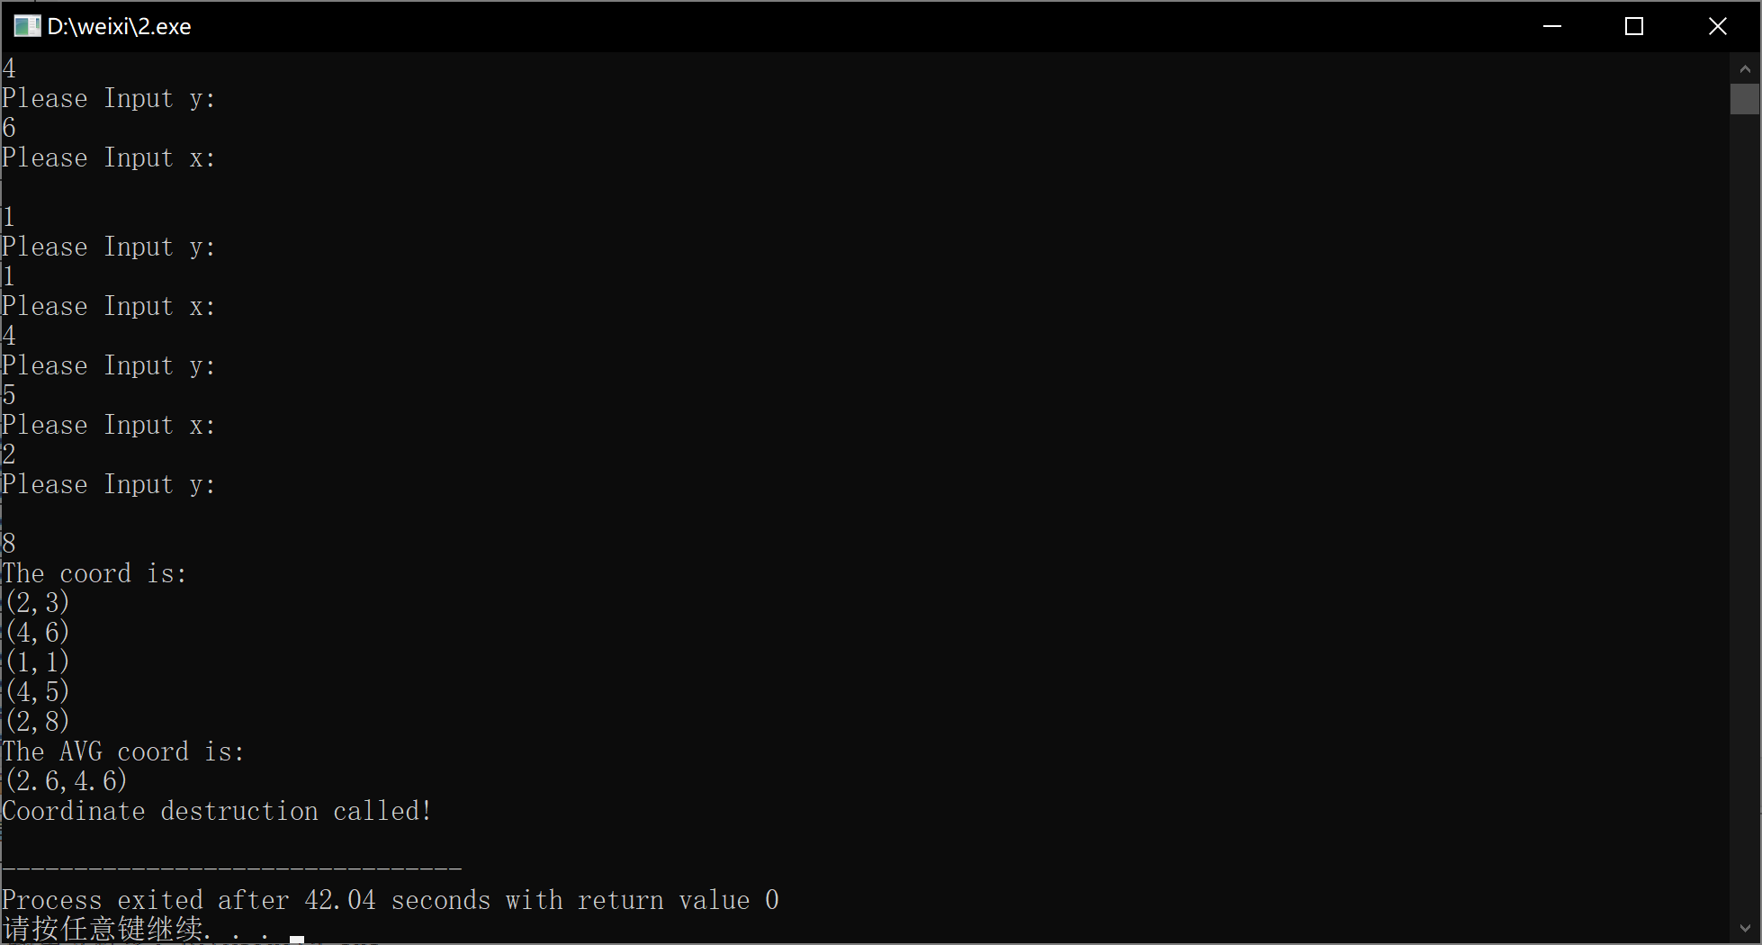

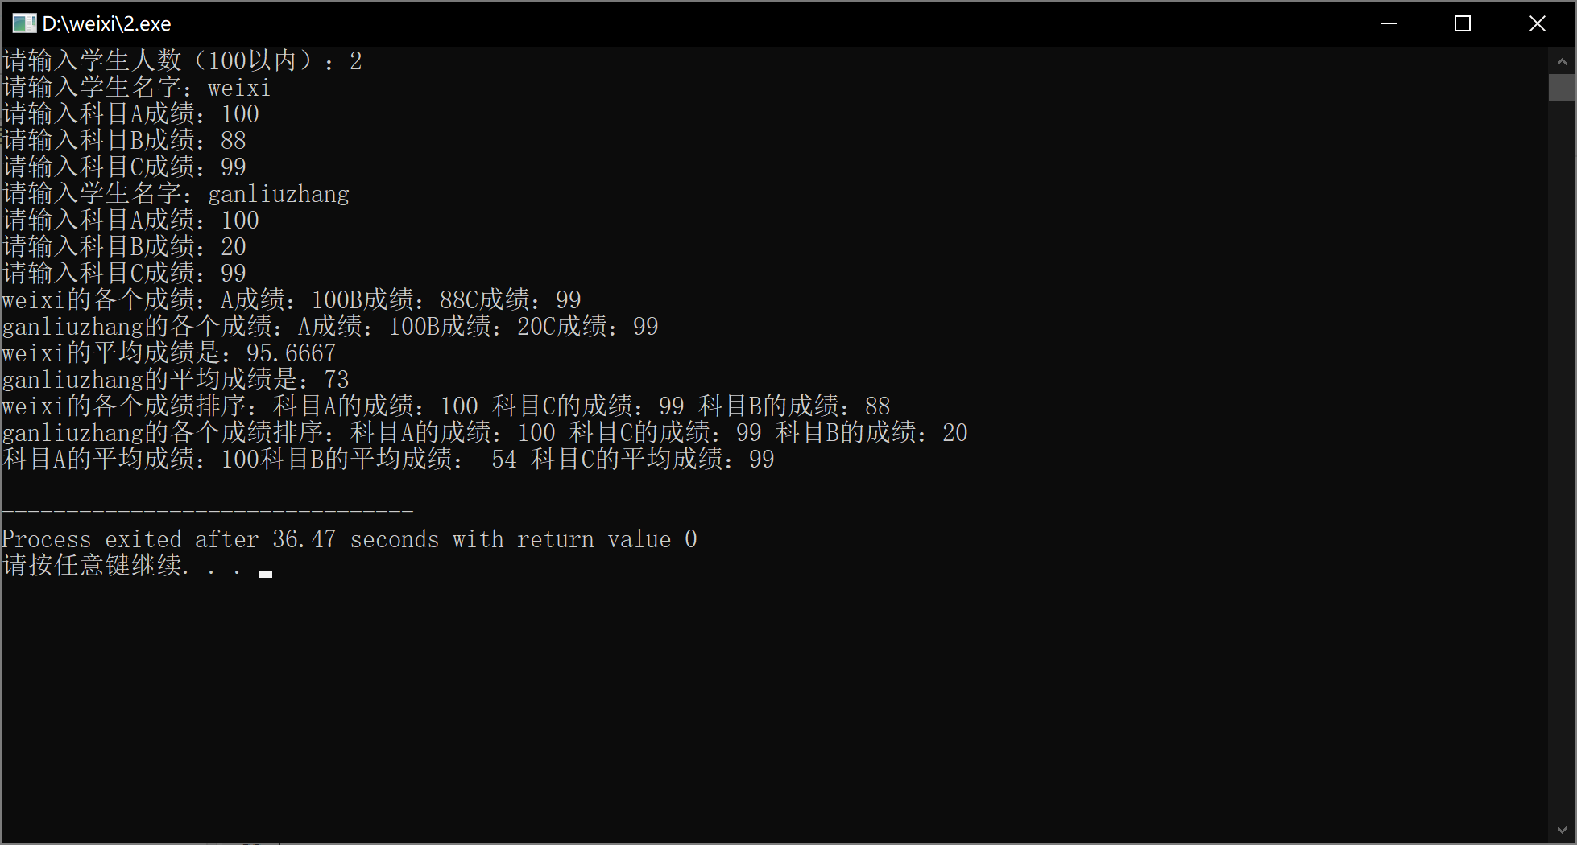

心得体会：理解了类和对象的概念，掌握了声明类和定义对象的方法

掌握了构造函数和析构函数的实现方法

初步掌握使用类和对象编制C++程序

Copyright ©2021-2099 xiwei. All rights reserved