源代码：

1、

#include <iostream>

using namespace std;

int add(int a, int b)

{

return (a + b);

}

#include <iostream>

using namespace std;

int add(int a, int b);

int main(void)

{

int x, y, sum;

cout << "Enter two numbers:" << endl;

cin >> x >> y;

sum = add(x, y);

cout << sum << endl;

return 0;

}

2、

#include <iostream>

using namespace std;

int min(int a[]);

int max(int a[]);

int main()

{

int a[5];

int i;

for (i = 0; i < 5;)

{

cout << "请输入第"<<i+1 << "个数（取值0~100，需要五个数）";

cin >> a[i];

if (a[i] > 100 || a[i] < 0)

{

cout << "刚刚的值不在范围内，请重新输入一个" << endl;

}

else

{

i++;

}

}

min(a);

max(a);

}

#include <iostream>

using namespace std;

int max(int a[])

{

int max = a[0], i;

for (i = 1; i < 5; i++)

{

if (max < a[i])

{

max = a[i];

}

}

cout << "最大：" << max << endl;

return 0;

}

#include <iostream>

using namespace std;

int min(int a[])

{

int min = a[0], i;

for (i = 1; i < 5; i++)

{

if (min > a[i])

{

min = a[i];

}

}

cout << "最小：" << min << endl;

return 0;

}

运行结果：

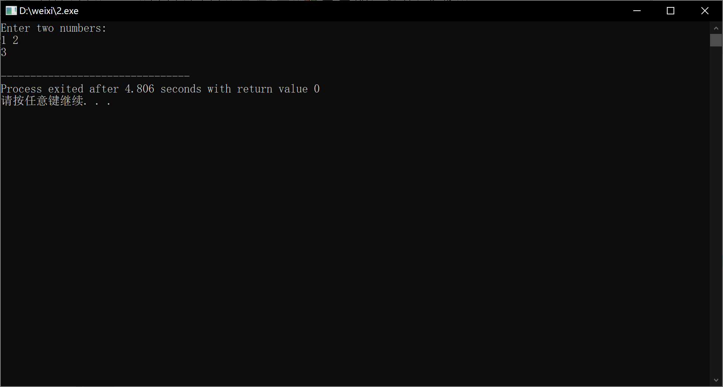

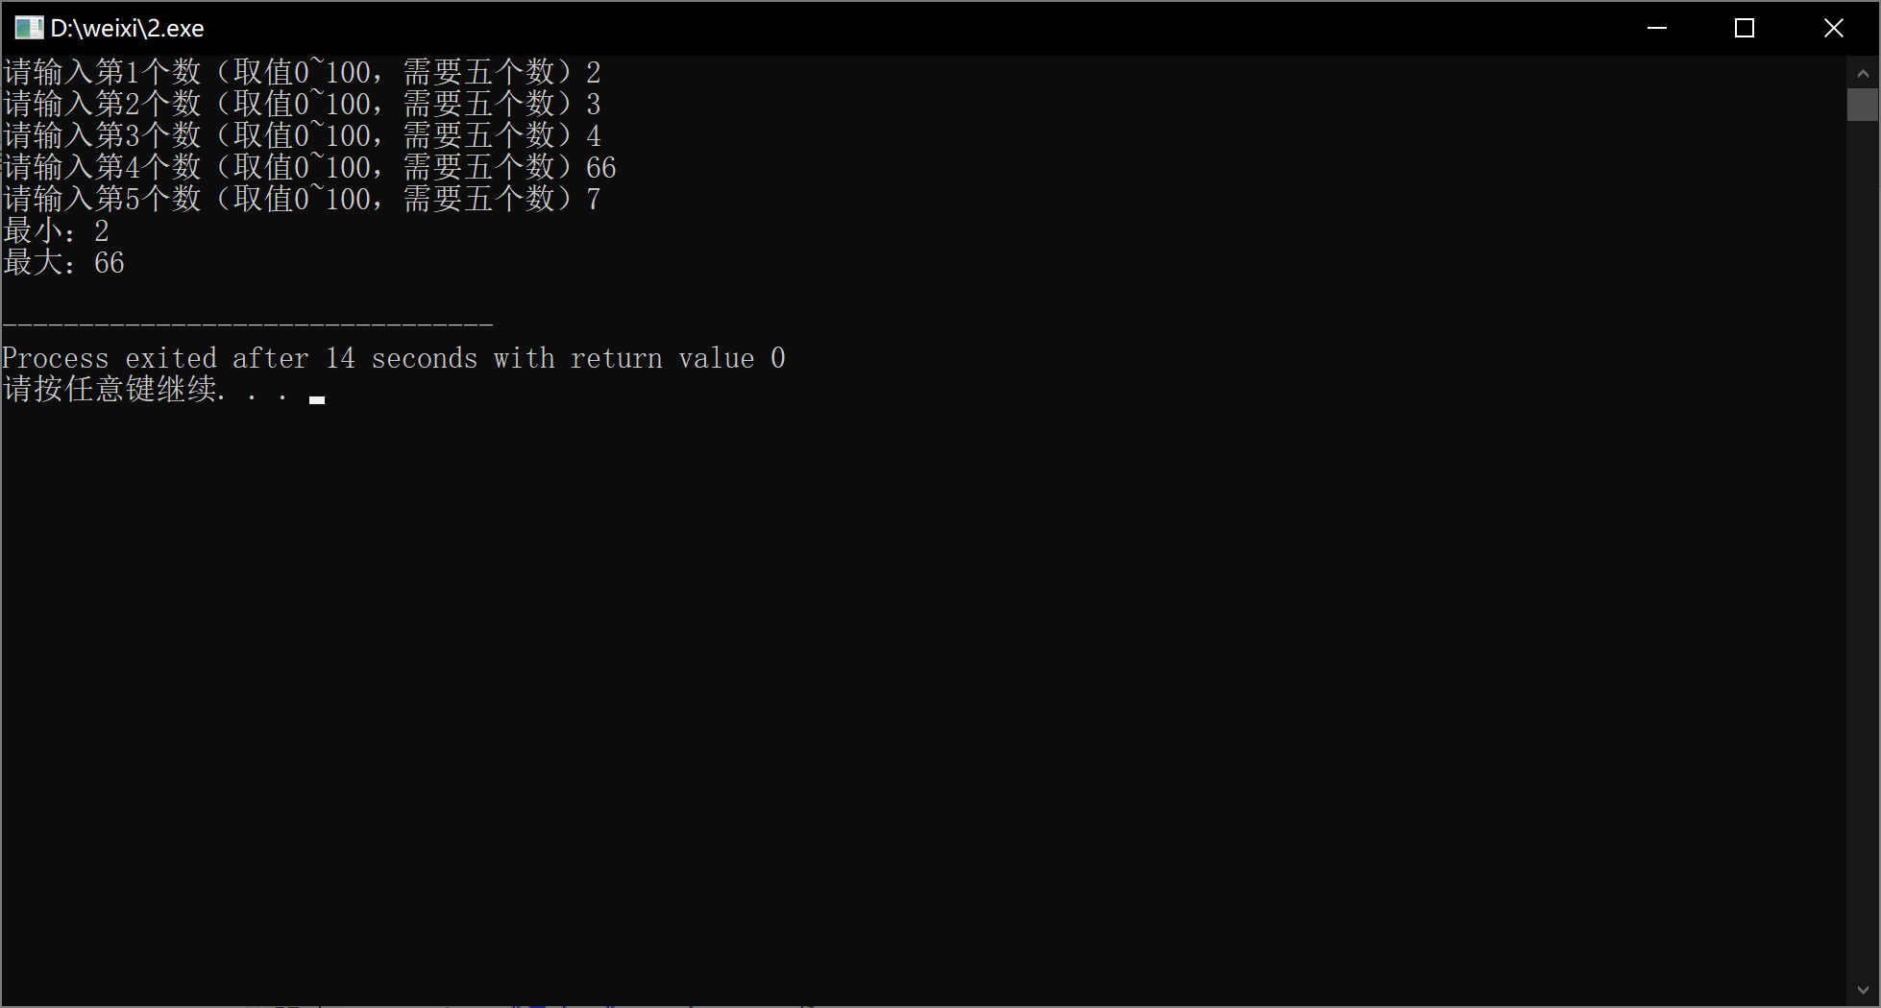

心得体会：掌握了建立和运行单文件程序与多文件程序的方法

Copyright ©2021-2099 xiwei.All rights reserved