源代码：

#include <iostream>

using namespace std;

class MyArray {

private:

int a[5];

public:

MyArray()

{

cout << "MyArray类对象已创立" << endl;

}

~MyArray()

{

cout << "MyArray类对象已撤销" << endl;

}

void input()

{

cout <<"请从键盘输入五个整数";

int i;

for (i = 0; i < 5; i++)

{

cin >> a[i];

}

}

void show()

{

cout << "显示排序以前的五个整数";

int i;

for (i = 0; i < 5; i++)

{

cout << a[i] << " ";

}

cout << endl;

}

void order()

{

cout << "显示排序以后的五个整数";

int i, j, t;

for (i = 0; i < 5; i++)

{

for (j = i; j < 5; j++)

{

if (a[i] > a[j])

{

t = a[i];

a[i] = a[j];

a[j] = t;

}

}

}

for (i = 0; i < 5; i++)

{

cout << a[i] << " ";

}

cout << endl;

}

};

class SortArray : public MyArray {

public:

SortArray()

{

cout << "SortArray类对象已创立" << endl;

}

~SortArray()

{

cout << "SortArray类对象已撤销" << endl;

}

};

int main()

{

SortArray A;

A.input();

A.show();

A.order();

return 0;

}

运行结果：

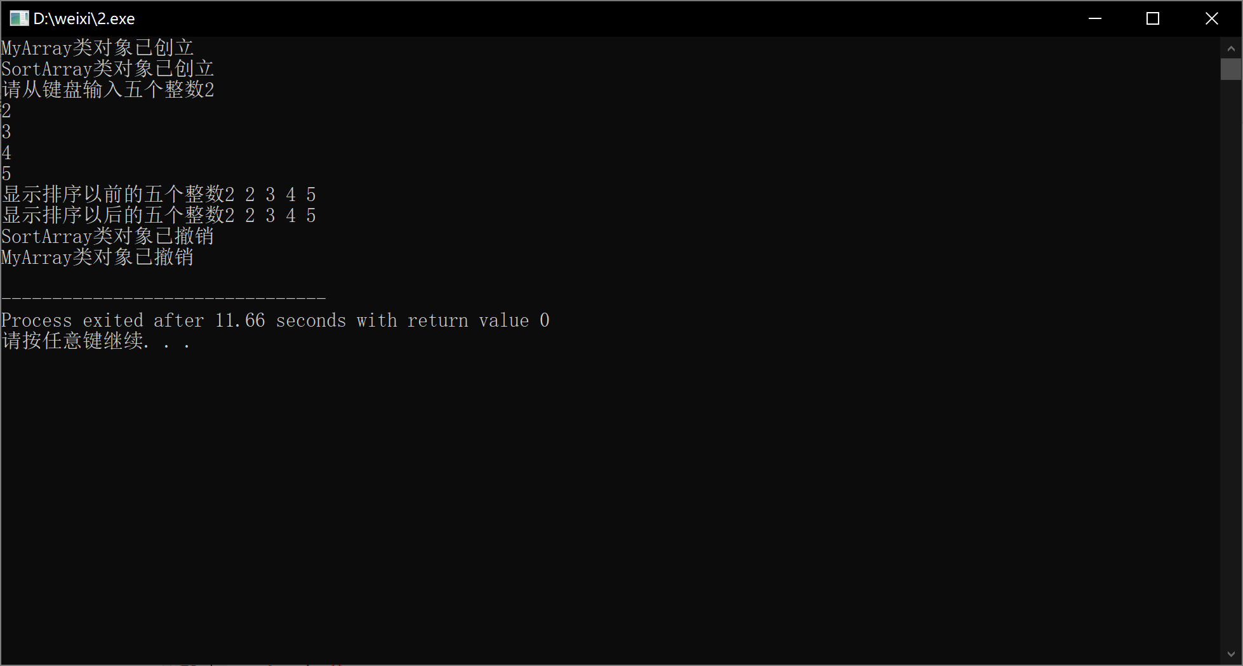

心得体会：掌握派生类的声明方法和派生类构造函数的定义方法

掌握不同方式下，构造函数与析构函数的执行顺序与构造规则

Copyright ©2021-2099 xiwei.All rights reserved