#include <iostream>

using namespace std;

class Complex {

    public:

        Complex(double a = 0.0, double b = 0.0);

        void print();

        Complex operator\*(Complex c);

    private:

        double real;

        double imag;

};

Complex::Complex(double a, double b)

{

    real = a;

    imag = b;

}

Complex Complex::operator\*(Complex c)

{

    Complex t;

    t.real = real \* c.real - imag \* c.imag;

    t.imag = real \* c.imag + imag \* c.real;

    return t;

}

void Complex::print()

{

    cout << real;

    if (imag > 0)

        cout << "+";

    if (imag != 0)

        cout << imag << "i" << endl;

}

int main()

{

    Complex a(2, 3), b(4, 5), c;

    c = a \* b;

    c.print();

    return 0;

}

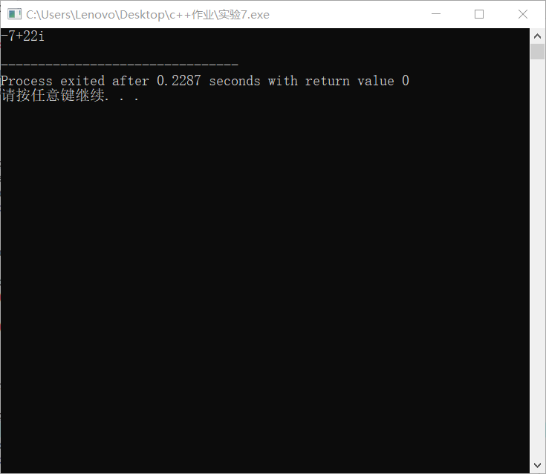

本次实验中我没有注意没有参数的构造函数，导致犯了no matching function for call to 'Complex::Complex()'，