# 第七次上机

#include<iostream>

using namespace std;

class Complex {

double real;

double imag;

public:

Complex(double r = 0.0, double i = 0.0);

void print();

Complex operator+(Complex c);

};

Complex::Complex(double r, double i)

{

real = r; imag = i;

}

Complex Complex::operator+(Complex c)

{

Complex temp;

temp.real = real*c.real-imag*c.imag;

temp.imag = real*c.imag+c.real*imag;

return temp;

}

void Complex::print()

{

cout << "total real=" << real << " " << " total imag=" << imag << endl;

}

int main()

{

double x1, x2, y1, y2;

cin >> x1 >> y1 >> x2 >> y2;

Complex com1(x1, y1), com2(x2, y2), total1;

total1 = com1 + com2;

total1.print();

return 0;

}

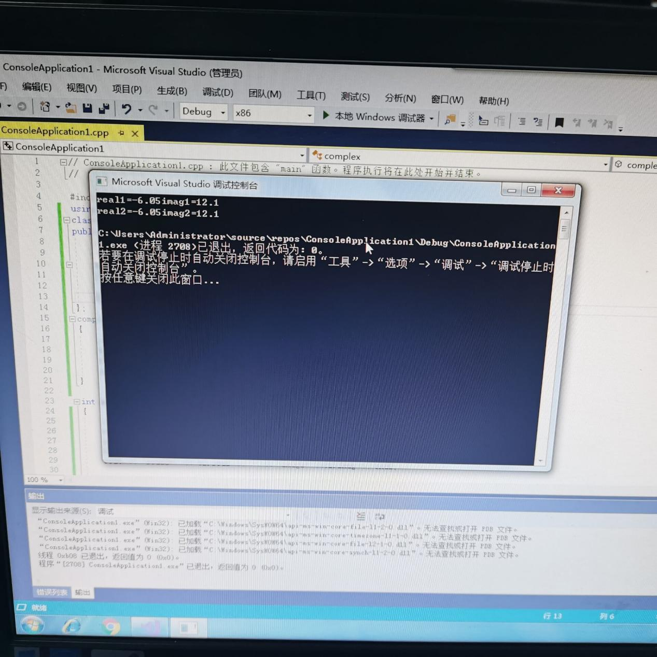

这次试验是我编的比较得心应手的一次，突然觉得不难了，虽然在这次编程过程中遇到了几个小问题，，一个是构造函数参数的问题，还有就是粗心的错误问题，但总是解决了。

Copyright ©2021-2099 JiahongFeng. All rights reserved