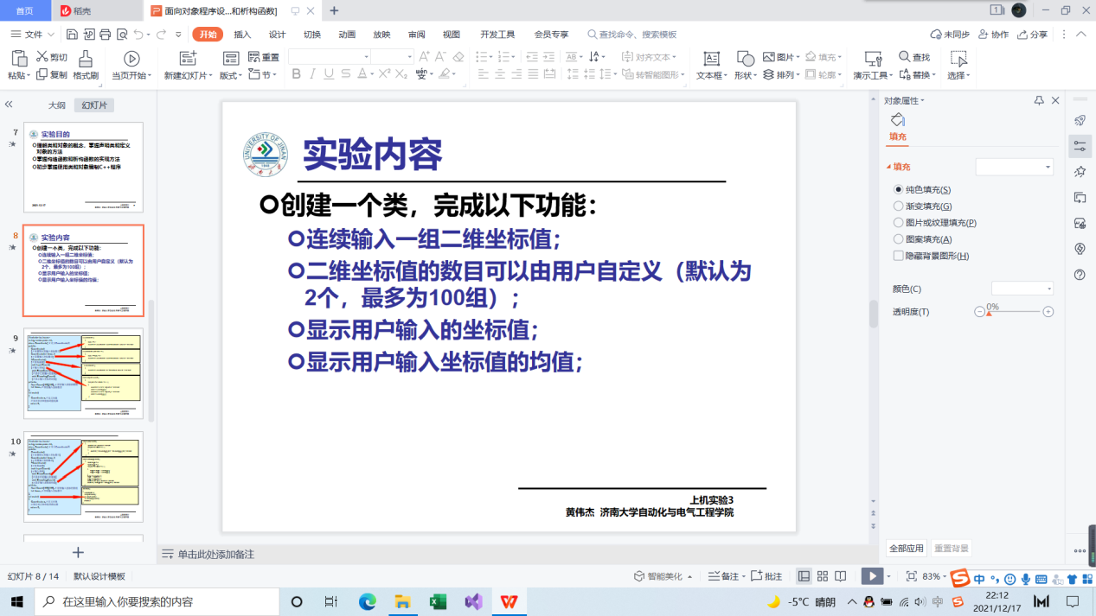

内容

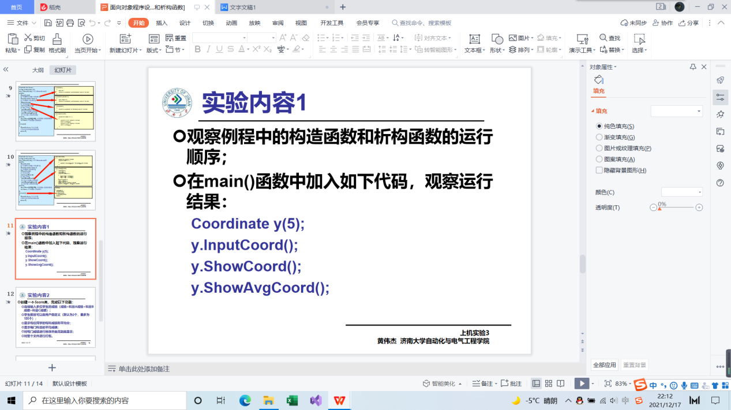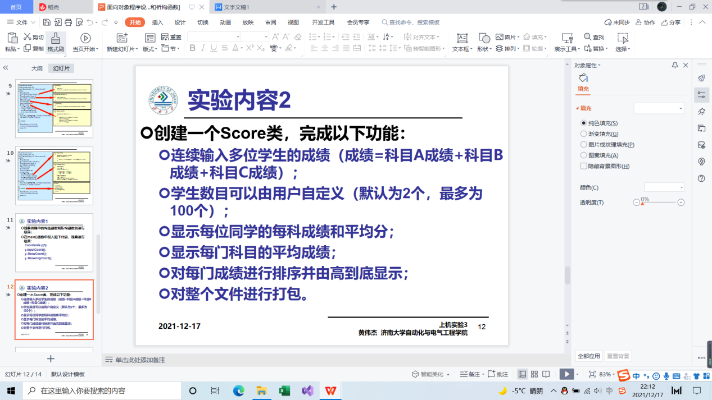

程序与结果

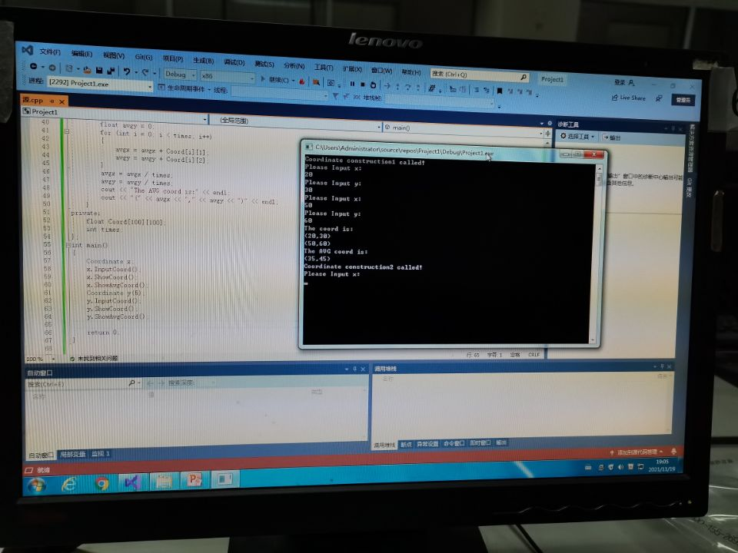

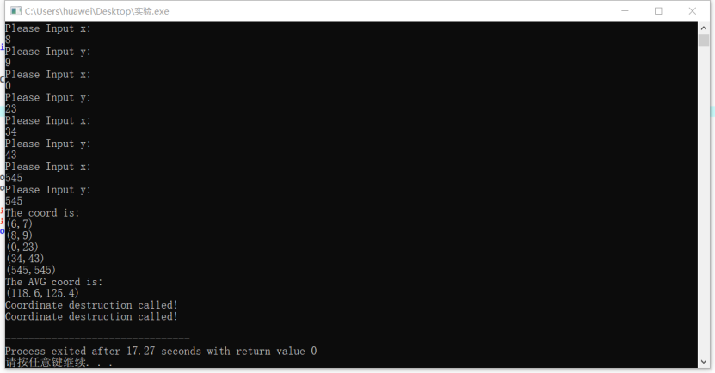

代码

#include<iostream>

using namespace std;

class Score

{

public:

Score(int stnumber = 2)

{

if (stnumber > 100)

number = 100;

else number = stnumber;

}

void input()

{

for (int i = 0; i < number; i++)

{

cout << "请输入学生姓名:" << endl;

cin >> name[i];

cout << "请输入科目A成绩：" << endl;

cin >> grade[i][1];

cout << "请输入科目B成绩：" << endl;

cin >> grade[i][2];

cout << "请输入科目C成绩：" << endl;

cin >> grade[i][3];

}

}

void showallstu()

{

for (int i = 0; i < number; i++)

{

cout << "姓名：" << name[i] << "科目A成绩：" << grade[i][1] << "科目B成绩：" << grade[i][2] << "科目C成绩：" << grade[i][2] << endl;

}

}

void showstuavg(int m)

{

cout << "姓名:" << name[m] << "平均成绩：" << (grade[m][1] + grade[m][2] + grade[m][3]) / 3 << endl;

}

void showavg(int i)

{

double all = 0;

switch (i)

{

case 1:

for (int m = 0; m < number; m++)

{

all += grade[m][1];

};

cout << "课程名称：A平均成绩：" << all / number << endl;

break;

case 2:

for (int m = 0; m < number; m++)

{

all += grade[m][2];

};

cout << "课程名称：B平均成绩：" << all / number << endl;

break;

case 3:

for (int m = 0; m < number; m++)

{

all += grade[m][3];

};

cout << "课程名称：C平均成绩：" << all / number << endl;

break;

}

}

void rank(int m)

{

int temp;

char tempname[100];

switch (m)

{

case 1:cout << "课程名：A" << endl;

break;

case 2:cout << "课程名：B" << endl;

break;

case 3:cout << "课程名：C" << endl;

break;

}

for (int i = 0;i < number - 1;i++)

{

if (grade[i][m] > grade[i + 1][m])

{

temp = grade[i + 1][m];

grade[i + 1][m] = grade[i][m];

grade[i][m] = grade[i + 1][m];

tempname[100] = name[i + 1][100];

name[i + 1][100] = name[i][100];

name[i][100] = tempname[100];

}

}

for (int i = number - 1;i > -1;i--)

{

cout << "姓名：" << name[i] << "成绩：" << grade[i][m] << endl;

}

}

private:

int number;

char name[100][100];

double grade[100][3];

};

int main()

{

Score stu;

stu.input();

stu.showallstu();

stu.showstuavg(1);

stu.showavg(1);

stu.rank(1);

getchar();

getchar();

return 0;

}

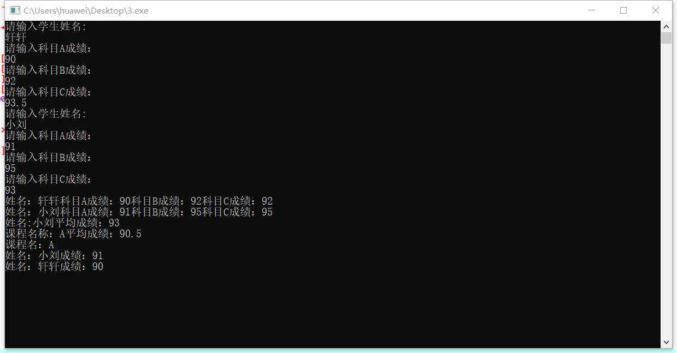

心得体会

本次实验主要是对于构造函数和析构函数的应用，构造函数使用时自动的，析构函数的使用也是自动的。同时构造函数使用时是没有返回值，析构函数是没有参数的，两者都是与类名相同的。也正因为这样，构造函数有重载函数，但是析构函数是没有重载函数的，因为没有参数。

Copyright ©2021-2099 Liuzongxuan. All rights reserved