内容



代码

#include<iostream>

using namespace std;

#include <string.h>

class TStudent

{

private:

char m_Name[6];

static float m_ClassMoney;

public:

void InitStudent(char*);

void ExpendMoney(float);

static void ShowMoney();

};

float TStudent::m_ClassMoney = 1000;

void TStudent::InitStudent(char name[])

{

strcpy(m_Name, name);

}

void TStudent::ExpendMoney(float money)

{

m_ClassMoney -= money;

cout << m_Name << "花费班费" << m_ClassMoney << endl;

}

void TStudent::ShowMoney()

{

cout << "班费还剩余" << m_ClassMoney << endl;

}

int main()

{

TStudent stu[3];

stu[0].InitStudent("A");

stu[1].InitStudent("B");

stu[2].InitStudent("C");

stu[0].ExpendMoney(50);

TStudent::ShowMoney();

stu[1].ExpendMoney(98.5);

TStudent::ShowMoney();

stu[2].ExpendMoney(500.53);

TStudent::ShowMoney();

}

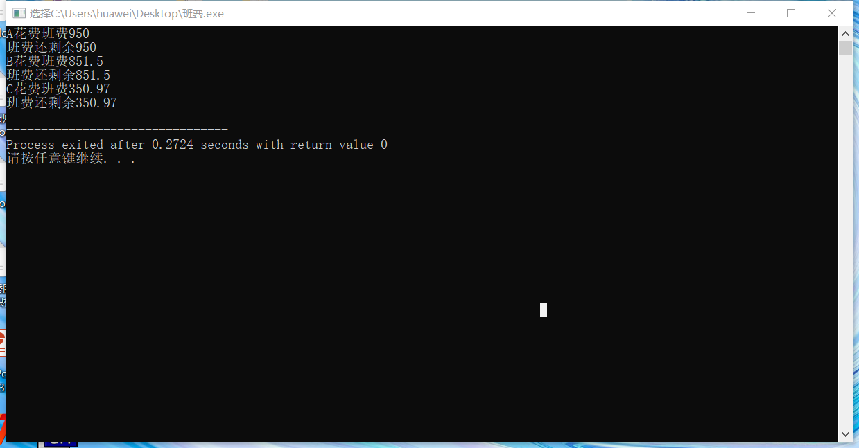

心得体会

静态成员变量，这次实验的时候我觉得难度较大体验较差。静态成员并不属于某一个对象，而是在所有对象之外单独开辟空间。而且静态数据成员只能在类外初始化

Copyright ©2021-2099 Liuzongxuan. All rights reserved