**实验内容**

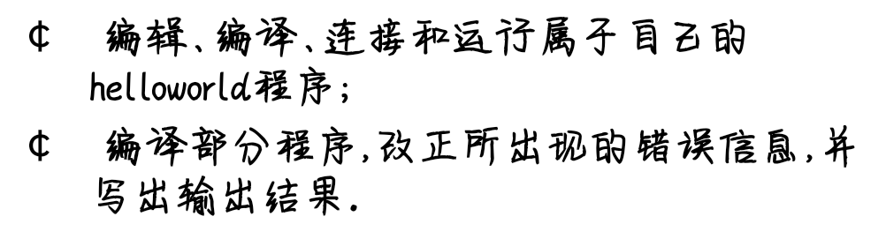

**程序代码**

#include <iostream>

using namespace std;

int main()

{ int age;

cout << "Please input your AGE： " << endl;

cin >> age;

cout << "Hello, world!I am " << age << endl;

return 0;

}

**程序结果**

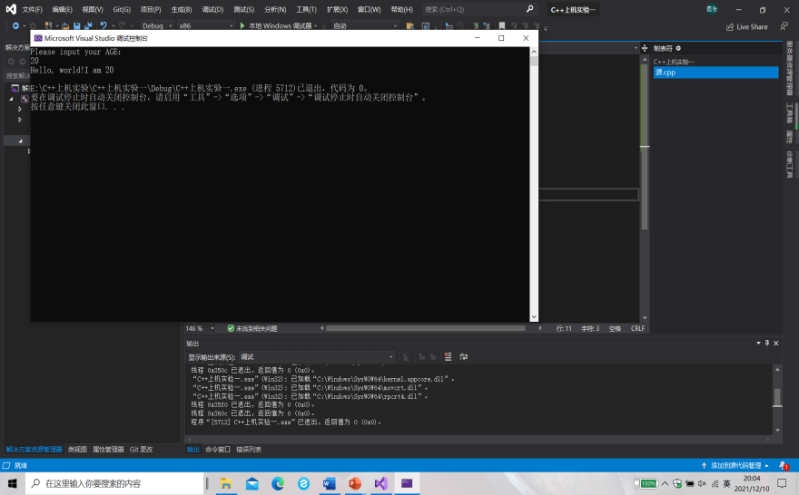

**实验内容（二）**

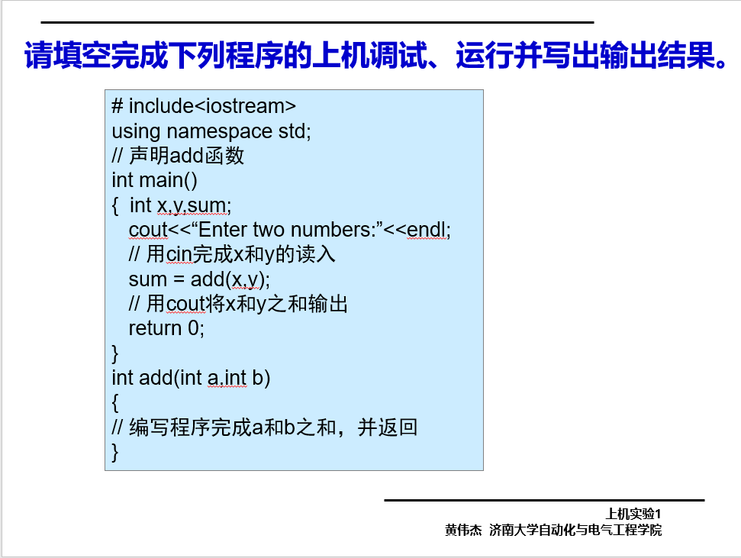

**程序代码**

# include<iostream>

using namespace std;

int add(int a, int b);

int main()

{

int x, y, sum;

cout << "Enter two numbers : " << endl;

cin >> x >> y;

sum = add(x, y);

cout << sum;

return 0;

}

int add(int a, int b)

{

return (a+b);

}

**程序结果**

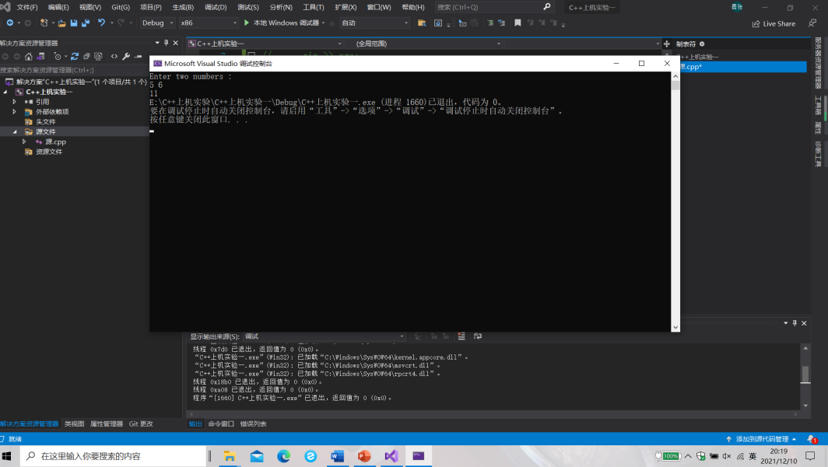

**感想心得**

需要在main函数前声明add函数，否则会发生错误。

输入语句是cin>>

输出语句是cout<<

Copyright ©2021-2099 BonanWu. All rights reserved