## 上机实验3：构造函数和析构函数

程序1：

#include<iostream>  
using namespace std;  
class Coordinate {  // 定义Coordinate类  
public: Coordinate()  
{  
    times = 2;  
    cout << "Coordinate construction1 called!" << endl;  
}  
      Coordinate(int times1)  
      {  
          times = times1;  
          cout << "Coordinate construction2 called!" << endl;  
      }  
      ~Coordinate()  
      {  
          cout << "Coordinate destruction called!" << endl;  
      }  
      
      
        void InputCoord()  
        {  
            for (int i = 0; i < times; i++)  
            {  
                cout << "Please Input x:" << endl;  
                cin >> Coord[i][1];  
                cout << "Please Input y:" << endl;  
                cin >> Coord[i][2];  
            }  
        }  
        void ShowCoord()  
        {  
            cout << "The coord is:" << endl;  
            for (int i = 0; i < times; i++)  
            {  
                cout << "(" << Coord[i][1] << "," << Coord[i][2] << ")" << endl;  
            }  
        }  
        void ShowAvgCoord()  
        {  
            float avgx = 0;  
            float avgy = 0;  
            for (int i = 0; i < times; i++)  
            {  
                avgx = avgx + Coord[i][1];  
                avgy = avgy + Coord[i][2];  
            }  
             
  
  
            avgx = avgx / times;  
            avgy = avgy / times;  
            cout << "The AVG coord is:" << endl;  
            cout << "(" << avgx << "," << avgy << ")" << endl;  
        }  
                        private:  
                            float Coord[100][100]; // 存放输入坐标的数组  
                            int times; // 存放输入坐标数目  
                        };  
                        int main()  
                        {  
                            Coordinate x; // 定义对象  
                            x.InputCoord();  
                            x.ShowCoord();  
                            x.ShowAvgCoord();  
                            return 0;  
                        }

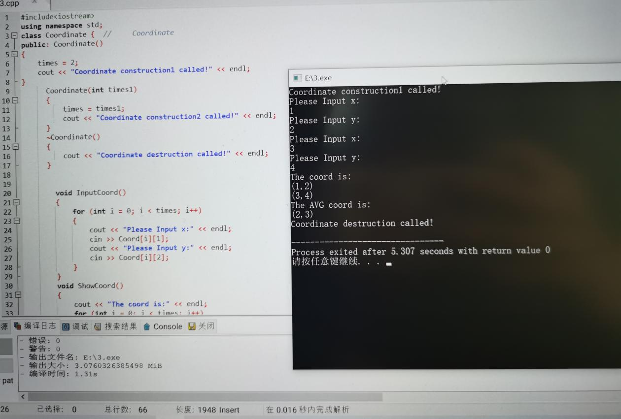

程序2：

#include<iostream>  
using namespace std;  
  
class Score  
{  
public:  
Score(int stnumber=2)  
{  
if(stnumber>100)  
number=100;  
else number=stnumber;  
}  
  
void input()  
{  
for(int i=0;i<number;i++)  
{  
//输入姓名  
cout<<"请输入学生姓名:"<<endl;  
cin>>name[i];  
//输入学生成绩  
cout<<"请输入科目A成绩："<<endl;  
cin>>grade[i][1];  
cout<<"请输入科目B成绩："<<endl;  
cin>>grade[i][2];  
cout<<"请输入科目C成绩："<<endl;  
cin>>grade[i][3];  
}  
}  
  
void showallstu()  
{  
for(int i=0;i<number;i++)  
{  
cout<<"姓名："<<name[i]<<" 科目A成绩："<<grade[i][1]<< " 科目B成绩："<<grade[i][2]<<" 科目C成绩："<<grade[i][2]<<endl;  
}  
}  
  
void showstuavg(int m)  
{  
cout<<"姓名:"<<name[m]<<" 平均成绩："<<(grade[m][1]+grade[m][2]+grade[m][3])/3<<endl;  
}  
  
void showavg(int i)  
{  
double all=0;  
switch (i)  
{  
case 1:  
for(int m=0;m<number;m++)  
   {  
   all+=grade[m][1];  
};  
cout<<"课程名称：A平均成绩："<<all/number<<endl;  
break;  
case 2:  
for(int m=0;m<number;m++)  
   {  
   all+=grade[m][2];  
};  
cout<<"课程名称：B平均成绩："<<all/number<<endl;  
break;  
case 3:  
for(int m=0;m<number;m++)  
   {  
   all+=grade[m][3];  
};  
cout<<"课程名称：C平均成绩："<<all/number<<endl;  
break;  
}  
}  
  
void rank(int m)  
{  
int temp;  
char tempname[100];  
switch (m)  
{  
case 1:cout<<"课程名：A"<<endl;  
break;  
case 2:cout<<"课程名：B"<<endl;  
break;  
case 3:cout<<"课程名：C"<<endl;  
break;  
}  
for (int i = 0; i < number-1; i++)  
{  
if(grade[i][m]>grade[i+1][m])  
{  
temp=grade[i+1][m];  
grade[i+1][m]=grade[i][m];  
grade[i][m]=grade[i+1][m];  
tempname[100]=name[i+1][100];  
name[i+1][100]=name[i][100];  
name[i][100]=tempname[100];  
}  
}  
for (int i = number-1; i > -1; i--)  
{  
cout<<"姓名："<<name[i]<<" 成绩："<<grade[i][m]<<endl;  
}  
}  
  
private:  
int number;  
char name[100][100];  
double grade[100][3];  
};  
  
int main()  
{  
Score stu;  
stu.input();  
stu.showallstu();  
stu.showstuavg(1);  
stu.showavg(1);  
stu.rank(1);  
getchar();  
getchar();  
return 0;  
}

