第六次实验报告

程序：

#include<iostream>

//#include<cmath>

#include<string>

using namespace std;

class MyArray {

public:

MyArray(int length);

~MyArray();

void Input();

void Display(string);

protected:

int\* alist;

int length;

};

MyArray::MyArray(int leng)

{

if (leng <= 0)

{

cout << "error length";

exit(1);

}

length = leng;

alist = new int[length];

if (alist == NULL)

{

cout << "assign failure";

exit(1);

}

cout << "MyArray类对象已创建!" << endl;

}

MyArray::~MyArray()

{

delete[] alist;

cout << "MyArray类对象已撤销!" << endl;

}

void MyArray::Input()

{

cout << "请从键盘输入" << length << "个整数:";

int i;

int\* p = alist;

for (i = 0; i < length; i++, p++)

cin >> \*p;

}

void MyArray::Display(string str)

{

int i;

int\* p = alist;

cout << str << length << "个整数: ";

for (i = 0; i < length; i++, p++)

cout << \*p << " ";

cout << endl;

}

int main()

{

MyArray a(5);

a.Input();

a.Display("显示已经输入的");

return 0;

}

程序结果：

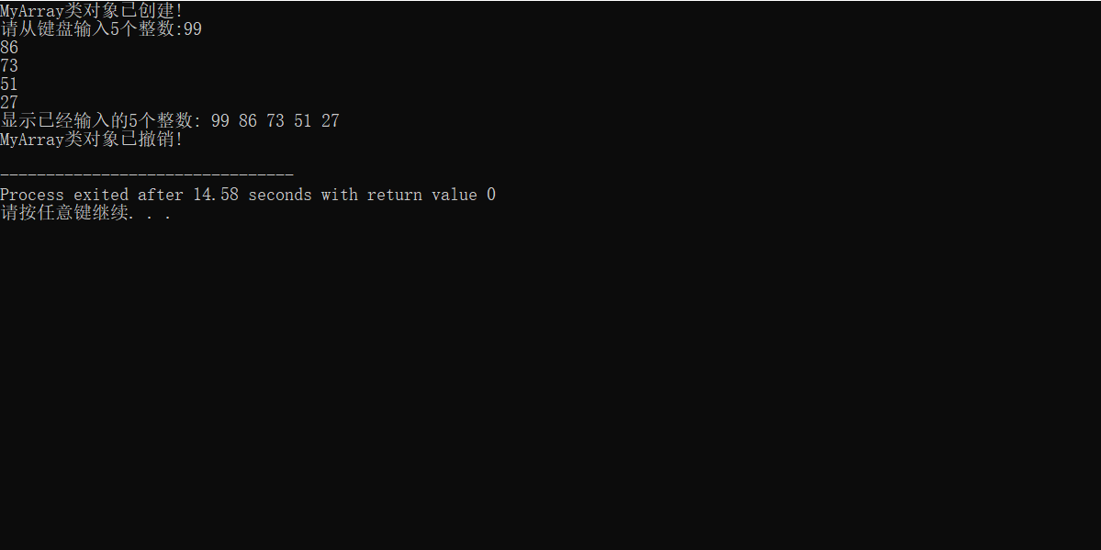

实验心得：

1. 掌握派生类的声明方法和派生类构造函数的定义方法
2. 掌握不同方式下，构造函数与析构函数的执行顺序与构造规则

Copyright ©2021-2099XiangYu. All rights reserved