Copyright ©2021-2099 Qin Yang. All rights reserved

1. 程序代码

#include<iostream>  
using namespace std;  
class Coordinate {  
public:  
 Coordinate()  
 {  
  times = 2;  
  cout << "Coordinate construction 1 called!" << endl;  
 }  
 Coordinate(int times1)  
 {  
  times = times1;  
  cout << "Coordinate construction 2 called!" << endl;  
 }  
 ~Coordinate()  
 {  
  cout << "Coordinate destruction called!" << endl;  
 }  
 void InputCoord()  
 {  
  for (int i = 0;i<times;i++)  
  {  
   cout << "Please Input x:" << endl;  
   cin >> Coord[i][1];  
   cout << "Please Input y:" << endl;  
   cin >> Coord[i][2];  
  }  
 }  
 void ShowCoord()  
 {  
  cout << "The coord is;" << endl;  
  for(int i=0;i<times;i++)  
  {  
   cout << "(" << Coord[i][1] << "," << Coord[i][2] << ")" << endl;  
  }  
 }  
 void ShowAvgCoord()  
 {  
  float avgx = 0;  
  float avgy = 0;  
  for(int i=0;i<times;i++)  
  {  
   avgx = avgx + Coord[i][1];  
   avgy = avgy + Coord[i][2];  
  }  
  avgx = avgx / times;  
  avgy = avgy / times;  
  cout << "The AVG coord is" << endl;  
  cout << "(" << avgx << "," << avgy << ")" << endl;  
 }  
private:  
 float Coord[100][100];  
 int times;  
};  
int main()  
{  
 Coordinate y(5);  
 y.InputCoord();  
 y.ShowCoord();  
 y.ShowAvgCoord();  
 return 0;  
}

1. 程序结果

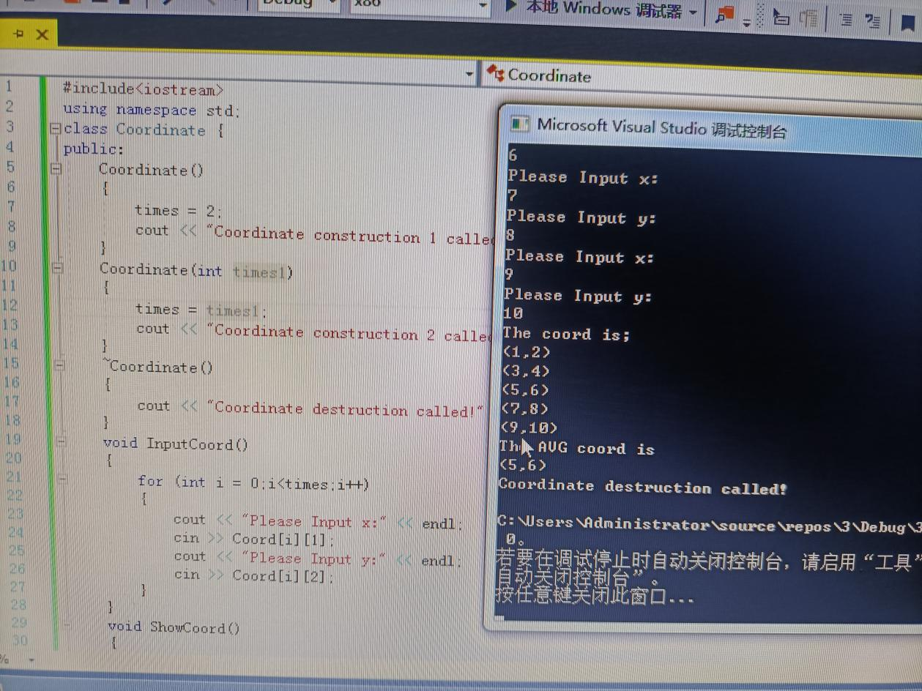

1. 感想心得

可以通过重载构造函数的方式实现构造函数接收数据的多样性。