Copyright ©2021-2099 Qin Yang. All rights reserved

1. 程序代码

#include<iostream>

using namespace std;

class Base {

public:

void setx(int i)

{

x = i;

}

int getx()

{

return x;

}

public:

int x;

};

class Derived :public Base {

public:

void sety(int i)

{

y = i;

}

int gety()

{

return y;

}

void show()

{

cout << "Base::x=" << x << endl; }

public:

int y;

};

int main()

{

Derived bb;

bb.setx(16);

bb.sety(25);

bb.show();

cout << "Base::x=" << bb.x << endl;

cout << "Derived::y=" << bb.y << endl;

cout << "Base::x=" << bb.getx() << endl;

cout << "Derived::y=" << bb.gety() << endl;

return 0;

}

1. 程序结果

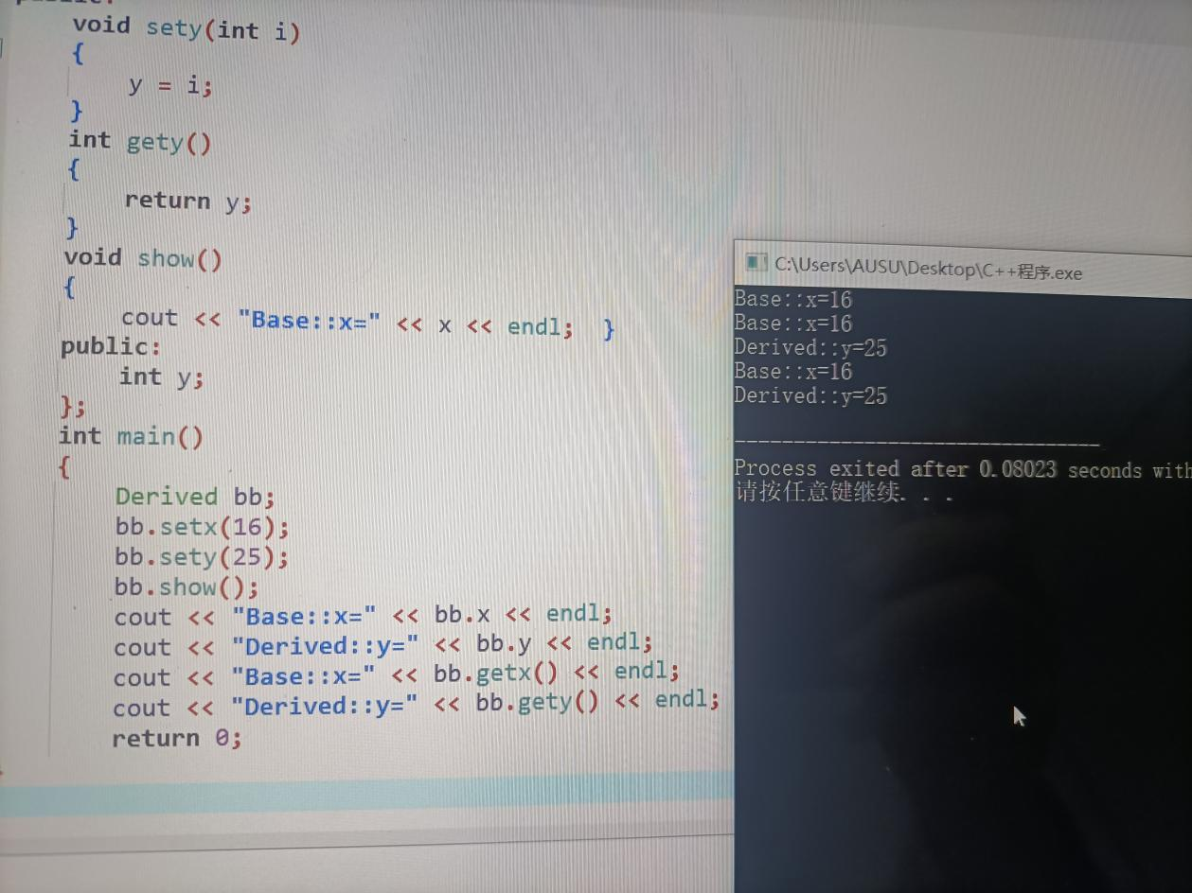

1. 感想心得

派生类无法直接继承访问基类的私有函数和变量；派生类的对象无法直接访问保护类型的变量，基类中的私有函数及变量以及基类中的保护函数及变量。