[1]

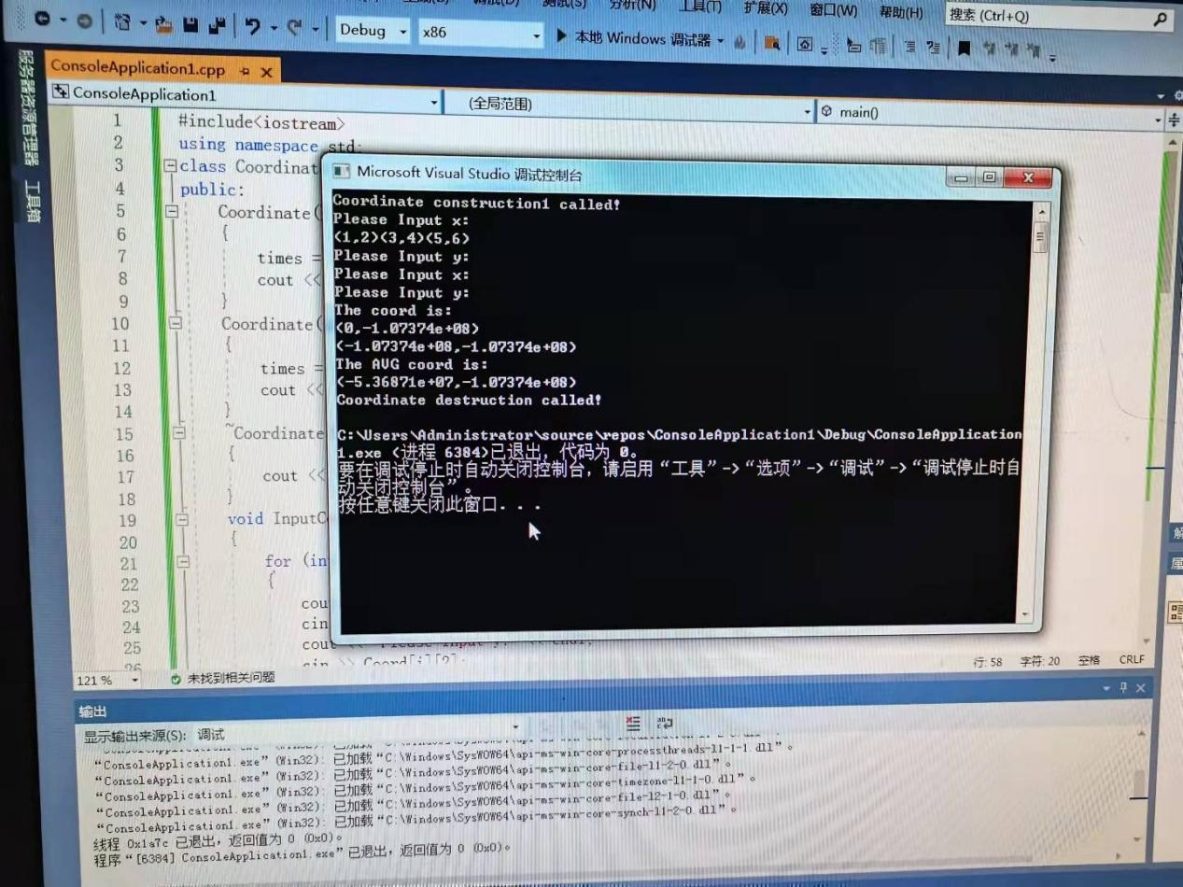

1. Copyright ©2021-2099 XinqiaoDong. All rights reserved