# 上机实验3

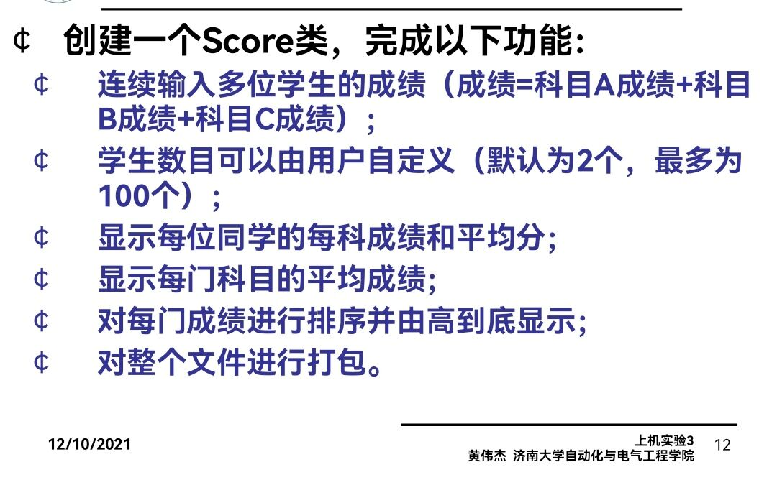

# 程序代码

#include <iostream>

#include<cstring>

using namespace std;

class Transcript {

private:

float grade[100][300];

int times;

char name[100][20];

float avg[100];

public:

Transcript(int times1);

void InputGrade();

void ShowGrade();

void ShowAvgGrade();

void sort();

};

Transcript::Transcript(int times1 = 2)

{

times = times1;

}

void Transcript::InputGrade()

{

for (int i = 0; i < times; i++)

{

cout << "请输入学生姓名：" << endl;

cin >> name[i];

cout << "请输入科目A成绩：" << endl;

cin >> grade[i][0];

cout << "请输入科目B成绩：" << endl;

cin >> grade[i][1];

cout << "请输入科目C成绩：" << endl;

cin >> grade[i][2];

}

}

void Transcript::ShowGrade()

{

for (int i = 0; i < times; i++)

{

cout << "姓名：" << name[i] << " 科目A成绩：" << grade[i][0] << " 科目B成绩:" << grade[i][1] << " 科目C成绩:" << grade[i][2] << endl;

}

}

void Transcript::ShowAvgGrade()

{

float avgA = 0;

float avgB = 0;

float avgC = 0;

for (int i = 0; i < times; i++)

{

avgA = avgA + grade[i][0];

avgB = avgB + grade[i][1];

avgC = avgC + grade[i][2];

avg[i] = (grade[i][0] + grade[i][1] + grade[i][2]) / 3;

}

avgA = avgA / times;

avgB = avgB / times;

avgC = avgC / times;

for (int i = 0; i < times; i++)

{

cout << "姓名：" << name[i] << " 平均成绩：" << avg[i] << endl;

}

cout << "课程名称：A 平均成绩：" << avgA << endl;

cout << "课程名称：B 平均成绩：" << avgB << endl;

cout << "课程名称：C 平均成绩：" << avgC << endl;

}

void Transcript::sort()

{

for (int k = 0; k < 3; k++)

{

for (int i = 0; i < times - 1; i++)

for (int j = 0; j < times - 1 - i; j++)

if (grade[j][k] < grade[j + 1][k])

{

float temp = grade[j + 1][k];

grade[j + 1][k] = grade[j][k];

grade[j][k] = temp;

char temp1[100][20];

strcpy_s(temp1[0], name[j + 1]);

strcpy_s(name[j + 1], name[j]);

strcpy_s(name[j], temp1[0]);

}

}

cout << "课程名称：A" << endl;

for (int i = 0; i < times; i++)

{

cout << "姓名：" << name[i] << " 成绩：" << grade[i][0] << endl;

}

cout << "课程名称：B" << endl;

for (int i = 0; i < times; i++)

{

cout << "姓名：" << name[i] << " 成绩：" << grade[i][1] << endl;

}

cout << "课程名称：C" << endl;

for (int i = 0; i < times; i++)

{

cout << "姓名：" << name[i] << " 成绩：" << grade[i][2] << endl;

}

}

int main()

{

Transcript x(2);

x.InputGrade();

x.ShowGrade();

x.ShowAvgGrade();

x.sort();

return 0;

}

# 程序结果

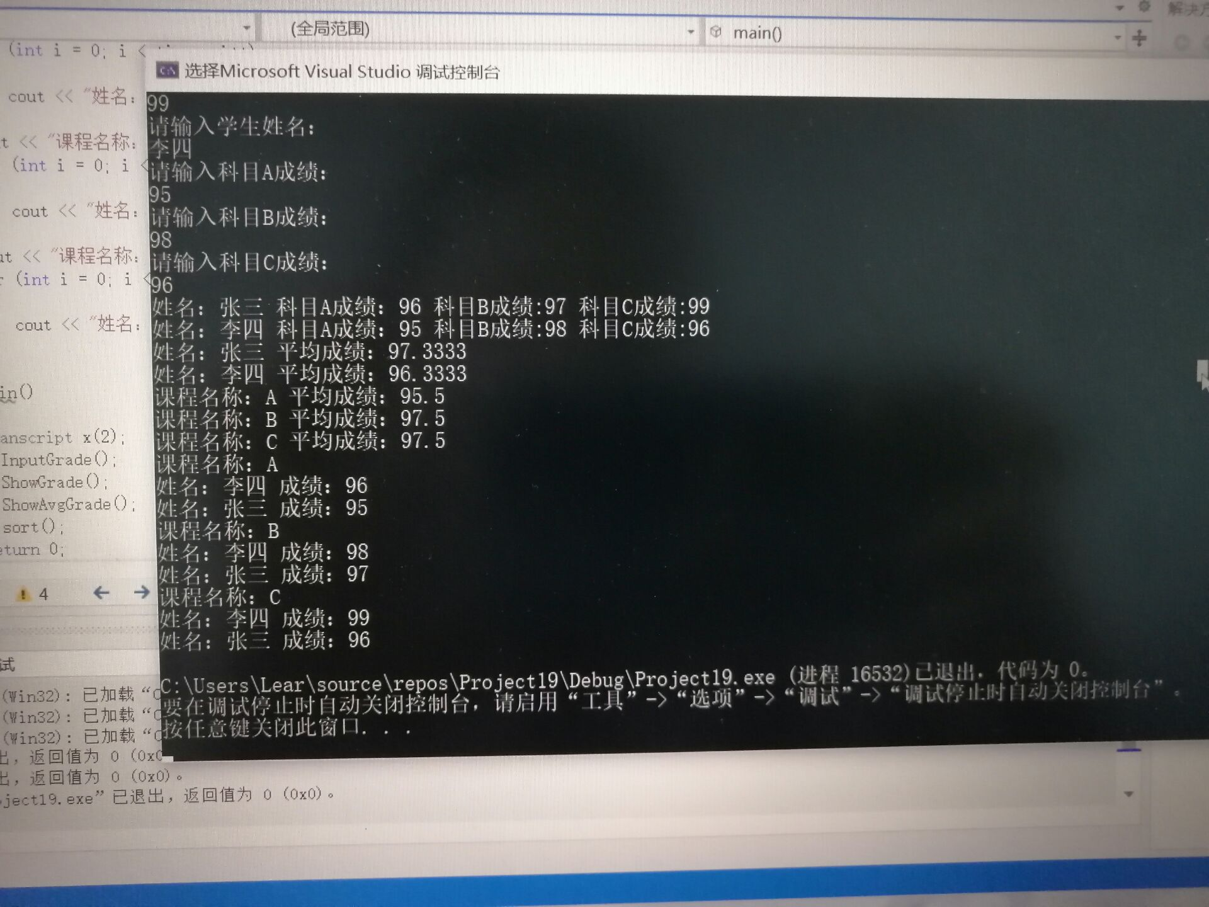

# 感想心得

这次实验我理解了类和对象的概念，掌握了声明类和定义对象的方法；学习了如何应用构造函数和析构函数。构造函数的主要目的是对类的成员变量进行初始化赋值,析构函数是在程序结束时对所用到的数据进行归零粉碎。这两个函数是面向对象中比较重要的。我还初步掌握了使用类和对象编制C++程序。

Copyright 2021-2099 Hubing. All rights reserved