#include <iostream>using namespace std;int main() {

int age;

cout<<“Please input your name：”<<endl; cin>>age;cout<<“Hello, world! I am ”<<name <<endl;return 0; }# include<iostream>using namespace std;int main(){

int x,y,sum;cout<<“Enter two numbers:”<<endl;cin>>x>>y;

sum = add(x,y);cout<<sum<<endl;

return 0;}int add(int a,int b){ return a+b;

}

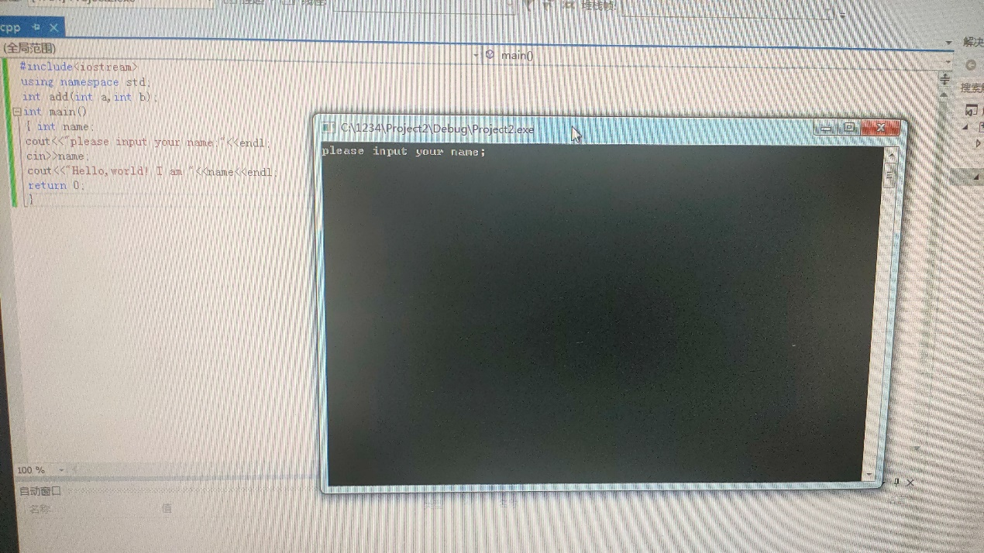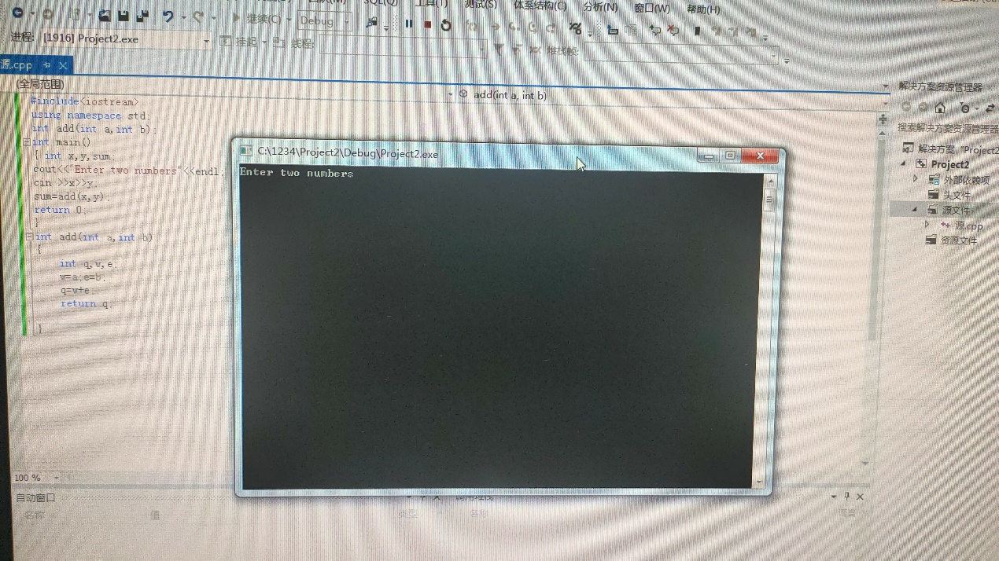感想：注意辨别count，cin对应的符号